INDOOR AIR QUALITY ASSESSMENT

Department of Quality Improvement Suite
Western Massachusetts Hospital
91 East Mountain Road
Westfield, MA



Prepared by:
Massachusetts Department of Public Health
Bureau of Climate and Environmental Health
Division of Environmental Health Regulations and Standards
May 2026

BACKGROUND
Building: | Department of Quality Improvement Suite (DQI) inside Western Massachusetts Hospital (WMH)
Address: | 91 East Mountain Road, Westfield, MA
Assessment Requested by: | Jeffery Dubiel, Director of Facilities
Reason for Request: | General indoor air quality (IAQ) and respiratory issues
Date of Assessment: | May 1, 2026
Massachusetts Department of Public Health/Bureau of Climate and Environmental Health/Division of Environmental Health Regulations and Standards (MDPH/BCEH/EHRS) Staff Conducting Assessment: | Thomas Murphy, Environmental  Analyst, EHRS
Building Description: | The DQI suite is located in the basement of WMH which is a multi-story brick building built in 1910. WMH is an 87-bed long term acute medical and specialty care hospital owned and operated by MDPH. The building has undergone significant renovations including, in 2023, when a major project replaced the original mechanical systems and provided new heating, ventilation, and central air conditioning systems; upgraded the electrical systems; replaced the existing roof and windows; and completed accessibility upgrades. https://www.mass.gov/info-details/western-massachusetts-hospital-hvac-mechanical-upgrades.
Windows: | Windows are openable in some offices however they are difficult to access due to their high location.

METHODS
Please refer to the IAQ Manual for methods, sampling procedures, and interpretation of results (MDPH, 2015).

RESULTS AND DISCUSSION
The following is a summary of indoor air testing results (Table 1).
- Carbon dioxide levels were below the MDPH guideline of 800 parts per million (ppm) in all areas assessed, indicating adequate air exchange at the time of assessment. However, the space was minimally occupied at the time of testing. Carbon dioxide levels would be expected to be higher with increased occupancy.
- Temperature was within the recommended range of 70°F to 78°F in all areas assessed.
- Relative humidity was below the MDPH recommended range of 40 to 60% in all areas assessed. Low relative humidity is common indoors during the heating season. Note that low relative humidity can lead to common symptoms such as dry skin, lips, and scalp; dry/scratchy throats and noses (nose bleeds); exacerbation of asthma, eczema, or allergies; dry/irritated eyes; and irritation of respiratory tract.
- Carbon monoxide levels were non-detectible (ND) in most areas. Towards the end of the assessment, levels around 2.8 ppm were detectible in the lower mechanical room and boiler room, and higher levels up to 6.8 ppm were detected outside in the front of the building. Carbon monoxide should not be present in a typical, indoor environment. If it is present, indoor carbon monoxide levels should be less than or equal to outdoor levels.
- Fine particulate matter (PM2.5) concentrations measured inside the DQI suite were ND which is below the National Ambient Air Quality Standard (NAAQS) level of 35 μg/m³ in all areas assessed.
- Volatile Organic Compounds (TVOC) concentrations were ND in all areas tested.

Ventilation
A heating, ventilating, and air conditioning (HVAC) system has several functions. First, it provides heating and, if equipped, cooling. Second, it is a source of fresh air. Finally, an HVAC system will dilute and remove normally occurring indoor environmental pollutants by introducing fresh air, filtering the airstream and ejecting stale air to the outdoors via exhaust ventilation. Even if an HVAC system is operating as designed, point sources of respiratory irritation may exist and lead to symptoms in sensitive individuals.
Air handling units (AHUs) on the roof bring in fresh air which is distributed through ceiling-mounted supply vents in the offices (Picture 1). According to WMH staff some supply vents in offices had a cover with holes in it to have the fresh air move laterally rather than straight down into the space (Picture 2). A fan coil unit in the ceiling heats and cools the air via a different supply vent, the air is then returned into exhaust vents (Picture 3). A fan coil unit does not have a fresh air supply itself, but contains a fan and filters to filter and circulate the air in the room (Figure 1). Given the layout of the exhaust vents in the DQI suite, consideration should be given to see if more exhaust vents can be added to areas without them.
An exhaust fan was observed in a window in the lower mechanical room (Picture 4). According to WMH staff it is used to eject air and moisture during summer months and, when not in use during the winter, it is tightly sealed.
The AHUs for this building were assessed during this visit. The MDPH/BCEH recommends that AHU filters be changed 2-4 times a year (or per the manufacturer’s recommendations) and be at least a minimum efficiency reporting value (MERV) 8, or higher if the equipment can handle them without a degradation in airflow, as these are adequate to filter out pollen, mold, and similar particulates (ASHRAE, 2012). The AHUs for WMH including the DQI suite use MERV 10 pleated filters and according to WMH staff they are changed at least 4 times a year.
Building mechanical systems are controlled through a building management system which can be accessed electronically by a computer. Systems should be set to allow for continuous fresh air and air circulation during all occupied periods. If other parameters such as carbon dioxide or humidity are measured by the system and fed into the building management system, these measurements can be used to ensure sufficient fresh air is being supplied for occupancy. Humidity measurements can be used to assess whether there is the potential for condensation during hot humid weather.
A thermostat was observed on a wall (Picture 5), and it was reported the temperature can be moved up or down within a specified range. The thermostat did not indicate if the HVAC system in the DQI suite is set to on, auto, or off. This is likely controlled by the building management system.
To have proper ventilation with a mechanical supply and exhaust system, the systems must be balanced to provide an adequate amount of fresh air to the interior of a room while removing stale air from the room. It is recommended that HVAC systems be re-balanced every five years to ensure adequate air systems function (SMACNA, 1994). WMH staff reported the system was balanced when it was installed within the past three years.

Microbial/Moisture Concerns

Sources of moisture
Plants were noted in some offices (Pictures 6 through 8). Plants can be a source of pollen or mold especially if overwatered or not well maintained. Plants without drip pans can damage porous surfaces they are placed on. In addition, at least one plant was on top of a paper plate (Picture 9), which can delaminate and be a source of mold growth. Plants should be kept away from the airstream of ventilation equipment to prevent the spread of pollen or mold.
Another possible source of moisture is water penetration through below-grade windows (Picture 10) and/or migration through below-grade building foundation components. It was reported by WMH staff that the windows in this suite were recently replaced. The building exterior, including windows, should be routinely checked for any sources of water infiltration.

Building materials prone to condensation/water damage
Although this assessment was done on during temperate spring weather, the DQI suite may be susceptible to condensation during hot, humid weather. The key to managing condensation in hot, humid weather indoors is understanding dew point. Condensation is the collection of moisture on a surface at or below the dew point. The dew point is the temperature that air must reach for saturation to occur. If a building material/component has a temperature below the dew point, condensation will accumulate on that material. Over time, condensation can collect and form water droplets.
Even though the DQI suite is equipped with air conditioning, the basement could still experience condensation on below grade floors and walls, particularly in areas where walls and floors have direct contact with soil, or where plumbing pipes with chilled water are present without adequate insulation. EHRS staff did not observe any visual evidence of condensation on the DQI suite basement floor during the time of the assessment.
In general, any material that is porous and capable of supporting mold growth should not be stored on floors and against walls capable of becoming moistened by condensation. Such materials include: cardboard boxes (Picture 11), cloth, paper, books, soft plastics (e.g., polyurethane), leather, upholstered furniture, and jute or latex-backed carpeting.

Other IAQ issues
Personal products, particularly those with volatile organic compounds (VOCs) including scents, can also be a source of respiratory irritation. VOCs are carbon-containing substances that can evaporate at room temperature. Exposure to low levels of total-VOCs (TVOCs) may produce eye, nose, throat and/or respiratory irritation in some sensitive individuals. While TVOCs measured in the office were all non-detect, products were noted in the DQI suite that can be sources of VOCs. These include cleaning/disinfecting wipes, hand sanitizers, and dry erase markers (Pictures 12 through 15). They should be used with good ventilation, and kept closed when not in use. Products with strong scents, including scent sprays and essential oils should not be used in a shared office space as many people are sensitive to fragrance compounds. Consult “Clean Air Is Odor Free” for more information on fragrances in buildings.
A personal fan with dust accumulated on it was noted in an office (Picture 16). When dust accumulates on the blades, it can be aerosolized during use. Fans should be checked and cleaned periodically to remove any dust.
As noted in the results section, carbon monoxide (CO) levels indoors were mostly non-detectable (ND) during this assessment. Prior to conducting indoor testing, outdoor CO levels were also ND. During the later part of the assessment, CO levels were detectable indoors (Table 1). Outdoor CO testing which was done after indoor testing was completed, ranged up to 6.8 ppm. These measurements show that outdoor CO levels increased during this assessment. It is important to note that CO measurements indoors were lower than the outdoor measurements, indicating the likely CO sources were outside the building. CO is produced when heating fuel oil, diesel or gasoline are combusted during operation of heating systems or operating motor vehicles.
Note that the US National Ambient Air Quality Standards (NAAQS) for carbon monoxide in outdoor air are 9 ppm measured over 8 hours, and 35 ppm measured over 1 hour (US EPA, 2025). Various guidelines and standards for carbon monoxide in indoor air exist, including:
- The Occupational Safety and Health Administration (OSHA) permissible exposure limit (PEL) for carbon monoxide is 50 ppm as an 8-hour time-weighted average (TWA) concentration (OSHA, 1997).
- The National Institute for Occupational Safety and Health (NIOSH) has established a recommended exposure limit (REL) for carbon monoxide of 35 ppm as an 8-hour TWA and 200 ppm as a ceiling (NIOSH, 2019).
- MDPH’s regulations for the operation of ice rinks includes the following:
  - Action Air Levels for Carbon Monoxide shall be a single air sample exceeding 30 parts per million (ppm) for carbon monoxide.
  - Notification air levels shall be a single air sample exceeding 60 parts per million (ppm) or six consecutive air samples which exceed 30 parts per million (ppm) for carbon monoxide.
  - Evacuation air levels shall be a single air sample exceeding 125 parts per million (ppm) for carbon monoxide (MDPH, 2004).
- Kidde, a major manufacturer of carbon monoxide alarms, uses the following criteria for the alarm activating (KIDDE, 2026):
  - 40 ppm: 10 hours
  - 50 ppm: 8 hours
  - 70 ppm: 1 to 4 hours
  - 150 ppm: 10 to 50 minutes
  - 400 ppm: 4 to 15 minutes
Note that the wind speed was approximately 7 mph at the beginning of the assessment and increased to 16 mph including wind gusts of 26 mph around the end of the assessment in the greater Westfield area on the day of this visit (WU, 2026). Several possible outdoor sources of CO exist singly or in combinations in the vicinity of the building:
- A large quarry about half a mile away which includes massive vehicles such as front-end loaders, dump trucks, excavators, and other combustion producing equipment.
- Vehicle traffic/idling around the perimeter of WMH, and landscaping equipment being used such as zero turn lawn mowers.
- Heavy Friday afternoon traffic on the Massachusetts Turnpike (Interstate 90) to the north and Route 20 to the south.
- Trains traveling on railroad tracks to the north near the Massachusetts Turnpike.
- Two large shopping plazas near WMH including a giant parking lot for the WalMart Supercenter located about half a mile away.
- A busy traffic light at the end of East Mountain Road where it meets Route 20 which results in a large number of vehicles idling.
The American Society of Heating, Refrigerating and Air-Conditioning Engineers (ASHRAE) has adopted the National Ambient Air Quality Standards (NAAQS) as one set of criteria for assessing IAQ and monitoring of fresh air introduced by HVAC systems (ASHRAE, 2022). The NAAQS are standards established by the US EPA to protect the public’s health from six criteria pollutants, including carbon monoxide and particulate matter (US EPA, 2006). As recommended by ASHRAE, pollutant levels in fresh air introduced into a building should not exceed the NAAQS levels (ASHRAE, 2022). According to the US EPA Region 1 “in New England, fuel combustion in residential housing, businesses, industry and utilities accounts for 10 to 20 percent of the total CO emissions, while mobile sources (cars, trucks, buses and off-road equipment such as marine engines and construction equipment) account for 80 to 90 percent” (US EPA, 2024).
Carbon monoxide should not be present in a typical, indoor environment. If it is present, indoor CO levels should be less than or equal to outdoor levels. During this assessment, CO levels were below US EPA NAAQS and outdoor ambient levels.
When activities occur nearby that may lead to elevated CO, occupants and facility staff can take steps to improve IAQ which may include temporarily closing exterior doors and windows. This will also reduce impacts from noise, particulate matter, and odors. A discussion was had with WMH staff about CO measurements found during the assessment and information was provided about carbon monoxide detectors installed in the building which can provide alerts about certain levels of CO in the building and notify WMH staff which CO measurements are the highest in the building if an alarm is triggered.
At least two interior doors had light visible beneath them (Pictures 17 and 18), indicating gaps which can allow the movement of potential odors, drafts, or moisture between WMH spaces. All exterior doors and interior doors leading between different sections of the building should be weather tight.
DQI staff had brought a portable indoor air quality sensor into the suite (Picture 19). The sensor was in close proximity to disinfectant wipes and hand sanitizer (Picture 20), which are VOC containing products. As the products were used, an alarm temporarily rang from the air sensor device and then shortly turned off after the VOCs dissipated and levels returned back to ND. Consumer-grade air quality instruments are becoming increasingly popular as equipment gets cheaper and knowledge about the impacts of air quality are publicized. These units are typically not as robust as those used in professional contexts, but they can provide useful data if caveats are applied. Information from these units can be used to track trends (e.g. what happens when windows are opened versus closed, how measurements change based on weather, or how use of air purifiers or filters impact measurements). For best results they should be placed in an area representative of the breathing zone of occupants, and away from point sources of pollutants such as hand sanitizer dispensers, cleaning wipes, and air freshener products. Each instrument comes with instructions for best use, including any “fresh air calibration” steps, battery changes, or handling instructions which should be followed. These units should not be exposed to atypical conditions such as excess moisture, high temperatures, or physical damage, as these may reduce the accuracy of the instrument.
Lastly, the MDPH EHRS recommends that occupied basement areas be tested for radon, and that this testing be conducted during the heating season while the building is normally occupied in a manner consistent with US EPA radon testing guidelines. Radon measurement specialists and other information can be found at www.nrsb.org and http://aarst-nrpp.com/wp, with additional information at: https://www.mass.gov/radon.

CONCLUSIONS/RECOMMENDATIONS
In view of the findings at the time of the visit, the following recommendations are made:

Ventilation recommendations
- Operate the HVAC system (supply/exhaust) to provide continuous fresh air ventilation during occupied hours.
- Determine if adding additional exhaust vents to the DQI suite could supplement airflow and remove stale air during maximum occupancy.
- Ensure building control systems are set to deliver comfortable temperatures during occupied periods.
- Continue to change filters for HVAC units at least two to four times a year or as per the manufacturers’ recommendations using filters with a Minimum Efficiency Rating Value (MERV) of 8 or better. Ensure HVAC cabinets are cleaned of debris during filter changes.
- Find out if the wall mounted thermostat in the DQI can provide information displaying the HVAC system is on continuously.
- Have the HVAC system balanced every 5 years in accordance with SMACNA recommendations (SMACNA, 1994).
- For buildings in New England, periods of low relative humidity during the winter are often unavoidable. Therefore, scrupulous cleaning practices should be adopted to minimize common indoor air contaminants whose irritant effects can be enhanced when the relative humidity is low. To control dust, a high efficiency particulate arrestance (HEPA) filter equipped vacuum cleaner in conjunction with wet wiping of all surfaces is recommended. Avoid the use of feather dusters. Drinking water during the day can help ease some symptoms associated with a dry environment (throat and sinus irritations).

Water damage recommendations
- Keep all indoor plants in good condition with non-porous drip pans and do not overwater. Properly maintain plants to avoid mold and odors. Keep plants out of the airstream of ventilation equipment.
- Consistently monitor the building exterior including areas near below-grade windows to monitor any sources of water infiltration.
- Remove any porous items such as cardboard boxes off the floor.

Other IAQ recommendations
- Use VOC-containing products in areas with good ventilation and keep tightly closed when not in use. Avoid products with strong scents and avoid mixing incompatible products.
- Refer to “Clean Air Is Odor Free” for more information on fragrances in buildings.
- Consistently check and clean the blades of personal fans.
- Given the numerous outside sources of carbon monoxide in the area of WMH, monitor weather conditions including strong winds. If vehicle or construction exhaust odors are detected, contact building management/facilities staff and close exterior doors/windows.
- Refer to Airnow data for Westfield for more information about outdoor air quality conditions, specifically ozone, PM2.5 and PM10. Provide outdoor air quality updates/resources to building staff to keep them informed.
- Consider installing digital sensor technology readouts in the DQI suite and WMH to provide continuous monitoring of the indoor air parameters such as carbon dioxide, carbon monoxide, temperature, relative humidity, and particulate matter. Sensors should be re-calibrated quarterly or according to manufacturers’ specifications and building management software updated as per manufacturers’ instructions, industrial standards, and/or change in operating systems. As an example, the following link illustrates how this technology is serving Boston Public Schools to improve air quality (i.e., carbon dioxide, temperature, relative humidity, carbon monoxide, and particulate matter). COVID-19 Health & Safety Information / Indoor Air Quality Sensor Dashboard (bostonpublicschools.org)
- Consider providing portable air purifiers as an additional method to filter air in the DQI suite. If air purifiers are provided, replace filters and equipment in accordance with manufacturers’ instructions. While air purifiers do not supply fresh air, they can remove particles including mold spores and microbes. Avoid the use of air purifiers that may produce ozone (EPA, 2003).
- Consider having the basement suite tested for radon. Radon measurement specialists and other information can be found at www.nrsb.org and http://aarst-nrpp.com/wp, with additional information at: https://www.mass.gov/radon.
- Please refer to resource manual and other related IAQ documents located on the MDPH’s website for further building-wide evaluations and advice on maintaining public buildings. These documents are available at: http://mass.gov/dph/iaq.

REFERENCES
ASHRAE. 2012. American Society of Heating, Refrigeration and Air Conditioning Engineers (ASHRAE) Standard 52.2-2012 -- Method of Testing General Ventilation Air-Cleaning Devices for Removal Efficiency by Particle Size (ANSI Approved).
ASHRAE, 2022. American Society of Heating, Refrigeration and Air Conditioning Engineers (ASHRAE) Ventilation for Acceptable Indoor Air Quality. ANSI/ASHRAE Standard 62.1-2022. Atlanta, GA.
KIDDE. 2026. Understanding Carbon Monoxide Levels. https://www.kidde.com/support/carbon-monoxide-alarms/co-levels-info
MDPH. 2015. Massachusetts Department of Public Health. Indoor Air Quality Manual: Chapters I-III. Available at: https://www.mass.gov/lists/indoor-air-quality-manual-and-appendices.
NIOSH. 2019. National Institute for Occupational Safety and Health. NIOSH Pocket Guide to Chemical Hazards: Carbon Monoxide. https://www.cdc.gov/niosh/npg/npgd0105.html
OSHA. 1997. Limits for Air Contaminants. Occupational Safety and Health Administration. Code of Federal Regulations. 29 C.F.R 1910.1000 Table Z-1-A.
SMACNA. 1994. HVAC Systems Commissioning Manual. 1st ed. Sheet Metal and Air Conditioning Contractors’ National Association, Inc., Chantilly, VA.
US EPA. 2003. “Ozone Generators that are Sold as Air Cleaners: An Assessment of Effectiveness and Health Consequences”. United States Environmental Protection Agency, Office of Air and Radiation, Indoor Environments Division, Washington, DC. Last updated September, 2018. https://www.epa.gov/indoor-air-quality-iaq/ozone-generators-are-sold-air-cleaners.
US EPA. 2006. National Ambient Air Quality Standards (NAAQS). United States Environmental Protection Agency, Office of Air Quality Planning and Standards, Washington, DC. https://www.epa.gov/criteria-air-pollutants/naaqs-table.
US EPA. 2024. Carbon Monoxide: Carbon Monoxide Maintenance Areas In New England. USEPA Region 1. Last Updated March 14, 2024. https://www3.epa.gov/region1/airquality/co.html
US EPA. 2025. National Ambient Air Quality Standards (NAAQS). US Environmental Protection Agency, Office of Air Quality Planning and Standards, Washington, DC. Last updated on November 4, 2025
WU. 2026. Weather Underground Westfield, MA May 1, 2026. https://www.wunderground.com/history/daily/KBAF/date/2026-5-1

Picture 1
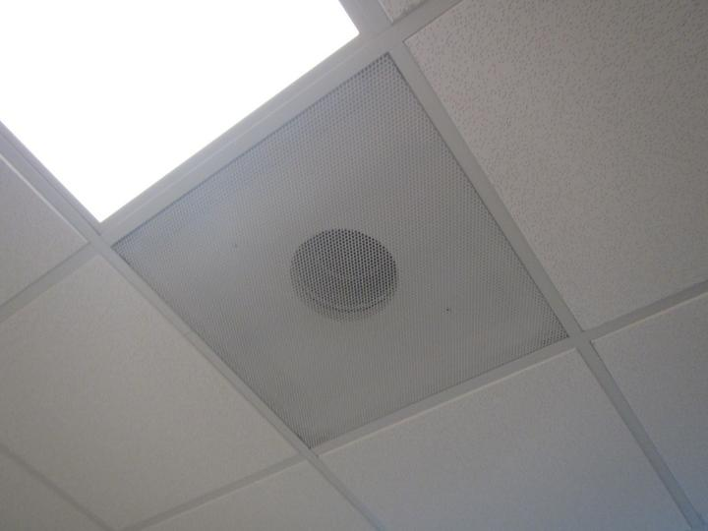
Ceiling mounted supply vent connected to AHU
Picture 2
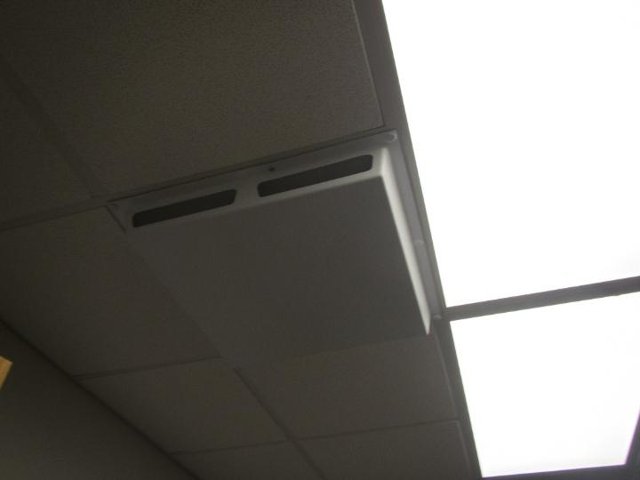
Covered supply vent with holes in it

Picture 3
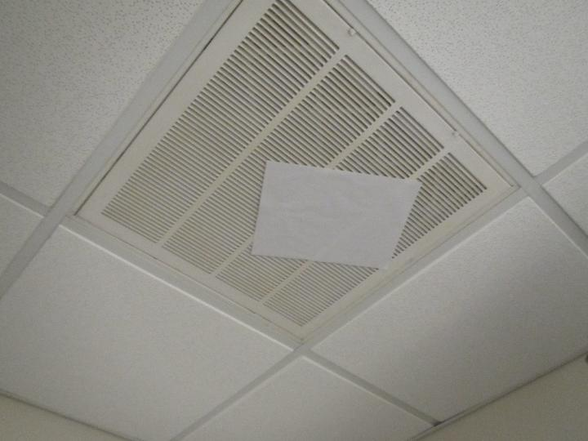
Paper stuck to exhaust vent showing strong suction of air

Picture 4
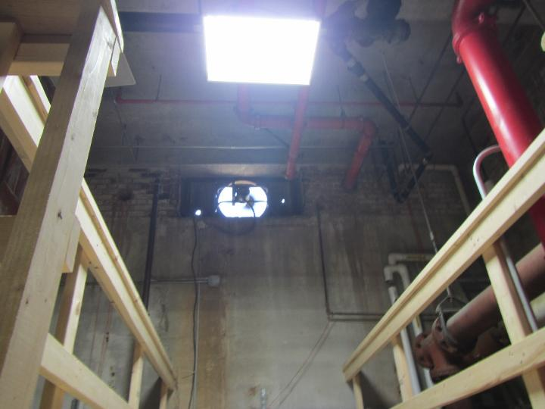
Exhaust fan in window in lower mechanical room
Picture 5
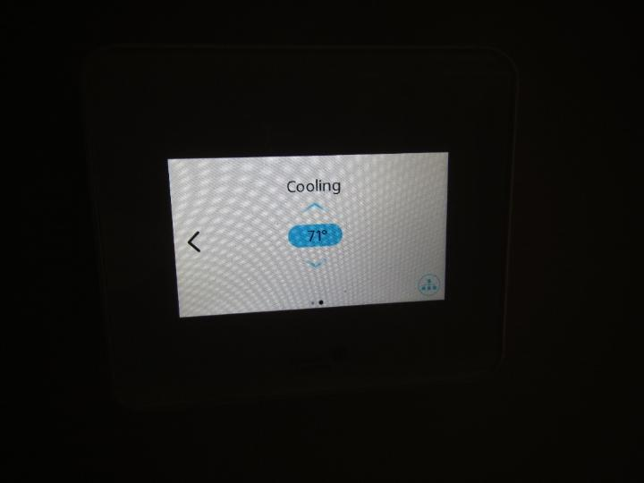
Thermostat on wall
Picture 6
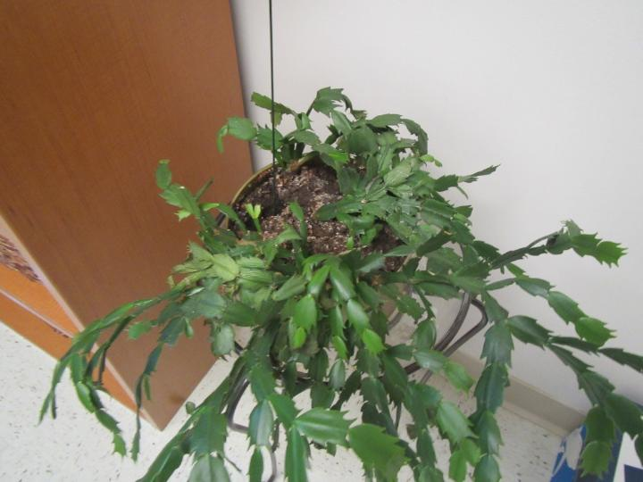
Plant in an office

Picture 7
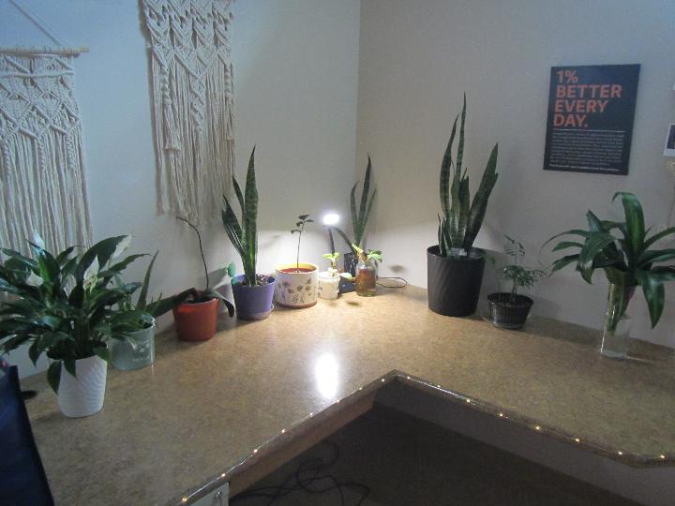
Plants in an office

Picture 8
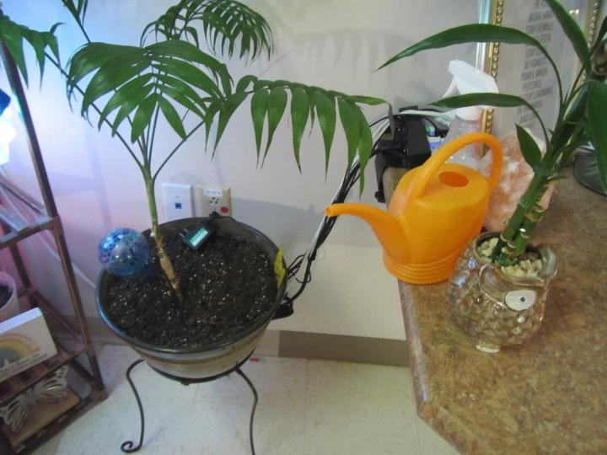
Plants in an office
Picture 9
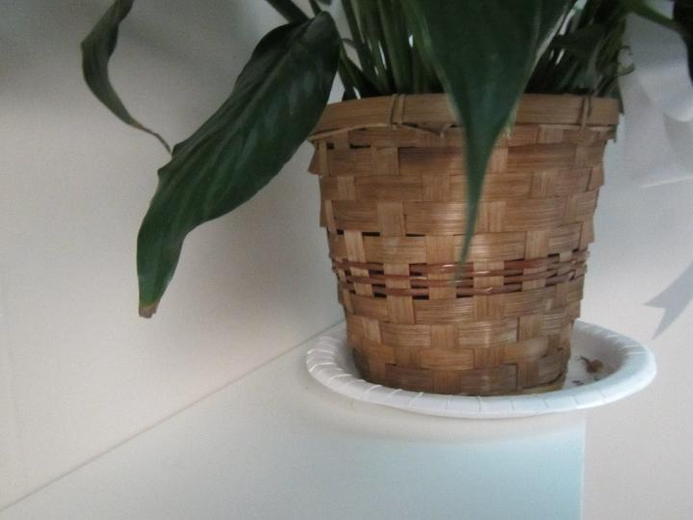
Plant on a paper plate on a shelf in an office

Picture 10
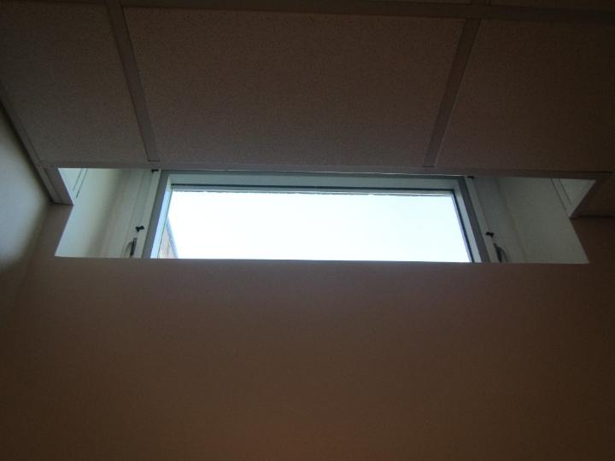
Below-grade window in an office
Picture 11
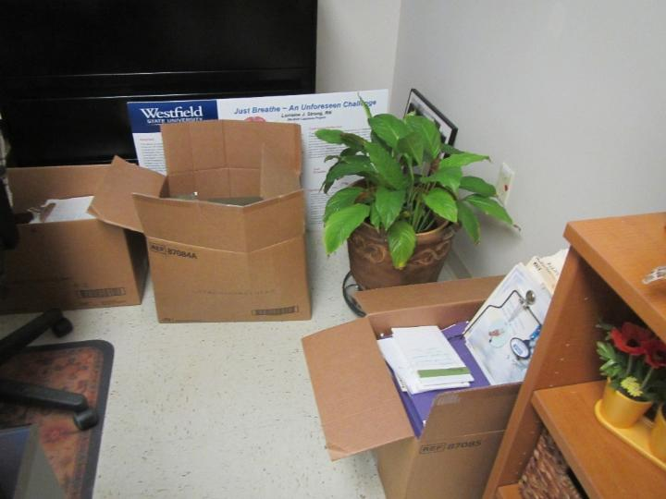
Carboard boxes in direct contact with floor, also a plant

Picture 12
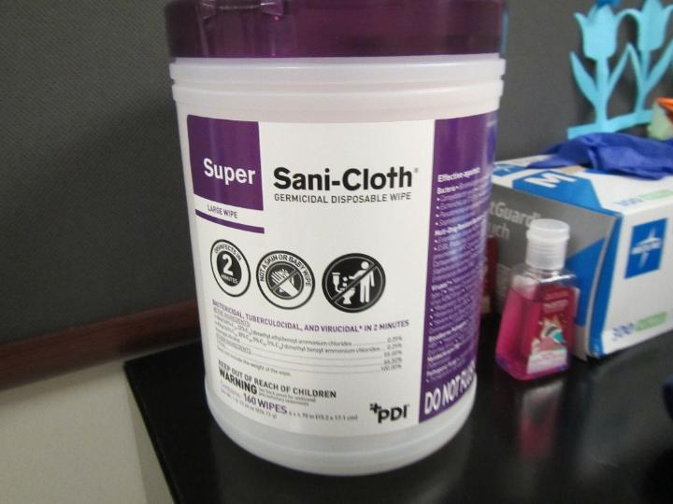
Disinfectant wipes (left) and hand sanitizer (right) in entrance area
Picture 13
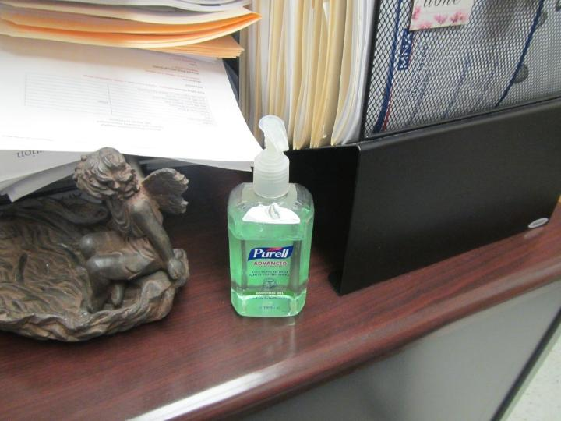
Hand sanitizer in an office

Picture 14
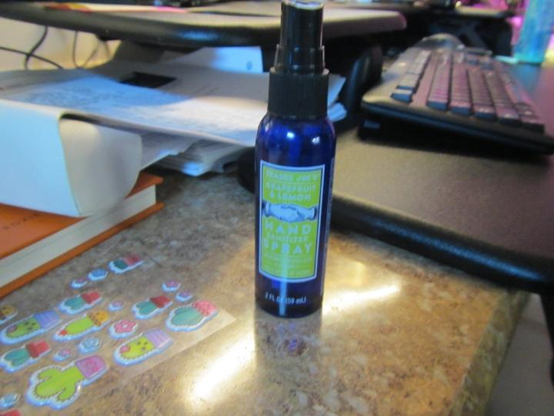
Hand sanitizer spray in an office
Picture 15
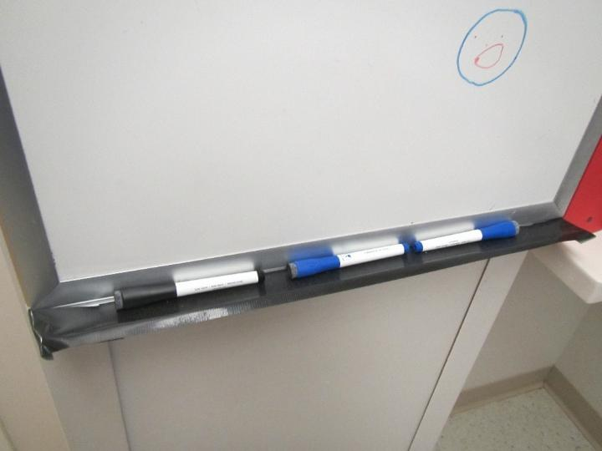
Dry erase markers in an office

Picture 16
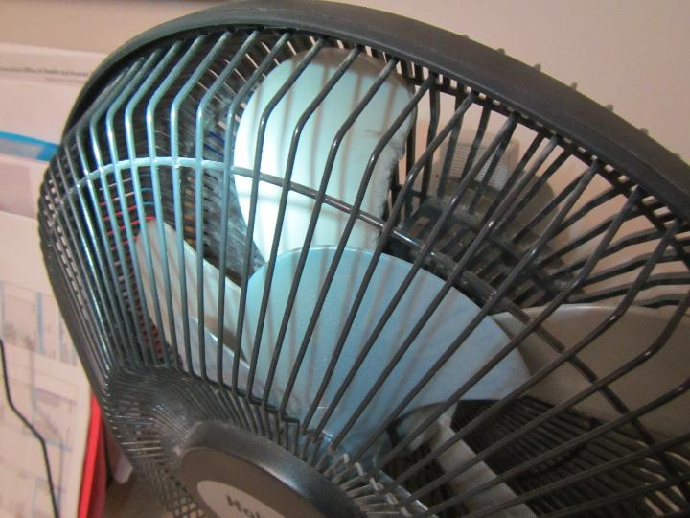
Personal fan accumulated with dust
Picture 17
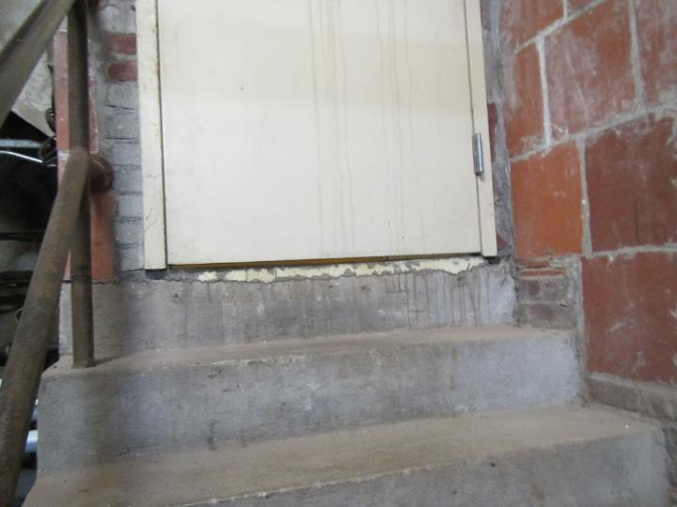
Gap underneath lower mechanical room entry door
Picture 18
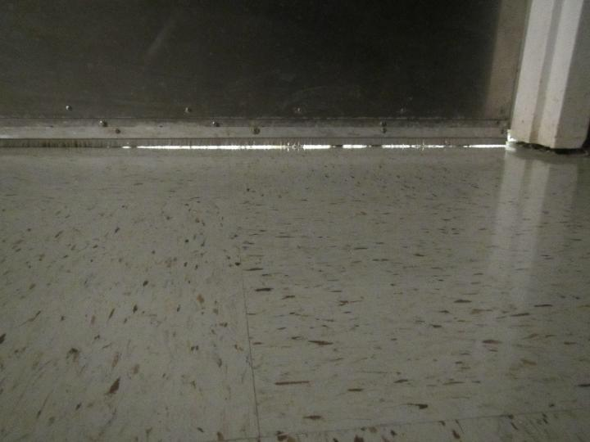
Light indicating gap underneath back interior exit door in DQI suite

Picture 19
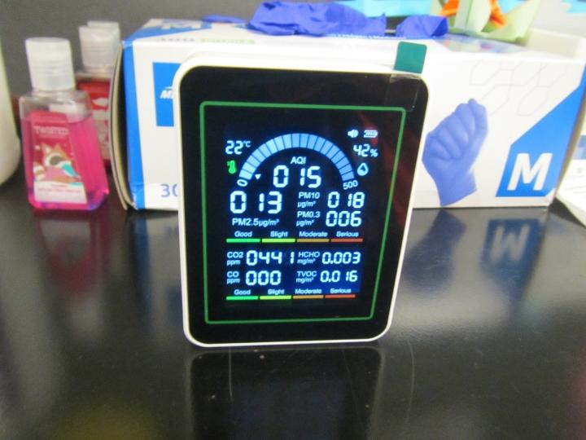
Portable air sensor in DQI suite (temporarily moved to take close up picture)
Picture 20
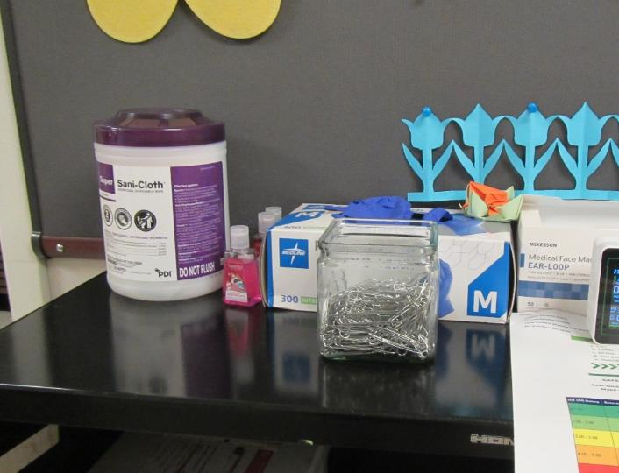
Disinfectant wipes and hand sanitizer (left) in close proximity to air sensor location (right)

Figure 1

Fan Coil Unit (FCU)

Air Diffuser

Outdoors Indoors

Fan

Heating/Cooling Coil

Air Mixing Plenum

Filter

Return
Air

Location | Carbon  Dioxide  (ppm) | Carbon Monoxide  (ppm) | Temp  (°F) | Relative  Humidity  (%) | PM2.5  (µg/m³) | TVOC  (ppm) | Occupants  in Room | Windows  Openable | Ventilation |  | Remarks
 |  |  |  |  |  |  |  |  | Supply | Exhaust | Remarks
Background (outside) | 398 | ND-6.8 | 62 | 26 | 17 | ND |  |  |  |  | Light/moderate breeze at start of assessment, noticeably stronger wind at end, note no carbon monoxide measured before assessment outside, levels up to 6.8 ppm measured outside after assessment, zero turn lawnmower cutting grass
DQI Suite Entrance | 513 | ND | 72 | 28 | ND | ND | 0 | N | Y | Y | Disinfectant wipes and hand sanitizer next to portable indoor air quality sensor
Office 474 | 632 | ND | 73 | 29 | ND | ND | 0 | Y | Y | N | Plants, hand sanitizer, cardboard boxes on floor
Office 473 | 601 | ND | 73 | 28 | ND | ND | 0 | Y | Y | N | Hand sanitizer, plants
Cubicle 472 | 635 | ND | 73 | 30 | ND | ND | 0 | Y | Y | N | Hand sanitizer spray
Office 471 | 602 | ND | 73 | 29 | ND | ND | 0 | N | Y | N | Dusty personal fan, plants, dry erase markers
Cubicle 1 | 644 | ND | 73 | 28 | ND | ND | 0 | N | Y | Y
Cubicle 2 | 638 | ND | 72 | 28 | ND | ND | 1 | N | Y | Y | Personal fan
Lower Mechanical Room | 531 | 2.8 | 70 | 25 | ND | ND | 0 | N | Y | Y | Exhaust vent in window, entrance door not weathertight
Boiler Room | 471 | 2.8 | 75 | 20 | ND | ND | 0 | N | Y | Y

