# BACKGROUND

**INDOOR AIR QUALITY**

**POST-OCCUPANCY ASSESSMENT**

**Municipal Police Training Committee**

**Western Massachusetts Regional State Police Academy**

**600 Kelly Way**

**Holyoke, MA**

Exterior view of
Municipal Police Training Committee
Western Massachusetts Regional State Police Academy
600 Kelly Way
Holyoke, MA


Prepared by:

Massachusetts Department of Public Health

Bureau of Environmental Health

Indoor Air Quality Program

May 2023

|  |  |
| --- | --- |
| Building: | Western Massachusetts Municipal Police Training Committee, Holyoke Regional Police Academy (MPTC) |
| Address: | 600 Kelly Way, Holyoke, MA |
| Assessment Requested by: | Debbianne Kennedy, Regional Planner, DCAMM |
| Reason for Request: | Post-occupancy assessment |
| Date of Post-Occupancy Assessment: | January 20, 2023 |
| Massachusetts Department of Public Health/Bureau of Environmental Health (MDPH/BEH) Staff Conducting Assessment: | Stefanie Santora, Environmental Analyst, Indoor Air Quality (IAQ) Program |
| Building Description: | The MPTC space is located in a one-story brick building previously occupied by commercial office space. The office space, except for the main café/dining area, has been remodeled into classrooms, meeting rooms, offices, staff dining/kitchen area, a physical fitness room, and gym. |
| Windows: | Not openable |

**METHODS**

Please refer to the IAQ Manual for methods, sampling procedures, and interpretation of results (MDPH, 2015).

**RESULTS AND DISCUSSION**

The following is a summary of indoor air testing results (Table 1).

* ***Carbon dioxide*** levels were above the MDPH guideline of 800 parts per million (ppm) in about half of areas surveyed indicating the need for an increased fresh air supply in those areas.
* ***Temperature*** was within or very close to the MDPH recommended range of 70°F to 78°F in all areas tested.
* ***Relative humidity*** was slightly below the MDPH recommended range of 40 to 60% in most areas tested, which is typical during the heating season.
* ***Carbon monoxide*** levels were non-detectable (ND) in all areas tested.
* ***Fine particulate matter (PM2.5)*** concentrations measured were below the National Ambient Air Quality Standard (NAAQS) limit of 35 μg/m3 in all indoor areas tested.

**Ventilation**

A heating, ventilating, and air conditioning (HVAC) system has several functions. First it provides heating and, if equipped, cooling. Second, it is a source of fresh air. Finally, an HVAC system will dilute and remove normally occurring indoor environmental pollutants by not only introducing fresh air, but by filtering the airstream and ejecting stale air to the outdoors via exhaust ventilation. Even if an HVAC system is operating as designed, point sources of respiratory irritation may exist and cause symptoms in sensitive individuals.

The HVAC system currently consists of 9 air handling units (AHUs) located on the roof, which draw in outside air and heat/cool it. Conditioned air is ducted to supply vents (Picture 1) and removed via ducted return vents. The building contractor reports that the existing AHU for the gym will be replaced with a new unit and an additional unit will be installed for the gym, for a total of 10 AHUs for the building.

The MDPH IAQ Program recommends AHU be equipped with filters of a Minimum Efficiency Reporting Value (MERV) of 8, which are adequate in filtering out pollen and mold spores (ASHRAE, 2012). The rooftop AHU filters in use at the MPTC could not be examined at the time of assessment. AHU filters should be changed two to four times annually or per the manufacturer’s recommendations. During filter changes, the AHU cabinet should be cleaned/vacuumed out to remove debris that may be a source of particulates and odors to the indoor air.

A heat pump was installed to recirculate and condition indoor air through ceiling air ducts in the five classrooms of the MPTC (Picture 2); this assists in heating classrooms in the winter and cooling in warmer months.

The HVAC system is controlled by digital thermostats (Picture 3). The MDPH IAQ Program recommends that the fan be set to the “on” setting to provide continuous circulation/filtration during occupied hours. Airflow is controlled using a fan switch that has two settings, *on* and *auto*. When the fan is set to *on,* the system provides a continuous source of air circulation and filtration. The *automatic* setting on the thermostat activates the HVAC system at a preset temperature. Once the preset temperature is reached, the HVAC system is deactivated. Therefore, no mechanical ventilation is provided until the thermostat re-activates the system. Thermostats noted during the assessment were set with the fan on “medium”.

As noted above, levels of carbon dioxide were higher than the recommended level in about half of the areas assessed (Table 1). The presence of increased levels of carbon dioxide in indoor air of buildings is attributed to occupancy; the greater the number of occupants, the greater the amount of carbon dioxide is produced. Carbon dioxide build-up may be the result of inefficient/non-functioning ventilation systems or occupancy higher than recommended in the space. Given that many areas with levels of carbon dioxide above 800 ppm were not occupied at the time of the assessment, this suggests that insufficient fresh air is being brought inside. Since the thermostats were set to have the fan on, it may be that dampers on the rooftop HVAC system are closed/set to mainly recirculate as an energy saving measure.

To maximize air exchange, the IAQ program recommends that both supply and exhaust ventilation operate continuously during periods of occupancy. To have proper ventilation with a mechanical ventilation system, the systems must be balanced after installation to provide an adequate amount of fresh air to the interior of a room while removing stale air from the room. It is recommended that HVAC systems be re-balanced every five years to ensure adequate air systems function (SMACNA, 1994). The building contractor reported that the system was balanced as part of the recent renovations.

**Microbial/Moisture Concerns**

No water-damaged materials or musty odors were observed during the visit. Note that relative humidity in the occupied space was below the MDPH comfort range of 40-60%. Relative humidity levels in the building would be expected to drop during the winter months due to heating. The sensation of dryness and irritation is common in a low relative humid environment. This is a very common problem during the heating season in the northeast part of the United States.

Water dispensers were observed on carpeted areas in classrooms (Picture 4). Leaks or spills that often occur around the water source can moisten carpeting and lead to microbial growth and odors. Wherever possible, water dispensers should be placed in non-carpeted areas, or on a waterproof mat.

**Other Concerns**

Dust/debris was noted on the kitchen exhaust vent (Picture 5). It is possible that this accumulation occurred due to kitchen appliances (i.e., stove, oven), previously located in the kitchen, which have since been removed as part of the renovation.

Most classrooms and offices have carpet tiles. Carpets and area rugs should be vacuumed regularly with a high efficiency particulate arrestance (HEPA) filter-equipped vacuum cleaner and cleaned annually (or semi-annually in soiled/high traffic areas) in accordance with Institute of Inspection, Cleaning and Restoration Certification (IICRC) recommendations (IICRC, 2012).

Hand sanitizers were observed in classrooms on each desk and air fresheners were observed in several areas (Picture 6). Air freshening products contain chemicals that can be irritating to the eyes, nose, and throat of sensitive individuals. Many air fresheners contain 1,4-dichlorobenzene, a VOC which may cause reductions in lung function (NIH, 2006). Furthermore, deodorizing agents do not remove materials causing odors, but rather mask odors that may be present in the area.

Pest collection traps were found in restrooms, kitchens, and around the perimeter of the MPTC (Picture 7). If not monitored frequently and disposed of properly, decaying organic material can produce odors. Note that rodent infestation, as a result of materials present in wastes, can produce indoor air quality related symptoms. Mouse urine is known to contain a protein that is a known sensitizer (US EPA, 1992). A sensitizer is a material that can produce symptoms in exposed individuals (e.g. running nose or skin rashes).

# RECOMMENDATIONS

In view of the findings at the time of assessment, the following recommendations are made:

## Ventilation recommendations

1. Ensure thermostats are activated. Set thermostat timers to the fan “on” setting to provide continuous filtration and ventilation during occupied hours.
2. Work with an HVAC technician or engineer to increase air exchange in areas with high levels of carbon dioxide, especially the gym and surrounding areas. This may include adjusting dampers and repairing any non-functional parts such as fans.
3. Change AHU filters two to four times annually or per the manufacturer’s instructions. Use MERV 8 or the best quality/highest MERV rated filters that can be used with current equipment.
4. During filter changes, vacuum debris from AHU cabinets.
5. It is recommended that the HVAC systems be rebalanced every five years (SMACNA, 1994).
6. Vacuum/clean dust/debris from supply, return, and exhaust vents as needed.

## Water damage recommendations

1. Place water resistant mats under water dispensers or move them to non-carpeted areas to avoid water damage to carpet and potential microbial growth.

## Other recommendations

1. Clean carpeting annually or semi-annually in soiled high traffic areas as per the recommendations of the IICRC (IICRC, 2012).
2. Clean dust/debris from exhaust vent in kitchen regularly.
3. Pest collection traps should be monitored by a professional on a regular basis. Ensure that any pest control contract allows for removal and replacement of traps.
4. To reduce the potential for and impacts from pest activity, follow integrated pest management guidelines, including blocking any gaps or holes pests can access, removing sources of food, water, or harborage, and regular cleaning to remove wastes and residues (MDFA, 1996).
5. Reduce or eliminate the use of air fresheners and hand sanitizers.
6. Refer to the resource manual and other related indoor air quality documents located on the MDPH’s website for further building-wide evaluations and advice on maintaining public buildings. These documents are available at <http://mass.gov/dph/iaq>.

**REFERENCES**

ASHRAE. 2012. American Society of Heating, Refrigeration and Air Conditioning Engineers (ASHRAE) Standard 52.2-2012 -- Method of Testing General Ventilation Air-Cleaning Devices for Removal Efficiency by Particle Size (ANSI Approved). 2012.

IICRC. 2012. Carpet Cleaning FAQ 4 Institute of Inspection, Cleaning and Restoration Certification. Institute of Inspection Cleaning and Restoration, Vancouver, WA.

MDFA. 1996. Integrated Pest Management Kit for Building Managers. Massachusetts Department of Food and Agriculture, Pesticide Bureau, Boston, MA. <https://www.mass.gov/doc/ipm-integrated-pest-management-kit-for-building-managers/download>.

MDPH. 2015. Massachusetts Department of Public Health. “Indoor Air Quality Manual: Chapters I-III”. Available at: [Indoor air quality - manual and appendices | Mass.gov](https://www.mass.gov/lists/indoor-air-quality-manual-and-appendices)

NIH. 2006. Chemical in Many Air Fresheners May Reduce Lung Function. *NIH News*. National Institute of Health. June 27, 2006. <http://www.nih.gov/news/pr/jul2006/niehs-27.htm>

SMACNA. 1994. HVAC Systems Commissioning Manual. 1st ed. Sheet Metal and Air Conditioning Contractors’ National Association, Inc., Chantilly, VA.

US EPA. 1992. Indoor Biological Pollutants. US Environmental Protection Agency, Environmental Criteria and Assessment Office, Office of Health and Environmental Assessment, research Triangle Park, NC. EPA 600/8-91/202. January 1992.

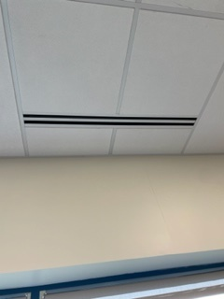**Picture 1**

**Supply vent in classroom**

**Picture 2**

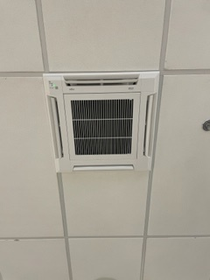

**Heat pump ceiling vent**

**Picture 3**

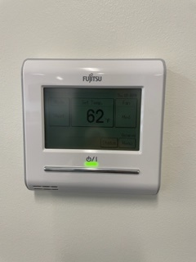

**Digital Thermostat**

**Picture 4**

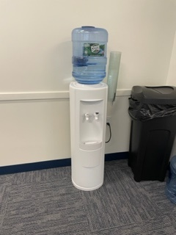

**Water cooler placed directly on carpet**

**Picture 5**

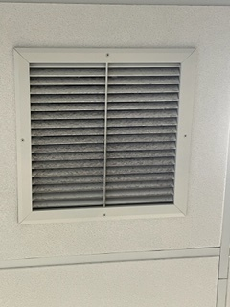

**Kitchen vent with dust/debris accumulation**

**Picture 6**

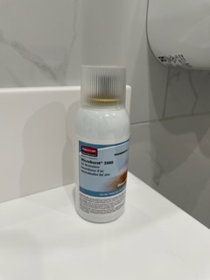

**Air freshener spray in restroom**

**Picture 7**

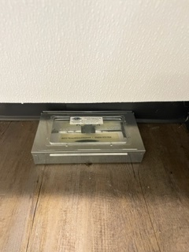

**Pest collection trap in restroom**

**Picture 7**

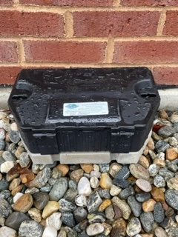

**Pest collection trap located against exterior of building**

| **Location** | **Carbon**  **Dioxide**  **(ppm)** | **Carbon Monoxide**  **(ppm)** | **Temp**  **(°F)** | **Relative**  **Humidity**  **(%)** | **PM2.5**  **(µg/m3)** | **Occupants**  **in Room** | **Windows**  **Openable** | **Ventilation** | | **Remarks** |
| --- | --- | --- | --- | --- | --- | --- | --- | --- | --- | --- |
| **Supply** | **Exhaust** |
| Background | 505 | ND | 57 | 45 | ND | 0 |  |  |  | Cloudy, light precipitation (snow, rain) |
| Foyer | 927 | ND | 71 | 37 | ND | 0 | N/A | Y | Y | Water cooler w/no mat |
| Staff Restroom | 1052 | ND | 71 | 42 | ND | 0 | N/A | N | Y | Air freshener |
| Gym | 1107 | ND | 70 | 54 | ND | 50 | N | Y | Y |  |
| Kitchen/Dining | 535 | ND | 69 | 35 | ND | 0 | N | Y | Y | Pest box, dust/debris on exhaust vent |
| Copy Room | 876 | ND | 71 | 39 | ND | 0 | N/A | Y | Y | photocopier w/dedicated exhaust |
| Storage #1 | 926 | ND | 74 | 35 | ND | 1 | N/A | Y | Y |  |
| Storage #2 | 1038 | ND | 71 | 40 | ND | 0 | N/A | Y | Y |  |
| 103 Staff Kitchen | 847 | ND | 71 | 38 | ND | 0 | N | Y | Y | Pest box |
| 105 | 616 | ND | 71 | 35 | ND | 0 | N | Y | Y |  |
| 106 | 583 | ND | 72 | 34 | ND | 0 | N | Y | Y |  |
| 107 | 625 | ND | 72 | 35 | ND | 0 | N | Y | Y |  |
| 110 | 629 | ND | 71 | 36 | ND | 0 | N | Y | Y |  |
| 111 | 619 | ND | 71 | 35 | ND | 0 | N/A | Y | Y | Storage bins on floor |
| 112 | 697 | ND | 70 | 37 | ND | 0 | N | Y | Y |  |
| 113 | 722 | ND | 70 | 36 | ND | 0 | N/A | Y | Y |  |
| 120 Medical/Well-ness Room | 730 | ND | 71 | 35 | ND | 0 | N/A | N | N | Sink, pest box |
| 125 Women’s Restroom | 719 | ND | 71 | 37 | ND | 0 | N/A | Y | Y |  |
| 126 Storage near Gym | 1254 | ND | 71 | 44 | ND | 0 | N | Y | Y |  |
| 131 | 871 | ND | 72 | 37 | ND | 0 | N/A | Y | Y |  |
| 135 | 858 | ND | 72 | 38 | ND | 0 | N/A | Y | Y |  |
| 136 | 880 | ND | 71 | 38 | ND | 0 | N/A | Y | Y |  |
| 140 | 1028 | ND | 71 | 41 | ND | 0 | N/A | Y | Y |  |
| 141 | 965 | ND | 71 | 40 | ND | 0 | N/A | Y | Y |  |
| 148 | 744 | ND | 71 | 36 | ND | 0 | N/A | Y | Y |  |
| 151 | 760 | ND | 73 | 35 | ND | 0 | N/A | Y | Y |  |
| 152 | 773 | ND | 72 | 36 | ND | 0 | N/A | Y | Y |  |
| 153 | 820 | ND | 72 | 37 | ND | 0 | N/A | Y | Y |  |
| 154 | 778 | ND | 72 | 36 | ND | 0 | N/A | Y | Y |  |
| 155 | 753 | ND | 71 | 37 | ND | 0 | N/A | Y | Y |  |
| 156 | 795 | ND | 70 | 38 | ND | 0 | N/A | Y | Y |  |
| 157 Conference rm | 639 | ND | 69 | 37 | ND | 0 | N/A | Y | Y |  |