WATER DAMAGE INVESTIGATION

Western Massachusetts Police Academy
1 Armory Street, #11
Springfield, Massachusetts

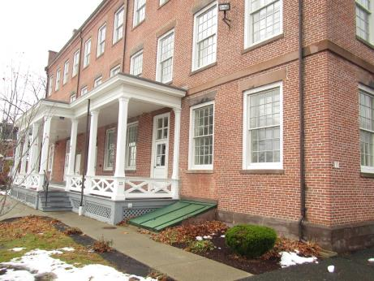

Prepared by:
Massachusetts Department of Public Health
Bureau of Environmental Health
Indoor Air Quality Program
November 2018

BACKGROUND
Building: | Western Massachusetts Police Academy (WMPA)
Address: | 1 Armory Street, #11, Springfield, Massachusetts
Assessment Requested by: | Thomas W. Therrien, Director of Operations, Springfield Technical Community College
Reason for Request: | Mold/water damage concerns
Date of Assessment: | November 19, 2018
Massachusetts Department of Public Health/Bureau of Environmental Health (MDPH/BEH) Staff Conducting Assessment: | Ruth Alfasso, Environmental Engineer/Inspector, Indoor Air Quality (IAQ) Program
Building Description: | The WMPA occupies a historic three-story brick building on the campus of the Springfield Technical Community College, which is a part of the Springfield Armory complex. The building interior was completely renovated prior to the WMPA use.
Windows: | Windows are not openable in most areas as they have been sealed from the inside with permanent storm windows.

IAQ Testing Results
Please refer to the IAQ Manual for methods, sampling procedures, and interpretation of results (MDPH, 2015). The following is a summary of testing results.
- Carbon dioxide levels were below the MDPH guideline of 800 parts per million (ppm) in all areas tested except the kitchen.
- Temperature was within or close to the lower end of the recommended range of 70°F to 78°F in the areas tested.
- Relative humidity was below the recommended range of 40 to 60% in areas tested at the time of the assessment.
- Carbon monoxide levels were non-detectable (ND) in all areas assessed.
- Moisture Measurements in all wallboard showed the material was dry at the time of assessment.
- Total Volatile Organic Compounds (TVOC) were ND in all areas tested.

Background and Discussion
The BEH/IAQ Program was asked to examine areas in the WMPA due to water damage from roof and HVAC system leaks. Areas of concern included the basement in and adjacent to the utility room and restrooms, and several rooms on the third floor. The rest of the building was not examined.

Ventilation
A heating, ventilating, and air conditioning (HVAC) system has several functions. First it provides heating and, if equipped, cooling. Second, it is a source of fresh air. Finally, an HVAC system will dilute and remove normally-occurring indoor environmental pollutants by not only introducing fresh air, but by filtering the airstream and removing stale air to the outdoors via exhaust ventilation. Even if an HVAC system is operating as designed, point sources of respiratory irritants may be present and produce symptoms in sensitive individuals. The following analysis examines and identifies components of the HVAC system and likely sources of respiratory irritant/allergen exposure due to water damage, aerosolized dust, and/or chemicals found in the indoor environment.
Mechanical air circulation in the WMPA is provided by air handing units served by geothermal heat pumps. The kitchen area examined (Table 1) did not have a supply or exhaust vent. This may account for the elevated levels of carbon dioxide measured there. Kitchens and other areas where moisture, odors and other pollutants may be generated should be equipped with direct-vented exhaust to avoid recirculating these to the rest of the building.

Microbial/Moisture Concerns
As mentioned above, the reason for this visit was to examine areas of past water damage for any ongoing issues. Both the basement and the third floor were examined.

Basement Area
The areas of the basement were examined for moisture, water-damaged materials and odors. A leak had been reported here in the past. Sections of gypsum wallboard (GW) were tested with a moisture meter and found dry. In the office adjacent to the utility room, the coving on the base of the wall was well-adhered which suggests it was not moist and not subject to chronic moisture (Picture 1). No musty or moldy odors were detected. Based on these observations, it did not appear that any water leak had any long-term impact on materials in the basement.
Of note were showers and floor drains in the restrooms (Picture 2). If these facilities are not used, the drains traps will dry out and allow sewer odors and moisture into occupied areas. In addition, porous items were stored on the floor in basement rooms (Picture 1) which could become moistened in hot, humid weather or due to leaks.
There was dust, debris, and rodent droppings in the utility room (Picture 3). This material can be a source of odors and microbial contamination, particularly if it is moistened.

Third Floor Rooms
Three rooms upstairs had water leaks from the roof. Ceiling tiles had been replaced after the leaks were discovered. No additional water-damaged ceiling tiles were observed at the time of the visit. The areas above the ceiling tiles were examined and found to be dry and free of stains and moldy/musty odors (Pictures 4 and 5).
In general, the US Environmental Protection Agency (US EPA) and the American Conference of Governmental Industrial Hygienists (ACGIH) recommends that porous materials (e.g., GW, carpeting) be dried with fans and heating within 24 to 48 hours of becoming wet (US EPA, 2008; ACGIH, 1989). If porous materials are not dried within this time frame, mold growth may occur.

Conclusions/Recommendations
Based on the observations made during the visit, the following recommendations are made:
- Consider installing an exhaust vent in the kitchen to remove odors and moisture directly outside.
- Ensure that areas with previous leaks are monitored regularly during wet weather so that drying can begin quickly.
- Avoid storing porous items on the basement floors.
- If the shower shown in Picture 2 is not used, the floor drains should be periodically moistened to prevent infiltration of sewer gas and moisture into the building.
- Periodically clean debris from the utility room floor.
- If rodents are a regular occurrence in this building, consult with a licensed pest control contractor regarding exclusion and removal. Use the principles of IPM to reduce pest issues in the building, including the sealing of pathways and reduction in sources of food and harborage. Consult “Integrated Pest Management Kit For Building Managers” (MDFA, 1996), http://www.mass.gov/eea/docs/agr/pesticides/publications/ipm-kit-for-bldg-mgrs.pdf.
- For more information on mold refer to the US EPA’s “Mold Remediation in Schools and Commercial Buildings”, available at: http://www.epa.gov/mold/mold-remediation-schools-and-commercial-buildings-guide.
- Refer to resource manuals and other related IAQ documents for further building-wide evaluations and advice on maintaining public buildings. Copies of these materials are located on the MDPH’s website: http://mass.gov/dph/iaq.

REFERENCES
ACGIH. 1989. Guidelines for the Assessment of Bioaerosols in the Indoor Environment. American Conference of Governmental Industrial Hygienists, Cincinnati, OH.
MDFA. 1996. Integrated Pest Management Kit for Building Managers. Massachusetts Department of Food and Agriculture, Pesticide Bureau, Boston, MA.
MDPH. 2015. Massachusetts Department of Public Health. “Indoor Air Quality Manual: Chapters I-III”. Available at: http://www.mass.gov/eohhs/gov/departments/dph/programs/environmental-health/exposure-topics/iaq/iaq-manual/.
US EPA. 2008. Mold Remediation in Schools and Commercial Buildings. US Environmental Protection Agency, Office of Air and Radiation, Indoor Environments Division, Washington, D.C. EPA 402-K-01-001. http://www.epa.gov/mold/mold-remediation-schools-and-commercial-buildings-guide.
Picture 1
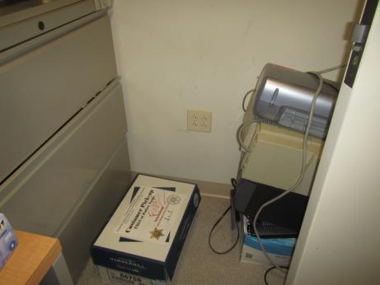
Coving on basement office wall, well adhered and box on the floor
Picture 2
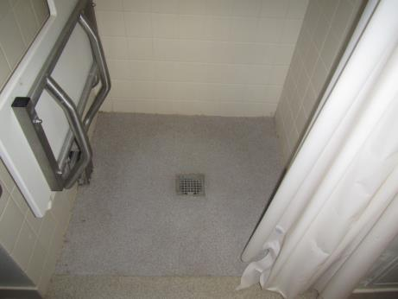
Shower drain in basement restroom
Picture 3
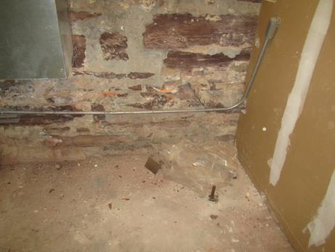
Brick debris and rodent droppings in the basement utility room
Picture 4
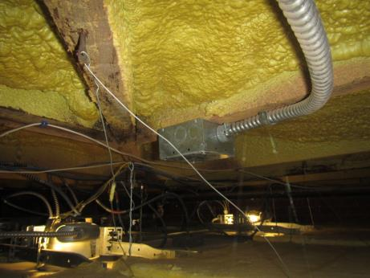
Space above ceiling tile system in kitchen is dry and free from water stains and odors
Picture 5
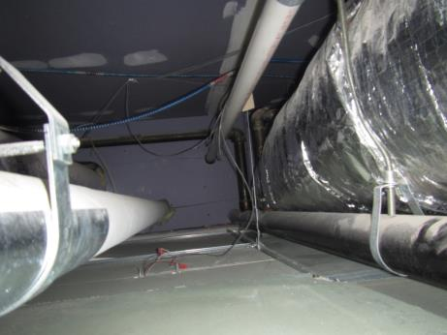
Space above ceiling tiles in training room, also dry and free of stains and odors

Location | Carbon  Dioxide  (ppm) | Carbon Monoxide  (ppm) | Temp  (°F) | Relative  Humidity  (%) | TVOC  (ppm) | Occupants  in Room | Windows  Openable | Ventilation |  | Remarks
 |  |  |  |  |  |  |  | Supply | Exhaust
Background | 385 | ND | 50 | 36 | ND |  |  |  |  | Rain/snow showers, fog
Basement utility area |  | ND |  |  | ND | 0 | N | N | N | Brick dust and mouse droppings, heating equipment, location of previous leak –all wallboard dry, coving in adjacent office is well adhered
Kitchen | 954 | ND | 71 | 35 | ND | 0 | N | N | N | NC, area of leak – ceiling above tiles is dry and no odors. Refrigerator, water, microwave
Gym | 517 | ND | 68 | 29 | ND | 0 | N | Y | Y | Gym mats, slight odor
Computer Training | 520 | ND | 69 | 29 | ND | 0 | N | N | Y | Area of leak, ceiling above is dry and no odors. DEM, HS

