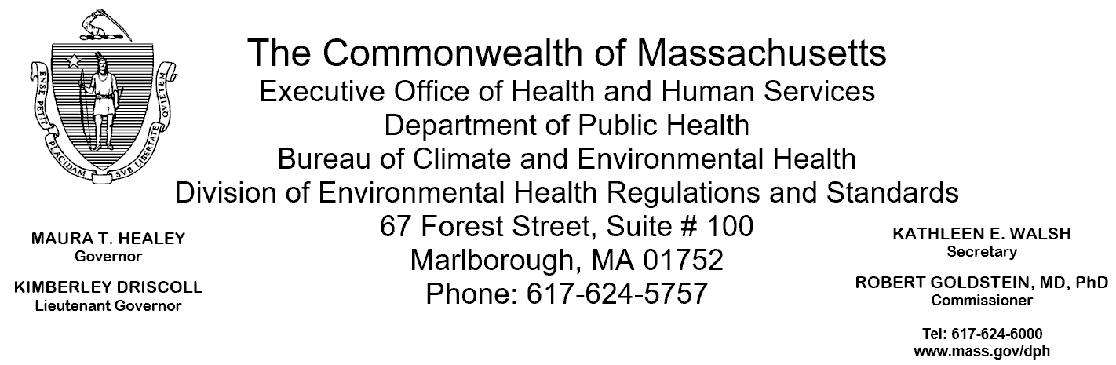

January 17, 2025

Nicholas, Cocchi
Western Massachusetts Recovery and Wellness Center
155 Mill Street
Springfield, MA 01108 (electronic copy)

Re: Facility Inspection – Western Massachusetts Recovery and Wellness Center, Springfield

The Massachusetts Department of Public Health (Department) Division of Environmental Health Regulations and Standards (EHRS) conducted an inspection of the Western Massachusetts Recovery and Wellness Center on November, 22, 2024 accompanied by Diane Bator, Standards and Training Coordinator, Lieutenant Michael Manning, Environmental Health and Safety Officer (EHSO), and Officer James Nepl, in accordance with Department regulations 105 CMR 451.000: Minimum Health and Sanitation Standards and Inspection Procedures for Correctional Facilities.

The inspection identified 24 total deficiencies: 17 deficiencies under the Required Standards (.100 and .200 series), 3 repeat deficiencies under the Required Standards, 3 deficiencies under the Recommended Standards (.300series), and 1 repeat deficiency under the Recommended Standards.

Overview

Section 1 provides details of all deficiencies, including repeat deficiencies, found during the inspection. These are categorized by Required Standards, Recommended Standards, or additional applicable regulatory standards.
Section 2 provides information on areas that EHRS found to be compliant.
Section 3 documents the areas that EHRS did not inspect.
Section 4 provides information on submitting a Plan of Correction for the identified deficiencies.
Section 5 outlines observations and recommendations related to the inspection.

SECTION 1: Health and Safety Deficiencies
Deficiencies under the Required Standards (.100 and .200 series)
17 new deficiencies and 3 repeat deficiencies (indicated by an *) were found during the inspection:

- HOUSING | 1st Floor | Day Room | 105 CMR 451.126 | Hot Water for Bathing and Hygiene: Hot water temperature 135°F at handwash sink
- HOUSING | 1st Floor | Resident’s Bathroom # 124 | 105 CMR 451.130* | Hot Water: Shower water temperature 121°F in shower # 4
- HOUSING | 2nd Floor/Women’s Unit | Room # 208 | 105 CMR 451.103 | Mattresses: Mattress damaged
- HOUSING | 2nd Floor/Women’s Unit | Room # 214 | 105 CMR 451.103 | Mattresses: Mattress damaged
- HOUSING | 3rd Floor | Resident’s Bathroom # 321 | 105 CMR 451.130* | Hot Water: Shower water temperature 123°F at shower # 4
- HOUSING | 3rd Floor | Resident’s Bathroom # 336 | 105 CMR 451.123 | Maintenance: Soap scum on walls in shower # 1, 2, 3, and 5
- HOUSING | 3rd Floor | Resident’s Bathroom # 336 | 105 CMR 451.123 | Maintenance: Soap scum on floors in shower # 1, 2, 3, 4, and 5
- HOUSING | 3rd Floor | Resident’s Bathroom # 336 | 105 CMR 451.130 | Hot Water: Shower water temperature 124°F at shower # 5
- HOUSING | 3rd Floor | Room # 313 | 105 CMR 451.103 | Mattresses: Mattress damaged
- HOUSING | 3rd Floor | Room # 325 | 105 CMR 451.103 | Mattresses: Mattress damaged
- KITCHEN | Dining Hall | Staff Break Room # 20 | 105 CMR 451.200 | Maintenance and Operation; Premises, Structure, Attachments, and Fixtures - Methods: Facility not cleaned as often as necessary; interior of microwave oven dirty. Standard found in 105 CMR 590; FC 6-501.12(A).
- KITCHEN | Dishwashing Area |  | 105 CMR 451.200 | Maintenance and Operation; Premises, Structure, Attachments, and Fixtures - Methods: Facility not in good repair, dish washing machine leaking. Standard found in 105 CMR 590; FC 6-501.11.
- KITCHEN | Handwash Sink (near Reach-in-Cooler) |  | 105 CMR 451.126* | Hot Water for Bathing and Hygiene: Hot water temperature 134°F at handwash sink

Deficiencies under the Recommended Standards (.300 series)
3 new deficiencies and 1 repeat deficiency (indicated by an *) were found during the inspection:

- HOUSING | 1st Floor | Room # 112 | 105 CMR 451.353 | Interior Maintenance: Wall damaged
- HOUSING | 3rd Floor | Janitor’s Closet # 331 | 105 CMR 451.353 | Interior Maintenance: Ceiling tiles water damaged
- HOUSING | 3rd Floor | Offices # 338/340/341 | 105 CMR 451.353 | Interior Maintenance: Carpet tiles missing in office # 338
- HOUSING | 3rd Floor | Room # 308 | 105 CMR 451.353* | Interior Maintenance: Wall surface damaged

SECTION 2: Areas Found to be in Compliance

EHRS inspected 102 additional areas of the facility which were found to be in compliance.

Section 3: Areas EHRS did not inspect

EHRS did not inspect 5 areas of the facility because they were either in use, locked, or under construction.

- 2nd Floor/Women’s Unit | Resident’s Bathroom # 222 | Unable to Inspect Shower # 1-5 - Under Construction
- 2nd Floor/Women’s Unit | Resident’s Bathroom # 238 | Unable to Inspect - In Use
- 2nd Floor/Women’s Unit | Room # 213 | Unable to Inspect - In Use
- 2nd Floor/Women’s Unit | Room # 215 | Unable to Inspect - In Use
- Nurse’s Exam Room # 137 |  | Unable to Inspect - In Use

SECTION 4: Plan of Correction

This facility does not comply with the Department’s regulations cited above. In accordance with 105 CMR 451.404, please submit a plan of correction within 10 working days of receipt of this notice which includes:

- Specific corrective steps to be taken
- A timetable for the corrective actions for larger projects
- The date by which correction will be achieved
- Any interim measures being implemented to ensure the health and safety of incarcerated individuals and facility staff
- The plan should be signed by the Superintendent or Administrator and submitted to my attention, at the address listed above.

SECTION 5: Observations and Recommendations

- The inmate population was 84 at the time of inspection.

To review the specific regulatory requirements please visit our website at www.mass.gov/dph/dcs and click on "Correctional Facilities" 105 CMR 451.000, it is available in both PDF and RTF formats. For more specific information about the food standards, you can download the merged food code, which can be found here.

An inspection may also include observations of other conditions which could constitute a threat to the health or safety of inmates or employees, including but not limited to the standards set forth by the Department as follows, and report on such pursuant to 451.402(B). You can use these links below to review these standards:
- 105 CMR 205.000: Minimum Standards Governing Medical Records and Conduct of Physical Examinations in Correctional Facilities
- 105 CMR 480.000: Minimum requirements for the Management of Medical or Biological Waste
- 105 CMR 500.000: Good Manufacturing Practices for Food

This inspection report is true and accurate to the best of my knowledge.
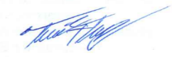
Sincerely,

Thomas F. Murphy
Environmental Analyst, EHRS, BCEH

