INDOOR AIR QUALITY ASSESSMENT

Westfield Athenaeum
6 Elm Street
Westfield, Massachusetts



Prepared by:
Massachusetts Department of Public Health
Bureau of Environmental Health
Indoor Air Quality Program
February 2013

Background/Introduction
At the request of Christopher Linquist, Director, the Massachusetts Department of Public Health (MDPH), Bureau of Environmental Health (BEH) provided assistance and consultation regarding indoor air quality (IAQ) at the Westfield Athenaeum (WA), 6 Elm St, Westfield, Massachusetts. The request was prompted by concerns related to indoor air quality in the basement storage area. On November 20, 2012, Ruth Alfasso, Environmental Engineer/Inspector and Kathleen Gilmore, Environmental Analyst/Regional Inspector in the IAQ Program visited the facility.
The WA is a two-story structure constructed with multiple additions. The original structure was built as a residence in 1838. An addition, which serves as the main section of the library, was constructed in 1927. Two other additions were made in 1966, one to the north side of the 1927 wing and a second to the west wall of the 1838 residence. A garage was added in 1974 that houses a bookmobile vehicle. As part of a renovation project in the late 1990s to address handicap access, a wall constructed in the basement area created a hallway allowing patrons to use the building elevator to access the basement-level community rooms while preventing access to the basement storage/work area.
The 1838 wing contains the administration office on the second floor, with the first floor housing part of the children’s library. The 1927 wing contains the main library stacks with a multiple-tiered balcony at the rear of the wing. The north 1966 wing contains periodicals and reference materials with a single balcony in the rear. The west 1966 wing houses a children’s library and restrooms.
The basement has a large storage/workroom, a mechanical ventilation room, an auditorium and several small rooms used for various community purposes. The garage is adjacent to the basement storage room on the north exterior wall of the 1966 wing. A double door connects the basement and garage. Windows in the building are openable with the exception of transom windows in the basement which were painted over and were not openable at the time of the assessment.
The BEH/IAQ program had previously visited this building in 1996 to perform a general IAQ assessment, and in September of 2011 to assess water damage and related IAQ concerns following the impacts of Tropical Storm Irene. These documents are available at the BEH/IAQ website (http://www.mass.gov/eohhs/gov/departments/dph/programs/environmental-health/exposure-topics/iaq/iaq-rpts/towns-u-z.html#Westfield) or on request. There were numerous recommendations made in the September 2011 assessment to improve indoor conditions specifically in the basement workroom and adjoining areas following the flooding and moisture issues exacerbated by Tropical Storm Irene and other recommendations made in the 1996 report to improve general IAQ. Appendix A contains a summary of those recommendations and actions that have been taken at the WA to meet them.

Methods
Air tests for carbon dioxide, carbon monoxide, temperature and relative humidity were conducted with the TSI, Q-Trak, IAQ Monitor, Model 7565. Air tests for airborne particle matter with a diameter less than 2.5 micrometers were taken with the TSI, DUSTTRAK™ Aerosol Monitor Model 8520. BEH staff also performed visual inspection of building materials for water damage and/or microbial growth.

Results
The WA has a daily employee population of approximately 15-20, with up to several hundred individuals visiting on a daily basis. The tests were taken under normal operating conditions. Test results appear in Table 1.

Discussion

Ventilation
Table 1 shows that carbon dioxide levels were below 800 parts per million (ppm) of air in all areas surveyed, indicating adequate air exchange in the building.
The ventilation system in the WA is divided into four sections: the 1966 north wing, the children’s library, the 1927 wing basement auditorium and the remainder of the building. The second floor of the 1838 wing, the upper levels of the 1927 wing and the basement level of the 1966 north wing do not have mechanical ventilation. Windows are the only means to provide ventilation in these areas. Window-mounted air conditioners provide cooling in these areas during warm weather.
The 1927 wing auditorium contains a fan system to circulate air when the auditorium is occupied. The air handling units (AHUs) for both the children’s library and the 1966 north wing are located in below grade mechanical rooms. Fresh air is drawn by the AHUs and distributed via ducted wall and/or ceiling-mounted air diffusers. Air is returned to the AHUs through ducted return vents. A new chiller for these systems was on site and in the process of being installed at the time of the MDPH visit.
To maximize air exchange, the MDPH recommends that both supply and exhaust ventilation operate continuously during periods of occupancy. In order to have proper ventilation with a mechanical supply and exhaust system, the systems must be balanced to provide an adequate amount of fresh air to the interior of a room while removing stale air from the room. It is recommended that HVAC systems be re-balanced every five years to ensure adequate air systems function (SMACNA, 1994). The date of the last balancing of these systems was not available at the time of the assessment.
Minimum design ventilation rates are mandated by the Massachusetts State Building Code (MSBC). Until 2011, the minimum ventilation rate in Massachusetts was higher for both occupied office spaces and general classrooms, with similar requirements for other occupied spaces (BOCA, 1993). The current version of the MSBC, promulgated in 2011 by the State Board of Building Regulations and Standards (SBBRS), adopted the 2009 International Mechanical Code (IMC) to set minimum ventilation rates. Please note that the MSBC is a minimum standard that is not health-based. At lower rates of cubic feet per minute (cfm) per occupant of fresh air, carbon dioxide levels would be expected to rise significantly. A ventilation rate of 20 cfm per occupant of fresh air provides optimal air exchange resulting in carbon dioxide levels at or below 800 ppm in the indoor environment in each area measured. MDPH recommends that carbon dioxide levels be maintained at 800 ppm or below. This is because most environmental and occupational health scientists involved with research on IAQ and health effects have documented significant increases in indoor air quality complaints and/or health effects when carbon dioxide levels rise above the MDPH guidelines of 800 ppm for schools, office buildings and other occupied spaces (Sundell et al., 2011). The ventilation must be on at all times that the room is occupied. Providing adequate fresh air ventilation with open windows and maintaining the temperature in the comfort range during the cold weather season is impractical. Mechanical ventilation is usually required to provide adequate fresh air ventilation.
Carbon dioxide is not a problem in and of itself. It is used as an indicator of the adequacy of the fresh air ventilation. As carbon dioxide levels rise, it indicates that the ventilating system is malfunctioning or the design occupancy of the room is being exceeded. When this happens a buildup of common indoor air pollutants can occur, leading to discomfort or health complaints. The Occupational Safety and Health Administration (OSHA) standard for carbon dioxide is 5,000 parts per million parts of air (ppm). Workers may be exposed to this level for 40 hours/week (OSHA, 1997).
The Department of Public Health uses a guideline of 800 ppm for publicly occupied buildings. A guideline of 600 ppm or less is preferred in schools due to the fact that the majority of occupants are young and considered to be a more sensitive population in the evaluation of environmental health status. Inadequate ventilation and/or elevated temperatures are major causes of complaints such as respiratory, eye, nose and throat irritation, lethargy and headaches. For more information concerning carbon dioxide, please see Appendix B.
Temperature readings ranged from 63ºF to 73ºF during the assessment, which were within or below the MDPH recommended comfort range (Table 1). The lowest readings were found in the basement areas of the building. The MDPH recommends that indoor air temperatures be maintained in a range of 70ºF to 78ºF in order to provide for the comfort of building occupants. In many cases concerning indoor air quality, fluctuations of temperature in occupied spaces are typically experienced, even in a building with an adequate fresh air supply.
The relative humidity measured ranged from 22 to 35 percent which were below the MDPH recommended comfort range. The MDPH recommends a comfort range of 40 to 60 percent for indoor air relative humidity. Moisture issues in the basement were the major concern during the September 2011 visit, including flooding and water penetration relating to Tropical Storm Irene along with high relative humidity. The remediation and repair work that had been performed in the building since that visit included several moisture control measures in the basement: fitting the existing sump with a cover, removal/disposal of moistened porous materials, and the use of a dehumidifier in the basement work area (Appendix A). The relative humidity is also lower due to the reduced relative humidity outside and the effects of the heating system. The dehumidifier should be used when needed and turned off during the heating season and other periods of low outdoor humidity. The sensation of dryness and irritation is common in a low relative humidity environment. Low relative humidity is a very common problem during the heating season in the northeast part of the United States.

Microbial/Moisture Concerns
In response to the September 2011 MDPH visit, the remediation efforts (as detailed in Appendix A) included removal of water-damaged and mold-contaminated materials from the basement and replacement of ceiling tiles. During the November 20, 2012 visit, a section of water-damaged ceiling tiles was observed in the entrance hallway to the children’s library and the basement hallway (Picture 1), indicating that there may still be roof leaks, plumbing leaks and/or leaks related to condensation from air conditioning components. Stained ceiling tiles can provide a source of mold and should be removed and replaced once the leak has been fixed. The sump area in the basement, which had been open at the time of the September 2011 visit had been covered (Picture 2) but the cover is not air-tight. Sealing the edges of the holes in the cover with a water-resistant material such as sealant foam or plumbing putty will decrease the infiltration of odors from the sump into the occupied area. If possible, this sump should also be cleaned periodically to remove debris that may decompose and produce odors.
The dehumidifier in the basement had a hose which drained the condensate into the sump; however the hose did not have a sufficient slope to drain completely (Picture 3). If this hose is cut or disconnected, for example during maintenance of the dehumidifier, stagnant water can leak out. It should be drained before the unit is serviced and protected from accidental disconnection by placing the unit closer to the sump to which it drains.
As noted in the 2011 report, the roof of the garage is flat but slopes toward the 1996 north wing creating another means for water to migrate towards the building structure. The roof has one catch basin drain that leads to a grassy area but there are no rain gutters or downspouts. As a result, water pools at the base of the foundation as evidenced by water damage along the exterior wall at the seam of the basement and garage. In this condition, water can penetrate through the garage walls to continue to moisten the garage floor.
The US Environmental Protection Agency and the American Conference of Governmental Industrial Hygienists (ACGIH) recommends that porous materials be dried with fans and heating within 24-48 hours of becoming wet (US EPA, 2001; ACGIH, 1989). If porous materials are not dried within this time frame, mold growth may occur. Water-damaged porous materials cannot be adequately cleaned to remove mold growth.
BEH staff conducted a perimeter inspection of the building’s exterior to identify potential sources of water penetration. Some basement windows are below grade and surrounded by window wells that contain grass, plant growth and debris, which can result in the accumulation of rainwater and subsequent water penetration into the basement. In addition, the growth of grass and roots against exterior walls can bring moisture in contact with the foundation, eventually leading to cracks and/or fissures in the below ground level. Over time, these conditions can undermine the integrity of the building envelope and provide a means of water entry into the building through capillary action through foundation concrete and/or masonry (Lstiburek & Brennan, 2001).

Other IAQ Evaluations
Indoor air quality can be negatively influenced by the presence of respiratory irritants, such as products of combustion. The process of combustion produces a number of pollutants. Common combustion emissions include carbon monoxide, carbon dioxide, water vapor and smoke (fine airborne particle material). Of these materials, exposure to carbon monoxide and particulate matter with a diameter of 2.5 micrometers (μm) or less (PM2.5) can produce immediate, acute health effects upon exposure. To determine whether combustion products were present in the indoor environment, BEH staff obtained measurements for carbon monoxide and PM2.5.

Carbon Monoxide
Carbon monoxide is a by-product of incomplete combustion of organic matter (e.g., gasoline, wood and tobacco). Exposure to carbon monoxide can produce immediate and acute health affects. Several air quality standards have been established to address carbon monoxide and prevent symptoms from exposure to these substances. The MDPH established a corrective action level concerning carbon monoxide in ice skating rinks that use fossil-fueled ice resurfacing equipment. If an operator of an indoor ice rink measures a carbon monoxide level over 30 ppm, taken 20 minutes after resurfacing within a rink, that operator must take actions to reduce carbon monoxide levels (MDPH, 1997).
The American Society of Heating Refrigeration and Air-Conditioning Engineers (ASHRAE) has adopted the National Ambient Air Quality Standards (NAAQS) as one set of criteria for assessing indoor air quality and monitoring of fresh air introduced by HVAC systems (ASHRAE, 1989). The NAAQS are standards established by the US EPA to protect the public health from six criteria pollutants, including carbon monoxide and particulate matter (US EPA, 2006). As recommended by ASHRAE, pollutant levels of fresh air introduced to a building should not exceed the NAAQS levels (ASHRAE, 1989). The NAAQS were adopted by reference in the Building Officials & Code Administrators (BOCA) National Mechanical Code of 1993 (BOCA, 1993), which is now an HVAC standard included in the Massachusetts State Building Code (SBBRS, 1997). According to the NAAQS, carbon monoxide levels in outdoor air should not exceed 9 ppm in an eight-hour average (US EPA, 2006).
Carbon monoxide should not be present in a typical, indoor environment. If it is present, indoor carbon monoxide levels should be less than or equal to outdoor levels. Outdoor carbon monoxide concentrations were measured in a range of non-detect (ND) to 2 ppm at the time of the assessment (Table 1). Carbon monoxide readings of 2- 4 ppm were noted in the basement work area, mechanical room and garage and were ND for the rest of the building (Table 1). This was likely related to exhaust from the garage where a vehicle had recently been running.
One of the recommendations from the September 2011 visit was to install an exhaust vent in the garage to remove combustion emissions and odors before they penetrate the inside of the basement workroom. Modifications to the garage to meet this recommendation were in process at the time of the visit: a hole was being cut into the masonry at the back of the garage which would reportedly be outfitted with an active exhaust fan (Picture 4). Once this measure is complete, use of the exhaust fan should reduce or eliminate any penetration of exhaust fumes, including carbon monoxide, into the basement areas.
Of note, a PVC pipe was observed extending from a basement window (Picture 5) on the wall adjacent to the back of the garage where the exhaust vent is being outfitted. Once the installation of the exhaust vent is complete, the PVC pipe should be sealed in order to prevent the migration of exhaust fumes into the basement.

Particulate Matter
The US EPA has established NAAQS limits for exposure to particulate matter. Particulate matter includes airborne solids that can be irritating to the eyes, nose and throat. The American Society of Heating Refrigeration and Air-Conditioning Engineers (ASHRAE) has adopted the National Ambient Air Quality Standards (NAAQS) as one set of criteria for assessing indoor air quality and monitoring of fresh air introduced by HVAC systems (ASHRAE, 1989). The NAAQS are a reference standard used by the US EPA and others to protect the public health from six criteria pollutants, including particulate matter (US EPA, 2006). As recommended by ASHRAE, pollutants in indoor air should not exceed the NAAQS levels (ASHRAE, 1989). The NAAQS were adopted by reference in the Building Officials & Code Administrators (BOCA) National Mechanical Code of 1993 (BOCA, 1993), which is now an HVAC standard included in the Massachusetts State Building Code (SBBRS, 1997).
Outdoor PM2.5 concentrations the day of the assessment were measured at 14 μg/m³. PM2.5 levels measured inside the building ranged from 11 to 18 μg/m³ (Table 1). Both indoor and outdoor PM 2.5 levels were below the NAAQS PM2.5 level of 35 μg/m³. Frequently, indoor air levels of particulates (including PM2.5) can be at higher levels than those measured outdoors.
A number of activities that occur indoors and/or mechanical devices can generate particulate during normal operations. Sources of indoor airborne particulates may include but are not limited to particles generated during the operation of fan belts in the HVAC system, use of stoves and/or microwave ovens in kitchen areas; use of photocopiers, fax machines and computer printing devices; operation of an ordinary vacuum cleaner and heavy foot traffic indoors.

Volatile Organic Compounds
Indoor air concentrations can be greatly impacted by the use of products containing volatile organic compounds (VOCs). VOCs are carbon-containing substances that have the ability to evaporate at room temperature. Frequently, exposure to low levels of total VOCs (TVOCs) may produce eye, nose, throat and/or respiratory irritation in some sensitive individuals. For example, chemicals evaporating from a paint can stored at room temperature would most likely contain VOCs. In an effort to identify materials that can potentially increase indoor VOC concentrations, BEH staff examined rooms for products containing these respiratory irritants.
Cleaning products were found in a number of rooms throughout the building including in the basement work area (Picture 6). Cleaning products contain chemicals that can be irritating to the eyes, nose and throat of sensitive individuals. These products should be properly labeled and stored in an area inaccessible to children. In addition, a Material Safety Data Sheets (MSDS) should be available at a central location for each product in the event of an emergency.
There are several photocopiers and a lamination machine in the building. Photocopiers and lamination machines can be sources of pollutants such as VOCs, ozone, heat and odors, particularly if the equipment is older and in frequent use. Both VOCs and ozone are respiratory irritants (Schmidt Etkin, 1992). Photocopiers and laminators should be kept in well ventilated rooms, and should be located near windows or exhaust vents.
Air fresheners and deodorizing materials were observed in a couple of areas (Pictures 7 and 8). Air deodorizers contain chemicals that can be irritating to the eyes, nose and throat of sensitive individuals. Many air fresheners contain 1,4-dichlorobenzene, a VOC which may cause reductions in lung function (NIH, 2006). Furthermore, deodorizing agents do not remove materials causing odors, but rather mask odors that may be present in the area.

Other Concerns
The area of concern that prompted this assessment was the basement work area. Although a significant amount of water-damaged materials were removed from this area since the September 2011 MDPH visit, there is still a large amount of materials stored in the room, including old materials which may be dusty and donated materials which may contain dust, pollen, pet hair and other allergens (Pictures 9 and 10). If a reduction in the amount of materials is not possible, the items should be cleaned as well as possible and stored in a manner that will allow access without disturbing other piles.
In addition, the floors in the basement work area were soiled and portions of the tiles were broken or peeling, increasing the potential for these materials to become aerosolized thus making the floors impossible to clean (Picture 11). As noted following the September 2011 visit, these tiles may also contain asbestos; therefore a determination of whether asbestos is present should be conducted by a licensed contractor. If asbestos is present, it should be remediated in conformance with all applicable Massachusetts asbestos abatement and hazardous materials disposal laws. If no asbestos is present, the tiles may be removed and replaced or the floor covered with a matting material to reduce the potential for dust aerosolizing during use of the room.
There were reports of occasional rodents in the building. Rodent infestation can result in indoor air quality related symptoms due to materials in their wastes. Mouse urine contains a protein that is a known sensitizer (US EPA, 1992). A sensitizer is a material that can produce symptoms (e.g., running nose or skin rashes) in sensitive individuals after repeated exposure.
A set of fluorescent light tubes were found leaning against a shelf in the basement workroom (Picture 12). These tubes can be easily broken if they fall or are dropped and can emit mercury when they break.
Ceiling fans (Picture 13) and personal fans were found dusty. These items should be periodically cleaned of dust so that they don’t re-aerosolize the material when used.
Several areas of the WA are carpeted, including the children’s story room, which is partially below grade. It was unclear if a regular carpet cleaning program was in place. The Institute of Inspection, Cleaning and Restoration Certification (IICRC), recommends that carpeting be cleaned annually (or semi-annually in soiled high traffic areas) (IICRC, 2005). Carpeting in below-grade areas are more likely to be subject to moistening from humid air or water leaks.
Plush toys were found in several areas of the children’s section (Picture 14). These toys may be exposed to human skin. This type of contact can leave oils, perspiration, hair and skin cells. Dust mites feed upon human skin cells and excrete waste products that contain allergens. In addition, if relative humidity levels increase above 60 percent, dust mites tend to proliferate (US EPA, 1992). In order to remove dust mites and other pollutants, frequent vacuuming of toys is recommended (Berry, 1994).
There were specific complaints of odors near the reference librarian’s desk. This location is adjacent to a photocopier, which may emit odors. The fins inside the nearby heating registers were also occluded with dust (Picture 15). When the heating system starts operating early in the heating season, accumulations of dust in contact with heated metal may start to offgas odors. These fins may be cleaned using a wand attachment on a vacuum cleaner or with a damp cloth before the beginning of the heating season to reduce these odors.

Conclusions/Recommendations
In view of these findings at the time of the visit, the following conclusions and recommendations are provided:
- Refer to Appendix A for a summary of recommendations and actions implemented following the September 2011 MDPH assessment.
- Complete the installation of the mechanical exhaust fan in the garage to vent vehicle exhaust from the building. Ensure that the vent is operated whenever a vehicle is in the garage.
- Seal PVC pipe extending from the basement window after the installation of the garage exhaust vent is complete.
- Operate all existing mechanical ventilation systems whenever the building is occupied. Consider using the window air conditioners in the auditorium on fan-only mode when the room is occupied and outside temperatures are not below freezing to supply some fresh air to the room.
- Examine the feasibility of installing a mechanical exhaust ventilation system for the basement storage/workroom.
- Remove any additional mold-contaminated materials in the basement. Store items away from exterior walls to prevent moistening.
- Remove and replace any water-damaged/mold-colonized building materials (e.g., floor tiles). This measure will remove actively growing mold colonies that may be present. Remove mold contaminated materials in a manner consistent with recommendations found in “Mold Remediation in Schools and Commercial Buildings” published by the US Environmental Protection Agency, Office of Air and Radiation, Indoor Environments Division, Washington, DC. This document can be downloaded from the US EPA website at: http://www.epa.gov/mold/mold_remediation.html.
- Continue to use dehumidifiers in below grade areas during humid or damp weather to reduce relative humidity. Ensure the dehumidifiers are cleaned and maintained as per the manufacture’s instruction to prevent microbial growth. The tube connection from the hose to the sump should be drained and cleaned periodically.
- Seal utility holes and other potential pathways to eliminate pollutant paths of migration from the basement to the first floor.
- Remove grass and debris from window wells. Consider installing rain shields over basement window wells to prevent water penetration into the basement.
- Install gutters and downspouts on the garage roof to direct rainwater at least 5 feet away from the foundation. Remove foliage to no less than five feet from the foundation.
- Examine the junction between the garage and the 1927 wing for degrading seals and repair as needed.
- For buildings in New England, periods of low relative humidity during the winter are often unavoidable. Therefore, scrupulous cleaning practices should be adopted to minimize common indoor air contaminants whose irritant effects can be enhanced when the relative humidity is low. To control for dusts, a high efficiency particulate arrestance (HEPA) filter equipped vacuum cleaner in conjunction with wet wiping of all surfaces is recommended. Drinking water during the day can help ease some symptoms associated with a dry environment (throat and sinus irritations).
- Consult with a licensed asbestos inspector to ascertain whether pipe insulation and floor tiles contain asbestos and encapsulate or remove in conformance with Massachusetts law. Do not remove/replace water-damaged ceiling tiles until this issue is resolved.
- Use the principles of integrated pest management (IPM) to reduce or eliminate pest infestations. Refer to the IPM Guide, which can be obtained at: http://www.mass.gov/eea/agencies/agr/pesticides/.
- Routinely clean accumulated dust and debris periodically from the surface of supply and exhaust vents, radiators and blades of personal fans.
- Clean carpeting annually or semi-annually in soiled high traffic areas as per the recommendations of the Institute of Inspection, Cleaning and Restoration Certification (IICRC). Copies of the IICRC fact sheet can be downloaded at: http://iicrc.org/consumers/care/commercial-carpet-cleaning/.
- Clean plush toys frequently to remove dust and dust mites.
- Refer to resource manual and other related indoor air quality documents located on the MDPH’s website for further building-wide evaluations and advice on maintaining public buildings. These documents are available at: http://mass.gov/dph/iaq.

References
ACGIH. 1989. Guidelines for the Assessment of Bioaerosols in the Indoor Environment. American Conference of Governmental Industrial Hygienists, Cincinnati, OH.
BOCA. 1993. The BOCA National Mechanical Code-1993. 8th ed. Building Officials & Code Administrators International, Inc., Country Club Hills, IL. M-308.1.
IICRC. 2005. Carpet Cleaning FAQ 4 Institute of Inspection, Cleaning and Restoration Certification. Institute of Inspection Cleaning and Restoration, Vancouver, WA.
IMC, 2009. 2009 International Mechanical Code. International Code Council Inc., Country Club Hills, IL.
Lstiburek, J. & Brennan, T. 2001. Read This Before You Design, Build or Renovate. Building Science Corporation, Westford, MA. U.S. Department of Housing and Urban Development, Region I, Boston, MA
MDPH. 1997. Requirements to Maintain Air Quality in Indoor Skating Rinks (State Sanitary Code, Chapter XI). 105 CMR 675.000. Massachusetts Department of Public Health, Boston, MA.
NIH. 2006. Chemical in Many Air Fresheners May Reduce Lung Function. NIH News. National Institute of Health. July 27, 2006. http://www.nih.gov/news/pr/jul2006/niehs-27.htm
OSHA. 1997. Limits for Air Contaminants. Occupational Safety and Health Administration. Code of Federal Regulations. 29 C.F.R. 1910.1000 Table Z-1-A.
SBBRS. 2011. Mechanical Ventilation. State Board of Building Regulations and Standards. Code of Massachusetts Regulations, 8th edition. 780 CMR 1209.0.
Schmidt Etkin, D. 1992. Office Furnishings/Equipment & IAQ Health Impacts, Prevention & Mitigation. Cutter Information Corporation, Indoor Air Quality Update, Arlington, MA.
SMACNA. 1994. HVAC Systems Commissioning Manual. 1st ed. Sheet Metal and Air Conditioning Contractors’ National Association, Inc., Chantilly, VA.
Sundell, J., H. Levin, W. W. Nazaroff, W. S. Cain, W. J. Fisk, D. T. Grimsrud, F. Gyntelberg, Y. Li, A. K. Persily, A. C. Pickering, J. M. Samet, J. D. Spengler, S. T. Taylor, and C. J. Weschler. 2011. Ventilation rates and health: multidisciplinary review of the scientific literature. Indoor Air, Volume 21: pp 191–204.

US EPA. 1992. Indoor Biological Pollutants. US Environmental Protection Agency, Environmental Criteria and Assessment Office, Office of Health and Environmental Assessment, research Triangle Park, NC. EPA 600/8-91/202. January 1992.
US EPA. 2001. Mold Remediation in Schools and Commercial Buildings. US Environmental Protection Agency, Office of Air and Radiation, Indoor Environments Division, Washington, DC. EPA 402-K-01-001. March 2001.
US EPA. 2006. National Ambient Air Quality Standards (NAAQS). US Environmental Protection Agency, Office of Air Quality Planning and Standards, Washington, DC. http://www.epa.gov/air/criteria.html.

Picture 1

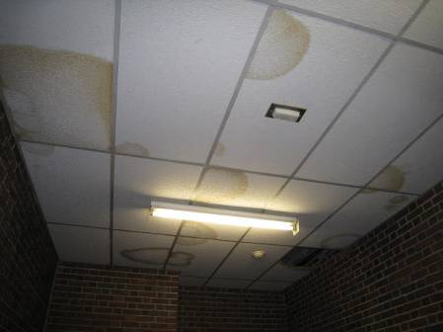

Water-damaged Ceiling Tiles

Picture 2

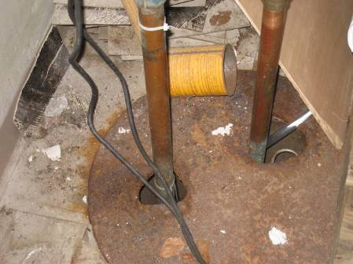

Sump Cover with Holes

Picture 3

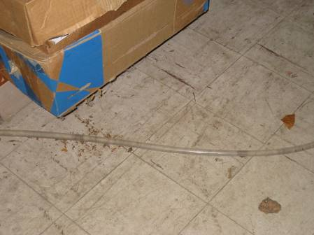

Long Drain Hose from Dehumidifier Containing Stagnant Water

Picture 4

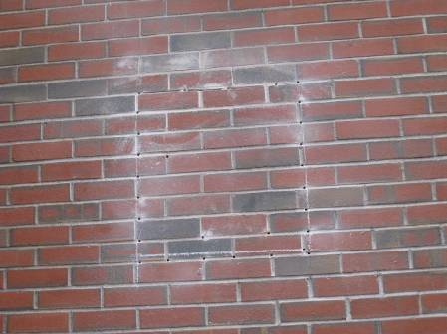

Location in Back of Garage Wall where Exhaust Vent is being Installed

Picture 5

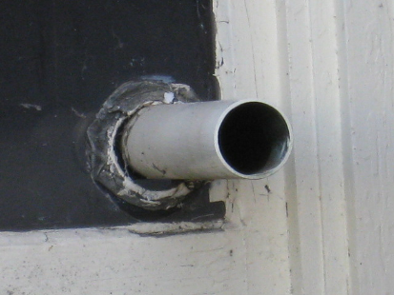

PVC Pipe Extending from Basement Window

Picture 6

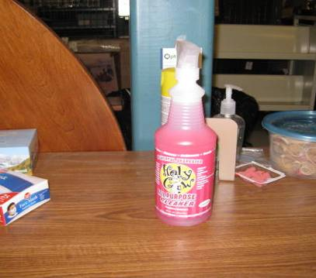

Cleaner in the Basement Work Area of the Athenaeum

Picture 7

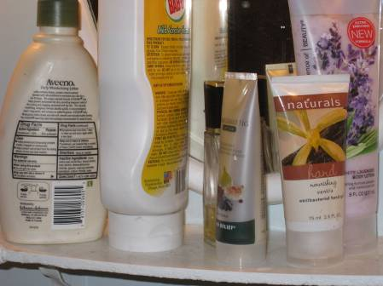

Air Fresheners and Scented Products

Picture 8

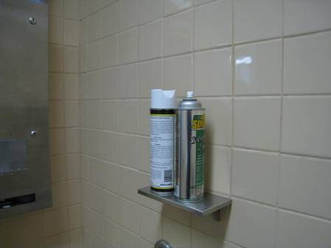

Deodorizing Spray in Restroom

Picture 9

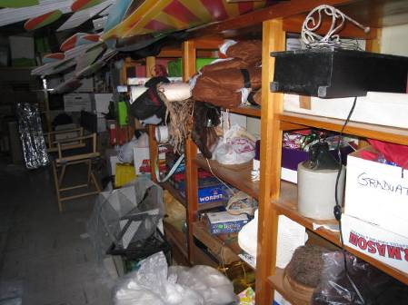

Stored Items in the Basement Work Area

Picture 10

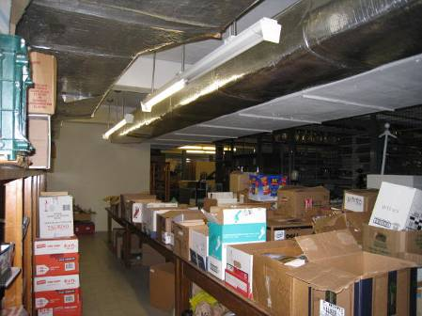

Boxes of Items, including Donations, in the Basement Work Area

Picture 11

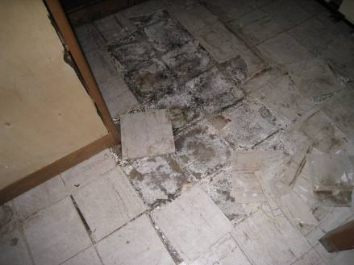

Damaged Floor Tiles in Basement Work Area

Picture 12

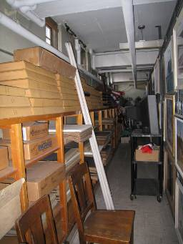

Stored Items on Shelves near Basement Walls
(Note Fluorescent Tubes Propped against Shelf)
Picture 13

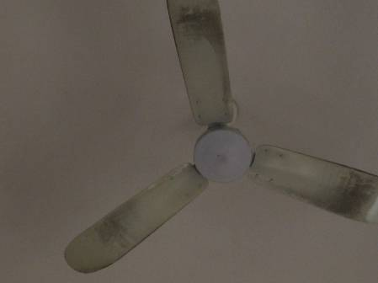

Dusty Ceiling Fan

Picture 14



Plush Toys in Children’s Area

Picture 15

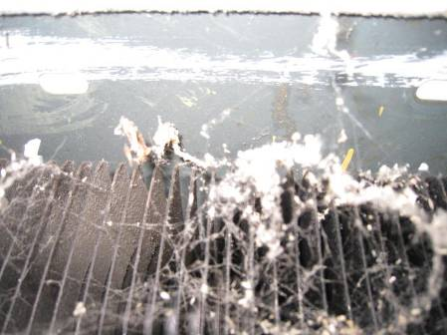

Dusty Radiator Fins in Reference Librarian Area
Location | Carbon  Dioxide  (ppm) | Carbon Monoxide  (ppm) | Temp  (°F) | Relative  Humidity  (%) | PM2.5  (µg/m³) | Occupants  in Room | Windows  Openable | Ventilation |  | Remarks
 |  |  |  |  |  |  |  | Supply | Exhaust | Remarks
Background | 523 | 2 | 41 | 25 | 14 |  |  |  |  | Partly sunny
Administration Break Room | 610 | ND | 73 | 29 | 13 | 1 | Y | N | N | Kitchen equipment (fridge, microwave, etc), tiled floor
Administration Suite | 606 | ND | 72 | 29 | 13 | 0 | Y | N | N | Carpet
Attic Storage Area | 647 | ND | 69 | 31 | 18 | 0 | N | N | N | Stored items
Basement Children’s Room | 598 | ND | 65 | 35 | 12 | 0 | Y | N | N | Window ACs, carpet
Basement Garage | 641 | 3 | 63 | 34 | 14 | 0 | N | N | N | DO
Basement Hallway | 539 | 3 | 67 | 25 | 12 | 0 | N | N | N | WD-CT, MT, floor tiles missing/damaged
Basement Mechanical Room | 623 | 2 | 63 | 34 | 13 | 0 | N | N | N
Basement Storage Shelve Area | 556 | 3 | 64 | 34 | 13 | 4 | Y | N | N
Basement Work Area | 531 | 4 | 64 | 35 | 12 | 5 | N | N | N | Floor fan on, door to garage open, missing/damaged floor tiles
Children’s Book Shelves O-R | 490 | ND | 71 | 22 | 14 | 0 |  |  |  | Plush animals, window, solar gain
Children’s Librarian area | 512 | ND | 72 | 23 | 13 | 1 | N | N | N | PC, clutter
Children’s Library | 628 | ND | 71 | 24 | 11 | 3 | Y | N | N
Children’s Library Play Area | 563 | ND | 71 | 23 | 11 | 0 | Y | N | N | Window AC, water damage below window
Chris Lindquist | 571 | ND | 72 | 30 | 13 |  | Y | Y | Y | DO, attached restroom has vent in ceiling to attic which has an exhaust fan, carpeted
Conference Room | 652 | ND | 72 | 30 | 13 | 0 | Y | Y | Y | Carpet
Fiction, J | 459 | ND | 71 | 22 | 13 | 3 | Y | Y | Y | Window
First Floor Adult Library | 634 | ND | 70 | 28 | 11 | 3 | N | Y | N | Space fans dirty, ceiling fans dirty
First Floor Main Desk | 634 | ND | 68 | 28 | 12 | 2 | N | Y | N | PC, PF
First Floor Staff Rest Room | 657 | ND | 68 | 29 | 11 | 0 | N | N | Y | Exhaust vent off, AD, cleaning products
Non-fiction 848-919 | 654 | ND | 71 | 28 | 14 | 1
Second Floor Adult Area | 689 | ND | 71 | 28 | 14 | 2 | N | Y | Y
Staff Reference Librarian Desk | 581 | ND | 70 | 28 | 12 | 3 | Y | Y | Y | Radiator fins dusty, odor reported. PC nearby
Teen Book Shelves, K | 614 | ND | 71 | 28 | 14 | 0 | N | N | N
Teen Lounge Area | 645 | ND | 71 | 28 | 14 | 1 | N | Y | Y | Area rug
Top Attic | 607 | ND | 67 | 35 | 14 | 0 | N | N | Y | Spinning attic fan opening in roof
Top Floor Glassed-in Area | 600 | ND | 72 | 27 | 13 | 0 | Y | N | N | Storage area for old books

Westfield Athenaeum Actions on MDPH Recommendations and Other Building Renovations

The report written following the visit in September 2011 had a number of recommendations specifically to improve conditions relating to moisture in the basement area following Tropical Storm Irene. The following are the recommendations made and information about work that had been done since that visit:

1. Consider installing a passive or mechanical exhaust fan in the garage to vent vehicle exhaust from the building. If not feasible, remove bricks from the east wall of the garage to reduce pressurization during time of high westerly winds.

This recommendation was in the process of being completed at the time of the November 2012 visit.

2. Consider replacing the sump pump for the garage drain inside the garage. If not feasible, render the sump pump as airtight as possible to prevent moisture evaporation into the storage room.

The sump pump had been outfitted with a cover. This cover should still be further sealed to reduce evaporation of moisture and transfer of odors.

3. Examine the feasibility of installing a mechanical exhaust ventilation system for the basement storage/workroom.

No mechanical ventilation has been installed in the basement workroom. It is not known whether it was determined to be feasible to install mechanical ventilation or not.

4. Check the weather-stripping around the bookmobile interior door. Check for air- tightness by monitoring for light and/or drafts around doors. Ensure doors accessing the basement fit completely flush with threshold.

Door to the bookmobile garage appeared to have weather-stripping and no light was visible beneath it when closed.

5. Remove any mold-contaminated materials (including stored items) in the basement.

Significant amounts of water-damaged and other material had been removed from the basement workroom. No stored items were noticeably water-damaged or mold-colonized at the time of the November 2012 visit; however there are still a significant amount of items stored in the basement.

6. Remove and replace any water-damaged/mold-colonized building materials (e.g., floor tiles). This measure will remove actively growing mold colonies that may be present. Remove mold contaminated materials in a manner consistent with recommendations found in “Mold Remediation in Schools and Commercial Buildings” published by the US Environmental Protection Agency, Office of Air and Radiation, Indoor Environments Division, Washington, DC. This document can be downloaded from the US EPA website at: http://www.epa.gov/iaq/molds/mold_remediation.html.

Floor tiles had not yet been replaced.

7. Ensure that the HVAC system in the basement mechanical room have all door and access panels closed. Keep the door to the mechanical room closed.

The door to the mechanical room was found closed during the November 20, 2012 visit.

8. Use dehumidifiers in below grade areas during hot, humid weather to reduce relative humidity. Ensure dehumidifiers are cleaned and maintained as per the manufacture’s instruction to prevent microbial growth.

A dehumidifier had been placed and was operating in the basement work area during the November 20, 2012 visit. It appeared to be clean and in good condition. Weather conditions at the time of the visit, and during the heating season in general, may not require dehumidification. The dehumidifier should continue to be used during damp or humid weather.

9 Seal utility holes and other potential pathways to eliminate pollutant paths of migration from the basement to the first floor.

Some utility holes have been sealed.

10. Install gutters and downspouts on the garage roof to direct rainwater at least 5 feet away from the foundation. Remove foliage to no less than five feet from the foundation.

No gutters/downspouts have been added/extended.

11. Examine the junction between the garage and the 1927 wing for degrading seals and repair as needed.

It was unclear if this had been completed.

12. For buildings in New England, periods of low relative humidity during the winter are often unavoidable. Therefore, scrupulous cleaning practices should be adopted to minimize common indoor air contaminants whose irritant effects can be enhanced when the relative humidity is low. To control for dusts, a high efficiency particulate arrestance (HEPA) filter equipped vacuum cleaner in conjunction with wet wiping of all surfaces is recommended. Drinking water during the day can help ease some symptoms associated with a dry environment (throat and sinus irritations).

A vacuum with a HEPA-equipped filter was not available at the Athenaeum at the time of the November 2012 visit.

13. Consult with a licensed asbestos inspector to ascertain whether pipe insulation and floor tiles contain asbestos and encapsulate or remove in conformance with Massachusetts law. Do not remove/replace water-damaged ceiling tiles until this issue is resolved.

Floor tiles had not been removed or encapsulated. It is not known if they contain asbestos.

