INDOOR AIR QUALITY ASSESSMENT
ODOR INVESTIGATION

Westfield High School
Administrative Suite
177 Montgomery Road
Westfield, Massachusetts



Prepared by:
Massachusetts Department of Public Health
Bureau for Environmental Health
Indoor Air Quality Program
June 2014

Background/Introduction
At the request of Mr. William Bancroft, Facilities Director at the Westfield High School (WHS), the Massachusetts Department of Public Health (MDPH), Bureau of Environmental Health (BEH) provided assistance and consultation regarding indoor air quality concerns at WHS, 177 Montgomery Road, Westfield, Massachusetts. On March 28, 2014, a visit to the WHS was made by Michael Feeney, Director of BEH’s Indoor Air Quality (IAQ) Program and Kathleen Gilmore, Environmental Analyst/Regional Inspector for BEH’s IAQ Program. The request was prompted by concerns of musty odors and mold growth in the Administrative Suite (AS). The areas investigated were limited to the AS where odors had been reported.
The WHS is a multi-wing brick building constructed in 1973. The AS is located on the first floor and consists of offices and open administrative spaces. Windows are single pane glass with metal frames and are openable.

Methods
Air tests for carbon dioxide, carbon monoxide, temperature and relative humidity were conducted with the TSI, Q-Trak, IAQ Monitor, Model 7565. Air tests for airborne particle matter with a diameter less than 2.5 micrometers were taken with the TSI, DUSTTRAK™ Aerosol Monitor Model 8520. MDPH staff also performed visual inspection of building materials for water damage and/or microbial growth.

Results
The WHS AS has approximately 18 staff and is visited by varying numbers of students during the school day. Tests were taken during normal operations, and results appear in Table 1.

Discussion

Ventilation
It can be seen from Table 1 that carbon dioxide levels were above 800 parts per million (ppm) in all locations tested in the AS indicating the lack of adequate fresh air supply at the time of assessment. The AS does not have mechanical ventilation. The only source of fresh air is openable windows. Vents located above the office doors (Picture 1) are connected to a ceiling-mounted air-handling unit (AHU) located in the staff kitchen (Picture 2) which provides air-conditioning during warm weather. Without proper supply and/or exhaust ventilation, indoor air pollutants can build up and lead to indoor air quality/comfort complaints.
Of note is a large passive vent located in the hallway wall of the kitchen (Picture 3). This vent was likely connected to the original air-conditioning AHU that was replaced by the current ceiling-mounted AHU. BEH/IAQ staff observed different floor tiles in this area which likely indicated that the original AHU was installed on the floor of the kitchen.
Minimum design ventilation rates are mandated by the Massachusetts State Building Code (MSBC). Until 2011, the minimum ventilation rate in Massachusetts was higher for both occupied office spaces and general offices, with similar requirements for other occupied spaces (BOCA, 1993). The current version of the MSBC, promulgated in 2011 by the State Board of Building Regulations and Standards (SBBRS), adopted the 2009 International Mechanical Code (IMC) to set minimum ventilation rates. Please note that the MSBC is a minimum standard that is not health-based. At lower rates of cubic feet per minute (cfm) per occupant of fresh air, carbon dioxide levels would be expected to rise significantly. A ventilation rate of 20 cfm per occupant of fresh air provides optimal air exchange resulting in carbon dioxide levels at or below 800 ppm in the indoor environment in each area measured. MDPH recommends that carbon dioxide levels be maintained at 800 ppm or below. This is because most environmental and occupational health scientists involved with research on IAQ and health effects have documented significant increases in indoor air quality complaints and/or health effects when carbon dioxide levels rise above the MDPH guidelines of 800 ppm for schools, office buildings and other occupied spaces (Sundell et al., 2011). The ventilation must be on at all times that the room is occupied. Providing adequate fresh air ventilation with open windows and maintaining the temperature in the comfort range during the cold weather season is impractical. Mechanical ventilation is usually required to provide adequate fresh air ventilation.
Carbon dioxide is not a problem in and of itself. It is used as an indicator of the adequacy of the fresh air ventilation. As carbon dioxide levels rise, it indicates that the ventilating system is malfunctioning or the design occupancy of the room is being exceeded. When this happens, a buildup of common indoor air pollutants can occur, leading to discomfort or health complaints. The Occupational Safety and Health Administration (OSHA) standard for carbon dioxide is 5,000 parts per million parts of air (ppm). Workers may be exposed to this level for 40 hours/week, based on a time-weighted average (OSHA, 1997).
The MDPH uses a guideline of 800 ppm for publicly occupied buildings. A guideline of 600 ppm or less is preferred in schools due to the fact that the majority of occupants are young and considered to be a more sensitive population in the evaluation of environmental health status. Inadequate ventilation and/or elevated temperatures are major causes of complaints such as respiratory, eye, nose and throat irritation, lethargy and headaches. For more information concerning carbon dioxide, consult Appendix A.
Temperature readings during the assessment ranged from 71°F to 73°F, which were within the MDPH recommended comfort range (Table 1). The MDPH recommends that indoor air temperatures be maintained in a range of 70°F to 78°F in order to provide for the comfort of building occupants. Temperature control complaints were reported by some occupants. As described above, the windows in the building are single pane with metal frames; this type of construction can allow heat to escape in the winter, creating drafts, and for sunlight to create a condition of solar gain and glare making temperature control difficult. Shades should be used to reduce solar gain as needed. In many cases concerning indoor air quality, fluctuations of temperature in occupied spaces are typically experienced, even in a building with an adequate fresh air supply.
The relative humidity at the time of the assessment ranged from 24 to 28 percent, which was below the MDPH recommended comfort range. The MDPH recommends a comfort range of 40 to 60 percent for indoor air relative humidity. Relative humidity levels in the building would be expected to drop during the winter months due to heating. The sensation of dryness and irritation is common in a low relative humidity environment. Low relative humidity is a very common problem during the heating season in the northeast part of the United States.

Odors and Microbial/Moisture Concerns
As previously mentioned, musty odors and concerns of mold growth prompted this assessment. On the day of the visit, BEH/IAQ staff did not observe signs of moisture or water damage in the AS. Staff reported that odors were more noticeable in the area of the kitchen.
The kitchen contains a floor drain that is the likely source of odors in the AS. A condensation drainpipe for the AHU terminates above the floor drain which is connected to the building drainage system (Picture 4). Drains typically have traps to prevent sewer odors/gases from penetrating into occupied spaces. During air-conditioning operation, moisture (e.g., condensation) will flow into the drain which fills the trap to form a watertight seal. During the heating season, the drain traps can dry out, which then may allow sewer gas/odors and moisture from the sewer system to enter occupied spaces of the office. In order to maintain the watertight seal, water should be poured down the drain routinely during the heating season to prevent back up of gas/odors into occupied spaces.
Of note is that the kitchen refrigerator partially covers the floor drain (Picture 4). Refrigerators are equipped with a fan to help cool the refrigerant and compressor. When operating, this fan can draw air from the floor. If the sewer/septic system becomes pressurized by increased water drainage after a rainstorm, air from the sewer can be forced up the line through the dry drain trap, which is then drawn and distributed into the AS by the refrigerator fan.
Plants were observed in a few rooms (Table 1, Picture 6). Plants, soil and drip pans can serve as sources of mold growth. Plants can also be a source of pollen. Plants should not be placed on porous materials, since water damage to porous materials may lead to microbial growth.

Other IAQ Evaluations
IAQ can be negatively influenced by the presence of respiratory irritants, such as products of combustion. The process of combustion produces a number of pollutants. Common combustion emissions include carbon monoxide, carbon dioxide, water vapor and smoke (fine airborne particle material). Of these materials, exposure to carbon monoxide and particulate matter with a diameter of 2.5 micrometers (μm) or less (PM2.5) can produce immediate, acute health effects upon exposure. To determine whether combustion products were present in the indoor environment, BEH/IAQ staff obtained measurements for carbon monoxide and PM2.5.

Carbon Monoxide
Carbon monoxide is a by-product of incomplete combustion of organic matter (e.g., gasoline, wood and tobacco). Exposure to carbon monoxide can produce immediate and acute health effects. Several air quality standards have been established to address carbon monoxide and prevent symptoms from exposure to these substances. The MDPH established a corrective action level concerning carbon monoxide in ice skating rinks that use fossil-fueled ice resurfacing equipment. If an operator of an indoor ice rink measures a carbon monoxide level over 30 ppm, taken 20 minutes after resurfacing within a rink, that operator must take actions to reduce carbon monoxide levels (MDPH, 1997).
The American Society of Heating Refrigeration and Air-Conditioning Engineers (ASHRAE) has adopted the National Ambient Air Quality Standards (NAAQS) as one set of criteria for assessing indoor air quality and monitoring of fresh air introduced by heating, ventilation and cooling (HVAC) systems (ASHRAE, 1989). The NAAQS are standards established by the US EPA to protect the public health from six criteria pollutants, including carbon monoxide and particulate matter (US EPA, 2006). As recommended by ASHRAE, pollutant levels of fresh air introduced to a building should not exceed the NAAQS levels (ASHRAE, 1989). The NAAQS were adopted by reference in the Building Officials & Code Administrators (BOCA) National Mechanical Code of 1993 (BOCA, 1993), which is now an HVAC standard included in the Massachusetts State Building Code (SBBRS, 2011). According to the NAAQS, carbon monoxide levels in outdoor air should not exceed 9 ppm in an eight-hour average (US EPA, 2006).
Carbon monoxide should not be present in a typical, indoor environment. If it is present, indoor carbon monoxide levels should be less than or equal to outdoor levels. On the day of assessment, outdoor carbon monoxide concentrations were non-detect (ND) (Table 1). Levels of carbon monoxide in the building during the assessment were ND (Table 1).

Particulate Matter (PM2.5)
The US EPA has established NAAQS limits for exposure to particulate matter. Particulate matter is airborne solids that can be irritating to the eyes, nose and throat. The NAAQS originally established exposure limits to particulate matter with a diameter of 10 μm or less (PM10). According to the NAAQS, PM10 levels should not exceed 150 microgram per cubic meter (μg/m³) in a 24-hour average (US EPA, 2006). These standards were adopted by both ASHRAE and BOCA. Since the issuance of the ASHRAE standard and BOCA Code, US EPA established a more protective standard for fine airborne particles. This more stringent PM2.5 standard requires outdoor air particle levels be maintained below 35 μg/m³ over a 24-hour average (US EPA, 2006). Although both the ASHRAE standard and BOCA Code adopted the PM10 standard for evaluating air quality, MDPH uses the more protective PM2.5 standard for evaluating airborne particulate matter concentrations in the indoor environment.
Outdoor PM2.5 concentrations measured 8 μg/m³ on the day of the visit (Table 1). PM2.5 levels measured inside the building ranged from 9 to 15 μg/m³ (Table 1). Frequently, indoor air levels of particulate matter can be at higher levels than those measured outdoors. A number of mechanical devices and/or activities that occur in buildings can generate particulate during normal operations. Sources of indoor airborne particulates may include but are not limited to particles generated during the operation of fan belts in the HVAC system, use of stoves and/or microwave ovens in kitchen areas; use of photocopiers, fax machines and computer printing devices; operation of an ordinary vacuum cleaner and heavy foot traffic indoors.

Volatile Organic Compounds
Indoor air concentrations can be greatly impacted by the use of products containing volatile organic compounds (VOCs). VOCs are carbon-containing substances that have the ability to evaporate at room temperature. Frequently, exposure to low levels of total VOCs (TVOCs) may produce eye, nose, throat and/or respiratory irritation in some sensitive individuals. For example, chemicals evaporating from a paint can stored at room temperature would most likely contain VOCs. In an effort to identify materials that can potentially increase indoor VOC concentrations, BEH/IAQ staff examined rooms for products containing these respiratory irritants.
There are several photocopiers in the building. Photocopiers can be sources of pollutants such as VOCs, ozone, heat and odors, particularly if the equipment is older and in frequent use. Both VOCs and ozone are respiratory irritants (Schmidt Etkin, 1992). Photocopiers and laminators should be kept in well ventilated rooms, and should be located near windows or exhaust vents.

Conclusions/Recommendations
In view of the findings at the time of the visit, the following recommendations are made:
- Pour water down the floor drain in the kitchen every 2- 3 days to ensure a water tight seal during the heating season.
- Open windows (weather permitting) to provide fresh outside air. Care should be taken to ensure windows are properly closed at night and weekends during winter months to avoid the freezing of pipes and potential flooding. In addition, keep windows closed during hot, humid weather to maintain indoor temperatures and to avoid condensation when air conditioning is activated.
- For buildings in New England, periods of low relative humidity during the winter are often unavoidable. Therefore, scrupulous cleaning practices should be adopted to minimize common indoor air contaminants whose irritant effects can be enhanced when the relative humidity is low. To control for dusts, a high efficiency particulate arrestance (HEPA) filter equipped vacuum cleaner in conjunction with wet wiping of all surfaces is recommended. Avoid the use of feather dusters. Drinking water during the day can help ease some symptoms associated with a dry environment (throat and sinus irritations).
- Move refrigerator away from the floor drain. Replace the condensation drip pan and make repairs to or replace the refrigerator as needed. Clean/disinfect the drip pan on a regular basis.
- Ensure indoor plants are equipped with drip pans. Examine drip pans periodically for mold growth and disinfect with an appropriate antimicrobial, as needed. Move plants away from the air stream of mechanical ventilation equipment.
- Consult with a HVAC engineering firm to determine the feasibility of providing mechanical supply and exhaust ventilation to the AS.
- Consider adopting the US EPA (2000) document, “Tools for Schools.” This document is available at: http://www.epa.gov/iaq/schools/index.html.
- Refer to resource manual and other related indoor air quality documents located on the MDPH’s website for further building-wide evaluations and advice on maintaining public buildings. These documents are available at: http://mass.gov/dph/iaq.

References
ASHRAE. 1989. Ventilation for Acceptable Indoor Air Quality. American Society of Heating, Refrigeration and Air Conditioning Engineers. ANSI/ASHRAE 62-1989.
BOCA. 1993. The BOCA National Mechanical Code-1993. 8th ed. Building Officials & Code Administrators International, Inc., Country Club Hills, IL. M-308.1
MDPH. 1997. Requirements to Maintain Air Quality in Indoor Skating Rinks (State Sanitary Code, Chapter XI). 105 CMR 675.000. Massachusetts Department of Public Health, Boston, MA.
OSHA. 1997. Limits for Air Contaminants. Occupational Safety and Health Administration. Code of Federal Regulations. 29 C.F.R 1910.1000 Table Z-1-A.
SBBRS. 2011. Mechanical Ventilation. State Board of Building Regulations and Standards. Code of Massachusetts Regulations, 8th edition. 780 CMR 1209.0.
Schmidt Etkin, D. 1992. Office Furnishings/Equipment & IAQ Health Impacts, Prevention & Mitigation. Cutter Information Corporation, Indoor Air Quality Update, Arlington, MA.
Sundell. 2011. Sundell, J., H. Levin, W. W. Nazaroff, W. S. Cain, W. J. Fisk, D. T. Grimsrud, F. Gyntelberg, Y. Li, A. K. Persily, A. C. Pickering, J. M. Samet, J. D. Spengler, S. T. Taylor, and C. J. Weschler. Ventilation rates and health: multidisciplinary review of the scientific literature. Indoor Air, Volume 21: pp 191–204.
US EPA. 2000. Tools for Schools. Office of Air and Radiation, Office of Radiation and Indoor Air, Indoor Environments Division (6609J). EPA 402-K-95-001, Second Edition. http://www.epa.gov/iaq/schools/actionkit.html
US EPA. 2006. National Ambient Air Quality Standards (NAAQS). US Environmental Protection Agency, Office of Air Quality Planning and Standards, Washington, DC. http://www.epa.gov/air/criteria.html.
Picture 1
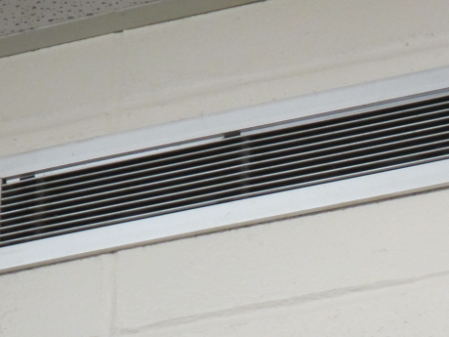
Passive vent located in an office
Picture 2
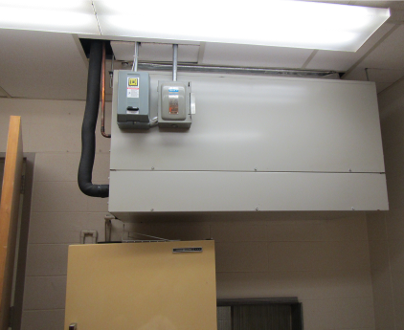
AHU in kitchen
Picture 3
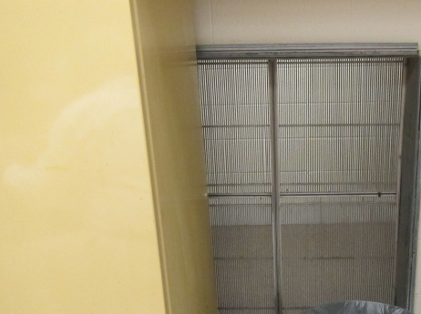
Large vent in kitchen
Picture 4
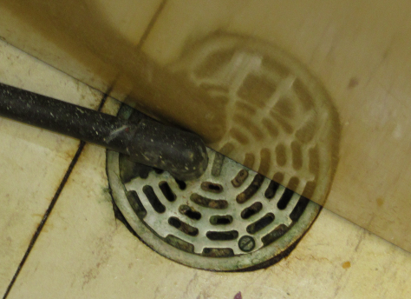
Floor drain in kitchen (note: partially obstructed by the refrigerator)
Picture 5
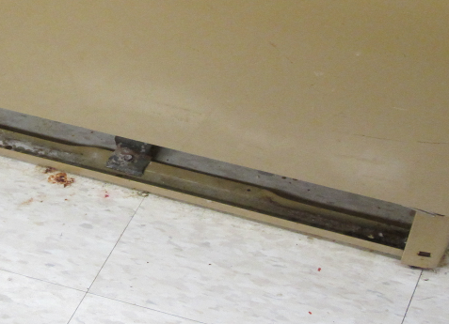
Missing drip pan under the refrigerator
Picture 6
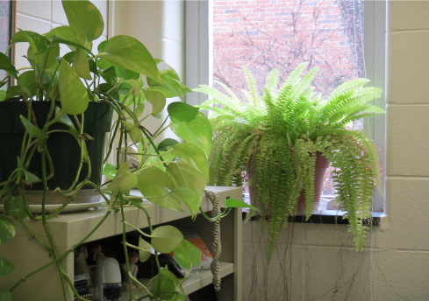
Plants located in office space
Location | Carbon  Dioxide  (ppm) | Carbon Monoxide  (ppm) | Temp  (°F) | Relative  Humidity  (%) | PM2.5  (µg/m³) | Occupants  in Room | Windows  Openable | Ventilation |  | Remarks
 |  |  |  |  |  |  |  | Supply | Exhaust | Remarks
Background | 343 | ND | 43 | 78 | 8 |  |  |  |  | Cloudy, slight drizzle
Administration area | 1826 | ND | 71 | 25 | 9 | 5 | N | N | N | PC, plants
Administrative assistant’s office | 1821 | ND | 72 | 24 | 10 | 1 | Y | Y | Y
Assistant principal’s office | 1887 | ND | 71 | 28 | 10 | 0 | Y | N | N
Reception area | 1826 | ND | 72 | 26 | 9 | 4 | Y | N | N | PC, plants
School officer’s office | 1888 | ND | 73 | 28 | 12 | 1 | N | N | N
Staff kitchen | 1813 | ND | 73 | 24 | 15 | 3 | N | N | N | Floor drain, Refrigerator missing drip pan, toaster, microwave

