INDOOR AIR QUALITY ASSESSMENT

Westfield High School
Career Center
177 Montgomery Road
Westfield, Massachusetts



Prepared by:
Massachusetts Department of Public Health
Bureau for Environmental Health
Indoor Air Quality Program
October 2012

Background/Introduction
At the request of Mr. Raymond K. Broderick, Principal, Westfield High School (WHS), the Massachusetts Department of Public Health (MDPH), Bureau of Environmental Health (BEH) provided assistance and consultation regarding indoor air quality concerns at the career center (CC) of WHS, 177 Montgomery Road, Westfield, Massachusetts. On September 7, 2012, a visit to the CC was made by Michael Feeney, Director of BEH’s Indoor Air Quality (IAQ) Program. The request was prompted by concerns regarding possible mold growth in the CC and related health concerns.
The WHS is a multi-wing brick building constructed in 1973. The CC is located on the first floor of a three-story wing located along the south exterior wall of the building. The interior of the CC was renovated after the building’s original construction. During this renovation, a wall system covered with vinyl wallpaper was installed over the original painted cement block walls and window wells (Picture 1). The original doors, that likely had passive door vents (Picture 2), were replaced with a set of solid oak doors lacking passive door vents (Picture 3). Windows in this office are metal frame with a single glass pane and are openable.

Methods
Air tests for carbon dioxide, carbon monoxide, temperature and relative humidity were conducted with the TSI, Q-Trak, IAQ Monitor, Model 7565. Air tests for airborne particle matter with a diameter less than 2.5 micrometers were taken with the TSI, DUSTTRAK™ Aerosol Monitor Model 8520. MDPH staff also performed visual inspection of building materials for water damage and/or microbial growth. The surface temperature of building components was measured with a ThermoTrace laser thermometer.

Results
The CC has approximately 4 staff and is visited by varying numbers of students during the school day. Tests were taken during normal operations. Test results appear in Table 1 for general IAQ parameters and Table 2 for surface temperature measurements.

Discussion

Ventilation
It can be seen from Table 1 that carbon dioxide levels were above 800 parts per million (ppm) in the CC indicating the lack of adequate fresh air supply at the time of assessment. The CC does not have a mechanical fresh air supply. An exhaust vent exists in the room, indicating that this room was originally designed to use a passive door vent (transfer air vent) to draw air from the main hallway, in a manner consistent with an adjacent room (Picture 2). As described previously, hallway doors to the CC were replaced with solid oak doors, preventing air movement into the CC when the doors are closed. It is also likely that the exhaust vent for this area was not operating at the time of the MDPH visit, which would result in decreased airflow and higher carbon dioxide levels. While the CC contains a wall-mounted air conditioner (Picture 4), the unit does not have a fresh air supply and serves only to cool recirculated air.
To maximize air exchange, the MDPH recommends that both supply and exhaust ventilation operate continuously during periods of school occupancy. In order to have proper ventilation with a mechanical supply and exhaust system, these systems must be balanced to provide an adequate amount of fresh air to the interior of a room while removing stale air from the room. It is recommended that existing ventilation systems be re-balanced every five years to ensure adequate air systems function (SMACNA, 1994). In its current configuration, the HVAC components cannot be balanced.
The Massachusetts Building Code requires that each room have a minimum ventilation rate of 20 cubic feet per minute (cfm) per occupant of fresh outside air or openable windows (SBBRS, 1997, BOCA, 1993). The ventilation must be on at all times that the room is occupied. Providing adequate fresh air ventilation with open windows and maintaining the temperature in the comfort range during the cold weather season is impractical. Mechanical ventilation is usually required to provide adequate fresh air ventilation.
Carbon dioxide is not a problem in and of itself. It is used as an indicator of the adequacy of the fresh air ventilation. As carbon dioxide levels rise, it indicates that the ventilating system is malfunctioning or the design occupancy of the room is being exceeded. When this happens, a buildup of common indoor air pollutants can occur, leading to discomfort or health complaints. The Occupational Safety and Health Administration (OSHA) standard for carbon dioxide is 5,000 parts per million parts of air (ppm). Workers may be exposed to this level for 40 hours/week, based on a time-weighted average (OSHA, 1997).
The MDPH uses a guideline of 800 ppm for publicly occupied buildings. A guideline of 600 ppm or less is preferred in schools due to the fact that the majority of occupants are young and considered to be a more sensitive population in the evaluation of environmental health status. Inadequate ventilation and/or elevated temperatures are major causes of complaints such as respiratory, eye, nose and throat irritation, lethargy and headaches. For more information concerning carbon dioxide, consult Appendix A.
The temperature measured in the CC was 78°F (Table 1). This measurement was within the MDPH recommended comfort range. The MDPH recommends that indoor air temperatures be maintained in a range of 70°F to 78°F in order to provide for the comfort of building occupants. In many cases concerning indoor air quality, fluctuations of temperature in occupied spaces are typically experienced, even in a building with an adequate fresh air supply.
The relative humidity measured was 72 percent (Table 1), which was above the MDPH recommended comfort range. Outdoor relative humidity was measured at 69 percent on a clear, sunny day. It is important to note that the relative humidity measurement was 3 percent higher indoors, similar to the background measurement taken outdoors, indicating that the indoor relative humidity measurement showed no unusual source of water vapor in the CC. MDPH recommends a comfort range of 40 to 60 percent for indoor air relative humidity. Relative humidity levels in the building would be expected to drop during the winter months due to heating. The sensation of dryness and irritation is common in a low relative humidity environment. Low relative humidity is a very common problem during the heating season in the northeast part of the United States.

Microbial/Moisture Concerns
While the relative humidity measured during the assessment is attributed to the hot, humid weather in the Westfield area at the time of the assessment, high relative humidity can have a detrimental effect on certain building components. According to the American Society of Heating Refrigeration and Air-Conditioning Engineers (ASHRAE), sustained relative humidity indoors of 70 percent or greater can wet building components, which will then result in microbial growth (ASHRAE, 1989).
In order for building materials to support mold growth, a source of water exposure is required. In this case, the most likely source of moisture appears to be prolonged periods of elevated indoor relative humidity as described above along with the thermal conditions described below. Operating the exhaust ventilation should remove excess moisture from the office.
The WHS interior walls were constructed using finished cement blocks. The exterior walls of the rooms around the CC were designed to have wall-mounted radiators heat the surface of the cement block wall. During the renovation, the interior walls of the CC were covered with gypsum wallboard (GW) which was then covered with vinyl wallpaper. In this configuration, the surface of the cement block wall is not heated as designed during the colder months, allowing for the creation of a thermal bridge. Where a thermal bridge exists, condensation is likely to form on the warm side of the cold object (i.e., the inside of the room in the winter); this can moisten materials, such as the space between the original cement block wall and the GW. The vinyl wallpaper is a water-impermeable material, which can trap water in the GW and cause water damage.
The window system configuration also makes the building highly susceptible to uneven heating. The window system of the building consists of a single pane of glass installed inside a metal frame. When exposed to direct sunlight, the glass and metal of the windows becomes heated. BEH/IAQ staff measured the temperature of the window glass and frames (Table 2) which were in direct sunlight on the day of the assessment. The window frame temperature was measured at 113°F while the outdoor temperature was 81°F (Table 2). The difference in temperature indicates that the windows, sill and wall are not energy efficient and can serve as thermal bridges. Because of the lack of insulating properties of the window system, the window components would be expected to be colder than the inside air temperature of the room during the heating season, leading to condensation, resulting in repeated exposure to moisture and potential mold growth in the GW. Water damage to this GW and peeling vinyl wallpaper were noted in the CC (Pictures 5 through 7).
Water-stained ceiling tiles were also observed (Picture 8); the likely source of moisture appears to be condensation generated by a pipe that supplies coolant to the wall-mounted air conditioner in the CC from the chiller. Condensation occurs in coolant supply pipes if spaces in the insulation exist or the R-value of the insulation is not sufficient or compromised. Spaces between insulation sections can allow moist air to be exposed to the metal of the chilled water pipes, resulting in condensation. If an air conditioning system has coolant pipes with an insufficient R-value, temperature could be transferred to the surface of the insulation, leading to condensation. Once water wets insulation, a thermal bridge is created, which results in further wetting of insulation and enhancing mold growth. The R-value of insulation is decreased by compression of the material. Wires used to suspend the coolant supply pipe were observed to tightly pinch the insulation, which would result in reduced insulating properties, which would likely lead to condensation (Picture 9).
The US Environmental Protection Agency (US EPA) and the American Conference of Governmental Industrial Hygienists (ACGIH) recommends that porous materials be dried with fans and heating within 24 to 48 hours of becoming wet (US EPA, 2001; ACGIH, 1989). If porous materials (e.g., cardboard, paper) are not dried within this time frame, mold growth may occur. Water-damaged porous materials cannot be adequately cleaned to remove mold growth. The application of a mildewcide to moldy porous materials is not recommended.
The condensation drain for the wall-mounted air conditioner is directly plumbed into the sink drain (Picture 10). In this configuration, if the sink trap is dry, air, moisture and associated odors may be drawn from the drain system by operation of the wall-mounted air conditioner.
A number of plants were observed in the CC. Moistened plant soil and drip pans can be a source of mold growth. Plants should be equipped with drip pans; the lack of drip pans can lead to water pooling and mold growth on windowsills. Plants may also be a source of pollen. Plants should be located away from the air stream of radiators and the wall-mounted air conditioner to prevent the aerosolization of mold, pollen or particulate matter throughout the CC.

Other IAQ Evaluations
Indoor air quality can be negatively influenced by the presence of respiratory irritants, such as products of combustion. The process of combustion produces a number of pollutants. Common combustion emissions include carbon monoxide, carbon dioxide, water vapor and smoke (fine airborne particle material). Of these materials, exposure to carbon monoxide and particulate matter with a diameter of 2.5 micrometers (μm) or less (PM2.5) can produce immediate, acute health effects upon exposure. To determine whether combustion products were present in the indoor environment, BEH/IAQ staff obtained measurements for carbon monoxide and PM2.5.

Carbon Monoxide
Carbon monoxide is a by-product of incomplete combustion of organic matter (e.g., gasoline, wood and tobacco). Exposure to carbon monoxide can produce immediate and acute health affects. Several air quality standards have been established to address carbon monoxide and prevent symptoms from exposure to these substances. The MDPH established a corrective action level concerning carbon monoxide in ice skating rinks that use fossil-fueled ice resurfacing equipment. If an operator of an indoor ice rink measures a carbon monoxide level over 30 ppm, taken 20 minutes after resurfacing within a rink, that operator must take actions to reduce carbon monoxide levels (MDPH, 1997).
The American Society of Heating Refrigeration and Air-Conditioning Engineers (ASHRAE) has adopted the National Ambient Air Quality Standards (NAAQS) as one set of criteria for assessing indoor air quality and monitoring of fresh air introduced by HVAC systems (ASHRAE, 1989). The NAAQS are standards established by the US EPA to protect the public health from six criteria pollutants, including carbon monoxide and particulate matter (US EPA, 2006). As recommended by ASHRAE, pollutant levels of fresh air introduced to a building should not exceed the NAAQS levels (ASHRAE, 1989). The NAAQS were adopted by reference in the Building Officials & Code Administrators (BOCA) National Mechanical Code of 1993 (BOCA, 1993), which is now an HVAC standard included in the Massachusetts State Building Code (SBBRS, 1997). According to the NAAQS, carbon monoxide levels in outdoor air should not exceed 9 ppm in an eight-hour average (US EPA, 2006).
Carbon monoxide should not be present in a typical, indoor environment. If it is present, indoor carbon monoxide levels should be less than or equal to outdoor levels. Outdoor carbon monoxide concentrations were non-detect (ND) at the time of assessment (Table 1). No measurable levels of carbon monoxide were detected in the CC during the assessment (Table 1).

Particulate Matter
The US EPA has established NAAQS limits for exposure to particulate matter. Particulate matter (PM) is airborne solids that can be irritating to the eyes, nose and throat. The NAAQS originally established exposure limits to PM with a diameter of 10 μm or less (PM10). According to the NAAQS, PM10 levels should not exceed 150 micrograms per cubic meter (μg/m³) in a 24-hour average (US EPA, 2006). These standards were adopted by both ASHRAE and BOCA. Since the issuance of the ASHRAE standard and BOCA Code, US EPA established a more protective standard for fine airborne particles. This more stringent PM2.5 standard requires outdoor air particle levels be maintained below 35 μg/m³ over a 24-hour average (US EPA, 2006). Although both the ASHRAE standard and BOCA Code adopted the PM10 standard for evaluating air quality, MDPH uses the more protective PM2.5 standard for evaluating airborne PM concentrations in the indoor environment.
Outdoor PM2.5 concentrations the day of the assessment were measured at 40 μg/m³. The PM2.5 levels measured in the CC was 38 μg/m³ (Table 1). While the indoor PM 2.5 level was above the NAAQS PM2.5 level of 35 μg/m³, the concentration was below the outdoor measurement. Indoor PM2.5 concentration would be reduced with lower outdoor concentrations. Frequently, indoor air levels of particulates (including PM2.5) can be at higher levels than those measured outdoors. A number of mechanical devices and/or activities that occur indoors can generate particulate during normal operations. Sources of indoor airborne particulates may include but are not limited to: particles generated during the operation of fan belts in the HVAC system; cooking in the cafeteria stoves and microwave ovens; use of photocopiers, fax machines and computer printing devices; operation of an ordinary vacuum cleaner; and, heavy foot traffic indoors.

Volatile Organic Compounds
Indoor air concentrations can be greatly impacted by the use of products containing volatile organic compounds (VOCs). VOCs are carbon-containing substances that have the ability to evaporate at room temperature. Frequently, exposure to low levels of total VOCs (TVOCs) may produce eye, nose, throat and/or respiratory irritation in some sensitive individuals. For example, chemicals evaporating from a paint can stored at room temperature would most likely contain VOCs. In an effort to identify materials that can potentially increase indoor VOC concentrations, BEH/IAQ staff examined rooms for products containing these respiratory irritants.
Cleaning products were found under the sink (Picture 10). Cleaning products contain chemicals that can be irritating to the eyes, nose and throat of sensitive individuals. These products should be properly labeled and stored in an area inaccessible to children. Additionally, a Materials Safety Data Sheet (MSDS) should be available at a central location for each product in the event of an emergency. Consideration should be given to providing teaching staff with school-issued cleaning products and supplies to ensure that MSDS information is available for all products used at the school.
Air deodorizing products were found to be in use. Air fresheners contain chemicals that can be irritating to the eyes, nose and throat of sensitive individuals. Many air fresheners contain 1,4-dichlorobenzene, a VOC which may cause reductions in lung function (NIH, 2006). Furthermore, deodorizing agents do not remove materials causing odors, but rather mask odors that may be present in the area.
A photocopier was not equipped with local mechanical exhaust ventilation to help reduce excess heat and odors. VOCs and ozone can be produced by photocopiers, particularly if the equipment is older and in frequent use. Ozone is a respiratory irritant (Schmidt Etkin, 1992).
In an effort to reduce noise from sliding chairs, tennis balls were sliced open and placed on chair legs. Tennis balls are made of a number of materials that are a source of respiratory irritants. Constant wearing of tennis balls can produce fibers and off-gas VOCs. Tennis balls are made with a natural rubber latex bladder, which becomes abraded when used as a chair leg pad. Use of tennis balls in this manner may introduce latex dust into the school environment. Some individuals are highly allergic to latex (e.g. spina bifida patients) (SBAA, 2001). It is recommended that the use of materials containing latex be limited in buildings to reduce the likelihood of symptoms in sensitive individuals (NIOSH, 1997).

Other Conditions
Other conditions that can affect indoor air quality were observed during the assessment. Items were observed on windowsills, tabletops, counters, bookcases and desks. The large number of items stored in classrooms provides a source for dusts to accumulate. These items (e.g., papers, folders, boxes) make it difficult for custodial staff to clean. Items should be relocated and/or be cleaned periodically to avoid excessive dust build up. In addition, these materials can accumulate on flat surfaces (e.g., desktops, shelving and carpets) in occupied areas and subsequently be re-aerosolized causing further irritation.

Conclusions/Recommendations
In view of the findings at the time of the visit, the following recommendations are made:
- Remove the GW that is installed over the exterior wall and window wells in a manner consistent with the US EPA recommendation contained in the document “Mold Remediation in Schools and Commercial Buildings.” Examine GW adjacent to the CC exterior wall and remove as needed if water-damaged. Restore the cement block wall to its original condition and function.
- Have the wall-mounted air conditioner condensation drain reconfigured to empty into the sink instead of the sink drain pipe.
- Re-insulate the coolant pipe for the wall-mounted air conditioner with insulation with an appropriate R-value for the temperature of the coolant. Install the insulation so it is not pinched by the pipe hangers. Once the insulation is repaired, remove and replace the water-damaged ceiling tiles.
- Undercut the hallway doors to provide transfer air for the exhaust vent in this room to operate when the hallway doors are closed. Operate the exhaust vent when the CC is occupied and repair the fan as needed.
- Reduce or eliminate plants in the CC. Use non-porous drip pans and keep them clean.
- Store cleaning products properly and out of reach of students. Ensure spray bottles are properly labeled. All cleaning products used at the facility should be approved by the school department with MSDSs available at a central location.
- Refrain from using air fresheners and deodorizers to reduce exposure to VOCs.
- Relocate the photocopier to an area with local exhaust ventilation or install local exhaust ventilation in areas where this equipment is used to reduce excess heat and odors.
- Replace tennis balls on chair legs with latex-free tennis balls or glides.
- Relocate or consider reducing the amount of materials stored in this room to allow for more thorough cleaning. Clean items regularly with a wet cloth or sponge to prevent excessive dust build-up.
- Consider adopting the US EPA document, “Tools for Schools” to maintain a good indoor air quality environment on the building (US EPA, 2000). This document can be downloaded from the Internet at: http://www.epa.gov/iaq/schools/index.html.
- Refer to resource manual and other related indoor air quality documents located on the MDPH’s website for further building-wide evaluations and advice on maintaining public buildings. These documents are available at: http://mass.gov/dph/iaq.

References
ACGIH. 1989. Guidelines for the Assessment of Bioaerosols in the Indoor Environment. American Conference of Governmental Industrial Hygienists, Cincinnati, OH.
ASHRAE. 1989. Ventilation for Acceptable Indoor Air Quality. American Society of Heating, Refrigeration and Air Conditioning Engineers. ANSI/ASHRAE 62-1989.
BOCA. 1993. The BOCA National Mechanical Code-1993. 8th ed. Building Officials & Code Administrators International, Inc., Country Club Hills, IL. M-308.1
MDPH. 1997. Requirements to Maintain Air Quality in Indoor Skating Rinks (State Sanitary Code, Chapter XI). 105 CMR 675.000. Massachusetts Department of Public Health, Boston, MA.
NIH. 2006. Chemical in Many Air Fresheners May Reduce Lung Function. NIH News. National Institute of Health. July 27, 2006. http://www.nih.gov/news/pr/jul2006/niehs-27.htm.
NIOSH. 1997. NIOSH Alert Preventing Allergic Reactions to Natural Rubber latex in the Workplace. National Institute for Occupational Safety and Health, Atlanta, GA.
OSHA. 1997. Limits for Air Contaminants. Occupational Safety and Health Administration. Code of Federal Regulations. 29 C.F.R 1910.1000 Table Z-1-A.
SBAA. 2001. Latex In the Home And Community Updated Spring 2001. Spina Bifida Association of America, Washington, DC.
SBBRS. 1997. Mechanical Ventilation. State Board of Building Regulations and Standards. Code of Massachusetts Regulations. 780 CMR 1209.0
Schmidt Etkin, D. 1992. Office Furnishings/Equipment & IAQ Health Impacts, Prevention & Mitigation. Cutter Information Corporation, Indoor Air Quality Update, Arlington, MA.
SMACNA. 1994. HVAC Systems Commissioning Manual. 1st ed. Sheet Metal and Air Conditioning Contractors’ National Association, Inc., Chantilly, VA.
US EPA. 2000. Tools for Schools. Office of Air and Radiation, Office of Radiation and Indoor Air, Indoor Environments Division (6609J). EPA 402-K-95-001, Second Edition. http://www.epa.gov/iaq/schools/tools4s2.html.
US EPA. 2001. “Mold Remediation in Schools and Commercial Buildings”. Office of Air and Radiation, Indoor Environments Division, Washington, DC. EPA 402-K-01-001. March 2001. Available at: http://www.epa.gov/iaq/molds/mold_remediation.html.
US EPA. 2006. National Ambient Air Quality Standards (NAAQS). US Environmental Protection Agency, Office of Air Quality Planning and Standards, Washington, DC. http://www.epa.gov/air/criteria.html.
Picture 1

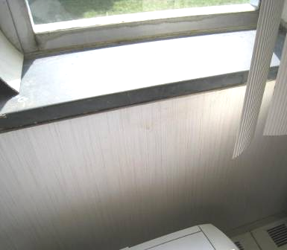

Vinyl wallpaper in the CC installed over the original walls

Picture 2

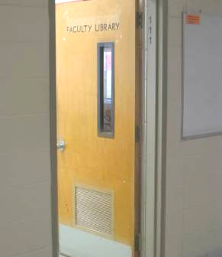

Nearby door with vent; it is likely the original door for CC had this design

Picture 3

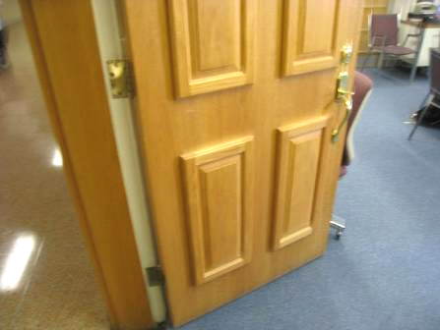

Oak hallway door of CC without transfer air vent

Picture 4

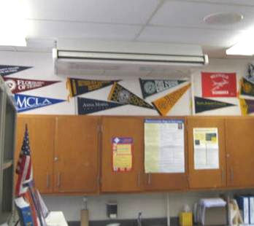

Wall-mounted air conditioner (arrow)

Picture 5

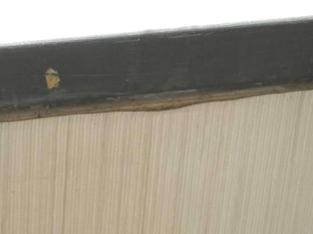

Water damage and peeling vinyl wallpaper

Picture 6

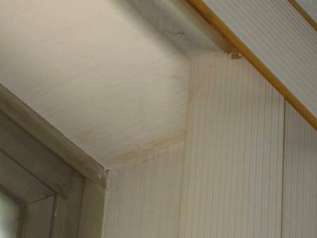

Water damage and peeling vinyl wallpaper

Picture 7

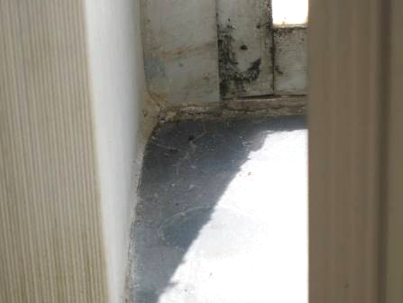

Water damage and peeling vinyl wallpaper

Picture 8

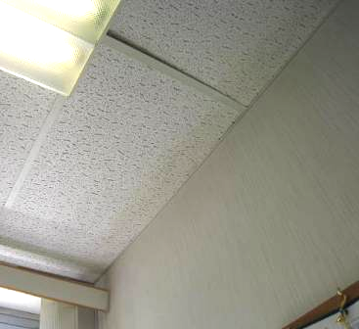

Water-stained ceiling tiles

Picture 9

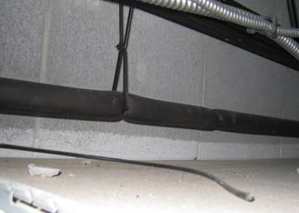

Wires used to suspend the coolant supply pipe pinching the insulation (arrow)

Picture 10

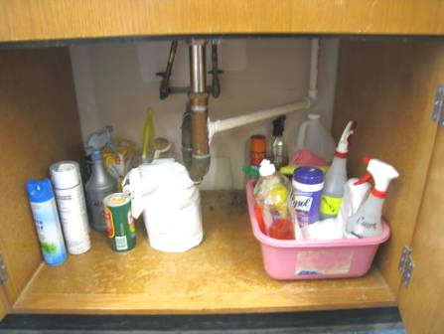

Condensation drain plumbed into the sink drain pipe (also note cleaning products)
Location | Carbon  Dioxide  (ppm) | Carbon Monoxide  (ppm) | Temp  (°F) | Relative  Humidity  (%) | PM2.5  (µg/m³) | Occupants  in Room | Windows  Openable | Ventilation |  | Remarks
 |  |  |  |  |  |  |  | Supply | Exhaust | Remarks
Background (outdoors) | 384 | ND | 81 | 69 | 40
Room 110 Career Center | 904 | ND | 78 | 72 | 38 | 4 | Y | N | Y | Exhaust off, photocopier, 3 water-damaged ceiling tiles, door open, wall-mounted AC (off)

Location/Component in Room 110 | Surface Temperature °F
Window frame | 113
Window sill | 101
Exterior wall | 84
Floor at base of exterior wall | 81
Floor 3" from base of exterior wall | 81
Hallway outside Room 110 | 79

A thermal bridge is an object (usually metallic) in a wall space through which heat is transferred at a greater rate than materials surrounding it. During the heating season, the window comes in contact with heated air from the interior and chilled air from the outdoors, resulting in condensation formation if the window temperature is below the dew point.
Condensation is the collection of moisture on a surface with a temperature below the dew point. The dew point is a temperature determined by air temperature and relative humidity. For example, at a temperature of 73°F and relative humidity of 57 percent indoors, the dew point for water to collect on a surface is approximately 57°F.
The R rating is a mathematical representation of the ability of insulation to prevent temperature transfer.

