INDOOR AIR QUALITY ASSESSMENT

Westport Senior Center
75 Reed Road
Westport, Massachusetts



Prepared by:
Massachusetts Department of Public Health
Bureau of Environmental Health
Emergency Response/Indoor Air Quality Program
August 2007

Background/Introduction
At the request of Susan Oliveria, Director, Westport Council on Aging (WCOA), the Massachusetts Department of Public Health (MDPH), Bureau of Environmental Health (BEH) provided assistance and consultation regarding indoor air quality concerns at the Westport Senior Center (WSC), 75 Reed Road, Westport, Massachusetts. The request was prompted by occupants complaints of exacerbation of allergy symptoms suspected of being related to mold, primarily in the basement.
On June 12, 2007, a visit to conduct an indoor air quality assessment at the WSC was made by Cory Holmes, an Environmental Analyst in BEH’s Emergency Response/Indoor Air Quality (ER/IAQ) Program. During the assessment Mr. Holmes was accompanied by John Medeiros, Maintenance Specialist, WCOA.
The WSC occupies a one-story cedar shingle-clad, granite foundation building that was built in the late 1800’s as a three-room school house. The building was renovated and an addition was added in the mid-1990’s. Windows are openable throughout the majority of the WSC.

Methods
Air tests for carbon dioxide, temperature and relative humidity were taken with the TSI, Q-Trak, IAQ Monitor. BEH staff also performed a visual inspection of building materials for water damage and/or microbial growth.

Results
The WSC has an employee population of approximately 10 and can be visited by up to 75 individuals daily. The tests were taken during normal operations. Test results appear in Table 1.

Discussion
Ventilation
It can be seen from Table 1 that carbon dioxide levels were below 800 parts per million (ppm) in all areas surveyed, indicating adequate ventilation in the building. The heating, ventilation and air conditioning (HVAC) system does not have the ability to introduce fresh outside air and rather recirculates only. It appears that the building was originally designed to provide fresh air to interior spaces solely by openable windows. Mechanical ventilation is provided by an air-handling unit (AHU) located in the attic or mechanical closets. Heated or cooled air is supplied to occupied areas via ceiling-mounted air diffusers and drawn back to the AHU by ceiling or wall-mounted return vents (Pictures 1 through 4).
Digital wall-mounted thermostats control the heating, ventilating and air-conditioning (HVAC) system and have fan settings of “on” and “automatic”. Thermostats were set to the “automatic” setting (Picture 5) during the assessment. The automatic setting on the thermostat activates the HVAC system at a preset temperature. Once the preset temperature is reached, the HVAC system is deactivated. Therefore, no mechanical ventilation is provided until the thermostat re-activates the system. Without a continuous source of fresh outside air and removal via the exhaust/return system, indoor environmental pollutants can build-up and lead to indoor air quality/comfort complaints.
To maximize air exchange, the MDPH recommends that both supply and exhaust ventilation operate continuously during periods of occupancy. In order to have proper ventilation with a mechanical supply and exhaust system, the systems must be balanced to provide an adequate amount of supply air to the interior of a room while removing stale air from the room. It is recommended that HVAC systems be re-balanced every five years to ensure adequate air systems function (SMACNA, 1994). The date of the last balancing of these systems was not available at the time of the assessment.
The Massachusetts Building Code requires that each room have a minimum ventilation rate of 20 cubic feet per minute (cfm) per occupant of fresh outside air or openable windows (SBBRS, 1997; BOCA, 1993). The ventilation must be on at all times that the room is occupied. Providing adequate fresh air ventilation with open windows and maintaining the temperature in the comfort range during the cold weather season is impractical. Mechanical ventilation is usually required to provide adequate fresh air ventilation.
Carbon dioxide is not a problem in and of itself. It is used as an indicator of the adequacy of the fresh air ventilation. As carbon dioxide levels rise, it indicates that the ventilating system is malfunctioning or the design occupancy of the room is being exceeded. When this happens, a buildup of common indoor air pollutants can occur, leading to discomfort or health complaints. The Occupational Safety and Health Administration (OSHA) standard for carbon dioxide is 5,000 parts per million parts of air (ppm). Workers may be exposed to this level for 40 hours/week, based on a time-weighted average (OSHA, 1997).
The MDPH uses a guideline of 800 ppm for publicly occupied buildings. A guideline of 600 ppm or less is preferred in schools due to the fact that the majority of occupants are young and considered to be a more sensitive population in the evaluation of environmental health status. Inadequate ventilation and/or elevated temperatures are major causes of complaints such as respiratory, eye, nose and throat irritation, lethargy and headaches. For more information concerning carbon dioxide, please see Appendix A.
Temperature readings ranged from 68º F to 74 º F, which were within or close to the lower end of the MDPH recommended comfort guidelines at the time of the assessment. The MDPH recommends that indoor air temperatures be maintained in a range of 70 º F to 78 º F in order to provide for the comfort of building occupants. In many cases concerning indoor air quality, fluctuations of temperature in occupied spaces are typically experienced, even in a building with an adequate fresh air supply. BEH staff visited the attic to examine the AHU with Mr. Medeiros and found that the main duct had become detached from the AHU (Pictures 6 and 7), making it difficult at best to control temperature. Pressurization of the attic can also force dirt, dust and other airborne particulates such as fiberglass (from insulation) into occupied areas, which can provide a source or skin and/or respiratory irritation. During the assessment the duct was temporarily reattached by Mr. Medeiros (Picture 8).
The relative humidity measured in the building ranged from 48 to 68 percent. During the assessment, relative humidity levels exceeded MDPH guidelines in the basement areas (Table 1). The MDPH recommends a comfort range of 40 to 60 percent for indoor air relative humidity. While temperature is mainly a comfort issue, relative humidity in excess of 70 percent for extended periods of time can provide an environment for mold and fungal growth (ASHRAE, 1989). Relative humidity levels in the building would be expected to drop during the winter months due to heating. The sensation of dryness and irritation is common in a low relative humidity environment. Low relative humidity is a very common problem during the heating season in the northeast part of the United States.

Microbial/Moisture Concerns
Dark staining, (possibly mold growth), was observed on the surface of the plaster ceiling and on stone walls in the corner of the maintenance storage room (Pictures 9 and 10). Although plaster and stone are not good media for mold growth, mold can grow on the surface of these materials if they are dusty in concert with moisture.
BEH staff examined conditions on the exterior of the building and observed missing/damaged mortar in several areas around the foundation that could be potential sources of water infiltration (Pictures 11 to 12). The US Environmental Protection Agency (US EPA) and the American Conference of Governmental Industrial Hygienists (ACGIH) recommends that porous materials be dried with fans and heating within 24 to 48 hours of becoming wet (ACGIH, 1989; US EPA, 2001). If porous materials are not dried within this time frame, mold growth may occur.
Musty odors were detected in the exercise room. The most likely source of odors was spaces around the door that opens into the unfinished dirt crawlspace (Picture 13). Open utility holes were also observed in ceilings and walls of the maintenance storeroom (Pictures 14 and 15), which can provide a means of odors and particulates into occupied areas.
Plants were noted in several areas. Plants can be a source of pollen and mold, which can be respiratory irritants for some individuals. Plants should be properly maintained and equipped with drip pans. Plants should also be located away from ventilation sources to prevent the entrainment and/or aerosolization of dirt, pollen or mold.

Other Concerns
Several other conditions that can potentially affect indoor air quality were identified. Open utility holes in the basement office were observed with exposed fiberglass insulation. Exposed fiberglass insulation was also observed around the kitchen water heater (Pictures 16 and 17). Fiberglass insulation can serve as a skin, eye and respiratory irritant.
Finally, several bees/wasps nests were observed on the outside of the building (Picture 18). These nests should be removed in a manner as to not introduce insects and/or pesticides into the building.

Conclusions/Recommendations
In view of the findings at the time of the visit, the following recommendations are made:
- Contact an HVAC engineering firm to ensure ductwork is properly secured to the AHU and working as designed (e.g., airtight).
- Consider operating the air-handling unit in the basement in the fan “on" mode (as opposed to the fan “auto” setting) to provide continuous air circulation.
- Consider adopting a balancing schedule of every 5 years for mechanical ventilation systems, as recommended by ventilation industrial standards (SMACNA, 1994).
- For buildings in New England, periods of low relative humidity during the winter are often unavoidable. Therefore, implementation of scrupulous cleaning practices should be implemented. This will minimize common indoor air contaminants whose irritant effects can be enhanced when the relative humidity is low. Use of vacuum cleaning equipment outfitted with a high efficiency particulate arrestance (HEPA) filter is recommended. Drinking water during the day can help ease some symptoms associated with a dry environment (throat and sinus irritations).
- Clean dark surfaces of ceiling plaster and stone walls in maintenance storeroom suspected of being mold growth with an appropriate antimicrobial followed by soap and water. Ensure surfaces are dried (e.g., with fans) properly to prevent further mold growth.
- Install weather-stripping around crawlspace door and seal all open utility holes in walls/ceilings to prevent odors/moisture from penetrating into occupied areas.
- Consider operating dehumidifiers in the basement during extended periods of high relative humidity (> 70%). If used, clean and disinfect dehumidifiers as per manufacturer’s instructions (or more frequently as needed) to prevent microbial growth.
- Repoint damaged areas of foundation to prevent water infiltration and further damage.
- Ensure plants have drip pans. Examine drip pans periodically for mold growth and disinfect with an appropriate antimicrobial where necessary. Keep plants away from the air stream of univents.
- Re-wrap insulation around kitchen water heater to prevent exposure to fiberglass insulation.
- Remove bees/wasps nests in a manner as to not introduce insects and/or pesticides into the building.
- Refer to “Mold Remediation in Schools and Commercial Buildings” published by the US Environmental Protection Agency (US EPA, 2001) for information concerning mold and mold remediation. Copies of this document can be downloaded from the US EPA website at: http://www.epa.gov/iaq/molds/mold_remediation.html.
- For further building-wide evaluations, advice on maintaining public buildings and other related indoor air quality documents see the MDPH’s website at http://www.state.ma.us/dph/beha/iaq/iaqhome.htm.
References
ACGIH. 1989. Guidelines for the Assessment of Bioaerosols in the Indoor Environment. American Conference of Governmental Industrial Hygienists, Cincinnati, OH.
ASHRAE. 1989. Ventilation for Acceptable Indoor Air Quality. American Society of Heating, Refrigeration and Air Conditioning Engineers. ANSI/ASHRAE 62-1989

BOCA. 1993. The BOCA National Mechanical Code/1993. 8th ed. Building Officials and Code Administrators International, Inc., Country Club Hill, IL. Section M-308.1.1.

OSHA. 1997. Limits for Air Contaminants. Occupational Safety and Health Administration. Code of Federal Regulations. 29 C.F.R 1910.1000 Table Z-1-A.

SBBRS. 1997. Mechanical Ventilation. State Board of Building Regulations and Standards. Code of Massachusetts Regulations. 780 CMR 1209.0

SMACNA. 1994. HVAC Systems Commissioning Manual. 1st ed. Sheet Metal and Air Conditioning Contractors’ National Association, Inc., Chantilly, VA.

US EPA. 2001. Mold Remediation in Schools and Commercial Buildings. US Environmental Protection Agency, Office of Air and Radiation, Indoor Environments Division, Washington, D.C. EPA 402-K-01-001. March 2001.
Picture 1

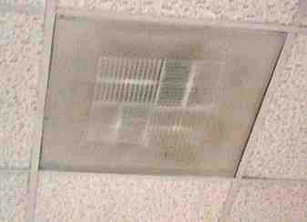

Ceiling-Mounted Air Diffuser

Picture 2

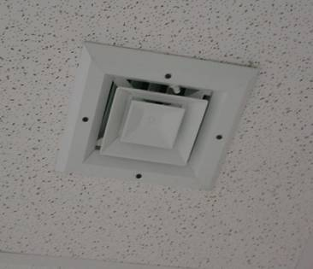

Ceiling-Mounted Air Diffuser in Basement

Picture 3

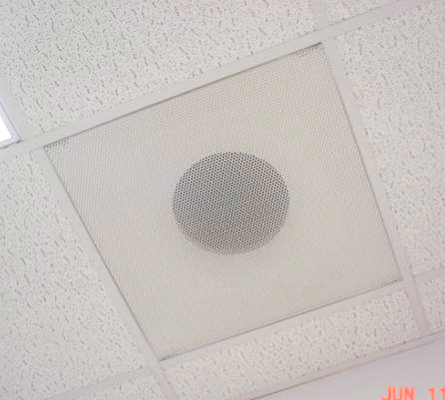

Ceiling-Mounted Return Vents

Picture 4

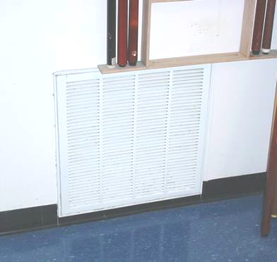

Wall-Mounted Return Vent in Basement
Picture 5

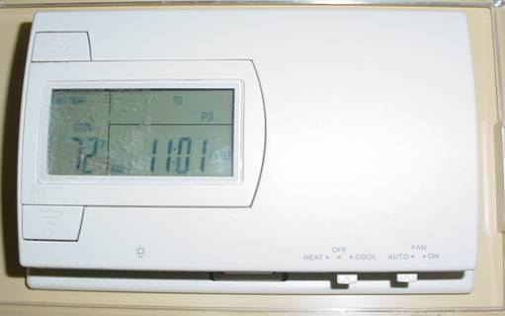

Digital Wall-Mounted Thermostat with Fan in “Auto” Position

Picture 6

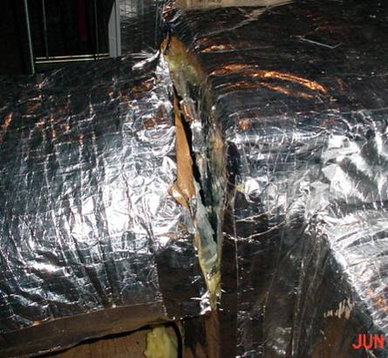

Section of Ductwork Detached from AHU
Picture 7

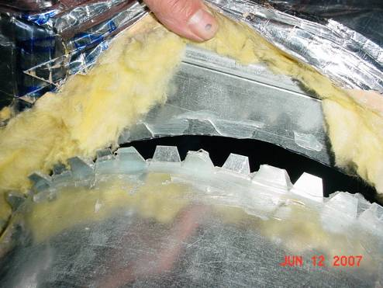

Close-Up of Ductwork Detached from AHU

Picture 8

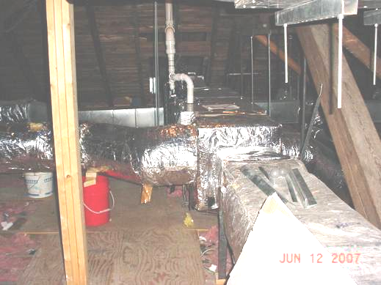

Section of Ductwork (Arrow) Temporarily Re-attached to AHU
Picture 9

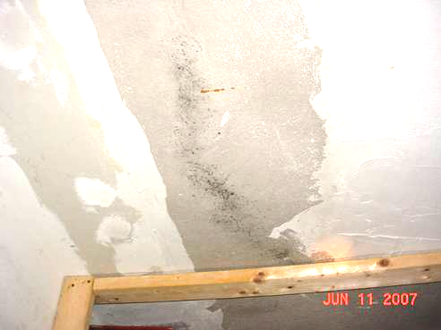

Dark Staining (Center) on Surface of Plaster Ceiling in Maintenance Storeroom

Picture 10

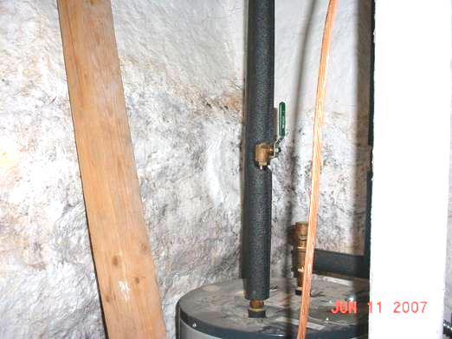

Dark Staining on Stone Foundation in Corner of Maintenance Storeroom
Picture 11

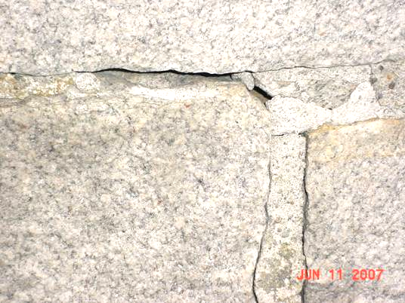

Missing/Damaged Mortar around Foundation Blocks

Picture 12

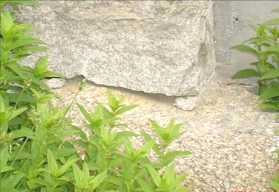

Missing/Damaged Mortar around Foundation Blocks
Picture 13

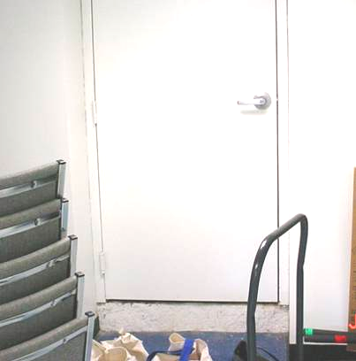

Spaces around Crawlspace Door in Exercise Room

Picture 14

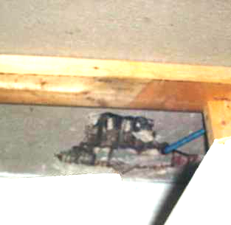

Open Utility Hole in Wall Plaster in Maintenance Storeroom
Picture 15

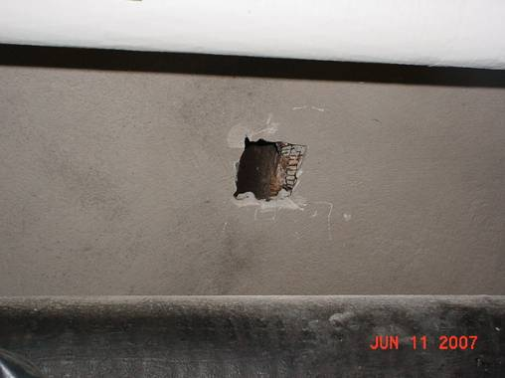

Open Utility Hole in Ceiling Plaster in Maintenance Storeroom

Picture 16

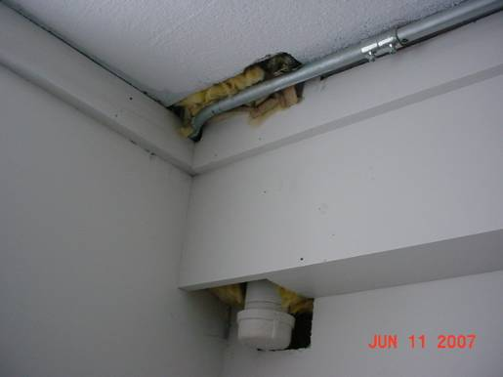

Open Utility Holes and Exposed Fiberglass Insulation in Basement Office
Picture 17

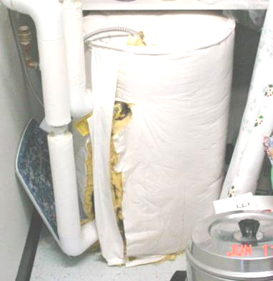

Exposed Fiberglass Insulation around Kitchen Water Heater

Picture 18

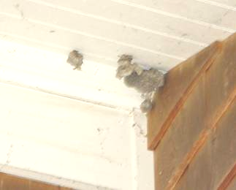

Bees/Wasps Nests around Perimeter of Building
Location |  | Carbon  Dioxide  (*ppm) |  | Temp  (°F) |  | Relative  Humidity  (%) |  | Occupants  in Room |  | Windows  Openable |  | Ventilation |  |  | Remarks
 |  |  |  |  |  |  |  |  |  |  |  | Supply | Exhaust
Background | 318 |  | 70 |  | 75 |  |  |  |  |  |  |  |  | Overcast, humid, winds 5-10 NNE
Arts/Crafts | 507 |  | 72 |  | 53 |  | 4 |  | Y |  | Y |  | Y
Kitchen | 587 |  | 74 |  | 53 |  | 0 |  | Y |  | Y |  | Y | Water heater-fiberglass
Dining Room | 596 |  | 74 |  | 51 |  | 4 |  | Y |  | Y |  | Y
Social Day Program | 687 |  | 74 |  | 51 |  | 8 |  | Y |  | Y |  | Y | Plants-on paper
Men’s Room |  |  |  |  |  |  |  |  |  |  |  |  |  | 2-water damaged ceiling tiles
Main Office | 492 |  | 73 |  | 48 |  | 1 |  | N |  | Y |  | Y | Dusty vents
Director’s Office | 481 |  | 72 |  | 48 |  | 0 |  | Y |  | Y |  | Y | Plants
Library | 527 |  | 72 |  | 49 |  | 1 |  | Y |  | Y |  | Y
Social Day Office | 476 |  | 73 |  | 51 |  | 0 |  | Y |  | Y |  | Y
Exercise Room | 485 |  | 70 |  | 58 |  | 0 |  | N |  | Y |  | Y | Musty odors-spaces around crawlspace door
Billiards Room | 608 |  | 69 |  | 66 |  | 0 |  | N |  | Y |  | Y
Computer Room | 534 |  | 69 |  | 67 |  | 0 |  | N |  | Y |  | Y
Outreach/Volunteer Office | 507 |  | 69 |  | 68 |  | 1 |  | N |  | Y |  | Y | Exposed fiberglass insulation, utility holes
Maintenance Storage | 600 |  | 68 |  | 68 |  | 0 |  | N |  | Y |  | Y | Dark staining on walls-corner and on ceiling, holes in wall/ceiling
Exterior |  |  |  |  |  |  |  |  |  |  |  |  |  | Missing/damaged mortar around granite block foundation

