Mold/Water Damage Investigation

Weymouth High School
One Wildcat Way
Weymouth, Massachusetts

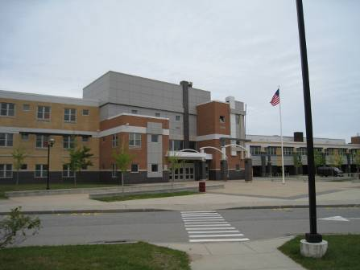

Prepared by:
Massachusetts Department of Public Health
Bureau of Environmental Health
Indoor Air Quality Program
August 2010

Background/Introduction
In response to a referral by the Massachusetts Department of Labor and Workforce Development (MDLWD), Division of Occupational Safety (DOS) via the United States Occupational Safety and Health Administration (OSHA), the Massachusetts Department of Public Health (MDPH), Bureau of Environmental Health (BEH) provided assistance and consultation regarding indoor air quality at Weymouth High School (WHS), One Wildcat Way, Weymouth, Massachusetts. On May 18, 2010, Cory Holmes, an Environmental Analyst/Regional Inspector within BEH’s Indoor Air Quality (IAQ) Program visited the WHS to conduct an assessment. Mr. Holmes was accompanied by Daniel McCormack, Chemicals Management and Surveillance Officer, Weymouth Health Department, and Tom Slattery, Facilities Director, Weymouth Public Schools. The request was prompted by concerns of potential mold growth and water infiltration, specifically in classrooms 3009, 3011 and 3017.
The WHS consists of two main buildings, “gold” and “maroon”. The gold building is a newly constructed addition completed in 2004. The maroon building, which formally served as the South Middle School, was completely renovated as part of the expansion project. The maroon house is connected to the gold house via two hallways (Picture 1).

Methods
BEH staff performed a visual inspection of building materials for water damage and/or microbial growth.

Results and Discussion
The assessment was prompted by concerns of potential mold growth from water damaged building materials reported by school staff in several third floor classrooms located in the gold building. In order for building materials to support mold growth, a source of water exposure is necessary. Identification and elimination of the source of water moistening building materials is necessary to control mold growth. As reported by Mr. Slattery, the following water sources identified in this area included; condensation related to a lack of complete insulation on heating, ventilation and air conditioning (HVAC) components above ceiling tiles, and water infiltration as a result of structural deficiencies related to roof construction and drainage.
The US Environmental Protection Agency (US EPA) and the American Conference of Governmental Industrial Hygienists (ACGIH) recommend that porous materials be dried with fans and heating within 24 to 48 hours of becoming wet (US EPA, 2001; ACGIH, 1989). If not dried within this time frame, mold growth may occur. Once mold has colonized porous materials, they are difficult to clean and should be removed/discarded.
Mr. Slattery reported that repair work was conducted between 2007 and 2009 to replace/re-wrap HVAC components to prevent condensation. After this work was completed water-damaged ceiling tiles were replaced. In addition, the Weymouth School Department (WSD) hired a private building contractor to inspect the roof/flashing for proper construction, which led to major repairs that were conducted building-wide from September to November 2009.
In response to employee concerns regarding mold, the WSD hired American Environmental Consultants, Inc. (AEC) to conduct microbiological indoor air testing at WHS. Testing was conducted on July 21, 2009, in classrooms 3009, 3017, 3030 and 3043 as well as outside for comparison. The AEC report concluded that, based on site observations and laboratory data, areas tested did not have concerns of mold growth (AEC, 2009).
As previously mentioned, BEH staff conducted an evaluation on May 18, 2010, to follow-up on remediation efforts to prevent further water-penetration/condensation issues in classrooms 3009, 3017, 3030 and 3043, as well as other areas of reported concern including classroom 3011 and the culinary arts kitchen. At the time of the assessment, no further water damage/infiltration and/or mold growth was reported or observed.

Conclusions/Recommendations
It appears that repairs made to both HVAC components as well as the building envelope were successful in preventing further water damage and mold growth, The success of such work is evidenced by lack of leaks following unprecedented rainfall and flooding during March of 2010. At this time, no further actions are recommended.

References
ACGIH. 1989. Guidelines for the Assessment of Bioaerosols in the Indoor Environment. American Conference of Governmental Industrial Hygienists, Cincinnati, OH.
AEC. 2009. American Environmental Consultants, Inc. Report of Microbiological Indoor Air Testing at Weymouth High School, One Wildcat Way, Weymouth, MA. Dated July 24, 2009.
US EPA. 2001. Mold Remediation in Schools and Commercial Buildings. US Environmental Protection Agency, Office of Air and Radiation, Indoor Environments Division, Washington, D.C. EPA 402-K-01-001. March 2001.
Picture 1

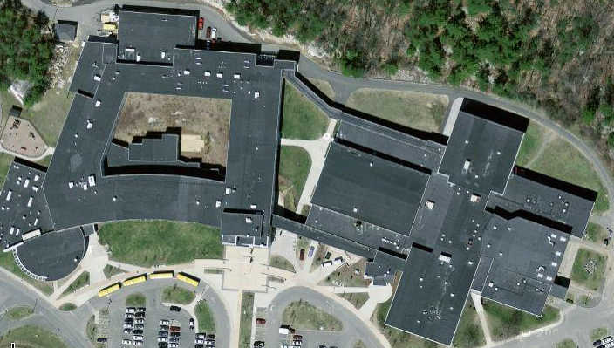

Exterior Hallways (Indicted by Arrows) Connecting Gold Building (Left) and Maroon Building (Right)

