What is Xerostomia?

(zero-STOH-mee-ah)




Oral Health in Massachusetts: A Fact Sheet

What is the public health issue?
Xerostomia (pronounced zero-STOH-mee-ah) is more commonly known as ‘dry mouth’ or a lack of saliva in the mouth for an extended period of time; and the condition affects one in four individuals in the US.¹

What causes xerostomia?
Medication Use: There are more than 500 prescription and non-prescription drugs associated with xerostomia.¹ Among the more likely types to cause problems are those used to treat depression and anxiety, congestion and allergic reactions, high blood pressure, diarrhea, muscle spasms, urinary incontinence, and Parkinson’s disease.²
It’s also important to note that as the number of medications used at the same time increases so may the severity of the dry mouth.

Certain Diseases and Conditions: Sjogren’s Syndrome is an autoimmune disease that affects approximately four million people. With this disease, the immune system destroys all fluid producing cells resulting in the reduction of salivary flow. Also, as many as half of all people with Rheumatoid Arthritis have dry mouth symptoms, as well as many with Lupus Erythematosis, Diabetes, Parkinson’s Disease, and HIV/AIDS.

Certain Diseases and Conditions: Xerostomia is a side effect of radiation therapy for head and neck cancer. As the radiation treatment progresses, it can destroy the ability of the salivary glands to produce saliva. The severity of this can be related to the dose and frequency of the radiation treatments. In addition, certain chemotherapy drugs may also decrease salivary production.

Why is saliva important?
Saliva serves as a lubricant for the mouth, it naturally cleanses the teeth and mouth, coats tooth surfaces with minerals, aids in swallowing food, it provides antibacterial activity, and it helps the mouth to form words for understandable speech. When salivary glands function normally, they produce one to two liters of saliva each day.

How does Dry Mouth Affect Oral Health?
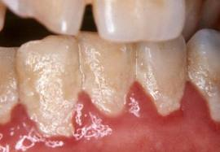
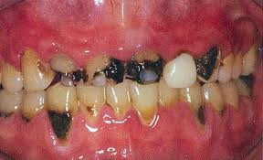
Saliva is important and when it’s not available, problems do occur. If saliva flow is reduced, food and bacteria will stay on the teeth resulting in plaque build-up or an increases accumulation of bacteria on the teeth and gums. The resulting build-up can contributes to periodontal (gum) disease and tooth decay (cavities). A dry, rough or fissured tongue can also result from reduced salivary flow and cause painful eating and chewing, as well as bad breath. Additionally, the overall lack of saliva can alter the ability to taste foods and can contribute to malnourishment.
Plaque/Bacteria

Tooth Decay

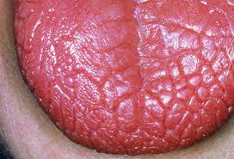
What are the signs of Xerostomia?

- Sticky, dry feeling in the mouth
- Trouble chewing, swallowing, tasting, or speaking
- A burning feeling in the mouth, a dry feeling in the throat, cracked lips
- Bacteria and yeast infections (Candidiasis) in the mouth
- A dry, rough or fissured tongue, mouth sores, an infection in the mouth, bad breath (halitosis)
- Feeling constantly thirsty throughout the day.³

You should always discuss changes in your overall health and your oral/dental health including new medications with your physician and dental professional for proper diagnosis and treatment.

What is the treatment for Xerostomia?
The best treatment for xerostomia or dry mouth is to treat the symptoms:

- Drink or sip water frequently throughout the day. This is the most helpful, easiest and inexpensive way to relieve symptoms. Drinking fluoridated water is best, as the fluoride can help to prevent tooth decay.
- Use sugar-free gum and/or sugar-free hard candies to help stimulate saliva production. When looking for these products look for the ingredient xylitol on the package. Xylitol is a 100% natural sweetener that can be found in berries, fruit, vegetables and mushrooms.
- Use alcohol-free and sugar-free products made specifically to stimulate saliva production. These products have salivary enzymes made to mimic the antimicrobial properties of real saliva. ²
- Keep your mouth clean by brushing your teeth and tongue with a fluoride toothpaste after each meal and snack.
- Receive regular dental check-ups, at least every 4 to 6 months to make sure your teeth and gums stay healthy.
- Avoid certain foods and drinks which will increase your risk for tooth decay. These include coffee and tea with sugar, soda and sugar-based juices/drinks, candy and alcohol. Also, using tobacco products, including smoking.

References
- Academy of General Dentistry. “Dry mouth linked to prescription and over the counter drugs”. General Dentistry,

(Oct 2009); Accessed online at www.agd.org.
- National Institute of Dental and Craniofacial Research. Online fact sheet accessed at

http://www.nidcr.nih.gov/oralhealth/topics/drymouth
- Cassolato SF, Turnbull RS. “Estonia: clinical aspects and treatment”. Gerontology, vol 20:2; 64-67.

For more information, contact:
Massachusetts Department of Public Health
Office of Oral Health
250 Washington Street
Boston, MA 02108-4619
Oral.Health@state.ma.us



