**INDOOR AIR QUALITY ASSESSMENT**

**Frontier Regional School District Administration Building**

**219 Christian Ln RFD1**

**Whately, MA**

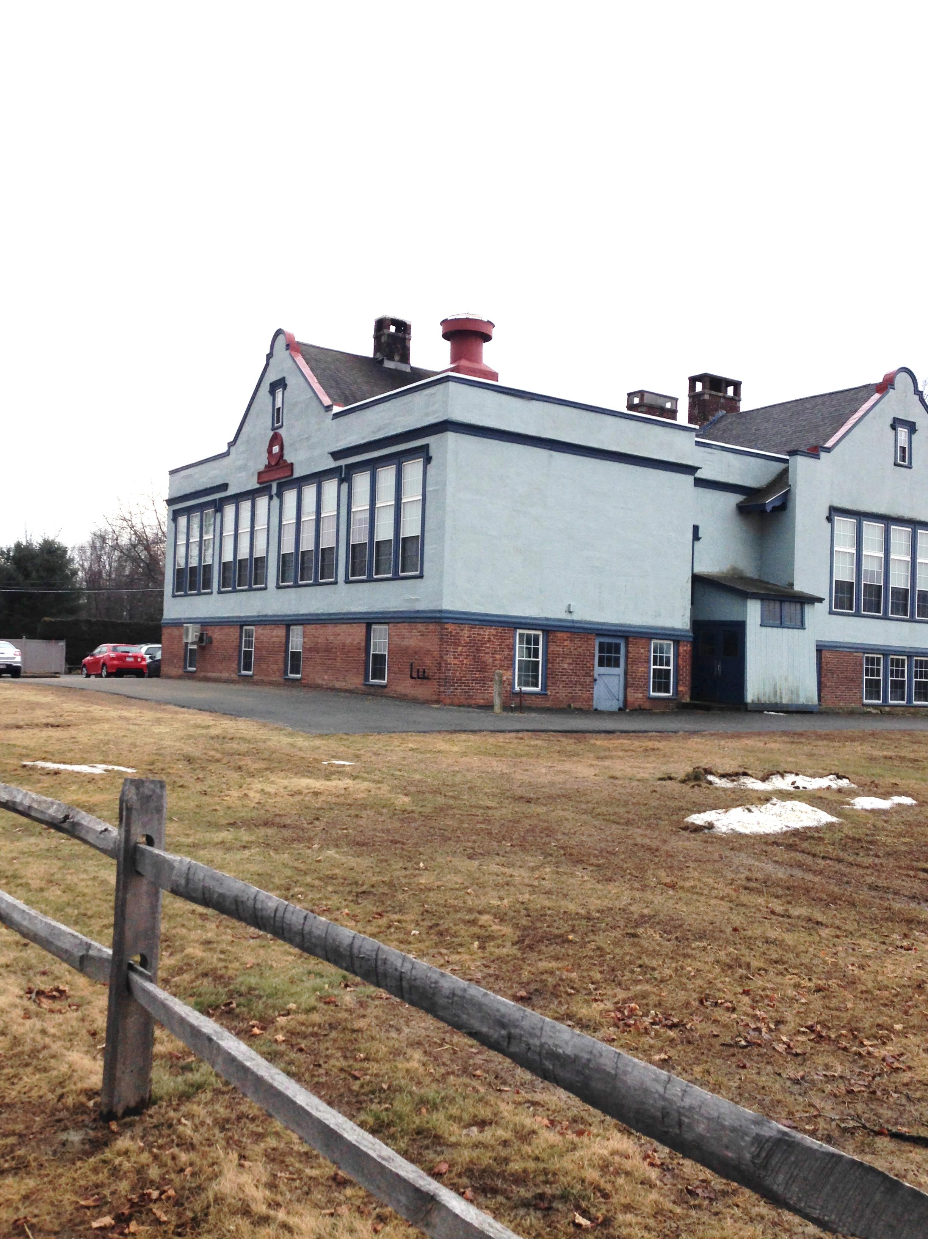

Prepared by:

Massachusetts Department of Public Health

Bureau of Environmental Health

Indoor Air Quality Program

April 2016

**BACKGROUND**

|  |  |
| --- | --- |
| **Building:** | Frontier Regional School District Administration Building |
| **Address:** | 219 Christian Ln RFD1, Whately, MA |
| **Assessment Requested by:** | Martha H. Barrett, Superintendent |
| **Reason for Request:** | Reports of respiratory problems in building |
| **Date of Assessment:** | February 25, 2016 |
| **Massachusetts Department of Public Health/Bureau of Environmental Health (MDPH/BEH) Staff Conducting Assessment:** | Mike Feeney, Director, Indoor Air Quality (IAQ) Program  Stephanie Santora, Administrative Assistant, IAQ Program  Brenda Netreba, Environmental Analyst, Community Assessment Program (CAP)  Melanie Jetter, Environmental Analyst, CAP |
| **Date Building Constructed:** | 1915 |
| **Building Description:** | Constructed as a brick and stucco schoolhouse |
| **Building Population:** | Approximately 15 employees |

# METHODS

Please refer to the IAQ Manual for methods, sampling procedures, and interpretation of results (MDPH, 2015).

# RESULTS and DISCUSSION

The following is a summary of indoor air testing results (Table 1).

* ***Carbon dioxide*** levels were below the MDPH recommended level of 800 parts per million (ppm) in all of the areas surveyed, with two exceptions; the After School Room and another basement room, indicating adequate air exchange in most of the building.
* ***Temperature*** was within the MDPH recommended range of 70°F to 78°F in all occupied areas surveyed.
* ***Relative humidity*** was below the MDPH recommended range of 40 to 60% in most areas tested.
* ***Carbon monoxide*** levels were non-detectable in all areas tested.
* ***Particulate matter (PM2.5)*** concentrations measured were below the National Ambient Air Quality (NAAQS) level of 35 μg/m3 in all areas tested.

## Ventilation

It is important to note that the building is not equipped with a functioning ventilation system. The original natural/gravity feed ventilation system has been abandoned, thus the sole source of ventilation in the building is openable windows. In addition, a number of areas were empty/sparsely populated at the time of the assessment; low occupancy can greatly reduce carbon dioxide levels. Carbon dioxide levels would be expected to increase with higher occupancy and windows closed.

Ventilation was originally provided by grated, louvered, wall vents (Picture 1). The wall vents are connected by a ventilation shaft to vault-like “air-mixing” rooms in the basement (Pictures 2 through 4). Air movement in such a system is provided by the stack effect. Heating elements located in the base of the ventilation shaft warm the air (Picture 3), which rises up the ventilation shaft. This system was designed to draw outside air into the air-mixing rooms through windows, which are currently kept closed. Although this system has been abandoned most of the ducts, shafts, and vents are still present, creating pathways for air to migrate between areas of the building.

As mentioned, ventilation is solely dependent on the use of openable windows. For cooling, an air conditioning system was installed. This system is designed to recirculate air in hot, humid weather and has no means to either introduce fresh air or exhaust air. Some work areas in the basement have neither vents nor openable windows.

Restrooms in the basement either do not have exhaust vents or the vents were not operating during the assessment. Odors in restrooms were noticeable, likely due to dry drain traps in the restroom floors. Wetted drain traps prevent gasses/odors in the drain system from entering the building. An operating restroom exhaust system is important to mechanically remove odors and water vapor.

## Furnace Exhaust Emissions

BEH/IAQ staff examined the basement and found an air mixing room directly below offices in the front of the building. The ceiling has two louvers that open to allow air to be drawn into the mixing room as part of the gravity ventilation system (Pictures 5 and 6). Of note, is a hinged door (Picture 7), which appears to open into the original furnace that remains abandoned in place (Picture 8). The current functional furnace appears to have a flue that is connected to the original chimney for the old furnace. If the connection between the old furnace and chimney were not properly disconnected, it is feasible that furnace exhaust may be penetrating the air mixing room located below the front offices. Furnace exhaust could then enter occupied space via the ceiling louvers. Exposure to products of combustion from oil burning furnaces is a significant source of respiratory irritants and carbon monoxide. It is highly recommended that the chimney be inspected and properly separated from the old furnace if not already done.

## Microbial/Moisture Concerns

A large number of records are stored in a below-grade carpeted area (Picture 9). Some parts of the building contain wall-to-wall carpet that is likely over 15 to 20 years old. The average lifespan of carpeting is approximately eleven years (Bishop, 2002). It was unclear if the building has a regular carpet cleaning program. The Institute of Inspection, Cleaning and Restoration Certification (IICRC), recommends that carpeting be cleaned annually (or semi-annually in soiled high traffic areas) (IICRC, 2012).

A significant musty odor exists in the records area, due to moistening of materials on the floor from condensation that occurs during hot and humid weather. The US Environmental Protection Agency (US EPA) and the American Conference of Governmental Industrial Hygienists (ACGIH) recommends that porous materials be dried with fans and heating within 24 to 48 hours of becoming wet (US EPA, 2008; ACGIH, 1989). If porous materials are not dried within this time frame, mold growth may occur.

Of note was the report of birds inside the building exhaust system. BEH/IAQ staff could not confirm if the rooftop vent in the front of the building has bird screens (Picture 10). However, it does appear that bird screens are missing from the rear air shafts (Picture 11). These shafts should be thoroughly evaluated to determine if bird roosting/wastes are present. Bird wastes and nesting materials warrant clean-up and appropriate disinfection.

Certain molds are associated with bird waste and are of concern for immuno-compromised individuals. Diseases of the respiratory tract may also result from exposure to bird waste. Exposure to bird wastes is thought to be associated with the development of hypersensitivity pneumonitis in some individuals. Psittacosis (bird fancier's disease) is another condition closely associated with exposure to bird wastes in bird raising and other occupational settings. While immune-compromised individuals have an increased risk of health impacts following exposure to the materials in bird wastes, these impacts may also occur in healthy individuals exposed to these materials.

The methods to be employed in clean-up of a bird waste problem depends on the amount of waste and the types of materials contaminated. The MDPH has been involved in several indoor air investigations where bird waste has accumulated within ventilation ductwork. Accumulation of bird wastes have required the clean-up of such buildings by a professional cleaning contractor. In less severe cases, the cleaning of the contaminated material with a solution of sodium hypochlorite has been an effective disinfectant (CDC, 1998). Disinfection of non-porous materials can be readily accomplished with sodium hypochlorite. Porous materials contaminated with bird waste should be examined by a professional restoration contractor to determine if the material is salvageable. Where a porous material has been colonized with mold or bacteria, it is recommended that the material be discarded (ACGIH, 1989).

The protection of both the cleaner and other occupants present in the building must be considered as part of the overall remedial plan. Where cleaning solutions are to be used, the “cleaner” is required to be trained in the use of personal protective methods and equipment (to prevent either the spread of disease from the bird wastes and/or exposure to cleaning chemicals). In addition, the method used to clean up bird waste may result in the aerosolization of particulates that can spread to occupied areas via openings (doors, etc.) or by the ventilation system. Methods to prevent the spread of bird waste particulates to occupied areas or into ventilation ducts must be employed. In these instances, the result can be similar to the spread of renovation-generated dusts and odors in occupied areas. To prevent this, the cleaner should employ the methods listed in the SMACNA *Guidelines for Containment of Renovation in Occupied Buildings* (SMACNA, 1995).

Plants were observed in several areas (Table 1). Plants can be a source of pollen and mold, which can be respiratory irritants to some individuals. Plants should be properly maintained, over-watering of plants should be avoided and drip pans should be inspected periodically for mold growth.

## Other IAQ Evaluations

Staff also report that the building was significantly impacted by wind-borne top soil from the farm immediately adjacent to the building (Picture 12). As described by building occupants, the dust forms a fine coating on surfaces inside the After School Program and window frames/sills with west-facing offices on the first floor. Top soil can contain a number of microorganisms (e.g., bacteria and mold), minerals, various pesticides used in farming, and vermiculite, all of which can be respiratory irritants.

## Health Concerns

At the request of the superintendent of the Frontier Regional and Union 38 School District, BEH staff from the Community Assessment Program (CAP) conducted in-person interviews with interested administration building employees at the time of the IAQ Assessment on February 26, 2016. The interviews included the administration of a questionnaire by BEH/CAP staff to obtain information on the type and frequency of symptoms experienced by some administration building employees. The questionnaire was closely modeled on surveys used previously by BEH as well as those used by the National Institute of Occupational Safety and Health (NIOSH) and the U.S. Environmental Protection Agency (US EPA). The questionnaire elicited information on specific symptoms that have been reported in the scientific/medical literature as commonly experienced by occupants of buildings with indoor air quality problems as well as information on perceived air quality and personal health factors. These types of questionnaires are used to systematically collect building-related health and environmental complaints. The information collected, in conjunction with the assessment of the indoor environment, can be used to evaluate possible associations between indoor air quality and health and to recommend appropriate follow-up, if warranted.

The administration building has an employee population of approximately 15 and seven individuals (46%) participated in the BEH interview. All responses were reviewed to identify the types of diseases and symptoms that were reported, their frequency of occurrence, and whether any unusual patterns emerged suggestive of a possible association with indoor environmental conditions in the administration building (Appendix A).

### Employee Interview Results

Information from the seven individuals is summarized below. Under both state and federal regulations, personally-identifying information shared by employees is confidential; therefore, the following discussion provides summary information only.

### Health Effects

The average age of the employees was approximately 56 years old and the average length of employment at the administration building at its current location was 9 years. Smoking status was obtained in the interviews due to the role of smoking in respiratory health. Among the 7 employees, four reported that they were current or former smokers, and three had never smoked.

The most commonly reported symptoms (with at least 4 of the 7 employees reporting that they experienced the symptom at least once in the four weeks prior to the interview) were: dry, itching, burning, watering or irritated eyes; stuffy or runny nose or sinus congestion not related to an infection; sore, hoarse or dry throat; skin irritation, dryness, redness or rash; headaches; and sneezing. Three of the seven employees also experienced pain or stiffness in their back, shoulders or neck; unusual tiredness, fatigue or drowsiness; and coughing at least once in the last four weeks. Respondents were asked if they experienced these symptoms primarily inside the building, outside the building, or both. Employees who reported experiencing the following conditions reported experiencing the symptoms primarily inside the building: sore, hoarse, or dry throat (7), a stuffy nose (5), eye irritation (4), headaches (4), sneezing (4), skin irritation (4), pain or stiffness in neck, shoulders or back (3), or coughing (3). Respondents were asked if there was a particular time of day or week when their symptoms became worse or occurred more frequently. Overall, there did not appear to be a consistent pattern among respondents with the most employees reporting no observable pattern.

Concerned employees were also asked if they had been diagnosed by a doctor with any of the following conditions: asthma, eczema, hay fever, or migraine headaches. Of the 7 participating employees, two reported being diagnosed with asthma, two with eczema, and one with hay fever. The majority of the individuals with a reported diagnosis of asthma, hay fever or eczema reported to MDPH that they had been diagnosed with their condition prior to working at the school administration building.

### Building Concerns

BEH/CAP also asked the administration building employees several questions about their perceptions of environmental conditions in their work surroundings. The most commonly reported conditions as reported by at least 4 of the 7 interviewees were as follows:

* Unusual dust (5)
* Moldy odors (5)
* Air was too dry (5)
* Air was too stuffy (5)
* Indoor air temperatures were too cold (5)
* Indoor air temperatures that are too hot (4)

A few participants mentioned concerns about furnace smell and mice and bats inside of the building.

Employees who participated in the interviews were asked if they had any other health or building related concerns at the Frontier Regional and Union 38 School District Administration Building that had not yet been discussed. Five participants described the presence of mold in the basement offices and storage areas. Two of the five employees experienced skin irritation, dryness or rash when in direct contact with the mold. Four participants shared concerns about sewage odors from the bathrooms during septic system backups that permeated from the bathrooms in the basement up throughout the building. Three participants shared concerns about inhaling dust particles from nearby agricultural fields, believed to consist of tobacco and potato farms. Participants described situations on windy days where dust particles blow against the building, and accumulate on the inside window sill. On windy days, symptoms such as coughing, sneezing, and irritated, itchy eyes appear to worsen.

### Symptomology and Building Location

The locations where individuals reported working in the building and their health concerns were evaluated with respect to the results from the environmental testing conducted by BEH/IAQ staff. All seven employees reported that there were specific locations within the administration building where they spend the majority of their time. Four individuals reported working primarily in one location throughout the course of a given day. Three individuals reported having two or more locations they frequented throughout the typical workday.

### Health Discussion

The respiratory/irritant and other symptoms reported among participants in this health investigation are generally those most commonly experienced in buildings with indoor air quality problems. These included stuffy or runny nose or sinus congestion not related to an infection; sore, hoarse or dry throat; headaches; unusual tiredness, fatigue or drowsiness; and itchy, runny, or watery eyes; and coughing. Such symptoms are commonly associated with ventilation problems in buildings, although other factors (e.g., odors, microbiological contamination) may also contribute (Passarelli, 2009; Norbäck, 2009; Burge, 2004; Stolwijk, 1991).

Results from environmental sampling indicate a number of opportunities for exposure to allergens, i.e., mold growth from water damage and dust. Given that exposure to excessive dust and mold can exacerbate pre-existing symptoms (e.g., asthma, allergies) and promote skin irritation, it is possible that some individuals may be reacting to mold and excessive dust differently than the general population. Allergic responses include hay fever type symptoms such as runny nose and red eyes. It is important to note that the onset of allergic reaction to triggers such as mold/moisture can be either immediate or delayed.

### Other Health Concerns

As mentioned previously, employees who participated in the interviews were concerned about inhaling dust particles treated with pesticides from the nearby agricultural fields that enters the building on windy days. In general, pesticides can be sources of eye, nose, and throat irritation.

# CONCLUSIONS/RECOMMENDATIONS

A number of building conditions, described in the report, may contribute to respiratory symptoms. These conditions/issues combined with a lack of a mechanical ventilation system to filter air can play a role in causing and/or exacerbating respiratory symptoms described by building occupants. Based on conditions observed at the time of assessment, the following recommendations are provided.

1. Determine if: a) the current operating furnace is properly connected and venting from the building, and b) if the original furnace is still connected to the chimney. The old furnace should be disconnected from the chimney completely, in order to prevent products of combustion from entering occupied space.
2. Permanently seal/render airtight the louvers in the ceiling shown in Picture 5.
3. Permanently seal the furnace door shown in Picture 7.
4. Install carbon monoxide detectors in each occupied level of the building.
5. Install bird screens on all ventilation shafts and vents. Have the airshafts properly cleaned/of bird waste as needed.
6. Remove carpeting from the records room. Carpeting in below grade spaces is *not* recommended due to the likely generation of condensation during hot, humid weather on a basement floor/foundation that is not insulated.
7. Occupied areas should have either a mechanical ventilation system or opening windows. Consideration should be given to relocating work areas with vents or windows.
8. For buildings in New England, periods of low relative humidity during the winter are often unavoidable. Therefore, scrupulous cleaning practices should be adopted to minimize common indoor air contaminants whose irritant effects can be enhanced when the relative humidity is low.
9. Use a vacuum cleaner equipped with a high efficiency particulate arrestance (HEPA) filter in conjunction with wet wiping to remove dust from all surfaces. Avoid the use of feather dusters.
10. Windows in occupied spaces cannot be sealed to prevent topsoil from entering the building since windows are the sole source of fresh air for occupied spaces. Methods to reduce the amount of airborne dust should include dust control measures (e.g., by the farm). If not obtainable, the installation of a covered chain link fence of sufficient height to intercept windblown topsoil is recommended.
11. Consider reducing the number of plants. Indoor plants should be properly maintained and equipped with drip pans to prevent water damage to porous building materials and be located away from ventilation sources to prevent the aerosolization of dirt, pollen or mold.
12. Drinking water during the day can help ease some symptoms associated with a dry environment (throat and sinus irritations).
13. Refer to resource manual and other related indoor air quality documents located on the MDPH’s website for further building-wide evaluations and advice on maintaining public buildings. These documents are available at <http://mass.gov/dph/iaq>.

ATSDR Disclaimer language: *This report was supported in part by funds provided through a cooperative agreement with the Agency for Toxic Substances and Disease Registry, U.S. Department of Health and Human Services. The findings and conclusions in these reports are those of the author(s) and do not necessarily represent the views of the Agency for Toxic Substances and Disease Registry or the U.S. Department of Health and Human Services. This document has not been revised or edited to conform to agency standards.*

# REFERENCES

ACGIH. 1989. Guidelines for the Assessment of Bioaerosols in the Indoor Environment. American Conference of Governmental Industrial Hygienists, Cincinnati, OH.

Bishop, J. 2002. Institute of Inspection, Cleaning and Restoration Certification.: A Life Cycle Cost Analysis for Floor Coverings in School Facilities.

Burge, PS. 2004. Sick building syndrome. Occupational and Environmental Medicine 61:185 190.

CDC. 1998. Compendium of Measures to Control Chlamydia psittaci Infection Among Human (Psittacosis and Pet Bats (Avian Chlamydiosis), 1998. *MMWR 47:RR-10. July 10, 1998.*

IICRC. 2012. Institute of Inspection, Cleaning and Restoration Certification. Carpet Cleaning: FAQ. Retrieved from http://www.iicrc.org/consumers/care/carpet-cleaning/#faq.

MDPH. 2015. Massachusetts Department of Public Health. “Indoor Air Quality Manual: Chapters I-III”. Available from [http://www.mass.gov/eohhs/gov/departments/dph/programs/environmental-health/exposure-topics/iaq/iaq-manual/](http://www.mass.gov/eohhs/gov/departments/dph/programs/environmental-health/exposure-topics/iaq/iaq-manual/" \o "MDPH.  2015.  Massachusetts Department of Public Health.  \“Indoor Air Quality Manual: Chapters I-III\”)

Norbäck, D. 2009. An update on sick building syndrome. Current Opinion in Allergy and Immunology 9:55-59.

Passarelli, GR. 2009. Sick building syndrome: an overview to raise awareness. Journal of Building Appraisal 5(1):55-66.

SMACNA. 1995. IAQ Guidelines for Occupied Buildings Under Construction. 1st ed. Sheet Metal and Air Conditioning Contractors’ National Association, Inc., Chantilly, VA.

Stolwijk, J. 1991. Sick-building syndrome. Environmental Health Perspectives 95:99-100

US EPA. 2008. Mold Remediation in Schools and Commercial Buildings. US Environmental Protection Agency, Office of Air and Radiation, Indoor Environments Division, Washington, D.C. EPA 402-K-01-001. <http://www.epa.gov/mold/mold-remediation-schools-and-commercial-buildings-guide>.

**Picture 1**

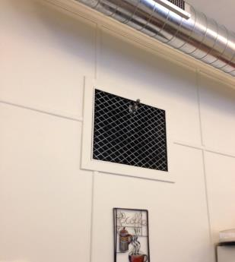

**Vents to original ventilation system**

**Picture 2**

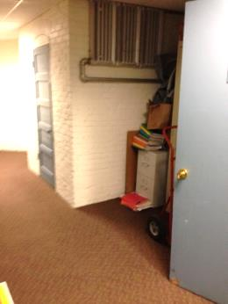

**Air mixing room**

**Picture 3**

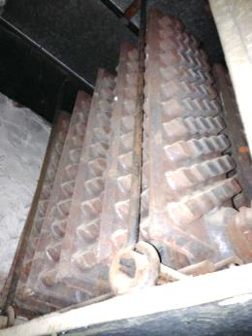

**Heating element at base of fresh air supply**

**Picture 4**

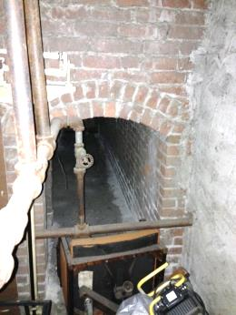

**Base of return vent connected to rooftop air shafts**

**Picture 5**

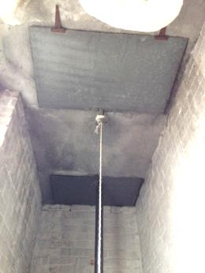

**Louver in ceiling beneath offices in the front of the building**

**Picture 6**

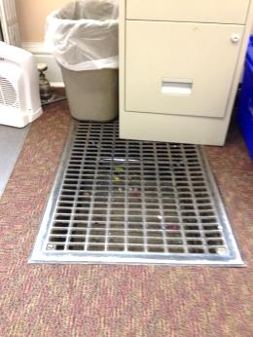

**Open louver in floor of office**

**Picture 7**

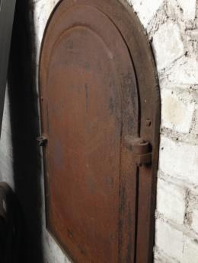

**Door that opens into the original furnace**

**Picture 8**

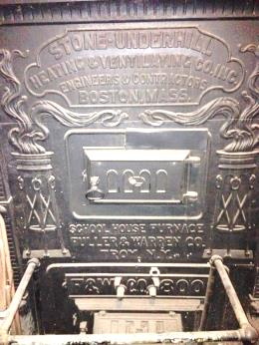

**Original furnace in basement**

**Picture 9**

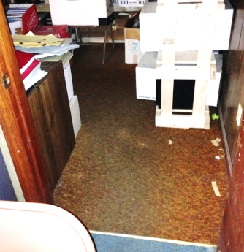

**Records room in basement with carpet**

**Picture 10**

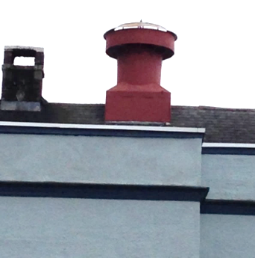

**Airshaft at front of building**

**Picture 11**

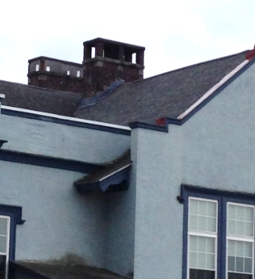

**Airshaft at rear of the building, one missing bird screens (arrow)**

**Picture 12**

**Topsoil on stairs inside after school room
Photo taken by Frontier Regional School District personnel on February 24, 2016
**

**Topsoil on stairs inside after school room**

**Photo taken by Frontier Regional School District personnel on February 24, 2016**

| **Location** | **Carbon**  **Dioxide**  **(ppm)** | **Carbon Monoxide**  **(ppm)** | **Temp**  **(°F)** | **Relative**  **Humidity**  **(%)** | **PM2.5**  **(µg/m3)** | **Occupants**  **in Room** | **Windows**  **Openable** | **Ventilation** | | **Remarks** |
| --- | --- | --- | --- | --- | --- | --- | --- | --- | --- | --- |
| **Supply** | **Exhaust** |
| Outside | 460 | ND | 59 | 42 | 2 |  |  |  |  | Breezy, sunny |
| Main Lobby | 718 | ND | 73 | 29 | 5 | 1 | N | N | N | Carpet |
| Elementary Curriculum Dir Off | 744 | ND | 74 | 29 | 5 | 0 | Y | N | N | Carpet |
| Superintendent Office | 760 | ND | 73 | 30 | 5 | 1 | Y | N | N | Carpet, plants, open duct vent |
| Special Education Office | 721 | ND | 73 | 30 | 6 | 0 | Y | N | N | Carpet, PC |
| Business Manager Office | 633 | ND | 71 | 40 | 6 | 0 | Y | N | N | Carpet, Plants, PC |
| Bookkeeper Office | 686 | ND | 73 | 37 | 5 | 2 | Y | N | N | Carpet, Plants, PC (4) |
| Administrative Assistant Office | 675 | ND | 73 | 38 | 5 | 2 | Y | N | N | Carpet, Plants (13), PC (2) |
| Kitchen | 705 | ND | 72 | 42 | 6 | 1 | Y | N | N | Fax, fridge, microwave, coffee maker (2), PC (3), stove, open duct vent |
| Attic | 490 | ND | 60 | 55 | 16 | 0 | Y | N | N |  |
| Basement (Bottom of Stairwell) | 623 | ND | 73 | 29 | 6 | 0 | N | N | N | Carpet |
| Basement (After School Room) | 802 | ND | 72 | 29 | 6 | 3 | Y | N | N | Carpet, plants, PC (4), fridge, microwave, exterior door duct-taped along edges |
| Basement (1st rm at bottom of stairwell) | 801 | ND | 74 | 29 | 8 | 0 | N | N | N | Carpet |
| Basement (file room) | 659 | ND | 73 | 29 | 5 | 0 | N | N | N | Carpet |
| Basement (Boiler room) | 647 | ND | 72 | 29 | 6 | 0 | N | N | N |  |
| Basement (Bathroom 1) |  |  |  |  |  |  | N | N | N |  |
| Basement (Bathroom 2) |  |  |  |  |  |  | Y |  |  | Floor drain, ceiling light/fan, window |