

CHAPTER VIII:

WHEN THERE ARE SICK

FOOD EMPLOYEES

## IMPORTANT RESOURCES

**Food Protection Program: 617-983-6712**

For policy and technical assistance with the environmental investigation such as conducting a HACCP risk assessment, initiating enforcement actions and collecting food samples. On-site investigation assistance is often available for larger outbreaks.

**Epidemiology Program: 617-983-6800**

For technical assistance with the epidemiologic investigation such as obtaining medical histories, coordinating stool specimen submissions and developing questionnaires. On-site investigation assistance is often available for larger outbreaks.

**State Public Health Laboratory: 617-983-6616**

For technical assistance with the collection protocol for food and enteric specimens.

Updated February, 2019

# A. Local Board of Health Responsibility

As stated in Chapter IV, the local board of health (LBOH) may be notified by the Massachusetts Department of Public Health (MDPH) through the Massachusetts Virtual Epidemiologic Network (MAVEN), or through a fax or phone call, that there is a case of foodborne illness in its community. Through follow-up of the case, it may be learned that the ill individual is a food employee. The presence of sick food employees may also be learned through a regular or outbreak environmental investigation as described in Chapter VII. Whatever the source of the information, it is a priority and should be investigated within 24 to 48 hours of notification. Depending on the LBOH’s staffing in your jurisdiction, a health agent, public health nurse or food inspector will take the lead on the investigation.

Infected food employees can be a significant contributing factor in foodborne illness outbreaks. Fecal-oral transmission by food employees with gastrointestinal symptoms such as nausea, abdominal cramps, vomiting and diarrhea is possible since pathogens can be shed during illness, as well as after symptoms resolve. In some cases, such as with norovirus infection, viral particles can even be shed before symptoms begin. Infected skin lesions on food employees may also be reservoirs of pathogens, such as *Staphylococcus aureus*, which can be transmitted to food when there is direct contact between the food and the infected lesion.

Both *105 CMR 590.000: Minimum Sanitation Standards for Food Establishments* in the *Employee Health* sectionand *105 CMR 300.000: Summary of Reportable Disease, Surveillance, and Isolation and Quarantine Requirements* give legal authority to the LBOH. The LBOH is required to act promptly to see that ill food employees are not continuing to work once a food service establishment is notified that one of its employees could be carrying a communicable disease. Under the federal and MA Food Codes, this requires working closely with the Person-in-Charge (PIC) at the food service establishment. Voluntary compliance from establishments and food employees is expected, but suspension and closure of the establishment, and/or restriction and exclusion of employees are tools used by the LBOH to gain this compliance.

Timely interventions are essential when dealing with ill food employees. Precautionary actions, specific to the disease agent involved, must be taken, and in some cases, rapid public notification must also be implemented. **LBOHs should never hesitate to call MDPH staff for assistance!**

# B. Definition of a Food Employee

As stated in 105 CMR 590.000, a "food employee means an individual working with unpackaged food, food equipment or utensils, or food-contact surfaces. This could include the owner, individual having supervisory or management duties, person on the payroll, family member, volunteer, person performing work under contractual agreement, or any other person working in a food establishment. In health care facilities, this includes those who set up trays for patients to eat, feed or assist patients in eating, give oral medications or give mouth/denture care. In day care operations, schools and long-term care facilities, which are licensed food establishments, this includes those who prepare food for clients to eat, feed or assist clients in eating or give oral medications." In other words, if one is inspecting a food service establishment, or following up on a foodborne illness complaint, anyone in the facility handling food is a "food employee." This is an expanded definition from the Federal Food Code. This definition is very similar to the one found in 105 CMR 300.000.

Under the current Food Code, it is the responsibility of the PIC to make sure that food employees are reporting to the PIC symptoms of illness, a diagnosis of illness and exposures to foodborne diseases. During every inspection, but especially during a foodborne illness investigation, an interview with the PIC is extremely important.

Questions to ask:

1. Are any food employees not at work due to illness?
2. Have any food employees reported symptoms of illness?
3. Have any food employees reported exposure to any foodborne illnesses?
4. Have you excluded/restricted any employees within the timeframe of the foodborne illness complaint, if it is a complaint investigation?
5. Have there been any diarrheal or vomiting incidents at the food service establishment within the timeframe of the foodborne illness complaint?

# C. What to Do If You Discover an Ill Food Employee?

**1. Confirm the illness.** Whenever a food employee is reported to have a disease capable of being spread through food, the diagnosis and/or symptomatology should be confirmed immediately. If the initial report is received from a health care provider, confirmatory laboratory tests from an approved laboratory should be requested. If laboratory results are negative for common enteric pathogens (i.e., *Salmonella*, *Shigella*, *Campylobacter*, *Giardia*, *Cryptosporidium*, *E. coli* O157:H7) symptoms should be confirmed with the health care provider and be compatible with a communicable enteric illness. The LBOH may be responding to a report already received through MAVEN and confirmatory lab results may already be a part of that report. If not, an Enteric Disease Reporting Form (Attachment 4-2 at the end of Chapter IV) should be started in MAVEN or a hard copy faxed to MDPH.

**2. Exclude/Restrict the Food Employee.** *105 CMR 300.000* and *105 CMR 590.000* are the official documents describing exclusion and restriction requirements for ill employees. Attachment 8-1 *Employee Health Guidance Document* at the end of this chapter is offered as an aid to understanding the requirements for both food inspectors and the PIC.

**3. Identify and Dispose of Food Contaminated by the Infected Food Employee.** Collect specific information about the food employee's duties and responsibilities at the food service establishment. Determine if food on the premises prepared or served by the ill food employee should be discarded based on: hygienic practices observed, foods handled, and method of preparation. Be specific as to food handled and dates on which it was handled for the entire time the food employee was symptomatic while working. The exception to that rule is a person with hepatitis A virus (HAV). The infectious period for HAV is two weeks prior to onset of symptoms and up to one week after onset.

Figure 8-1: Questions to Ask Employee and/or PIC

* 1. What dates did the employee work while he/she was symptomatic?
  2. What specific foods were touched by the employee's bare hands and not subsequently cooked prior to service?
  3. Does the food employee wash his/her hands after using the bathroom?
  4. Does the food employee wash his/her hands as necessary during the day?
  5. Does the food employee use disposable gloves? Properly?

**Foods which may have become contaminated by an infected food employee should be**

**embargoed or disposed of in accordance with 105 CMR 590.000.**

**4. Interview and Educate Other Food Employees.** Other food employees in the food service establishment should be interviewed about their health status and, if symptomatic, should be excluded by the PIC. Employees reporting symptoms should be referred to their physicians or offered testing kits to confirm other possible cases. Providing the food employees with a letter explaining the situation to the physician and requesting enteric testing is extremely helpful in acquiring the desired results. A sample letter is included in the attachments to this chapter. Education on the symptoms, mode of transmission and prevention for the pathogen, if known, or enteric pathogens in general, should be done. Fact sheets, available online from MDPH, should be distributed to all food employees. Be sure to inquire about food employees not at work during the interview time. Work with the PIC to make sure that all food employees receive the necessary interview, educational materials, testing kits, and exclusion/restriction orders. See Attachment 8-2: Handwashing Education Poster at the end of this chapter that can be distributed to the food service establishment.

**5. Testing all Food Employees in Outbreak Situations.** In an outbreak situation, all **symptomatic and asymptomatic** employees must submit a stool specimen within 24 to 48 hours. This is to ensure the removal of a food employee who may be a continuous source of contamination. In addition, it may help to determine the etiologic agent that is causing the outbreak, if that is not already known, or the extent of the outbreak among the food employees. The Massachusetts State Public Health Laboratory (SPHL) will test stool specimens for pathogens in question free of charge. Enteric kits are available from MDPH and should be distributed to the employees. Alternatively, testing can be done at any accredited laboratory but will most likely involve a cost to either the food employee or the establishment. Positive isolates must be cultured and submitted to the SPHL. Accredited laboratories in Massachusetts should be aware of this requirement. Food employees who fail to submit stool specimens within 24 to 48 hours must be restricted from work until they comply. A sample letter that can be used by LBOHs to request employee submission of stool specimens is Attachment 8-3 at the end of this chapter. The LBOH should coordinate with the SPHL as described in Chapter IX.

**6. If Applicable, Notify the Public.** When a public notice is anticipated, such as in a HAV exposure, food preparation facilities and the medical community must be notified in order to be prepared to respond. A sample public notice and press release is provided as Attachment 8-4 and 8-5 at the end of this chapter. All public inquiries should be directed to the LBOH, the Epidemiology Program or the Food Protection Program (FPP).

# D. Specific Disease Control Measures

Information below is outlined in the "Employee Health Guidance Document," found at the end of this chapter. That document was designed to assist LBOHs working with the food establishment's Person-in-Charge (PIC) to clarify the requirements of the 2013 Federal Food Code and 105 CMR 590.000, the Massachusetts Food Code. In many instances, the reinstatement requirements are, not only different in 590.000, but 105 CMR 300.000, "Reportable Diseases, Surveillance and Isolation and Quarantine Requirements,” actually takes precedence. LBOHs are encouraged to call the FPP or the Epidemiology Program to discuss particular situations. Both the information below, and the guidance document, focuses on the primary ill person, and exclusions and restrictions, as well as reinstatement, are based on 105 CMR 300.000. Minimum periods of quarantine for **contacts** of the ill person are described in 105 CMR 300.000. Massachusetts also recognizes other diseases that can be transmitted through food, such as *Campylobacter* spp., *Giardia* *lamblia*, *Yersinia*, *Vibrio* spp. and others. There are specific isolation and quarantine requirements for them in 105 CMR 300.000. LBOHs who become aware of ill food employees in a food establishment with diseases that may be transmitted through food should consult with the FPP or Epidemiology Program immediately.

**Norovirus:** Nausea and vomiting are common symptoms of norovirus. Food employees who experience nausea and vomiting should be excluded from food handling duties unless it can be determined that their symptoms are from a non-infectious cause. Food employees who are diagnosed with norovirus must be excluded from food handling duties for either 72 hours past the resolution of symptoms or 72 hours past the date the specimen positive for norovirus was produced, whichever occurs last. Contacts of norovirus cases who are food employees and have diarrhea or vomiting shall be excluded from food handling duties for 72 hours past the resolution of symptoms. Again, laboratories in Massachusetts are aware that positive norovirus specimens must be sent to the State Public Health Laboratory for genotyping.

**Shiga toxin-producing *E. coli*:** Food employees diagnosed with Shiga toxin-producing *E. coli* must be excluded. They can be reinstated after diarrhea has resolved AND there is medical documentation of two consecutive negative stool specimens, taken 48 hours after antibiotic therapy has been completed, and taken 24 hours apart.

***S*. Typhi (Typhoid Fever):** Food employees with a diagnosis of Typhoid Fever must be excluded from the food establishment.They may only be reinstated with medical documentation of three consecutive negative stool specimens, starting one month after symptoms started, 48 hours after antibiotic therapy has been completed, and taken 48 hours apart.

***Shigella* spp.:** Food employees with a diagnosis of *Shigella* spp. must be excluded from the food establishment. They may be reinstated when symptoms have resolved AND there is medical documentation of two consecutive negative stool specimens, 48 hours after antibiotic therapy has been completed, and taken 24 hours apart.

**Non-typhoidal *Salmonella*:** Food employees with a diagnosis of non-typhoidal *Salmonella* must be excluded from the food establishment. They may be reinstated when symptoms have resolved AND there is medical documentation of two negative stool specimen, taken 48 hours after antibiotic therapy has been completed. In outbreak circumstances, two consecutive negative stool specimens are required, taken 24 hours apart.

**Hepatitis A:** Detailed information on HAV is explained in Section E. below.

# E. HAV Control Measures

Reports of HAV cases require immediate action. A confirmed case of HAV in a food employee is a serious event and requires that the risk for both co-workers and the public be assessed as quickly as possible.

Since the incubation period for HAV can be as long as 50 days, a prevention measure is available for those who might have been exposed. Immune globulin (IG) or HAV vaccine, if administered appropriately, within two weeks of exposure, can provide protection and is effective in preventing the illness completely or lessening the severity. (Please see below for more information on IG and hepatitis A vaccine.) This is particularly important when trying to prevent further cases among co-workers of a positive food employee. The sooner IG or vaccine is given, the more effective it is in preventing infection. **Food employees who can provide documentation that they have had hepatitis A in the past or are immunized against hepatitis A will not need to receive IG or another dose of vaccine, nor be restricted.**

The infectious period, hygiene, work habits, foods prepared, methods of food preparation and symptoms of the positive employee can help to determine the likelihood that consumers were exposed to contaminated food. If the risk is considered high, based on established criteria, efforts must be made to find those consumers and advise them to be evaluated for preventive treatment, i.e. the administration of IG or vaccine.

There are two methods for post-exposure prophylaxis (PEP) for HAV: single antigen HAV vaccine and immunoglobulin (IG). These two methods are used to manage different situations.

1) For healthy persons aged 12 months–40 years, single-antigen hepatitis A vaccine at the age-appropriate dose is preferred to IG because of vaccine advantages, including long-term protection and ease of administration, and the equivalent efficacy of vaccine to IG.

2) For persons aged >40 years, IG is preferred because of the absence of information regarding vaccine performance in this age group and because of the more severe manifestations of hepatitis A in older adults. Vaccine can be used if IG cannot be obtained. The magnitude of the risk of HAV transmission from the exposure should be considered in decisions to use vaccine or IG in this age group.

3) For children aged <12 months and persons for whom vaccine is contraindicated, IG should be used.

4) For persons > 12months, immunocompromised persons, and persons with chronic liver disease, IG should be used. (However, both IG and hepatitis A vaccine can be used for these persons, based on clinical judgment.)

IG provides protection against HAV through passive transfer of antibody. When administered within 14 days of exposure to an infectious case, IG is 80-90% effective in preventing symptomatic infection. IG only provides protection for 3-5 months.

The performance of HAV vaccine, when administered within 14 days after exposure, approaches that of IG in healthy children and adults aged 2–40 years. Because older adults and persons with certain medical conditions were not included in the study, the findings might not be generalizable to all populations and settings. People receiving HAV vaccine will need to receive a second dose at least six months following the first to ensure long-term immunity.

**(For additional information, please see the MMWR on updated recommendations**

**of the** [**Advisory Committee on Immunization Practices (ACIP)**](http://www.cdc.gov/mmwr/preview/mmwrhtml/mm5641a3.htm?s_cid=mm5641a3_e)

**and the** [**CDC website**](http://www.cdc.gov/vaccines/vpd-vac/hepa/default.htm)**.)**

A *Hepatitis Case Report Form* must be completed by the LBOH on paper or via MAVEN if not previously reported or entered into the system.

# F. Recommended Procedure for Hepatitis A Suspect Case Investigation

**1. Confirm the Case.** The confirmation of hepatitis A requires serologic testing to detect antibodies against hepatitis A virus (HAV) which are anti-HAV. The antibody response to HAV consists initially of the IgM class antibody which usually becomes detectable at the time of illness, approximately 30-days post-exposure. Therefore, the presence of IgM is associated with active or recent HAV infection. **An IgM anti-HAV positive test is necessary to confirm an active or recent HAV infection.** The appearance of the IgG class of anti-HAV follows the IgM response by several weeks. IgG antibody to HAV persists for life in most cases.

Some laboratories first test for the presence of total antibody against HAV (i.e., IgM and IgG combined) and then test further for IgM if this test is positive. Some laboratories only test for IgM antibodies.

Figure 8-2: Results Possible When Testing for Antibody Against HAV

* 1. Total antibody negative = no evidence of HAV infection = susceptible.
  2. Total antibody positive and IgM negative = prior infection with HAV, possibly years ago, or immunized, currently immune, not an active case, not infectious.
  3. Total antibody positive and IgM positive = a case of active hepatitis A, recent infection and possibly infectious, follow-up is necessary.

Occasionally, a laboratory will report a HAV serology as "IgM and IgG positive." Although this wording can be confusing, it usually indicates that the specimen was total antibody positive. One should always confirm that a specific test for IgM anti-HAV was performed and that it was positive.

**2. Determine the Period of Infectivity.** Fecal shedding of the virus peaks during the weeks prior to onset of symptoms. For purposes of public health intervention, a patient should be considered to be infectious for 14 days prior to the onset of symptoms to seven days after onset of symptoms. If reported symptoms are vague and jaundice was present, use the date when jaundice was first noticed. If no symptoms were noted, the date the blood was drawn should be used in place of a date of onset.

**3. Report to MDPH.** Notify MDPH, Epidemiology Program, at 617-983-6800 as soon as you hear of a suspect/confirmed hepatitis A case in a food employee.

**4. Exclude the Food Employee.** No food employee may return to work until all symptoms have subsided AND at least one week has passed since symptom onset.

**5. Inspect the Food Establishment.** The food establishment inspection should involve the following:

* Focus on handwashing practices and restroom facilities, the types of foods and beverages that are served, and how these foods and beverages are handled.
* Obtain a very careful history of which days and shifts the infected person worked, exact duties, types of food handled, any use of disposable gloves, as well as an assessment of the employee's hygiene. Inquire about tasks performed by the infected employee during his/her infectious period which may have differed from normal job duties. Ascertain if food prepared on shift is carried over to the next shift or to the next day. Determine if other employees eat food prepared by the index case. Ask the case whether she/he worked while symptomatic with diarrhea or vomiting; if so, note the dates on which this occurred. Ask the case if he/she is a food employee at any other establishments.
* Institute rigorous handwashing and ensure that there is no bare-hand contact with ready-to-eat foods, including foods served raw or handled after the cooking process. High risk foods include, but are not limited to: lettuce, tomatoes and other vegetables put on sandwiches; ingredients of all salads, including fruits and vegetables on salad bars; sliced cooked foods which may become contaminated during deboning or slicing procedures; handling of cold cuts; cake icing or decorations; ice that is scooped by hand or with a possibly contaminated scoop; and condiments for drinks such as olives, lime or lemon wedges.
* Ensure that the ill food employee is excluded according to *105 CMR 300.000* Isolation and Quarantine Requirements.
* Obtain a complete list of all employees. Survey other employees for symptoms consistent with hepatitis A. If other employees are symptomatic, they should also be excluded from work and tested for hepatitis A.

**6. Immunize Contacts with Hepatitis A Vaccine or IG.** HAV can be transmitted by food contaminated with feces from an infected food employee. When a food employee has been diagnosed with hepatitis A, other food employees working with that infected person, must receive hepatitis A vaccine or immune globulin if they are susceptible individuals. It needs to be administered within 14 days after exposure to HAV or it is not likely to prevent secondary cases.

The LBOH must ensure that other employees receive vaccine or IG. If an employee elects not to receive the vaccine or IG, the employee must be excluded from working for 28 days according to *105 CMR 300.000.* The exception to this exclusion is if documentation of HAV vaccination can be produced or serologic immunity to HAV demonstrated.

**7. Assess the Likelihood of Transmission to the Patrons of the Food Establishment.** A determination should be made whether or not there is a sufficient risk of HAV transmission to the public to warrant notification of the establishment's patrons. Hepatitis A vaccine or IG administration to patrons is usually not recommended, but should be considered if the following conditions exist:

* The infected person is directly involved in handling, without gloves, foods that will not be cooked before eaten;
* The infected person is assessed to have less than adequate personal hygiene OR worked while symptomatic with diarrhea; and
* Patrons can be identified and provided vaccine or IG within two weeks of exposure. In settings where repeated exposures to HAV may have occurred, such as institutional settings, stronger consideration of vaccine or IG use may be warranted.

**8. If Applicable, Notify the Public.** If it is determined that patrons would benefit from IG administration, the LBOH will be involved in posting public notices, issuing press releases and/or holding press conferences to identify and inform patrons at risk. The LBOH should consult with MDPH regarding whether a public clinic to administer vaccine is necessary. Obtaining vaccine or IG for use in a public clinic will also need to be part of the discussion between the LBOH and MDPH. IG is no longer manufactured by MDPH and can be difficult to obtain. In most cases, however, exposed individuals are referred to their health care provider for preventive treatment. A sample public notice (Attachment 8-4) and press release (Attachment 8-5) can be found at the end of this chapter.

**9. Maintain Surveillance.** The PIC of the establishment should monitor employees daily for the presence of signs and symptoms of hepatitis A, including nausea, vomiting, diarrhea, abdominal pain, fever and jaundice. If symptoms appear in other employees, they should be excluded from work until they have been evaluated by their health care provider and tested for hepatitis A. This monitoring should continue for 50 days past the last day that the food employee worked while infectious. The LBOH should also visit the establishment during this time to confirm compliance with all recommended control measures.

**10. Take Steps for Prevention.** As stated previously in this chapter regarding communicable diseases, the establishment food employees should be educated about the disease, its signs and symptoms and the importance of not working while ill. The education should also include the importance of good hygiene, such as frequent hand-washing and no bare-hand contact with ready-to-eat foods. The Federal Food Code does allow bare-hand-contact in some very specific situations, but the MDPH FPP has maintained its stricter guideline of no bare-hand-contact of ready-to-eat food precisely due to the risks associated with the practice.

# G. Hepatitis A Vaccine

Hepatitis A vaccination provides pre-exposure protection against HAV infections, and is recommended for persons who are at increased risk for infection and for any person wishing to attain immunity. The populations at increased risk for HAV infection or the adverse consequences of infection are:

* + Persons traveling to or working in countries that have high or intermediate prevalence of infection;
  + Children in communities that have high rates of hepatitis A and periodic hepatitis A outbreaks;
  + Men who have sex with men
  + Illegal-drug users;
  + Persons who have occupational risk for infection;
  + Persons who have chronic liver disease;
  + Persons who have clotting-factor disorders; and other groups under consideration.

# References:

Council to Improve Foodborne Outbreak Response (CIFOR). Guidelines for Foodborne Disease Outbreak Response. 2nd edition. Atlanta: Council of State and Territorial Epidemiologists; 2014.

Food and Drug Administration. Bad Bug Book, Foodborne Pathogenic Microorganisms and Natural Toxins. Second Edition. (Appendix 5) 2012. https://www.fda.gov/downloads/Food/FoodborneIllnessContaminants

/UCM297627.pdf

Summary of Reportable Diseases, Surveillance, and Isolation and Quarantine

Requirements, extracted from 105 CMR 300.000:

<http://www.mass.gov/eohhs/docs/dph/cdc/reporting/rdiq-reg-summary.pdf>

# Attachments:

Attachment 8-1: Employee Health Guidance Document

Attachment 8-2: Handwashing Educational Poster

Attachment 8-3: Sample Order Letter for Submission of Stool Sample

Attachment 8-4: Sample Public Notice

Attachment 8-5: Sample Press Release

Attachment 8-6: Hepatitis A Report Form

Attachment 8-7: Vomiting and Diarrheal Clean-up Policy Template

**Guidance Document for Local Boards of Health, Health Department Staff and Food Service "Persons in Charge"**

**Employee Health, Chapter 2-2 (590.002)**

This document exists to clarify the requirements under "Employee Health," Chapter 2-2, from the current MA Food Code,105 CMR 590.000, and the 2013 Federal Food Code with the 2015 Amendments. (In some instances, 105 CMR 300.00, Reportable Diseases, Surveillance, and Isolation and Quarantine Requirements will take precedence.)

**Red ink shall indicate Massachusetts' specific requirements. Please highlight these if printing this document in black and white.**

**IMPORTANT RESOURCES**

**Food Protection Program 617-983-6712**

**Epidemiology Program 617-983-6800** (Regular & Emergency)

**2-2 EMPLOYEE HEALTH**

For purposes of this guidance document, in addition to the definitions given in the above-mentioned codes (which are repeated here and underlined), the following are definitions pertaining to "Employee Health."

"asymptomatic" means (1) without obvious symptoms; not showing or producing indications of a disease or other medical condition, such as an individual infected with a pathogen but not exhibiting or producing any signs or symptoms of vomiting, diarrhea, or jaundice; and (2) includes not showing symptoms because symptoms have resolved or subsided, or because symptoms never manifested.

"confirmed disease outbreak" means a foodborne disease outbreak in which laboratory analysis of appropriate specimens identifies a causative agent and epidemiological analysis implicates the food as the source of the illness.

"diarrhea" means loose, watery stools that occur more frequently than usual; at least three episodes within a 24-hour period.

"exclude" means to prevent a person from working as an employee in a food establishment or entering a food establishment as an employee.

"fever" means a measured temperature of at least 100 degrees F (37.8 degrees C.) A measured temperature is preferred, but a history of feeling feverish, having chills and warmer than usual to the touch is considered a fever.

"health practitioner" means a physician licensed to practice medicine, or if allowed by LAW, a nurse practitioner, physician assistant, or similar medical professional.

"highly susceptible population" (HSP) means persons who are more likely than other people in the general population to experience foodborne disease because they are: 1) immunocompromised; preschool age children, or older adults; and 2) obtaining food at a facility that provides services such as custodial care, health care, or assisted living, such as a child or adult day care center, kidney dialysis center, hospital or nursing home, or nutritional or socialization services such as a senior center.

"impermeable" means capable of holding liquid inside or keeping liquids from penetrating to the inside from the outside.

"jaundice" means a yellowing of the usual white part of the eyeball or of the skin; clay colored stools or dark urine.

"lesion" means an opening in the skin such as a boil or infected wound from which pus or drainage occurs.

"restrict" means to limit the activities of a food employee so that there is no risk of transmitting a disease that is transmissible through food and the food employee does not work with exposed food, clean equipment, utensils, linens, or unwrapped single-service or single-use articles.

“Shiga toxin-producing *Escherichia coli*" (STEC) means any *E. coli* capable of producing Shiga toxins (also called verocytotoxins). STEC infections can be asymptomatic or may result in a spectrum of illness ranging from mild, non-bloody diarrhea, to hemorrhagic colitis (i.e., bloody diarrhea), to hemolytic uremic syndrome (HUS - a type of kidney failure). Examples of serotypes of STEC include: *E. coli* O157:H7; *E. coli* O157:NM; *E. coli* O26:H11; *E. coli* O145:NM; *E. coli* O103:H2; and *E. coli* O111:NM. STEC are sometimes referred to as VTEC (verocytotoxigenic *E. coli*) or as EHEC (Enterohemorrhagic *E. coli*). EHEC are a subset of STEC which can cause hemorrhagic colitis or HUS.

"sore throat" means pain when swallowing, reddened edges of the throat or white patches on the back of the throat.

"vomiting" means ejecting the contents of the stomach out through the mouth, sometimes forcefully.

**2-201.11 and 590.002(E) Responsibility of Permit Holder, Person in Charge, Food Employees and Conditional Employees**

**2-201.11(A)** The **permit holder** shall require food employees and conditional employees to report to the person in charge information about their health and activities as they relate to diseases that are transmissible through food.

A food employee or conditional employee shall report the information in a manner that allows the person in charge to reduce the risk of foodborne disease transmission, including providing necessary additional information, such as:

1) the date of onset of illness symptoms listed in Table 1; (P)

2) date of diagnosis, with or without symptoms, by a health practitioner of any diseases below

in Table 2; (P)

3) meets any of the criteria for high-risk conditions listed in Table 3. (P)

**Table 1: Symptoms of Disease**

a) Vomiting

b) Diarrhea

c) Jaundice

d) Sore throat with fever

e) Lesion with pus such as a boil or Infected wound that is open and/or draining

**Table 2: Diagnosis of Disease**

a) Norovirus

b) Hepatitis A virus

c) *Shigella* spp. (current or within the last month)

d) Shiga Toxin-producing *Escherichia coli* (current or within the last month)

e) Typhoid fever (caused by *Salmonella* Typhi) (current or within the last 3 months)

f) non-typhoidal *Salmonella*

g) Any other diseases transmissible through food so designated in 105 CMR 300.000:

"Summary of Reportable Diseases, Surveillance and Isolation and Quarantine Requirements."

**Table 3: Food Employee or Conditional Employee Meets One or More of These High-Risk Conditions:**

a) Is suspected of being the source of a confirmed disease outbreak because he/she prepared or

consumed food implicated in the outbreak;

b) Is suspected of being exposed to a confirmed disease outbreak because he/she attended or worked in a setting where there is a confirmed disease outbreak;

c) Has consumed food at an event prepared by a person who is ill;

d) Lives in the same household as a person diagnosed with 1-5 below: or

e) Lives in the same household as, and has knowledge about, a person who attends or works in a setting where there is a confirmed disease outbreak of a disease listed below:

1) Norovirus within the past 48 hours of the last exposure

2) Shiga toxin-producing *E. coli* within the past 3 days of the last exposure

3) *Shigella* spp. within the past 3 days of the last exposure

4) Typhoid fever within the past 14 days of the last exposure

5) Hepatitis A virus within the past 30 days of the last exposure

**2-201.11(B, C & D) Responsibility of the Person in Charge (P)**

1) The **Person in Charge** shall notify the Regulatory Authority when a food employee or conditional employee exhibits symptoms of jaundice or reports a diagnosis of diseases listed in Table 2. (Pf)

[Also 590.002(E)]

2) The **Person in Charge** shall ensure that a food employee who exhibits or reports symptoms listed in Table 1 above or a diagnosis of diseases listed in Table 2 above or meets high-risk criteria listed in Table 3 above is excluded or restricted as described in 2-201.12 below. [590.002(F)] (P)

3) The **Person in Charge** shall ensure that all conditional employees are not made food employees and do not work at the food establishment until all exclusions and restrictions can be lifted as described below in 2-201.13. [590.002(F)] (P)

4) The **Person in Charge** shall ensure that all food employees meet all criteria for the removal, adjustment or retention of exclusions and restrictions as described in 2-201.13 [590.002(F)] below prior to the food employee resuming work at the food establishment. (P)

**2-201.11(E & F) and 590.002(E) Responsibility of Food Employees and Conditional Employees to Report**

1. A **Food Employee** or **Conditional Employee** shall report to the Person in Charge the information as specified under 2-201.11(A) symptoms as in Table 1, diagnoses as in Table 2, or high risk situations as in Table 3; (Pf) and

2) Comply with all exclusions and restrictions as specified in 2-201.12 and the removal, adjustment or retention of those exclusions and restrictions as in 2-201.13. (P) [590.002(F)]

Important questions for the Person in Charge to ask the Food Employee or Conditional Employee, in order to determine if they should be excluded or restricted are:

1) Does the employee currently have symptoms?

2) What symptoms?

3) When did the symptoms start?

4) Has he/she seen a health practitioner?

**2-201.12 Exclusions and Restrictions (P)**

**Table 4 Exclude Food Employees and Conditional Employees**

exhibiting any symptoms listed in Table 1 above, or having a diagnosis

of any diseases listed in Table 2 above, **EXCEPT:**

a) if the employee provides a written document from a health practitioner stating that the symptom is not related to an infectious process related to a foodborne illness but symptoms are from a medication or chronic illness; or

b) if the employee provides a written document from a health practitioner stating that a diagnosis of *Shigella* or Shiga Toxin-producing *E. Coli* within the last month or Typhoid Fever within the previous 3 months was treated appropriately and has laboratory results as required under 590.002(F) which are listed in Table 9, Removal of Exclusions and Restrictions; or

c) an employee with a lesion/wound may cover it with a tightly fitting bandage on the arms or other parts of the body; or an impermeable cover such as a finger cot or stall is required on the wrists or fingers as well as a single-use glove over the bandage.

**Table 5 Restrict Food Employees and Conditional Employees who:**

a) cannot bandage a lesion, such as a boil, or wound adequately as described above in Table 4c.

b) meets any of the criteria listed in Table 3 above and works with a HSP.

See **Table 6** for Exclusions and Restrictions of Employees or Conditional Employees due to Symptoms of Illness (Table 1).

See **Table 7** for Exclusions and Restrictions of Employees or Conditional Employees due to Diagnosis of Illness (Table 2)**.**

**\*\*\*\*\*\*VERY IMPORTANT\*\*\*\*\*\***

**ALL REQUIRED STOOL SPECIMENS MUST BE TAKEN NO EARLIER THAN**

**48 HOURS AFTER ANTIBIOTIC THERAPY HAS BEEN COMPLETED**

**and DONE AT LEAST 24 HOURS APART**

**[Except Typhoid Fever (*S.* Typhi) which is 3 stools 48 hours apart]**

**[In an outbreak situation, employees can be excluded until stool specimens are submitted.]**

**2-201.13 and 590.002(F) Removal, Adjustment, or Retention of Exclusions and Restrictions (P)**

**(A)** See **Table 8** for Reinstatement of Employees or Conditional Employees who have been Excluded or Restricted due to Symptoms of Illness (Table 1).

**(B)** See **Table 9** for Reinstatement of Employees or Conditional Employees who have been Excluded or Restricted due to a Diagnosis of Illness (Table 2).

**(C)** Employees or Conditional Employees who were restricted due to conditions stated in **Table 3** may be reinstated if:

1) **Norovirus** and ONE of the following conditions is met:

a) More than 48 hours have passed since the last day the food employee

was potentially exposed; or

b) More than 48 hours have passed since the food employee's household contact

became asymptomatic.

2) ***Shigella* spp.** or **Shiga Toxin-producing *Escherichia coli*** and ONE of the following conditions is met:

a) More than 3 calendar days have passed since the last day the food employee

was potentially exposed; or

b) More than 3 calendar days have passed since the food employee's household

contact became asymptomatic.

3) **Typhoid fever** and ONE of the following conditions is met:

a) More than 14 calendar days have passed since the last day the

food employee was potentially exposed; or

b) More than 14 calendar days have passed since the food employee's

household contact became asymptomatic.

(According to 105 CMR 300.000, if a food employee is a household contact of a confirmed case of Typhoid Fever, that food employee is treated the same as the case and must submit 3 negative stools before being reinstated.)

4) **Hepatitis A** and ONE of the following conditions is met:

a) Food employee is immune to hepatitis A virus infection because:

1) has had a prior illness from hepatitis A

2) has been vaccinated against hepatitis A

3) has received Immune globulin in the last three months; or

b) More than 30 calendar days have passed since the last day the

food employee was potentially exposed; or

c) More than 30 calendar days have passed since the food employee's

household contact became jaundiced;

d) 2-201.13(J)(4)(f) of the Federal Food Code is not allowed by 105 CMR 590.000.

(Refers to bare-hand contact of ready-to-eat foods.)

**Consultation with the Regulatory Authority is REQUIRED in certain circumstances, but is strongly encouraged in all situations involving sick food employees or conditional employees. The Regulatory Authority also may call the Food Protection Program and/or the Epidemiology Program for consultation at any time.**

**Table 6: Exclusions and Restrictions Due to Symptoms**

|  |  |  |  |
| --- | --- | --- | --- |
| **Symptoms** | **Works with HSP (Yes/No?)** | **Exclude** | **Restrict** |
| **Vomiting and/or diarrhea** | Either | Yes |  |
| **Jaundice (if onset in the last 7 days)** | Either | Yes |  |
| **Sore throat with fever** | Yes | Yes |  |
| No |  | Yes |
| **Uncovered infected wound or pustular boil** | Either |  | Yes |

**Jaundice must be reported to the regulatory authority**

**Table 7: Exclusions and Restrictions by Disease Diagnosis**

|  |  |  |  |  |
| --- | --- | --- | --- | --- |
| **Disease** | **Symptomatic** | **Works with HSP** | **Exclude** | **Restrict** |
| **Norovirus (Nausea & Vomiting)** | Yes | Either | Yes |  |
| No | Yes | Yes |  |
| No | No |  | Yes |
| **Shiga Toxin-Producing *E.coli* (current or within the last month)** | Yes | Either | Yes |  |
| No | Yes | Yes |  |
| No | No |  | Yes |
| **Typhoid fever**  **(S. Typhi) current or in the last three months without receiving antibiotic therapy** | Yes | Either | Yes |  |
| No | Yes | Yes |  |
| No | No |  | Yes |
| **Shigella spp. (current or within the last month)** | Yes | Either | Yes |  |
| No | Yes | Yes |  |
| No | No |  | Yes |
| **Non-typhoidal Salmonella** | Yes | Either | Yes |  |
| No | Either |  | Yes |
| **Hepatitis A (Jaundice or within 7 days of onset of jaundice)** | Yes | Either | Yes |  |
| No | Either | Yes |  |
| **Any other diseases per 105 CMR 300.000, contact MDPH Food Protection Program or the Epidemiology Program.** | | | | |

**All exclusions due to disease diagnosis must be reported to the regulatory authority**

**Table 8: Removal of Exclusions and Restrictions**

**When Person No Longer has Symptoms**

|  |  |  |
| --- | --- | --- |
| **Type of Symptoms** | **Works with HSP** | **Reinstate** |
| **Vomiting and/or diarrhea** | Either | Yes, no symptoms for 48 hours, preferably 72 hours |
| **Jaundice** | Either | Yes, if has been jaundiced for more than 7 days. |
| **Sore throat with fever** | Either | Yes, with medical documentation of more than 24 hours of antibiotic therapy for strep pyogenes OR at least one negative throat culture for same or health practitioner determination that person is free of same |
| **Uncovered infected wound or pustular boil** | Either | Yes, when scabbed over or covered properly |

**If employee had jaundice, reinstatement must have the approval of the regulatory authority **

**Table 9: Removal of Exclusions and Restrictions Due to**

**Diagnosis When Person No Longer Has Symptoms**

|  |  |  |
| --- | --- | --- |
| **Disease** | **Works with HSP** | **Reinstate** |
| **Norovirus** | Either | Reinstate after symptoms resolved for 72 hours; or 72 hours after positive test, whichever occurs last. |
| **Shiga Toxin-Producing *E.coli* (current or within the last month)** | Either | Reinstate if symptoms resolved AND medical documentation of 2 consecutive negative stool specimens, 48 hours after antibiotic therapy completed, and taken 24 hours apart. |
| **S. Typhi (Typhoid Fever)(current or in the last three months without receiving antibiotic therapy)** | Either | Reinstate with medical documentation that person is free from Typhoid fever, including documentation of 3 consecutive negative stool cultures, starting one month after symptoms started, 48 hours after antibiotic therapy completed, and taken 48 hours apart. |
| **Shigella spp. (current or within the last month)** | Either | Reinstate if symptoms resolved AND medical documentation of 2 consecutive negative stool specimens, 48 hours after antibiotic therapy completed, and 24 hours apart. |
| **Non-typhoidal Salmonella** | Either | Medical documentation of 2 negative stool specimens, 48 hours after antibiotic therapy completed. In outbreak circumstances, 2 consecutive negative stool specimens are required, 24 hours apart. |
| **Hepatitis A** | Either | Reinstate after one week from onset of symptoms, or for cases with unknown onset, one week past the date of positive blood test. |
| **Any other diseases per 105 CMR 300.000, contact MDPH Food Protection Program or the Epidemiology Program.** | | |

**All reinstatements from exclusions and restrictions due to disease diagnosis must be made

with the approval of the regulatory authority**

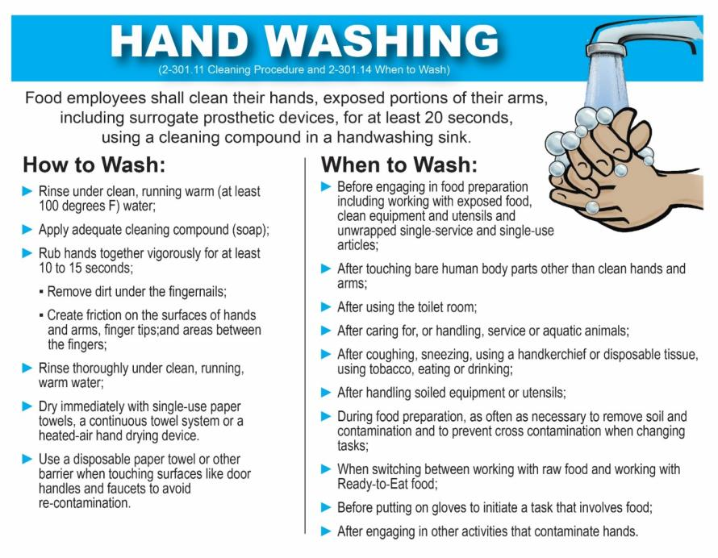

**Attachment 8-3: Sample Order Letter for Submission of Stool Specimens**

BOARD OF HEALTH LETTERHEAD

# DATE

*FOOD ESTABLISHMENT*

*ADDRESS*

# SALUTATION

The *BOARD OF HEALTH* was notified on *DATE* of a suspected foodborne illness outbreak involving *NUMBER OF ILL* people who had become ill with *SYMPTOMS/DIAGNOSIS* on or about *DATE.* All who became ill ate meals prepared at the *FOOD ESTABLISHMENT IN CITY/TOWN*.

The *BOARD OF HEALTH* is investigating all potential sources of contamination, including infected food employees. Since it is possible the food employees presently working may have also become infected after ingesting contaminated food, the *BOARD OF HEALTH* is requesting that all food employees that worked at the *FOOD ESTABLISHMENT* from *DATE* until the present time submit stool samples within 48 hours *(AND, IN SOME CASES, A SECOND STOOL SAMPLE WILL ALSO BE REQUIRED TO BE SUBMITTED 24 to 48 HOURS LATER)*. In addition, please submit a list of those food handlers and a brief description of their responsibilities such as line cook, server, etc. to the *BOARD OF HEALTH* by *DATE*. Food employees should submit stool sample to *NAME/PLACE.* Food employees, who do not submit a stool sample by *DATE*, shall be excluded from working as a food handler until they comply with the request.

This request is in accordance with FC 8-501.10 and FC 8-501.20 as amended by Massachusetts Regulation 105 CMR 590.008(N), Prevention of Foodborne Disease Transmission by Employees, Investigation and Control.

Failure to comply with this order may result in an emergency closure or suspension of your food permit or food service operation. If you are issued an emergency closure or suspension order, you may request a hearing before the *BOARD OF HEALTH*. Your request must be in writing and shall be filed in the office of the *BOARD OF HEALTH, ADDRESS* within 10 days after receipt of this order.

If you have any questions, please call me at *TELEPHONE.*

Sincerely,

*HEALTH AGENT/DIRECTOR*

cc. MA Food Protection Program

**Attachment 8-4: Sample Public Notice**

**DEAR GUEST:**

An employee of this restaurant was recently diagnosed as having hepatitis A. As a precautionary measure, all of the restaurant employees have received appropriate medical treatment for hepatitis A. As a result of this, we have been asked by state and local health officials to post the following information:

**Exposure:** It is the opinion of state and local health departments, that patrons who ate uncooked or cold food served from this restaurant anytime between **[insert appropriate dates]** and **[insert appropriate dates]** have potentially been exposed to hepatitis A.

**Cold or uncooked foods include salads and salad items, rolls, breads, hamburger and hot dog buns, fruit or vegetable garnishes, cold desserts, hamburger or sandwich condiments such as pickles and onions, chips, and ice, or beverages containing ice.**

**Prevention:** Persons who ate cold or uncooked foods at the restaurant from **[insert appropriate dates]** to **[insert appropriate dates]** should contact a health care provider and receive appropriate medical treatment for a possible exposure to hepatitis A.

**Symptoms of hepatitis A:** Symptoms of hepatitis A are age-related, with adults and adolescents more likely to experience the "classic" symptoms of fever, fatigue, loss of appetite, nausea and jaundice (dark brown urine, yellow skin and/or the whites of the eyes). In children, hepatitis A infections usually have minimal flu-like symptoms or upset stomach symptoms, or no symptoms at all, and children usually do not develop jaundice. When symptoms do occur, they generally last one to two weeks, although on rare occasions adults can feel sick for as long as several months.

**Where to obtain information about hepatitis A?**

**Health Care Provider**

**Local Health Department**

[Insert appropriate telephone, e-mail and/or web address]

**Massachusetts Department of Public Health**

Bureau of Infectious Disease and Laboratory Sciences: 617-983-6800

**Link to hepatitis A Fact Sheet:**

<http://www.mass.gov/eohhs/gov/departments/dph/programs/id/epidemiology/factsheets.html>

**Attachment 8-5: Sample Press Release**

**Massachusetts Department of Public Health**

**Bureau of Infectious Disease and Laboratory Sciences**

**305 South St**

**Jamaica Plain, MA 02130**

**Phone: 617-983-6800**

**Hepatitis A**

[**Insert appropriate town and date]:** Today Massachusetts State and Local Public Health Authorities announced that a case of hepatitis A occurred in a food employee at the **[insert appropriate facility name],** located in **[insert appropriate town].**

Health officials warn that people who ate cold or uncooked foods at this restaurant between the dates of **[insert appropriate dates]** may be at risk for developing hepatitis A. Cold or uncooked foods include salads and salad items, rolls, breads, hamburger and hot dog buns, fruit or vegetable garnishes, cold desserts, hamburger or sandwich condiments such as pickles and onions, chips and ice, or beverages containing ice.

Customers who ate cold or uncooked foods or are unsure of what they ate from this restaurant between **[insert appropriate dates]** should contact their health care provider and receive appropriate medical treatment for a possible exposure to hepatitis A.

The early signs and symptoms of hepatitis A are fever, fatigue, loss of appetite, nausea, vomiting, diarrhea, jaundice (dark urine, yellowing of the skin or the whites of the eyes.) The illness varies in severity, with mild cases lasting two weeks or less and more severe cases lasting four to six weeks or longer. Some individuals, especially children, may not develop jaundice, and may have an illness so mild that it can go unnoticed. However, even mildly ill persons can still be highly infectious. Persons with illness suggestive of hepatitis should consult a health care provider even if symptoms are mild.

Hepatitis A virus is spread as a result of fecal contamination (fecal-oral route) and may be spread from person to person through close contact or through food handling. The virus can be spread by contaminated food and beverages.

Persons who ate cold or uncooked foods from **[insert appropriate restaurant]** between **[insert appropriate dates]** are urged to be particularly thorough in handwashing after toileting, and prior to food preparation, to avoid any potential further spread of disease. Handwashing should include vigorous soaping of the hands. All surfaces should be washed including the back of the hands, wrists, between fingers and under fingernails. Hands should be thoroughly rinsed with running water.

Further information can be obtained from local health departments, health care providers or the Massachusetts Department of Public Health, Bureau of Infectious Disease and Laboratory Sciences at 617-983-6800.

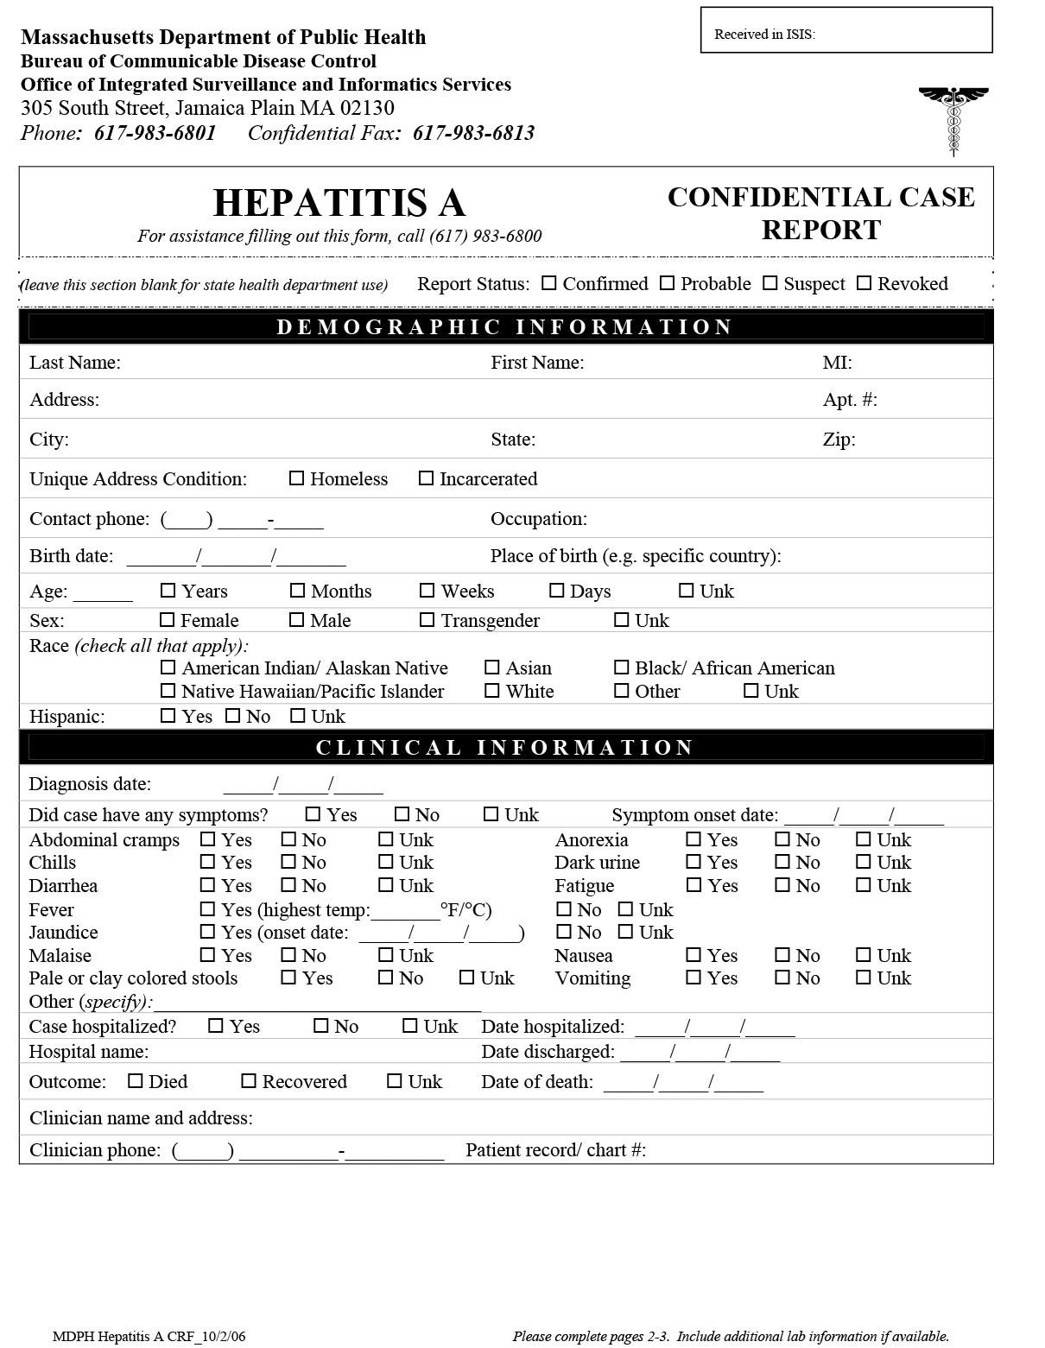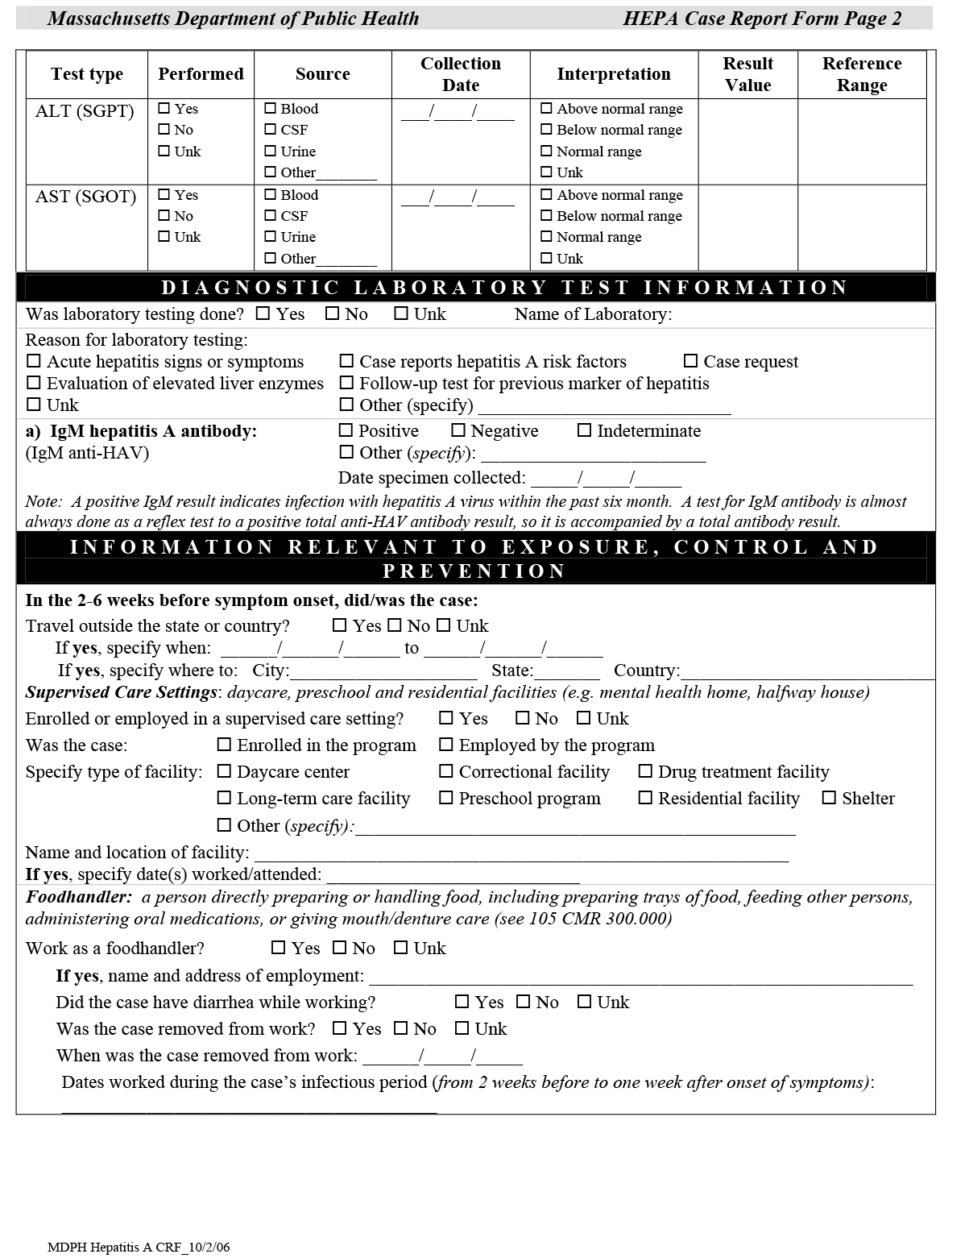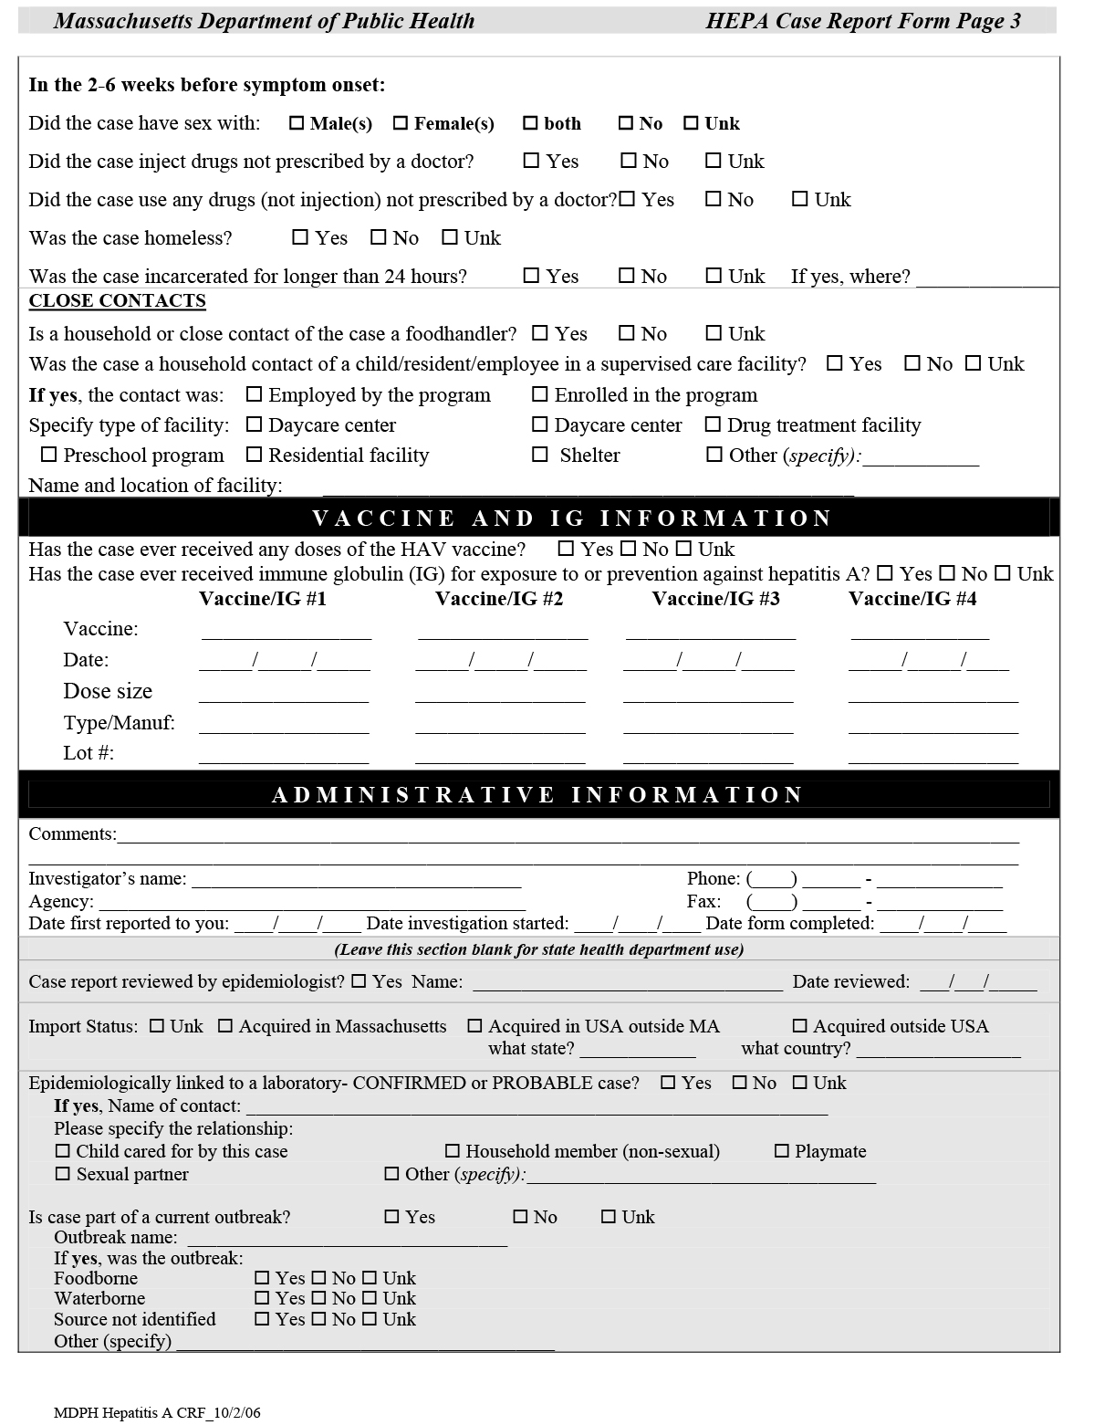

**Vomit and Diarrhea Clean-Up Procedure Template**

**WHY DO WE HAVE THIS PROCEDURE?**

Vomiting and diarrhea can be symptoms of several very contagious diseases and it is the responsibility of food service management to protect both employees and customers from transmission of these diseases. The most important ways of accomplishing

this task are:

1) ensure that employees understand the importance of frequent

handwashing and that they know where and how to wash their hands;

2) ensure that employees understand their responsibility to report

all disease symptoms, such as vomiting, diarrhea, jaundice,

fever and sore throat; diagnosis of diseases; and exposure to

others who are sick to the Person in Charge;

3) ensure that employees are trained and do not handle food that

is ready to eat with their bare hands;

4) ensure that employees understand the importance of following

all regular cleaning and sanitizing procedures on a daily

basis and special cleaning and sanitizing procedures such as this one.

New employees will be trained in all of the above-mentioned procedures within the first week of hiring. Reminder trainings will be done for all food service staff on an **ANNUAL** basis.

**VOMIT/DIARRHEA CLEAN-UP KIT**

A vomit/diarrhea clean-up kit is stored in a labeled bin in Contents of Clean-up Kit:

1) Personal Protective Equipment (PPE)

disposable gloves, nitrile or non-latex

face and eye shields (clean and sanitize after use)

disposable shoe covers

disposable aprons

masks

hair covers

2) Paper towels

3) Absorbent material: baking soda, Red Z powder, or kitty litter

4) Scoop or scraper, preferably disposable

5) Large plastic bags with twist ties

6) Caution tape, or other method for closing off areas

Buckets, wiping cloths, detergent and sanitizers will also be needed and are available in various locations throughout the food service area. The Person-in-Charge is responsible for refilling the clean-up kit after use. Extra supplies will be on hand. All supplies will be purchased or ordered at the time of the incident so that the kit is ready for use as soon as possible after the incident.

**WHEN A VOMITING OR DIARRHEA INCIDENT OCCURS**

1) Remove the following from the area if no contact with vomit or diarrhea:

a) employees and/or customers

b) packaged food or food in closed containers

c) portable equipment, linens and open single-use and single-service articles.

For diarrhea, the immediate area that is visibly soiled should be the area of clean-up concentration. For vomiting, since particles can be in the air, an area of 25 feet in all directions should be considered the clean-up area. This is very important when considering which employees or customers need to be removed; the food; and open single-use and single-service articles that need to be discarded; the linens that will need to be washed; and the equipment that will need to be cleaned and sanitized.

2) If vomiting occurred, completely close off area around the spill for 25 feet in all directions.

Some small food service establishments will have to close during the clean-up of a vomiting incident either by an employee or a customer. In the case of closure, the Regulatory Authority should be called immediately to report the incident. A sign can be put at the entrance stating that the food service establishment will be closed until a time judged to be sufficient to accomplish the required clean-up.

a) , due to its small size, will close after a vomiting incident until clean-up is finished.

b) , will determine what areas will need to be cleaned and sanitized, but will remain open with limited service, unless the incident occurs in the only food prep area.

3) A trained employee should put on Personal Protective Equipment, gloves last.

All employees are trained in this clean-up procedure. If staffing allows, cooks should not be the first choice for carrying out the clean-up.

4) Sprinkle on vomit/fecal matter to soak up liquid. Using the scraper or scoop from the Clean-up Kit, and paper towels, carefully wipe up vomit/fecal matter and discard in a plastic trash bag. Then remove and discard gloves.

If staffing allows, a separate employee, wearing gloves and a mask, can hold the trash bag open by folding the top back over their hands so that the top of the bag is not contaminated in the process of discarding the paper towels, gloves, etc.

5) Wash hands and put on new disposable gloves and wash the area involved with detergent and warm water.

All surfaces within the incident area, plus all doorknobs, railings, wall corners or other places that you know are frequently touched should then be washed with soap and water. All restrooms should be cleaned also, even if they were not known to be affected by the incident. They are often used by employees and customers when they are not feeling well and the infectious germs will be there even if they cannot be seen.

All areas washed as described above will then be sanitized.

6) Sanitize hard or porous surfaces with chlorine bleach solution allowing the

area to remain wet for no less than 5 minutes; follow policy directions for

other surfaces or when using other sanitizers.

Bleach concentrations:

5.25% Sodium Hypochlorite 1 2/3 cup bleach per gallon of water 5000 PPM

or 6% dish machine sanitizer (1 part bleach to 10 parts water)

8.25% concentrated Sodium 1 cup bleach per gallon of water 5000 PPM

Hypochlorite (1 part bleach to 16 parts water)

Sanitizer to be used in this establishment will be

and will be left wet on hard surfaces for minutes before drying with paper towels.

Ammonium chloride sanitizers are ineffective against Norovirus so if those are the standard sanitizers used in a food service establishment, then chlorine bleach (or some other commercial product approved by the EPA to kill Norovirus) must be kept on hand for use during a vomit/diarrhea incident.

Bleach is available in several different concentrations so food service establishments need to be aware of the concentration they have available. Once opened, a bottle of bleach maintains its strength for 30 days so PUT THE DATE ON THE BOTTLE WHEN YOU OPEN IT. Discard it after 30 days.

Remember that bleach will discolor many items such as carpets, flooring, etc. Test a small area if there is any reason to believe that there will be a problem. Steam cleaning of carpets and upholstery is recommended once the vomit/diarrhea has been removed. Linens should be washed in hot water and dried in a hot dryer.

Open windows or increase ventilation as much as possible during the clean-up.

Make sure that all high-touch areas and restrooms are sanitized before areas are re-opened.

7) When totally finished cleaning up, dispose of all paper towels

and PPE in the plastic bag. Tie the bag closed and double

bag it before putting it in your regular trash.

8) Rinse food contact surfaces with clean water to remove chlorine residue left on the surface because you used 5000 PPM to kill the infectious agents and re-sanitize

with your usual 100 ppm sanitizer.

**RE-OPENING ESTABLISHMENT OR CLEANED AREAS**

When the above-described clean-up procedure has been completed, the areas may be re-opened. Establishments that closed for clean-up should call the Regulatory Authority and report that they are ready to re-open. The Regulatory Authority may, or may not, want to actually visit the establishment prior to re-opening.

Establishments should anticipate that some customers may request some kind of compensation. Management should discuss that with employees as part of the training on this procedure. The decision concerning compensation is entirely up to the establishment management.

**MONITORING EMPLOYEES FOR ILLNESS**

After incidents involving diarrhea and particularly vomiting, all employees, but particularly those involved in the clean-up, will be monitored for signs of illness for several days. The Person-in-Charge will remind employees to report symptoms of any illness.

**INCIDENT REPORT**

It is advisable for the Person-in-Charge to complete an incident report describing the date and time of the incident; which employees were in charge of the clean-up; an overall description of the area of the incident; how it was cleaned and sanitized; and the other areas of the establishment cleaned and sanitized. It should also state what food was discarded. This report should be kept in the establishment files in case there are any future questions about the incident.

**REFERENCES:**

"Clean-up and Disinfection for Norovirus ("Stomach Bug") Poster from disinfect-for-health.org.

Food Code, U.S. Public Health Service, FDA, 2013, Annex 3, Public Health Reasons/Administrative Guidelines, pages 395-397.

"Food Safety Sample SOP," NFSMI and USDA, Revised 2013.

"Guidelines for Responding to Vomiting and Diarrhea in Food Establishments," Rhode Island Department of Health, Yankee Conference Presentation by Cathy Feeney and Lydia Brown, September 22, 2016.

"Norovirus Information Guide," from SafeMark Best Practices, the Food Marketing Institute and Ecolab, July 2010.

"White Paper: Guidelines for Response to Vomiting and Diarrheal Incidents in Food Service Establishments," prepared by Paula Herald, PH.D., CP-FS, Technical Consultant, The Steritech Group, Inc., www.steritech.com.

Updated October 5, 2018