INDOOR AIR QUALITY ASSESSMENT

White Brook Middle School
200 Park St.
Easthampton, MA

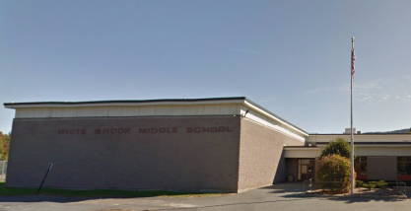

Prepared by:
Massachusetts Department of Public Health
Bureau of Environmental Health
Indoor Air Quality Program
April 2016

Background

Building: | White Brook Middle School (WBMS)
Address: | 200 Park St., Easthampton, MA
Assessment Requested by: | Dayle Doran, Business Director, Easthampton Public Schools
Reason for Request: | General indoor air quality (IAQ) concerns
Date of Assessment: | March 9, 2016
Massachusetts Department of Public Health/Bureau of Environmental Health (MDPH/BEH) Staff Conducting Assessment: | Sharon Lee, Environmental Analyst, IAQ Program
Date of Building Construction: | 1976
Building Description: | Single story, multi-wing facility
Building Population: | approximately 460 students in grades 5 to 8 and 50 staff members
Windows: | Mostly openable

METHODS
Please refer to the IAQ Manual for methods, sampling procedures, and interpretation of results (MDPH, 2015).

RESULTS and DISCUSSION
The following is a summary of indoor air testing results (Table 1).
- Carbon dioxide levels were above 800 parts per million (ppm) 31 of 64 areas surveyed, indicating a lack of air exchange in nearly 50 % of the areas tested.
- Temperature at the school was within or above the recommended range of 70°F to 78°F.
- Relative humidity was below the recommended range of 40 to 60% in all areas.
- Carbon monoxide levels were non-detectable in all indoor areas tested.
- Fine particulate matter (PM2.5) concentrations measured exceeded the National Ambient Air Quality Standard (NAAQS) level of 35 μg/m³ in approximately 20% of areas assessed. PM2.5 concentrations reflect dustloads at the school during the assessment.
The air sampling indicates that the ventilation system in the building is not providing enough fresh air. At the time of assessment, it was noted that mechanical systems were not operating in some areas, particularly the gymnasiums. To maximize air exchange, the BEH recommends that mechanical ventilation systems operate continuously during periods of school occupancy. Without the system operating as designed, normally occurring pollutants cannot be diluted or removed, allowing them to build up and lead to IAQ/comfort complaints.

Ventilation
A heating, ventilating, and air conditioning (HVAC) system has several functions. First it provides heating. Second, it is a source of fresh air. Finally, an HVAC system will dilute and remove normally occurring indoor environmental pollutants by not only introducing fresh air, but by filtering the airstream and ejecting stale air to the outdoors via exhaust ventilation. Even if an HVAC system is operating as designed, point sources of respiratory irritation may exist and cause symptoms in sensitive individuals. The following describes and identifies components of the HVAC system and likely sources of respiratory irritants/allergens in the indoor environment.
Fresh air in classrooms and central areas such as gymnasiums and cafeterias are provided by rooftop air-handling units (AHUs; Picture 1). Air from the AHUs is filtered, heated, and delivered via ceiling-mounted diffusers to classrooms (Picture 2) and ceiling-mounted supply vents in central areas (Picture 3).
Classroom air is returned to the AHUs by slots in the ceiling tile system that opens to the ceiling plenum (Picture 2). This system uses the entire space above the ceiling to draw air back to the AHU. Central spaces have wall- or ceiling-mounted exhaust vents (Picture 3) that are ducted directly to the AHUs.
AHUs for each open classroom grouping or pod is controlled by a single thermostat near the interior of the school. Often, these classrooms were not occupied. As a result, AHUs in many areas were providing excess heated air. Temperatures in many of these areas were augmented by solar gain. When possible, measures should be taken to reduce solar gain and increase cross ventilation in these classrooms by opening windows in opposite ends of each pod.
Supplemental heating is installed along exterior walls in some classrooms. These radiators should be cleaned and maintained periodically. Register caps should be in place for all equipment (Picture 4).

Microbial/Moisture Concerns
Stained ceiling tiles were observed in a number of areas (Picture 5; Table 1), predominately from roof drainage issues. Ceiling tiles observed in the home economics room were reportedly removed due to repeated damage to the ceiling tiles. This particular roof area is a low point at which water accumulates (Picture 6). Chronically wet ceiling tiles that remain in place can create a hazard, since saturated tiles can fall down. Missing ceiling tiles can also allow dust/debris in the plenum system to enter occupied spaces. Until roof drainage and repair measures can be completed water diverting ceiling tile systems should be considered to maintain the ceiling plenum system (Picture 7).
Staff also reported an incident where flooding occurred in the library area. Flooding occurred when a drainage pipe became corroded. The damaged pipe was replaced, and the carpet was reportedly cleaned, disinfected, and dried immediately. The carpet was dry at the time of the BEH/IAQ visit. Any future water damage issues should also be addressed promptly.
Floor carpeting is installed to the classroom edge, even in classrooms with exterior doors. Staining to carpeting in these areas indicated previous water damage. Wet carpet should be cleaned and dried immediately to prevent mold growth. The US Environmental Protection Agency (US EPA) and the American Conference of Governmental Industrial Hygienists (ACGIH) recommend that porous materials be dried with fans and heating within 24 to 48 hours of becoming wet (US EPA, 2001; ACGIH, 1989). If not dried within this time frame, mold growth may occur. Once mold has colonized porous materials, they are difficult to clean and should be removed/discarded.
In addition, light was observed around many of these exterior doors, indicating breaches that could allow water and pest entry. Further, these doors are frequently used to access the outdoors. To limit damage from potential water events and improve ease of cleaning in these areas, consideration should be given to removing carpeting in these areas (e.g. 2 feet from door) and replacing with vinyl floor tiles. Walk-off mats may serve as an alternative to continued damage or degradation of carpeting in this area.
Several sinks in classrooms had backsplashes with a gap (Table 1). Water that moves down through the gap and behind the backsplash can cause water damage, potentially resulting in mold growth.
Plants were observed in a few areas near heating sources and on carpeting (Pictures 8 and 9; Table 1). Plants can be a source of pollen and mold, which can be respiratory irritants to some individuals. Heating and ventilation sources can distribute pollen and mold from plants placed in close proximity. Plants that are overwatered can cause prolonged exposure of carpets to water. Plants should be properly maintained and equipped with drip pans and should be located away from air diffusers to prevent aerosolization of dirt, pollen, and mold.
Aquariums were found in a few areas of the school (Picture 10; Table 1). These need to be kept clean so that stagnant water and organic matter (e.g., soil, vegetation) do not become a source of odors.
The outside of the building was examined for conditions that may impact IAQ. BEH/IAQ staff observed damage to an exterior wall panel (Picture 11). Water between the exterior wall covering and insulation can freeze and thaw, which will cause damage.

Other IAQ Evaluations
Exposure to low levels of total volatile organic compounds (TVOCs) may produce eye, nose, throat, and/or respiratory irritation in some sensitive individuals. To determine if VOCs were present, BEH/IAQ staff examined rooms for products containing VOCs. BEH/IAQ staff noted candles, air fresheners, hand sanitizers, cleaners, and dry erase materials in use within the building (Pictures 12 and 13; Table 1). All of these products have the potential to be irritants to the eyes, nose, throat, and respiratory system of sensitive individuals.
Many areas of the school are carpeted, and these appeared stained, worn, and frayed due to use and age (Picture 14). The carpets are reportedly original to the building. The usable life of carpeting is approximately 10-11 years (IICRC, 2002). Aging carpet can produce fibers that can be irritating to the respiratory system. In addition, tears or lifting carpet can create tripping hazards. Consideration should be given to installing carpet vinyl edges to create smooth transitions. The Institute of Inspection, Cleaning, and Restoration Certification (IICRC) recommends that carpeting be cleaned annually (or semi-annually in soiled high traffic areas) (IICRC, 2012). Similarly, plush and upholstered items (Picture 15) should also be cleaned regularly.
Tennis balls were found sliced open and placed around chair legs to reduce noise (Picture 16; Table 1). Tennis balls are made of a number of materials that are a source of respiratory irritants. Constant wearing of tennis balls can produce fibers and off-gas VOCs. Tennis balls are made with a natural rubber latex bladder, which becomes abraded when used as a chair leg pad. Use of tennis balls in this manner may introduce latex dust into the school environment. Some individuals are highly allergic to latex (e.g. spina bifida patients) (SBAA, 2001). Use of materials containing latex should be limited to reduce the potential for symptoms in sensitive individuals (NIOSH, 1997). Latex-free glides can be used to prevent damage to floor materials.
Accumulations of pencil shavings, chalk dust, and dry erase marker debris (Pictures 17 and 18; Table 1) were found in classrooms. These materials can be aerosolized and cause irritation. Pencil sharpeners and chalkboard/whiteboard trays should be cleaned frequently. Pencil sharpeners should be moved away from airstream to prevent fire hazard, odors, and airborne irritant.
Dust control appeared to be a significant problem at the time of assessment. A large number of surfaces throughout the school were found with accumulated dust. Dust was observed on items, including personal fans, supply vents, radiators, and tabletops (Pictures 2 and 19; Table 1). Dust can be irritating to the eyes, nose and respiratory tract. Dust on ventilation equipment and fans should be cleaned to prevent re-aerosolization when the system is activated. To prevent dust buildup and redistribution, flat surfaces should also be wiped and cleaned with a vacuum equipped with the high efficiency particulate arrestance (HEPA) filter on a regular basis.

Conclusions/Recommendations
The age of the carpet, in combination with lack of ventilation and cleaning contribute to the PM2.5 concentrations measured at the time of the assessment. Improved cleaning activities, operation of ventilation equipment when the school is occupied, and replacement of carpeting in high traffic areas will help to reduce dustload within the building. The following short-term and long-term recommendations are provided to improve IAQ.

Short term Recommendations
- Operate supply and exhaust ventilation continuously in all areas during occupied periods. During temperate weather, use windows/doors to supplement fresh air and increase cross-ventilation. Ensure all HVAC equipment is maintained and supply vents are cleaned periodically to prevent dust re-aerosolization.
- Replace carpets in high-traffic areas to prevent continued carpet degradation/dust aerosolization and prevent tripping hazards.
- Use a HEPA vacuum in conjunction with wet wipes or microfiber clothes to clean flat surfaces and floors to reduce airborne dust.
- Clean carpeting and plush/upholstered items regularly and discard those that are worn out or too soiled to be cleaned. Refer to IICRC for additional cleaning suggestions.
- Clean supply vents and personal fans regularly to prevent aerosolization of debris.
- Consider reducing the amount of items stored in classrooms to make cleaning easier. Periodically move items to clean flat surfaces.
- Use shading or window films to decrease solar gain, particularly in classrooms facing the west to reduce excessive heat.
- Examine measures to improve roof drainage in the area above the home economics room.
- Replace stained ceiling tiles with water-diverting ceiling tiles. Ensure water-diverting ceiling tiles are well-maintained, and water collection vessels are cleaned and emptied daily to prevent odors.
- Ensure that the roof is examined regularly for deterioration and leaks, and that debris is removed regularly.
- Ensure that procedures are in place for occupants to report leaks, wet tiles, and other maintenance conditions so that work orders can be logged and repairs made promptly.
- Consider removing carpeting from areas around exterior doors (e.g. 2 feet out) and replacing with vinyl floor tiles. Walk-off mats may serve as an alternative to continued damage or degradation of carpeting in this area.
- Install vinyl edges to create smooth transitions where carpet is no longer adhered.
- Seal gaps between sink countertops and backsplashes with silicone caulking to prevent water damage behind sinks.
- Keep plants in good condition, avoid overwatering, and remove from the airstream of heating and ventilation equipment.
- Keep aquariums clean to prevent mold growth and odors.
- Repair damage to exterior wall panel.
- Install door sweeps and caulking to ensure doors are air tight.
- Reduce the use of cleaning products, sanitizers, and other products containing VOCs. Use only school-issued products, ensure they are properly labeled, and keep material safety sheets on file for each product at the school.
- Remove air deodorizers and scented candles to prevent respiratory irritation.
- Replace tennis balls in classrooms with latex-free glides.
- Keep pencil sharpeners away from air movement sources such as radiators, and ensure sharpeners are emptied regularly.
- Clean trays of whiteboard marker and chalk debris regularly.
- Install
- Consider adopting the US EPA (2000) document, “Tools for Schools”, as an instrument for maintaining a good IAQ environment in the building. This document is available at: http://www.epa.gov/iaq/schools/index.html.
- Refer to resource manual and other related IAQ documents located on the MDPH’s website for further building-wide evaluations and advice on maintaining public buildings. These documents are available at: http://mass.gov/dph/iaq.

Long-term Recommendations
- Contact a roof specialist to determine feasibility of regrading roof for improved drainage.
- Replace carpets throughout school.

References
ACGIH. 1989. Guidelines for the Assessment of Bioaerosols in the Indoor Environment. American Conference of Governmental Industrial Hygienists, Cincinnati, OH.
IICRC. 2002. Institute of Inspection, Cleaning and Restoration Certification. Carpet Cleaning: A Life-cycle Cost Analysis for Floor Coverings in School Facilities. Retrieved from https://www.carpet-rug.org/Documents/Scientific_Resources/0203_IICRC_Life-Cycle-Cost-Analysis.aspx
IICRC. 2012. Institute of Inspection, Cleaning and Restoration Certification. Carpet Cleaning: FAQ. Retrieved from http://www.iicrc.org/consumers/care/carpet-cleaning/#faq.
MDPH. 2015. Massachusetts Department of Public Health. Indoor Air Quality Manual: Chapters I-III. Available at: http://www.mass.gov/eohhs/gov/departments/dph/programs/environmental-health/exposure-topics/iaq/iaq-manual/.
NIOSH. 1997. NIOSH Alert Preventing Allergic Reactions to Natural Rubber Latex in the Workplace. National Institute for Occupational Safety and Health, Atlanta, GA.
SBAA. 2001. Latex In the Home And Community Updated Spring 2001. Spina Bifida Association of America, Washington, DC.
US EPA. 2000. Tools for Schools. Office of Air and Radiation, Office of Radiation and Indoor Air, Indoor Environments Division (6609J). EPA 402-K-95-001, Second Edition. http://www.epa.gov/iaq/schools/tools4s2.html.
US EPA. 2001. “Mold Remediation in Schools and Commercial Buildings”. Office of Air and Radiation, Indoor Environments Division, Washington, DC. EPA 402-K-01-001. March 2001. Available at: https://www.epa.gov/mold/mold-remediation-schools-and-commercial-buildings-guide

Picture

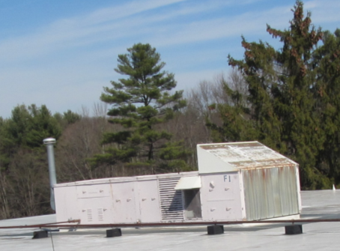

Rooftop air-handling unit

Picture

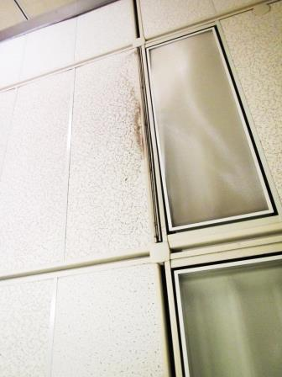
Supply vent
Return vent

Slotted, ceiling-mounted air diffuser and return vent; note dust accumulation
Picture

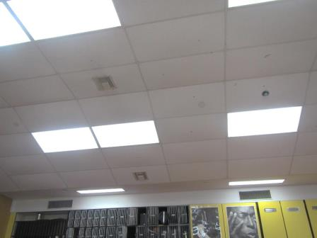
Supply vent
Return vent

Ceiling-mounted supply and return vent

Picture

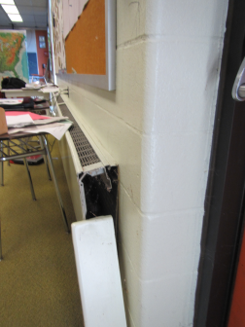

End cap to heat register not attached

Picture

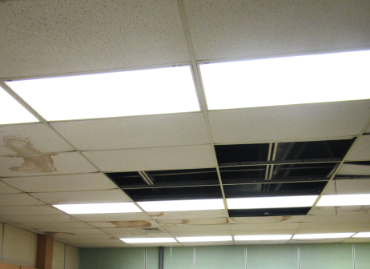

Missing and water-damaged ceiling tiles

Picture

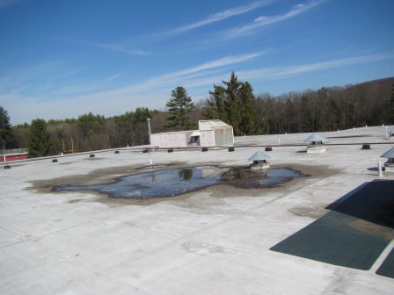

Water pooling on roof (approximately above home economics area)

Picture
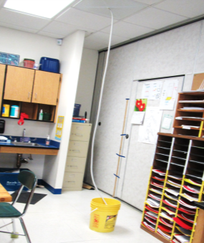

Example of water-diverting ceiling tile

Picture

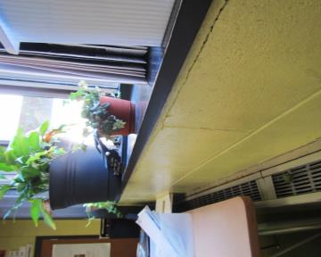

Plants above heating, note plant debris on heating elements
Picture

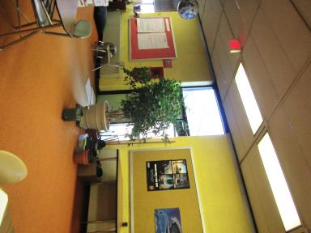

Plants on carpet
Picture

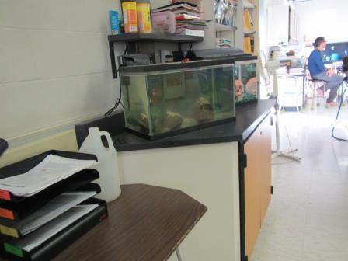

Aquarium, note water color
Picture

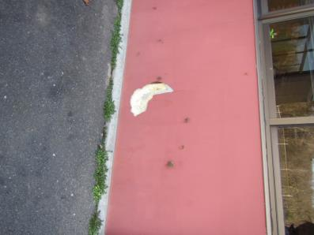

Damaged exterior wall

Picture

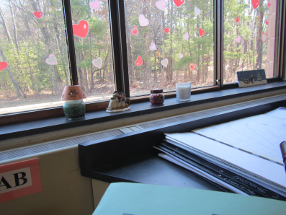

Scented candles near heating source
Picture

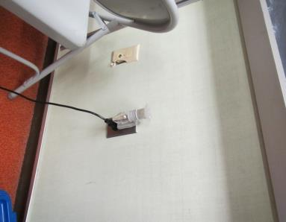

Plug-in air deodorizer

Picture

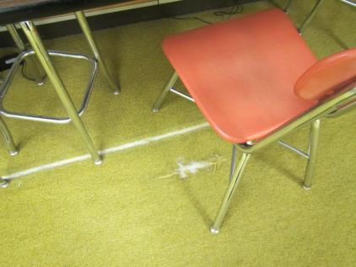

Fraying and non- continuous carpet surface
Picture

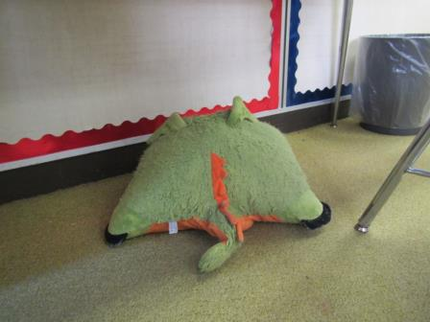

Fabric covered toy, note matted texture of upholstery

Picture

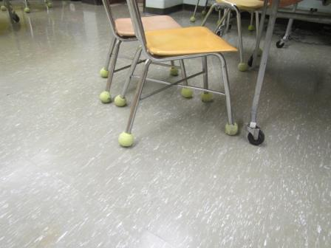

Tennis balls used on chair feet

Picture

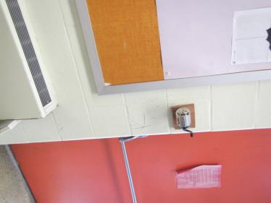

Pencil sharpener shavings noted in radiator due to proximity

Picture

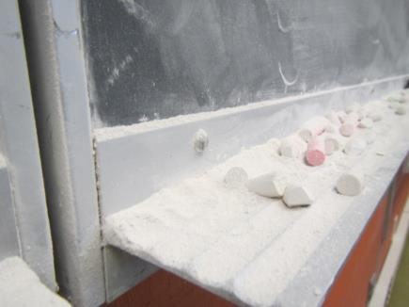

Chalk dust buildup in tray
Picture

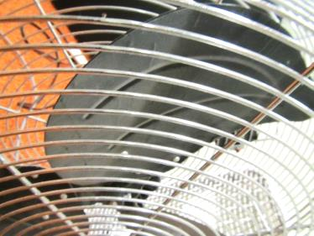

Dust settled on fan blade

Location | Carbon  Dioxide  (ppm) | Carbon Monoxide  (ppm) | Temp  (°F) | Relative  Humidity  (%) | PM2.5  (µg/m3) | Occupants  in Room | Windows  Openable | Ventilation |  | Remarks
 |  |  |  |  |  |  |  | Supply | Exhaust
Background | 431 | ND | 76 | 27 | 27 |  |  |  |  | Sunny
Principal’s office | 688 | ND | 73 | 31 | 25 | 0 | Y | Y
Main office | 656 | ND | 73 | 31 | 40 | 0 | U | Y
Murses office | 656 | ND | 72 | 31 | 27 | 2 | N | N | Y  bathroom | TB, DO
Gym A/B | 911 | ND | 75 | 37 | 192 | 0 | N | Y  Off | Y  Off | DO, 30 students in hallway
Gym C | 885 | ND | 74 | 33 | 192 | 0 | N | Y  Off | Y  Off | DO
311 music | 875 | ND | 73 | 33 | 19 | 0 | N | Y | Y | DO
602 home economics | 701 | ND | 73 | 31 | 27 | 0 | N | Y | Y | 7 MT, WD-CTs, TB, DO
631 | 712 | ND | 74 | 33 | 85 | 19 | N | Y | Y | 2-WD-CT
632 | 609 | ND | 75 | 31 | 77 | 23 | Y | N | Y | 1 AT, plants, PF
633 | 582 | ND | 75 | 31 | 44 | 0 | N | Y | Y | 6 computers, plants
634 | 663 | ND | 75 | 32 | 36 | 21 | Y | Y | Y | Plants, DEM, CD
635 | 728 | ND | 76 | 32 | 43 | 20 | Y | Y | Y
636 | 728 | ND | 76 | 32 | 43 | 20 | Y | Y | Y
637 | 663 | ND | 76 | 31 | 34 | 0 | N | Y | Y
611 | 738 | ND | 75 | 30 | 24 | 0 | N | Y | Y | TB, PF
610 | 845 | ND | 75 | 31 | 21 | 1 | Y | Y | Y | DO, Plants, TB, Aquarium, breach in sink backsplash, dust on flat surfaces
609 | 874 | ND | 75 | 33 | 46 | 22 | Y  Open | Y | Y | Dust, breach in sink backsplash, TB, candles
608 | 697 | ND | 74 | 31 | 29 | 0 | N | Y | Y | TB
603 | 830 | ND | 74 | 33 | 31 | 0 | N | Y | Y | TB, items, AT
East cafeteria | 904 | ND | 75 | 34 | 20 | 100 | N | Y | Y | TB
605 | 1045 | ND | 74 | 37 | 29 | 21 | Y | Y | Y | Plants, TB, PF, food
627 | 914 | ND | 75 | 34 | 12 | 0 | N | Y | Y | PF
625 | 871 | ND | 76 | 31 | 9 | 0 | Y | y | Y
626 | 878 | ND | 76 | 31 | 45 | 0 | Y | Y | Y
624 | 888 | ND | 77 | 30 | 22 | 0 | Y | Y | Y | PF
623 | 898 | ND | 77 | 30 | 22 | 1 | N | Y | Y | TB, light observed around exterior door
622 | 878 | ND | 77 | 30 | 11 | 0 | Y | Y | Y | PF, DEM
621 | 843 | ND | 76 | 30 | 16 | 0 | N | Y | Y | DO, CD
620 | 837 | ND | 76 | 30 | 11 | 0 | N | Y | Y | DO
Media | 700 | ND | 76 | 30 | 23 | 2 | N | Y | Y | photocopiers, plants
Computers | 857 | ND | 77 | 30 | 29 | 18 | N | Y | Y | 30 computers
TRC | 706 | ND | 76 | 29 | 81 | 0 | N | Y | Y | DO, TB, 20 computers
CTN | 865 | ND | 77 | 32 | 29 | 23 | N | Y | Y | 30 computers
408 | 665 | ND | 76 | 28 | 23 | 4 | N | Y | Y  Dusty | Photocopiers- odors, AT, WD-CT, laminator
409 | 664 | ND | 75 | 32 | 27 | 0 | N | Y | Y | PF
402 | 605 | ND | 76 | 31 | 24 | 2 | N | Y | Y | PF, WD-CT, ATs
Resources center | 778 | ND | 76 | 29 | 21 | 0 | N | Y | Y
417 | 701 | ND | 76 | 30 | 27 | 0 | N | Y  Rusty | Y | Signs of chronic water exposure on ceiling supply and exhaust vents
404 | 931 | ND | 75 | 34 | 37 | 0 | N | Y | Y | Dripping sink, Copiers, DO
South cafeteria | 957 | ND | 77 | 37 | 24 | 100 | N | Y | Y | TB, fans, WD-CT
522 | 853 | ND | 78 | 32 | 35 | 0 | N | Y | Y
531 | 908 | ND | 79 | 34 | 32 | 21 | N | Y | Y | DEM
532 | 671 | ND | 81 | 29 | 46 | 0 | Y | Y | Y | DEM, plants
533 | 839 | ND | 81 | 30 | 53 | 18 | Y | Y | Y | Light around exterior doors, PF-dusty, PS-near radiator
534 | 743 | ND | 83 | 28 | 42 | 0 | Y  Open | Y | Y
535 | 701 | ND | 83 | 28 | 64 | 21 | Y  Open | Y | Y | Light around exterior door, CPs
536 | 617 | ND | 84 | 24 | 32 | 0 | Y  Open | Y | Y | PF
537 | 766 | ND | 82 | 26 | 18 | 0 | N | Y | Y | DO
530 | 703 | ND | 84 | 24 | 23 | 0 | N | Y | Y | DO
512 | 786 | ND | 75 | 27 | 36 | 0 | N | Y | Y | AD, TB,PF
507 | 972 | ND | 78 | 31 | 13 | 0 | N | Y | Y | PF, light around exterior door, WD-CTs
510 | 862 | ND | 78 | 30 | 11 | 0 | Y | Y | Y | TB, plants, CPs, aquarium
509 | 882 | ND | 79 | 31 | 14 | 18 | Y | Y | Y | CPs, TB, plants
527 | 880 | ND | 80 | 30 | 31 | 0 | N | Y | Y | 25 computers, AD
520/521 | 612 | ND | 80 | 30 | 46 | 0 | N | Y | Y
523 | 641 | ND | 80 | 30 | 42 | 0 | N | Y | Y | Light around exterior door, PF, WD-CT
401 | 867 | ND | 77 | 31 | 32 | 1 | N | Y | N
522 | 754 | ND | 80 | 30 | 23 | 7 | N | Y | Y | CPs, AD, items
524 | 641 | ND | 73 | 11 | 42 | 0 | Y | Y | Y
525 | 1106 | ND | 80 | 33 | 28 | 22 | Y | Y | Y | Plants, AD
526 | 634 | ND | 81 | 29 | 26 | 19 | Y  Open | Y | Y | Plants, HS, DO
Faculty dining area | 654 | ND | 78 | 32 | 24 | 2 | Y | Y | Y
312 | 1197 | ND | 75 | 31 | 35 | 23 | N | Y | Y | WD-CT
Stage | 827 | ND | 74 | 27 | 21 | 3 | N | Y | Y

