INDOOR AIR QUALITY ASSESSMENT

White Brook Middle School
200 Park Street
Easthampton, MA

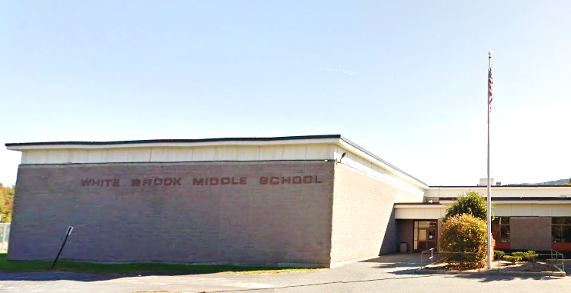

Prepared by:
Massachusetts Department of Public Health
Bureau of Environmental Health
Indoor Air Quality Program
February 2019

BACKGROUND

Building: | White Brook Middle School (WBMS)
Address: | 200 Park Street, Easthampton, MA
Assessment Requested by: | A parent
Reason for Request: | General indoor air quality (IAQ) concerns
Date of Assessment: | February 14, 2019
Massachusetts Department of Public Health/Bureau of Environmental Health (MDPH/BEH) Staff Conducting Assessment: | Michael Feeney, Director, IAQ Program
Date of Building Construction: | 1976
Building Description: | Single story, multi-wing facility
Building Population: | Approximately 450 students in grades 5 to 8 and 50 staff members
Windows: | Mostly openable

INTRODUCTION
The IAQ program has previously visited the WBMS in 2018. Wet carpeting was removed in a number of areas, including the library and hallways. Tennis balls were removed from chairs and peeling paint in the gymnasium was removed as recommended in the previous IAQ report. It was reportedly planned to have further carpeting removed from the library area. It is our understanding that the school was the subject of a successful vote for replacement in May 2018 (MassLive, 2018). In general, it will take several years for a new building to be constructed. Therefore the various recommendations in this report are geared towards improving/maintaining the conditions within the building to the extent possible while recognizing that the building will be replaced in the near future.
Under current Massachusetts School Building Authority (MSBA) regulations, the expected service life of a newly constructed or renovated school building is at least 50 years [963 CMR 2.03(b)]. Given that the WBMS is approximately 43 years old, it is expected that a number of building components have exceeded their expected service life, which will likely require increased maintenance or removal/replacement as needed until the building is replaced.

METHODS
Please refer to the IAQ Manual for methods, sampling procedures, and interpretation of results (MDPH, 2015).

RESULTS and DISCUSSION
The following is a summary of indoor air testing results (Table 1).
- Carbon dioxide levels were below the MDPH guideline of 800 parts per million (ppm) in the majority of areas surveyed, indicating adequate air exchange in most of the building. It is important to note that carbon dioxide levels would be expected to rise with increased occupancy. A few areas were slightly elevated and would benefit from introducing more fresh air to these rooms.
- Temperature was within the MDPH recommended range of 70°F to 78°F.
- Relative humidity was below the MDPH recommended range of 40 to 60%.
- Carbon monoxide levels were non-detectable in all areas tested.
- Fine particulate matter (PM2.5) concentrations measured were below the National Ambient Air Quality Standard (NAAQS) level of 35 μg/m³ in all areas assessed.

To maximize air exchange, the BEH recommends that mechanical ventilation systems throughout the building (classrooms, gymnasium, etc.) operate continuously during periods of occupancy. Without the system operating as designed, normally occurring pollutants cannot be diluted or removed, allowing them to build up and lead to IAQ/comfort complaints.

Ventilation
It is important to note that the HVAC system dates from the 1970s. Controlling temperatures in a large building with variable occupancy is difficult, and more so because many of the HVAC and associated equipment is over 40 years old. Efficient function of equipment of this age is difficult to maintain, since compatible replacement parts are often unavailable. According to the American Society of Heating, Refrigeration and Air-Conditioning Engineering (ASHRAE), the service life for the various components of the HVAC system is between 20 to 30 years, assuming routine maintenance of the equipment (ASHRAE, 1991). Despite attempts to maintain the equipment, the optimal operational lifespan of this equipment has been exceeded.
Of note that the relative humidity readings ranged from 16 to 21 percent, which were below the MDPH recommended comfort range the day of the assessment. The MDPH recommends a comfort range of 40 to 60 percent for indoor air relative humidity. Relative humidity in the building would be expected to drop during the winter months due to heating. The sensation of dryness and irritation is common in a low relative humidity environment. “Extremely low (below 20%) relative humidity may be associated with eye irritation [and]…may affect the mucous membranes of individuals with bronchial constriction, rhinitis, or cold and influenza related symptoms” (Arundel et al., 1986). Low relative humidity is a common problem during the heating season in the northeast part of the United States.

Microbial/Moisture Concerns
As noted previously, wet carpet was removed in a number of areas. The US Environmental Protection Agency (US EPA) and the American Conference of Governmental Industrial Hygienists (ACGIH) recommend that porous materials be dried with fans and heating within 24 to 48 hours of becoming wet (US EPA, 2008; ACGIH, 1989). If not dried within this time frame, mold growth may occur. Once mold has colonized porous materials, they are difficult to clean and should be removed/discarded.

Carpeting
Wall to wall carpeting exists in classroom areas and the library. As noted, carpeting was removed in a number of areas. Carpeting remains in several of the pod areas. As noted in the previous report, carpeting in schools, if well maintained, is expected to have a service life of 7 to 11 years (IICRC, 2002; Bishop, 2002). Worn carpet can be a source of dust, debris and other pollutants that can become readily aerosolized when trod upon. This condition can be exacerbated by low humidity that will occur during the heating season. While previous reports noted elevated particulate matter, none were noted during this assessment indicating the likely source was removed.

Other Conditions
Dust control appears to be improved since the previous IAQ assessment.

Conclusions/Recommendations
The following recommendations are provided to improve IAQ for the duration of use of the building:
- Monitor existing carpeting for material degradation (e.g., wear, unravelling, loss of adhesion to the floor). If present, remove carpet displaying material degradation. Routinely check carpeting after large rainfalls for damage from leakage and replace as necessary.
- Make efforts to increase fresh air supply to areas showing slightly elevated carbon dioxide levels (Table 1).
- Continue to operate supply and exhaust ventilation continuously in all areas during occupied periods.
- For buildings in New England, periods of low relative humidity during the winter are often unavoidable. Therefore, scrupulous cleaning practices should be adopted to minimize common indoor air contaminants whose irritant effects can be enhanced when the relative humidity is low. To control for dusts, a high efficiency particulate arrestance (HEPA) filter equipped vacuum cleaner in conjunction with wet wiping of all surfaces is recommended. Avoid the use of feather dusters. Drinking water during the day can help ease some symptoms associated with a dry environment (throat and sinus irritations).
- During temperate weather, use windows/doors to supplement fresh air and increase cross-ventilation.
- Ensure all HVAC equipment is maintained and supply vents are cleaned periodically to prevent dust re-aerosolization.

References
ACGIH. 1989. Guidelines for the Assessment of Bioaerosols in the Indoor Environment. American Conference of Governmental Industrial Hygienists, Cincinnati, OH.
Arundel, et.al. 1986. Indirect health effects of relative humidity in indoor environments. Environ Health Perspect. 1986 Mar;65:351-61.
ASHRAE. 1991. ASHRAE Applications Handbook, Chapter 33 “Owning and Operating Costs”. American Society of Heating, Refrigeration and Air Conditioning Engineers, Atlanta, GA.
Bishop. 2002. Bishop, J. & Institute of Inspection, Cleaning and Restoration Certification. A Life Cycle Cost Analysis for Floor Coverings in School Facilities.
IICRC. 2002. Institute of Inspection, Cleaning and Restoration Certification. Carpet Cleaning: A Life-cycle Cost Analysis for Floor Coverings in School Facilities.
MassLive. 2018. Easthampton voters OK new school construction 2,829 to 2,101. https://www.masslive.com/news/index.ssf/2018/05/easthampton_school_vote_failss.html
MDPH. 2015. Massachusetts Department of Public Health. Indoor Air Quality Manual: Chapters I-III. Available at: http://www.mass.gov/eohhs/gov/departments/dph/programs/environmental-health/exposure-topics/iaq/iaq-manual/.
US EPA. 2008. “Mold Remediation in Schools and Commercial Buildings”. Office of Air and Radiation, Indoor Environments Division, Washington, DC. EPA 402-K-01-001. Available at: https://www.epa.gov/mold/mold-remediation-schools-and-commercial-buildings-guide.
Picture 1
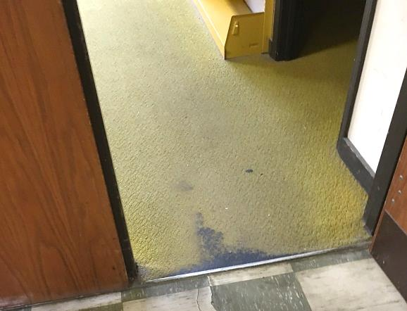
Severely worn carpet
Picture 2
Exposed carpet seams
Picture 3
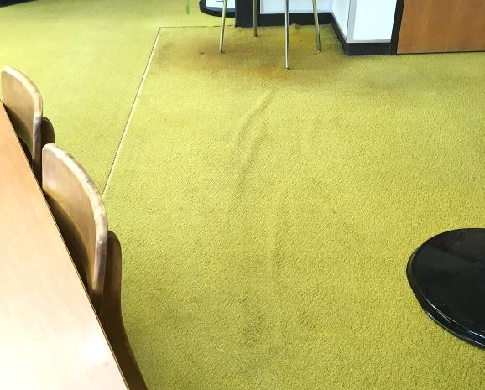
Rippled carpet
Picture 4
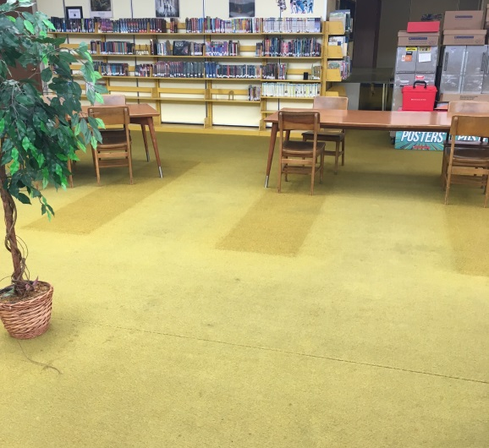
Faded carpet
Picture 5
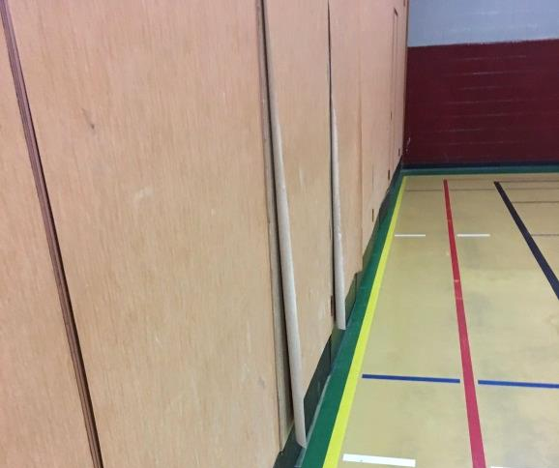
Peeling wall paper from dividers

Location | Carbon  Dioxide  (ppm) | Carbon Monoxide  (ppm) | Temp  (°F) | Relative  Humidity  (%) | PM2.5  (µg/m³) | Occupants  in Room | Windows  Openable | Ventilation |  | Remarks
 |  |  |  |  |  |  |  | Supply | Exhaust
Background | 288 | ND | 38 | 29 | 2
403 | 690 | ND | 71 | 20 | 1 | 7 | N | Y | Y
404 | 691 | ND | 72 | 20 | 1 | 2 | N | Y | Y
Cafeteria | 818 | ND | 73 | 20 | 1 | 22 | N | Y | Y
502 | 837 | ND | 73 | 16 | 2 | 26 | N | Y | Y | Carpet
507 | 770 | ND | 72 | 18 | 1 | 0 | N | Y | Y
508 | 739 | ND | 72 | 18 | 1 | 1 | N | Y | Y
509 | 762 | ND | 72 | 18 | 1 | 1 | N | Y | Y
510 | 829 | ND | 73 | 19 | 1 | 21 | N | Y | Y
521 | 792 | ND | 72 | 19 | 1 | 0 | N | Y | Y | Carpet
522 | 937 | ND | 71 | 21 | 3 | 21 | N | Y | Y | Carpet
523 | 908 | ND | 70 | 20 | 3 | 3 | N | Y | Y | Carpet
524 | 792 | ND | 70 | 19 | 2 | 3 | N | Y | Y | Carpet
525 | 780 | ND | 70 | 19 | 2 | 0 | N | Y | Y | Carpet
531 | 652 | ND | 74 | 16 | 1 | 15 | N | Y | Y | Carpet
532 | 573 | ND | 73 | 15 | 1 | 15 | N | Y | Y | Carpet
533 | 556 | ND | 73 | 15 | 1 | 15 | N | Y | Y | Carpet
535 | 539 | ND | 73 | 15 | 1 | 0 | N | Y | Y | Carpet
536 | 509 | ND | 72 | 15 | 1 | 0 | N | Y | Y | Carpet
600 | 406 | ND | 73 | 14 | 1 | 4 | N | Y | Y
605 | 417 | ND | 69 | 14 | 1 | 16 | N | Y | Y
610 | 423 | ND | 74 | 14 | 1 | 0 | N | Y | Y
611 | 492 | ND | 71 | 16 | 4 | 1 | N | Y | Y
620 | 346 | ND | 73 | 12 | 1 | 0 | N | Y | Y
621 | 382 | ND | 72 | 13 | 1 | 1 | N | Y | Y | Carpet
623 | 358 | ND | 73 | 14 | 1 | 2 | N | Y | Y
624 | 332 | ND | 72 | 13 | 1 | 0 | N | Y | Y | Carpet
625 | 341 | ND | 74 | 13 | 2 | 2 | N | Y | Y
626 | 345 | ND | 73 | 13 | 1 | 0 | N | Y | Y
627 | 366 | ND | 74 | 13 | 2 | 3 | N | Y | Y
631 | 488 | ND | 71 | 13 | 3 | 1 | N | Y | Y | Carpet
632 | 465 | ND | 71 | 15 | 1 | 0 | N | Y | Y | Carpet
633 | 548 | ND | 72 | 16 | 2 | 0 | N | Y | Y | Carpet
634 | 578 | ND | 72 | 16 | 2 | 1 | N | Y | Y | Carpet
636 | 525 | ND | 72 | 15 | 2 | 3 | N | Y | Y | Carpet
637 | 500 | ND | 72 | 15 | 2 | 4 | N | Y | Y | Carpet
638 | 589 | ND | 72 | 16 | 3 | 1 | N | Y | Y | Carpet
642 | 641 | ND | 73 | 16 | 1 | 18 | N | Y | Y
Library | 413 | ND | 70 | 15 | 1 | 13 | N | Y | Y | Carpet
Band Room | 328 | ND | 72 | 13 | 1 | 0 | N | Y | Y | Carpet

The service life is the median time during which a particular system or component of …[an HVAC]… system remains in its original service application and then is replaced. Replacement may occur for any reason, including, but not limited to, failure, general obsolescence, reduced reliability, excessive maintenance cost, and changed system requirements due to such influences as building characteristics or energy prices (ASHRAE, 1991).

