INDOOR AIR QUALITY ASSESSMENT

White Brook Middle School
200 Park Street
Easthampton, MA

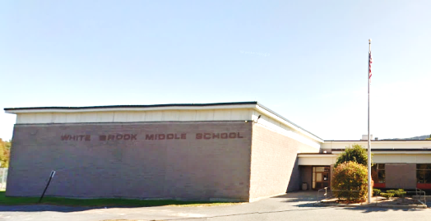

Prepared by:
Massachusetts Department of Public Health
Bureau of Environmental Health
Indoor Air Quality Program
June 2018

Background

Building: | White Brook Middle School (WBMS)
Address: | 200 Park Street, Easthampton, MA
Assessment Requested by: | A parent
Reason for Request: | General indoor air quality (IAQ) concerns
Date of Assessment: | June 8, 2018
Massachusetts Department of Public Health/Bureau of Environmental Health (MDPH/BEH) Staff Conducting Assessment: | Michael Feeney, Director, IAQ Program
Date of Building Construction: | 1976
Building Description: | Single story, multi-wing facility
Building Population: | Approximately 450 students in grades 5 to 8 and 50 staff members
Windows: | Mostly openable

BACKGROUND
The IAQ program has previously visited the WBMS in 2003 and 2016. The most recent 2016 assessment has been included as Appendix A to this report. It is our understanding that the school was the subject of a successful vote for replacement in May 2018 (MassLive, 2018). In general, it will take several years for a new building to be constructed. Therefore the various recommendations in this report are geared towards improving/maintaining the conditions within the building to the extent possible while recognizing that the building will be replaced in the near future.
Under current Massachusetts School Building Authority (MSBA) regulations, the expected service life of a newly constructed or renovated school building is at least 50 years [963 CMR 2.03(b)]. Given that the WBMS is approximately 43 years old, it is expected that a number of building componenets have exceeded their expected service life, which will likely require increased maintenance or removal/replacment as needed until the building is replaced.

METHODS
Please refer to the IAQ Manual for methods, sampling procedures, and interpretation of results (MDPH, 2015).

RESULTS and DISCUSSION
The following is a summary of indoor air testing results (Table 1).
- Carbon dioxide levels were above the MDPH guideline of 800 parts per million (ppm) 9 of 38 areas surveyed, indicating a lack of air exchange in about a quarter of the areas tested.
- Temperature was within the recommended range of 70°F to 78°F.
- Relative humidity was within or very close to the recommended range of 40 to 60%.
- Carbon monoxide levels were non-detectable in all areas tested.
- Fine particulate matter (PM2.5) concentrations measured were below the National Ambient Air Quality Standard (NAAQS) level of 35 μg/m³ in all areas assessed.

At the time of assessment, it was noted that mechanical systems were not operating in some areas, particularly the gymnasiums. To maximize air exchange, the BEH recommends that mechanical ventilation systems operate continuously during periods of occupancy. Without the system operating as designed, normally occurring pollutants cannot be diluted or removed, allowing them to build up and lead to IAQ/comfort complaints.

Ventilation
A thorough description of the heating, ventilating, and air conditioning (HVAC) systems exist in the 2016 IAQ assessment, included as Appendix A. It is important to note that while the supply of fresh air was adequate in warm weather during this visit (e.g., with windows/dampers open), the 2016 IAQ assessment indicates reduced air circulation.
It is important to note that the HVAC system dates from the 1970s. Controlling temperatures in a large building with variable occupancy is difficult, and more so because many of the HVAC and associated equipment is over 40 years old. Efficient function of equipment of this age is difficult to maintain, since compatible replacement parts are often unavailable. According to the American Society of Heating, Refrigeration and Air-Conditioning Engineering (ASHRAE), the service life for the various components of the HVAC system is between 20 to 30 years, assuming routine maintenance of the equipment (ASHRAE, 1991). Despite attempts to maintain the equipment, the optimal operational lifespan of this equipment has been exceeded.
In this condition, normally-occurring environmental pollutants can build up in the indoor environment due to sub-par functioning of the HVAC system. For this reason, methods to reduce sources of dust, debris, and other potential irritants should be implemented. The 2016 report included in Appendix A has additional information on sources of irritants found in the school during that visit.

Microbial/Moisture Concerns
Water-damaged ceiling tiles were observed in a number of areas. Chronically wet ceiling tiles that remain in place can become mold colonized if moistened for longer than 24 hours. Missing ceiling tiles can also allow dust/debris in the plenum system to enter occupied spaces. The US Environmental Protection Agency (US EPA) and the American Conference of Governmental Industrial Hygienists (ACGIH) recommend that porous materials be dried with fans and heating within 24 to 48 hours of becoming wet (US EPA, 2008; ACGIH, 1989). If not dried within this time frame, mold growth may occur. Once mold has colonized porous materials, they are difficult to clean and should be removed/discarded.

Carpeting
Wall to wall carpeting exists in classroom areas and the library. Both the 2003 and 2016 IAQ reports made recommendations with regarding the cleaning and/or removal of carpeting (Appendix A). It is important to note that the carpeting examined during the 2003 IAQ assessment appears to be the same carpet that is currently in classrooms and media center, which was likely installed during the original construction of the building in 1976. Signs of wear such as lost carpet pile (Picture 1), shrinkage exposing seams (Picture 2), rippling (Picture 3) and the fading (Picture 4) all show the degree to which carpeting has degraded. Carpeting in schools, if well maintained, is expected to have a service life of 7 to 11 years (IICRC, 2002; Bishop, 2002). Worn carpet can be a source of dust, debris and other pollutants that can become readily aerololized when trod upon. This condition can be exacerbated by low humidity that will occur during the heating season. Elevated particulate matter was noted in the 2016 IAQ report, where over 20% of the areas assessed had PM 2.5 particle measurements that were above the NAAQS of 35 μg/m³ (Appendix A). Increased PM2.5 can result in eye, nose, and respiratory system irritation. Individuals with a pre-existing respiratory condition such as asthma may experience increased symptoms.

Other Conditions
Tennis balls were found sliced open and placed around chair legs to reduce noise (Table 1), which was previously noted in the 2016 report (Appendix A). Tennis balls are made of a number of materials that are a source of respiratory irritants. Constant wearing of tennis balls can produce fibers and lead to off-gassing of VOCs. Tennis balls are made with a natural rubber latex bladder, which becomes abraded when used as a chair leg pad. Use of tennis balls in this manner may introduce latex dust into the school environment. Some individuals are highly allergic to latex (e.g., spina bifida patients) (SBAA, 2001). It is recommended that the use of materials containing latex be limited in buildings to reduce the likelihood of symptoms in sensitive individuals (NIOSH, 1997; NIOSH, 1998).
Dust control continues to be a significant problem. A large number of surfaces throughout the school were found with accumulated dust. Dust was observed on items and surfaces, including personal fans, supply vents, radiators and tabletops. Dust can be irritating to the eyes, nose and respiratory tract. Dust on ventilation equipment and fans should be cleaned to prevent re-aerosolization when the system is activated. To prevent dust buildup and redistribution, flat surfaces should also be wiped and cleaned with a vacuum equipped with the high efficiency particulate arrestance (HEPA) filter or wet wiped on a regular basis.
The gymnasium uses floor-to-ceiling dividers to separate Gym A and B from Gym C. The dividers have holes and are covered with vinyl wallpaper, which was peeling (Picture 5). One cement block wall in Gyms A and B was found to have peeling paint. Due to the age of the building, the peeling paint may contain lead. Lead paint should be remediated in a manner consistent with Massachusetts lead paint laws and regulations.
Refer to 2016 IAQ report for other conditions noted that remain present inside the building (Appendix A).

Conclusions/Recommendations
The building is scheduled to be replaced, however that process will take several years before a new building is open. Therefore, the following recommendations are designed to improve/maintain indoor air quality of the current building until the new building is opened.
Of primary concern is the reduction of airborne particles that appear to be associated with the 43-year-old carpeting. The IAQ Program recommends that the wall-to-wall carpeting be removed from classrooms and media center to reduce airborne dust. Until this is done, the carpeting will continue to be a source of respirable particulates no matter the amount of cleaning and/or operation of the HVAC system. Also given the age of the HVAC system, it is also recommended that improved cleaning activities be implemented throughout the school. To the extent possible, the operation of ventilation equipment should be improved when the building is occupied. The following recommendations are provided to improve IAQ for the duration of use of the building:
- Implement all remaining recommendations in the 2016 IAQ report. It appears that minimal implementation of recommendations made in the 2016 IAQ report (Appendix A) have been conducted to date.
- Remove wall-to-wall carpeting.
- Determine if peeling paint in the gyms contain lead. If paint contains lead, remove paint in a manner consistent with Massachusetts lead paint laws and regulations. If no lead is present, remove peeling paint.
- Remove tennis balls from the legs of desks and chairs and replace with a non-latex-containing material.
- Operate supply and exhaust ventilation continuously in all areas during occupied periods.
- During temperate weather, use windows/doors to supplement fresh air and increase cross-ventilation.
- Ensure all HVAC equipment is maintained and supply vents are cleaned periodically to prevent dust re-aerosolization.

References
ACGIH. 1989. Guidelines for the Assessment of Bioaerosols in the Indoor Environment. American Conference of Governmental Industrial Hygienists, Cincinnati, OH.
ASHRAE. 1991. ASHRAE Applications Handbook, Chapter 33 “Owning and Operating Costs”. American Society of Heating, Refrigeration and Air Conditioning Engineers, Atlanta, GA.
Bishop. 2002. Bishop, J. & Institute of Inspection, Cleaning and Restoration Certification. A Life Cycle Cost Analysis for Floor Coverings in School Facilities.
IICRC. 2002. Institute of Inspection, Cleaning and Restoration Certification. Carpet Cleaning: A Life-cycle Cost Analysis for Floor Coverings in School Facilities.
MassLive. 2018. Easthampton voters OK new school construction 2,829 to 2,101. https://www.masslive.com/news/index.ssf/2018/05/easthampton_school_vote_failss.html
MDPH. 2015. Massachusetts Department of Public Health. Indoor Air Quality Manual: Chapters I-III. Available at: http://www.mass.gov/eohhs/gov/departments/dph/programs/environmental-health/exposure-topics/iaq/iaq-manual/.
NIOSH. 1997. National Institute for Occupational Safety and Health. Alert Preventing Allergic Reactions to Natural Rubber latex in the Workplace. National Institute for Occupational Safety and Health, Atlanta, GA.
NIOSH. 1998. National Institute for Occupational Safety and Health. Latex Allergy A Prevention. National Institute for Occupational Safety and Health, Atlanta, GA.
SBAA. 2001. Latex In the Home And Community Updated Spring 2001. Spina Bifida Association of America, Washington, DC.
US EPA. 2008. “Mold Remediation in Schools and Commercial Buildings”. Office of Air and Radiation, Indoor Environments Division, Washington, DC. EPA 402-K-01-001. Available at: https://www.epa.gov/mold/mold-remediation-schools-and-commercial-buildings-guide.
Picture 1
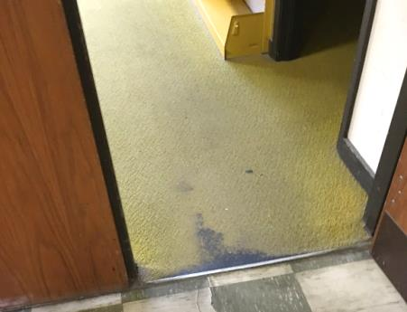
Severely worn carpet
Picture 2
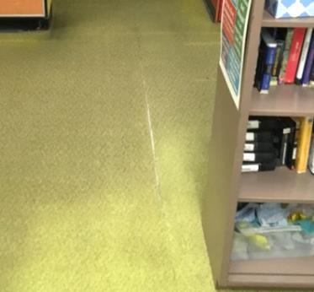
Exposed carpet seams
Picture 3
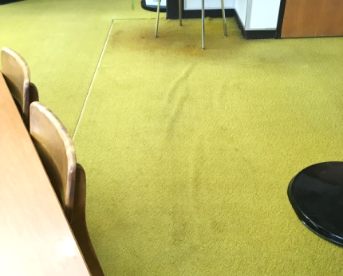
Rippled carpet
Picture 4
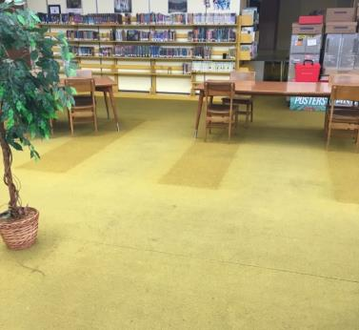
Faded carpet
Picture 5
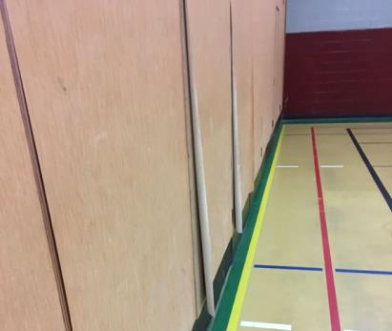
Peeling wall paper from dividers

Location | Carbon  Dioxide  (ppm) | Carbon Monoxide  (ppm) | Temp  (°F) | Relative  Humidity  (%) | PM2.5  (µg/m³) | Occupants  in Room | Windows  Openable | Ventilation |  | Remarks
 |  |  |  |  |  |  |  | Supply | Exhaust
Background | 422 | ND | 76 | 27 | 14 |  |  |  |  | Sunny
403 | 829 | ND | 76 | 54 | 11 | 2 | N | Y | Y | Tennis ball, floor fan
404 | 845 | ND | 77 | 53 | 8 | 5 | N | Y | Y | Tennis ball
407 Computer room | 1048 |  | 78 | 53 | 7 | 19 | N | Y | Y | 1 water-damaged ceiling tiles
509 | 845 | ND | 77 | 55 | 5 | 12 | Y | Y | Y | Tennis balls
512 | 834 | ND | 77 | 53 | 8 | 2 | N | Y | Y | Tennis balls
530 | 750 | ND | 77 | 56 | 9 | 15 | Y | Y | Y
531 | 647 | ND | 77 | 54 | 7 | 0 | N | Y | Y
532 | 652 | ND | 77 | 54 | 8 | 1 | Y | Y | Y
533 | 648 | ND | 77 | 54 | 6 | 0 | N | Y | Y
534 | 683 | ND | 78 | 54 | 6 | 0 | Y | Y | Y
535 | 802 | ND | 78 | 55 | 10 | 21 | Y | Y | Y
536 | 680 | ND | 77 | 55 | 7 | 11 | Y | Y | Y
537 | 675 | ND | 77 | 54 | 8 | 0 | Y | Y | Y
603 | 705 |  | 78 | 53 | 8 | 23 | N | Y | Y | Tennis balls
608 | 687 | ND | 77 | 55 | 5 | 0 | N | Y | Y | 7 water-damaged ceiling tiles
609 | 684 | ND | 77 | 53 | 5 | 23 | Y | Y | Y
610 | 648 | ND | 77 | 55 | 5 | 23 | Y | Y | Y | 1 water-damaged ceiling tiles  Plants
611 | 574 | ND | 76 | 55 | 5 | 3 | N | Y | Y
621 | 645 |  | 78 | 53 | 6 | 0 | Y | Y | Y
622 | 670 |  | 78 | 53 | 6 | 2 | Y | Y | Y
623 | 660 |  | 78 | 54 | 6 | 4 | Y | Y | Y
624 | 743 |  | 78 | 56 | 7 | 15 | Y | Y | Y
625 | 650 |  | 77 | 55 | 6 | 0 | Y | Y | Y
626 | 710 |  | 77 | 56 | 7 | 5 | Y | Y | Y | 2 water-damaged ceiling tiles
627 | 870 |  | 77 | 61 | 6 | 21 | N | Y | Y
631 | 566 | ND | 75 | 56 | 5 | 1 | N | Y | Y
632 | 573 | ND | 75 | 56 | 6 | 0 | Y | Y | Y | Plant
635 | 570 | ND | 76 | 55 | 5 | 1 | N | Y | Y
East cafeteria | 821 |  | 77 | 59 | 6 | 27 | N | Y | Y | Floor fan
Gym A | 846 | ND | 75 | 59 | 9 | 30+ | N | Y | Y | Peeling paint, peeling wall paper
Gym C | 732 | ND | 74 | 54 | 4 | 0 | N | Y | Y
Labs | 756 | ND | 76 | 55 | 5 | 3 | N | Y | Y
Labs | 771 | ND | 76 | 55 | 7 | 1 | N | Y | Y | Floor fan
Main Office | 603 | ND | 75 | 54 | 6 | 1 | N | Y | Y
Media center | 795 |  | 77 | 51 | 7 | 0 | N | Y | Y | Plants
Music | 521 | ND | 75 | 51 | 3 | 0 | N | Y | Y
Nurse | 538 | ND | 74 | 54 | 6 | 1 | N | Y | Y | Tennis balls
South cafeteria | 737 | ND | 77 | 55 | 5 | 6 | Y | Y | Y

The service life is the median time during which a particular system or component of …[an HVAC]… system remains in its original service application and then is replaced. Replacement may occur for any reason, including, but not limited to, failure, general obsolescence, reduced reliability, excessive maintenance cost, and changed system requirements due to such influences as building characteristics or energy prices (ASHRAE, 1991).

