OCTOBER IS WHITE CANE AWARENESS MONTH

The white cane is a symbol of independence and blindness. The white cane allows an Individual who is legally blind to travel independently. In 1931, the Lions Club began promoting the use of white canes for people who are blind as a national identification program.

International White Cane Day is October 15. All states and many other countries have White Cane laws, which allow pedestrians, who are legally blind, the right of way at street crossings. Most people who are legally blind have some usable vision.

When in doubt, ask if the person needs assistance.
Do not grab the person, cane or guide dog!
Do not distract or pet a guide dog.

Massachusetts White Cane Law states that All motorists, when they see a pedestrian who uses a guide dog or a white cane at a street crossing, must come to a complete stop.

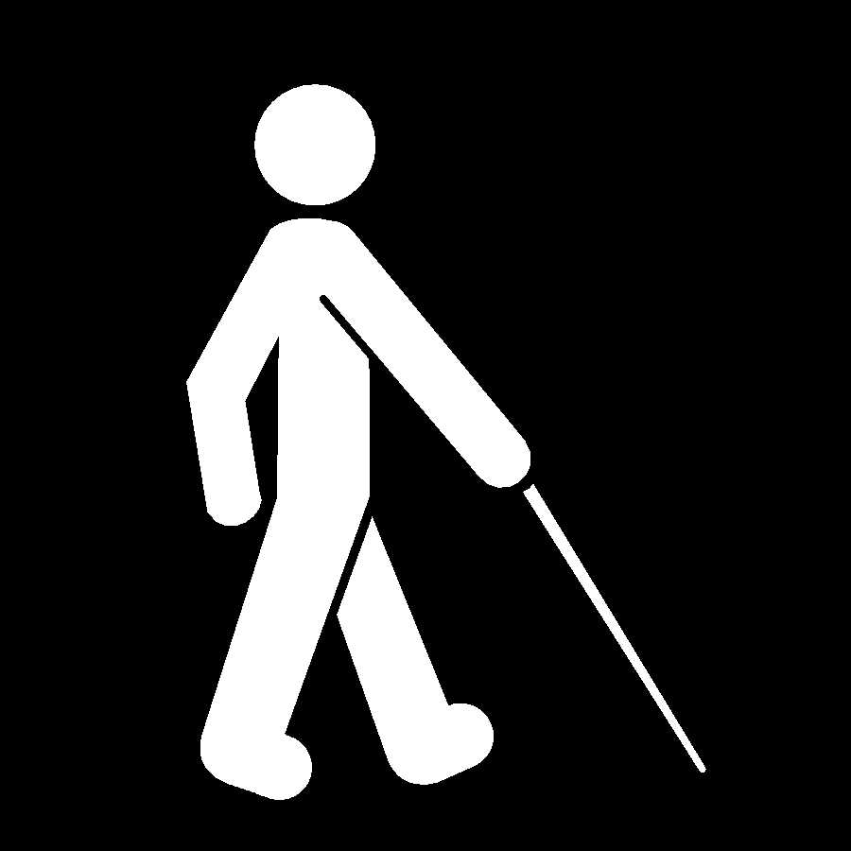
Top Ten List of DON'Ts
For Motorists When They See a Pedestrian
Using a White Cane or Guide Dog at a Street Crossing

(Adapted from “The Ten List of What Motorists Shouldn’t Do When They See A Blind Person” Hazard/Zelaya 1998)

10. Don’t stop your vehicle more than five feet from the crosswalk line.

- Don’t yell out “It’s OK to cross”.

- Don’t get impatient when waiting for pedestrian who is visually impaired to cross. If the pedestrian places the long cane into the street, it usually indicates a street crossing will begin. If the cane user takes a step back & pulls back the cane from the curb, it usually indicates the pedestrian may not be crossing at that time.

7. Don’t consider a “rolling” stop as a complete stop. A stop sign means STOP!

- Don’t turn right on red without coming to a full stop and looking for pedestrians on left and right. The Right on Red Law requires drivers to come to a complete stop prior to making right turn.

- Don’t fail to stop for pedestrians at all crosswalks. Come to a full STOP!

4. Don’t stop vehicle in the middle of a crosswalk.

- Don’t pass another vehicle, stopped, which may be waiting for pedestrians to cross the street.

- Don’t wave to pedestrians who are using a white cane or dog guide, to indicate that you are waiting for them to cross. They CAN NOT see you.

- Don’t HONK!

Massachusetts White Cane Law: All motorists, when they see a pedestrian who uses a guide dog or a white cane at a street crossing, must come to a complete stop.

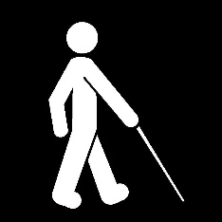
Please Come to
Massachusetts White Cane Day Celebration

Celebrate the independence of white canes
and
raise public awareness of the White Cane Law!

Monday, October 21, 2019
Massachusetts Statehouse, Boston MA
(Drop off address at 122 Bowdoin St., Boston 02108)
10-Noon-Grand Hall

Celebrate with White Cane & Guide Dog Users, Families, Friends, Orientation & Mobility Specialists, Vision Professionals, and Others to raise White Cane Awareness!

To register for the event on Eventbrite go to
https://www.eventbrite.com/e/white-cane-celebration-2019-tickets-67975351105?utm-campaign=social%2Cemail&utm-content=attendeeshare&utm-medium=discovery&utm-source=strongmail&utm-term=checkoutwidget
For more information or ADA requests (due by 10/5/18) contact the Mass. Commission for the Blind, Orientation and Mobility Department at 617-626-7581

Thanks to Bay State Council of the Blind, Massachusetts National Federation of the Blind and the Mass. Lions Club for their continued support of this event.

Massachusetts White Cane Law: General Law Chapter 90 Section 14A
Stop for White Cane and Dog Guide Users at Street Crossings-It’s the LAW!
October Is
White Cane
Awareness Month

Stop for White Cane
And
Guide Dog Users
At
Street Crossings
It’s the LAW!

Massachusetts White Cane Law: General Law Chapter 90 Section 14A
For more information, contact the Massachusetts Commission for the Blind
at 617-626-7581/V or www.mass.gov/mcb

