INDOOR AIR QUALITY ASSESSMENT

Department of Children and Families
South Central Area Office
185 Church Street
Whitinsville Section of
Northbridge, MA

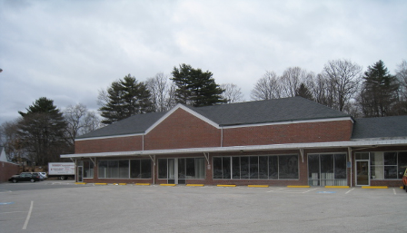

Prepared by:
Massachusetts Department of Public Health
Bureau of Environmental Health
Indoor Air Quality Program
July 2014

Background/Introduction
In response to a request by Erin McCabe, Field Operations Manager, Executive Office of Health and Human Services, Office of Leasing and State Owned Properties, the Massachusetts Department of Public Health (MDPH), Bureau of Environmental Health (BEH) provided assistance and consultation regarding indoor air quality (IAQ) and water damage following a flooding event at the Department of Children and Families (DCF), South Central Area Office located at 185 Church Street, Whitinsville, Massachusetts. Ms. McCabe reported that water penetrated into the DCF space following heavy precipitation during the weekend of March 29-30, 2014.
On April 4, 2014, a visit was made by Sharon Lee, Environmental Analyst/Inspector from BEH’s IAQ Program. At the time of that visit, an assessment detailing the extent of water damage was conducted in areas where flooding occurred. In addition, a general IAQ evaluation was conducted in areas not impacted by flooding. On April 9, 2014, Ms. Lee returned to the DCF area office with Cory Holmes, Environmental Analyst/ Regional Inspector from BEH’s IAQ Program, for follow-up regarding remediation activities of flood-impacted areas.
The DCF occupies space in a 50-year old, one-story building that formerly served as a supermarket. The DCF has occupied the space for over 30 years. The building has a red brick exterior and a peaked, asphalt-shingled roof. Interior areas have gypsum wallboard (GW) walls and carpet squares. Windows are openable in some areas of the building.

Methods
Air tests for carbon dioxide, carbon monoxide, temperature, and relative humidity were taken with the TSI, Q-Trak, IAQ Monitor 7565. Air tests for airborne particle matter with a diameter less than 2.5 micrometers were taken with the TSI, DUSTTRAK™ Aerosol Monitor Model 8520. Moisture content of porous building materials (i.e., GW and carpeting) was measured using a Delmhorst, BD-2000 Model Moisture Detector. BEH/IAQ staff also performed a visual inspection of building materials for water damage and/or microbial growth.

Results
The building currently houses approximately 40 employees. General IAQ tests were taken during normal operations. Results of the general IAQ evaluation conducted on April 4, 2014 in non-affected areas appears in Table 1. Figure 1 depicts flood impacted areas, including locations where materials were wet at the time of MDPH assessment.

Discussion

Ventilation
It can be seen from Table 1 that carbon dioxide levels were above 800 parts per million (ppm) in all areas surveyed on April 4, 2014, indicating inadequate air exchange in the building at the time of assessment. Fresh air is provided by ceiling-mounted diffusers ducted to air-handling units (AHUs) located on the roof. Air is ducted back to AHUs via ceiling-mounted return vents.
The heating, ventilation, and air conditioning (HVAC) system is controlled by digital thermostats. Thermostats examined had a fan switch with two settings, on and auto. When the fan is set to on, the system provides a continuous source of air circulation and filtration. The automatic setting on the thermostat activates the HVAC system at a pre-set temperature. Once the pre-set temperature is reached, the HVAC system is deactivated. Therefore, no mechanical ventilation is provided until the thermostat re-activates the system. At the time of assessment, all thermostat fan settings were in the “auto” position. As mentioned, this thermostat setting can limit airflow. The MDPH typically recommends that thermostats be set to the fan on setting during occupied hours to provide continuous air circulation. The fan “auto” setting can lead to IAQ/comfort complaints due to lack of air exchange.
To maximize air exchange, the MDPH recommends that both supply and exhaust ventilation operate continuously during periods of occupancy. In order to have proper ventilation with a mechanical supply and exhaust system, the systems must be balanced to provide an adequate amount of fresh air to the interior of a room while removing stale air from the room. It is recommended that HVAC systems be re-balanced every five years to ensure adequate air systems function (SMACNA, 1994).
Minimum design ventilation rates are mandated by the Massachusetts State Building Code (MSBC). Until 2011, the minimum ventilation rate in Massachusetts was higher for both occupied office spaces and general classrooms, with similar requirements for other occupied spaces (BOCA, 1993). The current version of the MSBC, promulgated in 2011 by the State Board of Building Regulations and Standards (SBBRS), adopted the 2009 International Mechanical Code (IMC) to set minimum ventilation rates. Please note that the MSBC is a minimum standard that is not health-based. At lower rates of cubic feet per minute (cfm) per occupant of fresh air, carbon dioxide levels would be expected to rise significantly. A ventilation rate of 20 cfm per occupant of fresh air provides optimal air exchange resulting in carbon dioxide levels at or below 800 ppm in the indoor environment in each area measured. MDPH recommends that carbon dioxide levels be maintained at 800 ppm or below. This is because most environmental and occupational health scientists involved with research on IAQ and health effects have documented significant increases in indoor air quality complaints and/or health effects when carbon dioxide levels rise above the MDPH guidelines of 800 ppm for schools, office buildings and other occupied spaces (Sundell et al., 2011). The ventilation must be on at all times that the room is occupied. Providing adequate fresh air ventilation with open windows and maintaining the temperature in the comfort range during the cold weather season is impractical. Mechanical ventilation is usually required to provide adequate fresh air ventilation.
Carbon dioxide is not a problem in and of itself. It is used as an indicator of the adequacy of the fresh air ventilation. As carbon dioxide levels rise, it indicates that the ventilating system is malfunctioning or the design occupancy of the room is being exceeded. When this happens, a buildup of common indoor air pollutants can occur, leading to discomfort or health complaints. The Occupational Safety and Health Administration (OSHA) standard for carbon dioxide is 5,000 parts per million parts of air (ppm). Workers may be exposed to this level for 40 hours/week, based on a time-weighted average (OSHA, 1997).
The MDPH uses a guideline of 800 ppm for publicly occupied buildings. A guideline of 600 ppm or less is preferred in schools due to the fact that the majority of occupants are young and considered to be a more sensitive population in the evaluation of environmental health status. Inadequate ventilation and/or elevated temperatures are major causes of complaints such as respiratory, eye, nose and throat irritation, lethargy and headaches. For more information concerning carbon dioxide, please see Appendix A.
Indoor temperature measurements at the time of the April 4, 2014 assessment ranged from 71° F to 78° F in occupied spaces (Table 1), which were within the MDPH recommended comfort range. The MDPH recommends that indoor air temperatures be maintained in a range of 70° F to 78° F in order to provide for the comfort of building occupants. In many cases concerning indoor air quality, fluctuations of temperature in occupied spaces are typically experienced, even in a building with an adequate fresh air supply.
Indoor relative humidity measurements at the time of the April 4, 2014 assessment ranged from 26 to 34 percent (Table 1), which were below the MDPH recommended comfort range. The MDPH recommends a comfort range of 40 to 60 percent for indoor air relative humidity. Humidity levels in the building would be expected to drop during the heating season. The sensation of dryness and irritation is common in a low relative humidity environment. Low relative humidity is a very common problem during the heating season in the northeast part of the United States.

Microbial/Moisture Concerns

Flooding-related Observations
DCF staff reported that approximately 70 percent of occupant spaces were damaged when water entered the building through two rear doors following a heavy rain that occurred during the weekend of March 29-30, 2014. DCF staff discovered several inches of water in cubicles when work resumed on Monday. DCF notified the property manager, who contacted a remediation firm, M.A. Restoration, Inc. The remediation firm was reportedly on-site Monday and began drying affected materials (e.g., GW, carpets) using fans, heat, and dehumidifiers. Plastic barriers were reportedly installed at that time to separate affected areas from occupied areas.
At the time of the MDPH inspection, the BEH/IAQ staff observed conditions around the exterior of the building on April 4, 2014. Poor drainage at the rear of the building likely resulted in water penetrating DCF office space. DCF staff reported that sewer drains designed to remove water from the back of the building were occluded with leaves/debris. At the time of the assessment, BEH/IAQ staff observed leaves around the sewer grates, high water level within sewer drains, and pooling water (Pictures 1 and 2). Water shedding off the hill behind the building likely added to the water load (Picture 3). In anticipation of weekend precipitation, BEH/IAQ staff recommended that sandbags be placed around the exterior to direct water away from the building. DCF staff reported that building management had sandbags installed the evening of April 4, 2014.
Drying activities were still on-going at the time of the April 4, 2014 assessment. As mentioned, plastic barriers were used to separate affected areas from un-affected areas (Pictures 4 and 5); however, staff indicated concerns that the plastic ‘doors’ were not preventing movement of dust/debris into occupied areas. BEH/IAQ staff examined carpet tiles and conducted moisture testing on all walls in the impacted area. Carpet tiles were dry at the time of assessment, although some tiles were no longer adhered to the floor. BEH/IAQ staff noted that vinyl coving had been removed, and holes were cut into the walls to allow for proper drying (Picture 6). Bookcases and file cabinets were also elevated to allow air circulation and thorough drying of carpets (Picture 7). Tubes were inserted into the holes of some walls to allow air to be pumped into the wall cavity, which aided drying (Picture 8). Although walls were dry in many of the areas affected, some GW was wet at the time of the April 4, 2014 assessment (Figure 1).
During the April 4, 2014 assessment, BEH/IAQ staff also observed paper files/materials damaged by water (Picture 9). While steps were taken to dry these materials, measures should also be taken to ensure that items such as books are dried thoroughly. Due to its compressed nature, the binding of books can often hold moisture. Furthermore, the glues used to adhere pages to the book cover can be a source of nutrients for mold to grow.
At the conclusion of the April 4, 2014 assessment, BEH/IAQ staff recommended:
- Remove at least 2-feet of GW, particularly where walls were still saturated (e.g., small offices), to prevent the potential for mold growth.
- Remove water-damaged GW that is painted with chalkboard paint, since the paint had created a barrier that prevented thorough drying.
- Replace lifting carpet floor tiles with new carpet tiles.
- Consider installing vinyl floor tiles in the access areas for the two exterior doors at the rear of the office space (Picture 10).
- Install zipping plastic barriers to create access to water-damaged areas.
- Install a fan or HEPA-filtered air purifier near access ways to remediation areas to prevent movement of dust into occupant areas.
- Implement the following prior to re-occupying affected spaces that have been dried:
  - Create barriers using plastic and tape to contain affected offices and prevent movement of materials from these offices into occupied areas.
  - Until baseboards can be replaced, seal shared walls with plastic and tape to prevent aerosolization of insulation into the affected cubicle areas via drying holes that were cut out.
  - Thoroughly clean (e.g., HEPA vacuum, wet wipe) office spaces to prevent irritation from debris.
  - Thoroughly clean carpet (e.g., intensive annual cleaning) once remediation is complete.
- Consider scanning/copying water-damaged paper files that cannot dry properly to prevent potential for mold growth.
During the follow-up assessment on April 9, 2014, BEH/IAQ staff noted sandbags were in place behind the building to prevent future flooding (Picture 11). BEH/IAQ staff observed that GW and insulation in a number of areas had been removed and/or replaced (Figure 1; Pictures 12 and 13). BEH/IAQ staff took moisture measurements to ensure all wet materials were dry; all GW that was not removed had dried.
The US Environmental Protection Agency (US EPA) and the American Conference of Governmental Industrial Hygienists (ACGIH) recommend that porous materials (e.g., carpeting, GW) be dried with fans and heating within 24 to 48 hours of becoming wet (US EPA, 2001; ACGIH, 1989). If not dried within this time frame, mold growth may occur. Once mold has colonized porous materials, they are difficult to clean and should be removed/discarded.

General/Building-wide Observations
Plants were noted in some areas (Table 1). Plants can be a source of pollen and mold, which can be respiratory irritants to some individuals. Plants should be properly maintained and equipped with drip pans and should be located away from air supplies to prevent the aerosolization of dirt, pollen and mold.
Water coolers and small refrigerators were observed in carpeted areas. Spills or leaks from this equipment can moisten carpet and lead to microbial growth and degradation of the carpet. MDPH recommends placing rubber or plastic trays beneath this equipment to protect the carpet from any leaks.
During an examination of the building exterior, BEH/IAQ staff observed efflorescence and missing mortar, particularly at the rear of the building (Picture 14). Efflorescence is a characteristic sign of water damage to brick and mortar, but it is not mold growth. As moisture penetrates and works its way through mortar, brick or plaster, water-soluble compounds dissolve, creating a solution. As the solution moves to the surface of the material, the water evaporates, leaving behind white, powdery mineral deposits. The aforementioned conditions are indicative of the chronic moisture experienced at the back of the building. Over time, these conditions can undermine the integrity of the building envelope and provide a means of water entry into the building via capillary action through foundation concrete and masonry (Lstiburek & Brennan, 2001). In addition, these breaches may provide a means for pests/rodents into the building.

Other IAQ Evaluations
Indoor air quality can be negatively influenced by the presence of respiratory irritants, such as products of combustion. The process of combustion produces a number of pollutants. Common combustion emissions include carbon monoxide, carbon dioxide, water vapor, and smoke (fine airborne particle material). Of these materials, exposure to carbon monoxide and particulate matter with a diameter of 2.5 micrometers (μm) or less (PM2.5) can produce immediate, acute health effects upon exposure. To determine whether combustion products were present in the indoor environment, BEH/IAQ staff obtained measurements for carbon monoxide and PM2.5.

Carbon Monoxide
Carbon monoxide is a by-product of incomplete combustion of organic matter (e.g., gasoline, wood and tobacco). Exposure to carbon monoxide can produce immediate and acute health effects. Several air quality standards have been established to address carbon monoxide and prevent symptoms from exposure to these substances. The MDPH established a corrective action level concerning carbon monoxide in ice skating rinks that use fossil-fueled ice resurfacing equipment. If an operator of an indoor ice rink measures a carbon monoxide level over 30 ppm, taken 20 minutes after resurfacing within a rink, that operator must take actions to reduce carbon monoxide levels (MDPH, 1997).
The American Society of Heating Refrigeration and Air-Conditioning Engineers (ASHRAE) has adopted the National Ambient Air Quality Standards (NAAQS) as one set of criteria for assessing indoor air quality and monitoring of fresh air introduced by HVAC systems (ASHRAE, 1989). The NAAQS are standards established by the US EPA to protect the public health from six criteria pollutants, including carbon monoxide and particulate matter (US EPA, 2006). As recommended by ASHRAE, pollutant levels of fresh air introduced to a building should not exceed the NAAQS levels (ASHRAE, 1989). The NAAQS were adopted by reference in the Building Officials & Code Administrators (BOCA) National Mechanical Code of 1993 (BOCA, 1993), which is now an HVAC standard included in the Massachusetts State Building Code (SBBRS, 2011). According to the NAAQS, carbon monoxide levels in outdoor air should not exceed 9 ppm in an eight-hour average (US EPA, 2006).
Carbon monoxide should not be present in a typical, indoor environment. If it is present, indoor carbon monoxide levels should be less than or equal to outdoor levels. On the day of assessment, outdoor carbon monoxide concentrations ranged from non-detect (ND) to 2 ppm (Table 1). No measurable levels of carbon monoxide were detected inside the building during the assessment (Table 1).

Particulate Matter
The US EPA has established NAAQS limits for exposure to particulate matter. Particulate matter includes airborne solids, which can result in eye and respiratory irritation if exposure occurs. The NAAQS originally established exposure limits to particulate matter with a diameter of 10 μm or less (PM10). According to the NAAQS, PM10 levels should not exceed 150 micrograms per cubic meter (μg/m³) in a 24-hour average (US EPA, 2006). These standards were adopted by both ASHRAE and BOCA. Since the issuance of the ASHRAE standard and BOCA Code, US EPA established a more protective standard for fine airborne particles. This more stringent PM2.5 standard requires outdoor air particle levels be maintained below 35 μg/m³ over a 24-hour average (US EPA, 2006). Although both the ASHRAE standard and BOCA Code adopted the PM10 standard for evaluating air quality, MDPH uses the more protective PM2.5 standard for evaluating airborne particulate matter concentrations in the indoor environment.
Outdoor PM2.5 was measured at 10 μg/m³ (Table 1). PM2.5 levels measured indoors ranged from 3 to 9 μg/m³ (Table 1), which were below the NAAQS PM2.5 level of 35 μg/m³. Frequently, indoor air levels of particulates (including PM2.5) can be at higher levels than those measured outdoors. A number of mechanical devices and/or activities that occur in buildings can generate particulate matter during normal operations. Sources of indoor airborne particulates may include but are not limited to particles generated during the operation of fan belts in the HVAC system, use of stoves and/or microwave ovens in kitchen areas; use of photocopiers, fax machines and computer printing devices; operation of an ordinary vacuum cleaner and heavy foot traffic indoors.
A variety of copying and printing devices were noted in occupied areas of the building. Of particular note is the copier room, which does not have a dedicated local exhaust vent. Also, areas where food is stored and heated or prepared, including coffee pots, microwaves and ovens, may all produce particulate matter. Areas such as these with a high potential accumulation of particulate matter or odors should be located close to exhaust ventilation and away from sensitive individuals when possible.

Volatile Organic Compounds
Indoor air concentrations can be greatly impacted by the use of products containing volatile organic compounds (VOCs). VOCs are carbon-containing substances that have the ability to evaporate at room temperature. Total volatile organic compounds (TVOCs) can result in eye and respiratory irritation if exposure occurs. For example, chemicals evaporating from a paint can stored at room temperature would most likely contain VOCs. In an effort to identify materials that can potentially increase indoor VOC concentrations, BEH/IAQ staff examined rooms for products containing these respiratory irritants.
Several rooms contained dry erase marker (DEM) boards and related materials (Table 1). Materials such as dry erase markers and dry erase board cleaners may contain VOCs, such as methyl isobutyl ketone, n-butyl acetate and butyl-cellusolve (Sanford, 1999), which can be irritating to the eyes, nose and throat.
Hand sanitizers were found in some offices and common areas (Table 1). Hand sanitizing products may contain ethyl alcohol and/or isopropyl alcohol, which are highly volatile and may be irritating to the eyes and nose and may contain fragrances to which some people may be sensitive.
Cleaning products contain chemicals that can be irritating to the eyes, nose and throat of sensitive individuals. These products should be properly labeled. Consideration should be given to working with building management to provide staff with cleaning products and supplies consistent with lease agreements to prevent any potential for adverse chemical interactions.
Air fresheners and deodorizing materials were observed in some areas (Table 1). Air deodorizers contain chemicals that can be irritating to the eyes, nose and throat of sensitive individuals. Many air fresheners contain 1,4-dichlorobenzene, a VOC which may cause reductions in lung function (NIH, 2006). Importantly, deodorizing agents do not remove materials causing odors, but rather mask odors that may be present in the area.

Other Conditions
Personal fans were observed in a number of areas. Dust accumulated on the blades of personal fans can become aerosolized when fans are reactivated. Fans should be cleaned periodically to prevent them from serving as a source of aerosolized particulates and irritants.
In some areas, accumulation of items, including papers, boxes and personal items were found stored on desks, tables and counters. Items should be relocated and/or cleaned periodically to avoid excessive dust build up.

Conclusions/Recommendations
In view of the findings at the time of the visit, the following recommendations are offered:
- Review recommendations made following the first assessment and reiterated earlier in this report.
- Continue with remediation/renovation activities. Once renovation activities are completed, ensure that both affected and non-affected areas by the flooding incident are cleaned thoroughly. Cleanup practices should include, but are not limited to:
  - Clean flat surfaces and decorative items with a wet cloth and/or HEPA-filtered vacuum.
  - Clean carpets per recommendations of the Institute of Inspection, Cleaning and Restoration Certification (IICRC, 2012). A deep cleaning of carpets should be conducted annually or semi-annually in soiled high traffic areas.
- Set thermostats to the fan “on” position to provide continuous air circulation/filtration during business hours.
- Work with HVAC engineer to increase the amount of fresh air supplied to the building to improve occupant comfort.
- Consider adopting a balancing schedule of every 5 years for all mechanical ventilation systems, as recommended by ventilation industrial standards (SMACNA, 1994).
- For buildings in New England, periods of low relative humidity during the winter are often unavoidable. Therefore, scrupulous cleaning practices should be adopted to minimize common indoor air contaminants whose irritant effects can be enhanced when the relative humidity is low. To control for dusts, a high efficiency particulate arrestance (HEPA) filter equipped vacuum cleaner in conjunction with wet wiping of all surfaces is recommended. Avoid the use of feather dusters. Drinking water during the day can help ease some symptoms associated with a dry environment (throat and sinus irritations).
- Consider relocating copiers and food preparation equipment to areas that have dedicated exhaust ventilation or install local exhaust in these areas.
- Avoid overwatering of plants. Ensure flat surfaces around plants are free of potting soil and other plant debris. Examine drip pans periodically for mold growth and disinfect with an appropriate antimicrobial where necessary.
- Place refrigerators and water dispensing equipment in non-carpeted areas or consider using a waterproof mat to contain spills or leaks.
- Clean personal fans periodically to prevent accumulation of dust on fan blades and subsequent aerosolization of dust.
- Relocate or consider reducing the amount of stored materials in offices to allow for more thorough cleaning. Move items off floors when possible. Clean items regularly with a wet cloth or sponge to prevent excessive dust build-up.
- Refer to resource manual and other related indoor air quality documents located on the MDPH’s website for further building-wide evaluations and advice on maintaining public buildings. These documents are available at http://mass.gov/dph/iaq.

References
ACGIH. 1989. Guidelines for the Assessment of Bioaerosols in the Indoor Environment. American Conference of Governmental Industrial Hygienists, Cincinnati, OH.
ASHRAE. 1989. Ventilation for Acceptable Indoor Air Quality. American Society of Heating, Refrigeration, and Air Conditioning Engineers. ANSI/ASHRAE 62-1989.
BOCA. 1993. The BOCA National Mechanical Code/1993. 8th ed. Building Officials and Code Administrators International, Inc., Country Club Hill, IL.
IICRC. 2012. Institute of Inspection, Cleaning and Restoration Certification (IICRC). Carpet Cleaning: FAQ. Retrieved from http://www.iicrc.org/consumers/care/carpet-cleaning/#faq.
Lstiburek, J. & Brennan, T. 2001. Read This Before You Design, Build or Renovate. Building Science Corporation, Westford, MA. U.S. Department of Housing and Urban Development, Region I, Boston, MA.
MDPH. 1997. Requirements to Maintain Air Quality in Indoor Skating Rinks (State Sanitary Code, Chapter XI). 105 CMR 675.000. Massachusetts Department of Public Health, Boston, MA.
NIH. 2006. Chemical in Many Air Fresheners May Reduce Lung Function. NIH News. National Institute of Health. July 27, 2006. http://www.nih.gov/news/pr/jul2006/niehs-27.htm
OSHA. 1997. Limits for Air Contaminants. Occupational Safety and Health Administration. Code of Federal Regulations. 29 C.F.R 1910.1000 Table Z-1-A
Sanford. 1999. Material Safety Data Sheet (MSDS No: 198-17). Expo Dry Erase Markers Bullet, Chisel, and Ultra Fine Tip. Sanford Corporation. Bellwood, IL.
SBBRS. 2011. Mechanical Ventilation. State Board of Building Regulations and Standards. Code of Massachusetts Regulations, 8th edition. 780 CMR 1209.0
SMACNA. 1994. HVAC Systems Commissioning Manual. 1st ed. Sheet Metal and Air Conditioning Contractors’ National Association, Inc., Chantilly, VA.
Sundell. 2011. Sundell, J., H. Levin, W. W. Nazaroff, W. S. Cain, W. J. Fisk, D. T. Grimsrud, F. Gyntelberg, Y. Li, A. K. Persily, A. C. Pickering, J. M. Samet, J. D. Spengler, S. T. Taylor, and C. J. Weschler. Ventilation rates and health: multidisciplinary review of the scientific literature. Indoor Air, Volume 21: pp 191–204.
US EPA. 2001. “Mold Remediation in Schools and Commercial Buildings”. Office of Air and Radiation, Indoor Environments Division, Washington, DC. EPA 402-K-01-001. March 2001. Available at: http://www.epa.gov/mold/mold_remediation.html.
US EPA. 2006. National Ambient Air Quality Standards (NAAQS). US Environmental Protection Agency, Office of Air Quality Planning and Standards, Washington, DC. http://www.epa.gov/air/criteria.html
Figure 1

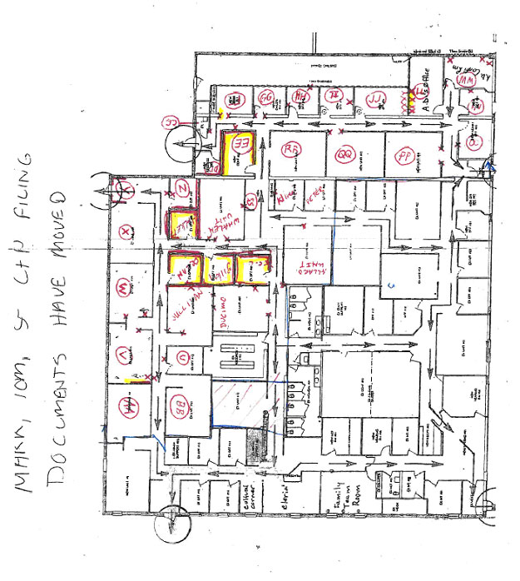
X = elevated moisture in wallboard (4/4/2014)
= saturated wallboard (4/4/2014)
= wallboard replaced (4/9/2014)

Floor plan indicating approximate areas of water damage
Picture 1

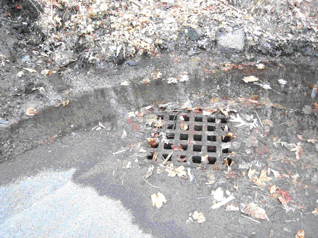

Leaf debris surrounding sewer grate and pooling water several days after storm

Picture 2

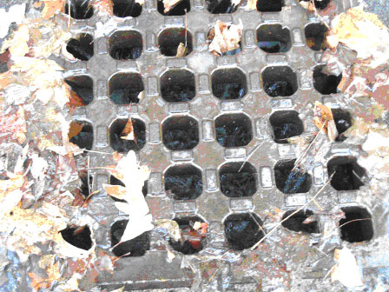

High water level within drain several days after storm

Picture 3

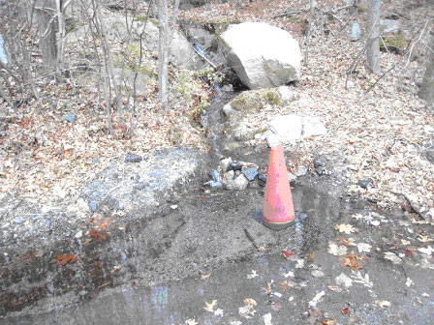

Water shedding off hill

Picture 4
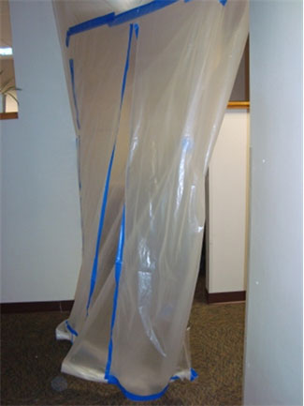

Plastic barrier, note plastic is not adhered to floor or walls

Picture 5

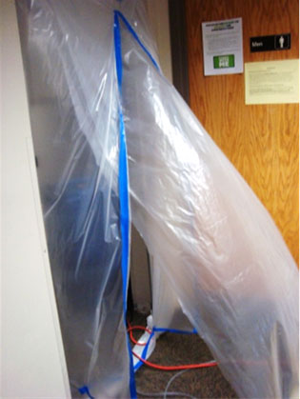

Barrier between spaces, note air pressurizing plastic barrier towards occupied areas

Picture 6

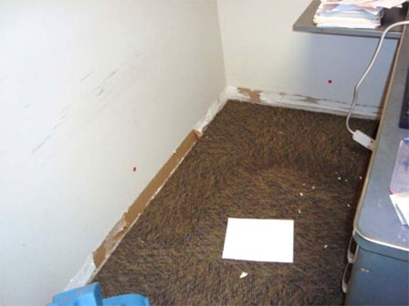

Vinyl base coving removed from water-damaged gypsum wallboard

Picture 7

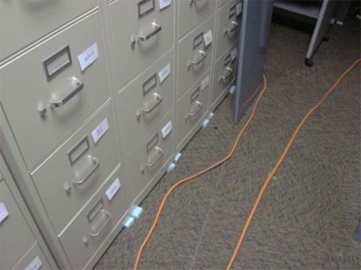

Styrofoam pieces used to elevate file cabinets to allow carpet drying

Picture 8

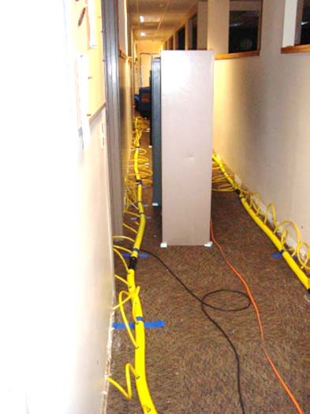

Tubes delivering air into wall cavity to facilitate drying

Picture 9

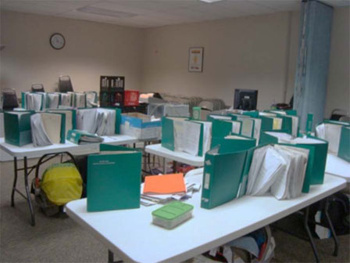

Water-damaged paper files propped for drying

Picture 10

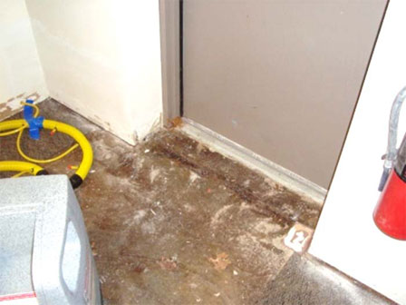

One doorway through which water entered building

Picture 11

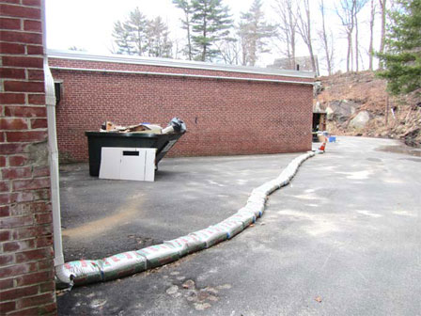

Sandbags used to create barrier against water

Picture 12

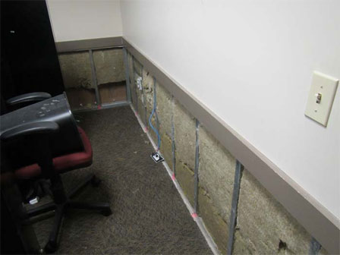

Water-damaged gypsum wallboard removed; removal of insulation in progress

Picture 13

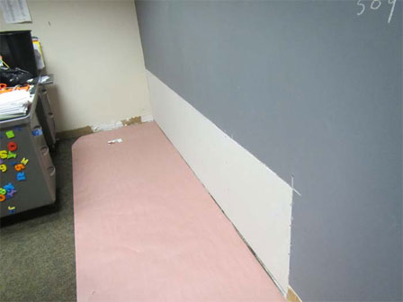

Water-damaged gypsum wallboard replaced

Picture 14

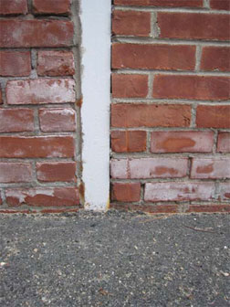

Efflorescence and missing/damaged mortar
Location | Carbon  Dioxide  (ppm) | Carbon Monoxide  (ppm) | Temp  (°F) | Relative  Humidity  (%) | PM2.5  (µg/m³) | Occupants  in Room | Windows  Openable | Ventilation |  | Remarks
 |  |  |  |  |  |  |  | Supply | Exhaust | Remarks
Background | 564 | ND - 2 | 55 | 30 | 10 |  |  |  |  | Cars idling, busy road
Alden | 1413 | ND | 75 | 34 | 8 | 0 | N | Y | N | Plants, DO
Bedard Office | 1215 | ND | 75 | 32 | 7 | 1 | N | Y | N | PF, plants, DO
Conference A | 1021 | ND | 73 | 32 | 8 | 0 | N | Y | Y | DO
Conference C | 1361 | ND | 75 | 34 | 3 | 1 | N | Y | N
Cultural Corner | 1131 | ND | 76 | 30 | 6 | 0 | Y | Y | N | AD
Ducimo Office | 1135 | ND | 75 | 30 | 6 | 1 | N | Y | N | DO
Employees Room | 1034 | ND | 74 | 31 | 6 | 0 | N | Y | Y | DO
Gardner Office | 1330 | ND | 76 | 28 | 6 | 1 | Y | Y | N | AD
Greaney Unit | 981 | ND | 78 | 26 | 6 | 2 | N | Y | Y | Items
Greaney’s Office | 1135 | ND | 76 | 28 | 6 | 1 | N | Y | N | DEM, DO
Halkett Unit | 1250 | ND | 75 | 28 | 6 | 0 | N | Y | N | AD, PF
Hamed Office | 1245 | ND | 77 | 31 | 7 | 1 | N | Y | N | PF, plants
Hamed Unit | 1312 | ND | 77 | 31 | 7 | 1 | N | Y | N | PF, plants
Hooten Office | 1206 | ND | 76 | 31 | 7 | 0 | N | Y | N | DO
Hooten Unit | 1236 | ND | 76 | 31 | 7 | 0 | N | Y | N | Fridge
Intakes | 1060 | ND | 77 | 28 | 7 | 0 | N | Y | N | Copier
Interview Room #1 | 1139 | ND | 71 | 31 | 8 | 1 | N | Y | Y | DO
Interview Room #4 | 1192 | ND | 72 | 30 | 9 | 0 | N | Y | N | DO
Interview Room #5 | 1115 | ND | 72 | 30 | 9 | 0 | N | Y | N
Kline Unit | 1207 | ND | 76 | 31 | 9 | 2 | N | Y | N | PF, CPs
Lawyer’s Office | 973 | ND | 77 | 27 | 7 | 1 | N | Y | Y
Lynne and Sue’s Office | 976 | ND | 76 | 28 | 6 | 1 | Y | Y | N | PF, plant
Mason Office | 1171 | ND | 77 | 30 | 7 | 0 | N | Y | N | PF
Reception | 1128 | ND | 71 | 32 | 7 | 1 | N | Y | N
Team Meeting Room | 1033 | ND | 73 | 31 | 8 | 0 | Y | Y | N | DO
Waiting Area | 1150 | ND | 71 | 31 | 9 | 2 | N | Y | N
Zalesky Office | 1065 | ND | 76 | 30 | 7 | 0 | N | Y | N | DO
Zalesky Unit | 1103 | ND | 75 | 30 | 7 | 3 | N | Y | N | Plants, PF, CPs

