INDOOR AIR QUALITY ASSESSMENT

Whitman Department of Public Works Administration Office
100 Essex Street
Whitman, Massachusetts



Prepared by:
Massachusetts Department of Public Health
Bureau for Environmental Health
Indoor Air Quality Program
February 2008

Background/Introduction
At the request of Richard H. Colvin, Health Agent, Whitman Board of Health, the Massachusetts Department of Public Health (MDPH), Bureau for Environmental Health (BEH) provided assistance and consultation regarding indoor air quality concerns at the Whitman Department of Public Works Administration Office (WDPW), 100 Essex Street, Whitman, Massachusetts. On November 2, 2007, a visit to conduct an indoor air quality assessment was made by Michael Feeney, Director of BEH’s Indoor Air Quality (IAQ) Program. The assessment was prompted by irritant respiratory symptoms that occupants believed to be attributed to poor air quality in the building.
The WDPW is a single-level, wood frame building originally constructed as a residence in the 1970s. The upper floor contains the WDPW office. The basement contains the furnace, storage areas, and a single garage that has its opening partially sealed with cinderblock to prevent exterior water penetration. Windows are openable in most rooms. No openable windows exist on the lower level.

Methods
Air tests for carbon dioxide, temperature and relative humidity were taken with the TSI, Q-Trak, IAQ Monitor. Screening for total volatile organic compounds (TVOCs) was conducted using an HNu Photo Ionization Detector (PID).

Results
The building has an employee population of 7. The tests were taken under normal operating conditions. Test results appear in Table 1.

Discussion
Ventilation
It can be seen from Table 1 that the carbon dioxide levels were below 800 parts per million (ppm) in all but one occupied area. This building does not have a mechanical, ducted heating, ventilating and air conditioning (HVAC) system. Heat is provided by baseboard registers, and cooling is provided by window-mounted air conditioners (WACs). The WACs did not appear to have the means to introduce fresh air.
The Massachusetts Building Code requires that each room have a minimum ventilation rate of 20 cubic feet per minute (cfm) per occupant of fresh outside air or have openable windows in each room (SBBRS, 1997; BOCA, 1993). The ventilation must be on at all times that the room is occupied. Providing adequate fresh air ventilation with open windows and maintaining the temperature in the comfort range during the cold weather season is impractical. Mechanical ventilation is usually required to provide adequate fresh air ventilation.
Carbon dioxide is not a problem in and of itself. It is used as an indicator of the adequacy of the fresh air ventilation. As carbon dioxide levels rise, it indicates that the ventilating system is malfunctioning or the design occupancy of the room is being exceeded. When this happens a buildup of common indoor air pollutants can occur, leading to discomfort or health complaints. The Occupational Safety and Health Administration (OSHA) standard for carbon dioxide is 5,000 parts per million parts of air (ppm). Workers may be exposed to this level for 40 hours/week, based on a time-weighted average (OSHA, 1997).
The MDPH uses a guideline of 800 ppm for publicly occupied buildings. A guideline of 600 ppm or less is preferred in schools due to the fact that the majority of occupants are young and considered to be a more sensitive population in the evaluation of environmental health status. Inadequate ventilation and/or elevated temperatures are major causes of complaints such as respiratory, eye, nose and throat irritation, lethargy and headaches. For more information concerning carbon dioxide, please see Appendix A.
Temperature readings in occupied areas were measured in a range of 67º F to 73º F, which were within the MDPH recommended comfort range in all but one area. The MDPH recommends that indoor air temperatures be maintained in a range of 70º F to 78º F in order to provide for the comfort of building occupants. In many cases concerning indoor air quality, fluctuations of temperature in occupied spaces are typically experienced, even in a building with an adequate fresh air supply.
The relative humidity measurements in the building ranged from 28 to 54 percent, with some areas below the MDPH recommended comfort range. The MDPH recommends a comfort range of 40 to 60 percent for indoor air relative humidity. Relative humidity levels in the building would be expected to drop during the winter months due to heating. The sensation of dryness and irritation is common in a low relative humidity environment. Low relative humidity is a very common problem during the heating season in the northeast part of the United States.

Microbial/Moisture Concerns
Water coolers were located over carpeting in a number of areas. One area had water-damaged carpet beneath the cooler. Water spillage or overflow of cooler catch basins can result in the wetting of the carpet. In addition, some coolers had residue/build-up in the reservoir. These reservoirs are designed to catch excess water during operation and should be emptied/cleaned regularly to prevent microbial and/or bacterial growth.

Other Concerns
Indoor air quality can be negatively influenced by the presence of respiratory irritants, such as products of combustion. The process of combustion produces a number of pollutants. Common combustion emissions include carbon monoxide, carbon dioxide, water vapor and smoke (fine airborne particle material). Of these materials, exposure to carbon monoxide can produce immediate, acute health effects upon exposure. To determine whether combustion products were present in the school environment, MDPH staff obtained measurements for carbon monoxide.
Carbon monoxide is a by-product of incomplete combustion of organic matter (e.g., gasoline, wood and tobacco). Exposure to carbon monoxide can produce immediate and acute health affects. Several air quality standards have been established to address carbon monoxide and prevent symptoms from exposure to these substances. The MDPH established a corrective action level concerning carbon monoxide in ice skating rinks that use fossil-fueled ice resurfacing equipment. If an operator of an indoor ice rink measures a carbon monoxide level over 30 ppm, taken 20 minutes after resurfacing within a rink, that operator must take actions to reduce carbon monoxide levels (MDPH, 1997).
The American Society of Heating Refrigeration and Air-Conditioning Engineers (ASHRAE) has adopted the National Ambient Air Quality Standards (NAAQS) as one set of criteria for assessing indoor air quality and monitoring of fresh air introduced by HVAC systems (ASHRAE, 1989). The NAAQS are standards established by the US EPA to protect the public health from six criteria pollutants, including carbon monoxide and particulate matter (US EPA, 2006). As recommended by ASHRAE, pollutant levels of fresh air introduced to a building should not exceed the NAAQS levels (ASHRAE, 1989). The NAAQS were adopted by reference in the Building Officials & Code Administrators (BOCA) National Mechanical Code of 1993 (BOCA, 1993), which is now an HVAC standard included in the Massachusetts State Building Code (SBBRS, 1997). According to the NAAQS, carbon monoxide levels in outdoor air should not exceed 9 ppm in an eight-hour average (US EPA, 2006). Carbon monoxide should not be present in a typical, indoor environment. If it is present, indoor carbon monoxide levels should be less than or equal to outdoor levels.
The first floor contains a gas stove. Non-detectable levels of carbon monoxide were detected in the WDPW offices prior to ignition of the stove. After lighting three of the burners on the top of the stove, levels of carbon monoxide were elevated on the first floor. At the burner level, carbon monoxide levels measured in a range of 9 to 14 parts per million (ppm) (Picture 1). After five minutes of continuous burner activation, carbon monoxide levels measured 4 ppm on the counter approximately 8 feet from the activated gas stove. The gas stove has a local exhaust vent to eject products of combustion outdoors. It is recommended that all gas cook tops and ovens be vented to the outdoors to prevent exposure to products of combustion (Lstiburek and Brennan, 2001).
A gas fired furnace (Picture 2) and water heater (Picture 3) were located in the basement. Due to the configuration of the water heater and its exhaust vent, carbon monoxide (CO) measurements were taken in the basement prior to and after activation of the hot water heater. No detectable levels of CO were measured in the basement at anytime during the assessment. In order to provide efficient combustion for the gas jet in the water heater and space heater that minimizes the production of CO, an adequate supply of combustion air is needed to provide oxygen. A combustion air vent is usually located in an area near the furnace. No observable combustion air vent could be identified in the basement.
Please note the position of the space heater relative to the water heater. The exhaust vent for the water heater is not continuous (Picture 4). Due to this configuration, products of combustion produced by the water heater can be drawn away from the vent system and directed into the basement when the space heater fan (Picture 5) is operating.
A drainpipe exists in the basement that is sealed with crumpled paper (Picture 6). Drain pipes should be properly sealed to prevent sewer odor penetration into the building. The two likely pathways for migration of basement odors upstairs are the stairwell and holes in the floor. In order to prevent basement odor migration, the basement door should be closed during working hours and all holes in the basement ceiling and foundation should be sealed.

Other IAQ Evaluations
The building shows signs of rodent infestation, as indicated by the presence of rodent droppings on the basement stairs. Rodent infestation can result in indoor air quality related symptoms due to materials in their wastes. Mouse urine is known to contain a protein that is a known sensitizer (US EPA, 1992). A sensitizer is a material that can produce symptoms including running nose or skin rashes in sensitive individuals. A three step approach is necessary to eliminate rodent infestation:
- removal of rodents;
- cleaning of waste products from the interior of the building; and
- reduction/elimination of pathways/food sources that are attracting rodents.
To eliminate exposure to allergens, rodents must be removed from the building. Please note that removal, even after cleaning, may not provide immediate relief since allergens can exist in the interior for several months after rodents are eliminated (Burge, 1995). A combination of cleaning, increase in ventilation and filtration should serve to reduce rodent associated allergens once the infestation is eliminated.

Conclusions/Recommendations
In view of the findings at the time of the visit, the following recommendations are made:
- Ensure the basement door remains closed.
- Consider replacing the gas stove with an electric model.
- Install a carbon monoxide digital readout in the basement stairwell. CO levels should be checked daily after the boiler is fired up during the heating season.
- Disconnect the space heater if heat from this unit is not needed.
- Seal abandoned drain pipe in a proper manner.
- Adequate combustion air needs to be provided for the water heater and space heater. A ground level fresh air intake may be necessary. Consult with the local fire prevention officer/building code officials to determine an appropriate method to provide combustion air for the water heater. If not feasible, consider replacing current gas water heater with electric model.
- Seal cracks in the foundation.
- Open windows to provide fresh air.
- Install weather-stripping and a door sweep to render the door to the lower level garage as airtight as possible.
- Seal all spaces that exist in the ceiling of the basement with an appropriate, fire-rated sealant.
- For buildings in New England, periods of low relative humidity during the winter are often unavoidable. Therefore, scrupulous cleaning practices should be adopted to minimize common indoor air contaminants whose irritant effects can be enhanced when the relative humidity is low. To control for dusts, a high efficiency particulate arrestance (HEPA) filter equipped vacuum cleaner in conjunction with wet wiping of all surfaces is recommended. Drinking water during the day can help ease some symptoms associated with a dry environment (throat and sinus irritations).
- Clean or replace filter for window-mounted air conditioners as per the manufacturer’s instructions or more frequently if needed.
- Use the principles of integrated pest management (IPM) to rid the building of pests in compliance with E.O. 403. The IPM Guide can be obtained at the following: http://www.state.ma.us/dfa/pesticides/publications/IPM_kit_for_bldg_mgrs.pdf . Activities that can be used to eliminate pest infestation may include the following activities:
  - Rinse recycled food containers. Seal recycled containers in a tight fitting lid to prevent rodent access.
  - Remove non-food items that rodents are consuming.
  - Store foods in tight fitting containers.
  - Avoid eating at work stations. In areas were food is consumed, periodic vacuuming to remove crumbs are recommended.
  - Clean crumbs and other food residues from toasters, toaster ovens, microwave ovens coffee pots and other food preparation equipment on a regular basis.
  - Examine each room and the exterior walls of the building for means of rodent egress and seal. Holes as small as ¼” is enough space for rodents to enter an area. If doors do not seal at the bottom, install a weather strip as a barrier to rodents.
  - Reduce harborages (i.e. cardboard boxes) where rodent may reside.
- Refer to resource manuals and other related indoor air quality documents for additional building-wide evaluations and advice on maintaining public buildings. These materials are located on the MDPH’s website: http://mass.gov/dph/indoor_air.
References
ASHRAE. 1989. Ventilation for Acceptable Indoor Air Quality. American Society of Heating, Refrigeration and Air Conditioning Engineers. ANSI/ASHRAE 62-1989

BOCA. 1993. The BOCA National Mechanical Code-1993. 8th ed. Building Officials & Code Administrators International, Inc., Country Club Hills, IL. M-308.1

Burge, H.A. 1995. Bioaerosols. Lewis Publishing Company, Boca Raton, FL.
Lstiburek, J. & Brennan, T. 2001. Read This Before You Design, Build or Renovate. Building Science Corporation, Westford, MA. U.S. Department of Housing and Urban Development, Region I, Boston, MA
MDPH. 1997. Requirements to Maintain Air Quality in Indoor Skating Rinks (State Sanitary Code, Chapter XI). 105 CMR 675.000. Massachusetts Department of Public Health, Boston, MA.
OSHA. 1997. Limits for Air Contaminants. Occupational Safety and Health Administration. Code of Federal Regulations. 29 C.F.R. 1910.1000 Table Z-1-A.

SBBRS. 1997. Mechanical Ventilation. State Board of Building Regulations and Standards. Code of Massachusetts Regulations. 780 CMR 1209.0

US EPA. 1992. Indoor Biological Pollutants. US Environmental Protection Agency, Environmental Criteria and Assessment Office, Office of Health and Environmental Assessment, research Triangle Park, NC. EPA 600/8-91/202 January 1992.

US EPA. 2006. National Ambient Air Quality Standards (NAAQS). US Environmental Protection Agency, Office of Air Quality Planning and Standards, Washington, DC. http://www.epa.gov/air/criteria.html.
Picture 1
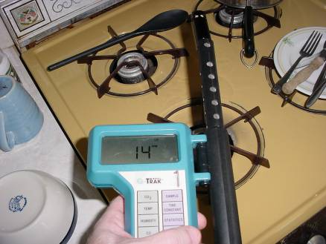

Carbon Monoxide Measurement in Kitchen with Gas Stove Combusting Fuel

Picture 2

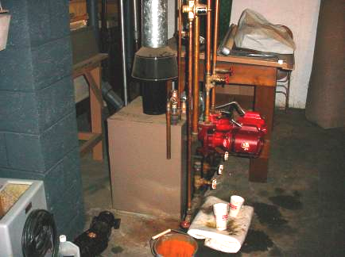

Gas Fired Furnace

Picture 3
Space Heater
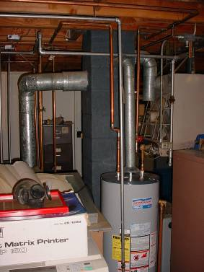

Gas Fired Water Heater, Note Space Heater Fan Location

Picture 4

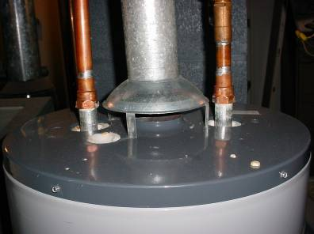

Water Heater Vent
Picture 5

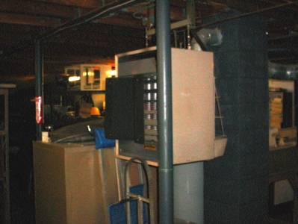

Space Heater near Furnace and Water Heater

Picture 6

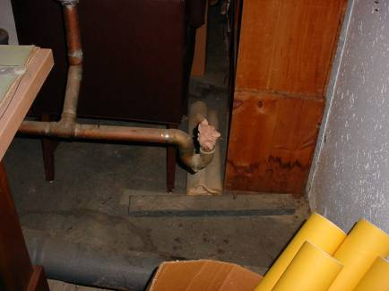

Drain Pipe Opening Sealed With Crumpled Paper
Location | Occupants  in Room | Carbon  Dioxide  (ppm) | Temp  (°F) | Relative  Humidity  (%) | Carbon Monoxide  (ppm) | Windows  Openable | Ventilation |  | Remarks
 |  |  |  |  |  |  | Supply | Exhaust | Remarks
Outside  (Background) |  | 337 | 54 | 58 | 0
Main office east | 2 | 881 | 67 | 54 | 0 | Y | N | N | Window mounted air conditioner  2 water damaged ceiling tiles
Main office center | 1 | 916 | 70 | 46 | 0 | Y | N | N | Photocopier
Main office west | 2 | 767 | 71 | 43 | 0 | Y | N | N | Mice dropping
Hearing room | 0 | 745 | 72 | 40 | 0 | Y | N | N
Kitchen | 0 | 744 | 73 | 42 | See text | Y | N | Y | Exhaust fan off
Basement | 0 | 443 | 73 | 28 | 0 | N | N | N
Garage | 0 | 422 | 71 | 28 | 0 | N | N | N

