WIC LOCATIONS

To find out about WIC, call **1-800-WIC-1007**

or a program near you.

English

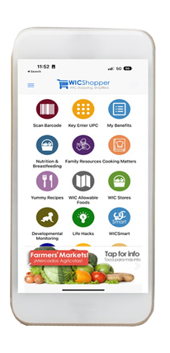

# WHAT FOODS CAN I GET FROM WIC?

WIC makes it easier for you to provide the healthy, delicious foods that you feel good about giving your family. WIC provides free healthy food, including:

* Baby food
* Brown rice
* Canned fish
* Cereal
* Cheese
* Dried or canned beans/peas
* Eggs
* Fruit juice
* Fruits & vegetables
* Infant formula
* Milk
* Peanut butter
* Tortillas
* Whole grain bread and pasta
* Tofu
* Yogurt

WIC has an electronic benefit card, a ‘WIC Shopper’ App, and WIC online ordering is now available at Walmart!

## @MassWIC

**BOSTON AREA**

Cambridge/Somerville (617) 575-5330

Chelsea/Revere (617) 887-4340

Dorchester North/Mattapan (617) 825-8994

Dorchester South/South Boston (617) 825-0805

East Boston (617) 568-6440

Jamaica Plain/Brighton (617) 983-6086

Roxbury/South End (617) 989-3055

South Cove (617) 521-6777

## CAPE

Cape Cod (508) 771-7896

Outer Cape (508) 240-0853

## CENTRAL

Framingham/Waltham (508) 620-1445

North Central (978) 345-6272

South Central (508) 765-0139

Worcester (508) 796-7000

## NORTHEAST

Lawrence (978) 681-4960

Lowell (978) 454-6397

North Shore (781) 599-7290

North Suburban (781) 338-7578

Northern Essex (978) 374-2191

## SOUTHEAST

Brockton (508) 588-8241

Fall River (508) 679-9349

New Bedford (508) 997-1500

Plymouth (508) 747-4933

Quincy (617) 376-8701

Taunton/Attleboro (508) 823-6346

## WESTERN

Berkshire North (413) 447-3495

Berkshire South (413) 528-0457

Franklin/Hampshire/No. Quabbin (413) 376-1160

Holyoke/Chicopee (413) 534-2460

Springfield North (413) 737-8868

Springfield South (413) 739-1100

Form #147

This institution is an equal opportunity provider.

**GOOD FOOD** *and*

**A WHOLE LOT MORE!**

[**www.mass.gov/wic**](http://www.mass.gov/wic)

2025

# WHO IS WIC FOR?

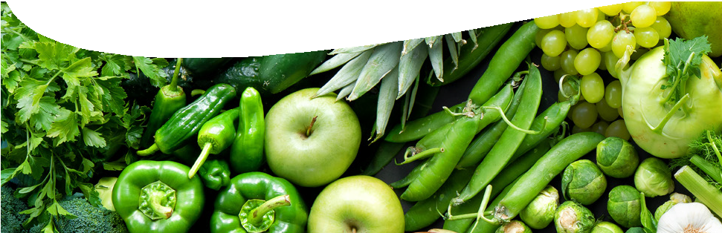

**WHAT IS WIC?**

WIC (Women, Infants and Children) is a nutrition program that provides

nutrition and health education, healthy food and other services free of charge to Massachusetts families who qualify.

# WHAT DOES WIC OFFER?

WIC’s goal is to get families off to a healthy start. To do this, WIC provides:

* Personalized nutrition consultations
* Free, healthy food
* Tips for eating well to improve health
* Referrals for medical and dental care, health insurance, child care, housing & fuel assistance, and other services that can benefit the whole family

But that’s not all! WIC offers breastfeeding classes, one-on-one breastfeeding support, as well as immunization screening and referrals. WIC also provides parents with opportunities to talk with other parents about nutrition and other health topics

that are important to their families.

WIC is for all kinds of families: married and single parents, working or not working. If you are a father, mother, grand parent, foster parent or other legal guardian of a child under 5, you can apply for WIC for your child.

You can participate in WIC if you:

* Live in Massachusetts
* Have a nutritional need (WIC staff can help you determine this)
* Are pregnant, breastfeeding, or a child under 5
* Have a family income less than WIC guidelines

You are automatically income eligible for WIC if you are currently receiving TAFDC, SNAP or MassHealth. (MassHealth members with Family Assistance or CommonHealth coverage are not automatically income eligible.) Foster kids under age 5 are also automatically eligible for WIC.

**2025 INCOME ELIGIBILITY GUIDELINES**

|  |  |  |  |  |
| --- | --- | --- | --- | --- |
| **HOUSEHOLD** | **YEARLY** | **MONTHLY** | **BI-WEEKLY** | **WEEKLY** |
| 1 | $28,953 | $2,413 | $1,114 | $557 |
| 2 | $39,128 | $3,261 | $1,505 | $753 |
| 3 | $49,303 | $4,109 | $1,897 | $949 |
| 4 | $59,478 | $4,957 | $2,288 | $1,144 |
| 5 | $69,653 | $5,805 | $2,679 | $1,340 |
| 6 | $79,828 | $6,653 | $3,071 | $1,536 |
| 7 | $90,003 | $7,501 | $3,462 | $1,731 |
| 8 | $100,178 | $8,349 | $3,853 | $1,927 |

# CAN MEN PARTICIPATE

**IN WIC?**

WIC welcomes men! WIC recognizes the important role that fathers, grandparents, stepparents, and other guardians play in caring for kids. Fathers and other caregivers of kids under 5 are encouraged to enroll and bring kids to appointments, attend nutrition and health workshops, and use WIC in the grocery stores.

# HOW DO I APPLY

**FOR WIC?**

It’s possible to start an application for WIC on-line by visiting [www.mass.gov/wic](http://www.mass.gov/wic) or the Mass WIC Facebook page, @MassWIC. Interested families can click on ‘Apply for WIC’ and submit some basic information to get their application started. Or you can

contact the WIC Program in your community to set up an appointment or call 1-800- 942-1007. Many WIC offices are open in the evenings and on Saturdays so you don’t have to miss school or work. Walk-ins are always welcome!