
WIC RIGHTS AND RESPONSIBILITIES

Massachusetts WIC Nutrition Program

Rights

- I have a right to receive benefits and nutrition services until the end of my certification period.
- I have the right to transfer to another WIC program in MA or any other state.
- I have the right to receive notification (15 days or less) if I or my child are no longer eligible to receive WIC benefits.
- I have the right to make a complaint if I feel I have been treated unfairly by WIC staff or store staff.
- I have the right as a WIC customer to have a good shopping experience. WIC customers are to be treated like all other customers. If you have any problems or concerns with your WIC shopping experience, contact the program immediately or Vendor Unit at State Office at 1-800-WIC-1007.
- I have the right to a fair hearing if I am not eligible or taken off the program. If I feel the decision was unfair, I can apply for a fair hearing by writing to WIC Program, 250 Washington Street, 6th floor, Boston, MA 02108 attn: WIC Director, or calling 1-800-WIC-1007 for assistance.
Responsibilities

- I will treat WIC staff and store staff with respect.
- I understand by sharing my email address and phone number that I am giving consent for the WIC program to contact me by email, phone, and/or text messaging for appointment reminders, information sharing, annual participant survey, formula/food product recalls, and/or emergency closings.
- I understand that I can cancel my consent by notifying the WIC program, if I no longer want to be contacted by email, phone, and/or text messaging.
- I understand if my WIC Card is lost, stolen, or damaged, I must call the WIC clinic, immediately.
- I understand I can only buy the approved WIC foods issued to my WIC Card and cannot substitute other formula and food/other items.
- I understand that I will be taken off the WIC program if I don’t obtain benefits for 2 months.
- I understand that posting WIC formula/food on the Internet through Craigslist, Facebook, etc. with the intent to sell WIC benefits, exchanging or giving away WIC formula/food will result in disqualification for up to one year and full cash repayment of those benefits.
- I understand that I must return all unused WIC formula/food to the WIC clinic.
- I am currently not receiving WIC benefits from another program, under another name, or in another state.
- I will notify WIC staff if I receive formula from MassHealth or other insurance companies.
- I understand that I will inform WIC if my household income, address, email address, or phone number changes.
- I understand that I may be taken off the program if I physically or verbally threaten WIC staff or store staff.
- I understand that I may be taken off the program for giving false information to get on WIC, including identity, address, gross household income (all working members, child support, rental income, and any other income resources), medical and health information.
Sharing of Information/Confidentiality

- I understand that my name and my child’s name, address, phone number, and date of birth may be given to other health and human service programs to conduct outreach and determine my family’s eligibility for the Massachusetts Head Start/Early Head Start programs as well as the Department of Transitional Assistance (DTA) that administers the Supplemental Nutrition Assistance Program (SNAP).
- I understand that if my child is enrolled in Head Start/Early Head Start that their name, address, date of birth, and dietary intake and eating patterns, height and weight measurements, hemoglobin/hematocrit and lead values held by WIC may be shared for the coordination of care with Head Start/Early Head Start Programs.
- I understand as a postpartum woman, my address and/or phone number may be given to Department of Public Health’s Pregnancy Risk Assessment Monitoring System to invite me to complete a pregnancy survey.
- I understand that my name and child’s name, address, phone number, date of birth, sex, race, ethnicity, language spoken, lead screening, blood lead test result/date, if applicable, WIC member ID number, and WIC service area may be given to the Department of Public Health Childhood Lead Poisoning Prevention Program for the prevention, screening, and identification of childhood lead poisoning. If my child is identified as not being screened for blood lead the Department of Public Health Environmental Epidemiology and Childhood Lead Poisoning Prevention Program will contact me to facilitate blood lead screening.
- These programs cannot use the information that WIC gives them for any purpose other than outreach for specific programs and cannot disclose the fact that you and your family are participating in WIC to anyone else. Except as required by law, anyone else must have your written permission to get your WIC records.

USDA Nondiscrimination Statement

In accordance with federal civil rights law and U.S. Department of Agriculture (USDA) civil rights regulations and policies, this institution is prohibited from discriminating on the basis of race, color, national origin, sex (including gender identity and sexual orientation), disability, age, or reprisal or retaliation for prior civil rights activity.
Program information may be made available in languages other than English. Persons with disabilities who require alternative means of communication to obtain program information (e.g., Braille, large print, audiotape, American Sign Language), should contact the responsible state or local agency that administers the program or USDA’s TARGET Center at (202) 720-2600 (voice and TTY) or contact USDA through the Federal Relay Service at (800) 877-8339.
To file a program discrimination complaint, a Complainant should complete a Form AD-3027, USDA Program Discrimination Complaint Form which can be obtained online at: https://www.usda.gov/sites/default/files/documents/USDA-OASCR%20P-Complaint-Form-0508-0002-508-11-28-17Fax2Mail.pdf, from any USDA office, by calling (866) 632-9992, or by writing a letter addressed to USDA. The letter must contain the complainant’s name, address, telephone number, and a written description of the alleged discriminatory action in sufficient detail to inform the Assistant Secretary for Civil Rights (ASCR) about the nature and date of an alleged civil rights violation. The completed AD-3027 form or letter must be submitted to USDA by:
- mail:
U.S. Department of Agriculture
Office of the Assistant Secretary for Civil Rights
1400 Independence Avenue, SW
Washington, D.C. 20250-9410; or
- fax:
(833) 256-1665 or (202) 690-7442; or
- email:
program.intake@usda.gov
This institution is an equal opportunity provider.

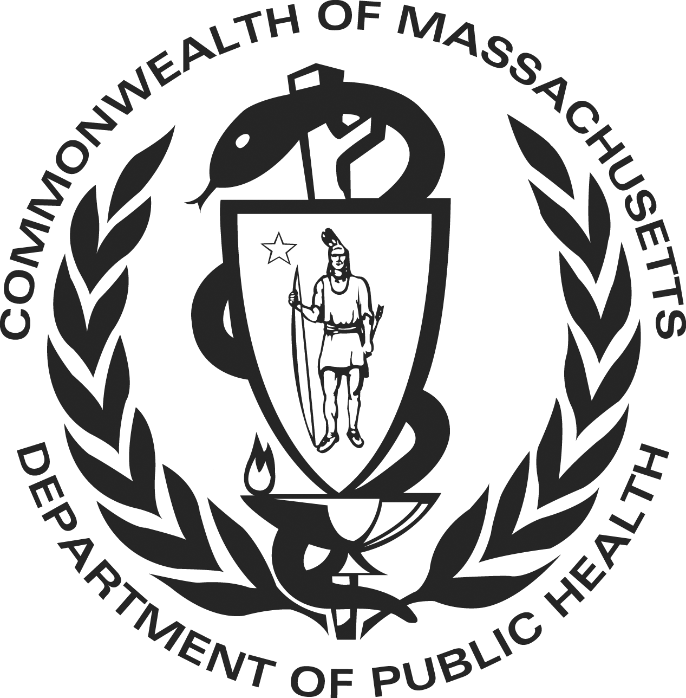

WIC Form # 138
09/2023

English

