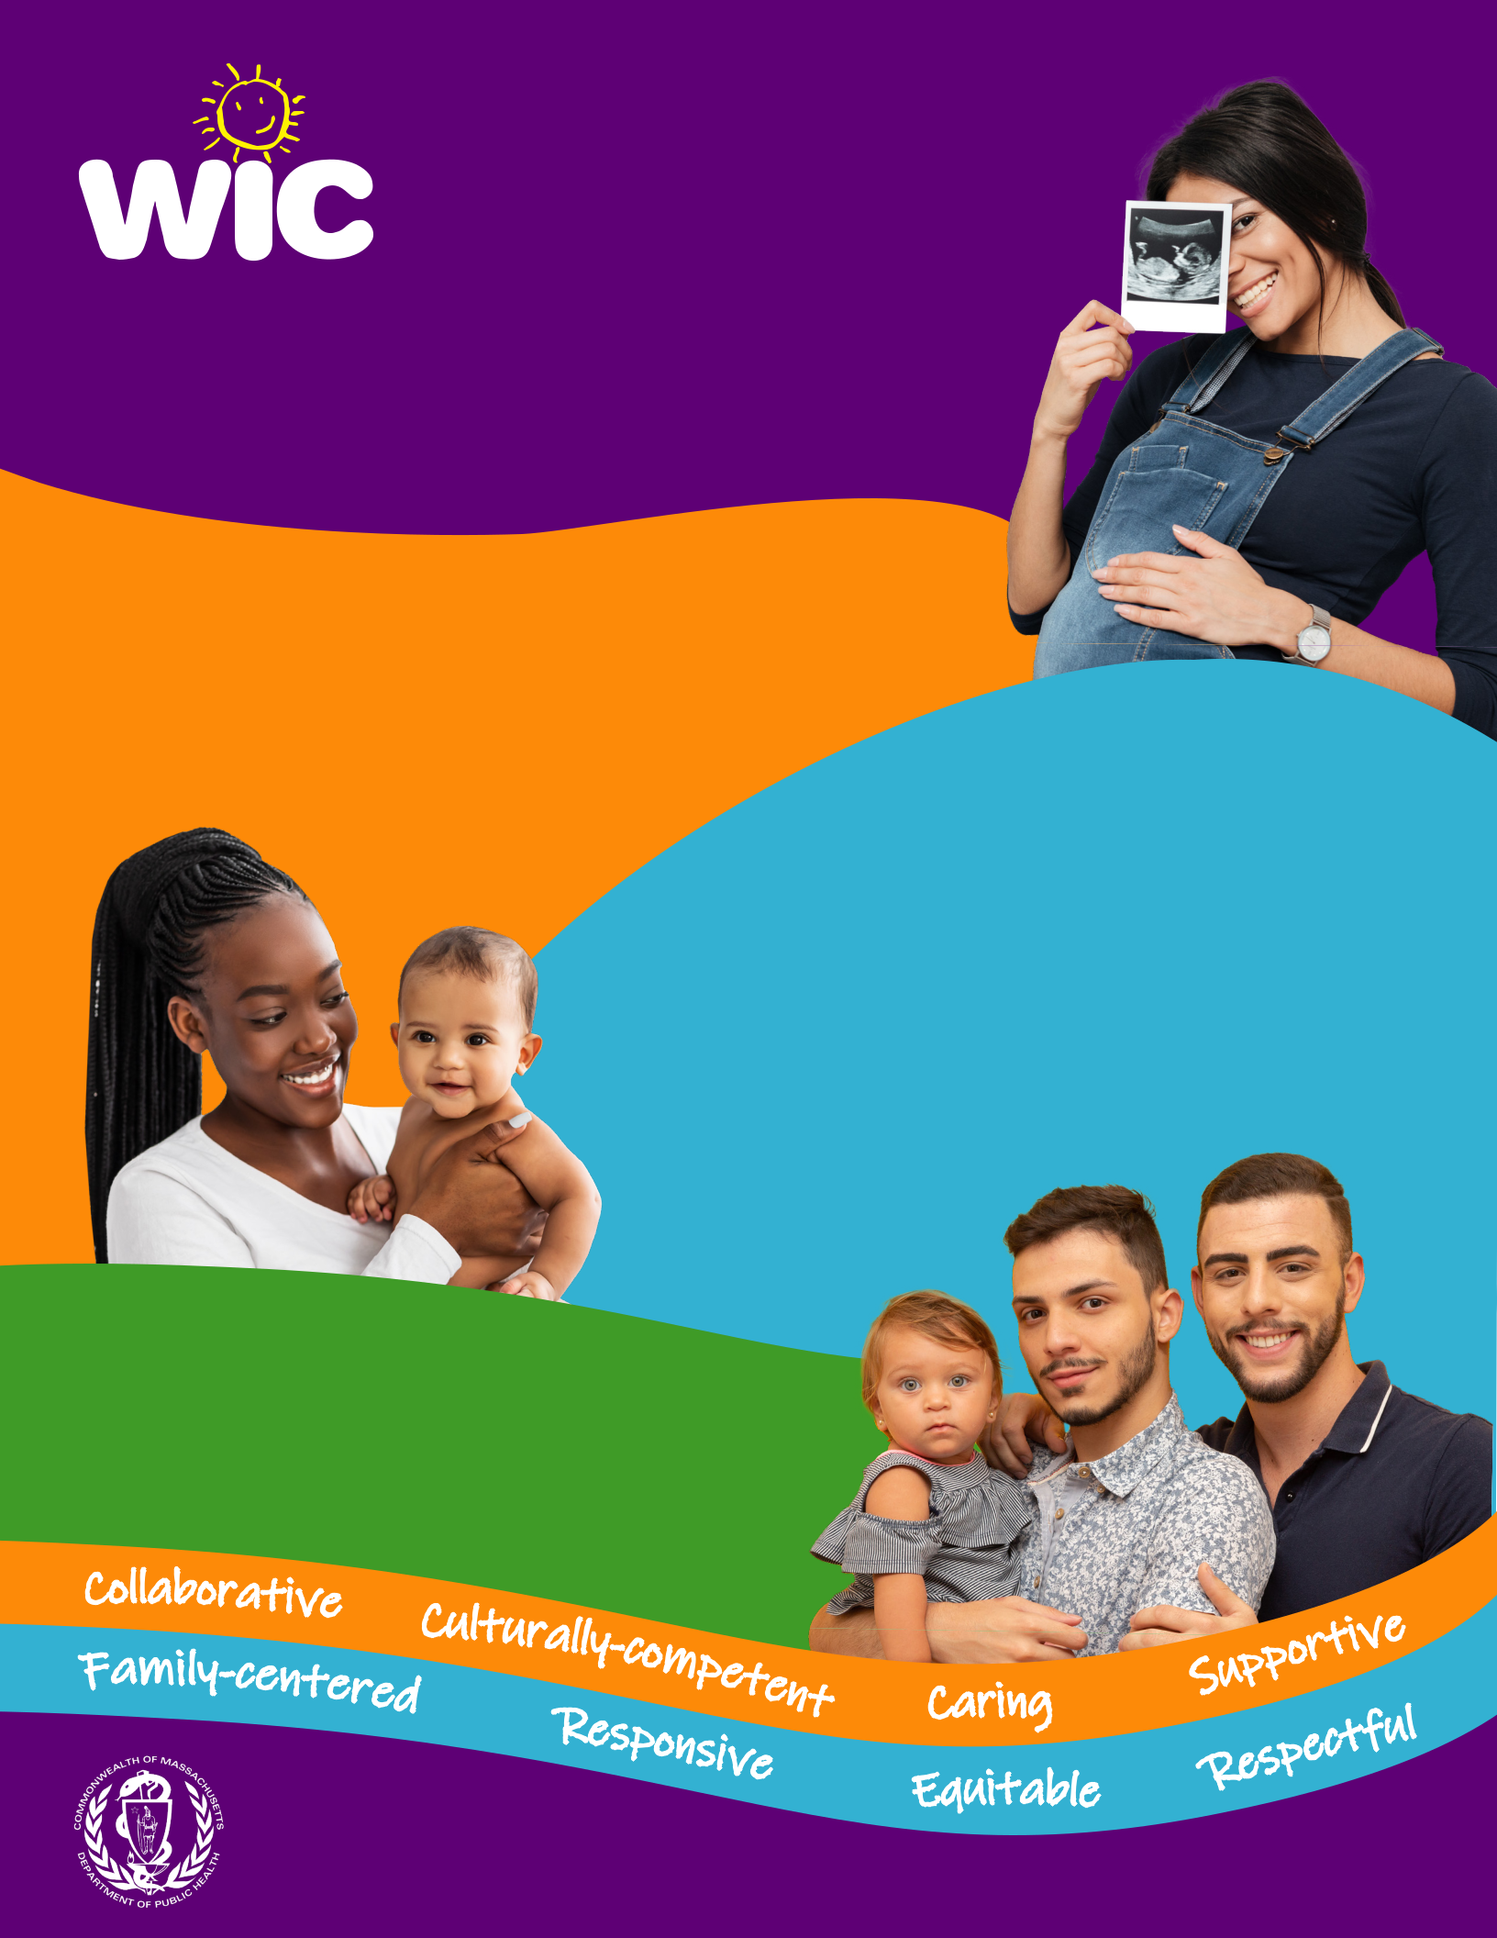
GOOD FOOD and

A WHOLE LOT MORE!

The Massachusetts Women, Infants and Children Nutrition Program (WIC) provides vital nutrition care during pregnancy and early childhood.

Vision

To ensure that all eligible families experience long-lasting nutrition and health benefits from WIC’s coordinated, easily accessible services.

Mission

To improve the health status of families by providing nutrition and health education, lactation support, nutritious foods and referrals to other health & human services. WIC collaborates with families, community organizations, health care providers, retail food stores, and state & federal partners to achieve this mission.

Values

WIC offers high-quality nutrition and health services in an environment that is:

www.mass.gov/wic

www.mass.gov/wic

This institution is an equal opportunity provider.

