Notice to Affected Household and Confirmation Notice– Sample Template A
Template for public water system to send notice to households of their lead results and provide confirmation to EPA and MassDEP:
TEMPLATE A - For households where the public water system’s 90th percentile level in their most recent sampling round is below the action level and the household’s drinking water lead sample result is greater than 15 ppb.
Instructions: Fill in the correct case-specific information in sections marked with brackets. Please remove the brackets before distributing the letter. Sections in italics are required and include:
- A clear explanation of the potential adverse effects on human health of drinking water that contains a concentration of lead that exceeds the lead action level;
- The steps that the owner or operator of the public water system is taking to mitigate the concentration of lead; and
- The necessity of seeking alternative water supplies until the date on which the concentration of lead is mitigated.
Translations for English Instructions – Brief translations in 27 languages for non-English speakers conveying the importance of this report.

LEAD- WIIN: TEMPLATE A - Use for households where the public water system’s 90th percentile level is below the action level and the household’s drinking water lead sample result is greater than 15 ppb.
Update or Delete all highlighted text and delete this box before sending out.

[INSERT PWS Name]
Important Information about Your Drinking Water
Lead Sample Results for Your Home
Dear [Consumer's Name],
EPA has provided us with information regarding a lead sample of drinking water taken at your home. This sample was collected by [sampler information] on [sample date]. The sample shows lead levels that are greater than the lead action level of 15 ppb. However, the 90th percentile value of the various water samples collected throughout our entire water system for compliance with the Lead and Copper Rule is below the lead action level. [Insert PWS name ] strongly urges you to take the steps listed on the next page to reduce your exposure to lead in drinking water.
The following table shows the results of the water sample taken at your home:
Sample  Collected | Lab Results  Received by Homeowner(s) | Lead Test  Results | Action Level at 90th  Percentile Level | MCLG
[Date] | [Date] | [x] ppb | 15 ppb | 0 ppb

What Does This Mean?
Drinking water that is tested for lead is compared to standards set by the U.S. Environmental Protection Agency (EPA). These standards include:
• 90th percentile value: The value that separates the bottom 90 percent of sample results from the top 10 percent.
• Action Level: The concentration of a contaminant which, if exceeded, triggers treatment or other requirements which a water system must follow. Under the authority of the Safe Drinking Water Act, EPA set the action level for lead in drinking water at 15 ppb. Water systems are required to act if the sample results are greater than 15 ppb in more than 10 percent of the samples collected for compliance.
• Maximum Contaminant Level Goal (MCLG): The level of a contaminant in drinking water below which there is no known or expected risk to health. MCLGs allow for a margin of safety. Because lead may pose serious health risks, EPA set an MCLG of 0 ppb for lead.

How Does Lead Enter Drinking Water?
Lead is a toxic heavy metal that is harmful if inhaled or swallowed. It can be found in air, soil, dust, food, drinking water, and products such as lead-based paints. Lead typically enters drinking water through plumbing materials. All homes, regardless of their age, may have plumbing that contains lead. However, homes built before 1986 are more likely to have lead pipes, fixtures, and solder. Brass faucets, fittings, and valves, including those advertised as “lead-free,” may contribute some, but much lower amounts of, lead to drinking water. Faucets and other brass fixtures made after January 2014 are essentially lead free (up to 0.25 percent weighted average of lead); those made earlier were allowed by federal law to contain up to 8 percent lead.

What Are the Health Effects of Lead?
Lead can cause serious health problems if too much enters the body from drinking water or other sources of lead. Pregnant women, infants, and young children have the highest risks of negative health effects from lead exposure. Lead exposure in children under the age of six has been linked to damage to the central and peripheral nervous system, learning disabilities, shorter stature, impaired hearing, impaired formation and function of blood cells, and lowered IQ. Lead can accumulate in our bodies over time, where it is stored in bones along with calcium. During pregnancy, lead is released from bones as maternal calcium and is used to help form the bones of the fetus. This can result in serious effects to the mother and her developing fetus, including reduced growth of the fetus and premature birth.
Adults exposed to lead could develop kidney problems or high blood pressure. Lead is stored in the bones and can be released later in life.
Screening is the only way to know if a child has been exposed to lead. All children in Massachusetts are required to be screened for lead. Children must be screened between 9-12 months, at age 2, at age 3, and again at age 4 if they live in a high-risk community. If you are concerned about your child’s lead exposure, ask your health care provider about testing your child to determine the levels of lead in their blood.
How Can I Reduce Exposure to Lead from Drinking Water?
As a concerned resident, there are several steps that you can take to reduce your and your family’s exposure to lead from drinking water. [Insert PWS name] recommends that you:
• Run your water to flush out lead. The longer water sits in your home piping, the more lead may leach from lead-containing fixtures. Before drinking, flush your pipes for several minutes by running your tap, taking a shower, doing laundry or a load of dishes.
• Use cold water to cook and to prepare baby formula. Do not cook with or drink water from the hot water tap; lead dissolves more easily into hot water. Do not use water from the hot water tap to make baby formula. Remember, boiling water DOES NOT remove lead from water.
• Identify and replace plumbing fixtures that contain lead with “lead-free” materials. Brass faucets, fittings, and valves, including those advertised as “lead-free,” may contribute lead to drinking water. The law currently allows pipes, fittings, and fixtures with up to 0.25 percent weighted average of lead to be identified as "lead-free.” Plumbing materials that are “lead-free” can also be identified by looking for “lead-free” certification marks (http://nepis.epa.gov/Exe/ZyPDF.cgi?Dockey=P100LVYK.txt).
- Find out if your home/building has a lead service line and make arrangements to remove it.
If the line connecting your home with the water main in the street is made of lead, it may contribute to higher lead levels in your water. Contact us to determine if you have a lead service line, and how you can arrange to have it replaced.
If applicable, [Insert PWS name] has a lead service line program and encourages home owners to take advantage of it. For more information see if applicable, [insert weblink]. If applicable, [Insert PWS name] has a list of all lead service line in the community. For more information see if applicable, [insert weblink].
• Consider using a filter certified for lead removal. Read the package to be sure the filter is approved to reduce lead. Verify the claims of manufacturers by checking with independent certifying organizations that provide lists of treatment devices that they have certified (e.g. ANSI/ NSF).
• Regularly clean faucet aerators. Aerators, the screens at the end of faucets, can collect debris such as small particles of metal. Rinse out collected materials to reduce debris accumulation.
• Consider using an alternative source. Until the concentration of lead in drinking water in your home or building is mitigated, you should consider using a different source of drinking water (i.e., bottled water).
• Periodically re-test your water for lead. Call [Insert PWS name] at [phone number] to find out how to get your water tested for lead. [Include information on your water system's testing program. For example, do you provide free follow-up testing? What labs in your area are certified to do lead in water testing?]
If you have health questions or concerns contact your health care provider.

What Steps Is My Water System Taking?
[Insert PWS name ] is taking the following steps to keep your drinking water safe:
• [We will work to keep drinking water corrosivity as low as possible because corrosive water can cause lead to leach from plumbing materials that contain lead.]
• We will continue to monitor lead levels in consumers’ homes to ensure that the 90th percentile value remains below the action level.
• [Insert additional steps that your system is taking here.]
Contact Information

Public Water System: Please contact [Insert PWS name] with questions at [phone number], [email address], or [mailing address].
MassDEP: For more information on reducing lead exposure around your home and the health effects of lead, visit MassDEP’s Web site at:
https://www.mass.gov/guides/is-there-lead-in-my-tap-water
Contact MassDEP Drinking Water Program at: program.director-dwp@mass.gov or 617-292-5770,
USEPA: Visit EPA's Web site at https://www.epa.gov/lead,
MA Department of Public Health: For more information about blood lead testing, Massachusetts lead poisoning prevention regulations, and annual and high-risk data reports, visit https://www.mass.gov/orgs/childhood-lead-poisoning-prevention-program.
National Lead Information Center: Call the National Lead Information Center at 800-424-LEAD.

Translations for English Instructions

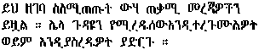
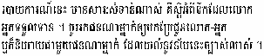
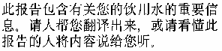
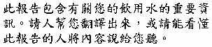
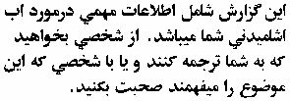
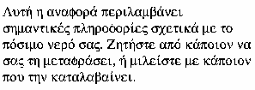
The translations below are examples state or public water systems may use. The translations are included in the Preparing Your Drinking Water Consumer Confidence Report Guidance for Water Suppliers. Translations are provided courtesy of the State of Washington Department of Health. None of these translations has been independently verified.

Translations for the English Text:
“This report contains important information about your drinking water. Have someone translate it for you, or speak with someone who understands it.”
Amharic: | Arabic:
Cambodian (Khmer): | Chinese (simplified):
Chinese (traditional): | Farsi:
French:  Ce rapport contient des informations importantes à propos de votre eau potable. Demander à quelqu’un de traduire ces informations pour vous ou discuter avec une personne qui comprend ces informations. | Greek:

Hebrew: | Hindi:
Hmong:  Dlaim ntawv tshaabxu nuav muaj lug tseemceeb heev nyob rua huv kws has txug cov dlej mej haus. Kuas ib tug paab txhais rua koj, los nrug ib tug kws paub lug thaam. | Japanese:
Korean: | Laotian:
Oromo: | Polish:
Punjabi: | Russian:

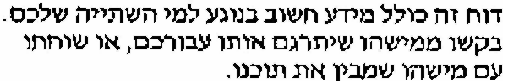
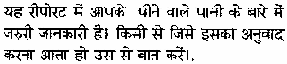
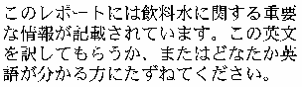
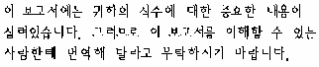
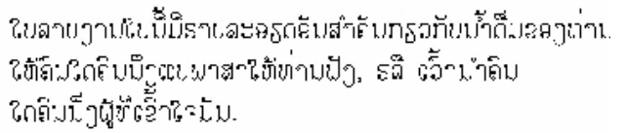
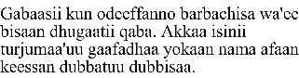
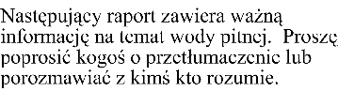
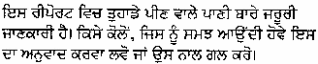
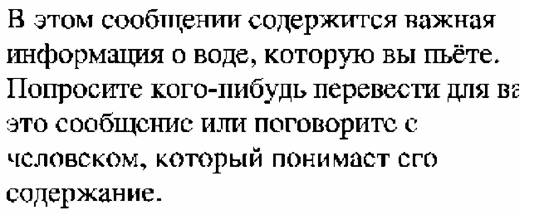

Samoan: | Serbo-Croatian:
Somali: | Spanish:
Tagalog: | Thai:
Tigrigna: | Ukranian:
Vietnamese:

