INDOOR AIR QUALITY ASSESSMENT

**Wilbraham Middle School**

466 Stony Hill Road

Wilbraham, MA

**January 2025**

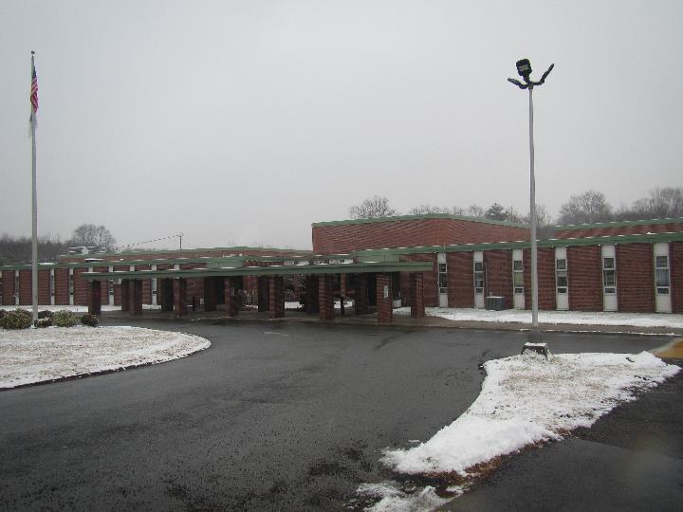

Prepared by:

Massachusetts Department of Public Health

Bureau of Climate and Environmental Health

Division of Environmental Health Regulations and Standards

Contents

EXECUTIVE SUMMARY 3

BACKGROUND 4

RESULTS AND DISCUSSION 5

Ventilation 5

HVAC System Maintenance 6

HVAC Types and Specific Conditions 7

Water Damage and Moisture Concerns 7

Sources of Respiratory Irritants/Possible Asthma Triggers 10

Other IAQ Issues 11

CONCLUSIONS AND RECOMMENDATIONS 11

REFERENCES 16

FIGURES 17

PICTURES 18

Ventilation Pictures 18

Water Damage pictures 23

Respiratory Irritants pictures 26

Table 1 27

Table 2A 34

Table 2B 35

Table 2C 36

Table 3 37

Table 4 39

# EXECUTIVE SUMMARY

The Massachusetts Department of Public Health’s (MDPH) Division of Environmental Health, Regulations and Standards (DEHRS) conducted an Indoor Air Quality (IAQ) assessment of Wilbraham Middle School located at 466 Stony Hill Road in Wilbraham on December 16, 2024. This assessment was requested by the Wilbraham Health Department in coordination with the facilities department for Hampden-Wilbraham Schools.

Any building can have IAQ issues. These issues can be made worse through conditions common to marginalized communities (Environmental Justice communities or EJ) such as inequitable exposure to outdoor air pollution and a greater likelihood of poor building conditions leading to deterioration of IAQ resulting in higher asthma rates. Wilbraham Middle School is not within an EJ community, and the town of Wilbraham does not contain any labeled EJ communities (<https://matracking.ehs.state.ma.us/Environmental-Data/ej-vulnerable-health/environmental-justice.html>). Note that the pediatric asthma rate for this school as of 2024 is 9.9%. This rate is not statistically significantly different from the statewide pediatric asthma prevalence rate of 9.6% (MAEPHT, 2024).

The assessment was conducted by evaluating several key elements within the school: a visual inspection of the heating, cooling, and ventilation (HVAC) systems, water/microbial damage, cleanliness, point sources of respiratory irritants such as chemicals, and electronic measurement of carbon dioxide (CO2), carbon monoxide (CO), temperature, relative humidity (RH), and small particulate matter (PM2.5) all taken with a Qtrak XP monitor. Data is collected in this manner to identify potential asthma triggers, allergens, and other environmental factors that can cause indoor air quality symptoms. Please refer to the [Indoor Air Quality Manual](https://www.mass.gov/lists/indoor-air-quality-manual-and-appendices#indoor-air-quality-manual-) on the MDPH website for methods, sampling procedures, and interpretation of results.

Overall conditions in this school are similar to other schools of this age and type. Some univents and many unit exhausts were not operating, were operating weakly, or had been retrofitted with non-standard parts in an attempt to repair them. While hot, humid summer weather had led to mold growth over the summer, no obvious signs of mold, including visible mold growth were noted during the assessment. The addition of dehumidifiers and cooling units will help prevent water damage in future summers if used appropriately. Many of the materials used in construction of schools of this age, such as concrete, hard wood, floor tile, and brick, are resistant to mold growth. (Results and Discussion)

Upon review of these findings, a number of primary recommendations are made to optimize existing systems and improve air exchange. (Conclusions and Recommendations)

* Have the exhaust system/unit exhausts evaluated and repaired by a professional HVAC engineering firm to increase air exchange.
* Use air purifiers, air scrubbers, and portable cooking equipment in accordance with manufacturer’s instructions.
* Move classroom materials away from univents and exhaust vents in all rooms to ensure proper air circulation and temperature control.
* Reduce clutter in classrooms, storage areas, and the science chemistry storage room

(Conclusions and Recommendations)

In 1999 and 2000 MDPH did two IAQ assessments of the school. These reports are available on request. Please note: this report contains a series of recommendations that should serve as Best Practices that apply to most public-school buildings across the Commonwealth and should be shared amongst other buildings in the school district.

# BACKGROUND

|  |  |
| --- | --- |
| Building: | Wilbraham Middle School (WMS) |
| Address: | 466 Stony Hill Road, Wilbraham, Massachusetts |
| Coordinated Via: | Wilbraham Health Department |
| Reason for Request: | General indoor air quality (IAQ) issues and mold issues |
| Date of Assessment: | December 16, 2024 |
| Massachusetts Department of Public Health/Bureau of Climate and Environmental Health (MDPH/BCEH) Staff Conducting Assessment: | Ruth Alfasso, Environmental Engineer/Inspector, Division of Environmental Health, Regulations and Standards |
| Building Description: | The WMS is a split-level brick building originally constructed in the 1960s. The classroom wing is two stories set perpendicular to the wing containing offices, the gym, library, and auditorium. |
| Windows: | Windows in the building are openable. |

# RESULTS AND DISCUSSION

The following is a summary of indoor air testing results (Table 1)

|  |  |  |
| --- | --- | --- |
| * ***Carbon dioxide (CO2)*** | *a measure of the adequacy of ventilation* | Levels were above the MDPH guideline of 800 parts per million (ppm) in over half of the areas surveyed, indicating a lack of air exchange, particularly in heavily-occupied classrooms. |
| * ***Temperature*** | *a measure of comfort* | Was mostly within/close to the MDPH recommended range of 70°F to 78°F in most occupied areas. |
| * ***Relative humidity*** | *a measure of comfort and, when in excess for an extended period, a way to reflect the potential for mold and fungal growth* | Was below the MDPH recommended range of 40 to 60% in most areas tested. This is reflective of outdoor conditions. Low relative humidity is common indoors during the heating season. Relative humidity would be expected to be higher during hot, humid weather. |
| * ***Carbon monoxide***   ***(CO)*** | *a product of combustion that can result in acute and long term cardiovascular, respiratory, and neurological symptoms* | Levels were non-detect (ND) in all areas tested. |
| * ***Particulate matter (PM2.5)*** | *a way to measure inhalable particle distribution in the air* | Concentrations were below the National Ambient Air Quality Standard (NAAQS) of 35 micrograms per cubic meter (μg/m3) in all areas tested. |

## Ventilation

Ventilation refers to both the supply of fresh air and the removal of stale air from a room. The introduction of fresh air into an occupied space will dilute normally occurring pollutants that are generated by occupancy and other activities. In addition, an HVAC system will remove pollutants from a building if operating appropriately. All ventilation systems throughout the building should operate continuously during periods of occupancy.

Most classrooms are equipped with unit ventilators (univent, Picture 1). Univents bring in fresh air from a vent on the outside of the building (Picture 2), filter, heat it, and supply the air through a vent on the top. Some room air is recirculated along with the fresh air through a vent at the bottom (Figure 1).

Mechanical ventilation to the gymnasium, resource room, and other common areas is provided by air handling units (AHUs). An AHU draws in air from the outside, heats it and distributes it via vents in the ceiling (Picture 3).

Classroom exhaust is provided by unit exhausts also located along the exterior walls (Picture 4). At the time of assessment, exhaust ventilation in many rooms was not operating, or was drawing very weakly. It was not known whether these vents were not functional or just deactivated. Wall-mounted or ceiling-mounted exhaust vents were noted in rooms without unit exhaust. Some of these were also not working. Without proper supply and exhaust ventilation, normally-occurring environmental pollutants can build up and lead to indoor air quality/comfort complaints. In addition, without proper exhaust ventilation, excess moisture cannot be removed from the building, which can lead to mold growth conditions over the summer.

Most rooms had some form of supplemental cooling, including wall-mounted ductless air conditioners (also known as mini-split units, Picture 5), window-mounted air conditioners (Picture 4), or portable air conditioners (Picture 6). Note that window air conditioners can supply a small amount of fresh air, while ductless units and portable units only recirculate room air. All these cooling systems create condensation that needs to be properly drained.

Many rooms are equipped with large portable air purifiers (also known as air scrubbers), which can filter a large volume of air every hour while operating (Picture 7). These have filters, typically high-efficiency particulate air (HEPA) filters, to remove particulates of all sizes. These, and other HEPA-filter air purifiers, are good for reducing non-gaseous pollutants in indoor air such as mold, bacteria, viruses, and respirable dusts. They need to be maintained in accordance with manufacturer’s instructions including filter changes.

Dehumidifiers were present in some rooms (Picture 8), which were installed to help reduce the potential for mold growth after a hot, humid summer. Dehumidifiers need to be emptied daily and cleaned regularly to prevent stagnant water and odors. Note that since humidity in the building was below the MDPH comfort level, use of dehumidifiers should be limited during the heating season to only areas with higher humidity or a high potential for mold growth, such as below-grade storage areas, and be stored for the winter otherwise.

The various types of ventilation components as well as devices that can move/redirect airflow that were identified in the building are listed in Table 2A, Table 2B and Table 2C.

### HVAC System Maintenance

* **MDPH recommends that filters of at least a Minimum Efficiency Rating Value (MERV) 8** be used as these are adequate to filter out pollen, mold, and similar particulates (ASHRAE, 2012). A univent was opened and the filter examined. Filters used in univents are pleated MERV 8 (Picture 9).
* **It was reported that MERV filters in univents are replaced two to four times a year**. MDPH recommends that filters be changed two to four times a year or as per the manufacturers’ recommendations.
* **Some of the univents were obstructed by items in front of return vents** or along the top (Table 1). To provide mechanical ventilation as designed and to prevent damage to machinery, both the supply and return vents (along the front/bottom of the unit) should be free and clear of obstructions.
* **Some univents had replacement supply vents that did not match the original equipment.** These replacement vents may not be as effective and may be difficult to clean.
* **As noted, many exhaust vents were not operating or had a very weak draw.** Lack of effective exhaust ventilation can reduce the ability of the ventilation system to provide fresh air, and can allow stale air, along with odors and pollutants, to linger.

### HVAC Types and Specific Conditions

**Balancing**

To have proper ventilation with a mechanical supply and exhaust system, a system must be balanced to provide an adequate amount of fresh air to the interior of a room while also removing stale air from the room. It is recommended that HVAC systems be re-balanced every five years to ensure adequate air systems function (SMACNA, 1994).

(see Ventilation pictures)

**Additional HVAC Conditions:**

* Note that unit exhausts are on the same side of the classroom as univents. This can create conditions where air short-circuits and goes directly from the univent to the exhaust without passing through the occupied areas of the room. This is made worse when units are blocked by furniture or items.
* Ceiling fans are present in some rooms (Picture 10). These can be helpful to mix room air.
* Ceiling fans, stand fans, and desktop fans need to be cleaned periodically to remove dust that can be aerosolized, or can become a medium for mold growth if moistened.

## Water Damage and Moisture Concerns

Please note that the MDPH does not recommend conducting mold testing in a typical water damage remediation. For details, please consult [Guidance Regarding Testing for Mold in Water-Damaged Public Buildings](https://www.mass.gov/info-details/guidance-regarding-testing-for-mold-in-water-damaged-public-buildings) | Mass.gov

The application of a mildewcide to moldy porous materials is not recommended.

Molds are found naturally in our environment both indoors and outdoors. Inside, mold growth may occur when items, particularly porous products such as paper or gypsum wallboard, are exposed to moisture. Typical water sources include leaks, floods, and condensation. To avoid mold growth, dry all water-damaged items and affected areas within 24-48 hours and reduce indoor humidity. Some people with chronic respiratory conditions, such as asthma, are more likely to experience health symptoms associated with molds, including allergic reactions and respiratory irritation. Controlling moisture is the key to preventing mold growth and potential health symptoms.

Hot humid summers are becoming more frequent due to climate change. Massachusetts has experienced hot, humid, and rainy summers in 2018, 2021, and 2023. July of 2021 was the wettest ever recorded in Massachusetts, and the three-month period from June through August, known as the meteorological summer, was the fourth wettest on record, according to the National Oceanic and Atmospheric Administration’s (NOAA) Centers for Environmental Information (NOAA, 2021). The summer of 2023 was also hot, and wet, being measured as the second rainiest on record (WBUR, 2023). The summer of 2024 also had significant stretches of hot, humid weather. These conditions are challenging for buildings, particularly those without central air conditioning.

During these hot and wet summers, extended periods of outdoor relative humidity above 70% occurred. Under these weather periods, public buildings experienced extended periods of water vapor exposure from high relative humidity. When exposed to these conditions, porous materials such as gypsum wallboard, cardboard, and other materials may become prone to developing mold colonization, particularly if located in areas that are prone to developing condensation on floors and walls (e.g., below grade space).

Mold concerns were the main reason for this assessment. Building facility staff have reported periodic mold and moisture-related issues in the building. In early August of 2024, mold and mold odors were reported in several rooms. Significant cleanup, investigation, and testing were conducted. During this process, to reduce indoor humidity, the school was equipped with the dehumidifiers and portable/window air conditioners that were found during this assessment. At that time, water-damaged ceiling tiles and other affected materials, such as papers, were removed and discarded, and other items were cleaned with a disinfectant. “Fogging” was conducted with an anti-microbial agent in some areas where mold was noted or suspected. The process of fogging for mold is not recommended by BCEH/DEHRS as it does not address the source of water, and will not remove moldy materials. In addition, this process may be regulated by the Massachusetts Pesticide Board which licenses pesticide applicators, and has specific requirements for pest control in schools (<https://www.mass.gov/doc/333-cmr-14-protection-of-children-and-families-from-harmful-pesticides>).

During this assessment, rooms were assessed for the presence of either mold or visible water damage and an exterior evaluation was conducted to identify potential pathways for water penetraion. The following issues were noted.

* **Water-damaged ceiling tiles were found in several locations (Picture 11; Table 1),** which can indicate current/historic roof/plumbing leaks or other water infiltration. Water-damaged ceiling tiles can provide a source of mold and should be replaced after a water leak is discovered and repaired.
* **Missing ceiling tiles were noted in a few areas.** Tiles that are removed to address leaks should be replaced once the leaks are repaired. A continuous ceiling tile system can keep dust and debris away from occupied areas**.**
* **Bowed or sagging ceiling tiles were found in some locations (Picture 12)** This is likely the result of moisture exposure from long periods of elevated relative humidity. While bowing tiles are not a direct IAQ issue, it is a reminder that long periods of high relative humidity may lead to water damage to other materials, particularly those stored in contact with cooler temperatures such as on uninsulated floors, and in the airstream of air conditioning.
* **One location with water-damaged ceiling tiles was a storage room for band/music.** Numerous instrument cases were stored in this and adjacent rooms. Instrument cases and instruments are at high risk for mold colonization and water damage due to being constructed of a variety of porous materials such as wood, cloth, and leather. In addition, one of the storage rooms had a sink which can be a source of leaks, or a source of sewer gases if the drain trap dries out.
* **Ductless mini-split air conditioners create condensation which needs to be drained.** Drain tubing and associated pumps should be checked periodically to prevent leaks due to clogs or malfunctions. Porous items should not be stored underneath these units.
* **Portable air conditioners also create condensation.** The models seen can either collect the condensation in a vessel that needs to be emptied regularly or can be connected to a pump to discharge the condensation to a drain. Also note that some of the portable air conditioners were equipped with vents to discharge waste heat into the ceiling plenum. With insufficient or no exhaust flow in the plenum, excess use of portable air conditioners can pressurize the plenum and force dust and debris from above the ceiling tile system into occupied areas.
* **Light was visible beneath some exterior doors** showing gaps that allow for uncontrolled drafts, moisture, and pest entry (Picture 13).
* **Sinks were present in some classrooms.** Seldom-used sinks can have their drains dry out, which removes the seal created by water in the drain trap. This can allow sewer gases, odors, and moisture into occupied areas.
* **Plants were noted in some classrooms and offices (Picture 14).** Plants should be well-maintained and placed on waterproof drip pans to prevent water damage to porous materials. Plants should be kept away from the airstream of ventilation equipment, so odors, moisture, and potential mold spores aren’t carried around the room.
* **A washer and dryer were noted in the vestibule of a classroom.** The dryer appears to be vented into a cap (Picture 15) rather than outside. Dryers that are not designed to be vented indoors, should be vented to the outside. As this dryer was along an interior wall, this is challenging. Venting a dryer indoors can increase humidity, and distribute odors such as fabric softener around occupied spaces. In addition, dryer vents should be cleaned frequently to prevent a buildup of lint which can cause a fire.
* **Moss was noted on the exterior of some windowsills (Picture 16).** This is an indication that this side of the building may not dry thoroughly. Moss and clinging plants should be removed periodically to limit damage to building materials.
* **Trees were noted overhanging and next to building.** Trees can prevent the exterior of the building from drying. Leaves and other debris can clog drains. And trees overhanging or touching a building can provide transport for pests. Trees should be trimmed at least five feet from the building exterior.

A list of water damage issues identified inside and outside the building is included as Table 3.

(see Water Damage Pictures)

**Mold Growth**

Porous materials (e.g., gypsum wallboard, ceiling tiles and carpeting) can be dried with fans and heating within 24 to 48 hours of becoming wet (US EPA, 2008).

If porous materials are not dried within this time frame, mold growth may occur.

## Sources of Respiratory Irritants/Possible Asthma Triggers

Asthma is a lung disease that can make breathing difficult. Without careful management of asthma, some people can have symptoms, like a tight feeling in the chest, shortness of breath, coughing, or wheezing. Although there is no cure for asthma, people with asthma can live healthy, active lives. A safe and healthy environment helps to reduce asthma symptoms.

**Comparison of Local and State-wide Asthma Rates (2024)**

9.9% of children

have asthma.

**Wilbraham Middle School**

9.6% of children

have asthma.

**Massachusetts**

8.3% of children

have asthma.

**Wilbraham**

* **Sometimes, learning tools and personal items in a classroom can be a source of irritants.** For example, a bird or insect nest is a great learning tool for students but may harbor microbes and allergens, as does a fish tank which could be a source of odors. Similarly, food-based projects can attract pests that carry disease or trigger allergies.
* **Dust, a common respiratory and eye irritant, can collect on surfaces and items.** Although janitorial and maintenance staff perform routine cleaning in classrooms, they may not be able to clean as effectively if classroom items are not picked up or surfaces are cluttered.
* Even with a properly functioning ventilation system, it is necessary to reduce the use of materials that can be a source of respiratory irritants to prevent symptoms in individuals who have sensitivity to such pollutants. **Without operational mechanical exhaust in most areas, irritants can linger.**

For guidance on maintaining an asthma-friendly healthy school environment, please consult the MDPH Asthma Prevention and Control Program’s [Clearing the Air: An Asthma Toolkit for Healthy Schools](https://www.maasthma.org/schooltoolkit).

Possible asthma triggers and/or airborne pollutants exist in the building. These are listed below as well as in (Table 4).

(see Sources of Respiratory Irritant Pictures)

* **Exposure to low levels of total volatile organic compounds (TVOCs)** may produce eye, nose, throat, and/or respiratory irritation in some sensitive individuals. Testing for TVOCs was not conducted, however MDPH staff examined rooms for products containing VOCs. MDPH staff noted hand sanitizers, and dry erase materials (Table 1) in use within the building. These products have the potential to be irritants to the eyes, nose, throat, and respiratory system of sensitive individuals. Consult “[Clean Air Is Odor Free](https://www.mass.gov/doc/clean-air-is-odor-free-removing-fragrances-to-improve-indoor-air-quality-in-schools-and-offices-0/download)” for more information on fragrances in schools and other building.
* **Some classrooms and storage rooms were cluttered with items (Picture 17).** Excess items can make it difficult to clean thoroughly. In addition, clutter can provide harborage for pests.
* **A science storage area had a variety of products (Picture 18).** While most of these appeared to be common household items, they are not stored in a very organized manner. Some containers appeared to be old, and some were not labeled. Chemical storage should be organized, with incompatible products separated. Unneeded, expired, or unknown materials should be discarded. This document <https://www.mass.gov/info-details/improper-chemical-storage-or-usage> can be used to help with science storage issues.

## Other IAQ Issues

*Radon*

Radon is a naturally occurring radioactive gas that seeps into buildings from the surrounding soil and at elevated levels can increase the risk of lung cancer.

The Environmental Protection Agency (EPA) conducted a National School Radon Survey “in which it discovered nearly one in five schools has at least one schoolroom with a short-term radon level above the action level of 4pCi/L (picocuries per liter) – the level at which the EPA recommends that schools take action to reduce the level” (US EPA, 1993).

**The MDPH therefore recommends that every school be tested for radon, and that this testing be conducted during the heating season while school is in session in a manner consistent with US EPA radon testing guidelines**. Radon measurement specialists and other information can be found at [www.nrsb.org](http://www.nrsb.org) and <http://aarst-nrpp.com/wp>, with additional information at: <https://www.mass.gov/radon>.

# CONCLUSIONS AND RECOMMENDATIONS

Please note: this report contains a series of recommendations that should serve as *Best Practices* that apply to most public-school buildings across the Commonwealth and should be shared amongst other buildings in the Hampden-Wilbraham School District:

|  |  |  |  |
| --- | --- | --- | --- |
|  | **HVAC System** | | **Helpful Links** |
|  | Have the mechanical exhaust systems evaluated building-wide for operation, and repair as needed. |  | |
| 1. If | Ensure all univents are on and operating continuously during occupied periods. |  | |
|  | Where possible, use matching replacement grills on univents. |  | |
|  | Ensure univents and unit exhausts are not blocked by furniture or items. |  | |
|  | Use openable windows during temperate weather for additional fresh air. Avoid opening windows during heavy precipitation, extreme cold, poor outdoor air quality, high pollen counts, or excessive noise. | <https://www.airnow.gov/> | |
|  | Ensure windows are closed tightly at the end of the day as well as during periods of elevated relative humidity (70%) and during freezing weather to prevent pipe bursts. |  | |
|  | Use air purifiers and air scrubbers, and place them so the filtered airstream is in the breathing zone of occupants. |  | |
|  | Air purifiers that use HEPA filters, with or without carbon filters, are good choices for occupied areas. Units that may produce ozone should not be used. Maintain all in accordance with manufacturer’s instructions. | <https://www.epa.gov/indoor-air-quality-iaq/ozone-generators-are-sold-air-cleaners> | |
|  | Change HVAC filters 2-4 times a year using MERV 8 or the best MERV-rating that can work with current equipment. | [ANSI/ASHRAE Standard 52.2-2017](https://www.ashrae.org/File%20Library/Technical%20Resources/COVID-19/52_2_2017_COVID-19_20200401.pdf) | |
|  | During filter changes, clean dust and debris from the inside of HVAC system cabinets. |  | |
|  | Clean dust and debris from vents, ceiling fans, and personal fans periodically. |  | |
|  | Clean and maintain mini-splits, portable air conditioners, and window air conditioners in accordance with manufacturers’ instructions. |  | |
|  | Use caution when ducting the waste heat from portable air conditioners into the ceiling plenum to avoid overpressure leading to dust and debris being pushed into occupied spaces. |  | |
|  | Ensure dehumidifiers are emptied regularly. Stop using dehumidifiers in most areas when humidity is low and resume when outdoor humidity rises. Continued use of humidifiers in storage areas with known water issues may be warranted all year. |  | |
|  | Remove blockages from univents and exhaust vents. |  | |
|  | Once mechanical exhaust systems are repaired/activated, have the HVAC system balanced if it has been more than 5 years since the last balancing. |  | |
|  | **Water damage** | | |
|  | Replace water-damaged suspended ceiling tiles. Repeated water damage to ceiling tiles indicates leaks from the roof or plumbing/HVAC system which should be repaired. | <http://www.epa.gov/mold/mold-remediation-schools-and-commercial-buildings-guide> | |
|  | Once leaks are repaired, replace missing ceiling tiles to maintain a continuous ceiling plenum. |  | |
|  | Do not store books, cardboard, or other porous items directly on ground-level floors or up against walls to prevent mold growth due to condensation on cool surfaces, Elevate items with pallets or store on shelving. |  | |
|  | While bowed/sagging ceiling tiles are not a source of mold, they indicate extended exposure to high humidity. Therefore, care should be taken with storage of materials in these areas during hot, humid weather and over the summer. |  | |
|  | Take special care with regards to water damage and condensation where musical instruments are stored. |  | |
|  | Ensure condensation from ductless and portable air conditioners is drained properly or emptied frequently. |  | |
|  | Seal spaces in and around exterior doors with weatherstripping, to prevent drafts, moisture, and pest entry. |  | |
|  | Properly maintain plants to avoid mold and odors. Keep plants away from airflow. |  | |
|  | Avoid venting of dryers into occupied spaces unless they are designed for such use. Venting the dryer outdoors may require moving the equipment to a location near an exterior wall. |  | |
|  | Use these guidelines to control for moisture and increase comfort in a non-air-conditioned school especially during heatwaves. | * Mold Growth Prevention During Hot, Humid Weather <https://www.mass.gov/service-details/preventing-mold-growth-in-massachusetts-schools-during-hot-humid-weather> * Remediation and Prevention of Mold Growth and Water Damage in Public Schools <https://www.mass.gov/service-details/remediation-and-prevention-of-mold-growth-and-water-damage-in-public-schools-and> * Methods for Increasing Comfort in Non-air-conditioned Schools <https://www.mass.gov/doc/methods-for-increasing-comfort-in-non-air-conditioned-schools/download> | |
|  | During summer months, pull furniture away (1 to 2 inches) from walls to prevent mold growth due to lack of airflow and remove impermeable wall coverings that can trap moisture such as laminated posters. |  | |
|  | Trim trees, branches, and shrubbery at least 5 feet away from the building. |  | |
|  | Clean moss from exterior windowsills and examine affected areas for breaches. |  | |
|  | Avoid use of “fogging” products for mold. Ensure any products used to clean mold are appropriate and used in accordance with package directions and state regulations. |  | |
|  | Ensure drain traps in classroom sinks and other areas are moistened periodically when school is out of session to prevent dry drain traps. |  | |
|  | **Respiratory Irritants/Possible Asthma Triggers** | | |
|  | Clean dust from surfaces, including chalk and dry erase dust, frequently using methods that do not aerosolize the dust, including HEPA-equipped vacuuming or wet wiping. Avoid using feather dusters or sweeping dust into the air. |  | |
|  | Reduce clutter. Periodically remove unwanted items. Store remaining items neatly and off the floor. Where rooms have a history of moisture issues, consider storing items in waterproof totes. |  | |
|  | Reduce use of products and equipment that create irritating volatile organic compounds (VOCs) and only use in well-ventilated areas. Minimize the use of air fresheners (e.g., plug-ins), deodorizers and scented products. | <https://www.mass.gov/cleaner-greener-healthier-schools>  [Clean Air Is Odor Free](https://www.mass.gov/doc/clean-air-is-odor-free-removing-fragrances-to-improve-indoor-air-quality-in-schools-and-offices-0/download) | |
|  | Use only District-approved cleaning products. Keep spray bottles properly labeled and out of the reach of children. |  | |
|  | Clean out science storage areas frequently and store only compatible products together. Ensure all items are closable, properly closed, and labeled. | <https://www.mass.gov/info-details/improper-chemical-storage-or-usage> | |
|  | **Other Recommendations to Improve Air Quality Conditions** | | |
|  | Test the school for radon by a certified radon measurement specialist during the heating season when school is in session. | Radon measurement specialists and other information can be found at: [www.nrsb.org](http://www.nrsb.org), and <http://aarst-nrpp.com/wp> | |
|  | To learn more about radon, review the MDPH’s Radon in Schools and Childcare Programs factsheet. | <https://www.mass.gov/radon>. | |
|  | Utilize the US EPA’s (2000), “Tools for Schools” as an instrument for maintaining a good IAQ environment in the building. | <https://www.epa.gov/iaq-schools>. | |
|  | For guidance on maintaining an asthma-friendly healthy school environment, please consult the MDPH Asthma Prevention and Control Program’s Clearing the Air: An Asthma Toolkit for Healthy Schools. | <https://www.maasthma.org/schooltoolkit> | |
|  | Include an IAQ component in the school’s Wellness Advisory Committee program. An IAQ plan should have an IAQ liaison/teacher representative, a member of maintenance/facilities and administration that conduct regular walk-throughs to identify on-going and/or potential environmental issues. |  | |

# REFERENCES

MAEPHT. 2024. Massachusetts Environmental Public Health Tracking. Massachusetts Department of Public Health – Bureau of Climate and Environmental Health. <https://matracking.ehs.state.ma.us/>

NOAA. 2021. Summer 2021 neck and neck with Dust Bowl summer for hottest on record. National Oceanic and Atmospheric Administration, 1401 Constitution Avenue NW, Room 5128, Washington, DC 20230 <https://www.noaa.gov/news/summer-2021-neck-and-neck-with-dust-bowl-summer-for-hottest-on-record>

SMACNA. 1994. HVAC Systems Commissioning Manual. 1st ed. Sheet Metal and Air Conditioning Contractors’ National Association, Inc., Chantilly, VA.

US EPA. 1993. Radon Measurement in Schools, Revised Edition. Office of Air and Radiation, Office of Radiation and Indoor Air, Indoor Environments Division (6609J). EPA 402-R-92-014.

US EPA. 2000. Tools for Schools. Office of Air and Radiation, Office of Radiation and Indoor Air, Indoor Environments Division (6609J). EPA 402-K-95-001, Second Edition. <https://www.epa.gov/iaq-schools>.

US EPA. 2008. Mold Remediation in Schools and Commercial Buildings. US Environmental Protection Agency, Office of Air and Radiation, Indoor Environments Division, Washington, D.C. EPA 402-K-01-001. <http://www.epa.gov/mold/mold-remediation-schools-and-commercial-buildings-guide>.

WBUR. 2023. “It’s been a summer of rain and flooding misery in Mass.” WBUR local news. September 12, 2023. <https://www.wbur.org/news/2023/09/12/summer-flooding-rain-massachusetts>

(Click to link back to report)

# FIGURES

**Figure 1**

**Unit Ventilator (Univent)**

Mixed Air

Air Diffuser

**Outdoors Indoors**

Fan

Heating/Cooling Coil

Air Mixing Plenum

Filter

Outdoor Return

Air Air

Air

Flow

Control

Louvers

**Air Flow**

= Fresh Air/Return Air

= Mixed Air

# PICTURES

## Ventilation Pictures

**Picture 1**

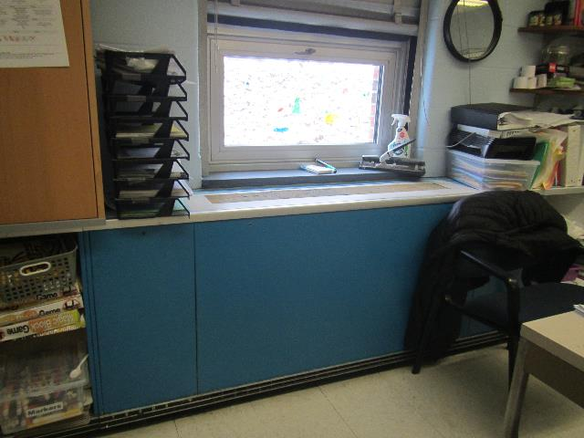

**Unit ventilator (univent) in a classroom**

**Picture 2**

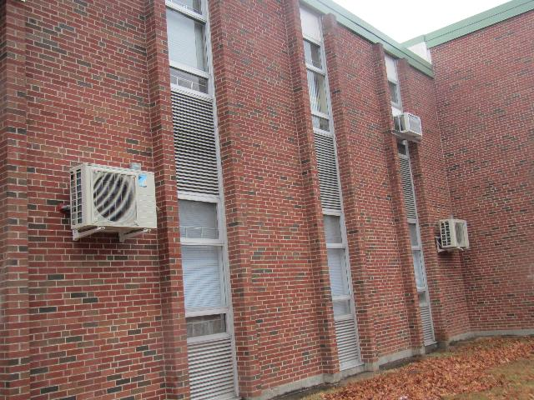

**Unit ventilator fresh air intakes, and unit exhaust vents on the side of the school; note exterior heat exchanger for ductless mini-splits**

**Picture 3**

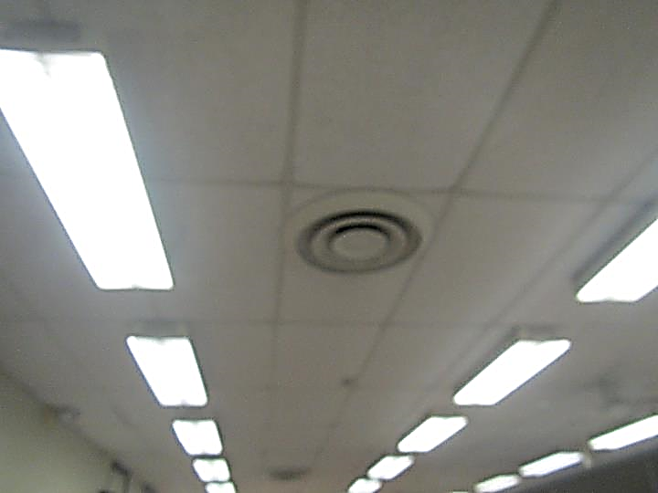

**Supply vent in the ceiling of the library**

**Picture 4**

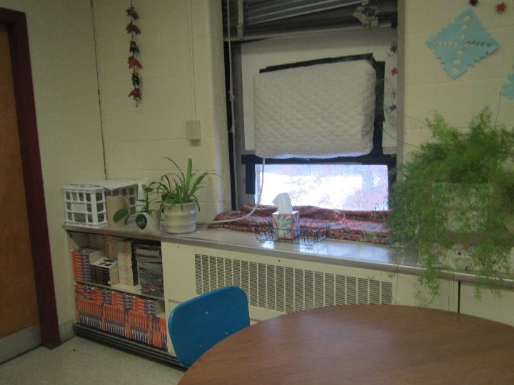

**Unit exhaust vent; note window air conditioner with quilted cover**

**Picture 5**

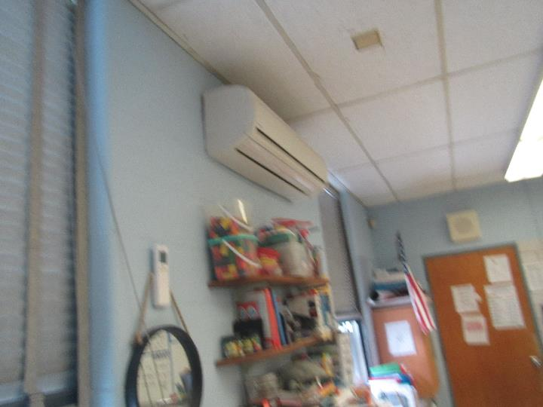

**Wall-mounted ductless mini-split air conditioner**

**Picture 6**

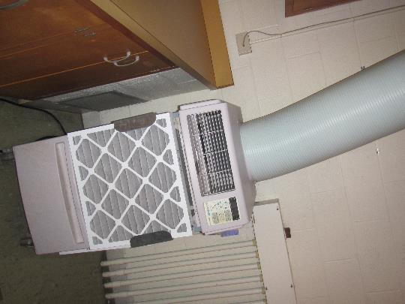

**Portable air conditioner with supplemental filter and vent into the ceiling**

**Picture 7**

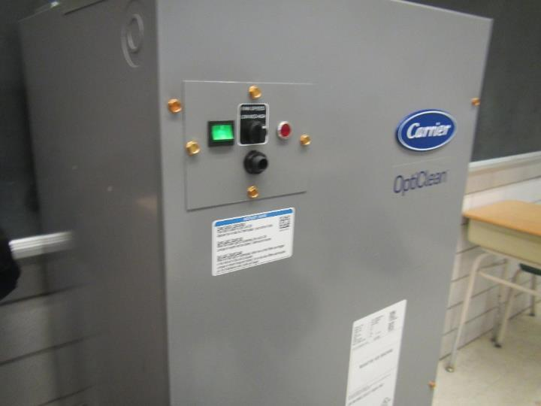

**Large volume “air scrubber” air purifier**

**Picture 8**

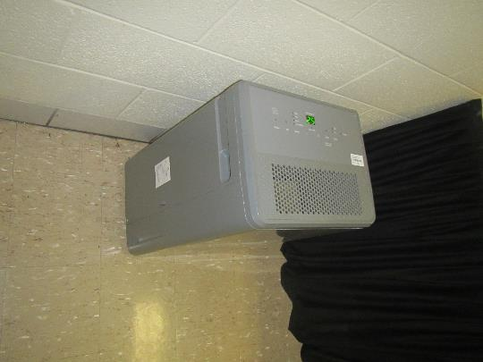

**Dehumidifier, note display at top reads 25, which is the relative humidity it is set to reduce to**

**Picture 9**

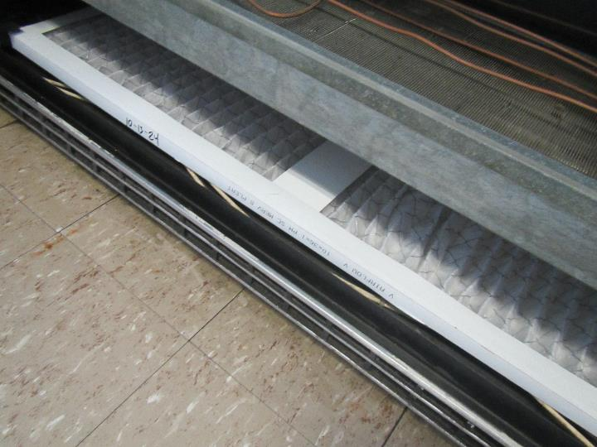

**Pleated MERV 8 filter in a univent**

**Picture 10**

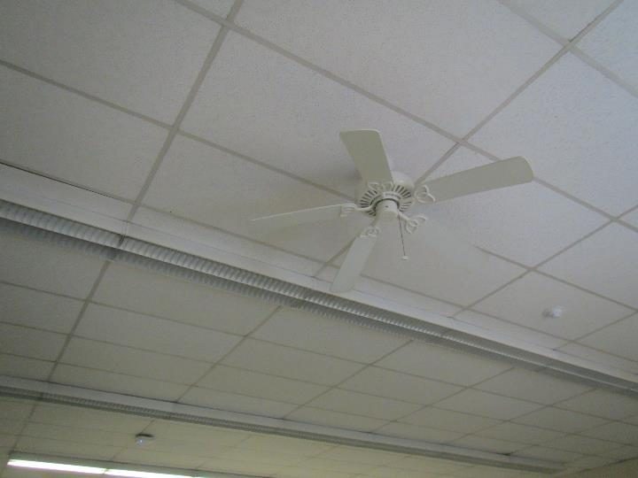

**Ceiling fan**

## Water Damage pictures

**Picture 11**

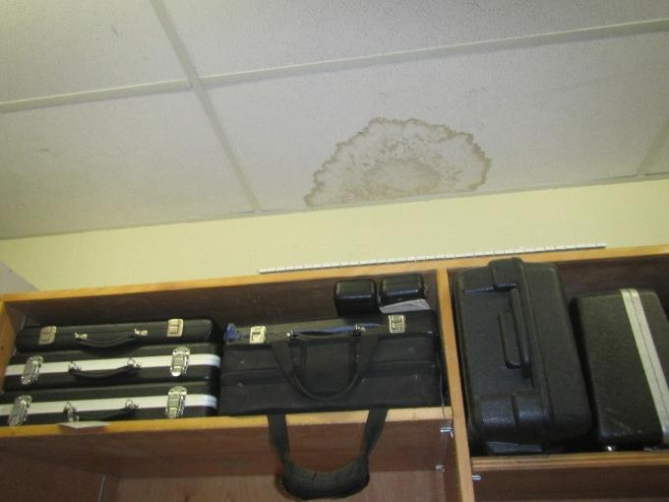

**Water-damaged ceiling tile in a music storage room**

**Picture 12**

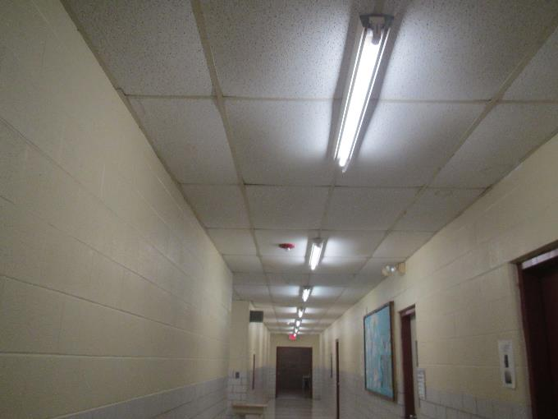

**Bowed ceiling tiles in a hallway**

**Picture 13**

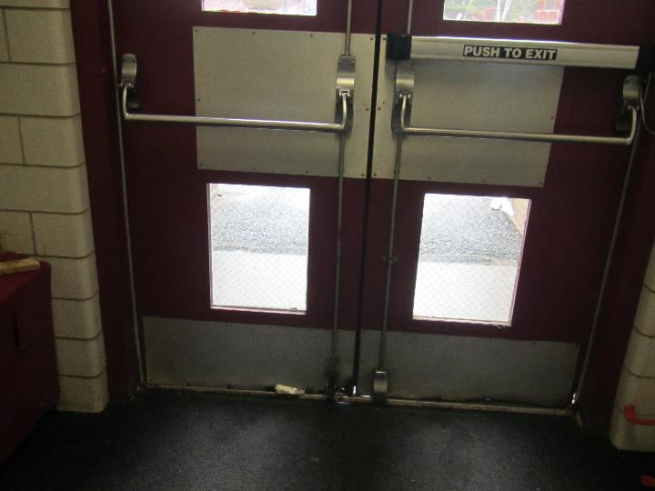

**Gaps under exterior door**

**Picture 14**

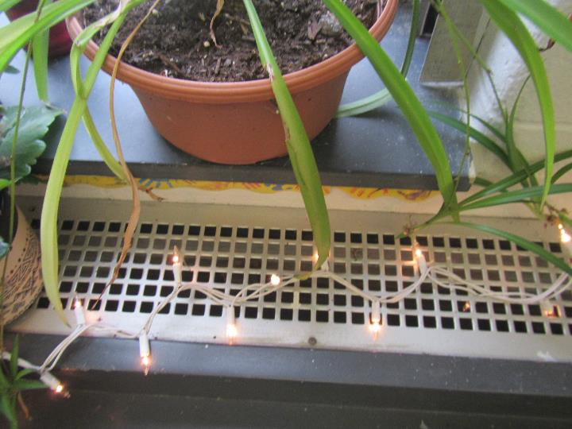

**Plant on univent**

**Picture 15**

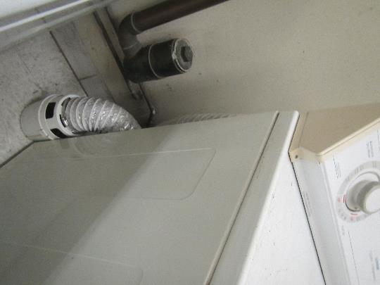

**Dryer venting inside a classroom**

**Picture 16**

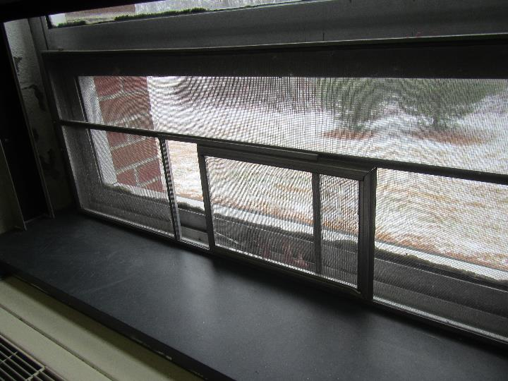

**Moss on exterior of windowsill**

## Respiratory Irritants pictures

**Picture 17**

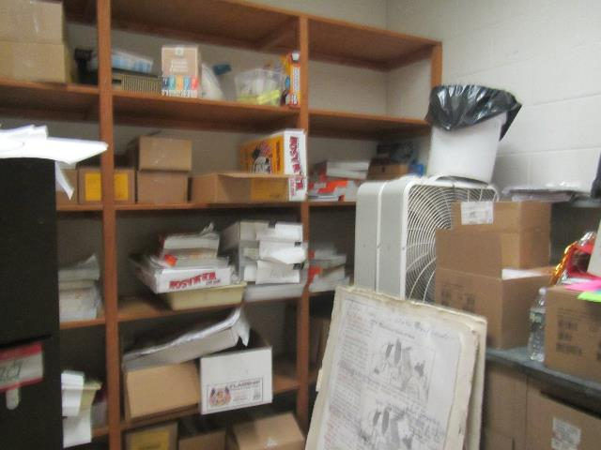

**Cluttered storage room**

**Picture 18**

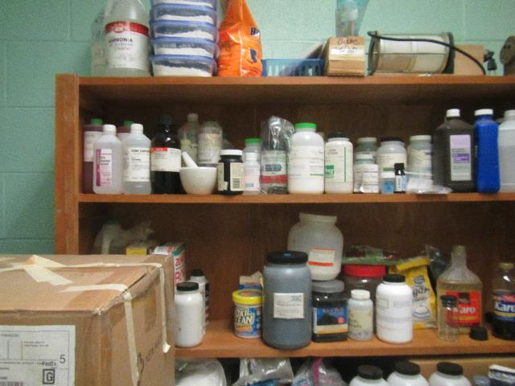

**Shelf of items in a science storage room**

Click to link back to report

# Table 1

| **Location** | **Carbon**  **Dioxide**  **(ppm)** | **Carbon Monoxide**  **(ppm)** | **Temp**  **(°F)** | **Relative**  **Humidity**  **(%)** | **PM2.5**  **(µg/m3)** | **Occupants**  **in Room** | **Windows**  **Openable** | **Ventilation** | | **Remarks** |
| --- | --- | --- | --- | --- | --- | --- | --- | --- | --- | --- |
| **Supply** | **Exhaust** |
| Background (outside) | 476 | NA | 39 | 62 | 16 |  |  |  |  | Light wintry mix |
| First floor classroom wing | | | | | | | | | | |
| 6 | 1303 | ND | 68 | 31 | 5 | 23 | Y | Y on | Y | NC, ductless, DEM |
| 5 | 1214 | ND | 70 | 29 | 5 | 18 | Y | Y on | Y | DEM, ductless, DEM |
| 4 | 1145 | ND | 70 | 31 | 3 | 22 | Y | Y on | Y off | chalk |
| 7 | 1164 | ND | 69 | 31 | 6 | 25 | Y | Y on | Y on | Chalk |
| 45 | 903 | ND | 70 | 27 | 3 | 0 | Y | Y | Y ceiling | Small room, DEM |
| 8 | 1049 | ND | 70 | 31 | 3 | 20 | Y | Y on | Y off | Ductless, DEM |
| 9 | 933 | ND | 68 | 29 | 5 | 22 | Y | Y on, loud | Y | Science sinks, air scrubber |
| 10 | 979 | ND | 69 | 30 | 2 | 24 | Y | Y | Y | DEM, science sinks, air scrubber |
| Nicoterra office | 714 | ND | 68 | 27 | 8 | 0 | Y | N | Y | Air scrubber, HS, DEM |
| 11 | 639 | ND | 70 | 27 | 7 | 1 | Y | Y | Y | Plants, DEM, science sinks, plants |
| 12 | 579 | ND | 67 | 28 | 3 | 1 | Y | Y on | Y ceiling | Plants |
| 13 | 700 | ND | 68 | 28 | 7 | 1 | Y | Y on | Y weak | AP, portable AC, DEM |
| 14 | 565 | ND | 69 | 27 | 11 | 0 | Y | Y on | Y weak | DEM, dehumidifier, stand fan |
| 15 | 900 | ND | 70 | 28 | 7 | 18 | Y | Y | Y | DEM, dehumidifier, ductless AC, chalk |
| 16 | 659 | ND | 69 | 27 | 11 | 1 | Y | Y on | Y off | Chalk, air scrubber |
| 17 | 666 | ND | 69 | 27 | 7 | 0 | Y | Y on | Y on | Damaged counter near unit exhaust, DEM, dehumidifier, chalk |
| LC 71 | 586 | ND | 70 | 26 | 5 | 0 | Y | Y on | Y ceiling | Portable AC, PC, AP, DEM, |
| Second floor classroom wing | | | | | | | | | | |
| Math resource | 975 | ND | 69 | 29 | 6 | 6 | No | Y on | Y ceiling | PS, DEM |
| 19 | 920 | ND | 69 | 29 | 7 | 1 | Y | Y | Y | DEM, window AC |
| 20 | 815 | ND | 68 | 31 | 9 | 23 | Y 1 open | Y on | Y weak | Sink, DEM, portable AC |
| 21 | 1215 | ND | 67 | 34 | 6 | 25 | Y | Y off | Y off | Air scrubber, DEM, ductless AC |
| 22 | 1371 | ND | 69 | 34 | 2 | 21 | Y | Y on | Y off | WAC, DEM |
| 23 | 1457 | ND | 71 | 33 | 8 | 23 | Y | Y on | Y on | WAC, DEM |
| 24 | 1076 | ND | 71 | 29 | 5 | 21 | Y | Y on | Y on | 2 WAC, DEM |
| Storage |  |  |  |  |  |  |  |  |  | WD CT, books, PC, electric/phone |
| 25 | 1076 | ND | 71 | 29 | 6 | 22 | Y | Y on | Y weak |  |
| 26 science | 1151 | ND | 70 | 29 | 3 | 20 | Y | Y on | Y weak | DEM, portable AC, CF, AP |
| 32 one side | 660 | ND | 69 | 29 | 8 | 1 | Y | Y on | Y off | WAC covered, DEM, CF |
| 32 other side | 675 | ND | 68 | 28 | 6 | 2 | Y | N | N | Heater – on, CF, window AC covered, all the ventilation is on the other side of the split room |
| 27 | 1050 | ND | 69 | 29 | 7 | 7 | Y | Y on | Y |  |
| 28 | 1020 | ND | 69 | 31 | 4 | 2 | Y | Y on | Y on | WAC covered, plants, portable AC |
| 29 | 950 | ND | 69 | 31 |  | 20 | Y | Y blocked | Y | WAC covered, air scrubber dehumidifier, DEM |
| 30 | 944 | ND | 70 | 30 | 4 | 17 | Y | Y | Y | WAC, DEM |
| 31 |  | ND | 69 | 31 | 3 | 21 | Y | Y | Y | WAC, DEM |
| 44 | 762 | ND | 69 | 29 | 6 | 0 | Y covered | Y | Y ceiling | Portable AC, books, DEM |
| Teacher’s lounge | 756 | ND | 72 | 26 | 5 | 0 | No | Y | Y ceiling | 2 CF one on, sink, 3 PCs, WD CT |
| Faculty women’s’ restroom | 858 | ND | 71 | 27 | 5 | 0 | No | N | Y on |  |
| Resource room (library) | 832 | ND | 69 | 29 | 4 | 0 | No | Y | Y | Fans, carpet |
| * Inner room | 832 | ND | 70 | 28 | 3 | 0 | No | Y covered | Y wall, on | Portable AC, storage room has clutter |
| * Dominici office | 981 | ND | 71 | 26 | 4 | 1 | No | N | N | Carpet |
| * Dias office | 802 | ND | 71 | 26 | 4 | 2 | No | Y ceiling | Y wall | CF, carpet |
| * Hraba office | 800 | ND | 70 | 27 | 3 | 1 | No | Y ceiling |  | CF, carpet |
| * Plasse office | 837 | ND | 71 | 28 | 4 | 13 | No | Y ceiling |  | CF on, carpet, DEM, PC |
| Ms. Cebula | 760 | ND | 70 | 27 | 4 | 0 | No | Y ceiling | On | Portable AC |
| Band | 1266 | ND | 69 | 32 | 4 | 28 | Y | Y | Y | DEM |
| Band office |  |  |  |  |  |  |  |  |  | MT |
| Music Storage |  |  |  |  |  |  |  |  |  | WD CT |
| Practice/storage |  |  |  |  |  |  |  |  |  | Sink, instrument cases |
| Music Storage |  |  |  |  |  |  |  |  |  | Instrument cases |
| Gym |  |  |  |  |  |  |  | Y | Y | Hallway has water damage |
| Stage | 598 | ND | 69 | 26 | 5 | 0 | No | Y | Y on | Carpet, CF |
| Main office waiting | 810 | ND | 70 | 29 | 5 | 0 | No | N |  | Area rug |
| Main office | 888 | ND | 71 | 27 | 4 | 3 | Y | N |  |  |
| Vice principal | 783 | ND | 71 | 27 | 3 | 0 | Y |  | Y wall | DEM, food |
| Principal | 770 | ND | 72 | 27 | 4 | 2 | Y | N | Y wall | DEM |
| Nurse | 842 | ND | 69 | 29 | 3 | 3 | Y | N |  | WAC on |
| Office conference | 846 | ND | 70 | 29 | 4 | 2 | Np |  | Y | DEM |
| Office | 831 | ND | 71 | 28 | 3 | 0 | No | N | Y | Electric/phone |
| Main office lounge | 790 | ND | 71 | 28 | 4 | 0 | No | ? | Y | sink and fridge |
| Assistant principle | 785 | ND | 71 | 28 | 5 | 0 | y | N | Y | DEM, food |
| 40 | 1616 | ND | 64 | 31 | 5 |  | No | Y on | No |  |
| VanDerBeken hallway main | 731 | ND | 69 | 30 | 7 | Class just left | Y |  | Y | Chalk, heater on wall electric? |
| VanDerBeken office | 897 | ND | 70 | 30 | 5 | 4 | Y | N | N | Fridge, DEM |
| News room | 793 | ND | 69 | 28 | 6 | 0 | No | N | Y | Foam on walls |
| Gelinas office | 724 | ND | 66 | 33 | 6 | 0 | No | N | N | WD CT, area rug (move to hallway) |
| Bogacz | 873 | ND | 70 | 30 | 6 | 6 | Y | Y |  | DEM, heater on wall, WD CT |
| R. Allen | 768 | ND | 71 | 28 | 7 | 16 | Y | Y on | Y | Art, sinks |
| K Boyer | 660 | ND | 70 | 28 | 7 | 2 | Y | Y on blocked | Y on |  |
| Cafeteria | 768 | ND | 69 | 30 | 4 | >100 | No | Y |  | CF on, WD CT |

(Click to link back to report)

# Table 2A

|  |  |  |  |  |  |
| --- | --- | --- | --- | --- | --- |
| **Equipment Present in Building**  **(X = Yes)** | **Type of Heating/Cooling Ventilation**  **Equipment** | **Fresh**  **Air**  **Supply**  **(X = Yes)** | **Type of Location(s)** | **Air Filters Installed**  **MERV Rating**  **(1-15, U*)**  **(X = Yes)** | **Comments** |
| X | Univents | X | Classrooms | 8 |  |
|  | Rooftop Air Handling Units |  |  |  |  |
|  | Outdoor, Ground-Installed Air Handling Units |  |  |  |  |
|  | Attic/Crawlspace Air Handling Units |  |  |  |  |
|  | Ceiling-Mounted Air Handling Units (including inside plenum) |  |  |  |  |
|  | Basement/Crawlspace-Installed Air Handling Units |  |  |  |  |
|  | Mechanical Room-installed Air Handling Units |  |  |  |  |
|  | Fan Coil Units |  |  |  |  |
| X | Window-Mounted Air Conditioners | X | Some classrooms |  |  |
| X | Portable air conditioners |  | Some classrooms |  |  |
| X | Ductless air conditioner |  | Some classrooms |  |  |
| X | Windows | X | Most rooms |  |  |
|  | Fan in window (blowing in) |  |  |  |  |
|  | Built in wall fan (switched) |  |  |  |  |
|  | Heat recovery ventilator unit |  |  |  |  |
|  | Energy recovery ventilator unit |  |  |  |  |
|  | Chilled Beam |  |  |  |  |
|  | Passive combustion supply vent in basement/boiler room |  |  |  |  |

# Table 2B

|  |  |  |  |  |
| --- | --- | --- | --- | --- |
| **Equipment Present in Building**  **(X = Yes)** | **Type of Exhaust Ventilation**  **Equipment** | **Ducted**  **To Outdoors**  **(X = Yes)** | **Type of Location(s)** | **Comments** |
|  | Rooftop Motors/Fans |  |  |  |
| X | Unit Exhaust | Y | Most classrooms | Many not drawing air or weak |
| X | Ceiling Return Vent |  | Some rooms |  |
|  | Ceiling Return Vent, Plenum |  |  |  |
|  | Wall Return Vent |  |  |  |
| X | Restroom Exhaust Vent | X |  | Not functioning |
|  | Photocopier Exhaust Vent |  |  |  |
|  | Garage |  |  |  |
|  | Chemical Hood(s) |  |  |  |
| X | Locker Rooms |  |  | Not visited |
| X | Showers |  |  | Not visited |
| X | Clothes Dryers | No |  |  |
|  | Gas Water Heaters |  |  |  |
|  | Furnace-Flue to Chimney |  |  |  |
|  | Furnace/Boiler direct vent or power vent (no combustion air supply) |  |  |  |
|  | Kiln, Pottery |  |  |  |
|  | Dark Room |  |  |  |
|  | Generator Room |  |  |  |
|  | Wood Shop Dust Collector |  |  |  |
|  | Spray Paint Booths |  |  |  |
|  | Fan in window (blowing out) |  |  |  |

# Table 2C

|  |  |  |  |
| --- | --- | --- | --- |
| **Equipment Present in Building**  **(X = Yes)** | **Type of Equipment** | **Type of Location(s)** | **Comments** |
|  | Floor Fans, pedestal |  |  |
| X | Floor Fans, portable | Classrooms, offices |  |
| X | Air Purifier (HEPA, other) | Classrooms, offices |  |
| X | Ceiling fan |  | Some central rooms |
|  | Floor heaters, portable |  |  |
| X | Refrigerators, Cold Beverage Vending Machines | Staff room |  |
|  | Radiator, wall-mounted |  |  |
|  | Radiator, floor-mounted |  |  |
|  | Passive Vents (Wall/Door) |  |  |

(Click to link back to report)

# Table 3

| **Found in Building**  **X = Yes** | **Water-Damaged Materials, Building Components or Stored Materials** | **Location** | **Visible Microbial Growth?**  **X = Yes** | **Musty odor detected?**  **X = Yes** | **Comments** |
| --- | --- | --- | --- | --- | --- |
|  | Books-other bound materials |  |  |  |  |
|  | Brick walls – broken, missing mortar |  |  |  |  |
|  | Brick walls – blocked weep holes |  |  |  |  |
|  | Cardboard boxes |  |  |  |  |
|  | Carpet tiles |  |  |  |  |
|  | Carpet - Area rugs |  |  |  |  |
|  | Carpet wall-to-wall |  |  |  |  |
|  | Ceiling tiles - affixed directly to ceiling surface |  |  |  |  |
| X | Ceiling tiles - bowing-in suspended ceiling | Classrooms | No | No |  |
|  | Ceiling tiles - water-stained in splined ceiling |  |  |  |  |
| X | Ceiling tiles - water-stained in suspended ceiling | By windows in a few classrooms | No | No |  |
|  | Chairs - laminated |  |  |  |  |
|  | Cloth |  |  |  |  |
|  | Countertops (around sinks) |  |  |  |  |
|  | Curtains |  |  |  |  |
|  | Dust/debris within AHU, uninvent, HVAC, chilled beam units, etc. (WD through condensation, humidity, or leaks) |  |  |  |  |
|  | Efflorescence (i.e., mineral deposits) |  |  |  |  |
|  | Engineered woods - particleboard, plywood, Masonite |  |  |  |  |
|  | Flooring – loosened tiles |  |  |  |  |
|  | Flooring - wooden |  |  |  |  |
|  | Furniture - laminated |  |  |  |  |
|  | Furniture - upholstered |  |  |  |  |
|  | Gypsum wallboard - ceiling |  |  |  |  |
|  | Gypsum wallboard - restroom wall |  |  |  |  |
|  | Gypsum wallboard - interior wall |  |  |  |  |
|  | Gypsum wallboard – located on exterior wall |  |  |  |  |
|  | HVAC drain pan – lack of draining |  |  |  |  |
|  | HVAC filters |  |  |  |  |
|  | Insulation- attic (paper-backed) |  |  |  |  |
|  | Insulation - inside air handling unit |  |  |  |  |
|  | Insulation - on pipe(s) fiberglass |  |  |  |  |
|  | Insulation - on pipe(s) other/plaster-like material |  |  |  |  |
|  | Insulation - wall cavity |  |  |  |  |
|  | Insulation – ceiling plenum |  |  |  |  |
|  | Modular furniture – walls/cloth partitions |  |  |  |  |
|  | Musical instrument cases |  |  |  |  |
|  | Plaster ceilings |  |  |  |  |
|  | Records/files |  |  |  |  |
|  | Refrigerator - door gasket |  |  |  |  |
|  | Refrigerator - drip pan |  |  |  |  |
|  | Refrigerator - Interior surfaces |  |  |  |  |
|  | Room divider - ceiling-mounted, sliding |  |  |  |  |
|  | Sink backsplash |  |  |  |  |
|  | Tables – laminated |  |  |  |  |
|  | Wallpaper |  |  |  |  |
|  | Wood - attic/roof materials |  |  |  |  |
|  | Wood - floor joists in basement ceiling |  |  |  |  |
|  | Wood - wall framing |  |  |  |  |
|  | Wood - window sills |  |  |  |  |
|  | Wood - window-mounted air conditioner framing |  |  |  |  |
| X | OTHER | Exterior windowsill moss |  |  |  |

WHAT ARE ENVIRONMENTAL ASTHMA TRIGGERS?

Asthma triggers are any chemical, pollutant, or allergen that can make your asthma worse. Asthma triggers can also be strong chemical smells, dust, or pets. Your asthma triggers may be different from those of other people. Not all asthma triggers affect people the same way. Environmental asthma triggers are found both indoors and outdoors. DPH link: [Asthma and Your Environment (mass.gov)](https://www.mass.gov/doc/asthma-and-your-environment-english/download)

(click to link back to report)

# Table 4

| **Condition Present**  **X = Yes** | **Possible asthma symptom-inducing environmental pollutant** | **Recommendation to reduce or eliminate the pollutant** |
| --- | --- | --- |
| X | Water Damage and/or Mold  (allergen) | Identify water source and repair to eliminate.  Clean non-porous materials.  Remove and replace porous materials susceptible to mold growth.  Perform regular water damage assessments as a tool to ensure timely mitigation as needed.  Use NIOSH water damage assessment protocol as a guide: [NIOSH water damage assessment guideline](https://www.cdc.gov/niosh/docs/2019-115/pdfs/2019-115.pdf?id=10.26616/NIOSHPUB2019115&inf_contact_key=241b5c2ed98c27d94b530dedc36f1623f651f238aa2edbb9c8b7cff03e0b16a0). |
|  | Moistening of building components during hot, humid weather (>2 days in length) (mold, allergen) | Remove materials not dried in <2 days in a manner consistent with [US EPA Mold Removal in Commercial Buildings guideline](https://www.epa.gov/mold/pdf-version-checklist-mold-remediation-mold-remediation-schools-and-commercial-buildings).  Use dehumidification in occupied basement areas and other areas with chronic dampness. |
| X | Vegetation against exterior of building (water damage-mold) | Remove all vegetation preventing building exterior drying.  Remove all vegetation capable of falling onto a building or depositing debris onto the roof. |
|  | Personal humidifiers (lack of proper maintenance)  (pollutant and allergen) | Clean and maintain properly.  Use distilled water to eliminate metal and water treatment odors.  Maintain hydration by increasing water consumption. |
| X | Drains: Floor drains, Sink drains (abandoned use)  Water bubblers (abandoned use) | If in use, pour water into drain at least twice a week.  If not in use, seal the drain with an appropriate material in accordance with Massachusetts Plumbing Code (248 CMR 10.00). |
|  | Live Animals (turtles, gerbils, birds, rabbits, etc.) | Ensure cleanliness or remove animals from the location. |
|  | Improperly maintained aquariums and terrariums (allergen) | Maintain such equipment properly to eliminate odor.  Discontinue use. |
| X | Plants and flowers  (allergen and mold) | Keep indoor plants well maintained and not overwatered. Monitor for signs of mold and pests.  Ensure water for cut flowers does not become stagnant.  Ensure dried plant material is free of odors, mold, and pests and handled carefully  If asthma risks are high, eliminate plants and flowers. |
| X | HVAC system moisture issues  (mold, allergen) | Consult ASHRAE’s minimum standards for HVAC maintenance and inspection of commercial HVAC systems (<https://www.ashrae.org/technical-resources/bookstore/standards-180-and-211>). |
|  | HVAC system contaminant issues (allergen) | Consult ASHRAE’s minimum standards for HVAC maintenance and inspection of commercial HVAC systems (<https://www.ashrae.org/technical-resources/bookstore/standards-180-and-211>). |
|  | Indoor swimming pool odors outside of swimming pool (mold, chemical) | Maintain and operate pool HVAC systems to vent odors from building.  Ensure locker room exhaust vents are operating during building hours.  All doors leading to pool should be rendered airtight and be closed. |
| X | Pollen (allergen) | Recommend installation of MERV 8 or better filters if HVAC engineer confirms HVAC system can be so equipped without adversely affecting function.  Cut grass after hours.  Cut grass in a pattern to direct clippings away from exterior wall.  Remove trees and shrubs from in front of windows and air intakes. |
|  | Dry air | Maintain hydration.  Avoid overheating of air. |
|  | Dust mites  (allergen) | Recommendation to remove non-official upholstered furniture, area rugs, pillows, cushions, etc.  Cleaning with use of HEPA-filtered vacuum cleaner.  Eliminating clutter, storing items in dust and moisture-proof containers, and regularly removing dust through wet wiping. |
|  | Pests, including rodents and cockroaches  (allergen) | Use of integrated pest management guidelines, including:   * Proper disposal of food containers * Proper storage of food products in airtight containers * Elimination of use of food as art projects * Remove pest harborages/clutter * Regular monitoring for pests   [EPA IPM guideline link](https://www.epa.gov/ipm/introduction-integrated-pest-management) |
|  | Latex-containing materials | Remove tennis balls from furniture legs. |
|  | Fragrances  (chemical) | Eliminate point sources, such as:   * Plug-in air fresheners * Aroma/oil reed diffusers * Scented sprays * Discontinue use of other scented materials * Consult DPH fragrance guideline: [*Clean air is odor-free*](https://www.mass.gov/doc/clean-air-is-odor-free-removing-fragrances-to-improve-indoor-air-quality-in-schools-and-0/download) |
|  | Strong smells from /use of Chemicals (such as cleaning products)  (chemical) | Use building-issued cleaning products.  Use products in accordance with manufacturer’s instructions including dilution, application, and ventilation.  Avoid using products that are stronger than needed for the situation. |
|  | Strong odors from new building materials (carpeting/furniture)  (chemical) | Use low VOC-emitting materials.  Air out materials (outside or in unoccupied area) prior to installation. |
|  | Tobacco smoke  Secondhand Smoke  (pollutant) | Eliminate tobacco smoking.  Seal all shared wall penetrations. |
|  | Products with a strong odor such as paint, perfume, hairspray, air fresheners, bug-spray, laminators, candles, wax melters, dry erase markers and other VOC-containing products  (chemical) | If essential:   * Provide proper exhaust ventilation to eject aerosolized product directly outdoors. * Avoid/reduce use during occupied hours.   If not necessary, remove and eliminate. |
|  | Vehicle exhaust  (pollutant) | Enforce anti-idling regulations and post signs to give notice.  Relocate vehicles away from fresh air intakes.  Require cars to park face-in at building walls.  [MA anti-idling law FAQs](https://www.mass.gov/files/documents/2018/02/20/idling-faq.pdf#:~:text=The%20Massachusetts%20Anti-Idling%20Law%20The%20goal%20of%20the,sometime%20wonder%20when%20idling%20might%20be%20considered%20necessary.) |
|  | Vapors and or fumes from gas, oil, or kerosene stoves  (pollutant) | Operate stove hood when stove in use.  Install stove hood if not present.  Ensure equipment is in good working order. |
|  | Ozone (pollutant) | Eliminate use of ozone generating equipment. |
| X | Window Air Conditioners (if not properly maintained) (allergen) | Equip with proper filter and clean periodically.  Clean drip pans.  Install in window with weathertight, non-mold-growth sustaining material. |
|  | Pottery (pollutant) | Do not operate kiln during occupied hours.  Operate kiln with exhaust system activated.  Seal all seams and holes in kiln vent.  Ensure kiln exhaust discharge terminates outdoors. |
| X | Carpeting (allergen) | Clean carpeting in a manner consistent with IICRC standards, including regular vacuuming with a high efficiency particulate air (HEPA) filtered vacuum in combination with annual cleaning or semi-annual cleaning in soiled high traffic areas. |
|  | Sweeping/dusting vs HEPA vacuuming/wet wiping  (allergen or pollutant) | Refrain from using feather dusters or brooms.  Utilize HEPA vacuums and wet wiping to minimize aerosolizing particulate matter. |
| X | Lack of adequate air exchange/mechanical ventilation | Make repairs as necessary and ensure all HVAC system components are operating continuously when building is occupied. |
|  | Lack of local exhaust at source of pollution (vocational shop activities, kitchen exhaust hood) (all) | Recommend installation of exhaust ventilation to direct pollutants directly outdoors. |
|  | Renovating buildings while occupied  (chemical) | Use all SMACNA guidelines for Renovation While Buildings Are Occupied. For information, visit <https://www.mass.gov/service-details/construction-and-renovation-generated-pollutants-in-occupied-buildings>. |
| X | Chemistry program chemical storage  (chemical) | Repair (if needed) and operate chemical storeroom vents appropriately.  Reduce or eliminate unneeded or overstocked chemicals.  Store all chemicals in a manner to separate incompatible chemicals.  Keep chemical storerooms clean. |
| X | Photocopiers/duplicating machines | All machines should have dedicated exhaust vents. |