INDOOR AIR QUALITY ASSESSMENT

Wilbraham Public Library
25 Crane Park Drive
Wilbraham, Massachusetts

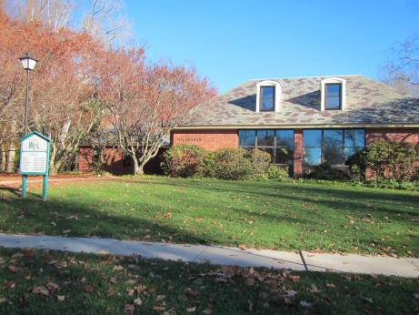

Prepared by:
Massachusetts Department of Public Health
Bureau of Environmental Health
Indoor Air Quality Program
February 2017

Background
Building: | Wilbraham Public Library (WPL)
Address: | 25 Crane Park Dr, Wilbraham, MA
Assessment Requested by: | Karen Demers, Director, WPL
Reason for Request: | Mold issues in foyer and basement
Date of Assessment: | November 18, 2016
Massachusetts Department of Public Health/Bureau of Environmental Health (MDPH/BEH) Staff Conducting Assessment: | Michael Feeney, Director, IAQ Program
Building Description: | Originally constructed as a one-story building.
Year of Construction: | 1967
Windows: | Openable

Methods
Please refer to the IAQ Manual for methods, sampling procedures, and interpretation of results (MDPH, 2015).

IAQ Testing Results
The following is a summary of indoor air testing results (Table 1).
- Carbon dioxide levels were below 800 parts per million (ppm) in all areas assessed, indicating adequate fresh air in the space at the time of this assessment.
- Temperature was within the recommended range of 70°F to 78°F in all areas assessed.
- Relative humidity was below the recommended range of 40% to 60% in most all assessed as is typical during the heating season.
- Carbon monoxide levels were non-detectable in all areas assessed.
- Fine particulate matter (PM2.5) concentrations measured were below the National Ambient Air Quality Standard (NAAQS) level of 35 μg/m³ in all areas assessed.

Ventilation
The assessment results indicate that the ventilation system is providing adequate fresh air for the occupancy in the building. Note that many areas had low occupancy, which can reduce the creation of carbon dioxide. To maximize air exchange, the BEH recommends that mechanical ventilation systems operate continuously during periods of occupancy. Without the system operating as designed, normally occurring pollutants cannot be diluted or removed, allowing them to build up and lead to IAQ/comfort complaints.
A heating, ventilating, and air conditioning (HVAC) system has several functions. First it provides heating and, if equipped, cooling. Second, it is a source of fresh air. Finally, an HVAC system will dilute and remove normally occurring indoor environmental pollutants by not only introducing fresh air, but by filtering the airstream and ejecting stale air to the outdoors via exhaust ventilation. Even if an HVAC system is operating as designed, point sources of respiratory irritation may exist and cause symptoms in sensitive individuals. The following analysis examines and identifies components of the HVAC system and likely sources of respiratory irritant/allergen exposure due to water damage, aerosolized dust, and/or chemicals found in the indoor environment.
The lobby contains two fan coil units (FCUs). These FCUs do not prove fresh air, but heats/cool and recirculate air. The cabinets of each FCU have little, if any, functional insulation and the filters inside them were ajar, preventing them from providing adequate filtration during operation. Note that the FCUs are original equipment, dating from 1967 which makes them about 50 years old. Function of equipment of this age is difficult to maintain, since compatible replacement parts are often unavailable. According to the American Society of Heating, Refrigeration and Air-Conditioning Engineers (ASHRAE), the service life for a unit heater, hot water or steam is 20 years, assuming routine maintenance of the equipment (ASHRAE, 1991). Despite attempts to maintain the FCUs, the operational lifespan of the equipment has been exceeded.
Restrooms have exhaust vents which were not operating during this visit. Without functioning exhaust ventilation, water vapor and other pollutants generated inside the building would be redistributed inside the space.
It is recommended that HVAC systems be re-balanced every five years to ensure adequate air systems function (SMACNA, 1994). It is not known when the systems were last balanced.

Microbial/Moisture Concerns
A musty odor was detected in the foyer which was traced to the two FCUs located there. Each FCU is installed behind a decorative wooden cover. The wooden covers had extensive mold growth/staining corresponding to the flow of air from the units (Picture 1). It is likely the wood covering was repeatedly moistened by condensation that resulted from the entrainment of hot, humid air during summer months. The excess humidity may originate from outside through the exterior doors and an open chimney flue in the meeting room, and/or may result from restroom-related moisture due to the inactive exhaust fans. The condition of these covers suggested that the mold growth has been ongoing for several years.
Mold colonization was also found on pipe insulation in the basement (Picture 2). This very likely occurred because the insulation was insufficient for the temperature of the water from the chiller, leading to condensation on the insulation surface, which then can chronically moisten the pipe wrapping and result in mold growth. In addition, once wet, the ability of insulation to prevent temperature transfer becomes reduced which may accelerate condensation. Mold-colonized materials should be removed and a sufficiently-insulating material used to replace it. A possible source of moisture in the basement is an open conduit located in the basement wall (Picture 3). All open pipes found in buildings should be rendered airtight to prevent odors and water vapor movement from outdoors to the indoor environment.
Water-damaged ceiling panels were observed in a number of areas, but do not appear to be mold-colonized. The source of the water to these panels should be mitigated and water-damaged materials should be properly removed and replaced.

Conclusions/Recommendations
Based on observations at the time of assessment, the following is recommended:
- Remove mold-colonized wood from foyer FCUs.
- Remove water-damaged insulation from pipes in basement area and replace with insulation having a sufficient R Value to prevent condensation when operating in chilling mode.
- Seal ends of all abandoned pipes and conduit in the basement area.
- Repair the exhaust vents for the restrooms in the foyer and ensure they operate when the building is occupied.
- Close the fireplace flue. If not intended for use, seal the flue on both ends to prevent cold air and rainwater from entering the chimney.
- Due to the age and condition of the units, consideration should be given to replacing the FCUs in the foyer.
- Render the exterior doors to the foyer as airtight as feasible and ensure they are kept closed, especially during the cooling season.
- Repair any sources of water infiltration and repair or replace water-damaged ceiling panels.
- Have the HVAC system balanced every 5 years in accordance with SMACNA recommendations (SMACNA, 1994).
- Refer to resource manual and other related IAQ documents located on the MDPH’s website for further building-wide evaluations and advice on maintaining public buildings. These documents are available at: http://mass.gov/dph/iaq.

References
ASHRAE. 1991. ASHRAE Applications Handbook, Chapter 33 “Owning and Operating Costs”. American Society of Heating, Refrigeration and Air Conditioning Engineers, Atlanta, GA.
MDPH. 2015. Massachusetts Department of Public Health. Indoor Air Quality Manual: Chapters I-III. Available at: http://www.mass.gov/eohhs/gov/departments/dph/programs/environmental-health/exposure-topics/iaq/iaq-manual/.
SMACNA. 1994. HVAC Systems Commissioning Manual. 1st ed. Sheet Metal and Air Conditioning Contractors’ National Association, Inc., Chantilly, VA
Picture 1
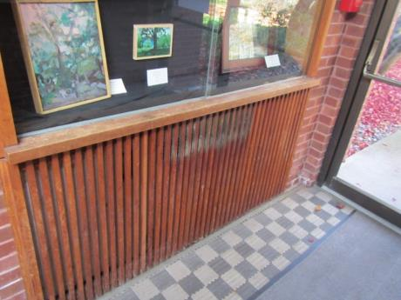
Mold-colonized wood on FCU cover in foyer
Picture 2
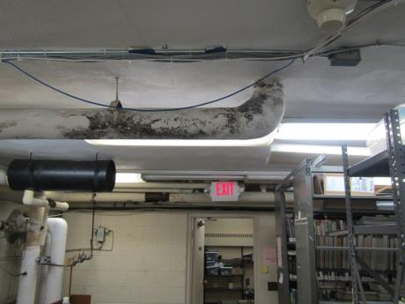
Mold-colonized pipe insulation in basement area
Picture 3
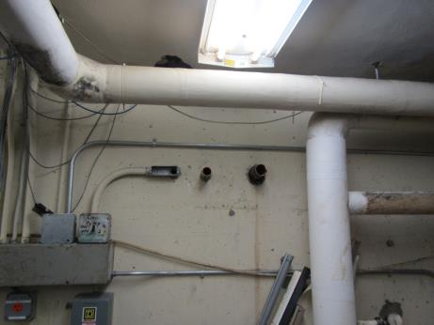
Open abandoned pipe/conduit in the basement area

Location | Carbon  Dioxide  (ppm) | Carbon Monoxide  (ppm) | Temp  (°F) | Relative  Humidity  (%) | PM2.5  (µg/m³) | Occupants  in Room | Windows  Openable | Ventilation |  | Remarks
 |  |  |  |  |  |  |  | Supply | Exhaust
Background (outdoors) | 422 | ND | 57 | 47 | 10
Brooks Rooms | 566 | ND | 71 | 37 | 2 | 0 | Y | Y | Y
Brooks kitchen | 554 | ND | 71 | 36 | 16 | 0 | Y | Y | Y | Exhaust off
Foyer | 568 | ND | 71 | 36 | 3 | 0 | Y | N | N
Picture book | 639 | ND | 71 | 36 | 5 | 0 | Y | Y | Y
Non print | 765 | ND | 72 | 38 | 4 | 0 | Y | Y | Y
Main desk | 650 | ND | 72 | 36 | 4 | 2 | Y | N | N
Music | 644 | ND | 72 | 35 | 5 | 2 | Y | Y | Y
Wilbraham Room | 634 | ND | 72 | 36 | 6 | 2 | Y | Y | Y
Director | 642 | ND | 72 | 35 | 5 | 0 | Y | N | N | Door open
Staff | 651 | ND | 73 | 36 | 6 | 3 | Y | Y | N | Door open
Mezzanine | 650 | ND | 73 | 34 | 4 | 0 | Y | N | N
Cutler | 667 | ND | 73 | 34 | 5 | 1 | Y | N | N | Window-mounted air conditioner
Break room | 615 | ND | 73 | 36 | 7 | 1 | Y | Y | N
Basement | 777 | ND | 74 | 39 | 7 | 0 | N | N | N

