**INDOOR AIR QUALITY ASSESSMENT**

**Willett Elementary School**

**32 Watson Avenue**

**Attleboro, MA**

Willett Elementary School, 32 Watson Avenue, Attleboro, MA


Prepared by:

Massachusetts Department of Public Health

Bureau of Environmental Health

Indoor Air Quality Program

May 2017

# Background

|  |  |
| --- | --- |
| Building: | Willett Elementary School |
| Address: | 32 Watson Avenue, Attleboro, MA |
| Assessment Requested by: | Parent request, coordinated via the Attleboro Public Schools and Attleboro Health Department |
| Reason for Request: | General indoor air quality (IAQ)  concerns |
| Date of Assessment: | April 28, 2017 |
| Massachusetts Department of Public Health/Bureau of Environmental Health (MDPH/BEH) Staff Conducting Assessment: | Cory Holmes, Environmental Analyst and  Ruth Alfasso, Environmental Engineer, IAQ Program |
| Date of Building Construction: | 1940’s, renovated in 1995 with addition |
| Building Description: | Two-story classroom wing, brick construction, with occupied basement and peaked/shingled roofs. |
| Building Population: | Approximately 460 students in grades K through 4 with a staff of approximately 50 |
| Windows: | Openable |

# IAQ Testing Results

Please refer to the IAQ Manual for methods, sampling procedures, and interpretation of results (MDPH, 2015). The following is a summary of indoor air testing results (Table 1).

* ***Carbon dioxide levels*** were above 800 parts per million (ppm) in about half of the locations assessed, indicating that additional air exchange is warranted in some areas.
* ***Temperature*** was within or very close to the recommended range of 70°F to 78°F the day of assessment.
* ***Relative humidity*** was within or close to the recommended range of 40 to 60% in most areas the day of the assessment; some areas were elevated and reflective of humid conditions outdoors the day of assessment.
* ***Carbon monoxide*** levels were non-detectable in all areas tested.
* **Fine particulate matter (PM2.5)** concentrations measured were below the NAAQS limit of 35 μg/m3 in all areas tested.

## Ventilation

A heating, ventilating and air conditioning (HVAC) system has several functions. First it provides heating and, if equipped, cooling. Second, it is a source of fresh air. Finally, an HVAC system will dilute and remove normally occurring indoor environmental pollutants by not only introducing fresh air, but by filtering the airstream and ejecting stale air to the outdoors via exhaust ventilation. Even if an HVAC system is operating as designed, point sources of respiratory irritation may exist and cause symptoms in sensitive individuals.

Fresh air is provided by a combination of unit ventilators (univents) located in individual classrooms (Picture 1) and air handing units (AHUs; Picture 2), which serve central areas such as the gym, library and office areas. The unit ventilators draw fresh air through a vent on the exterior wall (Picture 3). Air is mixed with return air from the room, filtered, heated (if needed) and delivered back to the room (Figure 1). Air from the AHUs is filtered, heated or cooled as needed, and delivered to rooms via ducted supply vents. Exhaust vents are located on the ceilings of rooms or in closets (Picture 4) and are ducted to fans on the roof. Additional exhaust vents are located in toilet rooms and other areas which produce pollutants.

While nearly all of the univents were operating at the time of the assessment, some exhaust vents did not appear to be operating, which may indicate they were deactivated or inoperable. In addition, some of the univents were partially blocked by items or furniture (Pictures 1 and 5; Table 1), which will reduce the effectiveness of the equipment. Additionally, in many classrooms, exhaust vents are located near the classroom doors and many of these doors were open, which reduces the effectiveness of the exhaust vent to draw stale air from the classroom.

In order to have proper ventilation with a mechanical supply and exhaust system, these systems must be balanced to provide an adequate amount of fresh air while removing stale air from a room. It is recommended that existing ventilation systems be re-balanced every five years to ensure adequate air systems function (SMACNA, 1994). It is unknown the last time these systems were balanced.

## Microbial/Moisture Concerns

Water-damaged ceiling tiles were observed in some classrooms and hallways (Picture 6; Table 1), which indicate leaks from the building envelope or plumbing system. These tiles should be replaced after the leak is found and repaired.

Plants were observed in a few areas (Picture 7; Table 1). Plants can be a source of pollen and mold, which can be respiratory irritants to some individuals. Plants should be properly maintained and equipped with drip pans and should be located away from air diffusers to prevent the aerosolization of dirt, pollen and mold. A few classrooms had terrariums, which should be kept clean to prevent odors.

Sinks were observed in a number of classrooms. Some of the sinks examined lacked caulking in the space between the backsplash and countertop (Picture 8; Table 1), which may allow water damage to building materials. Many sinks examined also had porous items (paper, boxes) stored inside the sink cabinet, which is a moist environment.

Plants and trees were observed close the exterior of the building envelope (Picture 9). This can lead to deterioration of the building envelope due to root infiltration and dampness against the exterior surface. Plants can also be a source of debris and pollen to air intakes and drains. Plants should be trimmed away from the building and from overhanging the roof.

## Other IAQ Evaluations

Exposure to low levels of total VOCs (TVOCs) may produce eye, nose, throat, and/or respiratory irritation in some sensitive individuals. To determine if VOCs were present, BEH/IAQ staff examined rooms for products containing VOCs. BEH/IAQ staff noted hand sanitizers, cleaners, and dry erase materials in use within the building (Picture 8; Table 1). All of these products have the potential to be irritants to the eyes, nose, throat, and respiratory system of sensitive individuals. Photocopiers and laminators were located in the teacher’s work room. Photocopiers can emit ozone and TVOCs, especially when they are older or heavily used, laminators give off waste-heat and plastic odors.

A univent was opened and the filter examined. It was determined to be a type that provides minimal filtration. Pleated filters Minimum Efficiency Reporting Value (MERV) of 8 which are adequate in filtering out pollen and mold spores (ASHRAE, 2012) would be useful. Note, however, that an increase in filtration can cause stress on equipment, which needs to be evaluated to determine if the higher-rated filters will allow adequate function. Filters are reported to be changed in both univents and the AHUs three to four times a year.

Window air conditioners were observed in some classrooms (Table 1). Air conditioners have filters that need to be cleaned regularly to prevent the build-up of dust and debris.

Many classrooms had wall-mounted fans and some had additional personal fans. Some of these had dusty blades (Picture 10; Table 1). Some supply and exhaust vents were also observed to be dusty. This dust can be reaerosolized when the equipment is activated. In some areas, items, including books, papers, toys and decorative items were observed on floors, windowsills, tabletops, counters, bookcases, and desks (Picture 11; Table 1), which can make it more difficult for custodial staff to clean.

Finally, most classrooms had carpeting that appeared to be dated to the 1995 addition/renovation project. In many areas, this carpeting was visibly worn, frayed, wrinkled and stained (Picture 12; Table 1). The usable life of carpeting in schools is approximately 10-11 years (IICRC, 2002). Aging carpet can produce fibers that can be irritating to the respiratory system. In addition, tears or lifting carpet can create tripping hazards. It was reported by school officials that a carpet replacement program was being initiated. Carpeting should be cleaned annually or semi-annually in soiled high traffic areas as per the recommendations of the Institute of Inspection, Cleaning and Restoration Certification (IICRC, 2012). Some classrooms had area rugs, which should also be cleaned regularly and discarded when too worn out or soiled to be cleaned.

# Conclusions/Recommendations

The following recommendations are made to assist in improving IAQ:

1. Operate all supply and exhaust ventilation equipment continuously during occupied periods.
2. Use openable windows to supplement fresh air during temperate weather. Ensure all windows are tightly closed at the end of the day.
3. Remove items and furniture blocking univents.
4. Check exhaust vents for air draw periodically and repair any non-operating vents.
5. In rooms with exhaust vents near doors, ensure doors are closed during occupancy for optimal operation.
6. Consider adopting a balancing schedule of every 5 years for all mechanical ventilation systems, as recommended by ventilation industrial standards (SMACNA, 1994).
7. Ensure roof and plumbing leaks are repaired and replace water-damaged ceiling tiles.
8. Properly maintain plants, including drip pans, to prevent water damage to porous materials. Plants should also be located away from air diffusers to prevent the aerosolization of dirt, pollen, and mold.
9. Properly maintain terrariums to prevent odors.
10. Repair/caulk open sink backsplashes. Refrain from storing porous items or large amounts of items under sinks.
11. Trim back trees and plants from next to the building and overhanging the roof.
12. Reduce use of products and equipment that create VOCs and ozone; only use in well-ventilated areas.
13. Ensure exhaust ventilation is operating in areas with photocopiers and laminators.
14. Consider upgrading to a pleated filter of MERV 8 in univents and AHUs, if these can be used with the current equipment. Continue to change filters 2-4 times a year.
15. Regularly clean/vacuum univent cabinets, supply/return vents and fans to avoid aerosolizing accumulated particulate matter.
16. Clean window-mounted air conditioner filters prior to the start of the cooling season and according to the manufacturer’s instructions.
17. Clean carpeting and area rugs regularly and discard those that are worn out or too soiled to be cleaned.
18. Continue with plans to replace outdated carpeting past its useful life.
19. Consider reducing the amount of items stored in classrooms to make cleaning easier. Periodically move items to clean flat surfaces.
20. Continue to adopt the US EPA (2000) document, “Tools for Schools”, as an instrument for maintaining a good IAQ environment in the building available at: <http://www.epa.gov/iaq/schools/index.html>.
21. Refer to resource manual and other related IAQ documents located on the MDPH’s website for further building-wide evaluations and advice on maintaining public buildings. These documents are available at: <http://mass.gov/dph/iaq>.

# References

ASHRAE. 2012. American Society of Heating, Refrigeration and Air Conditioning Engineers (ASHRAE) Standard 52.2-2012 -- Method of Testing General Ventilation Air-Cleaning Devices for Removal Efficiency by Particle Size (ANSI Approved). 2012.

IICRC. 2002. Institute of Inspection, Cleaning and Restoration Certification. A Life-Cycle Cost Analysis for Floor Coverings in School Facilities.

IICRC. 2012. Institute of Inspection, Cleaning and Restoration Certification. Carpet Cleaning: FAQ. Retrieved from <http://www.iicrc.org/consumers/care/carpet-cleaning>.

MDPH. 2015. Massachusetts Department of Public Health. “Indoor Air Quality Manual: Chapters I-III”. Available at: <http://www.mass.gov/eohhs/gov/departments/dph/programs/environmental-health/exposure-topics/iaq/iaq-manual/>.

SMACNA. 1994. HVAC Systems Commissioning Manual. 1st ed. Sheet Metal and Air Conditioning Contractors’ National Association, Inc., Chantilly, VA.

US EPA. 2000. Tools for Schools. Office of Air and Radiation, Office of Radiation and Indoor Air, Indoor Environments Division (6609J). EPA 402-K-95-001, Second Edition. <http://www.epa.gov/iaq/schools/index.html>.

**Picture 1**

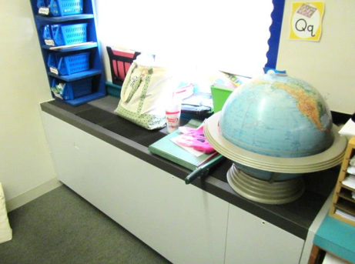

**Classroom univent, note items on top of diffuser**

**Picture 2**

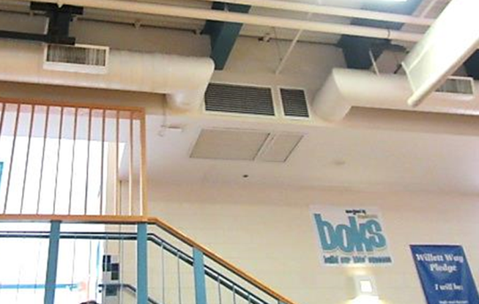

**Air handling unit in gym**

**Picture 3**

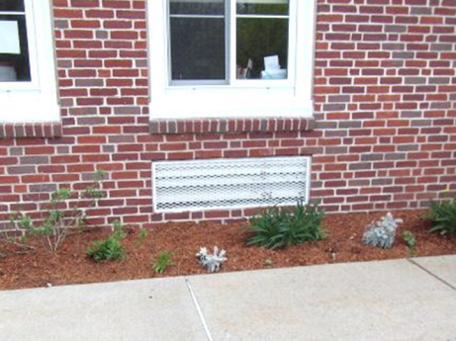

**Univent fresh air intake**

**Picture 4**

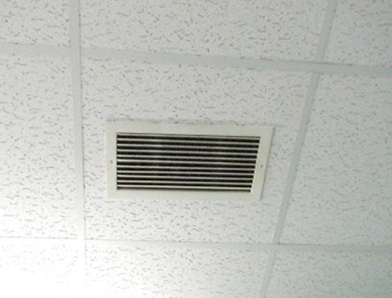

**Ceiling-mounted exhaust vent**

**Picture 5**

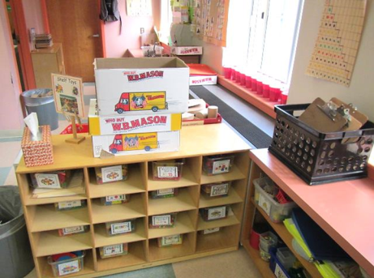

**Univent obstructed by classroom furniture**

**Picture 6**

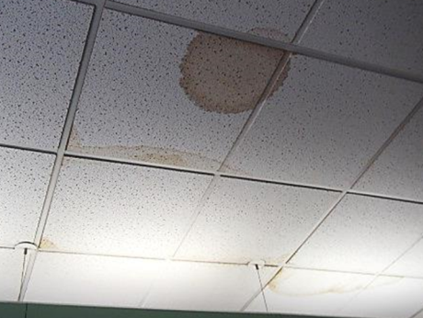

**Water-damaged ceiling tiles**

**Picture 7**

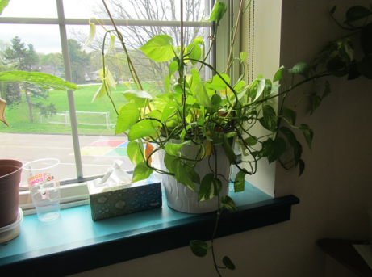

**Plants in classroom**

**Picture 8**

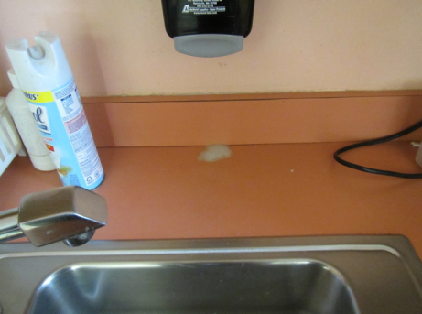

**Unsealed sink backsplash, also note cleaning/sanitizing product**

**Picture 9**

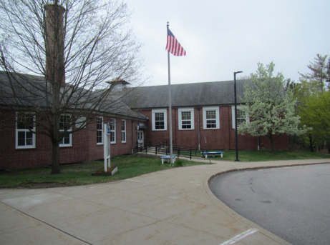

**Trees next to building**

**Picture 10**

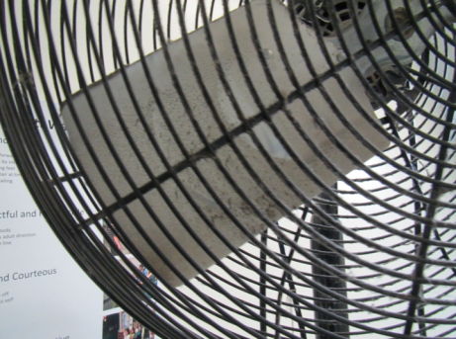

**Dust on fan blades**

**Picture 11**

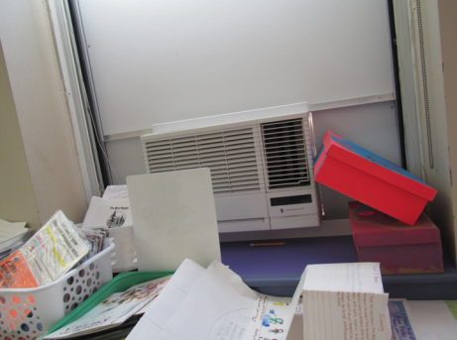

**Paper and other items on counter**

**Picture 12**

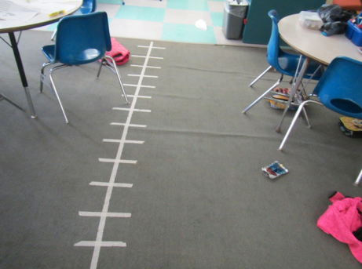

**Wrinkled, taped up carpeting in classroom**

| Location | **Carbon**  **Dioxide**  **(ppm)** | **Carbon**  **Monoxide**  **(ppm)** | **Temp**  **(°F)** | **Relative**  **Humidity**  **(%)** | **PM2.5 (ug/m3)** | **Occupants**  **in Room** | **Windows**  **Openable** | **Ventilation** | | **Remarks** |
| --- | --- | --- | --- | --- | --- | --- | --- | --- | --- | --- |
| Background | 399 | ND | 75 | 63 | 18 |  |  |  |  | Warm, humid, AM rain |
| **2nd Floor** |  |  |  |  |  |  |  |  |  |  |
| 201 Art | 780 | ND | 72 | 63 | 12 | 21 | Y | Y | Y |  |
| 202/204 Storage |  |  |  |  |  |  |  | N | N | Slight musty smell, area is organized and on shelves |
| 202 | 778 | ND | 72 | 58 | 16 | 0 | Y | Y | Y | Carpeting worn, sink and toilet room, PS, DEM |
| 203 | 620 | ND | 72 | 61 | 10 | 4 | Y | Y | Y |  |
| 204 | 835 | ND | 72 | 59 | 17 | 18 | Y  Open | Y | Y | Exhaust vent dusty, CF, items under sink, toilet room |
| 205 | 539 | ND | 72 | 61 | 12 | 1 | Y | Y | Y | 23 occupants gone ~15-20 mins, items on UV |
| Music Room | 1127 | ND | 72 | 61 | 15 | 21 | Y | Y | Y | PF, sink |
| Women’s Room |  |  |  |  |  |  |  |  | Y | Exhaust vent dusty |
| **1st Floor** |  |  |  |  |  |  |  |  |  |  |
| 101 | 1354 | ND | 71 | 63 | 5 | 1 | Y | Y | Y | 21 occupants gone ~ 8 mins, exhaust off |
| 102 | 596 | ND | 73 | 57 | 16 | 1 | Y | Y UV on | Y | PF, sink, carpeting worn and wrinkled, plush items |
| 103 | 973 | ND | 72 | 60 | 15 | 21 | Y | Y UV on | Y | Carpeting, worn, area rug, plants, sink, CP, HS, DEM |
| 104 | 881 | ND | 72 | 64 | 11 | 7 | Y  Open | Y | Y | 23 occupants gone ~8 mins, UV obstructed-furniture, 1 WD CT/ 1 WD CT (restroom) |
| 105 | 785 | ND | 71 | 63 | 8 | 2 | Y | Y | Y | DO, 18 occupants gone ~15 mins |
| 107 | 870 | ND | 72 | 63 | 14 | 2 | Y | Y | Y | WD CT, worn carpeting, DEM, HS |
| 108 | 1168 | ND | 73 | 66 | 8 | 23 | Y | Y | Y | Exhaust off, plants, DO, terrariums |
| 109 | 904 | ND | 73 | 64 | 9 | 24 | Y | Y | Y | Exhaust off, plants, 1 WD CT |
| 110 | 941 | ND | 73 | 60 | 7 | 19 | Y | Y | Y | DO, 8 WD CT-historic |
| 111 | 1155 | ND | 72 | 61 | 14 | 25 | Y | Y | Y | Worn carpet and area rug, sink, DEM |
| 112 | 1250 | ND | 73 | 61 | 16 | 23 | Y | Y | Y | Carpeting worn, AI, DEM, sink, items on UV |
| 113 | 763 | ND | 72 | 60 | 19 | 24 | Y | Y | Y | DEM, sink, microwave, HS |
| 114 | 971 | ND | 72 | 61 | 17 | 14 | Y | Y | Y | HS, DEM, sink, partly carpeted |
| Hallway Room | 824 | ND | 72 | 59 | 18 | 9 | Y | N | N | Table set up in hallway, NC |
| Library | 548 | ND | 72 | 58 | 15 | 0 | Y | Y | Y | Worn carpeting, door to outside |
| Library - Small Room | 588 | ND | 73 | 57 | 14 | 0 | N | N | N |  |
| McVittie and Peck | 755 | ND | 72 | 57 | 16 | 0 | N | N | N | 3 WD CT, HS, fan, heater |
| Teacher's Planning | 606 | ND | 72 | 57 | 13 | 0 | Y | Y | Y | Laminator, PC, carpeted, WD CT |
| Main Office | 672 | ND | 73 | 57 | 13 | 2 | Y | Y | Y |  |
| Nurse | 631 | ND | 73 | 56 | 13 | 1 | Y | Y | Y | Sink |
| Principal’s Office | 588 | ND | 73 | 56 | 12 | 0 | Y | Y | N |  |
| Kindergarten 10 | 1002 | ND | 73 | 58 | 16 | 2 | Y | Y | Y | Carpet - stained, CP, HS, sink backsplash open, toilet room, dust/debris on UV |
| **Basement** |  |  |  |  |  |  |  |  |  |  |
| 001 | 1841 | ND | 71 | 68 | 10 | 25 | Y | Y | Y | Exhaust off, DO |
| 002 | 1811 | ND | 73 | 62 | 11 | 25 | Y | Y on | Y | WAC, sink and fridge, HS, NC |
| 003 | 1546 | ND | 72 | 62 | 13 | 25 | Y | Y | Y | Solar heating, DEM, sink |
| 004 | 668 | ND | 72 | 61 | 7 | 3 | Y | Y | Y | 1 WD CT |
| 005 | 809 | ND | 72 | 62 | 21 | 20 | y 1 open | Y | Y | Computers (~25), DEM, plant, worn carpeting, WAC |
| 006 SPED | 823 | ND | 73 | 58 | 14 | 14 | N | Y | Y |  |
| 007 | 803 | ND | 72 | 58 | 13 | 1 | N | N | N |  |
| 008 Gym Office | 760 | ND | 70 | 61 | 4 | 0 | N | Y | Y | Old shower |
| 009 SPED | 671 | ND | 71 | 57 | 13 | 0 | N | N | Y | NC except small rug, trampoline, DEM |
| Cafeteria | 596 | ND | 70 | 64 | 8 | 1 | Y | Y | Y | Exhaust off, 1 WD CT |
| Gym | 685 | ND | 69 | 64 | 5 | 19 | Y | Y | Y | PF-dusty |
| Elevator Lobby | 964 | ND | 72 | 56 | 14 | 0 | N | N | N | AT |