Background/Introduction

INDOOR AIR QUALITY ASSESSMENT

William Gould Vinal Elementary School
102 Old Oaken Bucket Road
Norwell, MA

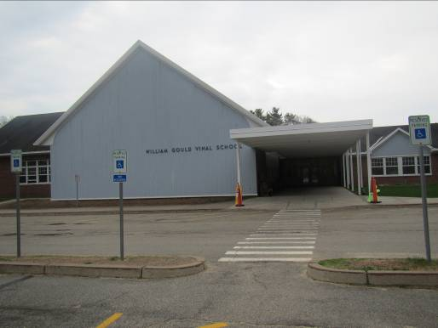

Prepared by:
Massachusetts Department of Public Health
Bureau of Environmental Health
Indoor Air Quality Program
June 2015
At the request of Brian Flynn, Health Agent, Town of Norwell, the Massachusetts Department of Public Health (MDPH), Bureau of Environmental Health (BEH) provided assistance and consultation regarding indoor air quality (IAQ) concerns at the William Gould Vinal Elementary School (VES) located at 102 Old Oaken Bucket Road, Norwell, MA. On May 5, 2015, Ruth Alfasso, Environmental Engineer/Inspector in BEH’s IAQ Program visited the VES to conduct an IAQ assessment.
Note that the winter of 2014/2015 had record-breaking amounts of snow and days of cold/below freezing weather (NWS, 2015; WBZ, 2015). These conditions put unusual stress on building structures and equipment, leading to an increase in reports of roof and structural damage, water intrusion from snow and snowmelt and freezing-related damage to pipes and other heating, ventilating and air conditioning (HVAC) components. In addition, labor/time taken to remove snow and deal with damage likely resulted in strained resources for routine maintenance activities. These difficulties were reported by facility staff at many schools and other public buildings in Massachusetts during the winter of 2014/2015.
The school was originally built in the late 1960s with a two-story addition added in 2002. Most of the roof area is peaked with shingles and a few areas consisting of flat rubber membrane. Classrooms have tiled floors and drop ceiling tile systems. Most classrooms have openable windows.

Methods
Air tests for carbon monoxide, carbon dioxide, temperature and relative humidity were conducted with the TSI, Q-Trak, IAQ Monitor, Model 7565. Air tests for airborne particle matter with a diameter less than 2.5 micrometers were taken with the TSI, DUSTTRAK™ Aerosol Monitor Model 8532. BEH/IAQ staff also performed a visual inspection of building materials for water damage and/or microbial growth.

Results
The school houses approximately 550 students in grades pre-k through 5 with a staff of approximately 150. Tests were taken during normal operations and results appear in Table 1.

Discussion

Ventilation
It can be seen from Table 1 that carbon dioxide levels were above 800 parts per million (ppm) in 25 of 43 areas surveyed at the time of the assessment, indicating poor air exchange in more than half the areas surveyed. Some areas were empty or sparsely populated at the time tests were taken, and a few areas had windows open, which can greatly reduce carbon dioxide levels. Carbon dioxide levels would be expected to be higher with full occupancy and windows closed.
Fresh air in most classrooms is supplied by unit ventilators (univents) (Picture 1). A univent is designed to draw air from outdoors through a fresh air intake located on the exterior wall of the building (Picture 2). Return air is drawn through an air intake located at the base of each unit where fresh and return air are mixed, filtered, heated and provided to classrooms through an air diffuser located in the top of the unit (Figure 1). Univents were found obstructed with items in a few areas (Picture 1). In order for univents to provide fresh air as designed, they must remain free of obstructions. Importantly, these units must remain on and be allowed to operate while rooms are occupied. Wall-mounted exhaust vents, some of which were also obstructed with items, remove stale air from classrooms (Picture 3).
Univents and classroom exhaust vents were found to be operating at the time of the assessment, even in classrooms where carbon dioxide levels were above 800 ppm. Two conditions were observed that may contribute to this. Univents have dampers that regulate the flow of fresh air. When viewed from outside, these dampers appeared to be in a reduced flow positon, this may have been an attempt during the winter to increase comfort and prevent frozen pipes and mechanical damage. Dampers may be able to be adjusted to provide more fresh air. Also, the configuration of supply and exhaust vents is designed to draw air across the room. With many of the classroom doors open and many exhaust vents located near doors, the exhaust vents may be drawing air from the hallways instead of from the room. Keeping doors closed may be useful in allowing the exhausts to function as designed.
Outside air for common areas such as the library, gymnasium, auditorium and administrative areas, is provided by rooftop air handling units (AHUs). Fresh air is drawn through intakes, where it is filtered, heated or cooled and ducted to ceiling-mounted supply diffusers. Return air is drawn in through ceiling-mounted return vents and ducted back to AHUs.
Additional exhaust ventilation in restrooms, the nurse’s office and kitchen is provided by vents that go directly to fans on the roof. The exhaust vent in the nurse’s office was observed to be drawing weakly; this is an area where exhaust ventilation is particularly important to remove odors and microorganisms from the indoor environment.
To maximize air exchange, the MDPH recommends that both supply and exhaust ventilation operate continuously during periods of occupancy. In order to have proper ventilation with a mechanical supply and exhaust system, the systems must be balanced to provide an adequate amount of fresh air to the interior of a room while removing stale air from the room. It is recommended that HVAC systems be re-balanced every five years to ensure adequate air systems function (SMACNA, 1994). The date of the last balancing was believed to be at the time of the renovation, in 2002.
Minimum design ventilation rates are mandated by the Massachusetts State Building Code (MSBC). Until 2011, the minimum ventilation rate in Massachusetts was higher for both occupied office spaces and general classrooms, with similar requirements for other occupied spaces (BOCA, 1993). The current version of the MSBC, promulgated in 2011 by the State Board of Building Regulations and Standards (SBBRS), adopted the 2009 International Mechanical Code (IMC) to set minimum ventilation rates. Please note that the MSBC is a minimum standard that is not health-based. At lower rates of cubic feet per minute (cfm) per occupant of fresh air, carbon dioxide levels would be expected to rise significantly. A ventilation rate of 20 cfm per occupant of fresh air provides optimal air exchange resulting in carbon dioxide levels at or below 800 ppm in the indoor environment in each area measured. MDPH recommends that carbon dioxide levels be maintained at 800 ppm or below. This is because most environmental and occupational health scientists involved with research on IAQ and health effects have documented significant increases in indoor air quality complaints and/or health effects when carbon dioxide levels rise above the MDPH guidelines of 800 ppm for schools, office buildings and other occupied spaces (Sundell et al., 2011). The ventilation must be on at all times that the room is occupied. Providing adequate fresh air ventilation with open windows and maintaining the temperature in the comfort range during the cold weather season is impractical. Mechanical ventilation is usually required to provide adequate fresh air ventilation.
Carbon dioxide is not a problem in and of itself. It is used as an indicator of the adequacy of the fresh air ventilation. As carbon dioxide levels rise, it indicates that the ventilating system is malfunctioning or the design occupancy of the room is being exceeded. When this happens, a buildup of common indoor air pollutants can occur, leading to discomfort or health complaints. The Occupational Safety and Health Administration (OSHA) standard for carbon dioxide is 5,000 parts per million parts of air (ppm). Workers may be exposed to this level for 40 hours/week, based on a time-weighted average (OSHA, 1997).
The MDPH uses a guideline of 800 ppm for publicly occupied buildings. A guideline of 600 ppm or less is preferred in schools due to the fact that the majority of occupants are young and considered to be a more sensitive population in the evaluation of environmental health status. Inadequate ventilation and/or elevated temperatures are major causes of complaints such as respiratory, eye, nose and throat irritation, lethargy and headaches. For more information concerning carbon dioxide, consult Appendix A.
Indoor temperature measurements the day of the assessment ranged from 68 °F to 75 °F (Table 1), which were within or close to the MDPH recommended comfort range. The MDPH recommends that indoor air temperatures be maintained in a range of 70 °F to 78 °F in order to provide for the comfort of building occupants. In many cases concerning indoor air quality, fluctuations of temperature in occupied spaces are typically experienced, even in a building with an adequate fresh air supply.
The relative humidity measured in the building during the assessment ranged from 45 to 60 percent, which was within the MDPH recommended comfort range in all areas surveyed (Table 1). The MDPH recommends a comfort range of 40 to 60 percent for indoor air relative humidity. Relative humidity levels in the building would be expected to drop during the winter months due to heating. The sensation of dryness and irritation is common in a low relative humidity environment. Low relative humidity is a very common problem during the heating season in the northeast part of the United States.

Microbial/Moisture Concerns
A few water-damaged ceiling tiles were observed during the assessment (Table 1), indicating current/historic roof/plumbing leaks or other water infiltration. Water-damaged ceiling tiles can provide a source of mold and should be replaced after a water leak is discovered and repaired.
In one area a sink was located over carpeting (Picture 4). Overflow/spills from sinks and water dispensers can moisten carpeting. It is recommended that these items be located on/over non-porous flooring or a waterproof mat.
The refrigerator in the staff breakroom was examined and the gasket had visible staining/debris (Picture 5). This gasket should be cleaned with an antimicrobial solution. Refrigerators should be cleaned regularly to prevent odors and microbial growth.
The exterior of the building was also examined for conditions that could lead to water infiltration or other sources of indoor air pollutants. Some downspouts were observed to be broken or missing parts (Picture 6) and some debris that appeared to be portions of a gutter/downspout or flashing was observed on the ground along the perimeter of the building (Picture 2). In addition, leaks were observed in joints in the gutters (Picture 7). Broken drainage channels can lead to water penetration along the base of the building and damage to the foundation. These items should be repaired.
Plants were observed growing on exterior walls in a few areas (Picture 8). Vines and other plants can hold moisture against the building and lead to deterioration of the building envelope. Plants should be removed to five feet from the foundation.
Gaps, as evidenced by visible light (Picture 9), were observed around some of the doors to the outside indicating that weather-stripping is worn or missing. These gaps can allow unfiltered air and pests into the building and should be repaired.

Other IAQ Evaluations
Indoor air quality can be negatively influenced by the presence of respiratory irritants, such as products of combustion. The process of combustion produces a number of pollutants. Common combustion emissions include carbon monoxide, carbon dioxide, water vapor and smoke (fine airborne particle material). Of these materials, exposure to carbon monoxide and particulate matter with a diameter of 2.5 micrometers (μm) or less (PM2.5) can produce immediate, acute health effects upon exposure. To determine whether combustion products were present in the indoor environment, BEH/IAQ staff obtained measurements for carbon monoxide and PM2.5.

Carbon Monoxide
Carbon monoxide is a by-product of incomplete combustion of organic matter (e.g., gasoline, wood and tobacco). Exposure to carbon monoxide can produce immediate and acute health effects. Several air quality standards have been established to address carbon monoxide and prevent symptoms from exposure to these substances. The MDPH established a corrective action level concerning carbon monoxide in ice skating rinks that use fossil-fueled ice resurfacing equipment. If an operator of an indoor ice rink measures a carbon monoxide level over 30 ppm, taken 20 minutes after resurfacing within a rink, that operator must take actions to reduce carbon monoxide levels (MDPH, 1997).
The American Society of Heating Refrigeration and Air-Conditioning Engineers (ASHRAE) has adopted the National Ambient Air Quality Standards (NAAQS) as one set of criteria for assessing indoor air quality and monitoring of fresh air introduced by HVAC systems (ASHRAE, 1989). The NAAQS are standards established by the US EPA to protect the public health from six criteria pollutants, including carbon monoxide and particulate matter (US EPA, 2006). As recommended by ASHRAE, pollutant levels of fresh air introduced to a building should not exceed the NAAQS levels (ASHRAE, 1989). The NAAQS were adopted by reference in the Building Officials & Code Administrators (BOCA) National Mechanical Code of 1993 (BOCA, 1993), which is now an HVAC standard included in the Massachusetts State Building Code (SBBRS, 2011). According to the NAAQS, carbon monoxide levels in outdoor air should not exceed 9 ppm in an eight-hour average (US EPA, 2006).
Carbon monoxide should not be present in a typical, indoor environment. If it is present, indoor carbon monoxide levels should be less than or equal to outdoor levels. On the day of the assessment, outdoor carbon monoxide concentrations were measured at non-detect (ND) (Table 1). No measurable levels of carbon monoxide were detected inside the building (Table 1).

Particulate Matter
The US EPA has established NAAQS limits for exposure to particulate matter. Particulate matter includes airborne solids that can be irritating to the eyes, nose and throat. The NAAQS originally established exposure limits to PM with a diameter of 10 μm or less (PM10). In 1997, US EPA established a more protective standard for fine airborne particulate matter with a diameter of 2.5 μm or less (PM2.5). This more stringent PM2.5 standard requires outdoor air particle levels be maintained below 35 μg/m³ over a 24-hour average (US EPA, 2006). Although both the ASHRAE standard and BOCA Code adopted the PM10 standard for evaluating air quality, MDPH uses the more protective PM2.5 standard for evaluating airborne PM concentrations in the indoor environment.
Outdoor PM2.5 concentrations were measured at 70 to 90 μg/m³ (Table 1). PM2.5 levels measured in the building ranged from 6 to 60 μg/m³ (Table 1), more than half of which were above the NAAQS PM2.5 level of 35 μg/m³. Note that particulate levels outdoors on the day of the assessment were elevated in the area due to weather conditions; according to AirNow (http://www.airnow.gov), a website run by the U.S. EPA, PM2.5 levels statewide were within the “moderate” category, as defined by PM2.5 levels of between 50 and 100 μg/m³. Particulate matter levels indoors are influenced by levels outdoors, particularly when filtration for air handling equipment is inadequate.
A univent was opened during the assessment in order to examine the filters. The filter was the correct size and was fit flush within the univent cabinet, but it was of a type that provides minimal filtration (Picture 10). It should be determined if filters with an increased dust spot efficiency can be installed. The dust spot efficiency is the ability of a filter to remove particulate matter of a certain diameter from air passing through the filter. Filters that have been determined by ASHRAE to meet its standard for a dust spot efficiency of a minimum of 40 percent would be sufficient to reduce airborne particulate matter (Thornburg, D., 2000; MEHRC, 1997; ASHRAE, 1992). Pleated filters with a Minimum Efficiency Reporting Value (MERV) dust-spot efficiency of 9 or higher are recommended. Note that increasing filtration can reduce airflow (called pressure drop), which can subsequently reduce the efficiency of the unit due to increased resistance. Prior to any increase of filtration, each univent should be evaluated by a ventilation engineer to ascertain whether it can maintain function with more efficient filters.
In addition, indoor air levels of particulate matter (including PM2.5) can be at higher levels than those measured outdoors. A number of activities that occur indoors and/or mechanical devices can generate particulate matter during normal operations. Sources of indoor airborne particulate matter may include but are not limited to particles generated during the operation of fan belts in the HVAC system, use of stoves and/or microwave ovens in kitchen areas; use of photocopiers, fax machines and computer printing devices; operation of an ordinary vacuum cleaner and heavy foot traffic indoors.

Volatile Organic Compounds
Indoor air concentrations can be greatly impacted by the use of products containing volatile organic compounds (VOCs). VOCs are carbon-containing substances that have the ability to evaporate at room temperature. Frequently, exposure to low levels of total VOCs (TVOCs) may produce eye, nose, throat and/or respiratory irritation in some sensitive individuals. For example, chemicals evaporating from a paint can stored at room temperature would most likely contain VOCs. In an effort to identify materials that can potentially increase indoor VOC concentrations, BEH/IAQ staff examined rooms for products containing these respiratory irritants.
Classrooms contained dry erase boards and related materials. Materials such as dry erase markers and dry erase board cleaners may contain VOCs, such as methyl isobutyl ketone, n-butyl acetate and butyl-cellusolve (Sanford, 1999), which can be irritating to the eyes, nose and throat.
Hand sanitizer was also observed in some areas (Table 1); these products may contain ethyl alcohol and/or isopropyl alcohol, which are highly volatile and may be irritating to the eyes and nose. Sanitizing products may also contain fragrances to which some people may be sensitive.
There are several photocopiers and a laminator in the building (Table 1). Photocopiers can be sources of pollutants such as VOCs, ozone, heat and odors, particularly if the equipment is older and in frequent use. Both VOCs and ozone are respiratory irritants (Schmidt Etkin, 1992). Photocopiers, large printers, laminators, shredders and other office equipment that may produce VOCs, dusts and odors should be kept in well-ventilated rooms and should be located near windows or exhaust vents.
In a few classrooms, tennis balls were found sliced open and placed around chair legs to reduce noise (Picture 11). Tennis balls are made of a number of materials that are a source of respiratory irritants. Constant wearing of tennis balls can produce fibers and off-gas VOCs. Tennis balls are made with a natural rubber latex bladder, which becomes abraded when used as a chair leg pad. Use of tennis balls in this manner may introduce latex dust into the school environment. Some individuals are highly allergic to latex (e.g. spina bifida patients) (SBAA, 2001). It is recommended that the use of materials containing latex be limited to reduce the potential for symptoms in sensitive individuals (NIOSH, 1997). Latex-free glides should be used for this purpose.

Other Conditions
An operating kiln was observed (Picture 12), which was generating excess heat into the art room. The kiln had a vent above it to remove waste heat and other pollutants, but appeared to be drawing weakly. In addition, a cushion was observed next to the kiln. Flammable items should not be stored next to kilns as this is a fire risk. If a dedicated kiln room is unavailable, consider only operating the kiln when the classroom is unoccupied.
Several of the outside overhanging areas, including near the entrance of the school, appeared to have birds nesting in them; one area had accumulated bird wastes on the wall. Birds can be a source of disease, and bird wastes and feathers can contain mold and mildew, which can be irritating to the respiratory system. Holes/breaches that birds have been nesting in should be sealed and bird waste cleaned with an antimicrobial solution.
A pet guinea pig was observed in one classroom in a penned area on carpeting (Picture 13). Pets and pet wastes can be a source of allergens and pet food and water can be attractive to pests. Pets and their living areas should be kept as clean as possible including removal of wastes, old food and accumulations of hair. Further, this carpeting should not be used for student seating or general classroom activities; consider discarding it at the end of the school year.
Area rugs were observed in most classrooms (Table 1). It was reported that these rugs are purchased new, no less than every two years. Some of the rugs were found to have dirt/debris on them and a few had worn/tattered edges, which can release particulate matter. Rugs should be vacuumed regularly using a HEPA-filtered vacuum cleaner and discarded when they become too worn.
Some areas in the school (e.g., the library) were carpeted. The Institute of Inspection, Cleaning and Restoration Certification (IICRC) recommends that carpeting be cleaned annually (or semi-annually in soiled high traffic areas) (IICRC, 2012). Regular cleaning with a high efficiency particulate air (HEPA) filtered vacuum in combination with annual cleaning will help to reduce accumulation and potential aerosolization of materials from the carpeting.
In many classrooms, large numbers of items were on floors, windowsills, tabletops, counters, bookcases and desks, which provide a source for dusts to accumulate. These items (e.g., papers, folders, boxes) make it difficult for custodial staff to clean. Items should be relocated and/or be cleaned periodically to avoid excessive dust buildup. In addition, dust and debris can accumulate on flat surfaces (e.g., desktops, shelving and carpets) in occupied areas and subsequently be re-aerosolized causing further irritation.
Items were observed hanging from the ceiling tile system in one classroom. In some areas, items were observed to be hanging from the ceiling (Picture 14). These items can be a source for dusts to accumulate as well as disturbing the ceiling tile system, allowing for dust and debris from the ceiling tile system/plenum to enter occupied space.

Conclusions/Recommendations
In view of the findings at the time of the visit, the following recommendations are made:
- Operate all supply and exhaust ventilation systems throughout the building continuously during periods of occupancy to maximize air exchange.
- Remove blockages (e.g., items, furniture) from the front and top of univents and from the area of exhaust vents.
- Examine univents dampers and adjust to provide more fresh air as needed.
- Consider keeping classroom doors closed for better air exchange and exhaust function.
- Ensure all exhaust vents/fans are operational and activated during occupied hours.
- Change filters for air handling equipment (univents and AHUs) 2 to 4 times a year. Vacuum interior of units prior to activation to prevent the aerosolization of dirt, dust and particulate matter. Ensure filters fit flush in their racks with no spaces in between allowing bypass of unfiltered air into the unit.
- Consider replacing existing univent filters with a greater dust-spot efficiency (e.g., MERV 9). Prior to any increase of filtration, each piece of air handling equipment should be evaluated by a ventilation engineer as to whether it can maintain function with more efficient filters.
- Consider adopting a balancing schedule of every 5 years for all mechanical ventilation systems, as recommended by ventilation industrial standards (SMACNA, 1994).
- For buildings in New England, periods of low relative humidity during the winter are often unavoidable. Therefore, scrupulous cleaning practices should be adopted to minimize common indoor air contaminants whose irritant effects can be enhanced when the relative humidity is low. To control dusts, a high efficiency particulate arrestance (HEPA) filter equipped vacuum cleaner in conjunction with wet wiping of all surfaces is recommended. Avoid the use of feather dusters. Drinking water during the day can help ease some symptoms associated with a dry environment (throat and sinus irritations).
- Ensure roof/plumbing leaks are repaired and replace any remaining water-damaged ceiling tiles and other building materials. Disinfect areas of water leaks with an appropriate antimicrobial, as needed.
- Consider placing a waterproof mat under sinks, or replace carpeting in these areas with tile.
- Clean staff refrigerators regularly. Clean refrigerator gaskets with an antimicrobial solution to remove debris and staining.
- Repair the gutter system, including replacing missing or broken downspouts and leaks at joints. Repair any missing or damaged flashing.
- Remove plants growing on exterior walls and trim plans near the base of the building to five feet away from the foundation.
- Replace weather-stripping on doors so that they seal tightly. Monitor for gaps by observing for light or drafts.
- Replace tennis balls with latex-free glides.
- Ensure local exhaust ventilation for the kiln is operating as designed, make repairs/adjustments as needed. Remove any items from direct contact with the kiln. Consider only firing the kiln during unoccupied hours.
- Seal holes in overhangs where birds nest and clean bird waste from the exterior of the building with an antimicrobial solution.
- Keep pets and associated living spaces clean and remove any waste promptly. Do not use carpeting from pet areas for general classroom purposes.
- Relocate or consider reducing the amount of materials stored in classrooms to allow for more thorough cleaning of classrooms. Clean items regularly with a wet cloth or sponge to prevent excessive dust buildup.
- Refrain from hanging items from the ceiling tile system.
- Clean upholstered furniture annually or more frequently if needed.
- Clean carpeting regularly in accordance with The Institute of Inspection, Cleaning and Restoration Certification (IICRC) recommendations (IICRC, 2012). Discard any worn out area rugs.
- Consider adopting the US EPA (2000) document, “Tools for Schools”, as an instrument for maintaining a good indoor air quality environment in the building. This document is available at: http://www.epa.gov/iaq/schools/actionkit.html.
- Refer to resource manual and other related indoor air quality documents located on the MDPH’s website for further building-wide evaluations and advice on maintaining public buildings. These documents are available at: http://mass.gov/dph/iaq.

References
ASHRAE. 1989. Ventilation for Acceptable Indoor Air Quality. American Society of Heating, Refrigeration and Air Conditioning Engineers. ANSI/ASHRAE 62-1989.
ASHRAE. 1992. Gravimetric and Dust-Spot Procedures for Testing Air-Cleaning Devices Used in General Ventilation for Removing Particulate Matter. American Society of Heating, Refrigeration and Air Conditioning Engineers. ANSI/ASHRAE 52.1-1992.
BOCA. 1993. The BOCA National Mechanical Code/1993. 8th ed. Building Officials and Code Administrators International, Inc., Country Club Hill, IL.
IICRC. 2012. Institute of Inspection, Cleaning and Restoration Certification. Carpet Cleaning: FAQ. Retrieved from http://www.iicrc.org/consumers/care/carpet-cleaning/#faq.
MDPH. 1997. Requirements to Maintain Air Quality in Indoor Skating Rinks (State Sanitary Code, Chapter XI). 105 CMR 675.000. Massachusetts Department of Public Health, Boston, MA.
MEHRC. 1997. Indoor Air Quality for HVAC Operators & Contractors Workbook. MidAtlantic Environmental Hygiene Resource Center, Philadelphia, PA.
NIOSH. 1997. NIOSH Alert Preventing Allergic Reactions to Natural Rubber latex in the Workplace. National Institute for Occupational Safety and Health, Atlanta, GA.
NWS. 2015. Boston Breaks Seasonal Snowfall Record. National Weather Service, Taunton MA. March 15, 2015. http://www.weather.gov/box/BostonRecordSnow.
OSHA. 1997. Limits for Air Contaminants. Occupational Safety and Health Administration. Code of Federal Regulations. 29 C.F.R 1910.1000 Table Z-1-A.
Sanford. 1999. Material Safety Data Sheet (MSDS No: 198-17). Expo® Dry Erase Markers Bullet, Chisel, and Ultra Fine Tip. Sanford Corporation. Bellwood, IL.
SBAA. 2001. Latex In the Home And Community Updated Spring 2001. Spina Bifida Association of America, Washington, DC.
SBBRS. 2011. Mechanical Ventilation. State Board of Building Regulations and Standards. Code of Massachusetts Regulations, 8th edition. 780 CMR 1209.0.
Schmidt Etkin, D. 1992. Office Furnishings/Equipment & IAQ Health Impacts, Prevention & Mitigation. Cutter Information Corporation, Indoor Air Quality Update, Arlington, MA.
SMACNA. 1994. HVAC Systems Commissioning Manual. 1st ed. Sheet Metal and Air Conditioning Contractors’ National Association, Inc., Chantilly, VA.
Sundell. 2011. Sundell, J., H. Levin, W. W. Nazaroff, W. S. Cain, W. J. Fisk, D. T. Grimsrud, F. Gyntelberg, Y. Li, A. K. Persily, A. C. Pickering, J. M. Samet, J. D. Spengler, S. T. Taylor, and C. J. Weschler. Ventilation rates and health: multidisciplinary review of the scientific literature. Indoor Air, Volume 21: pp 191–204.
Thornburg, D. 2000. Filter Selection: a Standard Solution. Engineering Systems 17:6 pp. 74-80.
US EPA. 2000. Tools for Schools. Office of Air and Radiation, Office of Radiation and Indoor Air, Indoor Environments Division (6609J). EPA 402-K-95-001, Second Edition. http://www.epa.gov/iaq/schools/tools4s2.html
US EPA. 2006. National Ambient Air Quality Standards (NAAQS). US Environmental Protection Agency, Office of Air Quality Planning and Standards, Washington, DC. http://www.epa.gov/air/criteria.html.
WBZ. 2015. Finishing Out The Coldest Month Ever Recorded in New England. CBS Boston. February 24, 2015. http://boston.cbslocal.com/2015/02/24/finishing-out-the-coldest-month-ever-recorded-in-new-england/
Picture 1

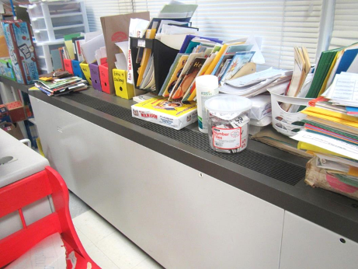

Unit ventilator (univent); note obstructing items

Picture 2

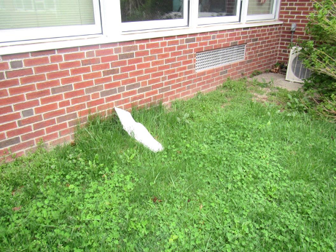

Univent air intake on side of building, note also piece of broken gutter or flashing
Picture 3

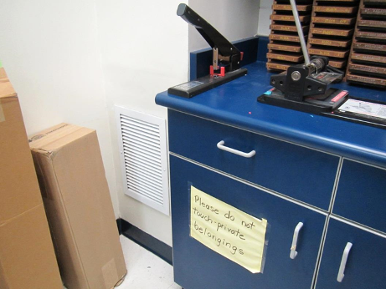

Wall-mounted exhaust vent, note partial obstruction with boxes

Picture 4

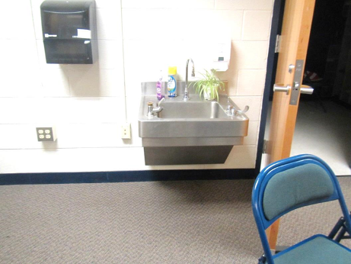

Sink over carpeting
Picture 5

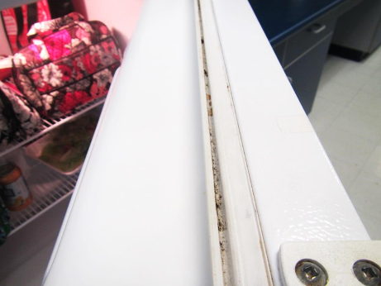

Refrigerator gasket with debris/staining

Picture 6

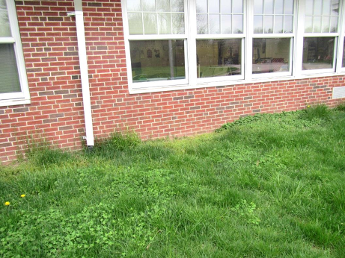

Downspout without extension elbow
Picture 7

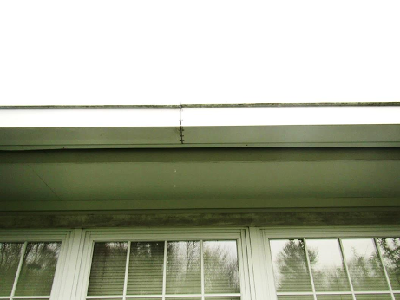

Water leaking through joint in gutter

Picture 8

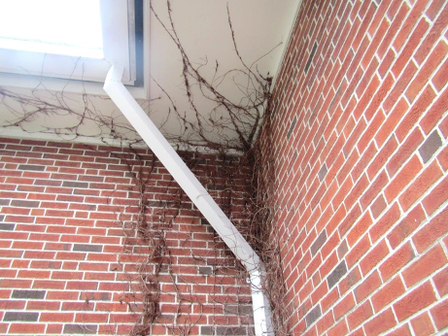

Clinging plants growing on brickwork and gutters
Picture 9

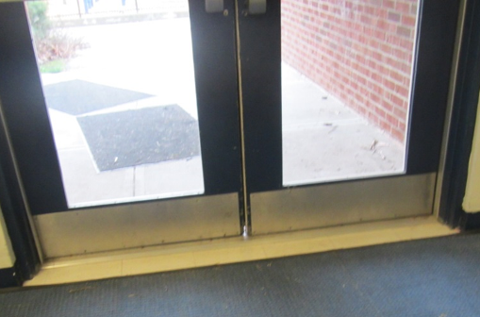

Light visible between doors to the outside

Picture 10

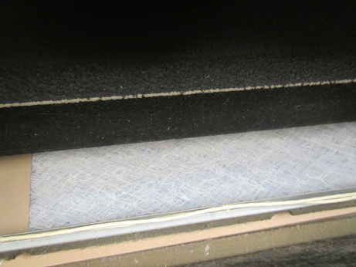

Mesh filter with low removal efficiency in univent
Picture 11

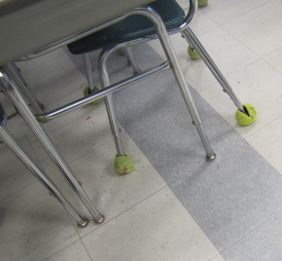

Open tennis balls used as chair glides

Picture 12

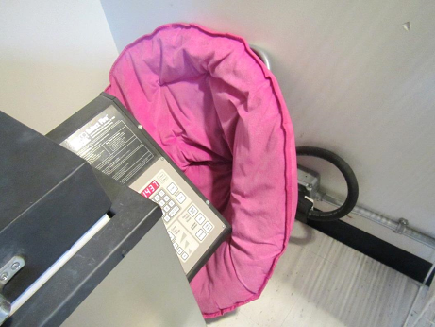

Kiln with cushion
Picture 13

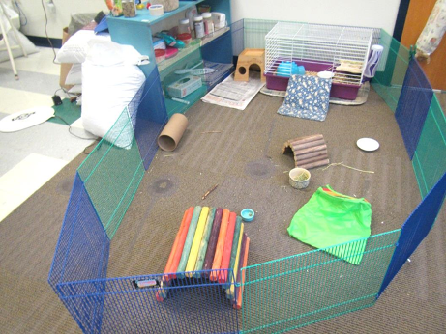

Guinea pig pen

Picture 14

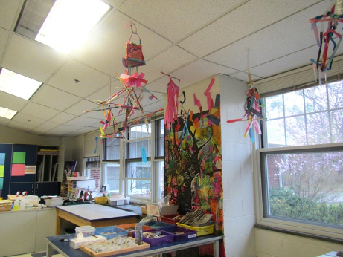

Items hanging from the ceiling
Location | Carbon  Dioxide  (ppm) | Carbon Monoxide  (ppm) | Temp  (°F) | Relative  Humidity  (%) | PM2.5  (µg/m³) | Occupants  in Room | Windows  Openable | Ventilation |  |  | Remarks
 |  |  |  |  |  |  |  | Supply | Exhaust
Background | 449 | ND | 66 | 69 | 70-90 |  |  |  |  |  | Showers
1 | 698 | ND | 71 | 53 | 34 | 1 | Y | Y UV |  | Y | Area rug, art supplies, sink
2 | 970 | ND | 71 | 52 | 41 | 15 | Y | Y UV |  | Y | Area rug, plants
2nd floor hallway end | 849 | ND | 73 | 59 | 45 | 4 | Y | N |  | N
3 | 805 | ND | 70 | 51 | 29 | 0 | Y | Y UV |  | Y | Area rug, exhaust obstructed
4 | 845 | ND | 70 | 51 | 29 | 0 | Y | Y |  | Y | Area rug, DEM
5 | 963 | ND | 71 | 51 | 31 | 0 | Y | Y |  | Y | Exhaust part obstructed, area rug
6 | 872 | ND | 71 | 51 | 25 | 0 | Y | Y UV |  | Y | DEM, area rug, 3 computers, exhaust part obstructed
7 special education | 1196 | ND | 71 | 52 | 30 | 2 | Y | Y UV |  | Y | Area rug, exhaust obstructed
8 | 1017 | ND | 71 | 56 | 40 | 21 | Y | Y UV |  | Y | DEM, HS, area rug
9 | 832 | ND | 71 | 61 | 50 | 21 | Y | Y UV |  | Y | Items on UV, exhaust partially obstructed, area rug, AI
10 | 720 | ND | 72 | 50 | 26 | 3 | Y | Y |  | Y | AHU, carpeting, PF
11 | 1062 | ND | 73 | 59 | 36 | 22 | Y | Y UV |  | Y | Sink, items, area rug
12 | 1005 | ND | 73 | 60 | 60 | 18 | Y | Y UV |  | Y | Plants, area rug
13 | 905 | ND | 73 | 58 | 46 | 16 | Y | Y UV |  | Y | Area rug – worn, microwave
14 | 782 | ND | 73 | 57 | 44 | 1 | Y | Y UV |  | Y | Computers, area rug, DEM
15 | 1398 | ND | 73 | 57 | 37 | 20 | Y | Y UV |  | Y | Dirt/debris on floor, AT, area rug
16 | 1268 | ND | 73 | 56 | 32 | 19 | Y | Y UV |  | Y | Area rug, sink, DEM
17 | 1180 | ND | 73 | 56 | 37 | 19 | Y | Y UV |  | Y | Plants on UV, TBs
18 | 917 | ND | 73 | 60 | 50 | 20 | Y | Y UV |  | Y
19 | 828 | ND | 73 | 60 | 49 | 21 | Y | Y UV |  | Y | 1 bowed tile, area rug
20 music | 703 | ND | 71 | 54 | 37 | 0 | Y | Y UV |  | Y | Carpet, music items, music storage
21 | 925 | ND | 74 | 59 | 47 | 19 | Y | Y UV |  | Y | Area rug, TB, PF, HS
22 | 865 | ND | 75 | 57 | 40 | 20 | Y | Y UV |  | Y | Area rug, DEM, HS
23 | 839 | ND | 75 | 58 | 39 | 24 | Y | Y UV |  | Y | Area rug, HS, PF
24 | 953 | ND | 75 | 59 | 44 | 26 | Y | Y UV |  | Y | Area rug
25 | 973 | ND | 74 | 60 | 47 | 17 | Y | Y UV |  | Y | Area rug, upholstered chairs, fan, plants, fake plants
26 | 820 | ND | 75 | 57 | 45 | 24 | Y | Y UV |  | Y | Area rug, PF, HS
27 | 1033 | ND | 75 | 56 | 46 | 23 | Y | Y UV |  | Y | Dead plant on UV, DEM, area rug
28 | 765 | ND | 74 | 56 | 51 | 17 | Y | Y UV |  | Y | Area rug, HS, CP, PF
122 computer lab (inside library) | 698 | ND | 71 | 46 | 24 | 2 | N | Y |  | Y | WD CT, computers carpet
128 art | 964 | ND | 72 | 56 | 25 | 2 | Y | Y |  | Y | Kiln on, exhaust for kiln seems weak, excess heat
129 | 580 | ND | 73 | 54 | 37 | 0 | Y | Y |  | Y | DEM
130 guidance | 751 | ND | 74 | 47 | 38 | 5 | Y | Y |  | Y | Area rug
132 | 688 | ND | 72 | 50 | 32 | 0 | N | Y |  | Y | Microwave
132B | 715 | ND | 71 | 50 | 36 | 0 | N | Y |  | Y | Principal’s office
132C | 669 | ND | 71 | 50 | 6 | 0 | N | Y |  | Y | Carpet
133 | 685 | ND | 72 | 45 | 24 | 5 | Y | Y |  | Y | AHU, toilet room, area rugs
153 teachers workroom | 627 | ND | 72 | 53 | 35 | 0 | Y | Y UV |  | Y | Laminator, PC
154 teacher’s lunchroom | 610 | ND | 71 | 56 | 34 | 1 | Y | Y UV |  | Y | Food, fridge (some staining on gasket), toaster (crumbs)
Bathroom between 1-2 |  |  |  |  |  |  | N | Y |  | Y
Gym | 559 | ND | 68 | 51 | 22 | 30 | N | Y |  | Y | AHU
Library | 669 | ND | 70 | 46 | 17 | 15 | U | Y |  | Y | AHU, carpeted, HS, 4 computers 1 WD CT
Main office | 714 | ND | 72 | 51 | 25 | 3 | N | Y |  | Y | Carpet, PF
Nurse’s office | 591 | ND | 70 | 52 | 25 | 2 | N | Y |  | Y weak
Women’s staff restroom |  |  |  |  |  |  | N | Y |  | Y | Candles and scented products

