INDOOR AIR QUALITY ASSESSMENT

William Gould Vinal Elementary School
102 Old Oaken Bucket Road
Norwell, MA

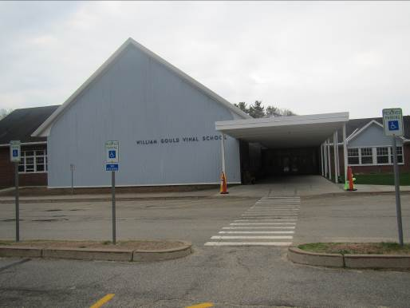

Prepared by:
Massachusetts Department of Public Health
Bureau of Environmental Health
Indoor Air Quality Program
February 2016

Background

Building: | Vinal Elementary School (VES)
Address: | 102 Old Oaken Bucket Road, Norwell, MA
Assessment Requested by: | Brian Flynn, Health Agent, Town of Norwell
Reason for Request: | Re-assessment to determine effectiveness of actions on previous recommendations. Previous visit was May 5, 2015, with report dated June 2015.
Date of Assessment: | January 7, 2016
Massachusetts Department of Public Health/Bureau of Environmental Health (MDPH/BEH) Staff Conducting Assessment: | Ruth Alfasso, Environmental Engineer, Indoor Air Quality Program
Date of Building Construction: | 1960s with a two-story addition added in 2002
Building Description: | Elementary School, brick construction, slanted shingled roof
Building Population: | 550 students in grades pre-k through 5 with a staff of approximately 150
Windows: | Mostly openable

IAQ Testing Results
Please refer to the IAQ Manual for methods, sampling procedures, and interpretation of results (MDPH, 2015). The following is a summary of indoor air testing result (Table 1).
- Carbon dioxide levels were above 800 parts per million (ppm) in a little less than half of the areas surveyed, indicating adequate air exchange in more than half of areas. Note that during the May 5, 2015 visit, more than half the carbon dioxide readings were above 800 ppm and several classrooms had windows open.
- Temperature was within the recommended range of 70°F to 78°F in about three quarters of areas tested and below in the remaining areas, which included the gymnasium and cafeteria.
- Relative humidity was below the recommended range of 40 to 60% in all areas tested. This is reflective of outdoor conditions.
- Carbon monoxide levels were non-detectable in all indoor areas tested. Background (outside) levels were 0.8 ppm, likely due to vehicle traffic.
- Fine particulate matter (PM2.5) concentrations measured were below the NAAQS limit of 35 μg/m³ in all areas tested. The background (outside) measurement was 37 μg/m³, slightly above the EPA NAAQS
This sampling indicates that the ventilation system in the building could provide more fresh air in some areas. Temperature control may need to be improved if occupants are reporting they are cold. Note that school staff report that measured temperatures from the MDPH 2015 report corresponded well with the temperature set points selected by teachers in those areas.

Ventilation
A heating, ventilating and air conditioning (HVAC) system has several functions. First it provides heating and, if equipped, cooling. Second, it is a source of fresh air. Finally, an HVAC system will dilute and remove normally occurring indoor environmental pollutants by not only introducing fresh air, but by filtering the airstream and ejecting stale air to the outdoors via exhaust ventilation. Even if an HVAC system is operating as designed, point sources of respiratory irritation may exist and cause symptoms in sensitive individuals. The following analysis examines and identifies components of the HVAC system and likely sources of respiratory irritant/allergen exposure due to water damage, aerosolized dust and/or chemicals found in the indoor environment.
Fresh air is provided by a combination of unit ventilators (univents) located in individual classrooms either along the outside wall (Picture 1) or on the ceiling, and air handling units (AHUs) on the roof which serve central areas such as the gym and cafeteria as well as supplement fresh air in some classrooms. The unit ventilators draw fresh air through a vent on the outside wall (Picture 2) or the roof. Air is mixed with return air from the room, filtered, heated (if needed) and delivered back to the room (Figure 1). Air from the AHUs is filtered, heated and delivered to rooms via ducted supply vents (Picture 3). Exhaust vents are located on the walls of classrooms and are ducted to fans on the roof (Picture 4). Additional exhaust vents are located in toilet rooms (Picture 5) and areas, such as kitchens and the kiln room, which produce pollutants.

Microbial/Moisture Concerns

No water-damaged materials were observed during this visit. A few sinks had porous items stored beneath them, where they could become damaged due to condensation on piping or leaks. Porous items and large amounts of items should not be stored under sinks.
Plants were observed in a few areas. Plants can be a source of pollen and mold, which can be respiratory irritants to some individuals. Plants should be properly maintained and equipped with drip pans and should be located away from air diffusers to prevent the aerosolization of dirt, pollen and mold.

Other IAQ Evaluations
Exposure to low levels of total VOCs (TVOCs) may produce eye, nose, throat, and/or respiratory irritation in some sensitive individuals. To determine if VOCs were present, BEH/IAQ staff examined rooms for products containing VOCs. BEH/IAQ staff noted air fresheners, hand sanitizers, cleaners, and dry erase materials in use within the building (Table 1). All of these products have the potential to be irritants to the eyes, nose, throat, and respiratory system of sensitive individuals.
Some personal fans, supply and exhaust vents were observed to be dusty (Table 1). In some areas, items were observed on the floor, windowsills, tabletops, counters, bookcases, and desks (Table 1). Most classrooms had area rugs, which should be cleaned

Actions on MDPH Recommendations
The following is a list of the recommendations made in the June 2015 MDPH report (in bold) and the actions that have been taken since then as confirmed by reports from VES personnel and MDPH staff observations during the January 2016 reassessment.
- Operate all supply and exhaust ventilation systems throughout the building continuously during periods of occupancy to maximize air exchange.
  - Supply and exhaust ventilation was operating in almost all areas examined.
- Remove blockages (e.g., items, furniture) from the front and top of univents and from the area of exhaust vents.
  - Blockages were not found in front of or on top of ventilation equipment.
- Examine univent dampers and adjust to provide more fresh air as needed.
  - School staff report that dampers had been opened on univents to allow for more fresh air.
- Consider keeping classroom doors closed for better air exchange and exhaust function.
  - Most classroom doors were closed at the time of the visit.
- Ensure all exhaust vents/fans are operational and activated during occupied hours.
  - Exhaust vents were found to be operational in all areas examined, including the Health/Nurses’ restroom where exhaust vents were not operating during the May 5, 2015 visit. According to school staff, a tripped breaker was found that prevented activation of some of the exhaust vents during the previous visit, this has been corrected.
- Change filters for air handling equipment (univents and AHUs) 2 to 4 times a year. Vacuum interior of units prior to activation to prevent the aerosolization of dirt, dust and particulate matter. Ensure filters fit flush in their racks with no spaces in between allowing bypass of unfiltered air into the unit.
  - School staff report this has been conducted.
- Consider replacing existing univent filters with a greater dust-spot efficiency (e.g., MERV 9). Prior to any increase of filtration, each piece of air handling equipment should be evaluated by a ventilation engineer as to whether it can maintain function with more efficient filters.
  - School staff reported that higher-efficiency filters have been installed.
- Consider adopting a balancing schedule of every 5 years for all mechanical ventilation systems, as recommended by ventilation industrial standards (SMACNA, 1994).
  - This has not been done since the last visit.
- For buildings in New England, periods of low relative humidity during the winter are often unavoidable. Therefore, scrupulous cleaning practices should be adopted to minimize common indoor air contaminants whose irritant effects can be enhanced when the relative humidity is low. To control dusts, a high efficiency particulate arrestance (HEPA) filter equipped vacuum cleaner in conjunction with wet wiping of all surfaces is recommended. Avoid the use of feather dusters. Drinking water during the day can help ease some symptoms associated with a dry environment (throat and sinus irritations).
  - Cleaning is reported to be conducted regularly. Locations examined appeared to be cleaned regularly.
- Ensure roof/plumbing leaks are repaired and replace any remaining water-damaged ceiling tiles and other building materials. Disinfect areas of water leaks with an appropriate antimicrobial, as needed.
  - No water-damaged materials were found during the visit.
- Consider placing a waterproof mat under sinks, or replace carpeting in these areas with tile.
  - A mat was observed under the water cooler in the main office (Picture 6).
- Clean staff refrigerators regularly. Clean refrigerator gaskets with an antimicrobial solution to remove debris and staining.
  - Staff refrigerators were observed to be clean with no gasket staining.
- Repair the gutter system, including replacing missing or broken downspouts and leaks at joints. Repair any missing or damaged flashing.
  - Examination of the exterior showed that the gutter system appears to be in good repair.
- Remove plants growing on exterior walls and trim plans near the base of the building to five feet away from the foundation.
  - Most plants had been removed away from the building, including most of the clinging ivy that had been observed during the previous visit.
- Replace weather-stripping on doors so that they seal tightly. Monitor for gaps by observing for light or drafts.
  - Some doors still had some light showing beneath them.
- Replace tennis balls with latex-free glides.
  - No tennis balls were observed to be used as glides during this visit.
- Ensure local exhaust ventilation for the kiln is operating as designed, make repairs/adjustments as needed. Remove any items from direct contact with the kiln. Consider only firing the kiln during unoccupied hours.
  - School staff report that the local exhaust for the kiln had been repaired. No items were observed in contact with the kiln during the visit.
- Seal holes in overhangs where birds nest and clean bird waste from the exterior of the building with an antimicrobial solution.
  - Bird nesting material and wastes had been removed from the outside.
- Keep pets and associated living spaces clean and remove any waste promptly. Do not use carpeting from pet areas for general classroom purposes.
  - No pets were observed during this visit.
- Relocate or consider reducing the amount of materials stored in classrooms to allow for more thorough cleaning of classrooms. Clean items regularly with a wet cloth or sponge to prevent excessive dust buildup.
  - Less clutter was observed during this visit, and items were found stored in plastic totes in many areas.
- Refrain from hanging items from the ceiling tile system.
  - No items were observed hanging from the ceiling tiles.
- Clean upholstered furniture annually or more frequently if needed.
  - This is reportedly being done.
- Clean carpeting regularly in accordance with The Institute of Inspection, Cleaning and Restoration Certification (IICRC) recommendations (IICRC, 2012). Discard any worn out area rugs.
  - This is reportedly being done

Conclusions/Recommendations
The findings during this visit show that significant work has been performed to improve the IAQ in the VES. The following additional recommendations are made to assist in improving IAQ and maintaining that improvement:
- Continue to work with maintenance staff to increase fresh air supply in areas with high carbon dioxide levels.
- Monitor exhaust vents periodically to ensure they are functioning and correct/repair as necessary.
- Continue with regular filter changes and cleaning of univents and AHUs.
- Properly maintain aquariums and plants to prevent odors and water damage
- Clean carpeting and area rugs regularly and discard those that are worn out or too soiled to be cleaned per previous recommendations.
- Consider adopting the US EPA (2000) document, “Tools for Schools”, as an instrument for maintaining a good IAQ environment in the building. This document is available at: http://www.epa.gov/iaq/schools/index.html.
- Refer to resource manual and other related IAQ documents located on the MDPH’s website for further building-wide evaluations and advice on maintaining public buildings. These documents are available at: http://mass.gov/dph/iaq.

References
IICRC. 2012. Carpet Cleaning FAQ 4 Institute of Inspection, Cleaning and Restoration Certification. Institute of Inspection Cleaning and Restoration. Vancouver, WA.
Massachusetts Department of Public Health (MDPH). 2015. “Indoor Air Quality Manual: Chapters I-III”. Available at: http://www.mass.gov/eohhs/gov/departments/dph/programs/environmental-health/exposure-topics/iaq/iaq-manual/.
US EPA. 2000. Tools for Schools. Office of Air and Radiation, Office of Radiation and Indoor Air, Indoor Environments Division (6609J). EPA 402-K-95-001, Second Edition. http://www.epa.gov/iaq-schools.
Picture 1
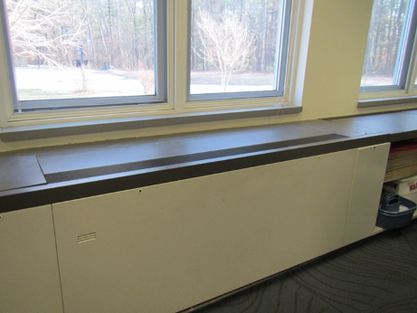
Unit ventilator (univent)
Picture 2
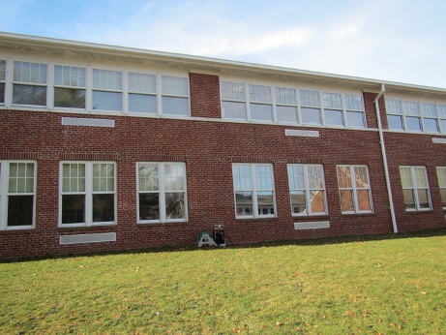
Univent intakes on side of building
Picture 3
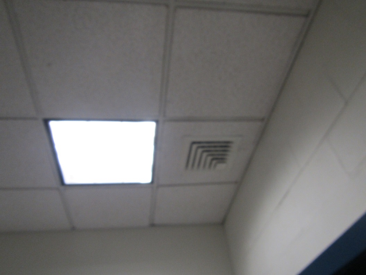
Typical supply vent
Picture 4
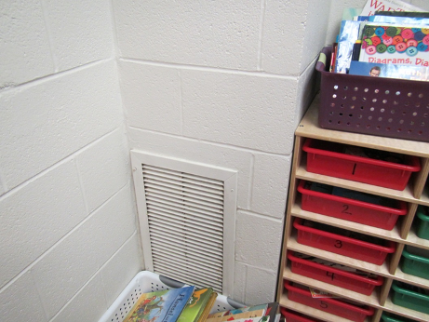
Exhaust vent in classroom
Picture 5
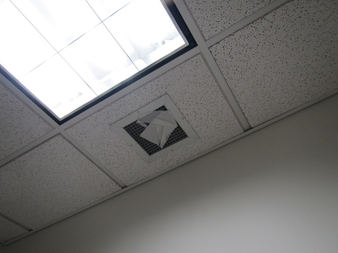
Exhaust vent in restroom, note paper on the grate showing unit is drawing air
Picture 6
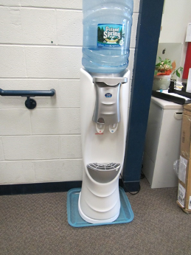
Waterproof mat under water cooler
Location | Carbon  Dioxide  (ppm) | Carbon Monoxide  (ppm) | Temp  (°F) | Relative  Humidity  (%) | PM2.5  (µg/m³) | Occupants  in Room | Windows  Openable | Ventilation |  |  | Remarks
 |  |  |  |  |  |  |  | Supply | Exhaust
Background (outside) | 405 | 0.8 | 32 | 17 | 37 |  |  |  |  |  | Cold and clear
Cafeteria | 427 | ND | 68 | 9 | 20 | 0 | Y | Y |  | Y
Main office | 477 | ND | 67 | 12 | 17 | 3 | Y | Y |  | Y | PC
Office/conference | 523 | ND | 68 | 13 | 21 | 0 | Y | Y |  | Y | Ductless AC
Gym | 460 | ND | 63 | 14 | 33 | 22 | N | Y |  | Y | Rubber balls
Library | 535 | ND | 65 | 16 | 17 | 25 | N | Y |  | Y | Carpet, aquarium
Stairwell, downstairs | 732 | ND | 72 | 14 | 22 | 2 | N | N |  | N | DEM, door to outside
Stairwell, upstairs | 803 | ND | 72 | 13 | 24 | 2 | N | N |  | N
1 | 728 | ND | 71 | 13 | 24 | 16 | Y | Y |  | Y | Area rug, PF in storage
2 | 743 | ND | 72 | 15 | 29 | 16 | Y | Y |  | Y | Plant, area rug, DEM,
3 | 1055 | ND | 72 | 16 | 19 | 22 | Y | Y |  | Y | Area rug, HS, DEM
4 | 988 | ND | 72 | 18 | 19 | 21 | Y | Y |  | Y | Area rug, PF
5 | 798 | ND | 71 | 14 | 24 | 23 | Y | Y |  | Y | Area rug
6 | 998 | ND | 72 | 17 | 29-30 | 15 | Y | Y |  | Y | Area rug, DEM, PF, HS
7 Sp.Ed. | 619 | ND | 71 | 13 | 23 | 2 | Y | Y |  | Y | DEM, area rug, HS
8 | 604 | ND | 70 | 13 | 22 | 17 | Y | Y |  | Y | Area rug
9 | 666 | ND | 70 | 15 | 24 | 19 | Y | Y |  | Y | Sink, area rug
10 | 605 | ND | 71 | 11 | 17 | 18 | Y | Y |  | Y | DEM, HS, ceiling UV
11 | 1001 | ND | 71 | 14 | 28 | 20 | Y | Y |  | Y | Area rug
12 | 1055 | ND | 71 | 16 | 26 | 18 | Y | Y |  | Y | DEM, area rug, plant
13 | 1206 | ND | 71 | 17 | 19 | 15 | Y | Y |  | Y | Area rug
14 | 1175 | ND | 71 | 15 | 23 | 21 | Y | Y |  | Y | Area rug, DEM
15 | 765 | ND | 72 | 15 | 19 | 22 | Y | Y |  | Y | Accumulated items, area rug, DEM
16 | 1100 | ND | 72 | 17 | 17 | 21 | Y | Y |  | Y | Area rug
17 | 1194 | ND | 72 | 18 | 25 | 19 | Y | Y |  | Y | Area rug, PF, DEM
18 | 1205 | ND | 71 | 17 | 33 | 21 | Y | Y |  | Y | DEM, area rug
19 | 1096 | ND | 71 | 17 | 19 | 21 | Y | Y |  | Y | Area rug, DEM
20 music | 938 | ND | 71 | 16 | 28 | 25 | Y | Y |  | Y | PF dusty, UV may be off
21 | 732 | ND | 70 | 14 | 14 | 1 | Y | Y |  | Y | PF
22 | 787 | ND | 71 | 14 | 16 | 1 | Y | Y |  | Y | Area rug, HS, DEM
23 | 877 | ND | 71 | 14 | 16 | 1 class just left | Y | Y |  | Y | Area rug, DEM
24 | 1035 | ND | 73 | 14 | 25 | 20 | Y | Y |  | Y | Area rug, PF-dusty, plant, art supplies, DEM, perfume odor
25 | 934 | ND | 73 | 16 | 15 | 18 | Y | Y |  | Y | Aquarium, DEM, area rug
26 | 905 | ND | 70 | 16 | 20 | 17 | Y | Y |  | Y | Area rug, DEM, PF
27 | 799 | ND | 70 | 14 | 18 | 1 | Y | Y |  | Y | Area rug, 3 PF, HS
28 | 742 | ND | 70 | 14 | 18 | 1 | Y | Y |  | Y | Area rug, DEM, PF
122 (computer) | 515 | ND | 66 | 15 | 23 | 0 | N | Y |  | Y | UV in ceiling (on)
128 Art | 732 | ND | 68 | 15 | 30 | 18 | Y | Y |  | Y | Water cooler, area rug, porous items under sink
130 Sp.Ed. | 481 | ND | 70 | 12 | 22 | 0 | Y | Y |  | Y | Area rug and mobility/exercise items,  HS
131 Health | 529 | ND | 66 | 14 | 26 | 1 | N | Y |  | Y | CP, exhaust in adjacent toilet room on
132 B principal | 485 | ND | 67 | 13 | 17 | 0 | Y | Y |  | Y | Plants
133 Sp.Ed. | 505 | ND | 70 | 12 | 21 | 4 | Y | Y |  | Y | UV on and also supply vents, area rugs, toilet room with working exhaust, DEM, microwave
151 | 481 | ND | 68 | 12 | 23 | 2 | Y | Y |  | Y | DEM, food, toaster
152 | 587 | ND | 69 | 12 | 21 | 0 | Y | Y |  | Y | Teacher’s lounge, 2 refrigerators (clean), microwave, laminator

