Background

INDOOR AIR QUALITY
WATER DAMAGE ASSESSMENT

Williams Intermediate School
200 South Street
Bridgewater, MA

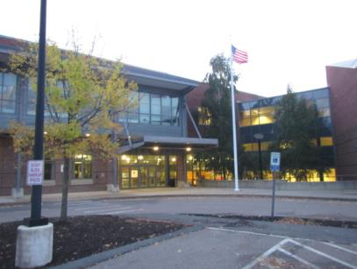

Prepared by:
Massachusetts Department of Public Health
Bureau of Environmental Health
Indoor Air Quality Program
November 2018

Building: | Williams Intermediate School (WIS)
Address: | 200 South Street, Bridgewater, MA
Assessment Requested by: | Paul Fox, Director of Facilities
Date of Assessment: | October 16, 2018
Bureau of Environmental Health/Indoor Air Quality (BEH/IAQ) Program Staff Conducting Assessment: | Cory Holmes, Environmental Analyst
Reason for Request: | Water infiltration and odor/mold concerns in Art rooms 101 and 102

Methods
BEH/IAQ staff performed moisture measurements of porous building materials and a visual inspection for water damage and/or microbial growth.

Results/Discussion

Microbial/Moisture Concerns
The visit was prompted by reports of odors believed to be caused by water-damaged materials in art rooms 101 and 102. It was reported by school maintenance personnel that in some wind/weather conditions, rainwater enters the classrooms through the exterior walls/building envelope and that this is a chronic condition that has occurred for years despite efforts to identify a source of entry. BEH/IAQ staff visited the classroom early AM prior to school opening, when odors were reportedly strongest.
Upon entry a musty odor was detected. It is important to note that staff reported that odors tend to dissipate, particularly when the mechanical ventilation system is operating and exchanging air. It is also important to note that the assessment occurred the morning after moderate to heavy wind/rain conditions. Although obvious water damage was apparent in the form of rusted/stained metal window frames, damaged ceiling tiles and peeling paint on walls in Art rooms 101 and 102 (Pictures 1 through 5), measurements of moisture in these materials indicated that they were dry and no visible mold growth on building materials were observed during the assessment. Picture 6 shows the exterior of the building where the windows leak into the Art rooms 101 and 102.
The MDPH recommend that air handling units (AHUs) be outfitted with filters of a Minimum Efficiency Reporting Value (MERV) of 8, which are adequate in filtering out pollen and mold spores (ASHRAE, 2012). The rooftop AHUs at WIS have a dual filtration system. Air is drawn through a pleated MERV 8 pre-filter, then through a 95% high efficiency post-filtration unit (Pictures 7 through 9). School maintenance staff report that MERV 8 pre-filters are changed two times per year and that the 95% high efficiency post-filters are changed once.

Conclusions/Recommendations
In view of the findings at the time of the visit, the following recommendations are made:
- Long-Term measures should be taken to address chronic water penetration issues including consultation with building envelope specialists/building engineers to conduct a thorough investigation and make recommendations to reduce water penetration.
- Until leaks are fixed, the following should be ongoing:
- Systematically perform building walk-throughs following any severe weather to check for leaks and promptly commence drying operations;
- Take measures to protect materials from further damage. Move porous items (e.g., books, paper, cardboard) away from areas with known water leaks;
- Scrape away loose paint and debris from walls and inspect for microbial growth.
- When time permits (e.g., school break), conduct thorough investigation into water-damaged walls in areas impacted by leaks, including the following measures to protect building materials and occupants:
- Prior to any destructive activities, deactivate mechanical ventilation components to avoid entrainment in HVAC system;
- Remove classroom items from general area or cover with plastic to aid clean up;
- Use depressurization techniques (e.g., fans blowing out windows);
- Use methods consistent with recommendations found in “Mold Remediation in Schools and Commercial Buildings” published by the US Environmental Protection Agency (US EPA, 2008). http://www.epa.gov/mold/mold-remediation-schools-and-commercial-buildings-guide.
- Continue to use/change filters on current schedule or increase as needed. MDPH recommends that filters are changed 2-4 times per year or as per the manufacture’s instructions.
- Continue to activate HVAC system prior to building occupancy to exchange air.
- Refer to resource manuals and other related indoor air quality documents for further building-wide evaluations and advice on maintaining public buildings. Copies of these materials are located on the MDPH’s website: http://mass.gov/dph/iaq.

References
ASHRAE. 2012. American Society of Heating, Refrigeration and Air Conditioning Engineers (ASHRAE) Standard 52.2-2012 -- Method of Testing General Ventilation Air-Cleaning Devices for Removal Efficiency by Particle Size (ANSI Approved). 2012.
US EPA. 2008. Mold Remediation in Schools and Commercial Buildings. US Environmental Protection Agency, Office of Air and Radiation, Indoor Environments Division, Washington, D.C. EPA 402-K-01-001. http://www.epa.gov/mold/mold-remediation-schools-and-commercial-buildings-guide.

Picture 1
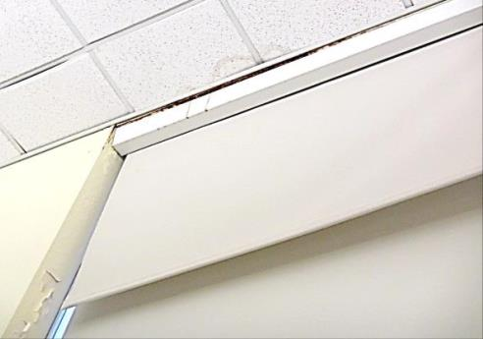
Water-damaged ceiling tiles, rust/drips on metal window fixture and peeling paint on wall in Art room 101
Picture 2
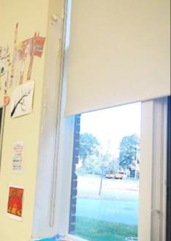
Water-damaged wall and peeling paint on wall in Art room 101
Picture 3
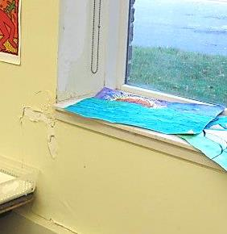
Water-damaged wall and peeling paint on wall in Art room 101
Picture 4
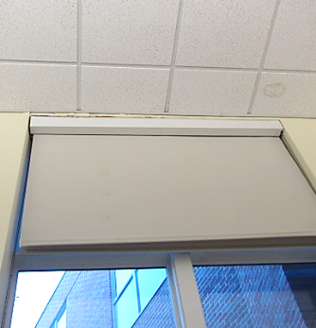
Water-damaged ceiling tiles and window frame (top) in Art room 102
Picture 5
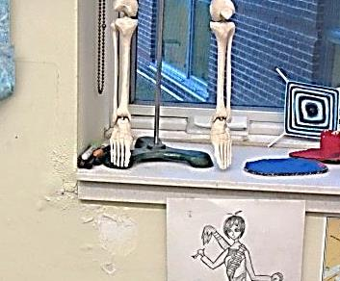
Water-damaged wall and peeling paint on wall in Art room 102
Picture 6
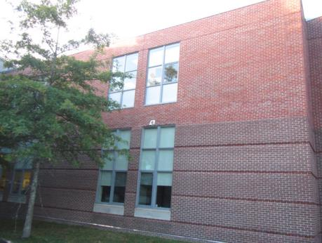
Exterior picture of windows outside Art rooms 101 and 102
Picture 7
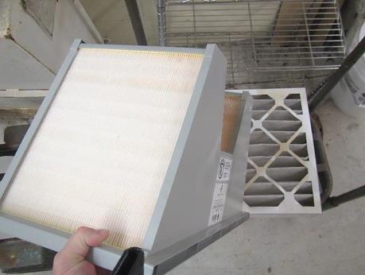
High efficiency (95%) filter (foreground), pleated MERV 8 filter (background)
Picture 8
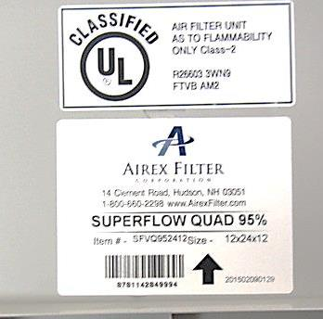
Label indicating 95% efficiency of post-filter
Picture 9
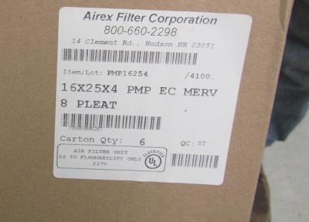
Label indicating MERV 8 efficiency of pre-filter

