INDOOR AIR QUALITY ASSESSMENT

Williams Intermediate School
200 South Street
Bridgewater, Massachusetts 02324

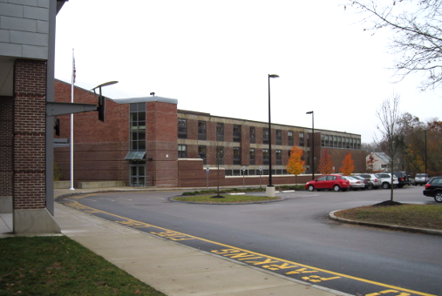

Prepared by:
Massachusetts Department of Public Health
Bureau of Environmental Health
Indoor Air Quality Program
January 2009

Background/Introduction
At the request of Mr. Al Baroncelli, Facilities Director for the Bridgewater-Raynham Regional School District, the Massachusetts Department of Public Health (MDPH), Bureau of Environmental Health (BEH) provided assistance and consultation in an on-going effort to monitor and improve indoor air quality conditions in each of the Bridgewater-Raynham Regional schools. On November 7, 2008, Cory Holmes, Environmental Analyst/Inspector for BEH’s Indoor Air Quality (IAQ) Program conducted an assessment at the Williams Intermediate School (WIS), 200 South Street, Bridgewater, Massachusetts.
The building was previously visited by BEH staff in May 2002, and a report was issued detailing environmental conditions observed at the time (MDPH, 2002). Subsequent to the 2002 assessment, a comprehensive addition and renovation project was conducted. The WIS consists of two wings: the north wing addition, which was built in 2006-2007, and the renovated south wing that was completed in 2007. The school consists of general classrooms, science classrooms, a gymnasium, kitchen/cafeteria, media center, art rooms, music rooms, teacher work rooms and office space. Windows are openable throughout the building.

Methods
Air tests for carbon dioxide, carbon monoxide, temperature and relative humidity were conducted with the TSI, Q-TRAK™ IAQ Monitor, Model 8554. Air tests for airborne particulate matter with a diameter less than 2.5 micrometers were taken with the TSI, DUSTTRAK™ Aerosol Monitor Model 8520. BEH staff also performed a visual inspection of building materials for water damage and/or microbial growth.

Results
The WIS currently houses grades 4 through 6 with a student population of approximately 925 and a staff of approximately 90. Tests were taken under normal operating conditions. Test results for the north wing appear in Table 1. Test results for the south wing appear in Table 2.

Discussion

Ventilation
It can be seen from Table 1 that carbon dioxide (CO₂) levels were above 800 parts per million (ppm) in 9 of 42 areas surveyed in the north wing, indicating adequate ventilation in the majority of areas surveyed during the assessment (Table 1). However, it is worthwhile to note that a number of rooms were sparsely populated, which generally results in lower CO₂ levels. Mechanical ventilation in the north wing is provided by rooftop air handling units ducted to ceiling-mounted supply and return vents (Pictures 1 through 5). Some exhaust vents are located near classroom doors (Picture 5). Due to their location, the exhaust capabilities of these vents can be diminished when the doors are left open (Picture 5). With the classroom doors open, the return/exhaust vent tends to draw air from the hallway into the classrooms instead of stale air out of the classroom.
Carbon dioxide levels in the south wing were above 800 ppm in of 12 of 30 areas (Table 2), indicating poor air exchange in a number of areas surveyed during the assessment. Classrooms in the south wing have a ventilation system consisting of unit ventilators (univents) (Pictures 6 and 7). A univent is designed to draw air from outdoors through a fresh air intake located on the exterior wall of the building (Picture 8). Return air is drawn through an air intake located at the base of the unit (Figure 1). Fresh and return air are mixed, filtered, heated and provided to classrooms through an air diffuser located in the top of the unit. Univents were deactivated in a few rooms (Table 2); in others, air diffusers were obstructed by various items (Picture 6) that can limit air exchange. The univents in classroom S-148 and S-321 were making a “rattling” noise, which can indicate a mechanical issue.
Exhaust ventilation in south wing classrooms is provided by wall vents ducted to rooftop motors. At the time of the assessment, building maintenance staff reported that two of the exhaust motors were inoperable and that replacement parts were on order. Exhaust vents in several classrooms were partially obstructed by furniture and other items (Picture 10). As with univents, in order to function properly, exhaust vents must be activated and allowed to operate free from obstructions while rooms are occupied.
Fresh air for common areas such as the gymnasium, cafeteria, library and administrative areas is provided by rooftop or ceiling-mounted air handling units (AHUs). AHUs draw in air from outdoor air intakes; filter, heat and/or cool the air, then distribute it to occupied areas via ceiling or wall-mounted air diffusers. Exhaust air is returned back to the AHUs via ceiling-mounted return vents. These systems appeared to be operating during the assessment.
To maximize air exchange, the MDPH recommends that both supply and exhaust ventilation operate continuously during periods of school occupancy. In order to have proper ventilation with a mechanical supply and exhaust system, the systems must be balanced to provide an adequate amount of fresh air to the interior of a room while removing stale air from the room. It is recommended that existing ventilation systems be re-balanced every five years to ensure adequate air systems function (SMACNA, 1994). The date of the last balancing of these systems reportedly occurred after construction/renovations in 2007.
The Massachusetts Building Code requires a minimum ventilation rate of 15 cubic feet per minute (cfm) per occupant of fresh outside air or have openable windows in each room (SBBRS, 1997; BOCA, 1993). The ventilation must be on at all times that the room is occupied. Providing adequate fresh air ventilation with open windows and maintaining the temperature in the comfort range during the cold weather season is impractical. Mechanical ventilation is usually required to provide adequate fresh air ventilation.
Carbon dioxide is not a problem in and of itself. It is used as an indicator of the adequacy of the fresh air ventilation. As carbon dioxide levels rise, it indicates that the ventilating system is malfunctioning or the design occupancy of the room is being exceeded. When this happens a buildup of common indoor air pollutants can occur, leading to discomfort or health complaints. The Occupational Safety and Health Administration (OSHA) standard for carbon dioxide is 5,000 parts per million parts of air (ppm). Workers may be exposed to this level for 40 hours/week based on a time weighted average (OSHA, 1997).
The MDPH uses a guideline of 800 ppm for publicly occupied buildings. A guideline of 600 ppm or less is preferred in schools due to the fact that the majority of occupants are young and considered to be a more sensitive population in the evaluation of environmental health status. Inadequate ventilation and/or elevated temperatures are major causes of complaints such as respiratory, eye, nose and throat irritation, lethargy and headaches. For more information concerning carbon dioxide, please see Appendix A.
Temperature measurements on the day of the assessment ranged from 69 F to 72º F in the north wing (Table 1) and from 68º F to 73º F in the south wing (Table 2). These temperatures were within or very close to the MDPH recommended comfort range. The MDPH recommends that indoor air temperatures be maintained in a range of 70º F to 78º F in order to provide for the comfort of building occupants. In many cases concerning indoor air quality, fluctuations of temperature in occupied spaces are typically experienced, even in a building with an adequate fresh air supply.
The relative humidity measured in the building ranged from 55 to 69 percent in the north wing (Table 1) and 61 to 68 percent in the south wing (Table 2). These relative humidity levels were above the MDPH recommended comfort range in a number of areas and reflective of elevated outdoor conditions (82 to 97%) on the day of the assessment. The MDPH recommends a comfort range of 40 to 60 percent for indoor air relative humidity. Relative humidity levels in the building would be expected to drop during the winter months due to heating. The sensation of dryness and irritation is common in a low relative humidity environment. Low relative humidity is a very common problem during the heating season in the northeast part of the United States.

Microbial/Moisture Concerns
Plants were noted in several classrooms. Plants can be a source of pollen and mold, which can be respiratory irritants for some individuals. Plants should be properly maintained and equipped with drip pans to prevent water damage to porous building materials, which can lead to mold growth. Plants should also be located away from ventilation sources (e.g., air intakes, univent diffusers) to prevent the entrainment and/or aerosolization of dirt, pollen or mold (Picture 4).

Other IAQ Evaluations
Indoor air quality can be negatively influenced by the presence of respiratory irritants, such as products of combustion. The process of combustion produces a number of pollutants. Common combustion emissions include carbon monoxide, carbon dioxide, water vapor and smoke (fine airborne particle material). Of these materials, exposure to carbon monoxide and particulate matter with a diameter of 2.5 micrometers (μm) or less (PM2.5) can produce immediate, acute health effects upon exposure. To determine whether combustion products were present in the school environment, BEH staff obtained measurements for carbon monoxide and PM2.5.

Carbon Monoxide
Carbon monoxide is a by-product of incomplete combustion of organic matter (e.g., gasoline, wood and tobacco). Exposure to carbon monoxide can produce immediate and acute health affects. Several air quality standards have been established to address carbon monoxide and prevent symptoms from exposure to these substances. The MDPH established a corrective action level concerning carbon monoxide in ice skating rinks that use fossil-fueled ice resurfacing equipment. If an operator of an indoor ice rink measures a carbon monoxide level over 30 ppm, taken 20 minutes after resurfacing within a rink, that operator must take actions to reduce carbon monoxide levels (MDPH, 1997).
The American Society of Heating Refrigeration and Air-Conditioning Engineers (ASHRAE) has adopted the National Ambient Air Quality Standards (NAAQS) as one set of criteria for assessing indoor air quality and monitoring of fresh air introduced by HVAC systems (ASHRAE, 1989). The NAAQS are standards established by the US EPA to protect the public health from six criteria pollutants, including carbon monoxide and particulate matter (US EPA, 2006). As recommended by ASHRAE, pollutant levels of fresh air introduced to a building should not exceed the NAAQS levels (ASHRAE, 1989). The NAAQS were adopted by reference in the Building Officials & Code Administrators (BOCA) National Mechanical Code of 1993 (BOCA, 1993), which is now an HVAC standard included in the Massachusetts State Building Code (SBBRS, 1997). According to the NAAQS, carbon monoxide levels in outdoor air should not exceed 9 ppm in an eight-hour average (US EPA, 2006).
Carbon monoxide should not be present in a typical, indoor environment. If it is present, indoor carbon monoxide levels should be less than or equal to outdoor levels. On the day of assessment, outdoor carbon monoxide concentrations were non-detect (ND). No levels of carbon monoxide were detected inside the building during the assessment (Tables 1 and 2).

Particulate Matter (PM2.5)
The US EPA has established NAAQS limits for exposure to particulate matter. Particulate matter is airborne solids that can be irritating to the eyes, nose and throat. The NAAQS originally established exposure limits to particulate matter with a diameter of 10 μm or less (PM10). According to the NAAQS, PM10 levels should not exceed 150 microgram per cubic meter (μg/m³) in a 24-hour average (US EPA, 2006). These standards were adopted by both ASHRAE and BOCA. Since the issuance of the ASHRAE standard and BOCA Code, US EPA established a more protective standard for fine airborne particles. This more stringent PM2.5 standard requires outdoor air particle levels be maintained below 35 μg/m³ over a 24-hour average (US EPA, 2006). Although both the ASHRAE standard and BOCA Code adopted the PM10 standard for evaluating air quality, MDPH uses the more protective PM2.5 standard for evaluating airborne particulate matter concentrations in the indoor environment.
Outdoor PM2.5 concentrations were measured at 13 μg/m³ (Tables 1 and 2). PM2.5 levels ranged from 2 to 22 μg/m³ in the north wing (Table 1) and from 4 to 13 μg/m³ in the south wing (Table 2). These PM2.5 levels were below the NAAQS PM2.5 level of 35 μg/m³. Frequently, indoor air levels of particulates (including PM2.5) can be at higher levels than those measured outdoors. A number of mechanical devices and/or activities that occur in schools can generate particulate during normal operations. Sources of indoor airborne particulates may include but are not limited to particles generated during the operation of fan belts in the HVAC system, cooking in the cafeteria stoves and microwave ovens; use of photocopiers, fax machines and computer printing devices; operation of an ordinary vacuum cleaner and heavy foot traffic indoors.

Volatile Organic Compounds
Indoor air quality can also be impacted by the presence of materials containing volatile organic compounds (VOCs). VOCs are substances that have the ability to evaporate at room temperature. Frequently, exposure to low levels of total VOCs (TVOCs) may produce eye, nose, throat and/or respiratory irritation in some sensitive individuals. For example, chemicals evaporating from a paint can stored at room temperature would most likely contain VOCs. In an effort to identify materials that can potentially increase indoor VOC concentrations, BEH staff examined classrooms for products containing these respiratory irritants.
The majority of classrooms contained dry erase boards and related materials. Materials such as dry erase markers and dry erase board cleaners may contain VOCs, such as methyl isobutyl ketone, n-butyl acetate and butyl-cellusolve (Sanford, 1999), which can be irritating to the eyes, nose and throat.

Other Conditions
Other conditions that can affect indoor air quality were observed during the assessment. In several classrooms, items were observed on windowsills, tabletops, counters, bookcases and desks. The large number of items stored in classrooms provides a source for dusts to accumulate. These items (e.g., papers, folders, boxes) make it difficult for custodial staff to clean. Items should be relocated and/or be cleaned periodically to avoid excessive dust build up. In addition, these materials can accumulate on flat surfaces (e.g., desktops, shelving and carpets) in occupied areas and subsequently be re-aerosolized causing further irritation.
Finally, a number of supply diffusers, exhaust/return vents and personal fans (Pictures 11 and 12) were observed to have accumulated dust. If exhaust vents are not functioning, backdrafting can occur, which can re-aerosolize accumulated dust particles. Re-activated univents and fans can also aerosolize dust accumulated on vents/fan blades.

Conclusions/Recommendations
In view of the findings at the time of the visit, the following recommendations are made to improve indoor air quality:
- Continue to operate all ventilation systems throughout the building (e.g., gym, auditorium, classrooms) continuously during periods of school occupancy.
- Increase the percentage of fresh air supplied by the HVAC system and univents as a means to improve air exchange.
- Monitor univents in classrooms S-148 and S-321 for proper function. Make adjustments and/or repair as needed.
- Continue with plans to repair rooftop exhaust vents.
- Remove all blockages from univents and exhaust vents to ensure adequate airflow.
- Close classroom doors to facilitate air exchange.
- Use openable windows (weather permitting) in conjunction with mechanical ventilation to supplement air exchange. Care should be taken to ensure windows are properly closed at night and weekends to avoid the freezing of pipes and potential flooding.
- Consider adopting a balancing schedule of every 5 years for all mechanical ventilation systems, as recommended by ventilation industrial standards (SMACNA, 1994).
- For buildings in New England, periods of low relative humidity during the winter are often unavoidable. Therefore, scrupulous cleaning practices should be adopted to minimize common indoor air contaminants whose irritant effects can be enhanced when the relative humidity is low. To control for dusts, a high efficiency particulate arrestance (HEPA) filter equipped vacuum cleaner in conjunction with wet wiping of all surfaces is recommended. Avoid the use of feather dusters. Drinking water during the day can help ease some symptoms associated with a dry environment (throat and sinus irritations).
- Ensure plants have drip pans. Examine drip pans periodically for mold growth and disinfect with an appropriate antimicrobial where necessary. Remove plants from the air stream of mechanical ventilation.
- Clean accumulated dust and debris periodically from supply diffusers, return/exhaust vents and personal fans.
- Relocate or consider reducing the amount of materials stored in classrooms to allow for more thorough cleaning of classrooms. Clean items regularly with a wet cloth or sponge to prevent excessive dust build-up.
- Consider adopting the US EPA (2000) document, “Tools for Schools”, to maintain a good indoor air quality environment on the building. This document can be downloaded from the Internet at: http://www.epa.gov/iaq/schools/index.html.
- Refer to resource manuals and other related indoor air quality documents for further building-wide evaluations and advice on maintaining public buildings. Copies of these materials are located on the MDPH’s website: http://mass.gov/dph/indoor_air

References
ASHRAE. 1989. Ventilation for Acceptable Indoor Air Quality. American Society of Heating, Refrigeration and Air Conditioning Engineers. ANSI/ASHRAE 62-1989
BOCA. 1993. The BOCA National Mechanical Code/1993. 8th ed. Building Officials & Code Administrators International, Inc., Country Club Hills, IL.
MDPH. 1997. Requirements to Maintain Air Quality in Indoor Skating Rinks (State Sanitary Code, Chapter XI). 105 CMR 675.000. Massachusetts Department of Public Health, Boston, MA.
OSHA. 1997. Limits for Air Contaminants. Occupational Safety and Health Administration. Code of Federal Regulations. 29 C.F.R 1910.1000 Table Z-1-A.
Sanford. 1999. Material Safety Data Sheet (MSDS No: 198-17). Expo® Dry Erase Markers Bullet, Chisel, and Ultra Fine Tip. Sanford Corporation, Bellwood, IL.
SBBRS. 1997. Mechanical Ventilation. State Board of Building Regulations and Standards. Code of Massachusetts Regulations. 780 CMR 1209.0.
SMACNA. 1994. HVAC Systems Commissioning Manual. 1st ed. Sheet Metal and Air Conditioning Contractors’ National Association, Inc., Chantilly, VA.
US EPA. 2006. National Ambient Air Quality Standards (NAAQS). . US Environmental Protection Agency, Office of Air Quality Planning and Standards, Washington, DC. http://www.epa.gov/air/criteria.html.
US EPA. 2000. Tools for Schools. Office of Air and Radiation, Office of Radiation and Indoor Air, Indoor Environments Division (6609J). EPA 402-K-95-001, Second Edition. http://www.epa.gov/iaq/schools/tools4s2.html
Picture 1

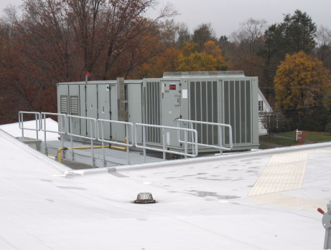

Rooftop Air Handling Unit

Picture 2

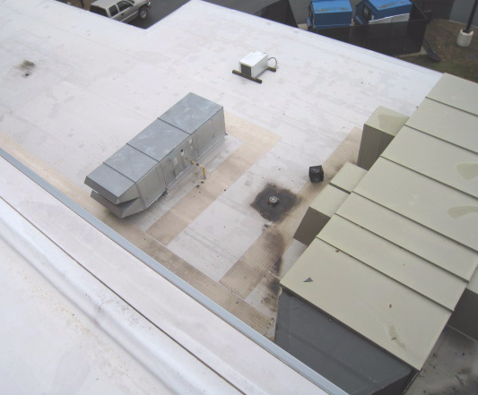

Rooftop Air Handling Units
Picture 3

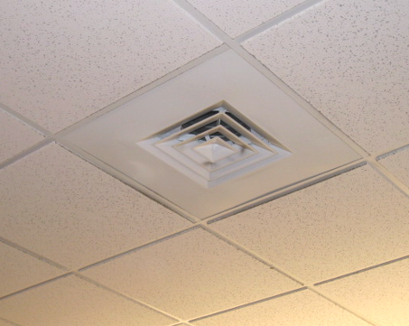

Ceiling-Mounted Supply Diffuser

Picture 4

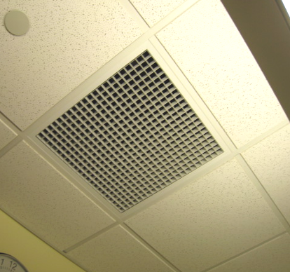

Ceiling-Mounted Return Diffuser
Picture 5

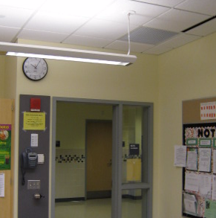

Proximity of Return Vent to Open Classroom Door

Picture 6

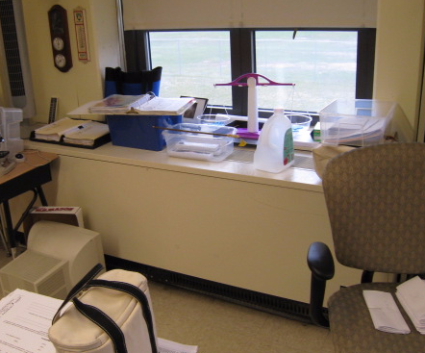

Typical Unit Ventilator (Univent) in Classroom, Note Items on Air Diffuser
Picture 7

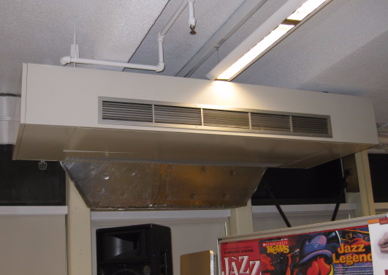

Ceiling –Mounted Univent

Picture 8

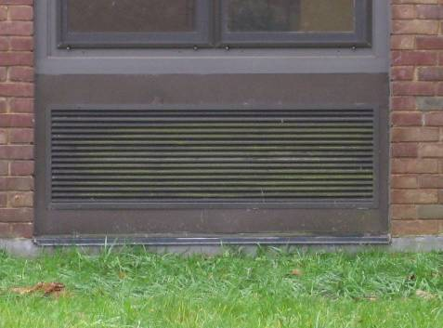

Univent Fresh Air Intake
Picture 9

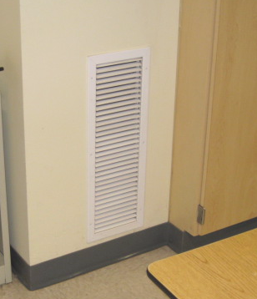

South Classroom Exhaust Vent

Picture 10

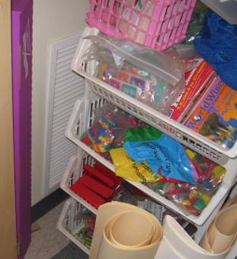

Partially Obstructed South Classroom Exhaust Vent
Picture 11

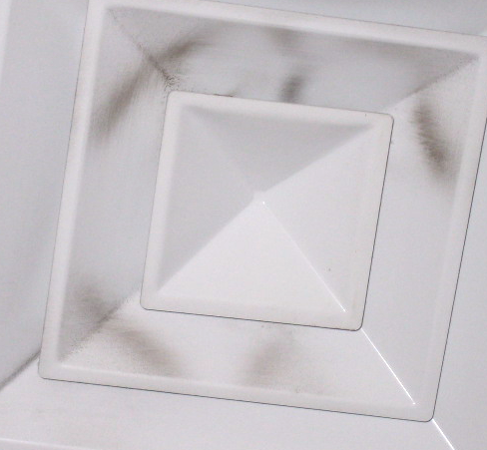

Accumulated Dust/Debris on Supply Diffuser

Picture 12

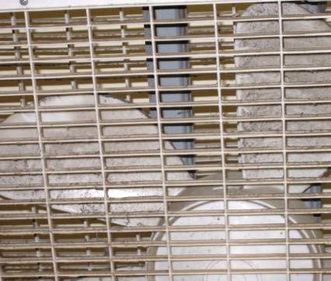

Accumulated Dust/Debris on Personal Fan
Location/ Room | Occupants  in Room | Temp  (°F) | Relative  Humidity  (%) | Carbon  Dioxide  (ppm) | Carbon Monoxide  (ppm) | PM2.5  (µg/m³) | Windows  Openable | Ventilation |  | Remarks
 |  |  |  |  |  |  |  | Supply | Exhaust | Remarks
background |  | 60 | 82-97 | 330 | ND | 13 |  |  |  | Intermittent rain AM, cool, overcast
N 316 | 26 | 70 | 69 | 820 | ND | 10 | Y | Y | Y | DO, PF
N 315 | 27 | 71 | 66 | 820 | ND | 11 | Y | Y | Y | DO
N 314 | 0 | 69 | 61 | 553 | ND | 8 | Y | Y | Y
N 312 | 0 | 69 | 63 | 521 | ND | 8 | N | Y | N | 1 WD CT corner
N 310 | 0 | 69 | 63 | 477 | ND | 8 | Y | Y | Y | Plants
N 311 | 25 | 69 | 65 | 790 | ND | 22 | Y | Y | Y | PF-dusty, plants
N 309 | 1 | 69 | 63 | 552 | ND | 8 | Y | Y | Y | 28 occupants gone 30 mins, DO
N 307 | 0 | 69 | 64 | 483 | ND | 8 | Y | Y | Y | DO, PF
N 308 | 10 | 69 | 64 | 556 | ND | 8 | Y | Y | Y | DO, PF
N 306 | 10 | 69 | 65 | 551 | ND | 9 | Y | Y | Y
N 305 | 0 | 69 | 64 | 542 | ND | 3 | Y | Y | Y
N 303 | 27 | 71 | 65 | 753 | ND | 5 | Y | Y | Y | Window open
N 302 | 0 | 71 | 61 | 532 | ND | 10 | Y | Y | Y | DO, PF
N 338 Library | 11 | 70 | 62 | 492 | ND | 5 | Y | Y | Y
N 304 | 0 | 70 | 62 | 502 | ND | 9 | N | Y | Y
N 304 | 1 | 69 | 62 | 432 | ND | 7 | Y | Y | Y | 27 occupants gone 1 hr
N 201 | 0 | 71 | 62 | 640 | ND | 7 | Y | Y | Y
N 202 | 24 | 71 | 63 | 708 | ND | 9 | Y | Y | Y | PF
N 204 | 1 | 71 | 61 | 530 | ND | 8 | Y | Y | Y | DO, 25 occupants gone 45 mins, plant
N 203 | 0 | 71 | 61 | 1060 | ND | 11 | Y | Y | Y | DO
N 205 | 27 | 72 | 63 | 1170 | ND | 12 | Y | Y | Y
N 207 | 1 | 71 | 60 | 632 | ND | 9 | Y | Y | Y | DO, 24 occupants gone I hr
N 206 | 26 | 72 | 61 | 942 | ND | 11 | Y | Y | Y | DO
N 208 | 0 | 72 | 59 | 470 | ND | 8 | N | Y | Y
N 209 | 0 | 72 | 55 | 439 | ND | 8 | Y | Y | Y
N 210 | 1 | 72 | 56 | 620 | ND | 8 | Y | Y | Y | DO
N 211 | 22 | 72 | 60 | 980 | ND | 11 | Y | Y | Y | DO
N 212 | 25 | 72 | 61 | 1140 | ND | 15 | Y | Y | Y | DO
N 110 | 31 | 71 | 63 | 933 | ND | 10 | Y | Y | Y | DO
N 109 | 30 | 71 | 63 | 930 | ND | 11 | Y | Y | Y
N 108 | 0 | 71 | 62 | 530 | ND | 7 | Y | Y | Y
N 106 | 24 | 69 | 63 | 700 | ND | 8 | Y | Y | Y | DO
N 105 | 2 | 70 | 63 | 658 | ND | 9 | Y | Y | Y | 27 occupants gone 5 mins, PF
N 104 | 25 | 70 | 64 | 748 | ND | 10 | Y | Y | Y
N 103 | 0 | 70 | 62 | 580 | ND | 3 | Y | Y | Y
N 127 | 0 | 71 | 57 | 571 | ND | 3 | Y | Y | Y | DO
N 127 D | 1 | 71 | 58 | 576 | ND | 3 | Y | Y | Y | DO
N 127 C | 1 | 71 | 57 | 582 | ND | 2 | Y | Y | Y | DO
N 101 | 4 | 70 | 60 | 492 | ND | 6 | Y | Y | Y | DO
N 102 | 26 | 71 | 63 | 740 | ND | 12 | Y | Y | Y | DO, plants
N 126 Main Office | 4 | 71 | 62 | 630 | ND | 7 | Y | Y | Y
Cafeteria | ~250 | 71 | 63 | 778 | ND | 13 | Y | Y | Y

Location/ Room | Occupants  in Room | Temp  (°F) | Relative  Humidity  (%) | Carbon  Dioxide  (ppm) | Carbon Monoxide  (ppm) | PM2.5  (µg/m³) | Windows  Openable | Ventilation |  | Remarks
 |  |  |  |  |  |  |  | Supply | Exhaust | Remarks
background |  | 60 | 82-97 | 330 | ND | 13 |  |  |  | Intermittent rain AM, cool, overcast
S 115 Music | 27 | 70 | 62 | 700 | ND | 6 | Y | Y | Y
S 113 | 2 | 69 | 62 | 685 | ND | 6 | Y | Y | Y
S 148 | 3 | 68 | 62 | 450 | ND | 7 | Y | Y | Y | UV-rattling noise, DO
S 112 | 0 | 69 | 63 | 563 | ND | 8 | Y | Y | Y
Gym | ~ 50 | 69 | 66 | 716 | ND | 13 | Y | Y | Y | Ceiling-mounted AHU
Gym Office | 1 | 69 | 65 | 676 | ND | 7 | N | Y | Y
S 218 | 2 | 69 | 64 | 513 | ND | 7 | Y | Y | Y | 27 occupants gone 55 mins, PF, DO
S 219 | 1 | 68 | 64 | 664 | ND | 7 | Y | Y | Y | 23 occupants gone 25 mins, DO, UV-off, PF-dusty
S 220 | 0 | 69 | 66 | 607 | ND | 5 | Y | Y | Y | Occupants at lunch
S 221 | 29 | 69 | 64 | 690 | ND | 6 | Y | Y | Y | Items on UV, DO
S 222 | 23 | 70 | 65 | 617 | ND | 8 | Y | Y | Y | No draw from exhaust vent, DO, PF
S 214 | 1 | 70 | 68 | 857 | ND | 8 | Y | Y | Y | Window open
S 215 | 24 | 71 | 66 | 968 | ND | 6 | Y | Y | Y | No draw from exhaust vent, DO, PF
S 216 | 25 | 71 | 65 | 1134 | ND | 7 | Y | Y | Y
S 332 | 0 | 71 | 64 | 1255 | ND | 7 | Y | Y | Y | No draw from exhaust vent, DO
S 331 | 1 | 69 | 62 | 600 | ND | 10 | Y | Y | Y | Window open, 23 occupants gone 20 mins, exhaust partially obstructed
S 330 | 1 | 69 | 63 | 540 | ND | 5 | Y | Y | Y | Window open, 26 occupants gone 15 mins, DO
S 329 | 1 | 70 | 64 | 583 | ND | 4 | Y | Y | Y | 26 occupants gone 15 mins, DO
S 328 | 0 | 71 | 62 | 690 | ND | 6 | N | Y | N | DO
S 327 | 27 | 71 | 63 | 856 | ND | 5 | Y | Y | Y | DO, PF
S 326 | 28 | 71 | 64 | 969 | ND | 6 | Y | Y | Y | DO
S 325 | 29 | 73 | 67 | 1600 | ND | 12 | Y | Y | Y | DO
S 324 | 1 | 72 | 62 | 681 | ND | 8 | Y | Y | Y | Window open, no draw from exhaust vent, 26 occupants gone 15 mins
S 323 | 28 | 71 | 62 | 902 | ND | 7 | Y | Y | Y | DO
S 322 | 0 | 72 | 60 | 780 | ND | 9 | N | Y | Y | Exhaust in restrooms
S 321 | 29 | 72 | 63 | 1089 | ND | 6 | Y | Y | Y | DO, UV-noise
S 320 | 28 | 71 | 61 | 833 | ND | 6 | Y | Y | Y | Window open
S 319 | 26 | 71 | 63 | 805 | ND | 6 | Y | Y | Y | No draw from exhaust vent, DO, window open
S 318 | 30 | 71 | 63 | 1070 | ND | 9 | Y | Y | Y
S 317 | 1 | 70 | 62 | 612 | ND | 7 | Y | Y | Y | 27 occupants gone 30 mins, DO

