INDOOR AIR QUALITY ASSESSMENT

Williams Intermediate School
200 South Street
Bridgewater, Massachusetts

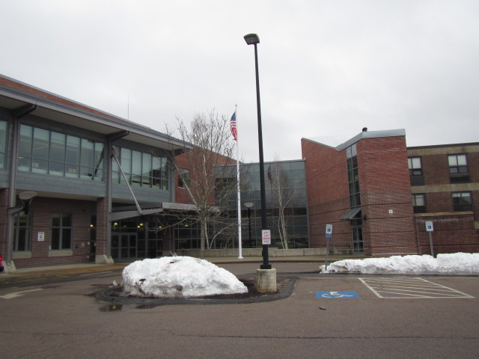

Prepared by:
Massachusetts Department of Public Health
Bureau of Environmental Health
Indoor Air Quality Program
March 2019

Background
Building: | Williams Intermediate School (WIS)
Address: | 200 South Street, Bridgewater, MA
Assessment Requested by: | Paul Fox Jr., Director of Facilities, Bridgewater-Raynham Regional School District
Date of Assessment: | March 15, 2019
Bureau of Environmental Health (BEH) Indoor Air Quality (IAQ) Program Staff Conducting Assessment: | Cory Holmes and Jason Dustin, Environmental Analysts
Date of Building Construction: | The WIS consists of two wings: the north wing addition, which was built in 2006-2007, and the renovated south wing that was completed in 2007 (built in 1960s). The school consists of general classrooms, science classrooms, a gymnasium, kitchen/cafeteria, media center, art rooms, music rooms, teacher work rooms and office space
Reason for Request: | Collaborative effort to perform general indoor air quality (IAQ) assessments throughout the Bridgewater-Raynham School District.
Building Population: | Approximately 970 students grades K-3 and approximately 100 employees
Windows: | Openable

Background
The building was last visited by BEH IAQ staff in October 2018 in response to water infiltration issues in the art rooms, and a report was issued detailing environmental conditions observed at the time (MDPH, 2018). This report can be viewed at https://www.mass.gov/info-details/indoor-air-quality-reports-cities-and-towns-b.

IAQ Testing Results
Please refer to the IAQ Manual for methods, sampling procedures, and interpretation of results (MDPH, 2015). The following is a summary of indoor air testing results (Table 1).
- Carbon dioxide levels were above the MDPH guideline of 800 parts per million (ppm) in 37 of 80 areas surveyed, indicating a lack of air exchange in a number of areas. This is most likely due to deactivated mechanical ventilation components as well as limitations on outside air introduction, which is typical during winter months and explained further in the Ventilation section of this report. It is also important to note that a number of classrooms had open windows or were empty/sparsely populated during the assessment, which would reduce carbon dioxide levels. Carbon dioxide levels would be expected to be higher with full occupancy/windows shut.
- Temperature was within or close to the MDPH recommended range of 70°F to 78°F in most areas tested. Some occupants expressed temperature control complaints.
- Relative humidity was within or close the MDPH recommended range of 40 to 60% in all areas tested.
- Carbon monoxide levels were non-detectable (ND) in all areas tested.
- Fine particulate matter (PM2.5) concentrations measured were below the NAAQS limit of 35 μg/m³ in all areas tested, with the exception of room N207 (65 μg/m³) that contained an essential oil diffuser.

Ventilation
A heating, ventilating, and air-conditioning (HVAC) system has several functions. First it provides heating and, if equipped, cooling. Second, it is a source of fresh air. Finally, an HVAC system will dilute and remove normally-occurring indoor environmental pollutants by not only introducing fresh air, but by filtering the airstream and ejecting stale air to the outdoors via exhaust ventilation. Even if an HVAC system is operating as designed, point sources of respiratory irritation may exist and cause symptoms in sensitive individuals.
Mechanical ventilation in the north wing addition is provided by rooftop air handling units (AHUs) ducted to ceiling-mounted supply and return vents (Pictures 1 and 2). It was reported by Mr. Fox that due to excessive heat, the rooftop unit was deactivated for a portion of the building, which would account for elevated carbon dioxide levels (Table 1).
Classrooms in the original south wing have a ventilation system consisting of unit ventilators (univents) (Picture 3) located on the exterior wall of classrooms. The fans of the univents were noted to be off in some classrooms (Table 1). A univent is designed to draw air from outdoors through a fresh air intake located on the exterior wall of the building (Picture 4). Return air is drawn through an air intake located at the base of the unit (Figure 1). Fresh and return air are mixed, filtered, heated and provided to classrooms through an air diffuser located in the top of the unit. Univents were obstructed by furniture/items in some rooms (Table 1), which can limit air exchange (Picture 5). It is also important to note that outside air is typically limited (by pneumatically adjusting intake louvers) during cold/winter months to provide comfort and prevent the freezing of pipes.
Although the original south wing was renovated in 2006-2007, the univents appear to be original to the building’s construction in the 1960s (over 50 years old). According to the American Society of Heating, Refrigeration and Air-Conditioning Engineers (ASHRAE), the service life for a unit heater, hot water or steam is 20 years, assuming routine maintenance of the equipment (ASHRAE, 1991). Despite attempts to maintain the univents (e.g., oiling bearings, changing filters regularly), the operational lifespan of this equipment has been exceeded. Maintaining the balance of fresh to exhaust air will become more difficult as the equipment ages and as replacement parts become increasingly difficult to obtain.
Exhaust ventilation in south wing classrooms is provided by wall vents (Picture 6) ducted to rooftop motors. At the time of the assessment, exhaust vents in several classrooms appeared to be not drawing air and/or partially obstructed by furniture and other items (Picture 7). In a few areas, exhaust vents could not be located (Table 1) suggesting they may be behind classroom furniture. As with univents, in order to function properly, exhaust vents must be activated and allowed to operate free from obstructions while rooms are occupied.
Some exhaust vents in both wings are located near classroom doors (Picture 6). Due to their location, the exhaust capabilities of these vents can be diminished when the doors are left open. With the classroom doors open, the return/exhaust vent tends to draw air from the hallway into the classrooms instead of stale air out of the classroom.
To maximize air exchange, the MDPH recommends that both supply and exhaust ventilation operate continuously during periods of occupancy. It was reported that the system is automated by computer controls but has been manually overridden in some areas. In order to have proper ventilation with a mechanical supply and exhaust system, the systems must be balanced to provide an adequate amount of fresh air to the interior of a room while removing stale air from the room. It is recommended that HVAC systems be re-balanced every five years to ensure adequate air systems function (SMACNA, 1994).

Microbial/Moisture Concerns
In order for building materials to support mold growth, a source of water is necessary. The north wing addition is experiencing chronic issues with water infiltration, as evidenced by water-damaged building materials and towels/cloths on windowsills throughout the building (Pictures 8 through 14). Porous building materials (e.g., gypsum wallboard, ceiling tiles) can become colonized with mold if wetted repeatedly. In addition, the towels/cloths themselves are porous and can become a source of mold.
Several classrooms contained either window or portable air conditioners (ACs). The computer network room (N337) had a wall-mounted unit. These devices must be properly cleaned/maintained including filters, to avoid particulates and microbial colonization. In addition, they should be monitored periodically for proper installation/drainage.
Plants, which can be a source of pollen and mold and be respiratory irritants to some individuals, were observed in a number of areas. Plants should be properly maintained and equipped with drip pans to prevent water leaks and damage. They should also be located away from air diffusers to prevent the aerosolization of dirt, pollen, and mold.

Other IAQ Evaluations

Volatile Organic Compounds (VOCs)
Exposure to low levels of total VOCs (TVOCs) may produce eye, nose, throat, and/or respiratory irritation in some sensitive individuals. IAQ staff examined rooms for products containing VOCs. IAQ staff noted air fresheners, scented hand sanitizers, cleaners, and dry erase materials within the building (Picture 15, Table 1). Since all of these products have the potential to have an irritant effect, their use should be minimized. Hand sanitizer products may contain ethyl alcohol and/or isopropyl alcohol, which are highly volatile and may be irritating to the eyes and nose. These products may also contain fragrances to which some people may be sensitive.

Other Conditions
The MDPH recommend that HVAC units be outfitted with filters of a Minimum Efficiency Reporting Value (MERV) of 8, which are adequate in filtering out pollen and mold spores (ASHRAE, 2012). The rooftop AHUs at WIS have a dual filtration system. Air is drawn through a pleated MERV 8 pre-filter, then through a 95% high efficiency post-filtration unit. School maintenance staff report that MERV 8 pre-filters are changed two times per year and that the 95% high efficiency post-filters are changed once.
The occupant of room S332 had reported dark debris coming from the univent. This could be the result of dust/debris accumulation within the unit (Picture 16), breakdown of insulation/sound-proofing material or the drawing in of outside debris particulates bypassing filters. While the reported particles may be unsightly and require regular cleaning, no elevated levels of airborne PM2.5 were measured in this area during the assessment. The unit contains a black/fibrous noise reduction/insulation pad that appears to be slowly disintegrating (Picture 17). Univent cabinets should be thoroughly vacuumed (or blown out using pressurized air) during filter changes.
Some personal fans, supply, and exhaust vents were also observed to have accumulated dust/debris (Picture 1, Table 1). Particulates can be reaerosolized from these items and they should be cleaned regularly. Dust accumulation was also observed on flat surfaces in some areas.
The school had carpeting or area rugs in several areas. These carpets should be vacuumed regularly with a HEPA-filtered vacuum to avoid particulates from causing further irritation or serving as a reservoir for microbial colonization. Also, carpeting and rugs should be cleaned at least once per year according to IICRC recommendations (IICRC 2012).
In several areas, items were observed on the floor, windowsills, tabletops, counters, bookcases, and desks (Picture 18). The large numbers of stored items provide a source for dusts to accumulate. These items (e.g., papers, folders, boxes) make it difficult for custodial staff to clean. Once aerosolized, they can act as irritants to eyes and the respiratory system. Items should be relocated and/or be cleaned periodically to avoid excessive dust build up.
In a few areas, tennis balls were found sliced open and placed on chair legs (Picture 19, Table 1). Tennis balls are made of a number of materials that are a source of respiratory irritants. Constant wearing of tennis balls can produce fibers and off-gas VOCs. Tennis balls are made with a natural rubber latex bladder, which becomes abraded when used as a chair leg pad. Use of tennis balls in this manner may introduce latex dust into the school environment. Some individuals are highly allergic to latex (e.g. spina bifida patients) (SBAA, 2001). It is recommended that the use of materials containing latex be limited to reduce the potential for symptoms in sensitive individuals (NIOSH, 1997). Latex-free glides should be used for this purpose.
Note that the Environmental Protection Agency (EPA) conducted a National School Radon Survey in which it discovered nearly one in five schools had “…at least one frequently occupied ground contact room with short-term radon levels above 4 [picocuries per liter] pCi/L” (US EPA 1993). The BEH/IAQ Program therefore recommends that every school be tested for radon, and that this testing be conducted during the heating season while school is in session in a manner consistent with USEPA radon testing guidelines. Radon measurement specialists and other information can be found at www.nrsb.org and http://aarst-nrpp.com/wp, with additional information at: http://www.mass.gov/eohhs/gov/departments/dph/programs/environmental-health/exposure-topics/iaq/radon.

Conclusions/Recommendations
Some of the conditions listed in this report can be remedied by the actions of building occupants. Other remediation efforts will require alteration to the building structure and equipment. Although the south addition is only ~ 12 years old, water penetration issues are prevalent around the building, which will require repairs to the building envelope, specifically to the window systems. Without repair/replacement, water intrusion will continue and likely get worse causing further damage to building materials and likely mold growth. For these reasons, a two-phase approach is recommended. The first consists of short-term measures to improve air quality and the second consists of long-term measures that will require planning and resources to adequately address overall IAQ conditions.
In view of the findings at the time of the visit, the following recommendations are made:

Short-Term Recommendations
In view of the findings at the time of the visit, the following recommendations are made:
- Continue with plans to implement recommendations listed in previous MDPH assessment https://www.mass.gov/info-details/indoor-air-quality-reports-cities-and-towns-b.
- Investigate temporary measures to reduce/eliminate water penetration issues around window systems.
- Operate the HVAC system to provide for continuous fresh air ventilation during occupied hours. If possible, the fans in univents and unit exhausts should be reset/programmed to operate continuously, not cycle on and off.
- Implement methods to increase fresh air to classrooms having elevated carbon dioxide levels (Table 1). This may include opening fresh air intake louvres further (weather permitting).
- Remove furniture and items blocking the front and top of univents and wall-mounted exhaust vents.
- Periodically assess whether exhaust vents (classrooms and restrooms) are drawing air and repair as needed.
- Use openable windows to supplement fresh air during temperate weather. Ensure all windows are closed tightly at the end of each day.
- Close classroom doors during occupancy to allow for more effective function of exhaust vents/air exchange.
- Work with staff to troubleshoot temperature control problems.
- Utilize a system to report and track maintenance issues (e.g., school dude) so that concerns can be reported by staff and maintenance staff can report when issues have been resolved.
- Consider adopting a balancing schedule of every 5 years for all mechanical ventilation systems, as recommended by ventilation industrial standards (SMACNA, 1994).
- As a temporary measure, change water-damaged ceiling tiles. Inspect the area above the stained tiles for water damage or odors and remediate or clean as necessary.
- Once building envelope repairs are made, refinish water-damaged ceilings and walls. Until this has been completed, avoid storing porous materials in areas of known leaks.
- Replace any missing ceiling tiles.
- Refrain from hanging materials from suspended ceiling tile systems.
- Install tight-fitting door gaskets and sweeps to doors communicating with the exterior.
- Regularly clean portable and window ACs including filters (e.g., teacher’s lunchroom).
- Ensure ACs are installed/draining properly (e.g., N337 computer network room).
- Keep classroom/office plants in good condition, avoid overwatering, and keep them away from the airstream of ventilation equipment.
- Reduce or eliminate the use of air fresheners, scented cleaners, hand sanitizers and dry erase materials to reduce irritation.
- Continue to change filters in HVAC units (AHUs/univents) 2 to 4 times a year with MERV 8 or higher filters.
- Thoroughly clean AHU and univent cabinets of dust and debris using a HEPA-filtered vacuum and/or pressurized air when filters are changed, particulary in room S332. Examine sound-proofing/insulation material for breakdown, replace if failing.
- Clean supply, return/exhaust vents and fans regularly to remove accumulated dust/debris.
- For buildings in New England, periods of low relative humidity during the winter are often unavoidable. Therefore, scrupulous cleaning practices should be adopted to minimize common indoor air contaminants whose irritant effects can be enhanced when the relative humidity is low. To control for dusts, a high efficiency particulate arrestance (HEPA) filter equipped vacuum cleaner in conjunction with wet wiping of all surfaces is recommended. Drinking water during the day can help ease some symptoms associated with a dry environment (throat and sinus irritations).
- Clean carpeting and rugs at least once per year according to IICRC recommendations (IICRC 2012). Area carpets too worn to be effectively cleaned should be replaced. Roll up and store area rugs in a clean, dry place during the summer.
- Relocate or consider reducing the amount of materials stored in classrooms to allow for more thorough cleaning of classrooms. Clean items regularly with a wet cloth or sponge to prevent excessive dust build-up.
- Replace tennis balls with latex-free balls/glides.
- Utilize the US EPA’s (2000), “Tools for Schools”, as an instrument for maintaining a good IAQ environment in the building available at: http://www.epa.gov/iaq/schools/index.html.
- For more information on mold refer to the US EPA’s “Mold Remediation in Schools and Commercial Buildings” (US EPA, 2008). Available at: http://www.epa.gov/mold/mold-remediation-schools-and-commercial-buildings-guide.
- The school should be tested for radon by a certified radon measurement specialist during the heating season when school is in session. Radon measurement specialists and other information can be found at: www.nrsb.org, and http://aarst-nrpp.com/wp.
- Refer to resource manuals and other related IAQ documents for further building-wide evaluations and advice on maintaining public buildings. Copies of these materials are located on the MDPH’s website: http://mass.gov/dph/iaq.

The following long-term measures should be considered:
- Work with a building envelope specialist/building engineer to investigate and provide recommendations to prevent water intrusion, particulary but not limited to windows. This measure should include a full building envelope evaluation (windows, flashing, masonry, etc.).
- Contact an HVAC engineering firm for an assessment of univents in the original south wing and the ventilation system’s control system (e.g., controls, air intake louvers, thermostats). Given the age/design of HVAC equipment in the original building, consider long-term plans for replacement.

References
ASHRAE. 1991. ASHRAE Applications Handbook, Chapter 33 “Owning and Operating Costs”. American Society of Heating, Refrigeration and Air Conditioning Engineers, Atlanta, GA.
ASHRAE. 2012. American Society of Heating, Refrigeration and Air Conditioning Engineers (ASHRAE) Standard 52.2-2012 -- Method of Testing General Ventilation Air-Cleaning Devices for Removal Efficiency by Particle Size (ANSI Approved).
IICRC. 2012. Institute of Inspection Cleaning and Restoration Certification. Institute of Inspection, Cleaning and Restoration Certification. Carpet Cleaning: FAQ.
MDPH. 2015. Massachusetts Department of Public Health. Indoor Air Quality Manual: Chapters I-III. Available at: http://www.mass.gov/eohhs/gov/departments/dph/programs/environmental-health/exposure-topics/iaq/iaq-manual/.
NIOSH. 1997. NIOSH Alert Preventing Allergic Reactions to Natural Rubber latex in the Workplace. National Institute for Occupational Safety and Health, Atlanta, GA.
SBAA. 2001. Latex In the Home And Community Updated Spring 2001. Spina Bifida Association of America, Washington, DC.
SMACNA. 1994. HVAC Systems Commissioning Manual. 1st ed. Sheet Metal and Air Conditioning Contractors’ National Association, Inc., Chantilly, VA.
US EPA. 1993. Radon Measurement in Schools, Revised Edition. Office of Air and Radiation, Office of Radiation and Indoor Air, Indoor Environments Division (6609J). EPA 402-R-92-014. https://www.epa.gov/sites/production/files/2014-08/documents/radon_measurement_in_schools.pdf.
US EPA. 2000. Tools for Schools. Office of Air and Radiation, Office of Radiation and Indoor Air, Indoor Environments Division (6609J). EPA 402-K-95-001, Second Edition. http://www.epa.gov/iaq/schools/index.html.
US EPA. 2008. Mold Remediation in Schools and Commercial Buildings. US Environmental Protection Agency, Office of Air and Radiation, Indoor Environments Division, Washington, D.C. EPA 402-K-01-001. http://www.epa.gov/mold/mold-remediation-schools-and-commercial-buildings-guide.
Picture 1
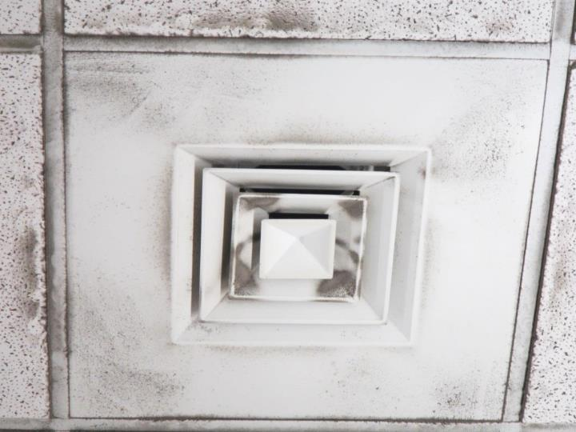
Ceiling-mounted supply diffuser, note accumulated dust/debris on louvers
Picture 2
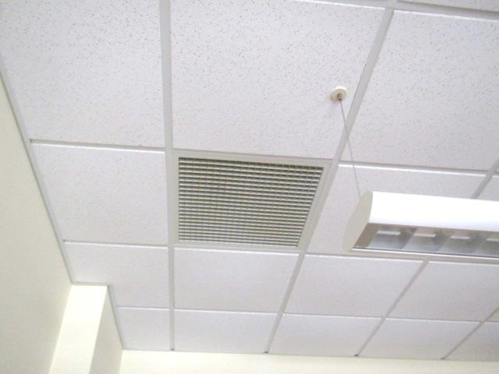
Ceiling-mounted return vent
Picture 3
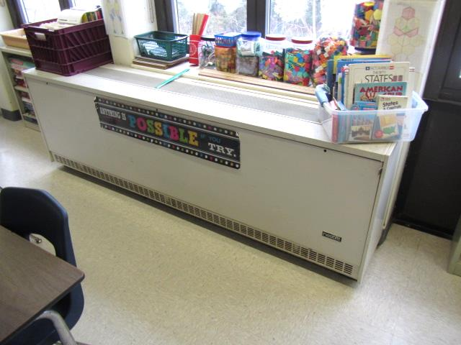
Unit Ventilator (Univent) in original South wing
Picture 4
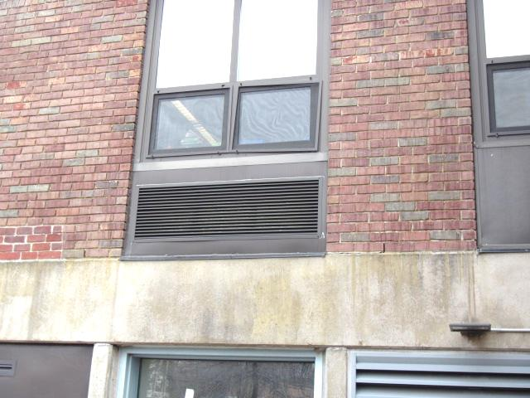
Univent fresh air intake
Picture 5
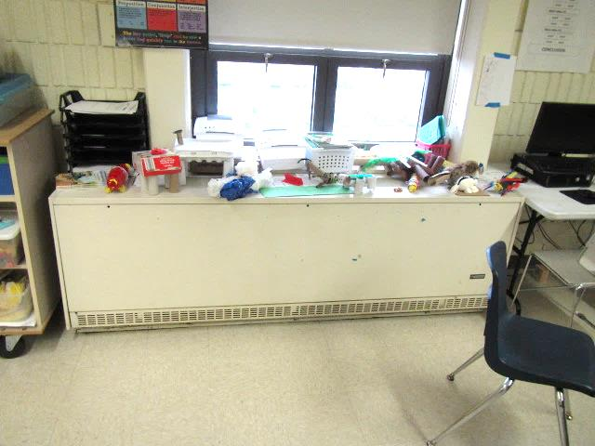
Items on top of univent air diffuser obstructing airflow
Picture 6
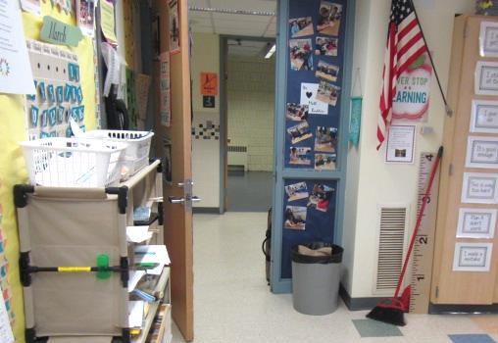
Classroom exhaust vent in original south wing in close proximity to open classroom door (arrows)
Picture 7
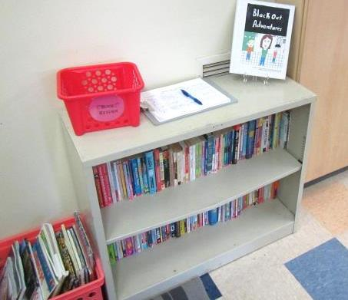
Exhaust vent (arrow) obstructed by book case
Picture 8
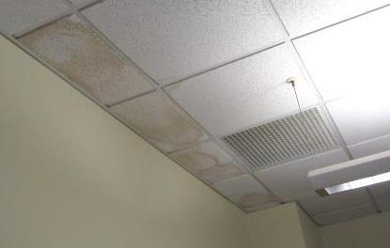
Water-damaged ceiling tiles
Picture 9
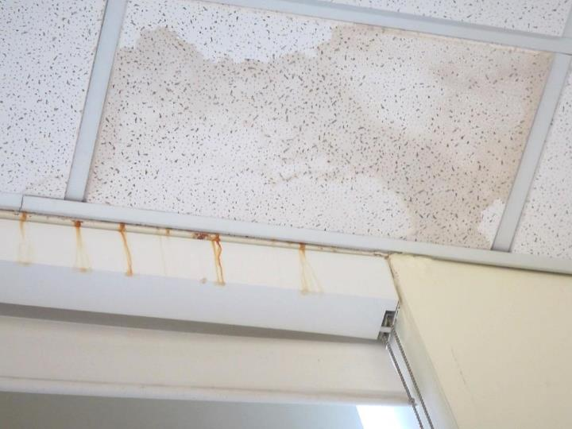
Water-damaged ceiling tiles and rust stains over windowsill
Picture 10
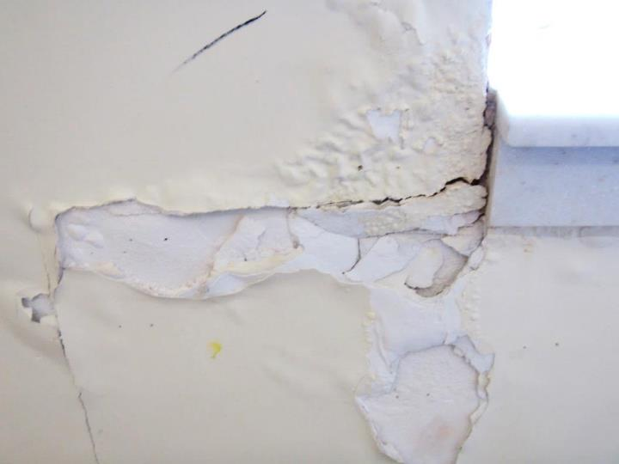
Peeling paint and water-damaged wall around window
Picture 11
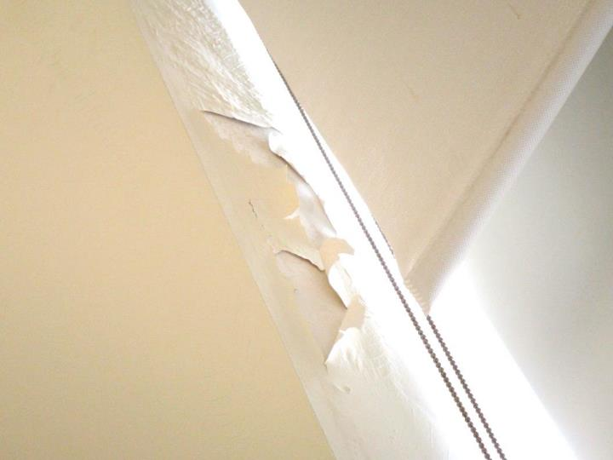
Peeling paint and water-damaged wall around window
Picture 12
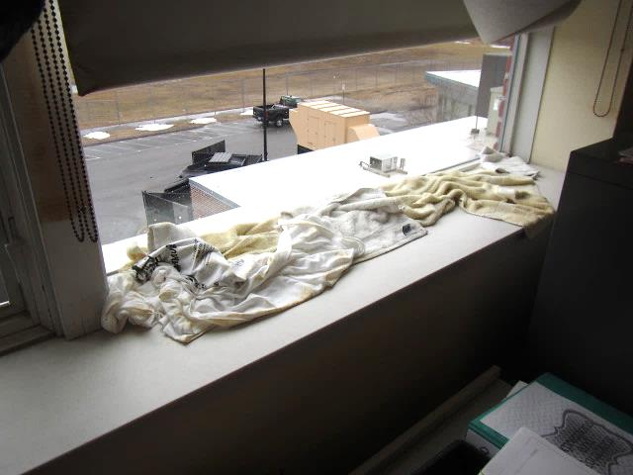
Towels/cloth on windowsill to absorb leaks in north wing
Picture 13
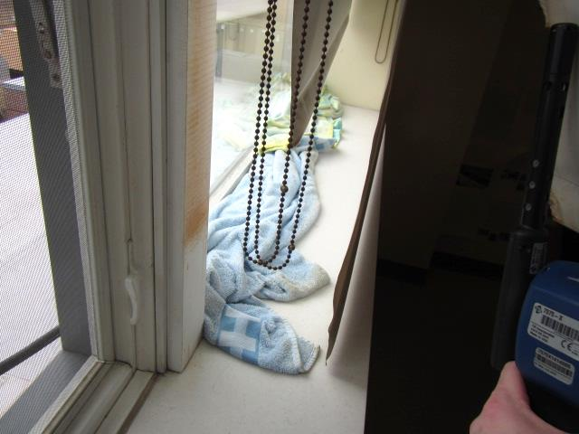
Towels/cloth on windowsill to absorb leaks in north wing
Picture 14
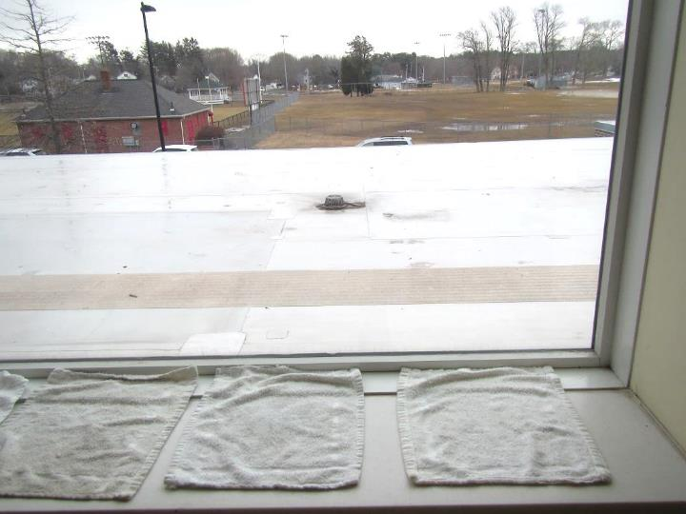
Towels/cloth on windowsill to absorb leaks in north wing
Picture 15
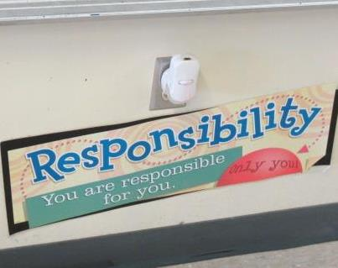
Plug-in air freshener
Picture 16
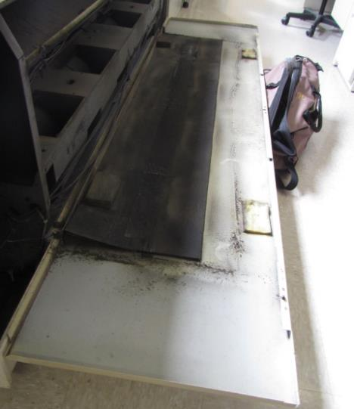
Dust/debris inside univent in classroom S332, note insulation pad
Picture 17
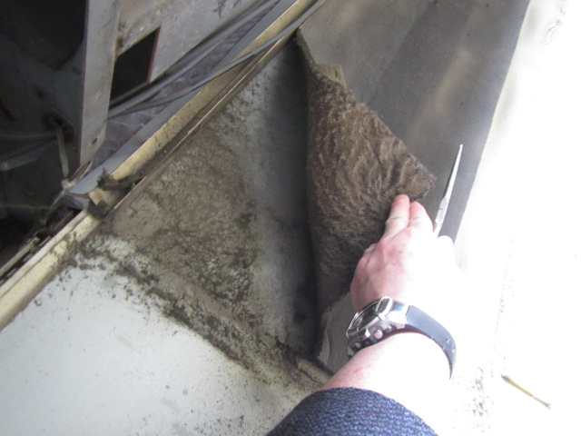
Close-up of dust/debris and insulation pad in classroom S332
Picture 18
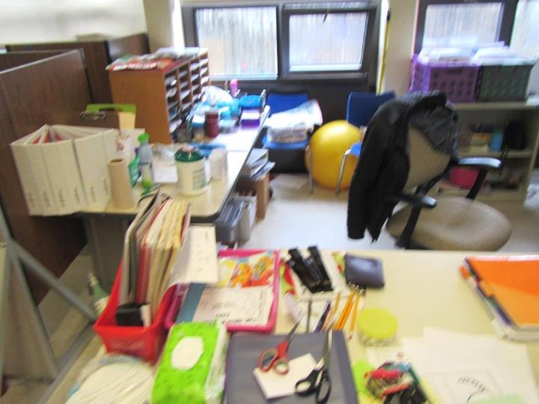
Accumulated items in classroom
Picture 19
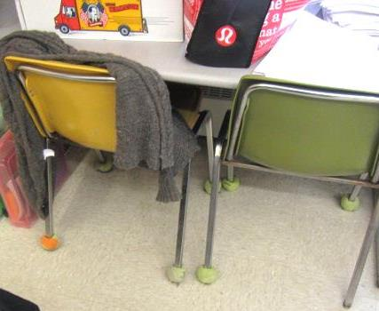
Tennis balls on chair legs

Location | Carbon  Dioxide  (ppm) | Carbon Monoxide  (ppm) | Temp  (°F) | Relative  Humidity  (%) | PM2.5  (µg/m³) | Occupants  in Room | Windows  Openable | Ventilation |  |  | Remarks
 |  |  |  |  |  |  |  | Intake | Exhaust
Background | 392 | ND | 58 | 71 | 9 |  |  |  |  |  | Cool, windy, intermittent rain, mostly cloudy
Third Floor
N339 | 675 | ND | 74 | 42 | 8 | 24 | Y  Open | Y |  | Y | Carpet
N338A | 709 | ND | 75 | 38 | 5 | 1 | Y | Y |  | Y | DO
N337 Computer Network Room |  |  |  |  |  |  | N | Y |  | Y | AC-wall, MT/WD CTs, DO
S318 | 1583 | ND | 76 | 48 | 12 | 19 | Y | Y |  | Y | UV off, items on UV
S317 | 870 | ND | 76 | 45 | 11 | 15 | Y  Open | Y |  | Y | UV off, PF, area rug/pillows
N316 | 2285 | ND | 74 | 45 | 12 | 27 | Y | Y |  | Y | Ventilation off, dust/debris on vents, PFs, 1 WD CT
N315 | 2285 | ND | 74 | 45 | 12 | 27 | Y | Y |  | Y | Window “out of order”, DO
N314 | 2736 | ND | 75 | 50 | 7 | 26 | Y | Y |  | Y | Dust/debris on vents, DO
N313 | 836 | ND | 76 | 44 | 10 | 0 | Y | Y |  | Y | DO, PF, 3 WD CT
N312 | 831 | ND | 77 | 41 | 18 | 0 | N | Y |  | Y | DO
N311 | 1494 | ND | 75 | 49 | 11 | 24 | Y | Y |  | Y | TB, PFs
N310 | 616 | ND | 68 | 54 | 10 | 26 | Y  Open | Y |  | Y | Windows leak-towels, dust/debris on vents, PF, 1 WD CT
N309 | 1023 | ND | 73 | 49 | 17 | 21 | Y  Open | Y |  | Y | DO
N308 | 737 | ND | 71 | 51 | 9 | 21 | Y  Open | Y |  | Y | Windows leak-towels, 1 WD CT
N306 | 889 | ND | 72 | 47 | 5 | 0 | Y | Y |  | Y | DO, dust/debris on vents, 7 WD CT, towels on windowsills
N307 | 1102 | ND | 74 | 45 | 8 | 23 | Y  Open | Y |  | Y
N305 | 900 | ND | 75 | 37 | 5 | 4 | Y | Y |  | Y | AT, 3 WD CT
N304 | 750 | ND | 76 | 38 | 1 | 1 | N | Y |  | Y | 24 occupants just left, DO, 5 WD CT, dust/debris on vents
N303 | 806 | ND | 77 | 39 | 2 | 23 | Y  Open | Y |  | Y | Dust/debris on vents
N302 | 1298 | ND | 76 | 41 | 22 | 0 | Y | Y |  | Y | Dust/debris on vents, 6 WD CTs, DO
N301 | 2900 | ND | 75 | 51 | 10 | 27 | Y | Y |  | Y
Library |  |  |  |  |  | 7 | Y | Y |  | Y | Carpet
S333 | 495 | ND | 73 | 45 | 8 | 6 | Y  Open | Y |  | ? | Exhaust could not be identified (behind bookcases?)
S332 | 634 | ND | 70 | 50 | 20 | 23 | Y  Open | Y |  | Y | Exhaust near hallway door, portable AC, DO, PF, dust/debris on vents, UV interior dust/debris, breakdown of insulation material
S331 | 722 | ND | 72 | 51 | 23 | 24 | Y | Y |  | ? | Exhaust could not be identified, UV off, plant
S330 | 653 | ND | 72 | 52 | 9 | 13 | Y  Open | Y |  | Y | DO
S329 | 780 | ND | 72 | 51 | 12 | 28 | Y  Open | Y |  | Y | Exhaust obstructed, DO, PF
S328 | 881 | ND | 74 | 44 | 18 | 2 | N | Y |  | Y | DO, TB, portable AC, UV off
S327 | 783 | ND | 74 | 49 | 23 | 23 | Y  Open | Y |  | Y | DO
S326 | 854 | ND | 74 | 50 | 10 | 26 | y | y |  | Y | Exhaust off/weak, UV off, PC
S325 | 486 | ND | 74 | 45 | 8 | 0 | Y | Y |  | Y | Exhaust off/weak, DO, PF
S324 | 524 | ND | 71 | 49 | 9 | 1 | Y | Y |  | Y | Exhaust off/weak, DO
S323 | 735 | ND | 72 | 44 | 9 | 0 | Y  Open | Y |  | Y | DO
S322 | 852 | ND | 77 | 45 | 9 | 9 | N | Y |  | Y | UV off, DO
Restrooms in S322 |  |  |  |  |  |  | N | N |  | Y | No make-up air, recommend passive door vent/undercut, floor drains occasional odors
Hallway outside S321 |  |  |  |  |  |  |  |  |  |  | 5 WD CTs
S321 | 550 | ND | 73 | 51 | 14 | 1 | Y  Open | Y |  | Y | 24 occupants gone~25 mins, DO, plug-in AF
S320 | 465 | ND | 72 | 50 | 9 | 1 | Y  Open | Y |  | Y
S319 | 639 | ND | 72 | 49 | 12 | 0 | Y  Open | Y |  | Y | PF
Second Floor
S213 | 740 | ND | 77 | 40 | 11 | 2 | Y | Y off |  | Y | DEM, UV
S214 | 761 | ND | 76 | 44 | 12 | 19 | Y | Y |  | Y | CPs, DEM
S215 | 816 | ND | 76 | 43 | 8 | 17 | Y | Y off |  | Y | DEM, HS
S216 | 766 | ND | 76 | 42 | 9 | 1 | Y | Y off |  | Y | HS, PF, temperature complaints (hot), DEM
S217 | 786 | ND | 76 | 43 | 8 | 1 | N | Y |  | Y | HS, CPs, DEM
S218 | 1003 | ND | 75 | 44 | 9 | 10 | Y | Y off |  | Y | DEM, HS
S219 | - | - | - | - | - | - | - | - |  | - | Testing in progress
S220 | 793 | ND | 75 | 48 | 7 | 17 | Y | Y |  | Y | DEM
S221 | 618 | ND | 74 | 46 | 10 | 23 | Y open | Y off |  | Y | PF, CPs, DEM
S222 | 882 | ND | 74 | 47 | 7 | 16 | Y | Y |  | Y | AI, HS, AF, DEM
N202 | 824 | ND | 75 | 42 | 9 | 19 | Y | Y |  | Y | DEM, HS
N204 | 505 | ND | 74 | 44 | 9 | 1 | Y | Y |  | Y | DEM, PF
N206 | 523 | ND | 73 | 48 | 11 | 24 | Y open | Y |  | Y | Heat complaints
N208 | 676 | ND | 75 | 44 | 10 | 0 | N | N |  | N | PF, HS
N209 | - | - | - | - | - | - | - | - |  | - | Locked, unoccupied
N212 | 1033 | ND | 73 | 46 | 8 | 1 | Y open | Y |  | Y | PF, CPs, DEM
N211 | 2065 | ND | 75 | 48 | 5 | 17 | Y | Y |  | Y
N210 | - | - | - | - | - | - | - | - |  | - | Locked, unoccupied
N207 | 1030 | ND | 75 | 47 | *65 | 22 | Y open | Y |  | Y | DEM, *essential oil diffuser
N205 | 1537 | ND | 76 | 48 | 21 | 24 | Y | Y |  | Y | DEM, HS
N203 | 1058 | ND | 75 | 45 | 9 | 25 | Y open | Y |  | Y | DEM, HS
N201 | 701 | ND | 76 | 34 | 7 | 1 | Y | Y |  | Y | PC, sink
First Floor
Café | 601 | ND | 73 | 47 | 6 | 100+ | Y | Y |  | Y | Reported window leaks
N127A | 691 | ND | 74 | 40 | 4 | 0 | N | Y |  | Y | Carpet tile
N127B | 820 | ND | 74 | 38 | 3 | 0 | Y | Y |  | Y | HS, CP, carpet tile
N127C | 777 | ND | 74 | 37 | 3 | 0 | Y | Y |  | Y | Carpet tile, plant
N127 open area | 787 | ND | 74 | 38 | 2 | 5 | N | Y |  | Y | WD CTs x 3, carpet tile
N127D | 794 | ND | 74 | 37 | 2 | 0 | Y | Y |  | Y
N126C | 806 | ND | 74 | 39 | 8 | 0 | Y | Y |  | Y | Carpet
N126B | 702 | ND | 74 | 40 | 12 | 0 | Y | Y |  | N | DEM, CPs
N110 | 1262 | ND | 74 | 41 | 10 | 21 | Y | Y |  | Y | DEM, CPs, portable AC unit
N109 | 2069 | ND | 75 | 49 | 12 | 24 | Y | Y |  | Y | HS, DEM
N108 | 1368 | ND | 74 | 47 | 10 | 25 | Y open | Y |  | Y | DEM
N107 | 907 | ND | 75 | 44 | 3 | 0 | N | Y |  | N | HS, DEM, temperature complaints
N106 | 2021 | ND | 75 | 48 | 11 | 22 | Y | Y |  | Y | HS, Portable AC
N104 | 1170 | ND | 75 | 44 | 8 | 19 | Y | Y |  | Y | DEM
N103 | 792 | ND | 74 | 41 | 1 | 0 | Y | Y |  | Y | WD CT, Teacher planning/dining
N102 | 1191 | ND | 74 | 46 | 11 | 21 | Y | Y dusty |  | Y | WD CT, WD GW, leaks around window, MT
N101 | 1320 | ND | 74 | 44 | 15 | 26 left 40 min ago | Y | Y |  | Y | WD CTs, WD GW, leaks around window
S148 | 552 | ND | 73 | 45 | 9 | 0 | Y | Y |  | N
S148C | 494 | ND | 74 | 43 | 9 | 1 | Y | Y |  | N | Radiator broke, personal heater, boxes on floor
S148D | 493 | ND | 73 | 45 | 9 | 2 | Y | Y |  | N
S115 | 658 | ND | 73 | 49 | 9 | 23 | Y | Y |  | Y | Window leak reported
S113 | 542 | ND | 73 | 46 | 9 | 1 | Y open | Y |  | Y | DEM
S112 | - | - | - | - | - | - | - | - |  | - | Locked, unoccupied
S111 | 584 | ND | 73 | 47 | 9 | 1 | Y open | Y |  | Y | DO, area rug, AI
Gym | 663 | ND | 72 | 48 | 11 | 28 | Y | Y |  | Y | MT and WD CT in hall outside gym
Lemoine | 783 | ND | 74 | 37 | 2 | 0 | Y | Y |  | N | HS
Main office | 713 | ND | 74 | 43 | 11 | 3 | Y | Y |  | Y | PC, HS, plants, dusty vents

