INDOOR AIR QUALITY ASSESSMENT

Winchendon District Court
80 Central Street
Winchendon, Massachusetts 01475

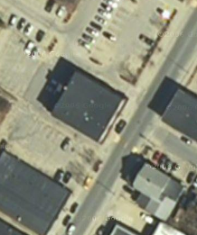

Prepared by:
Massachusetts Department of Public Health
Bureau of Environmental Health
Indoor Air Quality Program
February 2009

Background/Introduction
At the request of Christopher McQuade, Administrative Attorney/Leased Property Manager, Administrative Office of the Trial Court (AOTC), the Massachusetts Department of Public Health (MDPH), Bureau of Environmental Health (BEH) provided assistance and consultation regarding indoor air quality concerns at the Winchendon District Court (WDC), 80 Central Street, Winchendon, Massachusetts. The request was prompted by concerns attributed to musty odors in the building.
On September 26, 2008, a visit was made by Michael Feeney, Director of BEH’s Indoor Air Quality (IAQ) Program to the WDC to conduct an indoor air quality assessment. Mr. Feeney was accompanied by Lisa Hebert, an Environmental Analyst/IAQ Inspector within BEH’s IAQ Program.
The WDC is a two-story brick building built in the early 1900s. The building underwent renovations 7-8 years ago, which included new windows, new rubber membrane roof, carpeting, HVAC systems and lighting.

Methods
Air tests for carbon monoxide, carbon dioxide, temperature and relative humidity were conducted with the TSI, Q-TRAK™, IAQ Monitor, Model 8551. Air tests for airborne particle matter with a diameter less than 2.5 micrometers were taken with the TSI, DUSTTRAK™ Aerosol Monitor Model 8520. BEH staff also performed visual inspection of building materials for water damage and/or microbial growth.

Results
The courthouse has as employee population of approximately 10 and visited by up to 80 people on a daily basis. Tests were taken under normal operating conditions and results appear in Table 1.

Discussion
Ventilation
It can be seen from Table 1 that carbon dioxide levels were above 800 parts per million (ppm) in one of twenty-seven areas, indicating adequate air exchange in the building at the time of the assessment. It is also important to note, however, that several offices were empty/sparsely populated, which can greatly reduce carbon dioxide levels. Carbon dioxide levels would be expected to be higher with increased occupancy.
Ventilation is provided by a rooftop air handling unit (AHU). Fresh air is supplied to offices by ducted air diffusers, and stale air and contaminants are removed and returned to the AHU by ducted ceiling-mounted exhaust vents (Pictures 1 and 2).
Thermostats that control the HVAC system have fan settings of “on” and “automatic”. The majority of thermostats were set to the fan “auto” setting. The “automatic” setting on the thermostat activates the HVAC system at a preset temperature. Once the preset temperature is reached, the HVAC system is deactivated, whereas the fan “on” setting provides continuous airflow, which is recommended by the MDPH.
To maximize air exchange, the MDPH recommends that both supply and exhaust ventilation operate continuously during periods of occupancy. In order to have proper ventilation with a mechanical supply and exhaust system, the systems must be balanced to provide an adequate amount of fresh air to the interior of a room while removing stale air from the room. It is recommended that HVAC systems be re-balanced every five years to ensure adequate air systems function (SMACNA, 1994). It could not be determined when the HVAC system at WDC had last been balanced.
The Massachusetts Building Code requires a minimum ventilation rate of 20 cubic feet per minute (cfm) per occupant of fresh outside air or have openable windows in each room (SBBRS, 1997; BOCA, 1993). The ventilation must be on at all times that the room is occupied. Providing adequate fresh air ventilation with open windows and maintaining the temperature in the comfort range during the cold weather season is impractical. Mechanical ventilation is usually required to provide adequate fresh air ventilation.
Carbon dioxide is not a problem in and of itself. It is used as an indicator of the adequacy of the fresh air ventilation. As carbon dioxide levels rise, it indicates that the ventilating system
is malfunctioning or the design occupancy of the room is being exceeded. When this happens, a buildup of common indoor air pollutants can occur, leading to discomfort or health complaints. The Occupational Safety and Health Administration (OSHA) standard for carbon dioxide is 5,000 parts per million parts of air (ppm). Workers may be exposed to this level for 40 hours/week, based on a time-weighted average (OSHA, 1997).
The MDPH uses a guideline of 800 ppm for publicly occupied buildings. A guideline of 600 ppm or less is preferred in schools due to the fact that the majority of occupants are young and considered to be a more sensitive population in the evaluation of environmental health status. Inadequate ventilation and/or elevated temperatures are major causes of complaints such as respiratory, eye, nose and throat irritation, lethargy and headaches. For more information concerning carbon dioxide, consult Appendix A.
Temperature measurements in the building ranged from 67° F to 71° F, which were below the MDPH recommended lowest range in nineteen of twenty-seven areas surveyed (Table 1). The MDPH recommends that indoor air temperatures be maintained in a range of 70º F to 78º F in order to provide for the comfort of building occupants. In many cases concerning indoor air quality, fluctuations of temperature in occupied spaces are typically experienced, even in a building with an adequate fresh air supply.
The relative humidity measured in the building ranged from 48 to 56 percent at the time of the assessment, which was within the MDPH recommended comfort range (Table 1). The MDPH recommends a comfort range of 40 to 60 percent for indoor air relative humidity. Relative humidity levels in the building would be expected to drop during the winter months due to heating. Low relative humidity is a very common problem during the heating season in the northeast part of the United States.

Microbial/Moisture Concerns
The initial request for assessment came as a result of a musty odor presumed to be originating from the basement and entering the first floor office space of the WDC. Several areas of the basement had standing water at the time of the assessment (Picture 3). A perimeter floor drain was originally designed to collect groundwater and to deposit it into a large brick distribution box located in the basement (Picture 4). From the distribution box, water was designed to be collected and distributed out of the building. At the time of the assessment, this drain was not functioning due to an obstruction of the inflow pipe. During the assessment, however, a contractor removed the obstruction and water could be seen flowing into the distribution box from the perimeter drain. Additionally, the perimeter drain appeared to contain an accumulation of silt and debris which caused draining water to back up and escape the confines of the trough in the concrete floor (Picture 5). Old 2x4 pieces of wood adjacent to the drain were rotted due to moisture damage, as were portions of a wooden wall. Cardboard boxes, wood, paper and other porous debris are stored in the basement in the affected areas (Picture 6). Porous materials, when subjected to prolonged moisture, can promote mold colonization.
Walls in the basement, constructed of brick as well as newer block construction, exhibited water staining and efflorescence (Picture 7). Efflorescence is a characteristic sign of water damage, but it is not mold growth. As moisture penetrates and works its way through porous building materials (e.g., brick, plaster, cement), water-soluble compounds in the material dissolves, creating a solution. As this solution moves to the surface of the material, the water evaporates, leaving behind white, powdery mineral deposits. This condition indicates that moisture is penetrating through the building envelope in this area. This area should be cleaned, sealed, re-painted and monitored for further damage. If evidence of water penetration reoccurs, an evaluation of the building envelope/exterior in this area should be conducted for possible sources of water penetration.
There exist several conditions that may be contributing to water penetration into the basement of the WDC.
- The northeast side of the building had been landscaped utilizing mulch. The nature of mulch is that it holds water, which allows moisture to have prolonged contact with the exterior of the building. Prolonged exposure of masonry to water can result in water penetrating the building envelope. Plants were also observed growing in close proximity to the building (Picture 8). The growth of roots against exterior walls can bring moisture in contact with the foundation. Plant roots can eventually penetrate, leading to cracks and/or fissures in the sublevel foundation. Over time, this process can undermine the integrity of the building envelope, providing a means of water entry into the building via capillary action through foundation concrete and masonry (Lstiburek & Brennan, 2001).
- The topography of the parking areas behind the WDC slopes toward the building from multiple directions, thereby collecting surface water and any contamination contained within it and moving it toward the WDC. That may be one reason a portion of the basement exhibited standing water with evidence of a sheen indicative of petroleum products.
- Pavement adjacent to the building is cracked in several areas, which may allow water and contaminants to penetrate the surface of the driveway.
- The rear roof of the building does not have a gutter/downspout system. Rainwater from this roof will be directed to the rear wall of the building and may create a water infiltration condition through the foundation.
- A storm drain at the rear of the property was filled with debris. A storm drain filled with sediment can impede the drainage process, resulting in standing water at the base of the building. Additionally, the water level observed in the storm drain was higher than the floor of the basement, which may also result in water infiltration of the basement area.
Numerous window frames exhibited discoloration indicating windows may not be properly sealed (Picture 9). This condition may allow odors, particulates and contaminants as well as unconditioned air to enter the indoor environment. During the heating season, this condition could allow condensation to occur adjacent to the window frames. This condition may contribute to the mold colonization observed on the deteriorated caulking on several windows throughout the WDC. A large gap was observed on the bottom of the lockup door, which can allow moisture, pests, and unconditioned air to enter the lockup area. The door casing was exhibiting oxidation due to prolonged contact with moisture.
Water damaged ceiling tiles were observed in various locations within the WDC. The US Environmental Protection Agency (US EPA) and the American Conference of Governmental Industrial Hygienists (ACGIH) recommend that porous materials be dried with fans and heating within 24 to 48 hours of becoming wet (US EPA, 2001; ACGIH, 1989). If not dried within this time frame, mold growth may occur. Once mold has colonized porous materials, they are difficult to clean and should be removed/discarded.
Plants were observed within the WDC. Plant soil and drip pans can serve as a source of mold growth. Plants should be properly maintained and be equipped with drip pans. Plants should also be located away from the air stream of mechanical ventilation to prevent aerosolization of dirt, pollen or mold. Artificial plants were noted in one office and should be cleaned on a routine basis in order to eliminate dusts from accumulating and causing respiratory irritation.

Other IAQ Evaluations
Other sources of odors existed in the basement. The basement utility sink exhibited an accumulation of moist debris. If the sink is not currently in use, consideration may be given to removal of the sink and capping of the sewer line. If a sink is not in use, a dry drain trap could occur. The purpose of a drain trap is to prevent sewer system gases and odors from entering the occupied space. When water is poured into a trap, an air tight seal is created by the water in the U-bend section of the pipe. These drains must have water poured into the traps at least twice a week to maintain the integrity of the seal. Without water, the drain opens the room to the sewer system. If a mechanical device depressurizes the room, air, gas and odors can be drawn from the sewer system into the room. The effect of this phenomenon can be increased if heavy rains cause an air backup in the sewer system.
Having established the presence of standing water, odor sources and mold colonized materials in the basement, the most likely pathway for these materials to travel from the basement into occupied areas is through the basement door or seams in the walls up the top of the basement stairwell. Spaces were observed around the basement door, door frame and the ceiling of the stairway. The basement door is located on the first floor in an office area.
In order to explain how basement pollutants may be impacting the first floor, the following concepts concerning heated air and the creation of air movement must be understood.
- Heated air will create upward air movement (called the stack effect).
- Cold air moves to hot air, which creates drafts.
- As heated air rises, negative pressure is created, which draws cold air from outdoors through cracks or crevices in foundation walls.
- As air rises, airborne pollutants will travel in the created air stream.
- As the range of temperature between hot and cold air increases, the rate of upward airflow increases.
- The operation of the heating system and elevator can create negative air pressure in occupied areas, which can draw air and pollutants from the basement.
Each of these concepts has influence on the movement of air. Two distinct sources of odors beyond musty/mold odors exist in the basement.
As previously mentioned, at the rear of the basement area was standing water that had a sheen, indicative of the presence of a petroleum product such as gasoline (Picture 10). Two potential sources of petroleum are: leakage of oil from abandoned heating system [e.g., furnace (Picture 11)] or infiltration of gasoline from the storm drain on the northwest corner of the building (Picture 12). Gas and oil can form vapors that will contain volatile organic compounds (VOCs) which can irritate the eyes, nose and throat. The source of the contaminant should be investigated and remedied.
In an effort to identify materials that can potentially increase indoor VOC concentrations, BEH staff examined the CDC offices for products containing these respiratory irritants. Strong odors were noted in rooms which contained reed diffusers. A reed diffuser is generally composed of a small container holding scented oils, out of which protrude the reeds, in order to disperse the fragrance throughout the room (Picture 13). Air fresheners/deodorizers contain chemicals that can be irritating to the eyes, nose and throat of sensitive individuals. Many air fresheners contain 1,4-dichlorobenzene, a VOC which may cause reductions in lung function (NIH, 2006). Furthermore, deodorizing agents do not remove materials causing odors, but rather mask odors that may be present in the area.
Dry erase materials were observed in one room. Materials such as dry erase markers and dry erase board cleaners may contain volatile organic compounds (VOCs) (e.g., methyl isobutyl ketone, n-butyl acetate and butyl-cellusolve), which can be irritating to the eyes, nose and throat (Sanford, 1999).
Other conditions that can affect indoor air quality were observed during the assessment. Numerous offices exhibit compact fluorescent light bulbs. These bulbs contain and release mercury when broken; therefore, they must be properly stored, utilized and disposed with care.
Numerous pipes were observed in the basement with what appeared to be traces of a white, powdered insulating material (Picture 14). If the material contains asbestos, then it should be remediated in conformance with all applicable Massachusetts asbestos abatement and hazardous materials disposal laws. Additionally, a sump pump in the basement appeared to be connected to the city sewer.

Conclusions/Recommendations
The conditions noted at the WDC raise a number of indoor air quality issues. The general building conditions, maintenance, work hygiene practices, if considered individually, present conditions that could degrade indoor air quality. When combined, these conditions can serve to further degrade indoor air quality. Some of these conditions can be remedied by actions of building occupants. Other remediation efforts will require alteration to the building structure and equipment. For these reasons, a two-phase approach is required for remediation. The first consists of short-term measures to improve air quality and the second consists of long-term measures that will require planning and resources to adequately address the overall indoor air quality concerns.
In view of the findings at the time of the assessment, the following short-term measures should be considered for implementation:
- Weather-strip the door from the basement to the first floor to prevent musty odors from entering office space.
- Remove all porous materials (cardboard, paper storage) from the basement storage areas.
- Eliminate standing water in the basement. Remove mulch from north side of building which will reduce the contact time of water against the WDC foundation. Have the storm drain cleared to ensure appropriate drainage. Contact a firm to periodically clean and maintain the storm drain at the rear of the building. Avoid having snow plowed over the drain in the winter to prevent ice blockage.
- Contact the appropriate agency to identify and remedy the contamination responsible for the sheen observed on the standing water in the basement.
- Maintain integrity of pavement around perimeter of the building to eliminate surface water from entering crevices adjacent to the building.
- Develop and maintain a schedule of inspecting and cleaning perimeter drains in the basement and ensure that lines to the distribution box are in good repair.
- Remove all water damaged porous materials (including but not limited to cardboard, paper, rotted and water damaged wood) from the basement in accordance with EPA Guidelines for Mold Remediation of Schools and Commercial Buildings (US EPA, 2001).
- Discontinue the practice of storing porous materials in the basement.
- Repair windows to prevent unconditioned air, moisture and contaminants from entering the WDC.
- Install a gutter/downspout along the edge of the roof art the rear of the building to direct rainwater to the storm drain.
- Clean mold from caulking adjacent to windows. Replace deteriorated caulking.
- Properly abandon utility sink in basement if not in use. Abandoned pipes should be capped in accordance with the Massachusetts Plumbing Code.
- Ensure leaks are repaired and replace water damaged ceiling tiles. Examine the area above and around these areas for mold growth. Disinfect areas of water leaks with an appropriate antimicrobial.
- Ensure all plants are provided with drip pans and avoid over-watering. Examine drip pans periodically for mold growth. Disinfect with an appropriate antimicrobial where necessary.
- All plants in contact with the foundation or walls of the WDC should be removed.
- Eliminate use of air deodorizers/reed diffusers in the building.
- Seal gap at bottom of door of lock-up entrance.
- Contact town Public Works Department to determine the appropriate of configuration for basement sump pump.
- Operate all ventilation systems throughout the building continuously during periods of occupancy to maximize air exchange. Set thermostat controls to the fan “on” position to provide constant supply and exhaust ventilation during periods of occupancy.
- Use openable windows in conjunction with mechanical ventilation to supplement air exchange. Avoid opening windows during hot humid weather to avoid condensation problems. Care should also be taken to ensure windows are properly closed at night and weekends during winter months to avoid the freezing of pipes and potential flooding.
- Consider adopting a balancing schedule of every 5 years for all mechanical ventilation systems, as recommended by ventilation industrial standards (SMACNA, 1994).
- Change filters for air-handling equipment as per the manufacturer’s instructions or more frequently if needed. Vacuum interior of units prior to activation to prevent the aerosolization of dirt, dust and particulates. Ensure filters fit flush in their racks with no spaces in between allowing bypass of unfiltered air into the unit.
- In order to decrease the potential for particulates to become aerosolized, disposable filters with an increased dust spot efficiency can be installed in the AHU. The dust spot efficiency is the ability of a filter to remove particulates of a certain diameter from air passing through the filter. Filters that have been determined by ASHRAE to meet its standard for a dust spot efficiency of a minimum of 40% would be sufficient to reduce airborne particulates (MEHRC, 1997; ASHRAE, 1992). Note that increased filtration can reduce airflow produced by the AHU by increased resistance. Prior to any increase of filtration, each AHU should be evaluated by a ventilation engineer as to whether it can maintain function with more efficient filters.
- For buildings in New England, periods of low relative humidity during the winter are often unavoidable. Therefore, scrupulous cleaning practices should be adopted to minimize common indoor air contaminants whose irritant effects can be enhanced when the relative humidity is low. To control for dusts, a high efficiency particulate arrestance (HEPA) filter equipped vacuum cleaner in conjunction with wet wiping of all surfaces is recommended. Avoid the use of feather dusters. Drinking water during the day can help ease some symptoms associated with a dry environment (throat and sinus irritations).
- Refer to resource manual and other related indoor air quality documents located on the MDPH’s website for further building-wide evaluations and advice on maintaining public buildings. These documents are available at: http://mass.gov/dph/iaq.

The following long-term measures should be considered for implementation:
- Consider providing ventilation to basement.
- Consider replacing windows if repairs do not prove sufficient to eliminate air infiltration into the building.

References
ACGIH. 1989. Guidelines for the Assessment of Bioaerosols in the Indoor Environment. American Conference of Governmental Industrial Hygienists, Cincinnati, OH.
ASHRAE. 1989. Ventilation for Acceptable Indoor Air Quality. American Society of Heating, Refrigeration and Air Conditioning Engineers. ANSI/ASHRAE 62-1989.
ASHRAE. 1992. Gravimetric and Dust-Spot Procedures for Testing Air-Cleaning Devices Used in General Ventilation for Removing Particulate Matter. American Society of Heating, Refrigeration and Air Conditioning Engineers. ANSI/ASHRAE 52.1-1992.
BOCA. 1993. The BOCA National Mechanical Code/1993. 8th ed. Building Officials and Code Administrators International, Inc., Country Club Hill, IL.
Lstiburek, J. & Brennan, T. 2001. Read This Before You Design, Build or Renovate. Building Science Corporation, Westford, MA. U.S. Department of Housing and Urban Development, Region I, Boston, MA.
MDPH. 1997. Requirements to Maintain Air Quality in Indoor Skating Rinks (State Sanitary Code, Chapter XI). 105 CMR 675.000. Massachusetts Department of Public Health, Boston, MA.
MEHRC. 1997. Indoor Air Quality for HVAC Operators & Contractors Workbook. MidAtlantic Environmental Hygiene Resource Center, Philadelphia, PA.
NIH. 2006. Chemical in Many Air Fresheners May Reduce Lung Function. NIH News. National Institute of Health. July 27, 2006. http://www.nih.gov/news/pr/jul2006/niehs-27.htm.
OSHA. 1997. Limits for Air Contaminants. Occupational Safety and Health Administration. Code of Federal Regulations. 29 C.F.R 1910.1000 Table Z-1-A.
Sanford. 1999. Material Safety Data Sheet (MSDS No: 198-17). Expo® Dry Erase Markers Bullet, Chisel, and Ultra Fine Tip. Sanford Corporation. Bellwood, IL.
SBBRS. 1997. Mechanical Ventilation. State Board of Building Regulations and Standards. Code of Massachusetts Regulations. 780 CMR 1209.0.
SMACNA. 1994. HVAC Systems Commissioning Manual. 1st ed. Sheet Metal and Air Conditioning Contractors’ National Association, Inc., Chantilly, VA.
US EPA. 2001. “Mold Remediation in Schools and Commercial Buildings”. Office of Air and Radiation, Indoor Environments Division, Washington, DC. EPA 402-K-01-001. March 2001. Available at: http://www.epa.gov/mold/mold_remediation.html.
US EPA. 2006. National Ambient Air Quality Standards (NAAQS). US Environmental Protection Agency, Office of Air Quality Planning and Standards, Washington, DC. http://www.epa.gov/air/criteria.html.
Picture 1

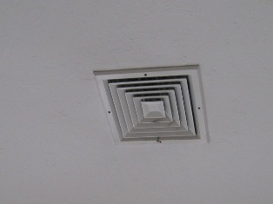

Air Supply Diffuse

Picture 2

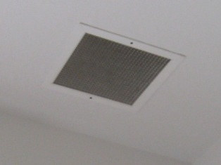

Exhaust Duct Grate
Picture 3

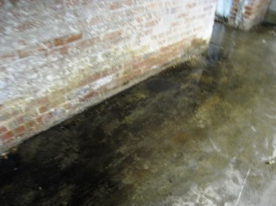

Standing Water on Basement Floor

Picture 4

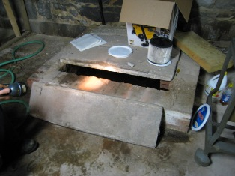

Distribution Box
Picture 5

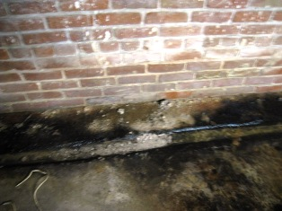

Perimeter Drain in Basement Floor
Note Debris in Trough

Picture 6

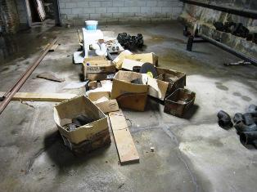

Wood, Cardboard and Debris Stored on Wet Floor
Picture 7

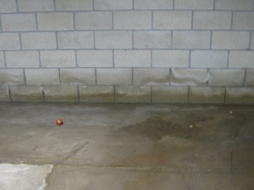

Water stains and efflorescence on basement wall

Picture 8

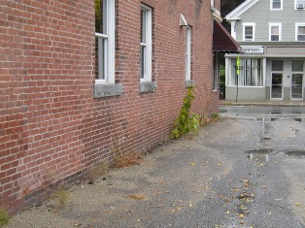

Plant Growth Against Base of Building
Picture 9

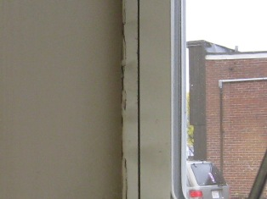

Discoloration of window frame due to air infiltration
Note deteriorated caulking

Picture 10

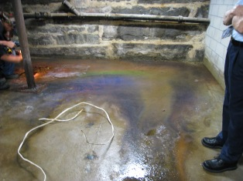

Standing Water Containing Sheen Indicative of
Petroleum Products

Picture 11

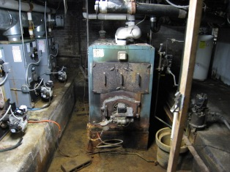

Abandoned Furnace in Basement

Picture 12

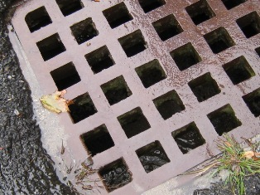

Storm Drain Located at North End of Building

Picture 13

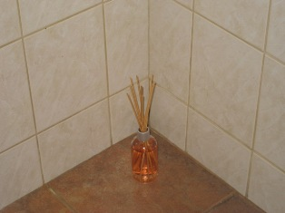

Reed Diffuser Emitting Fragrance

Picture 14

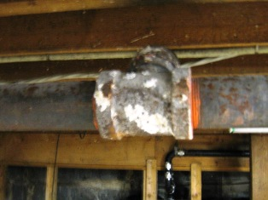

Remnants of Insulating Material on Pipe
Location | Occupants  in Room | Carbon  Dioxide  (ppm) | Temp  (°F) | Relative  Humidity  (%) | Carbon Monoxide  (ppm) | PM2.5  (µg/m3) | Windows  Openable | Ventilation |  | Remarks
 |  |  |  |  |  |  |  | Supply | Exhaust | Remarks
Outside  (Background) |  | 397 | 65 | 66 | ND | 2
Room 8 | 0 | 553 | 69 | 55 | ND | 1 | Y  0/5 open | Y  Off | Y  Off | DO
Room 9 | 0 | 605 | 69 | 55 | ND | 1 | Y  0/2 open | Y  Off | Y  Off | DO, Drapes
Court Room | 0 | 456 | 69 | 51 | ND | 3 | Y  0/4 open | Y  Off | Y  Off | DO
Room 4 | 0 | 521 | 69 | 51 | ND | 8 | Y  0/2 open | Y  Off | Y  Off | DO, Computer
Room 5 | 0 | 475 | 69 | 49 | ND | 1 | Y  0/4 open | Y  Off | Y  Off | DO, DEM
Room 7 | 0 | 588 | 69 | 52 | ND | 1 | Y  0/2 open | Y  Off | Y  Off | CF
Lobby | 0 | 557 | 69 | 50 | ND | 2 | Y  0/4 open | Y  Off | Y  Off | DO
Men’s Room | 0 | 610 | 70 | 50 | ND | 2 | Y  0/1 open | Y  Off | Y
Women’s Room | 0 | 550 | 70 | 51 | ND | 1 | Y  0/1 open | Y  Off | Y
Lockup | 0 | 622 | 68 | 51 | ND | 2 | N | Y | Y  Off | DO
Lockup office | 2 | 628 | 68 | 53 | ND | 1 | N | Y | N | WD CT
Lockup entrance | 1 | 729 | 68 | 55 | ND | 1 | N | Y | N | WD CTs, Gap at bottom of door
File Room 2 | 3 | 411 | 67 | 53 | ND | 6 | N | N | N
Women’s Room | 0 | 632 | 67 | 55 | ND | 5 | N | Y | Y | AD, diffuser sticks
Men’s Room | 0 | 664 | 67 | 55 | ND | 1 | N | Y | Y
Kitchen | 0 | 692 | 69 | 55 | ND | 2 | N | Y | Y | DO
Probation Officer 1 | 0 | 661 | 69 | 56 | ND | 2 | Y  0/1 open | Y  Off | Y  Off
Hallway | 0 | 601 | 69 | 54 | ND | 2 | N | N | N | WD CTs
Probation Officer 2 | 0 | 520 | 69 | 54 | ND | 1 | Y  0/1 open | Y  Off | Y  Off | WD CTs, PF
Probation Officer 3 | 1 | 626 | 70 | 54 | ND | 3 | Y | Y  Off | Y  Off | DO, Air diffuser sticks
Probation Office | 1 | 631 | 69 | 49 | ND | 2 | N | Y  Off | Y  Off | DO, copier, computer
File Room 1 | 1 | 738 | 70 | 48 | ND | 6 | N | Y  Off | Y  Off | DO
Clerk Magistrate | 1 | 682 | 71 | 51 | ND | 6 | Y  0/1 open | Y  Off | Y  Off | DO, Plant, computer
Clerk’s Office (Main – Rear) | 3 | 681 | 71 | 49 | ND | 5 | Y  0/2 open | Y | Y | DO
Clerk’s Office  (Main – Front) | 1 | 792 | 71 | 51 | ND | 5 | N | Y | N | DO
Foyer | 0 | 812 | 71 | 49 | ND | 5 | N | Y | Y
Basement | 0 | 676 | 68 | 73 | ND | 4 | N | N | N

