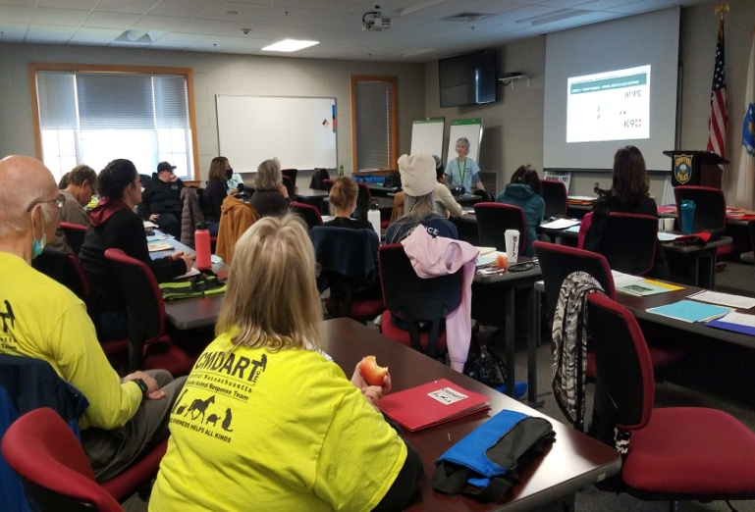

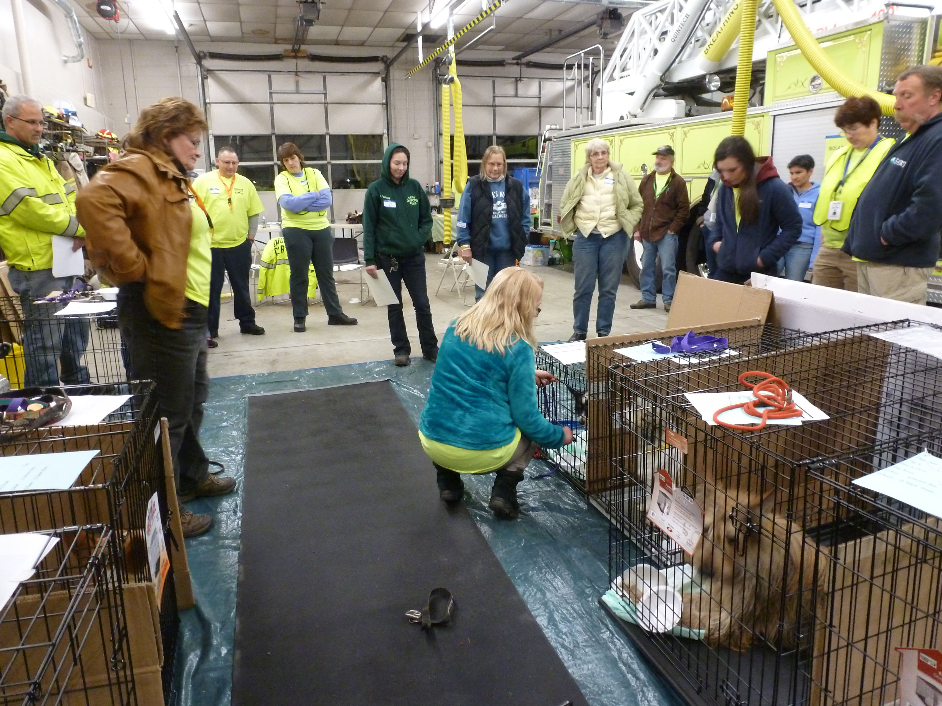

**Introduction to Animal Disaster Services and Basic Emergency Animal Sheltering (EAS)**

## Sunday, May 19, Murdock Middle High School

**3 Memorial Dr, Winchendon, MA 01475 9 a.m-3p.mish**

**Training in partnership with Emergency Management and the Animal Control Officers of Athol, Winchendon, Orange, Royalston, Irving, Gardner and other Northwest Worcester County towns. Local Community Emergency Response Teams (CERTS) will participate to help strengthen response capabilities in their towns.**

**CEU’s for Animal Control and Veterinary Technicians pending approval.**

**9-12:30 a.m. Part I Classroom instruction:**

Through films and lecture, participants will learn the best practices for being an animal responder in a disaster, EAS including intake protocols, interviewing skills, working with partner organizations in co-located shelters. The course will cover the basics of local, regional, and national response systems (animal response as it fits into the Incident Command System), psychological aspects of working a disaster for you and the client, kinds of EAS shelters, communication in a disaster, shelter assessments, Assistance animals in a shelter; coping with resources/ volunteers and “stuff” (donations), animal handling in stressful conditions and more.

***Lunch provided by the Winchendon/Athol Animal Control. Please note diet restrictions when registering.***

**1-3ish p.m. Part II Experiential Hands On Practice (Part 1 required)**

The second half of the day will be a live set up and practice of a basic (mock) emergency animal shelter including assessing supplies needed, shelter set up, intake procedures, use of a scanner, basic medical issues/limitations and referral, security in the shelter, coping with varied populations of clients and animals, practice techniques with animals, liaison with animal control. (Please note, only non-reactive animals are used for the training)

**Instructors: CMDART, local animal control, local vet techs/veterinarians.**

**Sign Up link for this course:**  [https://signup.com/go/rfVFXsX.](https://signup.com/go/rfVFXsX.%20)

**Deadline May 17, 5 p.m. CMDART message line is 508-803-1989 for additional questions.**

**Our Sponsor: Community Foundation of North Central Massachusetts**