Mold/Water Damage Investigation

Winchester High School
80 Skillings Road
Winchester, Massachusetts

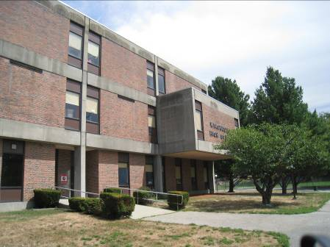

Prepared by:
Massachusetts Department of Public Health
Bureau of Environmental Health
Indoor Air Quality Program
August 2010

Background/Introduction
In response to concerns raised by a parent, the Massachusetts Department of Public Health (MDPH), Bureau of Environmental Health (BEH) provided assistance and consultation regarding indoor air quality at Winchester High School (WHS), 80 Skillings Road, Winchester, Massachusetts. On August 18, 2010, Cory Holmes and Sharon Lee, Environmental Analysts/Regional Inspectors within BEH’s Indoor Air Quality (IAQ) Program visited the WHS to conduct an assessment. BEH staff were accompanied by Peter Lawson, Facilities Manager, Town of Winchester, Jennifer Murphy, Director, Winchester Health Department, and Joe O’Brien, Head Custodian, WHS. The request was prompted by concerns of potential mold growth related to water infiltration.
The WHS is a three-story brick building constructed in the early 1970s. The school consists of 5 building blocks structured around a courtyard (Picture 1). Windows in the building are not openable.

Methods
BEH staff performed a visual inspection of mechanical ventilation components as well as building materials for water damage and/or microbial growth.

Results and Discussion

Microbial/Moisture Concerns
As mentioned ,the assessment was prompted by concerns of potential mold growth from water damage sustained during a roof leak that occurred in December 2009 and flooding during March 2010. Areas of concern included the 3rd floor math wing and cafeteria. As reported by Mr. Lawson, the 3rd floor math wing, specifically room C310, was an area of chronic water penetration. Following the roof leak in December of 2009, the roof in this area was reportedly repaired; all water-damaged ceiling tiles and insulation were removed/replaced and the area was cleaned and disinfected. Following remediation work, Envirotest Laboratory, Inc was contracted to conduct mold testing in a number of areas, including the math lounge and open area, hall outside room C312 and room C310. An outdoor sample was also taken for comparison purposes (i.e. background). The report issued by Envirotest did not call for any further corrective actions based upon their review of mold/moisture test results (Envirotest, 2010). At the time of the MDPH assessment, no further water damage/infiltration and/or evidence of mold growth was observed in the math classroom..
As discussed, concerns of mold growth in the cafeteria were also raised. BEH staff examined conditions in the cafeteria and did not observe water damage or mold growth in the area. However, accumulated dust/debris was observed on/around ceiling supply vents in the cafeteria and in other areas (Picture 2). Dust/debris will occasional accumulate on supply vents due to charges created by the flow of air attracting these particles. Vents should be cleaned periodically to prevent dust from becoming a mold growth medium during periods of elevated humidity/condensation.
BEH staff found the exterior door propped open to the TV studio/wood shop wing during a perimeter examination of the building. Directly inside the hallway, water-damaged/mold-colonized ceiling tiles were observed and a strong musty/mold odor was detected (Picture 3). This condition was reported to Mr. Lawson, who indicated that immediate corrective actions would be taken.
Water-damaged/mold-colonized cardboard boxes containing air filters were also observed in the basement (Picture 4). At the time of the assessment BEH staff recommended to Mr. O’Brien that the box and its contents be discarded.
The US Environmental Protection Agency (US EPA) and the American Conference of Governmental Industrial Hygienists (ACGIH) recommend that porous materials be dried with fans and heating within 24 to 48 hours of becoming wet (US EPA, 2001; ACGIH, 1989). If not dried within this time frame, mold growth may occur. Once mold has colonized porous materials, they are difficult to clean and should be removed/discarded.
BEH staff observed breaches in the building envelope and other conditions that could contribute to water penetration. These potential sources include:
- Plants/trees growing in close proximity to exterior walls, which can hold moisture against the building and prevent drying (Pictures 5 and 6). In addition, roots of trees can damage the buildings foundation;
- Damaged concrete foundation/masonry (Picture 7);
- Broken window panes sealed with plywood or other material (Picture 8);
- Damaged vents containing trash/debris (Picture 9);
- Subterranean air intake pits with pine needles/leaves and debris (Picture 10). Accumulated debris in the pits can collect moisture and become a source of mold growth and associated odors;
- Exterior wall panels sealed with masking tape (Picture 11); and
- Missing/damaged window caulking and joint sealant (Pictures 12 through 14). Window and expansion joint sealant may be composed of regulated materials [(e.g., asbestos, polychlorinated biphenyls (PCBs)]. For information regarding PCBs, please consult MDPH guidance (Appendix A).
These conditions can undermine the integrity of the building envelope and provide a means of water entry by capillary action into the building through exterior walls, foundation concrete and masonry (Lstiburek & Brennan, 2001). In addition, these breaches in exterior areas can provide a means of drafts and pest entry into the building.
It is important to note that the dirt crawlspace below the building reportedly becomes wet during heavy rain/flooding conditions. Crawlspaces are below grade and thus are prone to chronic moisture. Since dirt contains mold spores, the addition of moisture can result in more widespread mold growth. Mr. Lawson reported that areas where water accumulate are disinfected to prevent growth. Depressurization of the basement is important to draw mold spores and odors away from occupied areas. Without depressurization, materials and associated odors can migrate into occupied areas utility holes between the first floor and basement since air tends to rise from lower to upper floors, a condition known as the stack effect. It was reported by Mr. Lawson that the crawlspace is depressurized by a local exhaust system to prevent moisture and odors from entering the occupied space. Please note, the discharge vent for the local exhaust system is located in close proximity to another vent, which may serve as an air intake vent that can draw moisture and odors back into the building (Picture 15).

Other Conditions
BEH staff inspected air-handling units (AHUs) in the basement mechanical room. One of the units had a damaged filter access panel (Picture 16). Under these conditions, the damaged access panel prevents the AHU casing from being airtight, which can result in the draw air from the mechanical room into the unit. In this condition, the opportunity exists for airborne dirt, dust, odors and particulates to be drawn into the HVAC system and be distributed to occupied areas. Aerosolized dusts and particulates can provide a source of eye, skin and respiratory irritation to certain individuals.

Conclusions/Recommendations
It appears that roof repairs in the 3rd floor math wing were successful in preventing further water damage and mold growth. In addition, no water damage or mold growth was observed in the cafeteria at the time of the assessment. However, visible mold growth was observed on ceiling tiles in the TV studio/shop hallway and on cardboard boxes in the basement mechanical room. A number of issues were also identified along the exterior of the building that can allow for water penetration. At the time of the assessment, the Mr. Lawson reported that the town of Winchester was in the beginning phases of considering a building-wide feasibility study to address current and future needs of the school. However, this process can take several years to complete in order to obtain funding to build a new school and/or renovate an existing building.
For these reasons, a two-phase approach is recommended for remediation. The first consists of short-term measures that can be conducted as soon as practicable. The second consists of long-term measures that will require planning and resources to adequately address issues identified.

Short-Term Recommendations:
- Remove water-damaged/mold-colonized ceiling tiles in TV studio/shop hallway as well as any damaged insulation material that may be above ceiling tiles. This measure will remove actively growing mold colonies that may be present. Remove mold contaminated materials in a manner consistent with recommendations found in “Mold Remediation in Schools and Commercial Buildings” published by the US Environmental Protection Agency (US EPA, 2001). Copies of this document can be downloaded from the US EPA website at: http://www.epa.gov/iaq/molds/mold_remediation.html
- Discard water-damaged/mold-colonized boxes and their materials located in basement mechanical room. Clean and disinfect floor as needed.
- Store cardboard boxes on pallets or other means to prevent direct contact with floor.
- Clean supply, exhaust/return vents periodically of accumulated dust.
- Seal any/all utility holes and other potential pathways to eliminate pollutant paths of migration from the basement/crawlspace to the first floor. Ensure tightness by monitoring for light penetration and drafts.
- Remove plants/stumps in close proximity to the foundation. Trim trees back from exterior walls.
- Repair cracked, broken foundation masonry.
- Repair/replace damaged windows and exterior wall panels.
- Clean trash/debris from exterior vent shown in Picture 9. Make repairs to bird screen to prevent reoccurrence.
- Clean out subterranean pits periodically of accumulated debris.
- Seal window panes and frames to prevent water penetration drafts and pest entry. Address deteriorated window sealant in accordance with EPA regulations/MDPH guidance.
- Ensure crawlspace exhaust system is operating continuously. Ensure a preventative maintenance plan is in place for proper operation.
- Identify vents shown in Picture 15 as either supply or exhaust. Extend the supply vent at least 5-feet away from the exhaust vent to prevent entrainment.
- Repair/replace filter access panel on AHU shown in Picture 16.
- Consider adopting the US EPA (2000) document, “Tools for Schools”, as an instrument for maintaining a good indoor air quality environment in the building. This document is available at: http://www.epa.gov/iaq/schools/index.html.
- Refer to resource manual and other related indoor air quality documents located on the MDPH’s website for further building-wide evaluations and advice on maintaining public buildings. These documents are available at: http://mass.gov/dph/iaq.

Long-Term Recommendations
- Consider replacing all windows in the building as funds become available.
- Consider consulting with an architect, masonry firm or general contractor regarding the integrity of the building envelope, primarily concerning water penetration through the roof/exterior walls.

References
ACGIH. 1989. Guidelines for the Assessment of Bioaerosols in the Indoor Environment. American Conference of Governmental Industrial Hygienists, Cincinnati, OH.
Envirotest Laboratory, Inc. 2010. Airborne Air-O-Cell Results from the Winchester High School, 80 Skillings Road, Winchester, MA. Dedham, MA.
US EPA. 2001. Mold Remediation in Schools and Commercial Buildings. US Environmental Protection Agency, Office of Air and Radiation, Indoor Environments Division, Washington, D.C. EPA 402-K-01-001. March 2001.
Picture 1

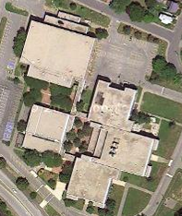

The Five Buildings of Winchester High School

Picture 2

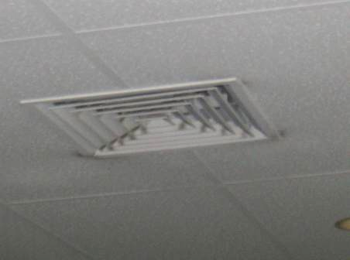

Dust/Debris Accumulation on/around Vent

Picture 3

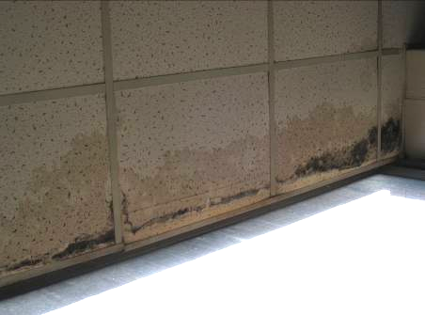

Water-Damaged/Mold-Colonized Ceiling Tiles in TV Studio/Wood Shop Hallway

Picture 4

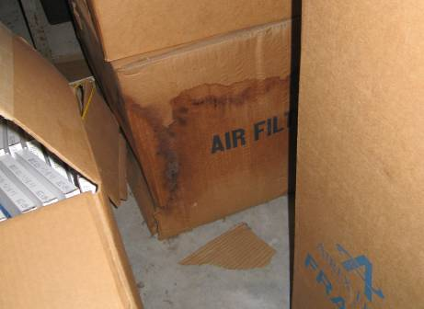

Water-Damaged/Mold-Colonized Box Containing Filters in Basement

Picture 5

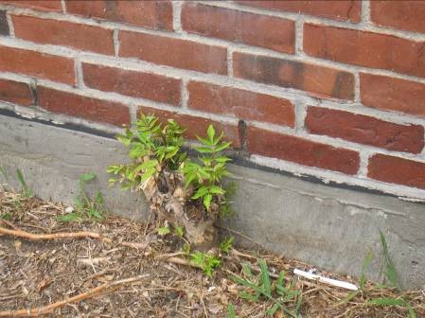

Tree Stump Growing against Foundation

Picture 6

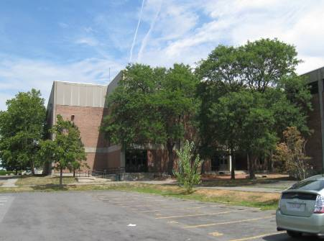

Trees/Branches in Close Proximity to Exterior Walls

Picture 7

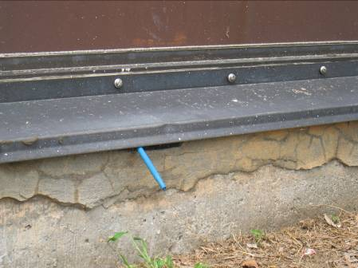

Damaged Concrete Foundation Masonry, Pen Inserted by BEH Staff to Show Depth

Picture 8

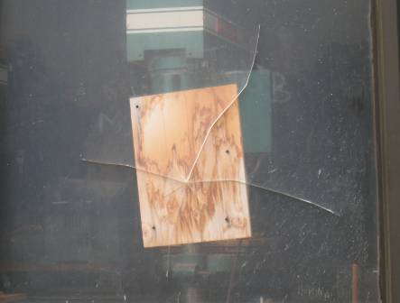

Broken Window Sealed with Plywood

Picture 9

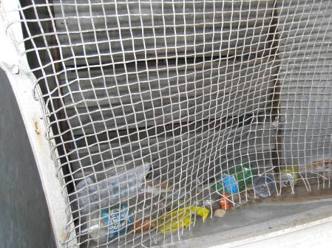

Damaged Vent, Note Trash and Debris

Picture 10

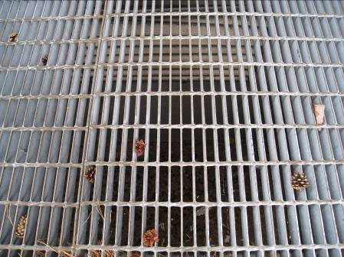

Subterranean Air Intake Pit

Picture 11

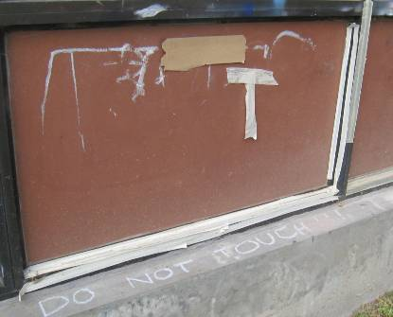

Exterior Wall Panels Sealed With Masking Tape

Picture 12

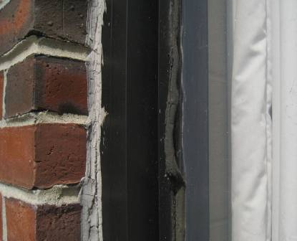

Damaged/Failing Window Caulking

Picture 13

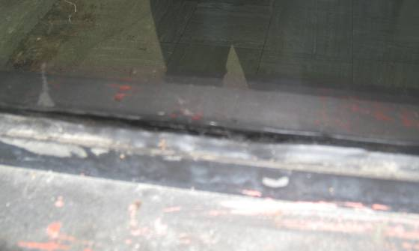

Missing/Damaged Window Caulking

Picture 14

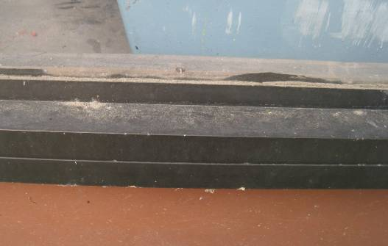

Missing/Damaged Window Caulking

Picture 15

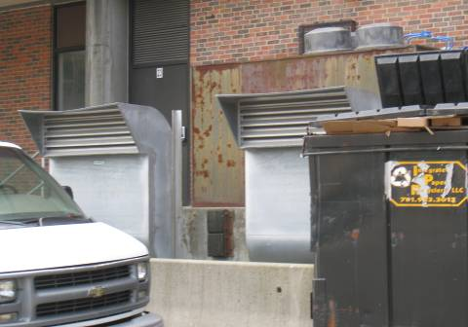

Supply and Intake Vent in Close Proximity, Note Vehicle Parked Adjacent to the Vents

Picture 16

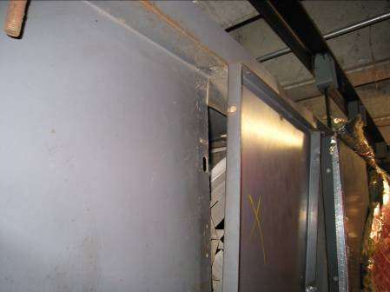

Damaged Filter Access Panel, Note Space/Opening

An Information Booklet Addressing PCB-Containing Materials in the Indoor Environment of Schools
and Other Public Buildings



Prepared by

Bureau of Environmental Health
Massachusetts Department of Public Health
December 2009
INTRODUCTION
The purpose of this information booklet is to provide assistance to school and public building officials and the general public in assessing potential health concerns associated with polychlorinated biphenyl (PCB) compounds in building materials used in Massachusetts and elsewhere. Recently, the U.S. Environmental Protection Agency (EPA) provided broad guidance relative to the presence of PCBs in building materials, notably PCBs in caulking materials. The most common building materials that may contain PCBs in facilities constructed or significantly renovated during the 1950s through the 1970s are fluorescent light ballasts, caulking, and mastic used in tile/carpet as well as other adhesives and paints.
This information booklet, developed by the Massachusetts Department of Public Health’s Bureau of Environmental Health (MDPH/BEH), is designed to supplement guidance offered by EPA relative to potential health impacts and environmental testing. It also addresses managing building materials, such as light ballasts and caulking, containing PCBs that are likely to be present in many schools and public buildings across the Commonwealth. This is because the Northeastern part of the country, and notably Massachusetts, has a higher proportion of schools and public buildings built during the 1950s through 1970s than many other parts of the U.S. according to a 2002 U.S. General Accounting Office report. The Massachusetts School Building Authority noted in a 2006 report that 53 percent of over 1,800 Massachusetts school buildings surveyed were built during the 1950s through 1970s. This information booklet contains important questions and answers relative to PCBs in the indoor environment and is based on the available scientific literature and MDPH/BEH’s experience evaluating the indoor environment of schools and public buildings for a range of variables, including for PCBs as well as environmental data reviewed from a variety of sources.
1. What are PCBs?
Polychlorinated biphenyl (PCB) compounds are stable organic chemicals used in products from the 1930s through the late 1970s. Their popularity and wide-spread use were related to several factors, including desirable features such as non-flammability and electrical insulating properties. Although the original use of PCBs was exclusive to closed system electrical applications for transformers and capacitors (e.g., fluorescent light ballasts), their use in other applications, such as using PCB oils to control road dust or caulking in buildings, began in the 1950s.
2. When were PCBs banned from production?
Pursuant to the Toxic Substance Control Act (TSCA) of 1976 (effective in 1979), manufacturing, processing, and distribution of PCBs was banned. While the ban prevented production of PCB-containing products, it did not prohibit the use of products already manufactured that contained PCBs, such as building materials or electrical transformers.
3. Are PCBs still found in building materials today?
Yes. Products made with PCBs prior to the ban may still be present today in older buildings. In buildings constructed during the 1950s through 1970s, PCBs may be present in caulking, floor mastic, and in fluorescent light ballasts. Available data reviewed by MDPH suggests that caulking manufactured in the 1950s through 1970s will likely contain some levels of PCBs. Without testing it is unclear whether caulking in a given building may exceed EPA’s definition of PCB bulk product waste of 50 parts per million (ppm) or greater. If it does, removal and disposal of the caulk is required in accordance with EPA’s TSCA regulations (40 CFR § 761).
4. Are health concerns associated with PCB exposure opportunities?
Although the epidemiological evidence is sometimes conflicting, most health agencies have concluded that PCBs may reasonably be anticipated to be a carcinogen, i.e., to cause cancer.
PCBs can have a number of non-cancer effects, including those on the immune, reproductive, neurological and endocrine systems. Exposure to high levels of PCB can have effects on the liver, which may result in damage to the liver. Acne and rashes are symptoms typical in those that are exposed to high PCB levels for a short period of time (e.g., in industry / occupational settings).
5. If PCBs are present in caulking material, does that mean exposure and health impacts are likely?
No. MDPH/BEH’s review of available data suggests that if caulking is intact, no appreciable exposures to PCBs are likely and hence health effects would not be expected. MDPH has conducted indoor tests and reviewed available data generated through the efforts of many others in forming this opinion.
6. How can I tell if caulking or light ballasts in my building may contain PCBs?
If the building was built sometime during the 1950s through 1970s, then it is likely that the caulking in the building and/or light ballasts may contain some level of PCBs. Light ballasts manufactured after 1980 have the words “No PCBs” printed on them. If the light ballast does not have this wording or was manufactured before 1980, it should be assumed that it contains PCBs.
7. What are light ballasts?
A light ballast is a piece of equipment that controls the starting and operating voltages of fluorescent lights. A small capacitor within older ballasts contains about one ounce of PCB oil. If light bulbs are not changed soon after they go out, the ballast will continue to heat up and eventually result in the release of low levels of PCBs into the indoor air.
8. Does the presence of properly functioning fluorescent light ballasts in a building present an environmental exposure concern?
No appreciable exposure to PCBs is expected if fluorescent light ballasts that contain PCBs are intact and not leaking or damaged (i.e., no visible staining of the light lenses), and do not have burned-out bulbs in them.

9. Should I be concerned about health effects associated with exposure to PCBs as a result of PCB-containing light ballasts?
While MDPH has found higher PCB levels in indoor air where light bulbs have burned-out, the levels are still relatively low and don’t present imminent health threats. A risk assessment conducted recently at one school did not suggest unusual cancer risks when considering a worst case exposure period of 35 years for teachers in that school. Having said this, MDPH believes that facility operators and building occupants should take prompt action to replace bulbs and/or ballasts as indicated to reduce/eliminate any opportunities for exposure to PCBs associated with PCB-containing light ballasts.
10. When should PCB-containing light ballasts be replaced?
If ballasts appear to be in disrepair, they should be replaced immediately and disposed of in accordance with environmental regulatory guidelines and requirements. However, if light bulbs burn out, the best remedy is to change them as soon as possible. If light bulbs are not changed soon after they go out, the ballast will continue to heat up and eventually result in the release of low levels of PCBs into the indoor air. Thus, burned-out bulbs should be replaced promptly to reduce overheating and stress on the ballast. As mentioned, ballasts that are leaking or in any state of disrepair should be replaced as soon as possible.
It should be noted that although older light ballasts may still be in use today, the manufacturers’ intended lifespan of these ballasts was 12 years. Thus, to the extent feasible or in connection with repair/renovation projects, the older light ballasts should be replaced consistent with the intended lifespan specified by the manufacturers.
11. Does MDPH recommend testing of caulking in buildings built during the 1950s -1980?
Caulking that is intact should not be disturbed. If caulking is deteriorating or damaged, conducting air and surface wipe testing in close proximity to the deteriorating caulking will help to determine if indoor air levels of PCBs are a concern as well as determining the need for more aggressive cleaning. Results should be compared with similar testing done in an area without deteriorating caulking. In this way, a determination can be made regarding the relative contribution of caulking materials to PCBs in the general indoor environment.
12. What if we determine that caulking in our building is intact and not deteriorating?
Based on a review of available data collected by MDPH and others, the MDPH does not believe that intact caulking presents appreciable exposure opportunities and hence should not be disturbed for testing. As with any building, regular operations and maintenance should include a routine evaluation of the integrity of caulking material. If its condition deteriorates then the steps noted above should be followed. Consistent with EPA advice, if buildings may have materials that contain PCBs, facility operators should ensure thorough cleaning is routinely conducted.
13. Should building facilities managers include information about PCB-containing building materials in their Operations and Maintenance (O&M) plans?
Yes. All buildings should have an O&M plan that includes regular inspection and maintenance of PCB building materials, as well as thorough cleaning of surfaces not routinely used. Other measures to prevent potential exposure to PCBs include increasing ventilation, use of HEPA filter vacuums, and wet wiping. These O&M plans should be available to interested parties.
14. Are there other sources of PCBs in the environment?
Yes. The most common exposure source of PCBs is through consumption of foods, particularly contaminated fish. Because PCBs are persistent in the environment, most residents of the U.S. have some level of PCBs in their bodies.
15. Where can I obtain more information?
For guidance on replacing and disposing of PCB building materials, visit the US EPA website: http://www.epa.gov/pcbsincaulk/. For information on health concerns related to PCBs in building materials, please contact MDPH/BEH at 617-624-5757.

