**INDOOR AIR QUALITY ASSESSMENT**

**Winchester Town Hall**

**71 Mount Vernon Street**

**Winchester, Massachusetts**

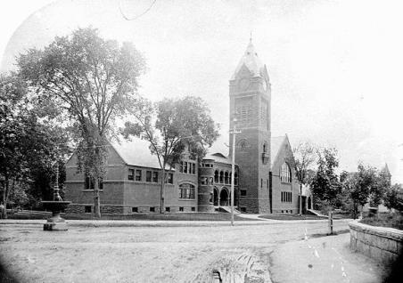

Prepared by:

Massachusetts Department of Public Health

Center for Environmental Health

Bureau of Environmental Health Assessment

Emergency Response/Indoor Air Quality Program

July 2004

# Background/Introduction

At the request of Joe Tabbi, Acting Director of Public Health in Winchester, the Massachusetts Department of Public Health (MDPH), Center for Environmental Health (CEH), Bureau of Environmental Health Assessment (BEHA) provided assistance and consultation regarding indoor air quality concerns at the Winchester Town Hall (WTH), Winchester, Massachusetts. The request was prompted by concerns over indoor air quality and cancer diagnoses among building occupants. On November 20, 2003, a visit to conduct an indoor air quality assessment was made to the WTH by Cory Holmes, an Environmental Analyst in BEHA’s Emergency Response/Indoor Air Quality (ER/IAQ) program. Mr. Holmes was accompanied by Mr. Tabbi during the assessment.

The WTH is a three-story, red brick building constructed in 1887. The building was renovated from 1987 to 1989. Windows are openable throughout the building. The building contains town offices and public meeting rooms. The basement of the building is occupied.

Due to IAQ concerns among staff, an environmental consultant, ATC Associates, previously conducted an IAQ inspection in November of 2001. The ATC report recommended: (1) installation of portions of the mechanical heating, ventilating and air-conditioning (HVAC) system that were not installed during previous renovations; (2) installation and regular replacement of high efficiency filters in the HVAC system; (3) maintenance of HVAC fan-coil units to ensure proper drainage; (4) modification of fan-coil units to improve fit of filters; (5) removal of all carpeting in the basement; (6) replacement of carpeting with a non-porous flooring material; (7) insulation of all pipes in the custodians office that are prone to condensation; (8) replacement of water damaged gypsum wallboard (GW) and insulation along the perimeter wall; (9) repair of leaks in the building envelope as necessary; (10) replacement of water damaged pipe insulation in the boiler room; (11) repair gutters and downspouts as needed; and (12) vacuuming of all upholstered furniture periodically with a high efficiency particulate arrestance (HEPA) filtered vacuum cleaner (ATC, 2001).

**Methods**

Air tests for carbon dioxide, carbon monoxide, temperature and relative humidity were taken with the TSI, Q-TRAK™ IAQ Monitor, Model 8551. Screening for total volatile organic compounds (TVOCs) was conducted using a Thermo Environmental Instruments Inc., Model 580 Series, Photo Ionization Detector (PID).

**Results**

The WTH has an employee population of approximately 40-50 and is visited by approximately 100-150 individuals daily. The tests were taken during normal operations. Test results appear in Table 1.

**Discussion**

**Ventilation**

It can be seen from Table 1 that carbon dioxide levels were below 800 parts per million (ppm) in all areas surveyed, indicating adequate ventilation in the building. However, it is important to note that a number of areas were unoccupied or sparsely populated, which can greatly reduce carbon dioxide levels.

Fresh, heated air is supplied by air-handling units (AHUs) that are located above the ceiling tile system in the basement and in a mechanical room on the third floor. Fresh air is drawn into the AHUs through fresh air intakes located on the exterior of the building (Pictures 1 and 2) and provided to occupied areas via ceiling-mounted air diffusers. Return air is drawn into ceiling-mounted vents and ducted back to AHUs. These systems were operating during the assessment. However, the fresh air intake was clogged with leaves and debris (Picture 3). Limiting air intake can lead to a reduction in fresh air distribution and also increases difficulty in controlling temperature.

Fan coil units (FCUs) located along the base of walls (Picture 4) provide supplemental heating or cooling as needed for each room. FCUs do not have the capability to introduce outside air; these units *only* recirculate air. These units were deactivated in the majority of areas surveyed during the assessment.

To maximize air exchange, the BEHA recommends that both supply and exhaust ventilation operate continuously during periods of occupancy. In order to have proper ventilation with a mechanical supply and exhaust system, the systems must be balanced to provide an adequate amount of fresh air to the interior of a room while removing stale air from the room. It is recommended that HVAC systems be re-balanced every five years to ensure adequate air systems function (SMACNA, 1994). The date of the last balancing of these systems was not available at the time of the assessment.

The Massachusetts Building Code requires a minimum ventilation rate of 20 cubic feet per minute (cfm) per occupant of fresh outside air or have openable windows in each room (SBBRS, 1997; BOCA, 1993). The ventilation must be on at all times that the room is occupied. Providing adequate fresh air ventilation with open windows and maintaining the temperature in the comfort range during the cold weather season is impractical. Mechanical ventilation is usually required to provide adequate fresh air ventilation.

Carbon dioxide is not a problem in and of itself. It is used as an indicator of the adequacy of the fresh air ventilation. As carbon dioxide levels rise, it indicates that the ventilating system is malfunctioning or the design occupancy of the room is being exceeded. When this happens, a buildup of common indoor air pollutants can occur, leading to discomfort or health complaints. The Occupational Safety and Health Administration (OSHA) standard for carbon dioxide is 5,000 parts per million parts of air (ppm). Workers may be exposed to this level for 40 hours/week, based on a time-weighted average (OSHA, 1997).

The Department of Public Health uses a guideline of 800 ppm for publicly occupied buildings. A guideline of 600 ppm or less is preferred in schools due to the fact that the majority of occupants are young and considered to be a more sensitive population in the evaluation of environmental health status. Inadequate ventilation and/or elevated temperatures are major causes of complaints such as respiratory, eye, nose and throat irritation, lethargy and headaches. For more information concerning carbon dioxide, please see [Appendix A](http://www.mass.gov/eohhs/docs/dph/environmental/iaq/appendices/carbon-dioxide.doc).

Temperature readings ranged from 68o F to 78 o F in occupied areas, which were close to the BEHA recommended comfort guidelines. The BEHA recommends that indoor air temperatures be maintained in a range of 70 o F to 78 o F in order to provide for the comfort of building occupants. In many cases concerning indoor air quality, fluctuations of temperature in occupied spaces are typically experienced, even in a building with an adequate fresh air supply. Temperature and poor airflow complaints were expressed in several areas. In some cases, thermostats were observed near heat-generating equipment, such as photocopiers/printers and a coffee maker (Picture 5). Heated air rising from this equipment can affect the thermostat. For example, heated air rising from a photocopier would activate the HVAC system to provide cold air to this area during summer months. In winter, the HVAC system would be deactivated by heated air from the photocopier interacting with the sensors in the thermostat, resulting in cooler temperatures.

The relative humidity measured in the building ranged from 33 to 52 percent, which was below the BEHA recommended comfort range in some areas. The BEHA recommends a comfort range of 40 to 60 percent for indoor air relative humidity. Relative humidity levels in the building would be expected to drop during the winter months due to heating. The sensation of dryness and irritation is common in a low relative humidity environment. Low relative humidity is a very common problem during the heating season in the northeast part of the United States.

**Microbial/Moisture Concerns**

The WTH has a history of mold growth resulting from water damaged carpeting in the basement. At the time of the assessment all carpeting had been removed and replaced or was in the process of being replaced. If the source of moisture is not remediated, it is possible that this new carpeting could become moistened in a manner similar to previously installed carpeting. The US Environmental Protection Agency (US EPA) and the American Conference of Governmental Industrial Hygienists (ACGIH) recommends that porous materials be dried with fans and heating within 24-48 hours of becoming wet (US EPA, 2001; ACGIH, 1989). If porous materials are not dried within this time frame, mold growth may occur. Water-damaged porous materials cannot be adequately cleaned to remove mold growth. The application of a mildewcide to moldy porous materials is not recommended.

Water damaged wall plaster and efflorescence observed in the basement lounge/break room (Picture 6) appears to be the result of water penetration through the building envelope. Efflorescence is a characteristic sign of water damage to brick and mortar, but it is not mold growth. As moisture penetrates and works its way through mortar around brick, water-soluble compounds in bricks and mortar dissolve, creating a solution. As the solution moves to the surface of the brick or mortar, the water evaporates, leaving behind white, powdery mineral deposits.

The building exterior was examined for potential sources of water penetration. While the WTH is equipped with a gutter/downspout system to direct rainwater away from the building, the gutter/downspout system was either clogged with debris and standing water (Picture 7) or damaged (Picture 8). In a number of areas, missing/damaged mortar around brickwork was observed (Pictures 9 & 10). These conditions can undermine the integrity of the building envelope as they provide a means for water to enter the building through the foundation concrete and masonry via capillary action (Lstiburek & Brennan, 2001). The splashing of rainwater along the edge of the building also routinely wets the base of exterior walls. This repeated moistening has created a characteristic stain around the building. Growth of moss on exterior brickwork (Picture 11) is also an indication of chronic wetting of building components. Moss growth can also damage building components, as it holds moisture against brickwork. North-facing corners and walls of this building are particularly vulnerable to moistening for extended periods of time, since the brick is not dried out by exposure to direct sunlight. Over time, excessive exposure of exterior brickwork to water can result in damage. During winter weather, the freezing and thawing of moisture in bricks can accelerate the deterioration of brickwork.

Water damaged/mold colonized porous materials (e.g., boxes, folders, carpeting) were observed in the attic storeroom (Pictures 12 & 13). Mr. Tabbi reported that the carpeting in this area is scheduled to be removed. BEHA staff also recommended the removal of all other mold-colonized porous materials.

A number of areas had water coolers installed over carpeting. Water spillage or overflow of cooler catch basins can result in the wetting of the carpet. In addition some of the coolers had residue/build-up in the reservoir. These reservoirs are designed to catch excess water during operation and should be emptied/cleaned regularly to prevent microbial and/or bacterial growth.

**VOC Sources**

Indoor air quality can also be negatively influenced by the presence of materials containing volatile organic compounds (VOCs). VOCs are carbon-containing substances that have the ability to evaporate at room temperature. Frequently, exposure to low levels of total VOCs may produce eye, nose, throat and/or respiratory irritation in some sensitive individuals. For example, chemicals evaporating from a paint can stored at room temperature would most likely contain VOCs. In an effort to determine whether VOCs were present in the building, air monitoring for TVOCs was conducted. Outdoor air samples were taken for comparison. Outdoor TVOC concentrations were non-detectable (ND) (Table 1). Indoor TVOC concentrations measured throughout the building were also ND.

Although no VOCs were detected in the indoor air, materials that produce VOCs exist. Photocopiers are located in a number of areas. VOCs and ozone can be produced by photocopiers, particularly if the equipment is older and in frequent use. Ozone is a respiratory irritant (Schmidt Etkin, 1992). Photocopiers should be located near local exhaust ventilation or in well-ventilated areas (e.g., hallways).

**Carbon Monoxide/Combustion Emissions**

Indoor air quality can be negatively influenced by the presence of respiratory irritants, such as products of combustion. The process of combustion produces a number of pollutants; however, the pollutant produced is dependent on the material combusted. Common combustion emissions include carbon monoxide, carbon dioxide, water vapor and smoke (fine airborne particle material). Carbon monoxide is a by-product of incomplete combustion of organic matter (e.g., gasoline, wood and tobacco). Exposure to carbon monoxide can produce immediate and acute health affects. *Carbon monoxide should not be present in a typical, indoor environment.* If it *is* present, indoor carbon monoxide levels should be less than or equal to outdoor levels. BEHA staff conducted air sampling for carbon monoxide. Outdoor carbon monoxide concentrations were ND (Table 1). Carbon monoxide levels measured in the WTH were also ND, with the exception of the engineering office. The engineering office had a carbon monoxide measurement of 2 ppm. The most likely source of carbon monoxide appeared to be vehicles idling in close proximity to the building (Picture 14). Under certain weather conditions, vehicle exhaust can enter the building through windows, which may in turn provide opportunities for exposure to combustion products such as carbon monoxide.

Several air quality standards have been established to address airborne pollutants and prevent symptoms from exposure to these substances. The MDPH established a corrective action level concerning carbon monoxide in ice skating rinks that use fossil-fueled ice resurfacing equipment. If an operator of an indoor ice rink measures a carbon monoxide level over 30 ppm, taken 20 minutes after resurfacing within the rink, that operator must take actions to reduce carbon monoxide levels (MDPH, 1997).

The United States Environmental Protection Agency has established National Ambient-Air Quality Standards (NAAQS). The NAAQS are standards established by the US EPA to protect the public health from 6 criteria pollutants, including carbon monoxide and particulate matter. According to the NAAQS, carbon monoxide levels in outdoor air should not exceed 9 ppm in an eight-hour average. ASHRAE has adopted the NAAQS as one set of criteria for assessing indoor air quality and monitoring of fresh air introduced by HVAC systems (ASHRAE, 1989). As recommended by ASHRAE, pollutant levels of fresh air introduced to a building should not exceed the NAAQS (ASHRAE, 1989). The NAAQS were adopted by reference in the Building Officials & Code Administrators (BOCA) National Mechanical Code of 1993 (BOCA, 1993), which is now an HVAC standard included in the Massachusetts State Building Code (SBBRS, 1997).

**Other Concerns**

FCUs are normally equipped with filters that provide minimum filtration to strain particulates from airflow. The FCUs in the WTH did not have racks into which filters could be fit properly. Filters were observed on the floor (Picture 15) or protruding from FCUs. In order to decrease aerosolized particulates, disposable filters with an increased dust spot efficiency can be installed. The dust spot efficiency is the ability of a filter to remove particulates of a certain diameter from air passing through the filter. Filters that have been determined by ASHRAE to meet its standard for a dust spot efficiency of a minimum of 40 percent (Minimum Efficiency Reporting Value equal to 9) would be sufficient to reduce many airborne particulates (Thornburg, 2000; MEHRC, 1997; ASHRAE, 1992). Note that increasing filtration can reduce airflow, a condition known as pressure drop, which can reduce the efficiency of the FCU due to increased resistance. Prior to any increase of filtration, a ventilation engineer should be consulted as to whether FCUs can maintain function with more efficient filters.

A number of FCUs had dirt, dust and debris accumulated within the air handling chambers. These conditions may be attributed to non-continuous equipment operation, which allows airborne particulates to settle within the units. In order to prevent equipment from serving as a source of aerosolized particulates, the air handling sections of FCUs should be regularly cleaned (e.g., during regular filter changes).

A number of return/exhaust vents in offices and restrooms also had accumulated dust. If exhaust vents are not functioning, backdrafting can occur, which can re-aerosolize dust particles. In addition, these aerosolized materials can accumulate on flat surfaces (e.g., desktops, shelving and carpets) in occupied areas and subsequently be re-aerosolized, causing further irritation.

Finally, a strong odor was detected in the basement restrooms. The source of this odor was a concentrated liquid air freshener. Air fresheners contain chemicals that can be irritating to the eyes, nose and throat of sensitive individuals. Furthermore, air fresheners do not remove materials causing odors, but rather mask odors that may be present in the area.

**Health Concerns**

The Winchester Board of Health (BOH) also contacted the Community Assessment Program (CAP) regarding the concerns over a suspected increase in cancer incidence among staff in the Winchester Town Hall. In order to further investigate these concerns, CAP staff asked the BOH to submit a written request to the BEHA that contained information on each individual diagnosed with cancer including primary site of cancer, approximate age and date of diagnosis, and approximate dates of employment at the Winchester Town Hall. This request for written documentation is consistent with BEHA’s protocol for conducting environmental health assessments.

On November 26, 2003 the BEHA received a written request from the BOH that contained a list of 23 current and former employees of the Winchester Town Hall who had reported a diagnosis of cancer. Name, gender, cancer type, approximate age at diagnosis, and specific department within the Town Hall were reported for each individual. Two individuals were reported as having an unknown cancer type. Dates of employment at the Town Hall were indicated for some, but not all individuals. Dates of diagnosis were not reported for any of the employees. Because information on employees was incomplete, CAP staff contacted the Winchester BOH in the Spring of 2004 to obtain additional information on individuals reported to the BEHA with a cancer diagnosis as originally requested. Subsequent to this follow-up, the BOH provided the CAP with dates of employment for most individuals. However, the Winchester BOH was not able to obtain information on dates of diagnosis for Town Hall employees.

CAP staff reviewed the most recent data available from the Massachusetts Cancer Registry (MCR) and the Registry of Vital Records and Statistics to confirm cancer diagnoses reported among Town Hall employees and to determine whether these diagnoses may represent an unusual pattern of cancer incidence. The MCR, a division within the MDPH Center for Health Information, Statistics, Research and Evaluation, is a population based surveillance system that has been monitoring cancer incidence in the Commonwealth since 1982. All new diagnoses of cancer among Massachusetts residents are required by law to be reported to the MCR within six months of the date of diagnosis (M.G.L. c.111. s 111b). This information is kept in a confidential database. Data are collected on a daily basis and are reviewed for accuracy and completeness on an annual basis. This process corrects misclassification of data (i.e., city/town misassignment) and deletes duplicate case reports. Once these steps are finished, the data for that year are considered “complete.” Due to the volume of information received by the MCR, the large number of reporting facilities, and the six-month period between diagnosis and required reporting, the most current registry data that are complete will inherently be a minimum of two years prior to the current date. At the time of this analysis, the most recent and complete data records available from the MCR include diagnoses that occurred from 1/1/1982 – 12/31/1999. Although the MCR data are currently complete through 1999, this is an on-going surveillance system that collects reports on a daily basis. Therefore, it is possible to review case reports for more recent years (i.e., 2000-present), which can provide a qualitative review of cancer patterns in a given area.

CAP staff were able to confirm the diagnoses of 13 individuals through the MCR. Massachusetts death records available from the Registry of Vital Records and Statistics, another division within the MDPH Center for Health Information, Statistics, Research and Evaluation were also searched but no additional diagnoses were confirmed via this mechanism. In some cases, the type of cancer confirmed via the MCR was different from that reported to the BEHA. Many different types of cancer were represented including cancers of the breast, colon, lung, ovary, kidney, and pancreas, as well as multiple myeloma, NHL and other less common types.

Because cancer is not one disease but a group of many different diseases caused by many different factors, the information reviewed does not suggest that an atypical pattern of any one cancer type is occurring among employees at the Winchester Town Hall or that a common factor (environmental or non-environmental) is likely related to these diagnoses. Cancers of the breast, lung, and colon are among the most common cancers diagnosed in Massachusetts and the U.S. as a whole. Together, these cancer types represented about half of the diagnoses confirmed among employees at the Winchester Town Hall (n = 10, 53%). Although cancer can occur at any age, most cancers are diagnosed more frequently in older populations (e.g., age 50 and older). Among Town Hall employees, the average age at diagnosis was 62 years and most diagnoses occurred in individuals over the age of 50 years (84%). In addition, the dates of diagnosis for these individuals ranged from 1985 to 2002 with no apparent temporal concentration of diagnoses. Finally, smoking is an important risk factor for cancers of the lung, kidney, and pancreas. Among the four individuals diagnosed with these cancer types, two reported being current or former smokers at the time of diagnosis and two were non-smokers.

Cancer in general has a long period of development or latency period (i.e., the interval between first exposure to a disease-causing agent and the appearance of symptoms of the disease [Last 1995]) that can range from 10 to 30 years and in some cases may be more than 40 to 50 years for solid tumors (Bang 1996; Frumkin 1995). Although it is not possible to determine what may have caused any one person’s diagnosis with cancer, the length of time in which an individual worked in a particular building can help determine the importance that their location might have in terms of exposure to a potential environmental source. Based on information provided from the Winchester BOH, an employment history for 11 of the 13 individuals confirmed in the MCR were available for further evaluation. One individual worked at the Town Hall less than six months prior to diagnosis of their first primary site cancer and between 11 and 15 years prior to diagnosis of their second primary site cancer. One individual worked in the Town Hall for less than 5 years prior to diagnosis. One individual was employed between six and ten years. Four individuals worked between 11 and 15 years and one individual worked in the Town Hall between 16 and 20 years. Finally, three individuals were employed for at least 20 years prior to diagnosis. Review of diagnosis information for these individuals revealed that a number of different primary cancer types were diagnosed among long term employees of the Town Hall (i.e., employed at least 10 years). Therefore, it is less likely that a common environmental exposure played a role in the diagnoses of these individuals.

CAP staff were not able to confirm the diagnoses of all individuals with cancer that were reported to the BEHA. There are several reasons for this described below. The MCR data is currently complete through 1999; however, this is an on-going surveillance system that collects reports on a daily basis. Although we reviewed the MCR data for cancer diagnoses through the present time, it is possible that some residents of Massachusetts diagnosed with cancer may not be included in the MCR files. For example, some individuals with recent cancer diagnoses (e.g., those diagnosed in 2003) may not have been reported to the MCR yet. In addition, if the cancer type reported was incorrect, we may not have been able to identify some individuals. Similarly, if the cancer type listed was the site of metastasis (i.e., spread), that individual may not have been identified because the MCR only collects reports of primary site (i.e., original location in the body) cancer diagnoses. Finally, some individuals may have actually been diagnosed with non-invasive cancer types (i.e., benign tumors) or other pre-cancerous or non-cancerous conditions. These individuals would not be included in the MCR data files. With respect to data available from the Registry of Vital Records and Statistics, recent deaths may not have been reported to the state yet. Also, out-of-state deaths would not be included in Registry records.

According to American Cancer Society statistics, cancer is the second leading cause of death in Massachusetts and the United States. Not only will one out of three people develop cancer in their lifetime, but this tragedy will affect three out of every four families. For this reason, cancers often appear to occur in “clusters,” and it is understandable that someone may perceive that there are an unusually high number of cancer cases in their surrounding neighborhoods or towns. Upon close examination, many of these “clusters” are not unusual increases, as first thought, but are related to such factors as local population density, variations in reporting or chance fluctuations in occurrence. In other instances, the “cluster” in question includes a high concentration of individuals who possess related behaviors or risk factors for cancer. Some, however, are unusual; that is, they represent a true excess of cancer in a workplace, a community, or among a subgroup of people. A suspected cluster is more likely to be a true cancer cluster if it involves a large number of cases of one type of cancer diagnosed in a relatively short time period rather than several different types diagnosed over a long period of time (i.e., 20 years), a rare type of cancer rather than common types, and/or a large number of cases diagnosed among individuals in age groups not usually affected by that cancer. These types of clusters may warrant further public health investigation.

Based on our review of the available diagnosis information as well as the most current cancer literature there does not appear to be an atypical pattern of cancer diagnoses among current and former employees of the Winchester Town Hall. That is, it does not appear that a common factor (either environmental or non-environmental) is likely related to diagnoses of cancer among these individuals. Although some individuals worked in the Town Hall for many years prior to their cancer diagnoses, there were a variety of cancers diagnosed among these individuals, indicating no pattern of any one type of cancer. In addition, some of the cancer types diagnosed among employees (e.g., cancers of the colon and ovary) are not associated with environmental risk factors. Additionally, while potential indoor air quality problems were noted in this report, these issues are not likely to be related to the incidence of cancer among employees at the school. For additional risk factor information on the types of cancers diagnosed among staff at the Winchester Town Hall, refer to Appendix B.

**Conclusions/Recommendations**

The conditions noted at the WTH raise a number of indoor air quality issues. BEHA staff also evaluated this information in an attempt to identify possible environmental sources that have been suggested to play a role in the development of cancer. No evidence of direct sources associated with the disease were identified in the building. The general building conditions, design and the operation (or lack) of HVAC equipment (FCUs), if considered individually, present conditions that could degrade indoor air quality. When combined, these conditions can serve to further negatively affect indoor air quality. These factors can be associated with a range of IAQ related health and comfort complaints (e.g. eye, nose, and respiratory irritations), but they are unlikely to be associated with cancer occurrences among employees. Some of the conditions can be remedied by actions taken by building occupants. Other remediation efforts will require alteration to the building structure and equipment. For these reasons a two-phase approach is required. The approach consists of **short-term** measures to improve air quality and **long-term** measures that will require planning and resources to adequately address overall indoor air quality concerns.

The following **short-term** measures should be considered for implementation:

* 1. Continue to implement recommendations listed in the ATC 2001 report.
  2. Remove and replace any mold contaminated/water damaged building materials in the attic storeroom and staff break room. This measure will remove actively growing mold colonies that may be present. Remove mold contaminated materials in a manner consistent with recommendations found in *Mold Remediation in Schools and Commercial Buildings* published by the US Environmental Protection Agency (US EPA) (US EPA, 2001). Copies of this document can be downloaded from the US EPA website at: <http://www.epa.gov/iaq/molds/mold_remediation.html>.
  3. Operate ventilation systems throughout the building continuously during periods of occupancy independent of thermostat control to maximize air exchange.
  4. Operate FCUs to facilitate airflow in office areas.
  5. Use openable windows to supplement airflow and control for comfort. Care should be taken to ensure windows are properly closed at night and weekends to avoid the freezing of pipes and potential flooding.
  6. Consult a ventilation engineer concerning re-balancing of the ventilation systems. Ventilation industrial standards recommend that mechanical ventilation systems be balanced every five years (SMACNA, 1994).
  7. Relocate photocopiers and other heat generating office equipment from the vicinity of thermostats.
  8. Encourage WTH staff to report any complaints concerning temperature control/preventive maintenance issues to the facilities department.
  9. For buildings in New England, periods of low relative humidity during the winter are often unavoidable. Therefore, scrupulous cleaning practices should be adopted to minimize common indoor air contaminants whose irritant effects can be enhanced when the relative humidity is low. To control for dusts, a HEPA filter equipped vacuum cleaner in conjunction with wet wiping of all surfaces is recommended. Drinking water during the day can help ease some symptoms associated with a dry environment (throat and sinus irritations).
  10. Repair/replace damaged gutters and downspouts.
  11. Remove carpeting around FCUs to avoid potential water damage to carpeting caused by condensation from FCUs during the cooling season. Consider replacing carpet in these areas with tile or other non-porous floor material.
  12. Continue to change HVAC filters on current schedule or more frequently if needed. Vacuum interior of FCUs and AHUs prior to activation to prevent the aerosolization of dirt, dust and particulates.
  13. Relocate or consider reducing the amount of materials stored in common areas to allow for more thorough cleaning. Clean items regularly with a wet cloth or sponge to prevent excessive dust build-up.
  14. Clean FCU return vents and exhaust vents periodically of accumulated dust.
  15. Refrain from or reduce the use of strong scented/VOC-containing cleaning materials.
  16. Post sign in parking lot to instruct visitors to shut off engines after five minutes as required by Massachusetts General Laws 90:16A. To reduce potential vehicle exhaust entrainment, consider posting signage requesting drivers not to “back in” to parking spaces.
  17. For further building-wide evaluations and advice on maintaining public buildings, see the resource manual and other related indoor air quality documents located on the MDPH’s website at <http://www.mass.gov/eohhs/gov/departments/dph/programs/environmental-health/exposure-topics/iaq/>.

The following **long-term measures** should be considered:

1. Contact an HVAC engineering firm to have FCUs fully evaluated for proper operation, and possible retrofit of filter racks. This measure is strongly recommended given the present condition of FCUs.
2. Consult with an architect and or general contractor regarding the integrity of the building envelope, primarily concerning water penetration through walls and the foundation. Examine the feasibility of repointing brickwork.

**References**

ACGIH. 1989. Guidelines for the Assessment of Bioaerosols in the Indoor Environment. American Conference of Governmental Industrial Hygienists, Cincinnati, OH.

ASHRAE. 1989. Ventilation for Acceptable Indoor Air Quality. American Society of Heating, Refrigeration and Air Conditioning Engineers. ANSI/ASHRAE 62-1989

ASHRAE. 1992. Gravimetric and Dust-Spot Procedures for Testing Air-Cleaning Devices Used in General Ventilation for Removing Particulate Matter. American Society of Heating, Refrigeration and Air Conditioning Engineers. ANSI/ASHRAE 52.1-1992.

ATC. 2001. ATC Associates, Inc. Indoor Air Quality Report, Winchester Town Hall, ATC Project No: 60.21397.0002 Task 4. Dated December 24, 2001.

Bang KM. Epidemiology of occupational cancer. *J Occup Med* 1996; 11(3):467-85.

BOCA. 1993. The BOCA National Mechanical Code/1993. 8th ed. Building Officials and Code Administrators International, Inc., Country Club Hill, IL. Section M-308.1.1.

Frumkin H. Carcinogens. In: *Occupational Health*, 3rd ed.; Levy BS and Wegman DH, Eds.; Little Brown and Company: Boston, 1995.

Last JM. A Dictionary of Epidemiology. International Epidemiological Association, Inc. Oxford University Press: New York, 1995.

Lstiburek, J. & Brennan, T. 2001. Read This Before You Design, Build or Renovate. Building Science Corporation, Westford, MA. U.S. Department of Housing and Urban Development, Region I, Boston, MA

M.G.L. 1986. Chapter 111: Section 111B: Malignant disease registry; reports. Massachusetts General Laws. M.G.L. c. 111 s. 111b.

MDPH. 1997. Requirements to Maintain Air Quality in Indoor Skating Rinks (State Sanitary Code, Chapter XI). 105 CMR 675.000. Massachusetts Department of Public Health, Boston, MA.

MEHRC. 1997. Indoor Air Quality for HVAC Operators & Contractors Workbook. MidAtlantic Environmental Hygiene Resource Center, Philadelphia, PA.

OSHA. 1997. Limits for Air Contaminants. Occupational Safety and Health Administration. Code of Federal Regulations. 29 C.F.R 1910.1000 Table Z-1-A.

SBBRS. 1997. Mechanical Ventilation. State Board of Building Regulations and Standards. Code of Massachusetts Regulations. 780 CMR 1209.0

Schmidt Etkin, D. 1992. Office Furnishings/Equipment & IAQ Health Impacts, Prevention & Mitigation. Cutter Information Corporation, Indoor Air Quality Update, Arlington, MA.

SMACNA. 1994. HVAC Systems Commissioning Manual. 1st ed. Sheet Metal and Air Conditioning Contractors’ National Association, Inc., Chantilly, VA.

Thornburg, D. 2000. Filter Selection: a Standard Solution. *Engineering Systems* 17:6 pp. 74-80.

US EPA. 2001. Mold Remediation in Schools and Commercial Buildings. US Environmental Protection Agency, Office of Air and Radiation, Indoor Environments Division, Washington, D.C. EPA 402-K-01-001. March 2001.

**Picture 1**

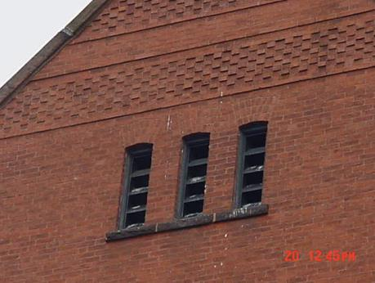

**Air Intake Vents for AHU on Third Floor**

**Picture 2**

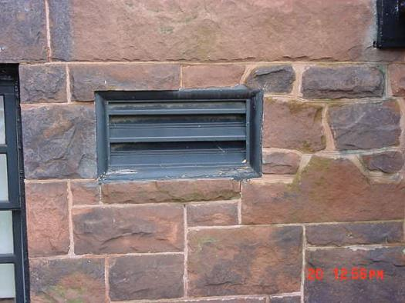

**Air Intake Vent for Basement AHU**

**Picture 3**

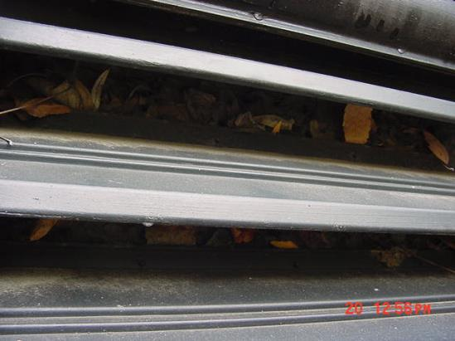

**Basement Air Intake Clogged With Leaves and Debris**

**Picture 4**

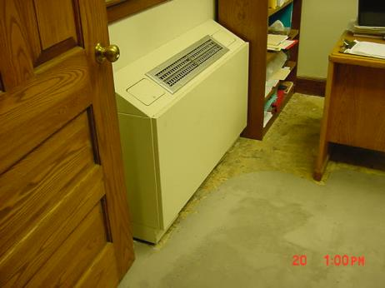

**Fan Coil Unit**

**Picture 5**

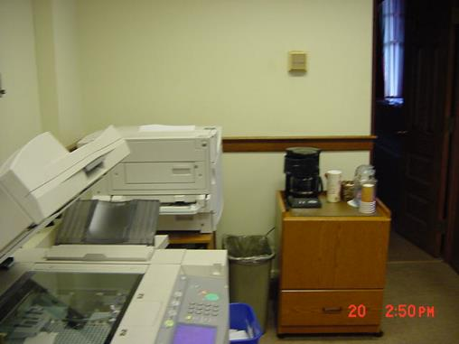

**Thermostat over Coffee Maker and Near Printer**

**Picture 6**

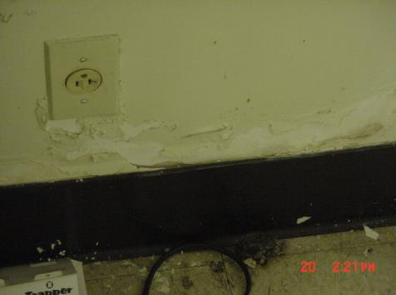

**Peeling Paint/Efflorescence in Basement Staff Lounge/Break Room**

**Picture 7**

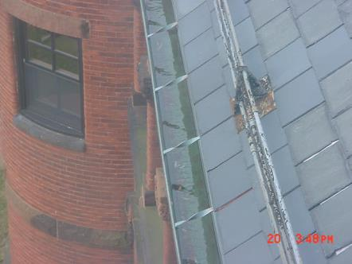

**Standing Water in Gutter System**

**Picture 8**

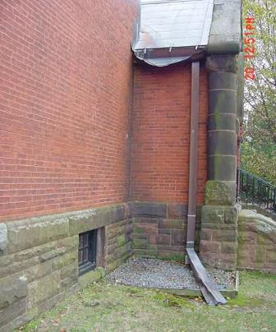

**Damaged Gutter/Downspout System**

**Picture 9**



**Missing/Damaged Mortar around Exterior Brick**

**Picture 10**

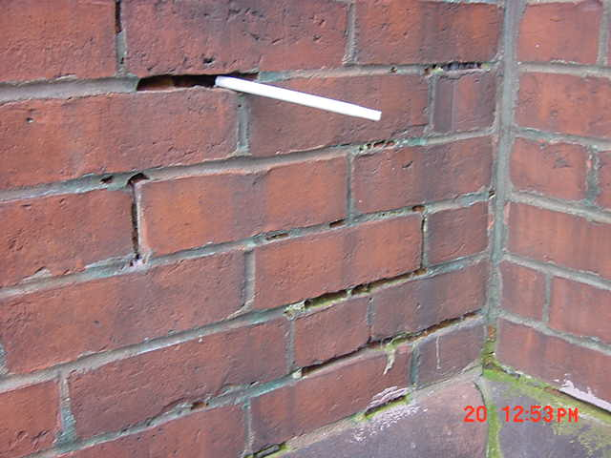

**Missing/Damaged Mortar around Exterior Brick, Pen Inserted by BEHA Staff**

**Picture 11**

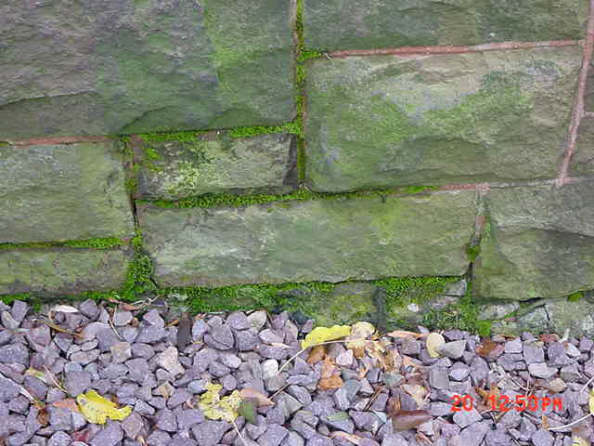

**Moss Growth Along Foundation**

**Picture 12**

**Picture 12 - Mold Colonized/Water Damaged Folders in Attic Storeroom
**

**Mold Colonized/Water Damaged Folders in Attic Storeroom**

**Picture 13**

**Picture 13 - Mold Colonized/Water Damaged Cardboard Boxes in Attic Storeroom
**

**Mold Colonized/Water Damaged Cardboard Boxes in Attic Storeroom**

**Picture 14**



**Truck Backed in against Building Near Office Window**

**Picture 15**

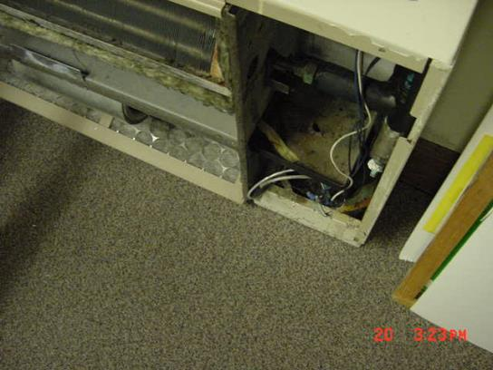

**Fan Coil Unit With Front Plate Removed, Note Filter on Carpeting**

| **Location/Room** | **Temp**  **(°F)** | **Relative**  **Humidity**  **(%)** | **Carbon**  **Dioxide**  **(*ppm)** | **CO (ppm)** | **TVOCs**  **(ppm)** | **Occupants**  **in Room** | **Windows**  **Openable** | **Ventilation** | | **Remarks** |
| --- | --- | --- | --- | --- | --- | --- | --- | --- | --- | --- |
| **Supply** | **Exhaust** |
| Background | 49 | 51 | 342 | ND | ND |  |  |  |  |  |
| BOH Office | 68 | 52 | 583 | ND | ND | 2 | N | N | N | FCU – off, filter not properly installed, minimal filtration |
| Building Dept. | 70 | 46 | 640 | ND | ND | 2 | Y | N | N | No filter in FCU |
| Restrooms Lower Level | 71 | 47 | 586 | ND | ND |  | Y | N | Y | Conc. Liquid Deodorant |
| Mystic Valley | 71 | 42 | 403 | ND | ND | 0 | Y | Y | N | Dislodged CT, Broken CT |
| Conservation | 78 | 43 | 490 | ND | ND | 0 | N | N | N |  |
| Staff Lounge | 72 | 42 | 522 | ND | ND | 0 | N | N | N | Efflorescence walls base of, WD wall plaster |
| Treasurer’s Office | 78 | 37 | 493 | ND | ND | 4 | Y | N | N | Accumulated items, PC |
| Waterfield Rm | 78 | 42 | 432 | ND | ND | 0 | N | Y | N |  |
| Eng Dept. | 78 | 39 | 498 | 2 | ND | 1 | Y | Y | N | 3 CT in office, PC, Blueprint machine, Dusty FCU, No filters, Vehicle parked close proximity, Dirt/dust flat surfaces in file room/old plans, Vents blocked |
| Archives | 72 | 41 | 486 | ND | ND | 0 | N | Y | N | FCU-on |
| Assessors | 78 | 44 | 674 | ND | ND | 3 | Y | N | N | Filters not installed |
| Selectman’s Rm | 72 | 38 | 474 | ND | ND | 0 | Y | Y | Y |  |
| Town Manager’s Reception | 74 | 39 | 476 | ND | ND | 1 | Y | N | N | Printer near Thermostat, WD ceiling plaster |
| Town Clerk | 74 | 37 | 530 | ND | ND | 1 | Y | N | N | Bubbler on carpet |
| Winchester Rm | 74 | 35 | 436 | ND | ND | 0 | N | N | N |  |
| Comptroller | 78 | 35 | 544 | ND | ND | 0 | Y | Y | Y | PC |
| Aberjona Rm | 78 | 33 | 420 | ND | ND | 0 | N | Y | N |  |
| Attic Storage Rm |  |  |  |  |  |  |  |  |  | WD – mold on folders, papers, boxes, WD carpet to be removed |
| Retirement | 72 | 37 | 441 | ND | ND | 1 | Y | N | N |  |
| Town Manager’s Office | 75 | 35 | 488 | ND | ND | 1 | Y | N | N |  |
| Assistant Town Manager’s Office | 70 | 35 | 507 | ND | ND | 1 | Y | N | N | WD Ceiling plaster |