INDOOR AIR QUALITY ASSESSMENT

Winchester Town Hall
71 Mt Vernon Street
Winchester

July 2024



Prepared by:
Massachusetts Department of Public Health
Bureau of Climate and Environmental Health
Indoor Air Quality Program

Contents

EXECUTIVE SUMMARY 3
BACKGROUND 5
RESULTS AND DISCUSSION 5
Ventilation 6
HVAC System Maintenance 6
HVAC Types and Specific Conditions 7
Water Damage and Moisture Concerns 7
Sources of Respiratory Irritants/Possible Asthma Triggers 9
Other IAQ Issues 10
CONCLUSIONS AND RECOMMENDATIONS 11
REFERENCES 15
PICTURES 16
Table 1 27
Table 2A 31
Table 2B 32
Table 2C 33
Table 3 34
Table 4 36

EXECUTIVE SUMMARY

The Massachusetts Department of Public Health’s Indoor Air Quality Program (MDPH IAQ) conducted an IAQ assessment of the Winchester Town Hall (WTH), located at 71 Mt Vernon St, Winchester, MA on June 11, 2024. This assessment was requested by the Health Director for the Town of Winchester.
Any building can have IAQ issues. These issues can be made worse through conditions common to marginalized communities (Environmental Justice communities or EJ) such as inequitable exposure to outdoor air pollution and a greater likelihood of poor building conditions leading to deterioration of IAQ resulting in higher asthma rates. While WTH is not itself in an EJ community, there are portions of Winchester which are.
The assessment was conducted by evaluating several key elements within the building; a visual inspection of the heating, cooling, and ventilating (HVAC) systems, water/microbial damage, cleanliness, point sources of respiratory irritants such as chemicals, and electronic measurement of carbon dioxide (CO₂), carbon monoxide (CO), temperature, relative humidity (RH), and small particulate matter (PM2.5) all taken with a Qtrak XP monitor. Data is collected in this manner to identify potential asthma triggers, allergens, and other environmental factors that can cause indoor air quality symptoms. Please refer to the Indoor Air Quality Manual on the MDPH website for methods, sampling procedures, and interpretation of results.
This building was visited twice previously, most recently in 2017. Both of those reports are available at https://www.mass.gov/info-details/indoor-air-quality-reports-cities-and-towns-w#winchester-. Prior to the June 2024 visit, responses to the recommendations in that report were submitted to the IAQ program. A summary of those responses to the 2017 report is included as Appendix A.
As a result of this assessment, there are several findings: conditions in this building are much the same as conditions found during the 2017 assessment. Fan coil units (FCU) are beyond their service life and do not have the ability to drain moisture as originally designed. In addition, filters do not fit properly in the units and sometimes fall onto the floor. Fresh air supply to this building is limited, which means it relies on open windows during all times of the year to provide fresh air. This represents a balancing act – while opening windows can bring in fresh air, it can also allow in vehicle exhaust, pollen, mold spores, wildfire smoke, pests, and noise, as well as excess moisture that may damage building materials. Some water damage in the form of stained ceiling tiles, damaged corkboard, and other items were noted in the building, and there are issues relating to materials stored in the WTH. (Results and Discussion)
Upon review of these findings, a number of recommendations are made to optimize existing systems and improve air exchange. Issues regarding the presence of point sources of irritation such as clutter can be addressed to reduce dust and odors. (Conclusions)
Based on the results of the assessment, the following primary recommendations are made:
- Keep at least some windows open in occupied rooms that lack mechanical ventilation unless there are poor outdoor conditions or occupant concerns. Such conditions may include: heavy precipitation, extreme cold, high pollen counts, idling vehicles, or excessive noise. Ensure windows are closed tightly at the end of the day.
- Maintain the fan coil units as well as possible, including ensuring filters fit securely to enable the FCUs to filter room air.
- Air purifier units that use HEPA filters with or without carbon filters are good choices for occupied areas; units that may produce ozone should not be used. Maintain all in accordance with manufacturer’s instructions.
- Reduce the number of items stored in rooms to make cleaning easier. (Conclusions and Recommendations)
Please note: this report contains a series of recommendations that should serve as Best Practices that apply to most public buildings across the Commonwealth and should be shared amongst other buildings in Winchester.

BACKGROUND

Building: | Winchester Town Hall (WTH)
Address: | 71 Mount Vernon Street, Winchester, MA
Coordinated Via: | Health Department Director Jen Murphy
Reason for Request: | General IAQ
Date of Assessment: | June 11, 2024
Massachusetts Department of Public Health/Bureau of Climate and Environmental Health (MDPH/BCEH) Staff Conducting Assessment: | Ruth Alfasso, Inspector, IAQ Program, and Jennifer Lajoie, Inspector, IAQ Program
Building Description: | Winchester Town Hall is a two-story brick building with an occupied basement. It was originally built in 1887 and has been used as the Town Hall since that time. The building has a complex shape, including a bell tower, and is located in Winchester Town Center next to the town’s public library. There is a waterway to the rear of the building. While various upgrades to the building have occurred, they are limited by the building’s status on the Historic Register.
Windows: | Most windows in the building are openable.

RESULTS AND DISCUSSION
The following is a summary of indoor air testing results (Table 1)
- Carbon dioxide (CO₂) | a measure of the adequacy of ventilation | Levels were below the MDPH guideline of 800 parts per million (ppm) in most of the areas surveyed. Note that most areas in this building lack mechanical ventilation, relying on open windows for fresh air.
- Temperature | a measure of comfort | Was within the MDPH recommended range of 70°F to 78°F in occupied areas.
- Relative humidity | a measure of comfort and, when in excess for an extended period, a way to reflect the potential for mold and fungal growth | Was within the MDPH recommended range of 40 to 60% in all areas tested. This is reflective of outdoor conditions. Relative humidity would be expected to be lower with cold outdoor temperatures and indoor heating, and higher during hot, humid weather.
- Carbon monoxide  (CO) | a product of combustion that can result in acute and long term cardiovascular, respiratory, and neurological symptoms | No carbon monoxide was detected during the assessment.
- Particulate matter (PM2.5) | a way to measure inhalable particle distribution in the air | Concentrations were below the National Ambient Air Quality Standard (NAAQS) of 35 micrograms per cubic meter (μg/m³) in all areas tested.

Ventilation
Ventilation refers to both the supply of fresh air and the removal of stale air from a room. The introduction of fresh air into an occupied space will dilute normally occurring pollutants that are generated by occupancy and other activities. In addition, a heating, ventilating and air-conditioning (HVAC) system will remove pollutants from a building if operating appropriately. All ventilation systems throughout the building should operate continuously during periods of occupancy.

When originally constructed in the 1800s, the building was likely unoccupied during the warmest, most humid, months of the year. The building originally used open windows (Picture 1) to provide cross ventilation during warm weather.

In the late 1980s, the building was renovated with the installation of some HVAC equipment. This included fan coil units (FCU) installed along exterior walls within the building (Picture 2) and in some interior rooms. The FCUs are designed to provide both heat and cooling. FCUs recirculate air and do not have the capacity to provide fresh air into buildings. Depending on the setting, heated or chilled water is pumped through a finned tube (Picture 3) that is connected to the furnace/chiller by copper pipes that are installed in the pipe chase. Water runs through the copper pipe into the coils, which heat/cool the air forced over the coils by the FCU fans.

Some rooms also had been retrofitted to have a fresh air supply, which was ducted in though ceiling-mounted vents (Picture 4). Restrooms are equipped with exhaust vents (Picture 5).

(Table 2B).

The various types of ventilation components as well as devices that can move/redirect airflow are listed in Table 2A, Table 2B and Table 2C.

HVAC System Maintenance
- Internal FCU components were in poor condition, with signs of corrosion and damage (Picture 6). Note that these units were likely installed in the mid-1980s, making them more than 30 years old. Function of equipment of this age is difficult to maintain since compatible replacement parts are often unavailable. According to the American Society of Heating, Refrigeration, and Air-Conditioning Engineers (ASHRAE), the service life for a unit heater (hot water or steam) is 20 years, assuming routine maintenance of the equipment (ASHRAE, 1991). Although attempts have been made to maintain the FCUs, the operational lifespan of the equipment has been exceeded.
- During the 2017 visit, IAQ staff noted the FCUs had filters lying on the floor beneath the fan. This was noted in some areas during this visit as well (Picture 7). During the 2017 visit, previously noted FCUs were not equipped with the proper fixtures to properly insert and hold the filters in place. Filters in FCU and other air handling equipment serve several functions, including protecting the units from damage from objects, keeping the fins clean to ensure adequate heat transfer, and filtering the airstream in the room to remove dust and other fine particles.
- Restroom exhaust vents could not be tested for draw, but they were dusty suggesting that they had been operating recently. Exhaust vents are important in restrooms to remove odors and moisture.
- In its current configuration the HVAC system cannot be balanced as recommended, since the WTH does not have a mechanical HVAC system with both fresh air supply and exhaust ventilation.
HVAC Types and Specific Conditions
Balancing
To have proper ventilation with a mechanical supply and exhaust system, a system must be balanced to provide an adequate amount of fresh air to the interior of a room while also removing stale air from the room. It is recommended that HVAC systems be re-balanced every five years to ensure adequate air systems function (SMACNA, 1994).
(see HVAC pictures)
Additional HVAC Conditions:
- In rooms without mechanical fresh air supply, open windows are the only source of fresh air. This means that windows should be opened during most occupied periods to provide some air exchange. It is difficult to maintain comfortable temperatures in all seasons while opening windows. In addition, open windows during heavy rain or hot, humid weather can bring in significant amounts of moisture which not only increases discomfort but can lead to water damage and mold growth.
- As most rooms in the building also lack exhaust ventilation, it is even more vital to control airborne contaminants that may be brought in or generated inside. This is discussed further in the sections below.

Water Damage and Moisture Concerns
Please note that the IAQ Program does not recommend conducting mold testing in a typical water damage remediation. For details, please consult Guidance Regarding Testing for Mold in Water-Damaged Public Buildings | Mass.gov
The application of a mildewcide to moldy porous materials is not recommended.

Molds are found naturally in our environment both indoors and outdoors. Inside, mold growth may occur when items, particularly porous products such as paper or gypsum wallboard, are exposed to moisture. Typical water sources include leaks, floods, and condensation. To avoid mold growth, dry all water-damaged items and affected areas within 24-48 hours and reduce indoor humidity. Some people with chronic respiratory conditions, such as asthma, are more likely to experience health symptoms associated with molds, including allergic reactions and respiratory irritation. Controlling moisture is the key to preventing mold growth and potential health symptoms.
Hot humid summers are becoming more frequent due to climate change. Massachusetts has experienced hot, humid, and rainy summers in 2018, 2021, and 2023. July of 2021 was the wettest ever recorded in Massachusetts, and the three-month period from June through August, known as the meteorological summer, was the fourth wettest on record, according to the National Oceanic and Atmospheric Administration’s (NOAA) Centers for Environmental Information (NOAA, 2021). The summer of 2023 was also hot, and wet, being measured as the second rainiest on record (WBUR, 2023). These conditions are challenging for buildings, particularly those without air conditioning.
During these hot and wet summers, extended periods of outdoor relative humidity above 70% occurred. Under these weather periods, public buildings experienced extended periods of water vapor exposure from high relative humidity. When exposed to these conditions, porous materials such as gypsum wallboard, cardboard, and other materials may become prone to developing mold colonization, particularly if located in areas that are prone to developing condensation on floors and walls (e.g., below grade space).
Of particular note is moisture and water damage associated with the operation of the FCUs. These units condense water from the air when warm, humid air comes in contact with the chilled fins in the units. FCUs with cooling are typically designed to collect this condensate in a drain pan and then drain it away from the unit. The FCUs in the WTH were not functioning correctly during the 2017 visit, alowing an overflow of condensate onto the floor, including in carpeted areas.
- Water-damaged ceiling tiles were found in a few locations (Table 1), which can indicate current/historic roof/plumbing leaks or other water infiltration. Water-damaged ceiling tiles can provide a source of mold and should be replaced after a water leak is discovered and repaired. One of these water-damaged ceiling tiles had dark staining that likely indicates mold growth (Picture 8).
- There was a water-damaged corkboard in the Waterfield room (Picture 9), This was noted in the 2017 report and was recommended to be removed. Odors were noted in the Waterfield room which are associated with water damaged corkboard. Corkboards can be a source of odors if they become moistened, and it is possible that there is mold on the back of the corkboard.
- Buckets were in place to collect water in the assessor’s office (Picture 10). Leaks should be repaired, and any water-damaged ceiling tiles should be replaced. Note that containers used for temporary collection of leaks should be emptied regularly to prevent odors due to stagnant water.
- There were also buckets to collect water hanging from a pipe in the mechanical room, and water on the floor. This may have resulted from condensation due to ineffective insulation on pipes.
- A hole was noted in the wall under a sink (Picture 12). This hole can allow moisture, dust, and pests into the room from behind the wall.
- Water dispensers were located over carpet (Picture 13). These appliances can spill or leak and moisten carpet. Carpet that is repeatedly or chronically moistened can become mold colonized.
- Plants were noted in some offices (Picture 14; Table 1). Plants can be a source of pollen or mold especially if overwatered or not well maintained.
- An aquarium was noted in an office (Picture 15). Aquariums should be well maintained to avoid odors associated with stagnant water.
- Food and food preparation equipment were noted in several areas, including one full kitchen with a stove and oven. Food preparation equipment should be kept clean to avoid smoke and odors that can linger due to the lack of exhaust ventilation. Crumbs should be cleaned regularly to prevent pests, and all food should be stored in pest-proof containers.
- The exterior of the building was inspected for sources of water infiltration and related irritants. Plants were noted growing on the exterior of the building (Picture 16). Ivy and other plants can degrade brick and mortar and may provide transportation for pests to enter the building. Other trees and plants were observed near the building where they can be a source of pollen, mold, and insects into the building.

A list of water damage issues identified inside and outside the building is included as Table 3.
(see Water Damage and Moisture Concern Pictures)
Mold Growth
Porous materials (e.g., gypsum wallboard, ceiling tiles and carpeting) can be dried with fans and heating within 24 to 48 hours of becoming wet (US EPA, 2008).
If porous materials are not dried within this time frame, mold growth may occur.

Sources of Respiratory Irritants/Possible Asthma Triggers

Asthma is a lung disease that can make breathing difficult. Without careful management of asthma, some people can have symptoms, like a tight feeling in the chest, shortness of breath, coughing, or wheezing. Although there is no cure for asthma, people with asthma can live healthy, active lives. A safe and healthy environment helps to reduce asthma symptoms.

- Personal products, particularly those with volatile organic compounds (VOCs) including scents, can also be a source of respiratory irritation. VOCs are carbon-containing substances that have the ability to evaporate at room temperature. Frequently, exposure to low levels of total VOCs (TVOCs) may produce eye, nose, throat and/or respiratory irritation in some sensitive individuals. Products noted were cleaners, air fresheners and perfume (Picture 17; Table 1).
- Dust, a common respiratory and eye irritant, can collect on surfaces and items. Although janitorial and maintenance staff perform routine cleaning, they may not be able to clean as effectively if items are not picked up or surfaces are cluttered.
- Even with a properly functioning ventilation system, it is necessary to reduce the use of materials that can be a source of respiratory irritants to prevent symptoms in individuals who have sensitivity to such pollutants. Without mechanical exhaust in most areas, irritants can linger.

For guidance on maintaining an asthma-friendly healthy school environment, please consult the MDPH Asthma Prevention and Control Program’s Clearing the Air: An Asthma Toolkit for Healthy Schools.
Possible asthma triggers and/or airborne pollutants exist in the building. These are listed below as well as in (Table 4).
(see Sources of Respiratory Irritant Pictures)

- Papers, books and other paper materials were found in WTH (Pictures 18 and 19). This material can be a source of, and collect, dust if not stored neatly and cleaned periodically. Paper and records storage in town halls is a common issue.
- Rooms on the upper levels are carpeted (Table 1). Carpeting should be cleaned regularly using a HEPA-filtered vacuum cleaner to remove dust and dirt without aerosolizing it. Carpeting should also be deep cleaned at least once a year. Ensure that water is extracted from the carpeting during the cleaning process and that carpeting is allowed to dry thoroughly before items, including areas rugs, are placed back on top.
- Air purifiers were noted in many rooms (Picture 20; Table 1). Air purifiers with high efficiency particulate air (HEPA) filters, with or without a carbon filter are a good choice for occupied areas. Some of the air purifiers in the building have an ionizing setting. This setting can produce ozone, which is a respiratory irritant and should not be used. Air purifiers should be placed where the filtered airstream will be in the breathing zone of occupants, and should be properly maintained, including filter changes.

Other IAQ Issues

Radon

Radon is a naturally occurring radioactive gas that seeps into buildings from the surrounding soil and at elevated levels can increase the risk of lung cancer.

The Environmental Protection Agency (EPA) conducted a National School Radon Survey “in which it discovered nearly one in five schools has at least one schoolroom with a short-term radon level above the action level of 4pCi/L (picocuries per liter) – the level at which the EPA recommends that schools take action to reduce the level” (US EPA, 1993). Other buildings, including housing, offices, and commercial buildings, may have radon levels of concern as well.

The MDPH IAQ Program recommends that every school be tested for radon, and that this testing be conducted during the heating season while school is in session in a manner consistent with US EPA radon testing guidelines. Other buildings where people spend time, especially buildings with occupied rooms in contact with or below the ground, should also be tested for radon. Radon measurement specialists and other information can be found at www.nrsb.org and http://aarst-nrpp.com/wp, with additional information at: https://www.mass.gov/radon.

CONCLUSIONS AND RECOMMENDATIONS

Please note: this report contains a series of recommendations that should serve as Best Practices that apply to many public buildings across the Commonwealth and should be shared amongst other buildings operated by the Town of Winchester.

As previously noted, the WTH was assessed in 2004 and 2017 Both reports are available at the following links:
- https://www.mass.gov/doc/winchester-town-hall-july-2004/download
- https://www.mass.gov/doc/winchester-town-hall-august-2017/download

Some of these recommendations were implemented, primarily replacing the basement hallways with a mold-resistant floor covering (see Appendix A). It is important to note that if relative humidity is not properly controlled, materials in the basement may become wet and become colonized by mold. Such materials include, but are not limited to:
- gypsum wallboard,
- cellulose ceiling tiles,
- baseboard wood,
- cardboard,
- paper,
- bound books,
- corkboard, and
- paper-covered pipe insulation.

In addition, high relative humidity will cause paper to absorb moisture, which in turn cause paper jams in photocopiers and computer printers (Fisher, N., 2024).
The basement of the WTH has experienced water damage likely related to high relative humidity experienced during hot, humid weather. In addition, due to the age of construction of the building; lack of mechanical ventilation equipment to provide adequate heated or chilled fresh air; lack of exhaust ventilation in restrooms, and water penetration through the foundation, the WTH space has limited ability to reduce relative humidity indoors even with properly operating FCUs that drain condensation.
Various issues noted may be typically found in town halls and similar buildings. However, the lack of mechanical fresh air supply in most rooms makes controlling temperature, humidity, and airborne contaminants significantly more difficult. Facility staff and occupants need to remain aware of the limitations of the system, use fan coil units and open windows to the best that they can be used, and limit or eliminate sources of airborne irritants in the building including reducing clutter.
Short-term recommendations can be implemented as soon as practicable, however long-term measures are more complex and will require planning and resources to adequately address overall indoor air quality issues within the building.

Short-term Recommendations
HVAC System |  | Helpful Links
1. | Keep at least some windows open in occupied rooms without mechanical ventilation unless contradicted by outdoor conditions or occupant concerns.  Such conditions may include: heavy precipitation, extreme cold, poor outdoor air quality, high pollen counts, idling vehicles, or excessive noise. | https://www.airnow.gov/
2. | Ensure windows are closed tightly at the end of the day.
3. | Maintain the FCUs as well as possible, including regular cleaning of the interior of cabinets. Ensure filters fit into each unit and are replaced regularly.
4. | It is important to note that areas inside the WTH that have FCUs operating to provide chilled air must have all exterior doors and windows closed in hot humid weather. In addition, doors connecting rooms with FCUs operating with other areas must be closed to prevent draw of hot, humid air outside and other areas of the building. Doors between office areas and hallways are the primary doors that should be closed.
5. | Air purifiers that use HEPA filters, with or without carbon filters, are good choices for occupied areas. Units that may produce ozone should not be used. Maintain all in accordance with manufacturer’s instructions. | https://www.epa.gov/indoor-air-quality-iaq/ozone-generators-are-sold-air-cleaners
6. | Air handling units that serve those rooms with mechanical ventilation should have filters changed at least twice a year using the best Minimum Efficiency Rating Value (MERV) that can work with current equipment. | ANSI/ASHRAE Standard 52.2-2017
7. | During filter changes, clean dust and debris from the inside of HVAC system cabinets.
Water Damage Sources
8. | Replace water-damaged ceiling tiles. Repeated water damage to ceiling tiles indicates leaks from the roof or plumbing/HVAC system which should be repaired. | http://www.epa.gov/mold/mold-remediation-schools-and-commercial-buildings-guide
9. | Until leaks can be repaired, regularly clean and empty buckets and reservoirs.
10. | Do not store cardboard or other porous items directly on ground-level floors to prevent mold growth due to condensation on cool surfaces, Elevate items with pallets or store on shelving.
11. | Seal spaces around exterior doors with weatherstripping, to prevent drafts, moisture, and pest entry.
12. | Properly maintain plants and aquariums to avoid mold and odors. Keep plants away from airflow.
13. | Seal areas under sinks to prevent entry of dust and pests from interior wall spaces.
14. | Place rubber or water resistant mats under water coolers/fountains or relocate to non-carpeted areas.
15. | Use these guidelines to control for moisture and increase comfort in a minimally air-conditioned building especially during heatwaves. | - Mold Growth Prevention During Hot, Humid Weather https://www.mass.gov/service-details/preventing-mold-growth-in-massachusetts-schools-during-hot-humid-weather  - Remediation and Prevention of Mold Growth and Water Damage in Public Schools https://www.mass.gov/service-details/remediation-and-prevention-of-mold-growth-and-water-damage-in-public-schools-and  - Methods for Increasing Comfort in Non-air-conditioned Schools https://www.mass.gov/doc/methods-for-increasing-comfort-in-non-air-conditioned-schools/download
16. | Remove clinging plants from the exterior of the building and trim other plants and trees at least 5 feet away from the building.
Respiratory Irritants/Possible Asthma Triggers
17. | Clean dust from surfaces, frequently using methods that do not aerosolize the dust, including HEPA-equipped vacuuming or wet wiping. Avoid using feather dusters or sweeping dust into the air.
18. | Reduce use of products and equipment that create irritating volatile organic compounds (VOCs) and only use in well-ventilated areas. Minimize the use of air fresheners (e.g., plug-ins), deodorizers and scented products. | https://www.mass.gov/cleaner-greener-healthier-schools  Clean Air Is Odor Free
19. | Ensure copiers and laminators are used in well-ventilated rooms.
20. | Develop procedures to sort and store paper and related items to prevent a buildup of large quantities of paper. Store remaining items neatly and off the floor. Where rooms have a history of moisture issues, consider storing items in waterproof totes
21. | Clean carpeting regularly using a HEPA-equipped vacuum cleaner, and deep clean periodically as recommended by the manufacturer.
22. | Remove corkboards.
Other Recommendations to Improve Air Quality Conditions
23. | Consider testing the building for radon by a certified radon measurement specialist during the heating season. | Radon measurement specialists and other information can be found at: www.nrsb.org, and http://aarst-nrpp.com/wp
24. | Address any additional recommendations from the 2017 report.
Long-term Recommendations
1. | Consult with a ventilation contractor to determine the feasibility of replacing fan coil units past their service life.
2 | Consult with a ventilation contractor to determine the feasibility of adding additional fresh air ventilation and mechanical exhaust ventilation to the building.

REFERENCES
ASHRAE. 2012. American Society of Heating, Refrigeration and Air Conditioning Engineers (ASHRAE) Standard 52.2-2012 -- Method of Testing General Ventilation Air-Cleaning Devices for Removal Efficiency by Particle Size (ANSI Approved).
Fisher, N. 2024. How Humidity Affects Your Copier And Paper Quality. Cobb Technologies, Richmond, VA. https://www.cobbtechnologies.com/blog/how-humidity-affects-your-copier-and-paper-quality.
NOAA. 2021. Summer 2021 neck and neck with Dust Bowl summer for hottest on record. National Oceanic and Atmospheric Administration, 1401 Constitution Avenue NW, Room 5128, Washington, DC 20230 https://www.noaa.gov/news/summer-2021-neck-and-neck-with-dust-bowl-summer-for-hottest-on-record
SMACNA. 1994. HVAC Systems Commissioning Manual. 1st ed. Sheet Metal and Air Conditioning Contractors’ National Association, Inc., Chantilly, VA.
US EPA. 1993. Radon Measurement in Schools, Revised Edition. Office of Air and Radiation, Office of Radiation and Indoor Air, Indoor Environments Division (6609J). EPA 402-R-92-014.
US EPA. 2008. Mold Remediation in Schools and Commercial Buildings. US Environmental Protection Agency, Office of Air and Radiation, Indoor Environments Division, Washington, D.C. EPA 402-K-01-001. http://www.epa.gov/mold/mold-remediation-schools-and-commercial-buildings-guide.
WBUR. 2023. “It's been a summer of rain and flooding misery in Mass.” WBUR local news. September 12, 2023. https://www.wbur.org/news/2023/09/12/summer-flooding-rain-massachusetts

(Click to link back to report)

PICTURES

Ventilation pictures
Picture 1

Open window
Picture 2
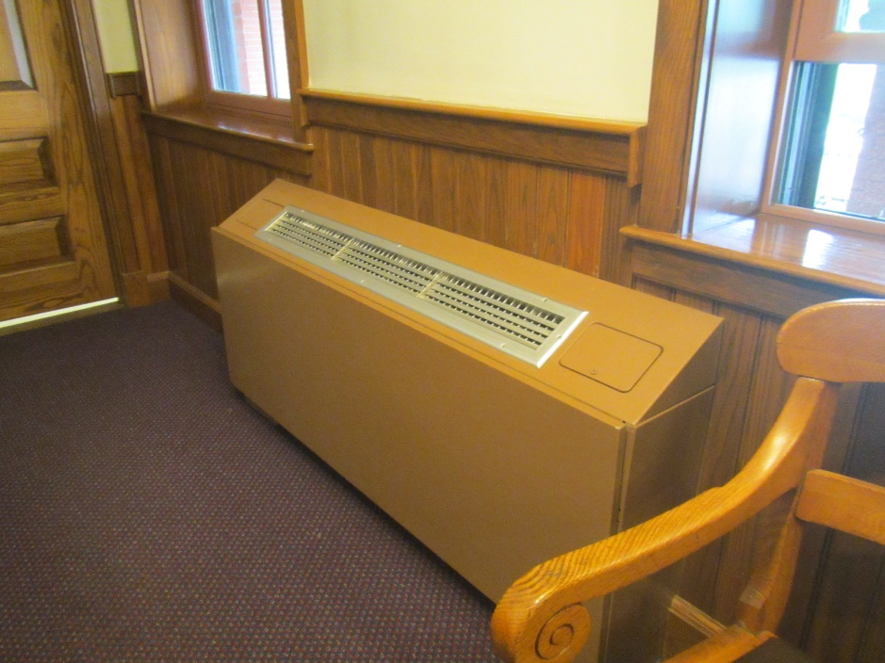
Fan coil unit (FCU)
Picture 3
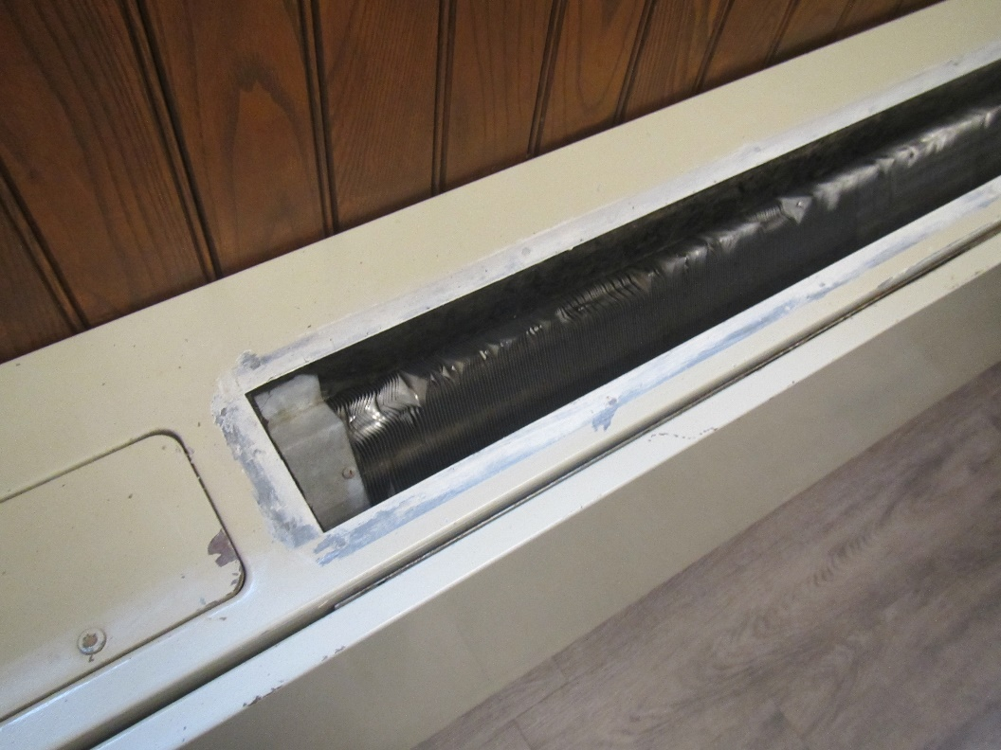
Damaged FCU showing finned tube inside
Picture 4
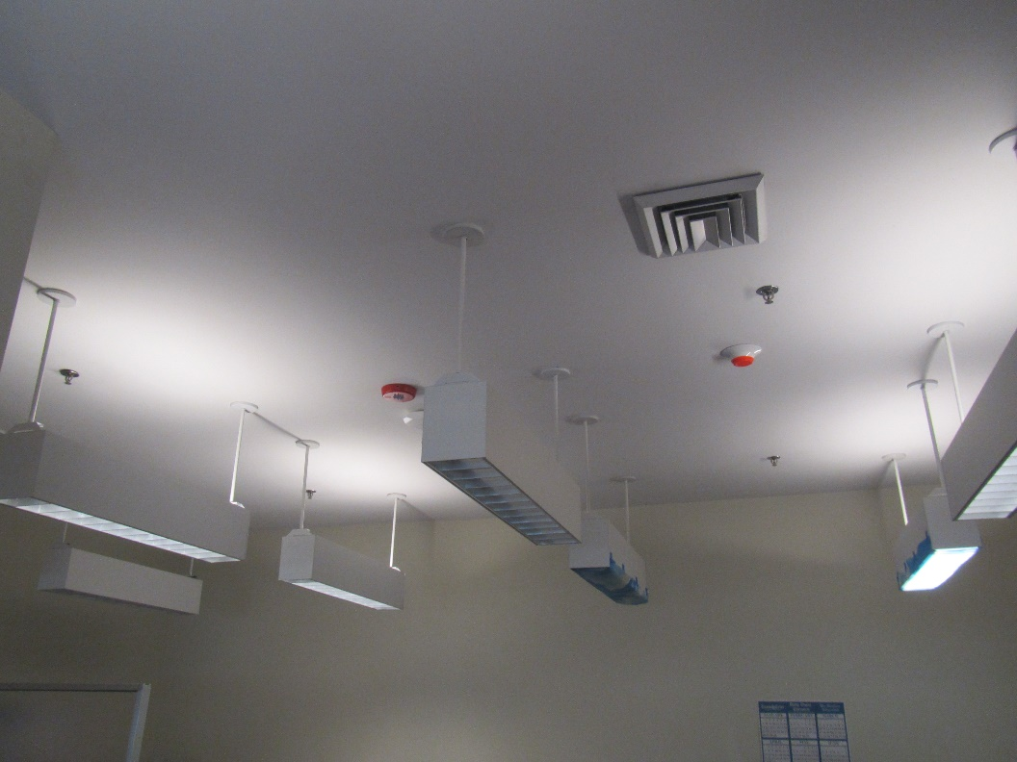
Ceiling-mounted fresh air supply vent
Picture 5
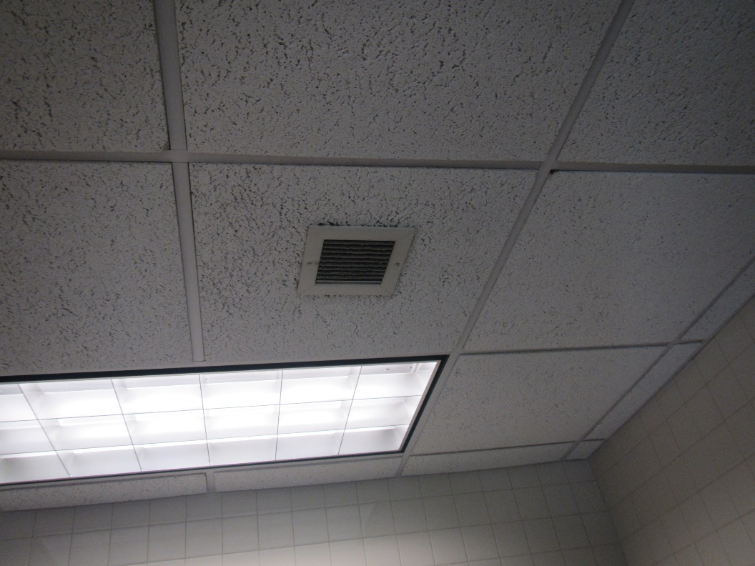
Exhaust vent in a restroom
Picture 6
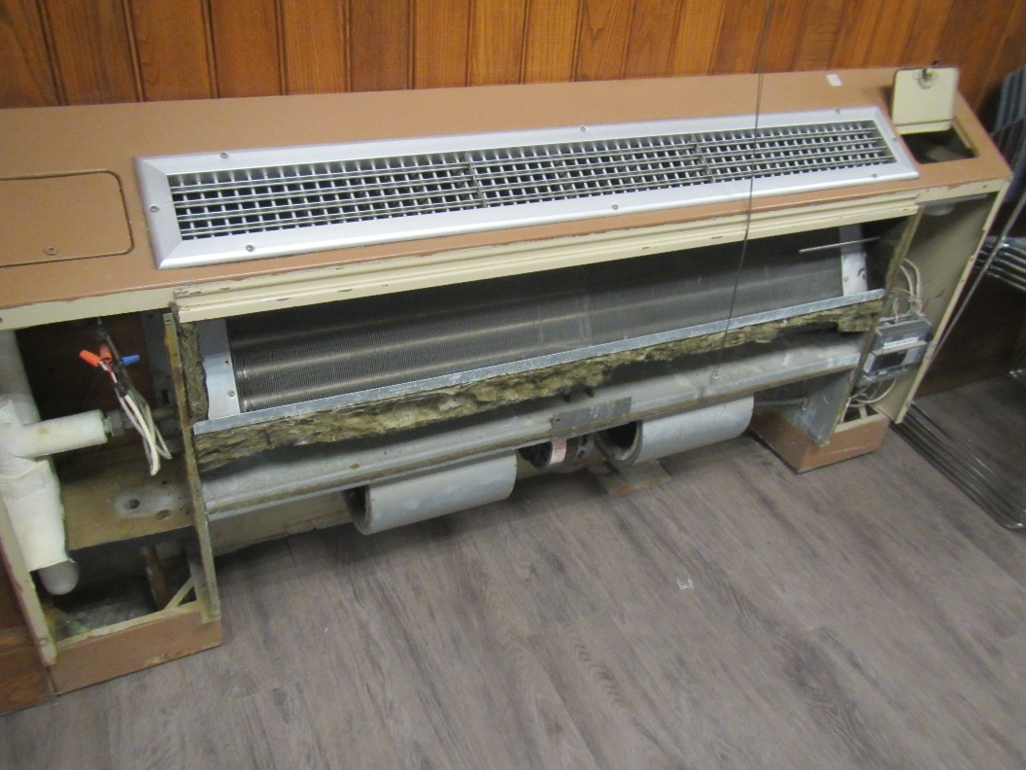
Interior of FCU
Picture 7
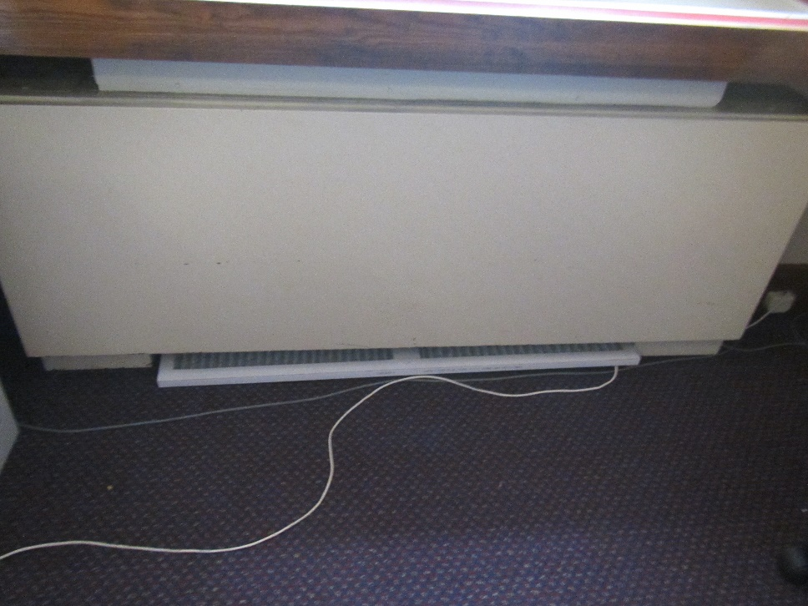
FCU filter on floor
Water Damage pictures
Picture 8
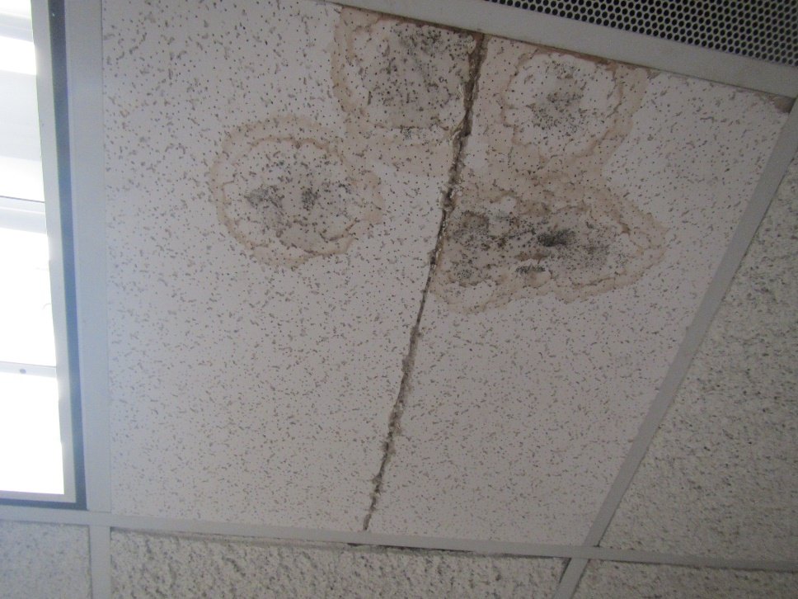
Water-damaged ceiling tiles that may be mold colonized (dark staining)
Picture 9

Water-damaged, wrinkled corkboard
Picture 10
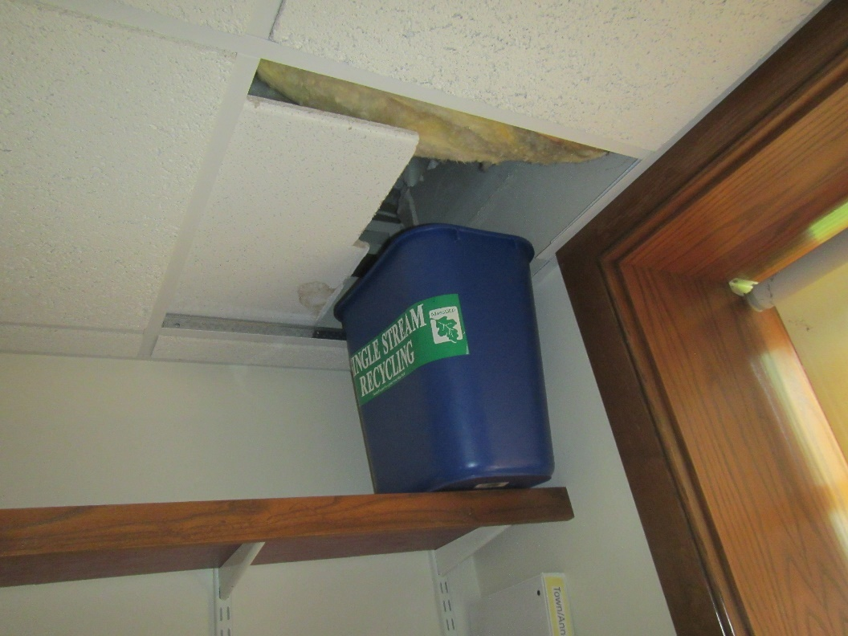
Water collection bucket in Assessors Office
Picture 11
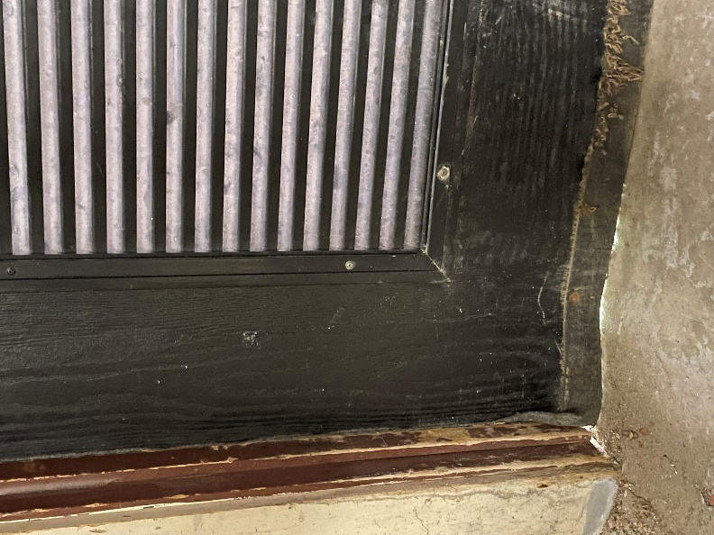
Hole beneath door in mechanical room
Picture 12
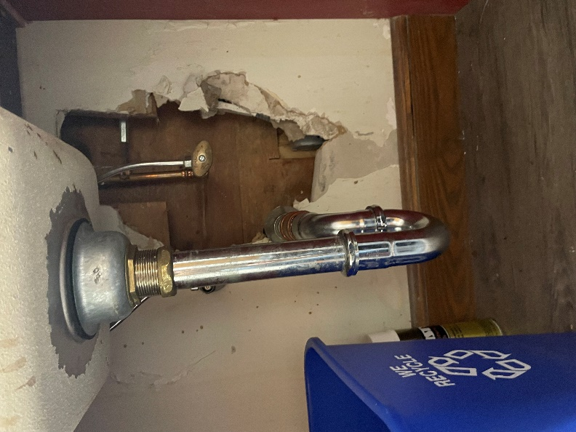
Hole under a sink
Picture 13
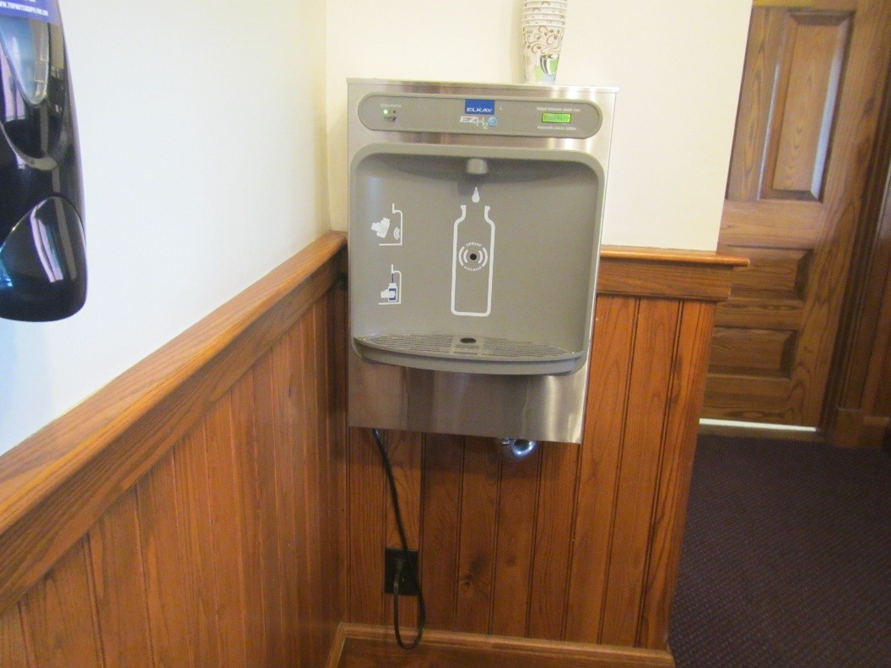
Water dispenser over carpet
Picture 14

Plants on a windowsill
Picture 15
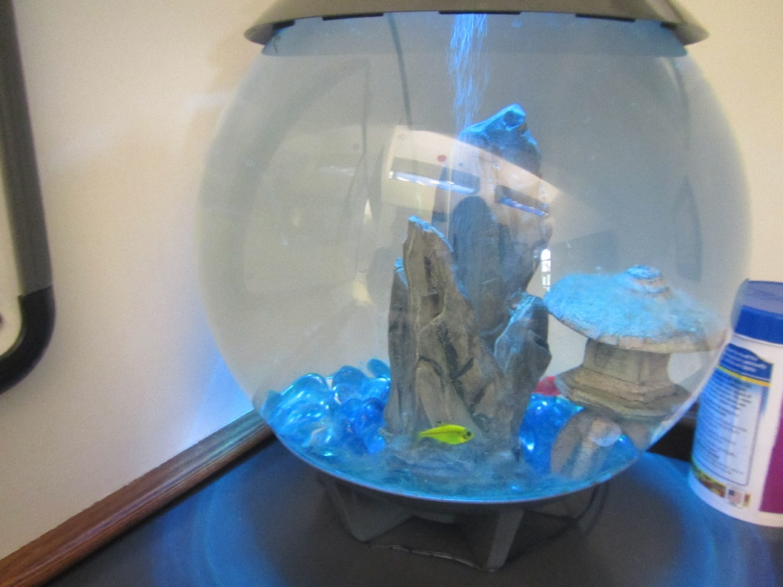
Aquarium
Picture 16
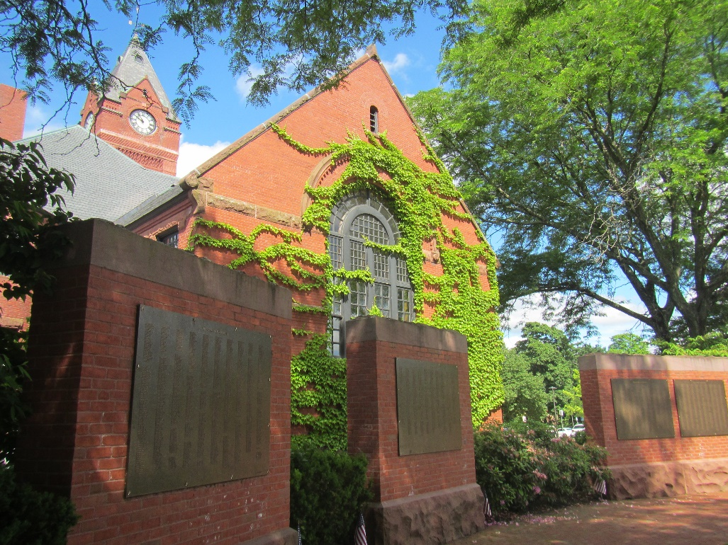
Ivy on the building

Respiratory Irritants pictures
Picture 17
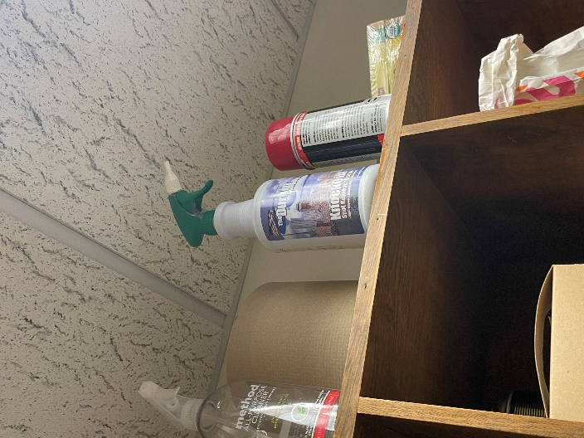
Various cleaning products in a storage area
Picture 18
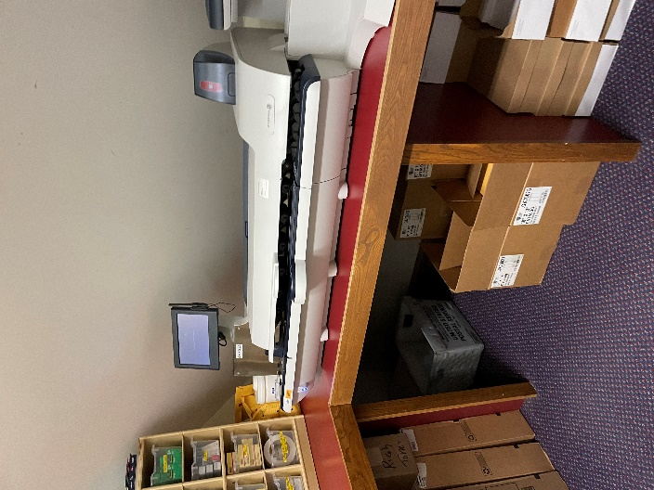
Boxes of materials and mail machine
Picture 19
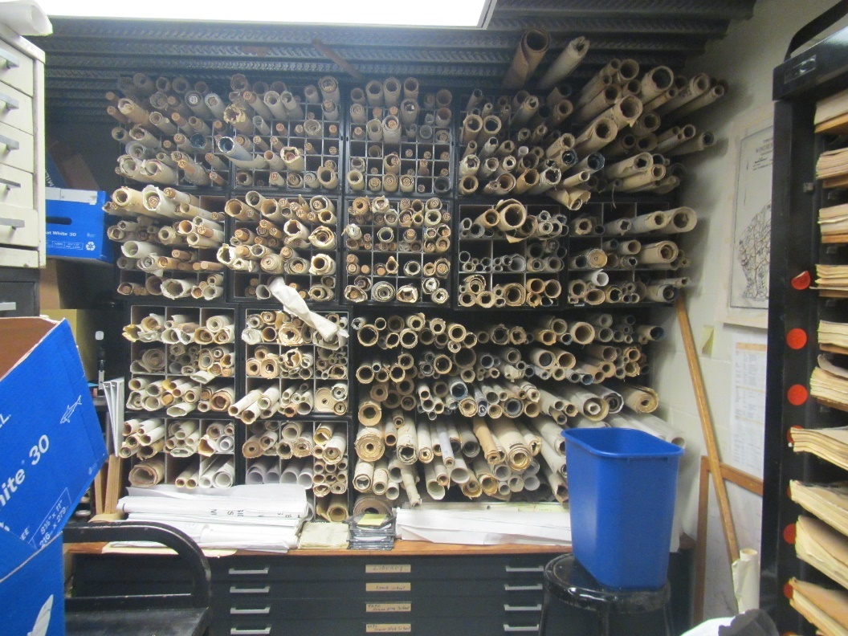
Large storage area for paper plans
Picture 20
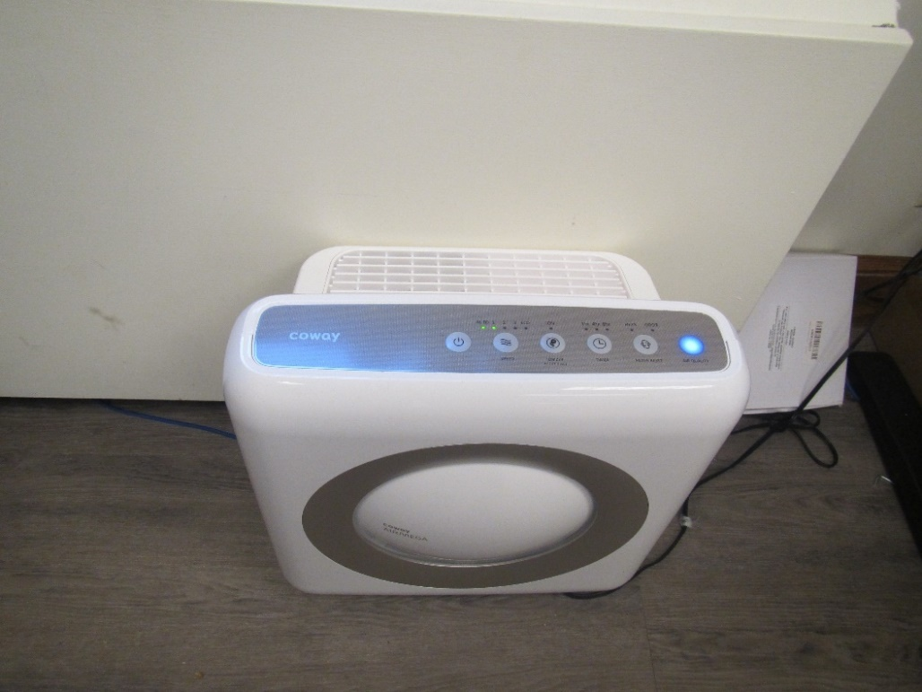
Air purifier with ionizer setting
Click to link back to report

Table 1

Location | Carbon  Dioxide  (ppm) | Carbon Monoxide  (ppm) | Temp  (°F) | Relative  Humidity  (%) | PM2.5  (µg/m³) | Occupants  in Room | Windows  Openable | Ventilation |  | Remarks
 |  |  |  |  |  |  |  | Supply | Exhaust
Background (outside) | 383 | ND | 74 | 53 | 2 |  |  |  |  | Mostly sunny
Basement
Health Director’s Office | 604 | ND | 74 | 53 | ND | 1 | Y | N | N | NC
Health Department main | 685 | ND | 74 | 54 | ND | 2 | Y 1 open | N | N | FCU, NC, AP – on (has ionizer setting), PC
Health Department nurse | 636 | ND | 75 | 54 | ND | 1 | N | Y | N
Conference room | 607 | ND | 73 | 56 | ND | 1 | N | Y | N | FCU
Building office | 617 | ND | 73 | 57 | ND | 0 | Y | N | N | FCU, NC
Building main | 641 | ND | 73 | 56 | ND | 3 | Y | N | N | PC, NC and walk-off mats,
Engineering | 406 | ND | 73 | 56 | 1 | 2 | Y | N | N | NC
Engineering vault | 398 | ND | 72 | 56 | ND | 0 | N | N | N | Old paper, metal ceiling, cement floor
Engineering rear | 386 | ND | 72 | 56 | 1 | 1 | Y 2 open | N | N | FCU off
Engineering rear office | 395 | ND | 72 | 56 | ND | 0 | Y 1 open | N | N | Area rug, NC, food, plant
Engineering staff room | 393 | ND | 72 | 56 | ND | 0 | N | y | N | (See pics) fridge, microwave, hole in wall behind sink
Engineering office | 407 | ND | 71 | 57 | 1 | 1 | Y | N | N | WD CT, NC, FCU, papers/clutter
Mechanical room | 483 | ND | 71 | 58 | ND | 0 | Y 1 open | N | N | Mechanical equipment, leaks, and buckets from pipes (Condensation?),water on floor, hole in door to outside, mats
Assessors | 490 | ND | 72 | 58 | ND | 1 | Y 1 open | N | N | Buckets and MT for leaks, FCU, WD CT, NC
Assessor’s office | 473 | ND | 72 | 58 | 1 | 0 | Y | N | N | MT with buckets for leaks, boxes on floor
Mystic valley room | 519 | ND | 71 | 57 | 1 | 1 | Y | Y | N | NC, plants, FCU
Health storage and kitchen | 573 | ND | 71 | 59 | ND | 1 | N | Y | N | Stove, refrigerator, vending, microwave, coffeemaker
Conservation/planning | 594 | ND | 71 | 59 | ND | 1 | Y |  |  | Recent WD CT (possible mold), NC
Conservation | 668 | ND | 71 | 61 | ND | 1 | Y | N | N | NC, AT, plants
First floor
Main area | 683 | ND | 72 | 56 | ND | 0 | N | N | Y | Carpet and upholstery
Town clerk | 680 | ND | 72 | 56 | ND | 2 | N | N | N | Carpet, PC
Town clerk office | 674 | ND | 73 | 55 | ND | 0 | N | N | N | Carpet
Tax | 1062 | ND | 73 | 57 | ND | 4 | N | N | N | PF on, plants, PC. Carpet
Tax office | 1105 | ND | 73 | 57 | ND | 0 | N | N | N | PC, carpet, plant, microwave (dirty)
Second floor
Town manager | 518 | ND | 73 | 54 | ND | 0 | Y | N | N | Plants, FCU, carpet
Town manager office | 537 | ND | 73 | 54 | ND | 0 | Y | N | N | Carpet, FCU, plants
Board room | 518 | ND | 73 | 54 | ND | 4 | Y | N | N | Carpet
Women’s restroom | 492 | ND | 73 | 56 | ND | 0 | Y | N | Y | WD CT
Third floor
Comptroller | 782 | ND | 70 | 55 | ND | 3 | Y open | Y | N | Carpet
Comptroller office | 899 | ND | 71 | 53 | ND | 1 | Y | Y | N | Carpet
Retirement | 693 | ND | 71 | 56 | ND | 1 | Y open | Y | N | Carpet, FCU blocked
Aberjona room | 717 | ND | 71 | 55 | ND | 1 | N | Y | N | IT equipment, clutter, 2 FCU in wall, DEM
HR | 1076 | ND | 72 | 57 | ND | 2 | Y very small | N |  | Carpet, AF/perfume odor
HR office | 1194 | ND | 73 | 57 | ND | 0 | Y very small | N |  | Carpet

(Click to link back to report)

Table 2A
Equipment Present in Building  (X = Yes) | Type of Heating/Cooling Ventilation  Equipment | Fresh  Air  Supply  (X = Yes) | Type of Location(s) | Air Filters Installed  MERV Rating  (1-15, U*)  (X = Yes) | Comments
 | Univents
X | Rooftop Air Handling Units | Y |  | U
 | Outdoor, Ground-Installed Air Handling Units
 | Attic/Crawlspace Air Handling Units
 | Ceiling-Mounted Air Handling Units (including inside plenum)
 | Basement/Crawlspace-Installed Air Handling Units
 | Mechanical Room-installed Air Handling Units
X | Fan Coil Units | N | Most offices/rooms
 | Window-Mounted Air Conditioners
 | Wall Louver-Controlled Gravity Air Supply
X | Windows |  | Most rooms
 | Fan in window (blowing in)
 | Built in wall fan (switched)
 | Heat recovery ventilator unit
 | Energy recovery ventilator unit
 | Chilled Beam
 | Passive combustion supply vent in basement/boiler room

*U = Filter Rating underdetermined due to inaccessibility during building visit

(Click to link back to report)

Table 2B
Equipment Present in Building  (X = Yes) | Type of Exhaust Ventilation  Equipment | Ducted  To Outdoors  (X = Yes) | Type of Location(s) | Comments
 | Rooftop Motors/Fans
 | Unit Exhaust
 | Ceiling Return Vent
 | Ceiling Return Vent, Plenum
 | Wall Return Vent
 | Kitchen Stove Hood
X | Restroom Exhaust Vent | X | Restrooms
 | Photocopier Exhaust Vent
 | Garage
 | Chemical Hood(s)
 | Locker Rooms
 | Showers
 | Clothes Dryers
 | Gas Water Heaters
 | Furnace-Flue to Chimney
 | Furnace/Boiler direct vent or power vent (no combustion air supply)
 | Kiln, Pottery
 | Dark Room
 | Generator Room
 | Wood Shop Dust Collector
 | Spray Paint Booths
 | Fan in window (blowing out)

Table 2C
Equipment Present in Building  (X = Yes) | Type of Equipment | Type of Location(s) | Comments
 | Floor Fans, pedestal
X | Floor Fans, portable | Offices
X | Air Purifier (HEPA, other) | Offices | Some appeared to have ionizing setting
 | Floor heaters, portable
X | Refrigerators, Cold Beverage Vending Machines | Break room
 | Radiator, wall-mounted
 | Radiator, floor-mounted
 | Passive Vents (Wall/Door) | One room as noted

(Click to link back to report)

Table 3
Found in Building  X = Yes | Water-Damaged Materials, Building Components or Stored Materials | Location | Visible Microbial Growth?  X = Yes | Musty odor detected?  X = Yes | Comments
 | Books-other bound materials
 | Brick walls – broken, missing mortar
 | Brick walls – blocked weep holes
 | Cardboard boxes
 | Carpet tiles
 | Carpet - Area rugs
 | Carpet wall-to-wall
 | Ceiling tiles - affixed directly to ceiling surface
 | Ceiling tiles - bowing-in suspended ceiling
 | Ceiling tiles - water-stained in splined ceiling
X | Ceiling tiles - water-stained in suspended ceiling | A few areas | Y | No
 | Chairs - laminated
 | Cloth
 | Countertops (around sinks)
 | Curtains
 | Dust/debris within AHU, uninvent, HVAC, chilled beam units, etc. (WD through condensation, humidity, or leaks)
 | Efflorescence (i.e., mineral deposits)
 | Engineered woods - particleboard, plywood, Masonite
 | Flooring – loosened tiles
 | Flooring - wooden
 | Furniture - laminated
 | Furniture - upholstered
 | Gypsum wallboard - ceiling
 | Gypsum wallboard - restroom wall
 | Gypsum wallboard - interior wall
 | Gypsum wallboard – located on exterior wall
X | HVAC drain pan – lack of draining | Most FCUs | no
 | HVAC filters
 | Insulation- attic (paper-backed)
 | Insulation - inside air handling unit
 | Insulation - on pipe(s) fiberglass
X | Insulation - on pipe(s) other/plaster-like material | Mechanical room
 | Insulation - wall cavity
 | Insulation – ceiling plenum
 | Modular furniture – walls/cloth partitions
 | Musical instrument cases
 | Plaster ceilings
 | Records/files
 | Refrigerator - door gasket
 | Refrigerator - drip pan
 | Refrigerator - Interior surfaces
 | Room divider - ceiling-mounted, sliding
 | Sink backsplash
 | Tables – laminated
 | Wallpaper
 | Wood - attic/roof materials
 | Wood - floor joists in basement ceiling
 | Wood - wall framing
 | Wood - window sills
 | Wood - window-mounted air conditioner framing
X | OTHER (cork board) |  |  | Y

WHAT ARE ENVIRONMENTAL ASTHMA TRIGGERS?
Asthma triggers are any chemical, pollutant, or allergen that can make your asthma worse. Asthma triggers can also be strong chemical smells, dust, or pets. Your asthma triggers may be different from those of other people. Not all asthma triggers affect people the same way. Environmental asthma triggers are found both indoors and outdoors. DPH link: Asthma and Your Environment (mass.gov)

(click to link back to report)

Table 4
Condition Present  X = Yes | Possible asthma symptom-inducing environmental pollutant | Recommendation to reduce or eliminate the pollutant
X | Water Damage and/or Mold  (allergen) | Identify water source and repair to eliminate.  Clean non-porous materials.  Remove and replace porous materials susceptible to mold growth.  Perform regular water damage assessments as a tool to ensure timely mitigation as needed.  Use NIOSH water damage assessment protocol as a guide: NIOSH water damage assessment guideline.
 | Moistening of building components during hot, humid weather (>2 days in length) (mold, allergen) | Remove materials not dried in <2 days in a manner consistent with US EPA Mold Removal in Commercial Buildings guideline.  Use dehumidification in occupied basement areas and other areas with chronic dampness.
X | Vegetation against exterior of building (water damage-mold) | Remove all vegetation preventing building exterior drying.  Remove all vegetation capable of falling onto a building or depositing debris onto the roof.
 | Personal humidifiers (lack of proper maintenance)  (pollutant and allergen) | Clean and maintain properly.  Use distilled water to eliminate metal and water treatment odors.  Maintain hydration by increasing water consumption.
 | Drains: Floor drains, Sink drains (abandoned use)  Water bubblers (abandoned use) | If in use, pour water into drain at least twice a week.  If not in use, seal the drain with an appropriate material in accordance with Massachusetts Plumbing Code (248 CMR 10.00).
 | Live Animals (turtles, gerbils, birds, rabbits, etc.) | Ensure cleanliness or remove animals from the location.
 | Improperly maintained aquariums and terrariums (allergen) | Maintain such equipment properly to eliminate odor.  Discontinue use.
X | Plants and flowers  (allergen and mold) | Keep indoor plants well maintained and not overwatered. Monitor for signs of mold and pests.  Ensure water for cut flowers does not become stagnant.  Ensure dried plant material is free of odors, mold, and pests and handled carefully  If asthma risks are high, eliminate plants and flowers.
X | HVAC system moisture issues  (mold, allergen) | Consult ASHRAE’s minimum standards for HVAC maintenance and inspection of commercial HVAC systems (https://www.ashrae.org/technical-resources/bookstore/standards-180-and-211).
 | HVAC system contaminant issues (allergen) | Consult ASHRAE’s minimum standards for HVAC maintenance and inspection of commercial HVAC systems (https://www.ashrae.org/technical-resources/bookstore/standards-180-and-211).
 | Indoor swimming pool odors outside of swimming pool (mold, chemical) | Maintain and operate pool HVAC systems to vent odors from building.  Ensure locker room exhaust vents are operating during building hours.  All doors leading to pool should be rendered airtight and be closed.
X | Pollen (allergen) | Recommend installation of MERV 8 or better filters if HVAC engineer confirms HVAC system can be so equipped without adversely affecting function.  Cut grass after hours.  Cut grass in a pattern to direct clippings away from exterior wall.  Remove trees and shrubs from in front of windows and air intakes.
 | Dry air | Maintain hydration.  Avoid overheating of air.
 | Dust mites  (allergen) | Recommendation to remove non-official upholstered furniture, area rugs, pillows, cushions, etc.  Cleaning with use of HEPA-filtered vacuum cleaner.  Eliminating clutter, storing items in dust and moisture-proof containers, and regularly removing dust through wet wiping.
 | Pests, including rodents and cockroaches  (allergen) | Use of integrated pest management guidelines, including:  - Proper disposal of food containers  - Proper storage of food products in airtight containers  - Elimination of use of food as art projects  - Remove pest harborages/clutter  - Regular monitoring for pests  EPA IPM guideline link
 | Latex-containing materials | Remove tennis balls from furniture legs.
X | Fragrances  (chemical) | Eliminate point sources, such as:  - Plug-in air fresheners  - Aroma/oil reed diffusers  - Scented sprays  - Discontinue use of other scented materials  - Consult DPH fragrance guideline: Clean air is odor-free
 | Strong smells from /use of Chemicals (such as cleaning products)  (chemical) | Use building-issued cleaning products.  Use products in accordance with manufacturer’s instructions including dilution, application, and ventilation.  Avoid using products that are stronger than needed for the situation.
 | Strong odors from new building materials (carpeting/furniture)  (chemical) | Use low VOC-emitting materials.  Air out materials (outside or in unoccupied area) prior to installation.
 | Tobacco smoke  Secondhand Smoke  (pollutant) | Eliminate tobacco smoking.  Seal all shared wall penetrations.
X | Products with a strong odor such as paint, perfume, hairspray, air fresheners, bug-spray, laminators, candles, wax melters, dry erase markers and other VOC-containing products  (chemical) | If essential:  - Provide proper exhaust ventilation to eject aerosolized product directly outdoors.  - Avoid/reduce use during occupied hours.  If not necessary, remove and eliminate.
 | Vehicle exhaust  (pollutant) | Enforce anti-idling regulations and post signs to give notice.  Relocate vehicles away from fresh air intakes.  Require cars to park face-in at building walls.  MA anti-idling law FAQs
 | Vapors and or fumes from gas, oil, or kerosene stoves  (pollutant) | Operate stove hood when stove in use.  Install stove hood if not present.  Ensure equipment is in good working order.
 | Ozone (pollutant) | Eliminate use of ozone generating equipment.
 | Window Air Conditioners (if not properly maintained) (allergen) | Equip with proper filter and clean periodically.  Clean drip pans.  Install in window with weathertight, non-mold-growth sustaining material.
 | Pottery (pollutant) | Do not operate kiln during occupied hours.  Operate kiln with exhaust system activated.  Seal all seams and holes in kiln vent.  Ensure kiln exhaust discharge terminates outdoors.
X | Carpeting (allergen) | Clean carpeting in a manner consistent with IICRC standards, including regular vacuuming with a high efficiency particulate air (HEPA) filtered vacuum in combination with annual cleaning or semi-annual cleaning in soiled high traffic areas.
 | Sweeping/dusting vs HEPA vacuuming/wet wiping  (allergen or pollutant) | Refrain from using feather dusters or brooms.  Utilize HEPA vacuums and wet wiping to minimize aerosolizing particulate matter.
X | Lack of adequate air exchange/mechanical ventilation | Make repairs as necessary and ensure all HVAC system components are operating continuously when building is occupied.
 | Lack of local exhaust at source of pollution (vocational shop activities, kitchen exhaust hood) (all) | Recommend installation of exhaust ventilation to direct pollutants directly outdoors.
 | Renovating buildings while occupied  (chemical) | Use all SMACNA guidelines for Renovation While Buildings Are Occupied. For information, visit https://www.mass.gov/service-details/construction-and-renovation-generated-pollutants-in-occupied-buildings.
 | Chemistry program chemical storage  (chemical) | Repair (if needed) and operate chemical storeroom vents appropriately.  Reduce or eliminate unneeded or overstocked chemicals.  Store all chemicals in a manner to separate incompatible chemicals.  Keep chemical storerooms clean.
X | Photocopiers/duplicating machines | All machines should have dedicated exhaust vents.

Short-term Recommendations:
- Use openable windows where possible to provide fresh air when the cooling system is not in use. Ensure that all windows are closed tightly at the end of the day. Do not open windows while air conditioning/cooling is operating to prevent condensation.
  - Building facility staff reported that this is a user issue.
- Install fixtures to hold filters in place in all FCUs.
  - Facility staff report that this was done.
- Raise the temperature of the FCU coolant to reduce condensation generation.
  - Facility staff report that this was done.
- Repair/maintain the FCUs to the greatest extent possible, given the age and current condition of the units. Inspect the condition of the drip pans beneath the coils in each FCU to ensure proper drainage and prevent clogs.
  - Facility staff report that this was done.
- Remove obstructions from in front of and on top of FCUs to allow for airflow.
  - Facility staff report that this is a user issue.
- Change FCU filters a minimum of 2 times a year. Vacuum unit interiors thoroughly and clean the drip pans. Consider using MERV 8 or better filters if it is determined that the extra resistance to airflow will not damage the units.
  - Facility staff report that they try to do this regularly, but that equipment is deteriorating, such as drip pans corroding.
- Remove any carpeting that in the past had been wet and not properly dried.
  - Facility staff report that all basement-level carpeting has been removed. Non-porous flooring in basement areas was observed during the 2024 IAQ assessment.
- Remove the cork board from the Waterfield Room.
  - This cork board was still present during the IAQ assessment, but no moldy/musty or sour odor was noted.
- Replace stained ceiling tiles. Inspect and clean the area above the stained tiles to remove dust/debris that may be colonized with mold.
  - Facility staff report that this is done regularly.
- Seal all cracks in brick and foundation stone on the west exterior wall and entrance.
  - Facility staff report that this has not been done.
- Consider installing fans or working windows in restrooms to provide exhaust ventilation and remove odors and moisture.
  - Facility staff report that there are exhaust vents in restrooms.
- Consider relocating refrigerators and water dispensers to areas with water-resistant surfaces, or place waterproof mats beneath these appliances.
  - Facility staff report that this is a user issue.
- Keep plants in good condition, avoid overwatering, and avoid placing them on porous items such as carpets or paper.
  - Facility staff report that this is a user issue.
- Ensure the gutter/downspout system is intact and directing water away from the building.
  - Facility staff report that this was done.
- Reduce the use of VOC-containing cleaners, sanitizers, and scented products, especially given the lack of ventilation in this building. Consider using HEPA-equipped vacuuming, wet wiping, and soap and water for regular cleaning tasks to prevent the introduction of VOCs and other potentially irritating chemicals into the indoor air.
  - Facility staff report that this was done/ongoing.
- Consider a comprehensive program of records management to reduce the amount of paper generated and needing storage.
  - Facility staff report that this is up to users of the building.
- Keep stored porous items off the floor and contained in an organized manner (e.g., shelves, cabinets or totes) to make them easier to clean. Non-porous stored items should be cleaned periodically using a HEPA-filter-equipped vacuum cleaner followed by wet wiping to prevent the buildup of dusts that can become re-aerosolized or dampened and mold-colonized.
  - Facility staff report that this is a user issue.
- Clean personal fans and heaters regularly to prevent aerosolization of debris. Ensure that air purifiers are maintained in accordance with manufacturer’s instructions.
  - Facility staff report that these are up to individual users.
- Clean carpeting and upholstered items regularly in accordance with IICRC recommendations (IICRC, 2012).
  - Facility staff report that this is done.

Long-term recommendations:
- Given carpet is beyond its expected service life, consideration should be given to replacing the carpet. If so, install floor tile in all below grade locations in the building.
  - As noted above, carpet has been removed in the basement and replaced with non-porous flooring,
- Consult a ventilation engineer regarding the function of the FCUs, temperature control systems and the chiller. Due to the configuration, age, and condition of the FCU system, consideration should be given to replacing damaged FCUs.
  - Facility staff report that a report was conducted, and the issues have been brought to the attention of financial staff for capital planning purposes.
- Consult with a building and HVAC engineer to determine the feasibility of installing supply and exhaust ventilation in the WTH.
  - Facility staff report that a report was conducted, and the issues have been brought to the attention of financial staff for capital planning purposes.

