INDOOR AIR QUALITY ASSESSMENT

Windsor Town Hall
1927 Route 9
Windsor, Massachusetts

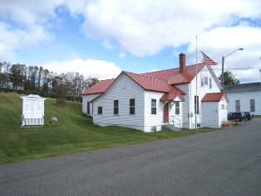

Prepared by:
Massachusetts Department of Public Health
Bureau of Environmental Health
Indoor Air Quality Program
January 2010

Background/Introduction
At the request of Barbara Giusti, Assistant Health Agent, Windsor Board of Health (BOH), the Massachusetts Department of Public Health (MDPH), Bureau of Environmental Health (BEH) provided assistance and consultation regarding indoor air quality concerns at Windsor Town Hall (WTH), 1927 Route 9, Windsor, Massachusetts. The request was prompted by complaints of odors in the building. On October 14, 2009, a visit to conduct an assessment was made to the WTH by Lisa Hébert, Environmental Analyst/Indoor Air Quality Inspector in BEH’s Indoor Air Quality (IAQ) Program. Ms. Hébert was accompanied by Ms. Giusti during the assessment.
The WTH is a two story wood framed building constructed in the late 1800s. In 1945, a renovation took place which increased the size of the main hall and added a performance stage to the building (Picture 1). This addition, unlike the original building, lacked a basement. The addition was built on ledge, which was visible within the crawlspace beneath the addition (Picture 2). In 2006, a renovation was undertaken which added two bathrooms to the building, but did not alter the footprint.
The building is utilized primarily for gatherings such as the Town Meeting, senior luncheons, sewing groups, elections, as well as Zoning Board and Conservation Commission meetings. The building consists of a main hall with a stage, a kitchen and the former selectboard office on the second floor, which is now used for storage. The WTH has a metal roof, a section of which was recently replaced and is heated by an oil, forced hot air system.
Windows in the building were designed to be opened, but most have been painted shut.

Methods
Air tests for carbon monoxide, carbon dioxide, temperature and relative humidity were conducted with the TSI, Q-Trak, IAQ Monitor, Model 7565. Air tests for airborne particle matter with a diameter less than 2.5 micrometers were taken with the TSI, DUSTTRAK™ Aerosol Monitor Model 8520. BEH staff also performed visual inspection of building materials for water damage and/or microbial growth. Moisture content of porous building materials was measured with a Delmhorst, BD-2100 Model, Moisture Detector equipped with a Delmhorst Standard Probe.

Results
The WTH is visited by up to 150 individuals during Town Meeting. However, most groups utilizing the WTH have an occupancy range between 13 and 60 people. Air sampling measurements were taken under normal operating conditions and results appear in Table 1. Moisture meter readings appear in Table 1.

Discussion

Ventilation
It can be seen from Table 1 that carbon dioxide levels were below 800 parts per million (ppm) in all areas surveyed at the time of the assessment, indicating adequate air exchange. It is important to note, however, that all of the rooms were empty or sparsely populated, which can greatly reduce carbon dioxide levels. Carbon dioxide levels would be expected to increase with full occupancy and windows closed. The air exchange/infiltration that does occur in the building is likely due to the condition of the windows in the building; namely, many are not weathertight, with cracked and broken window panes and deteriorated or missing glazing.
The ventilation system at WTH does not appear to be designed to provide either mechanical fresh air supply or exhaust ventilation, but rather recycles existing air. With a lack of fresh air supply and/or exhaust ventilation, any interior pollutants will remain inside the building and be continuously re-circulated. This situation can lead to air quality/comfort complaints especially during periods of maximum occupancy (e.g., town meeting).
Without an adequately functioning ventilation system, the only means to provide fresh air and/or remove pollutants from the indoor environment would be to open windows. As previously stated, numerous windows at WTH were painted shut, however, even if windows were operable, opening windows in the winter as a means of supplementing ventilation is not feasible in Massachusetts. Therefore, to best provide comfort for individuals occupying this space a properly functioning ventilation system would be necessary.
The Massachusetts Building Code requires a minimum ventilation rate of 20 cubic feet per minute (cfm) per occupant of fresh outside air or have openable windows in each room (SBBRS, 1997; BOCA, 1993). The ventilation must be on at all times that the room is occupied. Providing adequate fresh air ventilation with open windows and maintaining the temperature in the comfort range during the cold weather season is impractical. Mechanical ventilation is usually required to provide adequate fresh air ventilation.
Carbon dioxide is not a problem in and of itself. It is used as an indicator of the adequacy of the fresh air ventilation. As carbon dioxide levels rise, it indicates that the ventilating system is malfunctioning or the design occupancy of the room is being exceeded. When this happens, a buildup of common indoor air pollutants can occur, leading to discomfort or health complaints. The Occupational Safety and Health Administration (OSHA) standard for carbon dioxide is 5,000 parts per million parts of air (ppm). Workers may be exposed to this level for 40 hours/week, based on a time-weighted average (OSHA, 1997).
The MDPH uses a guideline of 800 ppm for publicly occupied buildings. A guideline of 600 ppm or less is preferred in schools due to the fact that the majority of occupants are young and considered to be a more sensitive population in the evaluation of environmental health status. Inadequate ventilation and/or elevated temperatures are major causes of complaints such as respiratory, eye, nose and throat irritation, lethargy and headaches. For more information concerning carbon dioxide, consult Appendix A.
Temperature measurements in the WTH ranged from 63° F to 68° F, which were below the MDPH recommended range in all areas surveyed (Table 1). The MDPH recommends that indoor air temperatures be maintained in a range of 70° F to 78° F in order to provide for the comfort of building occupants. In many cases concerning indoor air quality, fluctuations of temperature in occupied spaces are typically experienced, even in a building with an adequate fresh air supply.
The relative humidity measured in the building ranged from 40 to 42 percent at the time of the assessment, which was within the MDPH recommended comfort range (Table 1). The MDPH recommends a comfort range of 40 to 60 percent for indoor air relative humidity. Relative humidity levels in the building would be expected to drop during the winter months due to heating. The sensation of dryness and irritation is common in a low relative humidity environment. Low relative humidity is a very common problem during the heating season in the northeast part of the United States.

Microbial/Moisture Concerns
Numerous factors may contribute to the potential for moisture to enter the WTH building envelope. The original location of the building was likely chosen because it may have been the only spot at which a foundation was able to be dug due to proximity to ledge. As previously stated, the addition lacks a basement and ledge was observed in the crawlspace beneath it. As can be seen in Picture 3, the addition was built on top of ledge and into the hill on the north end of the building. The slope of the surrounding land is such that it directs surface water toward the building. Additionally, groundwater will travel down the slope either on or near ledge until it finds permeable soil or another outlet.
Sustained moisture at the base of the building is evident by heavy moss growth on the west side of the building (Picture 4). The presence of moss on the ground against the foundation is indicative of repeated water exposure. Moss is a sign of chronic dampness and can hold moisture against building surfaces which accelerates decomposition of building components. Additionally, since the building lacks a gutter/downspout system, rainwater from two sections of roofing converge in the northwest corner and deposit water onto the ground. Over time, this condition creates troughs adjacent to the foundation. These troughs collect and subsequently hold water close to the building’s foundation. As water splashes up from the troughs, clapboards are exposed to moisture. As can be seen in Picture 4, clapboards in this corner are showing signs of prolonged contact with water. Over time, these clapboards will deteriorate if current conditions remain.
BEH staff examined the exterior of the building to identify breaches in the building envelope and other conditions that could provide a source of water penetration. Several potential sources were identified:
- Missing mortar was observed on the bricks in the chimney (Picture 5).
- Peeling paint was observed on the exterior surfaces of WTH. This condition can expose wood fibers to moisture, which will accelerate its deterioration. One area of wood at the front of the building had already begun to decompose (Picture 6).
- Cracked, broken clapboards.
- Deteriorated or missing glazing was observed on many windows (Picture 7).
- Broken, cracked panes of glass were evident in several windows at WTH (Picture 8).
- Numerous cracks and holes were observed in the building foundation.
- A corrugated pipe, most likely a foundation drain, empties water in close proximity to the foundation (Picture 9).
The aforementioned conditions represent potential water penetration sources. Over time, these conditions can undermine the integrity of the building envelope and provide a means of water entry into the building via capillary action through foundation concrete and masonry (Lstiburek & Brennan, 2001). In addition, these breaches may provide a means for pests/rodents to enter the building.
Numerous conditions were also observed on the interior of the building that may indicate that moisture is entering/has entered the building. Water damage was observed on the ceiling of the second floor storage room, particularly adjacent to the chimney (Picture 10). Attic joists exhibit water damage. Ceiling panels are buckled in some areas of the main hall and do not touch the walls in some areas. Water damaged wood was observed in the kitchen ceiling as well.
Porous materials, such as cardboard boxes, books, files and documents are stored in the attic (Pictures 11 through 13). Many of the materials appear water damaged and possibly mold colonized. These materials are covered with dust and attic insulation. Additionally, rodents within the building appear to have been gnawing on book bindings. Porous materials stored in unconditioned spaces are subject to the absorption of moisture, which can subsequently lead to mold colonization. Mold colonized cardboard was found in the basement (Picture 14).
Indications of chronic moisture were evident throughout the basement. Metal window frames were severely oxidized, to the point where they were no longer weathertight (Picture 15). Metal surfaces of equipment throughout the basement were also observed to be heavily rusted (Picture 16). In addition, a sizable hole was observed in a concrete foundation wall in the basement.
Efflorescence was observed on the concrete walls of the basement. Efflorescence is a characteristic sign of water intrusion. As penetrating moisture works its way through concrete, it leaves behind characteristic mineral deposits. Efflorescence is a characteristic sign of water damage to building materials, but it is not mold growth. As moisture penetrates and works its way through building materials (e.g., concrete), water-soluble compounds dissolve, creating a solution. As this solution moves to the surface, the water evaporates, leaving behind white, powdery mineral deposits (Picture 17). The plywood base of the storage area that abuts the concrete wall was moist to the touch and was buckled and separated in some areas from repeated moisture exposure.
The US Environmental Protection Agency (US EPA) and the American Conference of Governmental Industrial Hygienists (ACGIH) recommend that porous materials be dried with fans and heating within 24 to 48 hours of becoming wet (US EPA, 2001; ACGIH, 1989). If not dried within this time frame, mold growth may occur. Once mold has colonized porous materials, they are difficult to clean and should be removed/discarded.

Other IAQ Evaluations
Indoor air quality can be negatively influenced by the presence of respiratory irritants, such as products of combustion. The process of combustion produces a number of pollutants. Common combustion emissions include carbon monoxide, carbon dioxide, water vapor and smoke (fine airborne particle material). Of these materials, exposure to carbon monoxide can produce immediate, acute health effects upon exposure. To determine whether combustion products were present in the indoor environment, BEH staff obtained measurements for carbon monoxide.

Carbon Monoxide
Carbon monoxide is a by-product of incomplete combustion of organic matter (e.g., gasoline, wood and tobacco). Exposure to carbon monoxide can produce immediate and acute health effects. Several air quality standards have been established to address carbon monoxide and prevent symptoms from exposure to these substances. The MDPH established a corrective action level concerning carbon monoxide in ice skating rinks that use fossil-fueled ice resurfacing equipment. If an operator of an indoor ice rink measures a carbon monoxide level over 30 ppm, taken 20 minutes after resurfacing within a rink, that operator must take actions to reduce carbon monoxide levels (MDPH, 1997).
The American Society of Heating Refrigeration and Air-Conditioning Engineers (ASHRAE) has adopted the National Ambient Air Quality Standards (NAAQS) as one set of criteria for assessing indoor air quality and monitoring of fresh air introduced by HVAC systems (ASHRAE, 1989). The NAAQS are standards established by the US EPA to protect the public health from six criteria pollutants, including carbon monoxide and particulate matter (US EPA, 2006). As recommended by ASHRAE, pollutant levels of fresh air introduced to a building should not exceed the NAAQS levels (ASHRAE, 1989). The NAAQS were adopted by reference in the Building Officials & Code Administrators (BOCA) National Mechanical Code of 1993 (BOCA, 1993), which is now an HVAC standard included in the Massachusetts State Building Code (SBBRS, 1997). According to the NAAQS, carbon monoxide levels in outdoor air should not exceed 9 ppm in an eight-hour average (US EPA, 2006).
Carbon monoxide should not be present in a typical, indoor environment. If it is present, indoor carbon monoxide levels should be less than or equal to outdoor levels. On the day of assessment, outdoor carbon monoxide concentrations were non-detect (ND) (Table 1). Carbon monoxide levels measured in the WTH were also ND.
Although carbon monoxide was not detected at the time of the assessment, potential sources of carbon monoxide in the building were observed. As previously described, oxidation was observed on metal surfaces in the basement. One of these surfaces was the exhaust duct from the furnace to the chimney, which was rusted through in several areas. The interior of the duct was heavily rusted as well, which may be an indication that condensation is occurring within the exhaust duct. In addition, an improperly sealed pipe was protruding from the basement chimney. On the second floor, an old outlet in the chimney was also not adequately sealed (Pictures 18 through 21). These conditions may allow carbon monoxide to enter the WTH. BEH informed Ms. Giusti that the repairs should be made as soon as possible and suggested that a carbon monoxide detector be installed in the building immediately.

Particulate Matter
The US EPA has established NAAQS limits for exposure to particulate matter. Particulate matter is airborne solids that can be irritating to the eyes, nose and throat. The NAAQS originally established exposure limits to particulate matter with a diameter of 10 μm or less (PM10). According to the NAAQS, PM10 levels should not exceed 150 microgram per cubic meter (μg/m³) in a 24-hour average (US EPA, 2006). These standards were adopted by both ASHRAE and BOCA. Since the issuance of the ASHRAE standard and BOCA Code, US EPA established a more protective standard for fine airborne particles. This more stringent PM2.5 standard requires outdoor air particle levels be maintained below 35 μg/m³ over a 24-hour average (US EPA, 2006). Although both the ASHRAE standard and BOCA Code adopted the PM10 standard for evaluating air quality, MDPH uses the more protective PM2.5 standard for evaluating airborne particulate matter concentrations in the indoor environment.
Outdoor PM2.5 concentrations the day of the assessment were measured at 6 μg/m³. PM2.5 levels measured inside the building ranged from 1 to 2 μg/m³ (Table 1), which were below the NAAQS PM2.5 level of 35 μg/m³. Frequently, indoor air levels of particulates (including PM2.5) can be at higher levels than those measured outdoors. A number of mechanical devices and/or activities that occur indoors can generate particulate during normal operations. Sources of indoor airborne particulates may include but are not limited to particles generated during the operation of fan belts in the HVAC system, cooking in the cafeteria stoves and microwave ovens; use of photocopiers, fax machines and computer printing devices; operation of an ordinary vacuum cleaner and heavy foot traffic indoors.

Other Conditions
Other conditions that can affect indoor air quality were observed during the assessment. It had been reported to BEH that several weeks earlier, numerous flies were observed within the WTH, followed by several days of a very strong, unidentified odor. This condition may have been caused by a sizable rodent die-off within the building. Indications of a heavy rodent infestation were visible in the kitchen cabinets and behind the stove (Pictures 22 and 23). Two nearly empty boxes of rodent bait were also observed in the kitchen, and numerous rodent and mole carcasses were observed throughout the building as well as shredded paper and cardboard indicative of rodent activity (Picture 24). It is likely that a good number of them died within the walls as well.
To penetrate the exterior of a building, rodents require a minimal breach of ¼ inch (MDFA, 1996). Numerous cracks and holes in the foundation and open crawlspace access panels were noted around the exterior of the building, each of which would be sufficient to allow rodents to enter the building. In addition, a number of open utility holes within the building were observed, which allowed pests to move more freely within the building (Picture 25). One such area is in the kitchen cabinet around the heating duct where large openings were observed. On the exterior of the building, substantial weed growth against the building provides rodent harborage as well.
Rodent infestation can result in indoor air quality related symptoms due to materials in their wastes. Mouse urine contains a protein that is a known sensitizer (US EPA, 1992). A three-step approach is necessary to eliminate rodent infestation:
- removal of the rodents;
- cleaning of waste products from the interior of the building; and
- reduction/elimination of pathways/food sources that are attracting rodents.
To eliminate exposure to allergens, rodents must be removed from the building. Please note that removal, even after cleaning, may not provide immediate relief since allergens can exist in the interior for several months after rodents are eliminated (Burge, 1995).
A large open duct was observed in the attic which appears to travel down through the main floor at the back of the stage and which may be either part of the existing heating system or may possibly terminate in the crawlspace (Picture 26). The purpose of this duct should be investigated and identified. If it is a duct that has been abandoned, then it should be appropriately sealed.
Breaches were observed in basement ducts (Picture 27). They should be sealed with appropriate sealant in order to increase the efficiency of the heating system and to eliminate the possibility of entrainment of particulates from the basement and distribution to the occupied space.
Linoleum in the kitchen was curled at the edges and at the seams, which can allow moisture from cleaning activities to travel beneath the linoleum’s surface. Prolonged contact with moisture will allow for further deterioration and may allow mold colonization to occur.
A substantial amount of peeling paint was observed on interior window sashes. This condition may allow paint particulates as well as dust to aerosolize within the occupied space.
Damaged floor tiles were observed in some areas (Picture 28). These floor tiles may contain asbestos. Intact asbestos-containing materials do not pose a health hazard. If damaged, asbestos-containing materials can be rendered friable and become aerosolized. Friable asbestos is a chronic (long-term) health hazard, but will not produce acute (short-term) health effects (e.g., headaches) typically associated with buildings believed to have indoor air quality problems. Where asbestos-containing materials are found damaged, these materials should be removed or remediated in a manner consistent with Massachusetts asbestos remediation laws (MDLI, 1993).

Conclusions/Recommendations
The conditions related to indoor air quality at the WTH raise a number of issues addressed in this report. Some of these conditions can be remedied by actions of building occupants. Other remediation efforts will require alteration to the building structure and equipment. For these reasons, a two-phase approach is required for remediation. The first consists of short-term measures to improve air quality and the second consists of long-term measures that will require planning and resources to adequately address the overall indoor air quality concerns.
The following short-term measures should be considered for implementation:
- Restore function to windows that have been painted shut.
- Contact a firm to design and install a gutter and downspout system that will direct rainwater as far as practicable from the foundation.
- Improve the grading of the ground away from the foundation in order to eliminate troughs and sink holes from the base of the building.
- Repair rotted, cracked and broken clapboards.
- Repaint surfaces that exhibit peeling paint.
- Contact a mason to re-point the chimney to eliminate leakage into the building.
- Repair missing, deteriorated glazing and broken windows.
- Repair cracks, holes in foundation to reduce access points for rodents.
- Assess exterior drain to determine if it is feasible to extend it further away from the building.
- Repair/replace water damaged ceiling materials on the second floor adjacent to the chimney as well as in the main hall.
- Documents, files and books stored in the attic should be reviewed and nonessential items discarded. Items which must be kept should be cleaned and properly stored.
- Remove and properly dispose of mold colonized cardboard from basement.
- Contact a heating technician to assess the furnace and to repair all conditions associated with the furnace/ductwork, which may allow carbon monoxide to enter the building.
- Acquire carbon monoxide detectors and place within the building consistent with the fire inspector’s recommendations.
- Repair hole in the foundation wall in basement above plywood storage area.
- Consider removing water damaged plywood from basement.
- Remove visible rodent carcasses.
- Due to the relatively large rodent population in the building, contact a licensed pest control firm to address the current rodent infestation.
- Clean rodent feces from throughout the building, particularly the kitchen cabinets and behind the stove. Disinfect surfaces and rinse with clean water.
- Seal numerous open utility holes throughout the building.
- Ensure food products are stored in containers with tight-fitting lids.
- Investigate purpose of the open duct in the attic. If it is not in use at the present time, it should be appropriately sealed.
- Seal breaches in heating ducts.
- Seal seams/edges of linoleum floor in kitchen to prevent moisture infiltration.
- Determine composition of damaged floor tiles. If found to contain asbestos, remediate damaged floor tiles in conformance with Massachusetts asbestos remediation and hazardous waste disposal laws (MDLI, 1993).
- For buildings in New England, periods of low relative humidity during the winter are often unavoidable. Therefore, scrupulous cleaning practices should be adopted to minimize common indoor air contaminants whose irritant effects can be enhanced when the relative humidity is low. To control for dusts, a high efficiency particulate arrestance (HEPA) filter equipped vacuum cleaner in conjunction with wet wiping of all surfaces is recommended. Avoid the use of feather dusters. Drinking water during the day can help ease some symptoms associated with a dry environment (throat and sinus irritations).
- Refer to resource manual and other related indoor air quality documents located on the MDPH’s website for further building-wide evaluations and advice on maintaining public buildings. These documents are available at: http://mass.gov/dph/iaq.

In view of the findings at the time of the assessment, the following long term recommendations should be considered:
  - Consider installing a mechanical ventilation system to provide adequate air exchange that introduces fresh outside air and exhaust ventilation to remove environmental pollutants from the building.
  - Consider installing replacement windows for the WTH.
  - Consider investigating the feasibility of installing a curtain drain further up slope to intercept water that is draining toward the WTH.

References
ACGIH. 1989. Guidelines for the Assessment of Bioaerosols in the Indoor Environment. American Conference of Governmental Industrial Hygienists, Cincinnati, OH.
ASHRAE. 1989. Ventilation for Acceptable Indoor Air Quality. American Society of Heating, Refrigeration and Air Conditioning Engineers. ANSI/ASHRAE 62-1989
BOCA. 1993. The BOCA National Mechanical Code/1993. 8th ed. Building Officials and Code Administrators International, Inc., Country Club Hill, IL.
Burge, H.A. 1995. Bioaerosols. Lewis Publishing Company, Boca Raton, FL.
Lstiburek, J. & Brennan, T. 2001. Read This Before You Design, Build or Renovate. Building Science Corporation, Westford, MA. U.S. Department of Housing and Urban Development, Region I, Boston, MA.
MDFA. 1996. Integrated Pest Management Kit for Building Managers. Massachusetts Department of Food and Agriculture, Pesticide Bureau, Boston, MA.
MDLI. 1993. Regulation of the Removal, Containment or Encapsulation of Asbestos, Appendix 2. 453 CMR 6,92(I)(i).
MDPH. 1997. Requirements to Maintain Air Quality in Indoor Skating Rinks (State Sanitary Code, Chapter XI). 105 CMR 675.000. Massachusetts Department of Public Health, Boston, MA.
OSHA. 1997. Limits for Air Contaminants. Occupational Safety and Health Administration. Code of Federal Regulations. 29 C.F.R 1910.1000 Table Z-1-A.
SBBRS. 1997. Mechanical Ventilation. State Board of Building Regulations and Standards. Code of Massachusetts Regulations. 780 CMR 1209.0
US EPA. 1992. Indoor Biological Pollutants. US Environmental Protection Agency, Environmental Criteria and Assessment Office, Office of Health and Environmental Assessment, research Triangle Park, NC. EPA 600/8-91/202 January 1992.
US EPA. 2001. Mold Remediation in Schools and Commercial Buildings. US Environmental Protection Agency, Office of Air and Radiation, Indoor Environments Division, Washington, D.C. EPA 402-K-01-001. March 2001.
US EPA. 2006. National Ambient Air Quality Standards (NAAQS). US Environmental Protection Agency, Office of Air Quality Planning and Standards, Washington, DC. http://www.epa.gov/air/criteria.html.
Picture 1

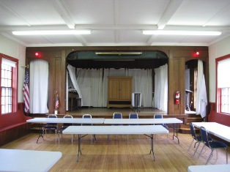

Performance Stage in Main Hall

Picture 2

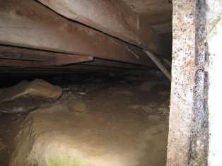

Exposed Ledge beneath Crawlspace

Picture 3

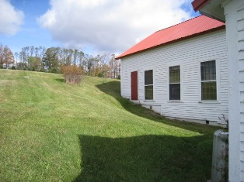

Addition Built into Side Hill

Picture 4

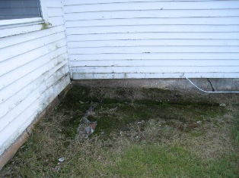

Moss Growth on Ground Adjacent to Building
Note Water Damaged Clapboards
Picture 5

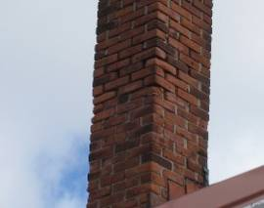

Missing Mortar on Chimney

Picture 6

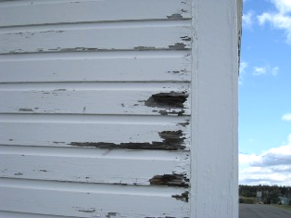

Peeling Paint Exposes Saturated Wood

Picture 7

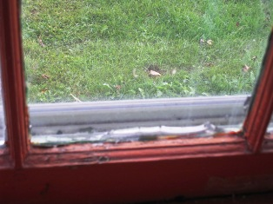

Deteriorated Glazing in Window

Picture 8

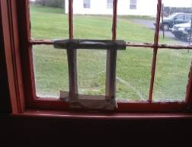

Broken Panes of Glass

Picture 9

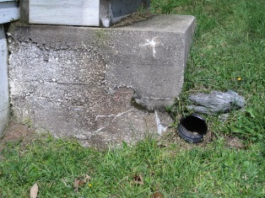

Drain Deposits Water Close to Foundation

Picture 10

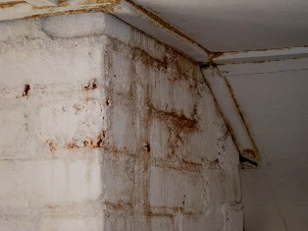

Water Damage to Ceiling Adjacent to Chimney

Picture 11

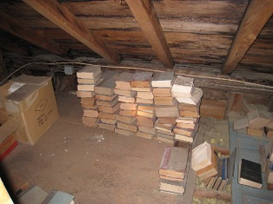

Books Stored in Attic

Picture 12

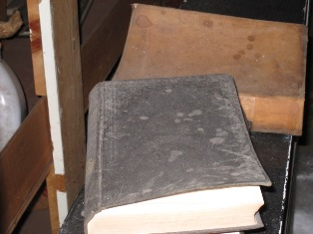

Water Damaged Books

Picture 13

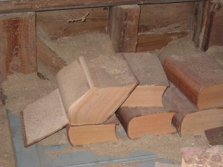

Books Covered With Insulation

Picture 14

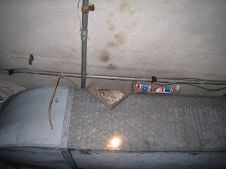

Mold Colonized Cardboard

Picture 15

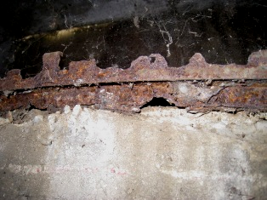

Section of Oxidized Window Frame

Picture 16

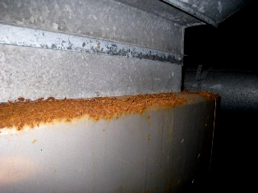

Top of Furnace Exhibits Rust

Picture 17

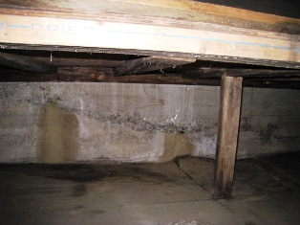

Efflorescence on Concrete Wall
Note Wet, Buckled Plywood Below

Picture 18

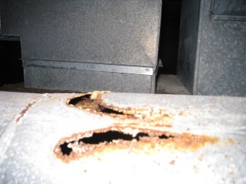

Holes in Exhaust Duct to Chimney
Picture 19

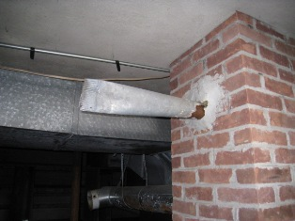

Abandoned Exhaust Duct in Chimney

Picture 20

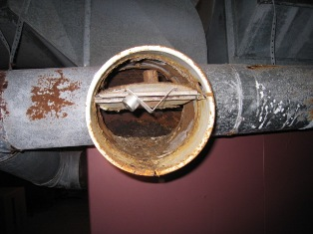

Heavy Oxidation of Interior Duct

Picture 21

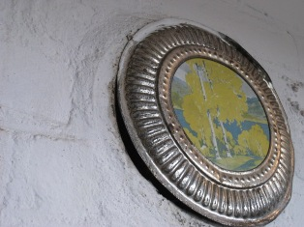

Ill-Fitting Cover to Chimney on Second Floor, Note Spaces around Cover

Picture 22

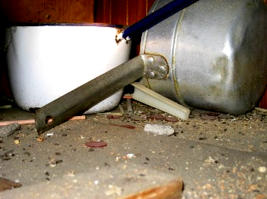

Rodent Droppings in Kitchen Cabinet

Picture 23

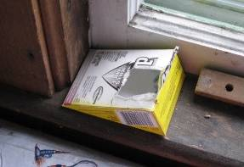

Nearly Empty Container of Rodent Bait

Picture 24

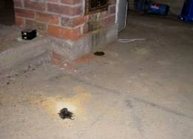

Rodent Carcasses in Basement

Picture 25

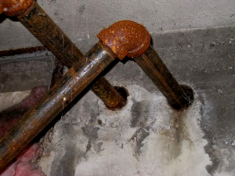

Open Utility Holes around Pipes

Picture 26

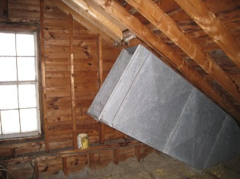

Open Duct in Attic

Picture 27

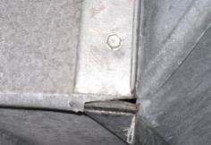

Breach in Duct

Picture 28

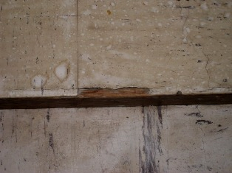

Cracked, Broken Floor Tile
Location | Occupants  in Room | Carbon  Dioxide  (ppm) | Temp  (°F) | Relative  Humidity  (%) | Carbon Monoxide  (ppm) | PM2.5  (µg/m3) | Windows  Openable | Ventilation |  | Remarks
 |  |  |  |  |  |  |  | Supply | Exhaust | Remarks
Outside  (Background) | - | 426 | 42 | 48 | ND | 6 | - | - | - | Sunny
Main Hall | 1 | 488 | 66 | 40 | ND | 1 | Y | N | N | DC, Windows painted shut
Kitchen | 0 | 655 | 64 | 41 | ND | 2 | Y | N | N | DO, Windows painted shut, evidence of rodent infestation,  Water damaged wooden ceiling moisture reading = 6 (low)
Storage (second floor) former selectboard room | 1 | 523 | 68 | 42 | ND | 2 | Y | N | N | DC, Windows painted shut, numerous flies, dead rodent
Basement | 1 | 484 | 63 | 41 | ND | 1 | N | N | N | DC, Dead mice and moles in basement, efflorescence,  Water damaged plywood moisture reading = 17.4 (high)

