Inaugural Issue **2022**

Massachusetts Board of Registration in Medicine

Quality & Patient Safety Division

Winter 2024 **2022**

Spotlight on Quality & Patient Safety

Welcome to the inaugural issue of Spotlight on Quality & Patient Safety. Spotlight is issued by the Massachusetts Board of Registration in Medicine Quality & Patient Safety Division (QPSD) to share aggregate Safety and Quality Review (SQR) report data and to share some of the good work being done by the hospitals, ambulatory surgery centers, and some ambulatory clinics in the Commonwealth. The QPSD would like to thank Tufts Medical Center and Emerson Hospital for sharing some performance improvement initiatives being undertaken at their respective facilities. If your organization would like to be featured in a future issue of Spotlight, please contact Trinh Ly-Lucas. Trinh’s contact information and information regarding the upcoming Patient Care Assessment virtual Boot Camp may be found on the final page.

Hospitals, ambulatory surgery centers, and certain ambulatory clinics are required to submit events of unexpected patient outcomes (SQR reports) to the QPSD. In this issue, the QPSD is providing data regarding the major categories of SQR reports submitted in the first three quarters of 2023. We are highlighting the most reported category of events: Surgery/Procedure. Some resources are included on page two.

Spotlight on Quality & Patient Safety

XYZ Ambulatory Clinic:

Ldlddldd

Dddd

**Resources:**

**PRE-PROCEDURE OPTIMIZATION:**

American Association of Nurse Anesthesiology: [Enhanced Recovery After Surgery - AANA - American Association of Nurse Anesthesiology](https://www.aana.com/practice/clinical-practice/clinical-practice-resources/enhanced-recovery-after-surgery/)

ERAS® Society: [Guidelines - ERAS® Society (erassociety.org)](https://erassociety.org/guidelines/)

Moningi S, Patki A, Padhy N, Ramachandran G. Enhanced recovery after surgery: An anesthesiologist's perspective. J Anaesthesiol Clin Pharmacol. 2019 Apr;35(Suppl 1):S5-S13. doi: 10.4103/joacp.JOACP_238_16. PMID: 31142953; PMCID: PMC6515715. [Enhanced recovery after surgery: An anesthesiologist's perspective - PMC (nih.gov)](https://www.ncbi.nlm.nih.gov/pmc/articles/PMC6515715/)

Rajan, Niraja MD*; Rosero, Eric B. MD, MSc†; Joshi, Girish P. MBBS, MD, FFARCSI†. Patient Selection for Adult Ambulatory Surgery: A Narrative Review. Anesthesia & Analgesia 133(6):p 1415-1430, December 2021. | DOI: 10.1213/ANE.0000000000005605 [Patient Selection for Adult Ambulatory Surgery: A Narrative... : Anesthesia & Analgesia (lww.com)](https://journals.lww.com/anesthesia-analgesia/fulltext/2021/12000/patient_selection_for_adult_ambulatory_surgery__a.10.aspx)

Tippireddy S, Ghatol D. Anesthetic Management for Enhanced Recovery After Major Surgery (ERAS) [Updated 2023 Jan 29]. In: StatPearls [Internet]. Treasure Island (FL): StatPearls Publishing; 2023 Jan. Available from: <https://www.ncbi.nlm.nih.gov/books/NBK574567/> [Anesthetic Management for Enhanced Recovery After Major Surgery (ERAS) - StatPearls - NCBI Bookshelf (nih.gov)](https://www.ncbi.nlm.nih.gov/books/NBK574567/)

**PREVENTION OF RETAINED FOREIGN OBJECTS:**

# The Joint Commission. Quick Safety Issue 20: Strategies to prevent URFOs (Updated May 2022) [quick-safety-20-update-5-3-22.pdf (jointcommission.org)](https://www.jointcommission.org/-/media/tjc/newsletters/quick-safety-20-update-5-3-22.pdf)

The Joint Commission. Sentinel Event Alert 51: Preventing unintended retained foreign objects. (2013). <https://www.jointcommission.org/-/media/tjc/documents/resources/patient-safety-topics/sentinel-event/sea_51_urfos_10_17_13_final.pdf>

Schwappach D, Pfeiffer Y. Root causes and preventability of unintentionally retained foreign objects after surgery: a national expert survey from Switzerland. Patient Saf Surg. 2023 Jun 9;17(1):15. doi: 10.1186/s13037-023-00366-9. PMID: 37296424; PMCID: PMC10251694.

[Root causes and preventability of unintentionally retained foreign objects after surgery: a national expert survey from Switzerland (nih.gov)](https://www.ncbi.nlm.nih.gov/pmc/articles/PMC10251694/pdf/13037_2023_Article_366.pdf)

**PREVENTION OF WRONG SITE/SIDE/PROCEDURE/PATIENT EVENTS:**

The Joint Commission. Universal Protocol Poster. (Retrieved December 12, 2023). [up_poster1pdf.pdf (jointcommission.org)](https://www.jointcommission.org/-/media/tjc/documents/standards/universal-protocol/up_poster1pdf.pdf)

**SPOTLIGHT: Tufts Medical Center**

**Reducing Alert Fatigue Associated with Medication Warnings in EPIC**

**Jules Trahan, PharmD**

Medication Safety Officer for Tufts Medicine

**Shuang Fan, PharmD, MS**

Applications Manger Tufts Medicine

Alert fatigue is defined as a “condition in which too many alerts consume time and mental energy to the point that both important warnings and clinically unimportant ones can be ignored.”1,2 After the implementation of EPIC at Tufts Medical Center in April of 2022, both prescribers and pharmacists reported seeing an increase in the number of medication warnings in EPIC compared to the legacy electronic health record. Many of these alerts were deemed to be clinically insignificant and contributed to medication errors in which critical alerts were missed.

As a result, the Tufts Medicine Clinical Decision Support Committee was created and embarked on a project with the goal of identifying and suppressing medication warnings that present to prescribers and pharmacists in EPIC that do not result in meaningful changes to medication orders and are deemed to be clinically insignificant.

EPIC medication warning data reports were developed to help analyze what medication alerts present to prescribers and pharmacists in EPIC. The multidisciplinary system-wide Clinical Decision Support Committee reviewed this data and approved all changes to EPIC’s alerting functionality.

The work of the Clinical Decision Support Committee has led to the suppression of many medication alerts that have been deemed not clinically significant. This reduction in non-significant alerts have led to a reduction in alert fatigue and help both prescribers and pharmacists focus on medication alerts that are truly impactful. The committee will continue to review other medication alerts and continue to assess opportunities to optimize the medication alert functionality in Epic.

**References**

1. McGreevey JD 3rd, Mallozzi CP, Perkins RM, Shelov E, Schreiber R. Reducing alert burden in electronic health records: state of the art recommendations from four health systems. Appl Clin Inform. 2020 Jan;11(1):1-12. Also available: https://dx.doi.org/10.1055/s-0039-3402715. PMID: 31893559. [10-1055-s-0039-3402715.pdf (nih.gov)](https://www.ncbi.nlm.nih.gov/pmc/articles/PMC6938713/pdf/10-1055-s-0039-3402715.pdf)
2. Peterson JF, Bates DW. Preventable medication errors: identifying and eliminating serious drug interactions. J Am Pharm Assoc (Wash). 2001 MarApr.

Spotlight on Quality & Patient Safety

**SPOTLIGHT: Emerson Health**

Spotlight on Quality & Patient Safety

**High Reliability**

**Christi Clark Barney, MSN, RN**

Vice President of Quality and Patient Safety

Chief Health Equity Officer

In Fall 2021 Emerson was faced with challenges common to many of the healthcare organizations in Massachusetts. In the wake of the acute phase of the COVID pandemic, fiscal thoughtfulness, workforce fatigue and staffing changes threatened to impact the established safety culture of the organization. The long-time standard bearers for safety were retiring or moving out of leadership roles and the tools used to support safety and quality analysis needed refreshing. In this context, Emerson Health sought to revitalize patient safety within the organization by hardwiring a high reliability foundation.

Leveraging an Equity-Informed High Reliability grant from MGB that uses enterprise risk management experts *SG Collaborative Solutions*, Emerson trained 100% of its Leadership team including Medical Staff Chairs and Chiefs on key high reliability concepts in CY 2022/23 and then instituted a number of best practices to reinvigorate the safety culture. As a component of the reliability work, the Quality and Patient Safety department (QPS) understood that the safety reporting system needed to be redesigned to reflect the principles of reliable data collection and to reflect contemporary patient safety concerns such as equity.

Emerson utilizes the RLDatix safety reporting platform, which is easily configurable, however the historic build included redundant locations, departments, and

Figure 1. Emerson standardized process for high reliability review of reported safety events.

overlapping reporting categories. The monthly reporting volume in 2021 was low, and the reporting lacked data integrity. Trends were difficult to identify and front-line users were skeptical of the overall process. There was an immediate need to overhaul the system to create meaningful data, build psychological safety for reporters and support data driven improvement work.

In the face of these real challenges, Emerson Health found strategies to invigorate safety reporting and safety culture to revitalize the organization. Each section of the reporting platform was reviewed for utility, clarity and efficiency with key stakeholders and front-line staff. This detailed review resulted in elimination of 415 specific event types, 4 general event types, and 102 department/location constraints. The submission forms were updated for ease of reporter use. A reliable process (Figure 1.) was instituted for QPS daily review of all submitted reports which ensured data integrity and action on the risks identified. The high reliability process steps of identifying risk, reviewing systems, and then evaluating human factors was used to examine each submitted event. Any leader tasked with incident review within the safety reporting system completed additional high reliability event review training to support use of the high reliability process steps. Hospital Orientation and Annual Education modules were refreshed to reflect high reliability constructs and explain the role of safety reporting in surfacing risks identified by front line staff. To ensure clarity of strategic intent, the Emerson Board Quality Committee created goals related to Equity Informed High Reliability training and the safety reporting processes.

These changes bore fruit. Safety reporting increased by 50% from CY 2021 to 2022 and rose an additional 25% from CY 2022 to 2023. The CY 2023 reporting volume in one week is now equal to what a month of reporting yielded in 2021 (Figure 2.). Most importantly, the reporting content itself has changed such that 70% of events reported in CY 2023 were near-miss or potential events, signaling a shift into pro-active risk identification by the front-line teams. 65% of reported events are investigated and closed within 2 weeks as per the standard established in the new process. The system issues that require longer time to closure are discussed with front line staff. The updated platform, combined with intentional high reliability training for organization leaders, supported use of safety data in meaningful organization projects such as Daily Safety Huddles, Workplace Violence Prevention initiatives, Safety Walk Rounds, and pro-active risk assessment of adverse events related to nursing staffing. In doing so, the connection between reporting and meaningful improvement revitalized the culture of safety. The Equity Informed High Reliability framework used in the organization ensures that reported issues are analyzed through a system reliability lens prior to human reliability review. This has decreased blame and finger pointing within use of the system.

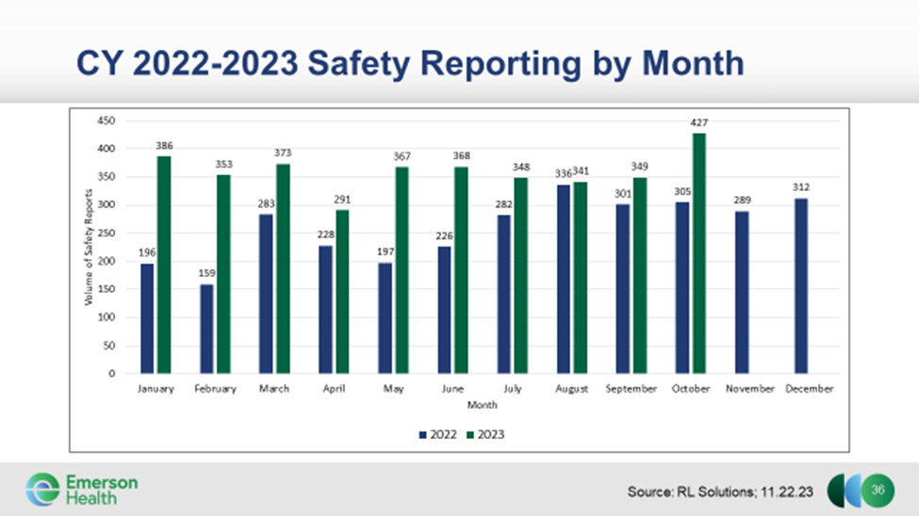

As another important component of the high reliability foundation, Collaborative Case Review (CCR) methodology replaced root cause analysis. A CCR assembles team members present during an event and leverages the perspective of the front-line staff in understanding risk within current system design for delivery of care. The sequence of reliability developed by SG Collaborative Solutions (Figure 3.) creates a standard method for evaluation of events. Intentional work by trained facilitators creates psychological safety within the CCR meeting to make the group discussion a safe space for learning, vulnerability, and reflection. Explicit discussion of normative human factors concepts such as cognitive bias in decision making allows the team to reflect at a deeper level without defensiveness.

Human performance and behavior is explored by role in the CCR setting, bringing to light issues of education (knowledge, skills, abilities) that highlight system issues related to preceptor training or infrequent use/skill scenarios among other issues. Individual choice and decision making is typically explored in a more private setting to support front line staff unless they are comfortable sharing with the group. CCR reviews include an opportunity to reflect on how the group is currently coping and a chance to consider additional

Figure 2. Safety reporting by month CY 2022 compared to CY 2023

Figure 3. Sequence of Reliability

support that would have been valuable proximal to the event being discussed. This process helps address fatigue and burnout and has led to enhancements to initial leadership response post clinical codes, workplace violence episodes and care events.

Risks identified during the CCR are then further evaluated for process improvement/corrective action plans which are shared with and refined by the local leaders. Over 100 CCR have been conducted since Fall 2021, with more than 700 corrective action plans developed. The corrective risk mitigation items are tracked in weekly interdisciplinary meetings led by the Chief Medical Officer, Chief Nursing Officer and VP of Quality and Patient Safety. Ninety-eight % of these corrective action plans have been completed to date.

One of the most important modifications to the safety reporting system was in building components that allow analysis of events for issues of health equity. The patient specific information section of the safety report form was expanded to pull sex, gender identity, ethnicity, race, and language from the medical record using the HL7 Search feature. New structured fields allow QPS Leadership review for issues of bias, health related social needs and other equity variables. Trending reports then help identify opportunities for staff education on equity issues. Stratified safety reporting data supported health equity projects for Joint Commission and Massachusetts 1115 waiver initiatives.

While all CCR include patient RELD SOGI data (Figure 4.) to frame understanding of the patient, some CCR have been convened specifically to discuss system design

issues to ensure equity in care delivery or highlight risk points in current processes for key HRSN variables such as access to transportation, a concern seen frequently in the suburban setting at Emerson where public transportation options are not readily available. Counterfactual questions are posed in a CCR to address potential cognitive bias and identify system risks.

The deeply inquisitive process has yielded important safety improvements for the organization and fostered engagement at all levels. Equity-informed High Reliability is the foundation of inquiry across Emerson Health. Many of the BORIM SQR submissions begin as CCR reviews which are then further discussed at the Professional Review Committee (PRC), Emerson’s Patient Care Assessment Committee. All Morbidity & Mortality (M&M) peer review discussions use the HRO framework, and this too flows into the PRC for another layer of high reliability analysis. Despite the challenges in the healthcare environment, Emerson’s safety culture has been revitalized by deeply incorporating Equity-informed High Reliability into the foundation of quality and safety.

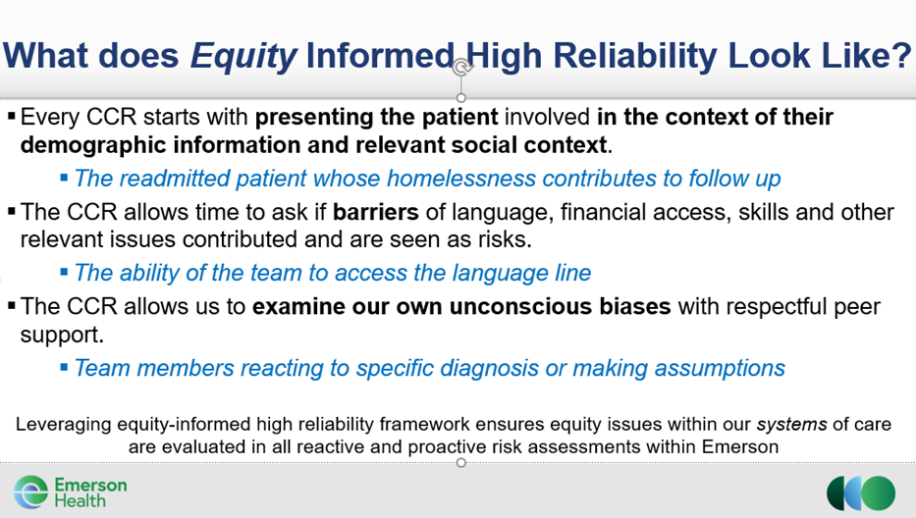

Figure 4. Incorporating equity analysis in Collaborative Case Review (CCR)



Patient Care Assessment (PCA) program and online reporting guidance, including a video tutorial, may be found at:

<https://www.mass.gov/patient-care-assessment-program>

**The Patient Care Assessment-Quality Assurance (PCA-QA) Report is due:**

**By March 30, 2024 for Ambulatory Surgery Centers and Clinics**

**By April 30, 2024 for all Hospitals**

The Quality & Patient Safety Division (QPSD) will be hosting a virtual **Patient Care Assessment Boot Camp on February 2, 2024** from 9am-11:30am. This program is strongly recommended for anyone who is new to reporting and/or anyone who would like additional information regarding reporting to the QPSD.

**NEW REPORT:** The first 30-40 minutes will focus on the new Patient Care Assessment-Quality Assurance (PCA-QA) Report. Participants can remain for the entire boot camp or just for the first portion of the program as this is a new report.

To register, please send an email message to [QPSD.Conference@state.ma.us](mailto:QPSD.Conference@state.ma.us).

Please include your: name, title/credentials, organization, and email address if someone else is registering for you.

Report Due

Quality Patient Safety Division (QPSD) Team

**(L to R) Dorothy Doweiko; Trinh Ly-Lucas, Daniel Kumin;**

**Mali Gunaratne; Daniela Brown; and Erin Long**

Questions and comments may be directed to

Trinh Ly-Lucas, MSN, AGNP-BC

Quality Analyst and Spotlight Editor

Quality & Patient Safety Division

Massachusetts Board of Registration in Medicine

[trinh.ly-lucas@mass.gov](mailto:trinh.ly-lucas@mass.gov)

This issue is provided by the Board of Registration in Medicine (BORIM), Division of Quality and Patient Safety (QPSD). The issue allows BORIM to share the practices and experiences of the healthcare clinicians and facilities that report to the QPSD. It does not necessarily include a comprehensive review of literature. Publication of this issue does not constitute an endorsement by the BORIM of any practices described in the issue and none should be inferred.