INDOOR AIR QUALITY ASSESSMENT

**Winter Hill Community Innovation School**

**At Edgerly Education Center**

8 Bonair Street

Somerville, MA

**June 2024**

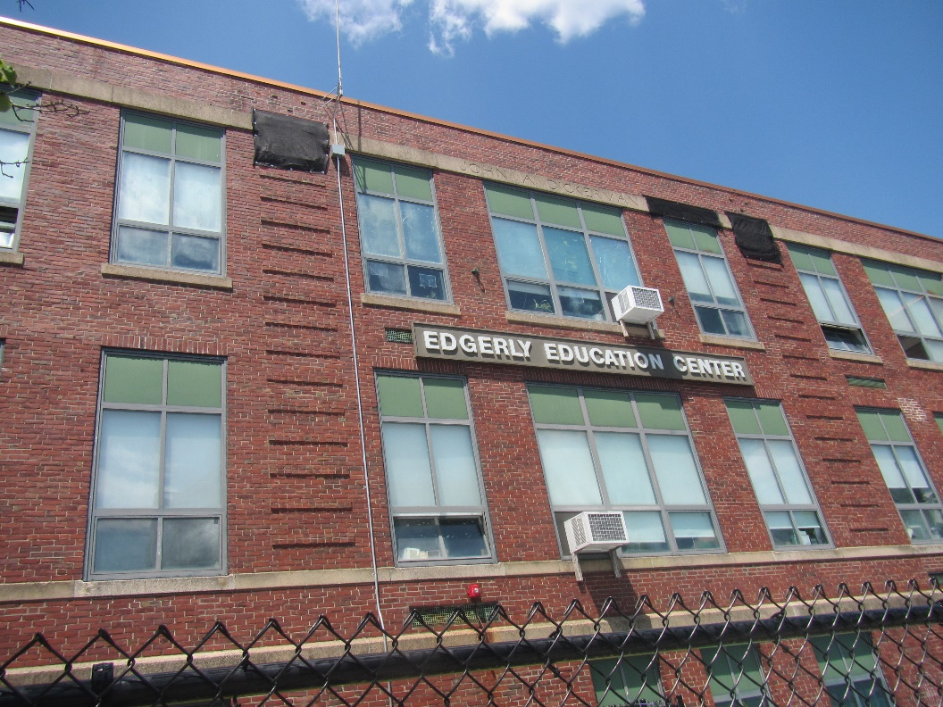

Prepared by:

Massachusetts Department of Public Health

Bureau of Climate and Environmental Health

Indoor Air Quality Program

Table of Contents

EXECUTIVE SUMMARY 3

BACKGROUND 5

RESULTS AND DISCUSSION 5

Ventilation 6

HVAC System Maintenance 7

HVAC Types and Specific Conditions 7

Water Damage and Moisture Concerns 8

Sources of Respiratory Irritants/Possible Asthma Triggers 9

Other IAQ Issues 12

[CONCLUSIONS AND RECOMMENDATIONS 12](https://massgov-my.sharepoint.com/personal/ruth_alfasso_mass_gov/Documents/Desktop/work%202020/reports%20since%20lockdown/somerville-winter-hill-school-june-2024%20test%20test%20test.docx#_Toc168920733)

REFERENCES 18

PICTURES 19

Table 1 28

Table 2A 35

Table 2B 36

Table 2C 37

Table 3 38

Table 4 40

# EXECUTIVE SUMMARY

The Massachusetts Department of Public Health’s Indoor Air Quality Program (MDPH IAQ) conducted an IAQ assessment of the Winter Hill Community Innovation School at its current location in the Edgerly Education Center located at 8 Bonair Street in Somerville on May 31, 2024. This assessment was requested by the Director of School Health Services.

Any building can have IAQ issues. These issues can be made worse through conditions common to marginalized communities (Environmental Justice communities or EJ) such as inequitable exposure to outdoor air pollution and a greater likelihood of poor building conditions leading to deterioration of IAQ resulting in higher asthma rates. Both the Winter Hill Community Innovation School’s current location at the Edgerly Education Center, and the original location, are within EJ communities. Note that the pediatric asthma rate for this school as of 2023 is 5.0% which is statistically significantly less than the statewide pediatric prevalence rate of 9.9% (MAEPHT, 2024).

The assessment was conducted by evaluating several key elements within the school; a visual inspection of the heating, cooling, and ventilating (HVAC) systems, water/microbial damage, cleanliness, point sources of respiratory irritants such as chemicals, and electronic measurement of carbon dioxide (CO2), carbon monoxide (CO), temperature, relative humidity (RH), and small particulate matter (PM2.5) all taken with a Qtrak XP monitor. Data is collected in this manner to identify potential asthma triggers, allergens, and other environmental factors that can cause indoor air quality symptoms. Please refer to the [Indoor Air Quality Manual](https://www.mass.gov/lists/indoor-air-quality-manual-and-appendices#indoor-air-quality-manual-) on the MDPH website for methods, sampling procedures, and interpretation of results.

As a result of this assessment, there are several findings: while most conditions found in this school are typical of elementary schools of this age and type, this school building lacks mechanical ventilation in a majority of rooms. That means it relies on open windows during all times of the year to provide fresh air. This represents a balancing act – while opening windows can bring in fresh air, it can also allow in outdoor pollutants, such as vehicle exhaust, pollen, mold spores, wildfire smoke, pests, and noise into the building. Excess water vapor during hot, humid weather and/or heavy rain may also enter the building , to cause damage building materials. Some water damage in the form of stained ceiling tiles was noted in the building. Rooms were also found to be cluttered, making routine cleaning and maintenance difficult (Results and Discussion).

Upon review of these findings, a number of recommendations are made to optimize existing systems and improve air exchange. Issues regarding the presence of point sources of irritation such as clutter can be addressed to reduce dust and odors (Conclusions).

Based on the results of the assessment, the following primary recommendations are made:

* Keep at least some windows open in occupied classrooms without mechanical ventilation unless there are outdoor pollutant conditions causing odors or occupant discomfort. Such conditions may include: heavy precipitation, extreme cold, high pollen counts, idling vehicles, or excessive noise. Ensure windows are closed tightly at the end of the day.
* Use the Carrier Opticlean HEPA equipped filter systems and/or other portable air purifiers in every occupied room that lacks mechanical ventilation. Facility staff should work with occupants to place the Carrier Opticlean HEPA equipped filter systems where they will be least disruptive and avoid blocking windows with the units. Smaller air purifiers should be placed so the filtered airstream is in the breathing zone of occupants. Units that use HEPA filters with or without carbon filters are good choices for occupied areas; units that may produce ozone should not be used. Maintain all in accordance with manufacturer’s instructions.
* Reduce the number of items stored in rooms to make cleaning easier. (Conclusions and Recommendations)

Please note: this report contains a series of recommendations that should serve as Best Practices that apply to most public-school buildings across the Commonwealth and should be shared amongst other buildings in the school district.

# BACKGROUND

|  |  |
| --- | --- |
| Building: | Winter Hill Community Innovation School (WHCIS) at the Edgerly Education Center (EEC) |
| Address: | 8 Bonair Street  Somerville, Massachusetts |
| Coordinated Via: | Director of School Health Services, Somerville Public Schools, Director of Infrastructure and Asset Management  City of Somerville, and the Superintendent of Somerville Public Schools. |
| Reason for Request: | General IAQ |
| Date of Assessment: | May 31, 2024 |
| Massachusetts Department of Public Health/Bureau of Climate and Environmental Health (MDPH/BCEH) Staff Conducting Assessment: | Ruth Alfasso, Inspector, IAQ Program |
| Building Description: | The EEC is a large brick building originally built in the 1930s. It has served as a school, a location for summer programs, and as administrative offices for the school department. Most recently, the building was repurposed to serve students from the Winter Hill Community Innovation School (WHCIS) when that school was abruptly closed due to building issues. Students from WHCIS are expected to occupy this building for five years until the WHCIS building is ready for reoccupancy. |
| Windows: | Most windows in the building are openable. |

# RESULTS AND DISCUSSION

The following is a summary of indoor air testing results (Table 1)

|  |  |  |
| --- | --- | --- |
| * ***Carbon dioxide (CO2)*** | *a measure of the adequacy of ventilation* | Levels were above the MDPH guideline of 800 parts per million (ppm) in most of the areas surveyed. This is due to the lack of mechanical ventilation in most areas of the school. |
| * ***Temperature*** | *a measure of comfort* | Was mostly within the MDPH recommended range of 70°F to 78°F in occupied areas. Temperatures in the second floor wing served by mechanical ventilation were slightly cooler than the recommended range, |
| * ***Relative humidity*** | *a measure of comfort and, when in excess for an extended period, a way to reflect the potential for mold and fungal growth* | Was within or close to the MDPH recommended range of 40 to 60% in all areas tested. This is reflective of outdoor conditions. Relative humidity would be expected to be lower with cold outdoor temperatures and indoor heating, and higher during hot, humid weather. |
| * ***Carbon monoxide***   ***(CO)*** | *a product of combustion that can result in acute and long term cardiovascular, respiratory, and neurological symptoms* | Levels ranged from non-detect (ND) to 3ppm. Outdoor levels near the exterior of the school were ND before the assessment and 3.0 – 4outdoors at the end of the assessment, likely due to traffic in the area. |
| * ***Particulate matter (PM2.5)*** | *a way to measure inhalable particle distribution in the air* | Concentrations were below the National Ambient Air Quality Standard (NAAQS) of 35 micrograms per cubic meter (μg/m3) in all areas tested. |

## Ventilation

Ventilation refers to both the supply of fresh air and the removal of stale air from a room. The introduction of fresh air into an occupied space will dilute normally occurring pollutants that are generated by occupancy and other activities. In addition, an HVAC system will remove pollutants from a building if operating appropriately. All ventilation systems throughout the building should operate continuously during periods of occupancy.

Most rooms in the EEC do not have any mechanical ventilation. The only source of fresh air is openable windows (Picture 1) with the exception of one wing on the second floor which has air handling units (AHU) that supply fresh air and provide cooling through ceiling-mounted vents (Picture 2). As reported by school staff, the AHUs and ductwork were retrofitted into the building when use was converted to year-round offices (Table 2B).

Heat in rooms is provided by steam radiators (Picture 3), most enclosed in a variety of styles of cabinets (Pictures 4 and 5). Steam for radiators is generated on site.

Most rooms were equipped with window-mounted air conditioners (Pictures 3 and 6), of which many were operating at the time of the visit. A window air conditioner can provide a small amount of fresh air during use when the unit is set to the fresh air setting. Note that in some smaller rooms, the installation of the window-mounted air conditioner blocks the only openable window (Picture 7).

Most rooms that lack supply ventilation also lack any form of mechanical exhaust. Restrooms without windows were equipped with exhaust vents (Picture 8). Due to the high ceilings, it could not be determined if restroom exhaust vents were drawing air.

The various types of ventilation components as well as devices that can move/redirect airflow that were identified in the building are listed in Table 2A, Table 2B and Table 2C.

### HVAC System Maintenance

* In the areas with mechanical ventilation, high ceilings did not allow for testing of airflow, however carbon dioxide levels in these areas were lower than in similarly occupied rooms elsewhere.
* Many of the radiator cabinets had visible dust and debris inside (Picture 5), which can lead to odors and microbial growth.

### HVAC Types and Specific Conditions

**Balancing**

To have proper ventilation with a mechanical supply and exhaust system, a system must be balanced to provide an adequate amount of fresh air to the interior of a room while also removing stale air from the room. It is recommended that HVAC systems be re-balanced every five years to ensure adequate air systems function (SMACNA, 1994).

(see HVAC pictures)

**Additional HVAC Conditions:**

* **In rooms without mechanical ventilation, which is the majority of rooms, open windows are the only source of fresh air**. This means that windows should be opened during most occupied periods to provide some air exchange. It is difficult to maintain comfortable temperatures in all seasons while opening windows. In addition, open windows during heavy rain or hot, humid weather can bring in significant amounts of moisture which not only increase discomfort but can lead to water damage and mold growth.
* **Most classrooms are equipped with one or more window-mounted AC units.** It is important to ensure that the units are not obstructed by items that would prevent airflow and that they are generally set to the “fresh air” mode. Filters should be cleaned/changed as per the manufacturer’s recommendation, or more frequently if needed. Note that window ACs can be operated in a fan-only mode to provide a small amount of fresh air without cooling.
* **Large-style air purifiers were purchased for every classroom in the building to assist with COVID-19 protection (Picture 9**). However, most of these units are no longer used. The Carrier Opticlean HEPA equipped filter system (Picture 9) units use high-efficiency particulate arrestance (HEPA) filters which are capable of removing very small particulates, including pollen, mold spores, smoke, and microbes. These units are sized to provide high flow through of air which can filter the air in an entire classroom one or more times per hour (ACH, or air changes per hour). **Without any form of mechanical ventilation, use of HEPA filters is the only means by which indoor air can be filtered in classrooms.**
* **Smaller air purifiers with HEPA filters were also found in classrooms (Picture 7).** These provide less overall filtration but may be quieter and easier to use in small rooms and can be moved to where they are needed.
* **As most rooms in the building lack exhaust ventilation, it is even more vital to control airborne contaminants that may be brought in or generated inside classrooms.** This is discussed further in the sections below.
* **The sole openable window in room 211D was blocked with carboard and curtains,** likely to allow the room to become fully dark. This prevents the window from being opened as needed. However, this room is one that has mechanical ventilation.

## Water Damage and Moisture Concerns

Please note that the IAQ Program does not recommend conducting mold testing in a typical water damage remediation. For details, please consult [Guidance Regarding Testing for Mold in Water-Damaged Public Buildings](https://www.mass.gov/info-details/guidance-regarding-testing-for-mold-in-water-damaged-public-buildings) | Mass.gov

The application of a mildewcide to moldy porous materials is not recommended.

Molds are found naturally in our environment both indoors and outdoors. Inside, mold growth may occur when items, particularly porous products such as paper or gypsum wallboard, are exposed to moisture. Typical water sources include leaks, floods, and condensation. To avoid mold growth, dry all water-damaged items and affected areas within 24-48 hours and reduce indoor humidity. Some people with chronic respiratory conditions, such as asthma, are more likely to experience health symptoms associated with molds, including allergic reactions and respiratory irritation. Controlling moisture is the key to preventing mold growth and potential health symptoms.

Hot humid summers are becoming more frequent due to climate change. Massachusetts has experienced hot, humid, and rainy summers in 2018, 2021, and 2023. July of 2021 was the wettest ever recorded in Massachusetts, and the three-month period from June through August, known as the meteorological summer, was the fourth wettest on record, according to the National Oceanic and Atmospheric Administration’s (NOAA) Centers for Environmental Information (NOAA, 2021). The summer of 2023 was also hot, and wet, being measured as the second rainiest on record (WBUR, 2023). These conditions are challenging for buildings, particularly those without air conditioning.

During these hot and wet summers, extended periods of outdoor relative humidity above 70% occurred. Under these weather periods, public buildings experienced extended periods of water vapor exposure from high relative humidity. When exposed to these conditions, porous materials such as gypsum wallboard, cardboard, and other materials may become prone to developing mold colonization, particularly if located in areas that are prone to developing condensation on floors and walls (e.g., below grade space).

* **Water-damaged ceiling tiles were found in a few locations (Picture 10; Table 1),** which can indicate current/historic roof/plumbing leaks or other water infiltration. Water-damaged ceiling tiles can provide a source of mold and should be replaced after a water leak is discovered and repaired. **Water-damaged ceiling plaster** was also noted (Table 1).
* **Plants were noted in some classrooms and offices (Picture 1; Table 1).** Plants can be a source of pollen or mold especially if overwatered or not well maintained. Some wooden windowsills showed signs of water damage due to plants (Picture 11).
* **Bowed or sagging ceiling tiles were noted in a some areas on the first floor (Picture 12; Table 1).** This is an indication that these rooms have been subjected to an extended period of high humidity. Some ceiling tiles near windows on upper floors also shows sagging.
* **Ground floor areas were carpeted, and some had other porous materials directly on the floor (Table 1).** Porous items should be elevated on shelves or pallets to prevent getting wet from condensation on the cool surface of the floor. While carpeting used in the school is designed to be resistant to water damage and mold growth, if odors occur due to moistening by condensation, carpeting should be removed.
* The exterior of the building was inspected for sources of water infiltration and related irritants**. Plants were noted growing on the exterior of the building (Picture 13)**. Ivy and other plants can degrade brick and mortar and may provide transportation for pests to enter the building. Other trees and plants were observed near the building where they can be a source of pollen, mold, and insects into the building.
* **Some windows in the building had visible condensation in between panes (Picture 1).** This indicates that the seal between the panes of the window has broken, allowing water vapor inside. In this condition windows are no longer energy efficient and can be heated by direct sunlight or chilled in cold winter weather. Loss of the air vacuum in energy efficient windows reduces the insulation capacity of the window.
* **No obvious signs of mold,** including visible mold growth, moldy or musty odors, were noted during the assessment. Materials used in construction of schools of this age, such as hard wood, plaster, vinyl floor tile, and brick, are resistant to mold growth.

A list of water damage issues identified inside and outside the building is included as Table 3.

(see Water Damage and Moisture Concern Pictures)

**Mold Growth**

Porous materials (e.g., gypsum wallboard, ceiling tiles and carpeting) can be dried with fans and heating within 24 to 48 hours of becoming wet (US EPA, 2008).

If porous materials are not dried within this time frame, mold growth may occur.

## Sources of Respiratory Irritants/Possible Asthma Triggers

Asthma is a lung disease that can make breathing difficult. Without careful management of asthma, some people can have symptoms, like a tight feeling in the chest, shortness of breath, coughing, or wheezing. Although there is no cure for asthma, people with asthma can live healthy, active lives. A safe and healthy environment helps to reduce asthma symptoms.

**Comparison of Local and State-wide Asthma Rates (2023)**

9.8% of children

have asthma

**Somerville**

9.9% of children

have asthma

**Massachusetts**

5.0% of children

have asthma

**Winter Hill Community**

* **Sometimes, learning tools and personal items in a classroom can be a source of irritants.** For example, a bird or insect nest is a great learning tool for students but may harbor microbes and allergens. Similarly, food-based projects can attract pests that carry disease or trigger allergies.
* **Personal products, particularly those with volatile organic compounds (VOCs) including scents, can also be a source of respiratory irritation.** VOCs are carbon-containing substances that have the ability to evaporate at room temperature. Frequently, exposure to low levels of total VOCs (TVOCs) may produce eye, nose, throat and/or respiratory irritation in some sensitive individuals. Products noted were dry erase markers, hand sanitizers and cleaners, and air fresheners (Picture 14; Table 1).
* **Dust, a common respiratory and eye irritant, can collect on surfaces and items.** Although janitorial and maintenance staff perform routine cleaning in classrooms, they may not be able to clean as effectively if classroom items are not picked up or surfaces are cluttered.
* Even with a properly functioning ventilation system, it is necessary to reduce the use of materials that can be a source of respiratory irritants to prevent symptoms in individuals who have sensitivity to such pollutants. **Without mechanical exhaust in most areas, irritants can linger.**

For guidance on maintaining an asthma-friendly healthy school environment, please consult the MDPH Asthma Prevention and Control Program’s [Clearing the Air: An Asthma Toolkit for Healthy Schools](https://www.maasthma.org/schooltoolkit).

Possible asthma triggers and/or airborne pollutants exist in the building. These are listed below as well as in (Table 4).

(see Sources of Respiratory Irritant Pictures)

As noted in the results section, carbon monoxide levels indoors ranged from ND to 3 ppm. Background levels also ranged from ND to 4, with higher levels being measured later in the day. Carbon monoxide comes from combustion. The US EPA has set national ambient air quality standard (NAAQS) for carbon monoxide as 9 ppm averaged over an eight-hour period, and this threshold cannot be exceeded more than once a year, or an area would be violating the standard.

According to the US EPA Region 1 “in New England, fuel combustion in residential housing, businesses, industry and utilities accounts for 10 to 20 percent of the total CO emissions, while mobile sources (cars, trucks, buses and off-road equipment such as marine engines and construction equipment) account for 80 to 90 percent” (US EPA, 2024). The EEC is located one block from a major thoroughfare (Broadway, Somerville), which carries various motor vehicles, including trucks and buses. Traffic along the streets adjacent to the school was steadily busy on the day of the assessment. In addition, a lot directly adjacent to the school is under construction, which can be a source of combustion products, dust, and noise.

* **Laminators were noted in the school (Picture 15).** Laminators melt plastic and can create fumes. They should be used away from students and with the windows open or ventilation operating. Photocopiers were noted in several areas. These, particularly if they are older or heavily used, can produce odors, particulates and ozone.
* **Art supplies were noted in some classrooms.** Many materials used for art such as paint, markers, some glues, and solvents/cleaners for art materials contain VOCs and can release them during use.
* **Some classrooms had chalk boards that appeared to be in use (Picture 16; Table 1)**. Airborne chalk dust can be irritating to the eyes and respiratory system.
* **Papers, books, and other paper materials were found haphazardly stored in classrooms**. This material can be a source of, and collect, dust if not stored neatly and cleaned periodically. Some classrooms and storage rooms had an excess of items that should be sorted through with unwanted items discarded.
* **Items were found hanging from the ceiling in a few locations (Picture 17).** These items can be difficult to clean. In addition, the process of hanging items from a suspended ceiling tile grid or ceiling can dislodge dust from the ceiling or from above ceiling tiles into occupied areas.
* **Rodent issues were reported by facility staff**. Given the age and location of the building, rodents will be very difficult to exclude completely. In addition, rodents are attracted to areas that use paste (derived from wheat) book binding (uses animal fat derived glues or other containers associated with food storage. Facility staff and occupants should follow the principles of Integrated Pest Management (IPM) and work with a certified IPM contractor to exclude and remove rodents. This includes storing all food in pest-proof containers, emptying trash regularly, avoiding storage of large piles of materials both inside and outside the building, closing/sealing holes in the building exterior, and reporting signs of rodents promptly to the applicable facility contact. Rodent dander and urine are allergenic to some people and can act as a sensitizer, meaning that allergies can be developed with repeated exposure. Areas where rodents have travelled or rested should be cleaned thoroughly to remove rodent waste and dander.
* **Most rooms in the school are carpeted** (Table 1). Carpeting should be cleaned regularly using a HEPA-filtered vacuum cleaner to remove dust and dirt without aerosolizing it. Carpeting should also be deep cleaned at least once a year. Ensure that water is extracted from the carpeting during the cleaning process and that carpeting is allowed to dry thoroughly before items, including areas rugs, are placed back on top.
* **Many classrooms had area rugs (Table 1).** Area rugs need to be cleaned regularly to remove dust, debris, and odors. Area rugs should be stored off the floor in a climate-controlled area during the summer to prevent moistening by condensation. Used area rugs should not be brought into the school as they may harbor allergens such as pet dander.

## Other IAQ Issues

*Radon*

Radon is a naturally occurring radioactive gas that seeps into buildings from the surrounding soil and at elevated levels can increase the risk of lung cancer.

The Environmental Protection Agency (EPA) conducted a National School Radon Survey “in which it discovered nearly one in five schools has at least one schoolroom with a short-term radon level above the action level of 4pCi/L (picocuries per liter) – the level at which the EPA recommends that schools take action to reduce the level” (US EPA, 1993).

**The MDPH IAQ Program therefore recommends that every school be tested for radon, and that this testing be conducted during the heating season while school is in session in a manner consistent with US EPA radon testing guidelines**. Radon measurement specialists and other information can be found at [www.nrsb.org](http://www.nrsb.org) and <http://aarst-nrpp.com/wp>, with additional information at: <https://www.mass.gov/radon>.

# CONCLUSIONS AND RECOMMENDATIONS

Please note: this report contains a series of recommendations that should serve as *Best Practices* that apply to most public-school buildings across the Commonwealth and should be shared amongst other buildings in the Somerville School District.

Issues typical to many schools were found in this building. However, the lack of mechanical ventilation in most classrooms makes controlling temperature, humidity, and airborne contaminants significantly more difficult. Facility staff and occupants need to remain aware of the limitations of the system, use open windows and window air conditioners to the best that they can be used, and limit or eliminate sources of airborne irritants in the building including reducing clutter.

**Short-term recommendations** can be implemented as soon as practicable, however **long-term measures** are more complex and will require planning and resources to adequately address overall indoor air quality issues within the building. Due to the face that the Winter Hill Community Innovation School will only be occupying this building for approximately five years, may not allow for all long-term recommendations to be conducted, however, as facility staff look towards future use of the building, they should consider the remaining long-term recommendations.

|  |  |  |
| --- | --- | --- |
| **Short-term Recommendations** | | |
| **HVAC System** | | **Helpful Links** |
| 1. | Keep at least some windows open in occupied classrooms without mechanical ventilation unless contraindicated by outdoor conditions or occupant concerns. Such conditions may include: heavy precipitation, extreme cold, poor outdoor air quality, high pollen counts, idling vehicles, or excessive noise. | <https://www.airnow.gov/> |
| 2. | Ensure windows are closed tightly at the end of the day. |  |
| 3. | Use the large-scale Carrier Opticlean HEPA equipped filter systems s and/or portable air purifiers in every occupied room that lacks mechanical ventilation. Facility staff should work with occupants to place the Carrier Opticlean HEPA equipped filter systems in locations where they will be least disruptive and avoid blocking windows with the units. |  |
| 4. | Smaller air purifiers should be placed so the filtered airstream is in the breathing zone of occupants. |  |
| 5. | Air purifiers that use HEPA filters, with or without carbon filters, are good choices for occupied areas. Units that may produce ozone should not be used. Maintain all in accordance with manufacturer’s instructions. | <https://www.epa.gov/indoor-air-quality-iaq/ozone-generators-are-sold-air-cleaners> |
| 6. | Air handling units that serve those rooms with mechanical ventilation should have filters changed at least twice a year using the best Minimum Efficiency Rating Value (MERV) that can work with current equipment. | [ANSI/ASHRAE Standard 52.2-2017](https://www.ashrae.org/File%20Library/Technical%20Resources/COVID-19/52_2_2017_COVID-19_20200401.pdf) |
| 7. | During filter changes, clean dust and debris from the inside of HVAC system cabinets. |  |
| 8. | Clean dust and debris from radiators and from inside radiator cabinets periodically. |  |
| 9. | Clean and maintain window-mounted air conditioners in accordance with manufacturer’s instructions. Use care when opening windows while air conditioning is operating to reduce excess energy use and prevent chilled surfaces from accumulating condensation. |  |
| **Water Damage Sources** | | |
| 10. | Replace water-damaged ceiling tiles. Repeated water damage to ceiling tiles indicates leaks from the roof or plumbing/HVAC system which should be repaired. | <http://www.epa.gov/mold/mold-remediation-schools-and-commercial-buildings-guide> |
| 11. | Repair water-damaged and peeling/flaking ceiling plaster. |  |
| 12. | Do not store cardboard or other porous items directly on ground-level floors to prevent mold growth due to condensation on cool surfaces, Elevate items with pallets or store on shelving. |  |
| 13. | Seal spaces around exterior doors with weatherstripping, to prevent drafts, moisture, and pest entry. |  |
| 14. | Properly maintain plants to avoid mold and odors. Keep plants away from airflow. |  |
| 15. | Use these guidelines to control for moisture and increase comfort in a non-air-conditioned school especially during heatwaves. | * Mold Growth Prevention During Hot, Humid Weather <https://www.mass.gov/service-details/preventing-mold-growth-in-massachusetts-schools-during-hot-humid-weather> * Remediation and Prevention of Mold Growth and Water Damage in Public Schools <https://www.mass.gov/service-details/remediation-and-prevention-of-mold-growth-and-water-damage-in-public-schools-and> * Methods for Increasing Comfort in Non-air-conditioned Schools <https://www.mass.gov/doc/methods-for-increasing-comfort-in-non-air-conditioned-schools/download> |
| 16. | While bowed/sagging ceiling tiles are not a source of mold, this indicates extended exposure to high humidity. Therefore, care should be taken with storage of materials in these areas during hot, humid weather and over the summer. |  |
| 17. | During summer months, pull furniture away (1 to 2 inches) from walls to prevent mold growth due to lack of airflow and remove impermeable wall coverings that can trap moisture such as laminated posters. |  |
| 18. | Remove clinging plants from the exterior of the building and trim other plants and trees at least 5 feet away from the building. |  |
| **Respiratory Irritants/Possible Asthma Triggers** | | |
| 19 | Ensure all bus drivers, delivery drivers, and parents are aware of anti-idling laws and the impact exhaust may have on building occupants. Enforce anti-idling regulations and post signs to give notice. | [MA anti-idling law FAQs](https://www.mass.gov/files/documents/2018/02/20/idling-faq.pdf#:~:text=The%20Massachusetts%20Anti-Idling%20Law%20The%20goal%20of%20the,sometime%20wonder%20when%20idling%20might%20be%20considered%20necessary.) |
| 20. | Clean dust from surfaces, including chalk and dry erase dust, frequently using methods that do not aerosolize the dust, including HEPA-equipped vacuuming or wet wiping. Avoid using feather dusters or sweeping dust into the air. |  |
| 21. | Reduce use of products and equipment that create irritating volatile organic compounds (VOCs) and only use in well-ventilated areas. Minimize the use of air fresheners (e.g., plug-ins), deodorizers and scented products. | <https://www.mass.gov/cleaner-greener-healthier-schools>  [Clean Air Is Odor Free](https://www.mass.gov/doc/clean-air-is-odor-free-removing-fragrances-to-improve-indoor-air-quality-in-schools-and-offices-0/download) |
| 22. | Use only District-approved cleaning products. Keep spray bottles properly labeled and out of the reach of children. |  |
| 23. | Ensure copiers and laminators are used in well-ventilated rooms. |  |
| 24. | Use the principals of IPM to reduce rodents and other pests in the building. Keep food and related products in pest-proof containers, clean food waste frequently, and avoid piles of materials that may serve as hiding spaces. | <https://www.mass.gov/doc/integrated-pest-management-ipm-toolkit/download>  <https://massnrc.org/ipm/docs/ipmkitforbuildingmanagers.pdf> |
| 25. | Clean areas where rodents have been thoroughly to remove waste and dander. |  |
| 26. | Periodically sort classroom and stored items to remove unwanted items. Store remaining items neatly and off the floor. Where rooms have a history of moisture issues, consider storing items in waterproof totes. |  |
| 27. | Clean carpeting regularly using a HEPA-equipped vacuum cleaner, and deep clean periodically as recommended by the manufacturer. |  |
| 28. | Clean area rugs frequently using a HEPA-equipped vacuum cleaner. Avoid bringing used area rugs into the school. |  |
| **Other Recommendations to Improve Air Quality Conditions** | | |
| 29. | Test the school for radon by a certified radon measurement specialist during the heating season when school is in session. | Radon measurement specialists and other information can be found at: [www.nrsb.org](http://www.nrsb.org), and <http://aarst-nrpp.com/wp> |
| 30. | To learn more about radon, review the MDPH’s Radon in Schools and Child Care Programs factsheet. | <https://www.mass.gov/radon>. |
| 31. | Utilize the US EPA’s (2000), “Tools for Schools” as an instrument for maintaining a good IAQ environment in the building. | <https://www.epa.gov/iaq-schools>. |
| 32. | For guidance on maintaining an asthma-friendly healthy school environment, please consult the MDPH Asthma Prevention and Control Program’s *Clearing the Air: An Asthma Toolkit for Healthy Schools*. | <https://www.maasthma.org/schooltoolkit> |
| 33. | Include an IAQ component in the school’s Wellness Advisory Committee program. An IAQ plan should have an IAQ liaison/teacher representative, a member of maintenance/facilities and administration that conduct regular walk-throughs to identify on-going and/or potential environmental issues. |  |
| **Long-term Recommendations** | | |
| 30. | Investigate the feasibility of adding mechanical ventilation to sections of the building that only have open windows as the sole source of fresh air supply. Consider both the current use as the WHCIS and future uses of the building. . |  |
| 31 | Given the configuration of the building’s ventilation system, consideration should be given to consulting a ventilation engineer regarding increasing occupant comfort in locations lacking mechanical HVAC systems. |  |

# REFERENCES

MAEPHT. 2024. Massachusetts Environmental Public Health Tracking. Massachusetts Department of Public Health - Bureau of Climate and Environmental Health. <https://matracking.ehs.state.ma.us/>

NOAA. 2021. Summer 2021 neck and neck with Dust Bowl summer for hottest on record. National Oceanic and Atmospheric Administration, 1401 Constitution Avenue NW, Room 5128, Washington, DC 20230 <https://www.noaa.gov/news/summer-2021-neck-and-neck-with-dust-bowl-summer-for-hottest-on-record>

SMACNA. 1994. HVAC Systems Commissioning Manual. 1st ed. Sheet Metal and Air Conditioning Contractors’ National Association, Inc., Chantilly, VA.

US EPA. 1993. Radon Measurement in Schools, Revised Edition. Office of Air and Radiation, Office of Radiation and Indoor Air, Indoor Environments Division (6609J). EPA 402-R-92-014.

US EPA. 2000. Tools for Schools. Office of Air and Radiation, Office of Radiation and Indoor Air, Indoor Environments Division (6609J). EPA 402-K-95-001, Second Edition. <https://www.epa.gov/iaq-schools>.

US EPA. 2008. Mold Remediation in Schools and Commercial Buildings. US Environmental Protection Agency, Office of Air and Radiation, Indoor Environments Division, Washington, D.C. EPA 402-K-01-001. <http://www.epa.gov/mold/mold-remediation-schools-and-commercial-buildings-guide>.

US EPA. 2024. Carbon Monoxide: Carbon Monoxide Maintenance Areas In New England. USEPA Region 1. Last Updated March 14, 2024. <https://www3.epa.gov/region1/airquality/co.html>

WBUR. 2023. “It's been a summer of rain and flooding misery in Mass.” WBUR local news. September 12, 2023. <https://www.wbur.org/news/2023/09/12/summer-flooding-rain-massachusetts>

(Click to link back to report)

# PICTURES

Ventilation pictures

**Picture 1**

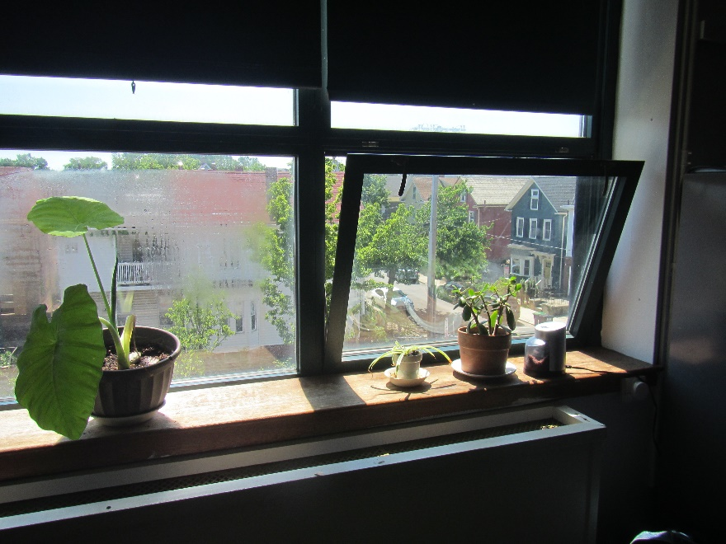

**Open classroom window, note plants on sill**

**Picture 2**

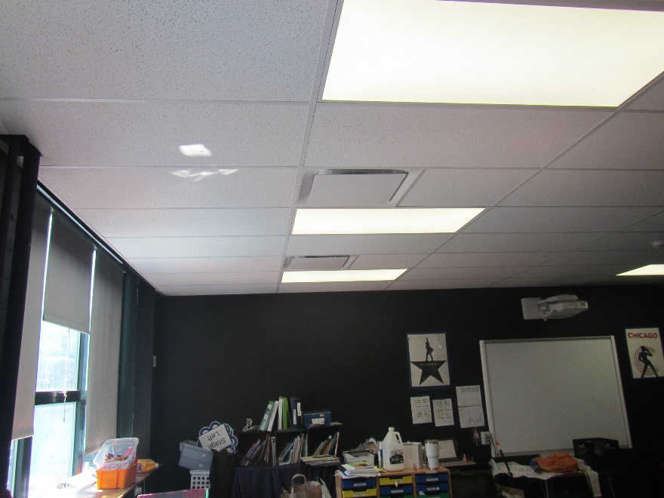

**Ceiling-mounted supply vents**

**Picture 3**

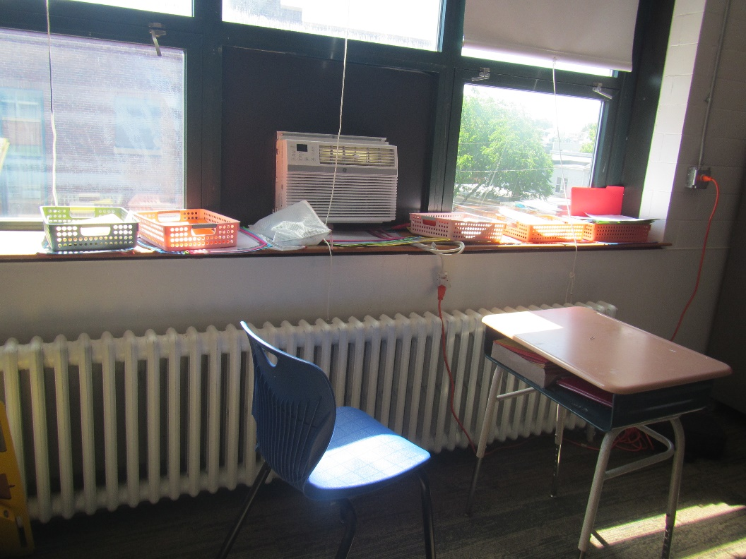

**Steam radiator and window air conditioner**

**Picture 4**

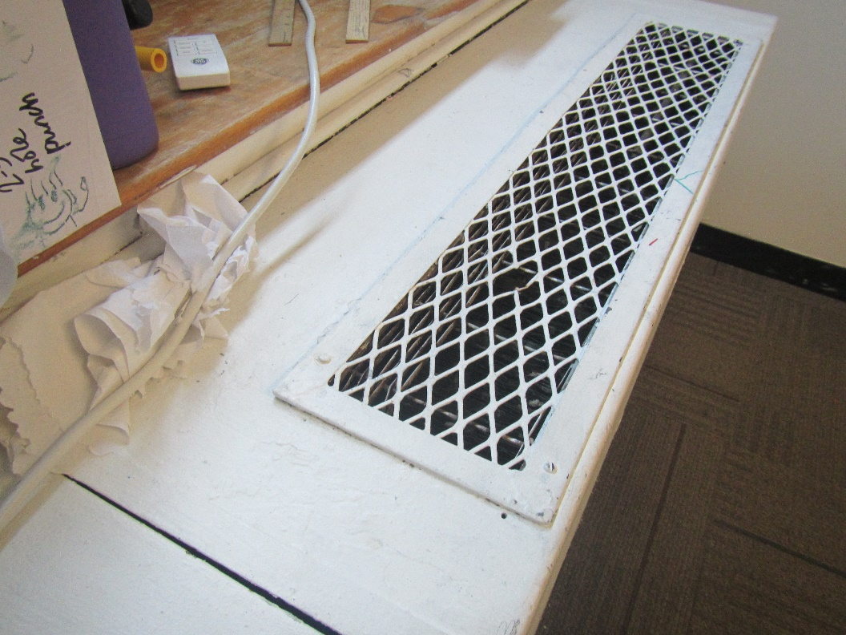

**Radiator cabinet**

**Picture 5**

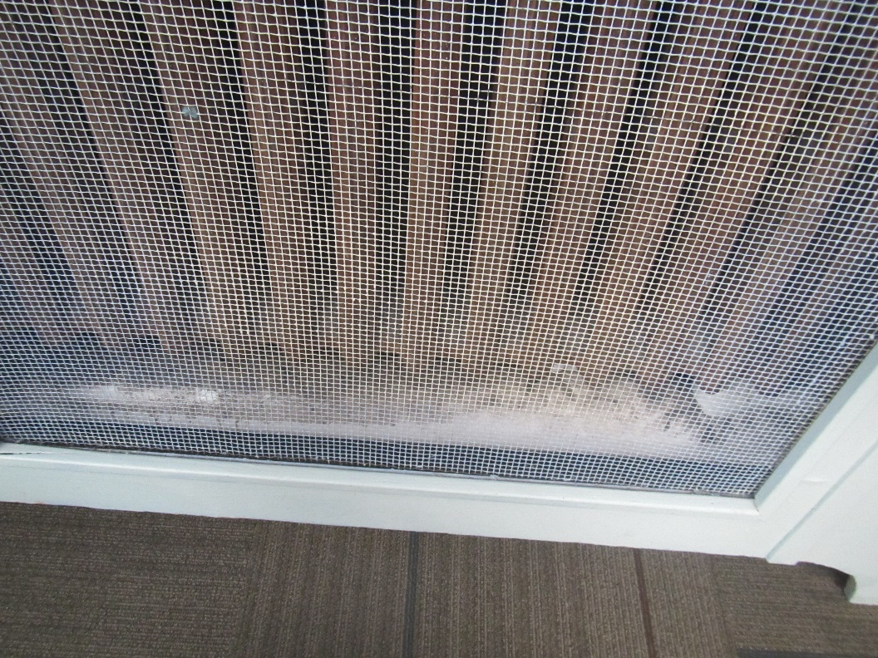

**Bottom of radiator cabinet showing accumulation of debris**

**Picture 6**

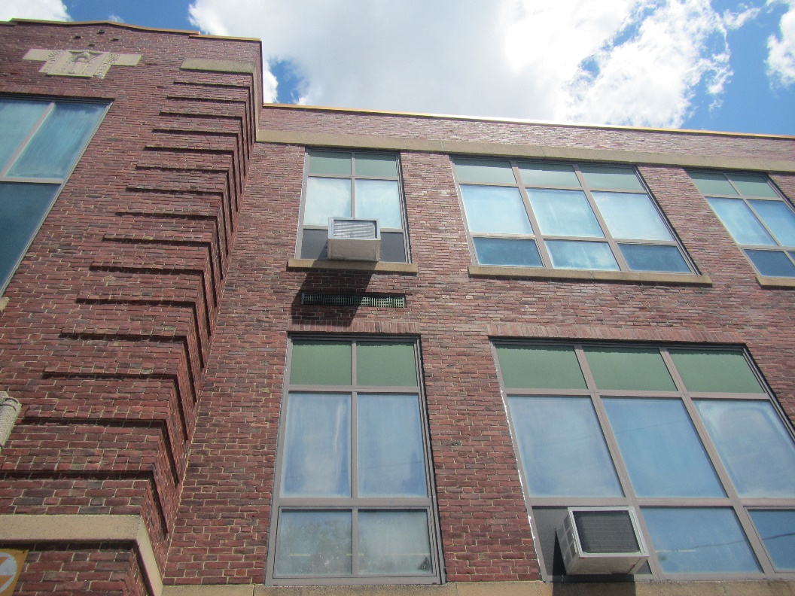

**Exterior view of window air conditioner**

**Picture 7**

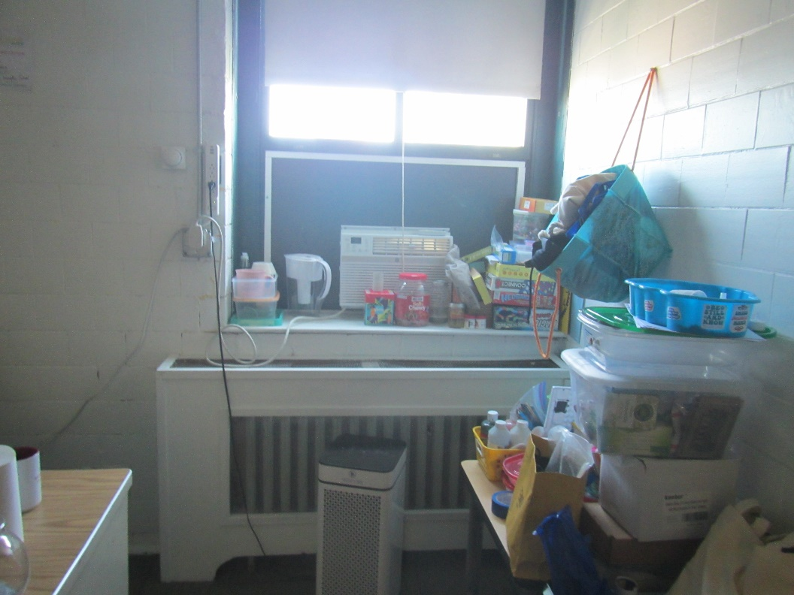

**Small room where window air conditioner blocks openable window, note air purifier, clutter**

**Picture 8**

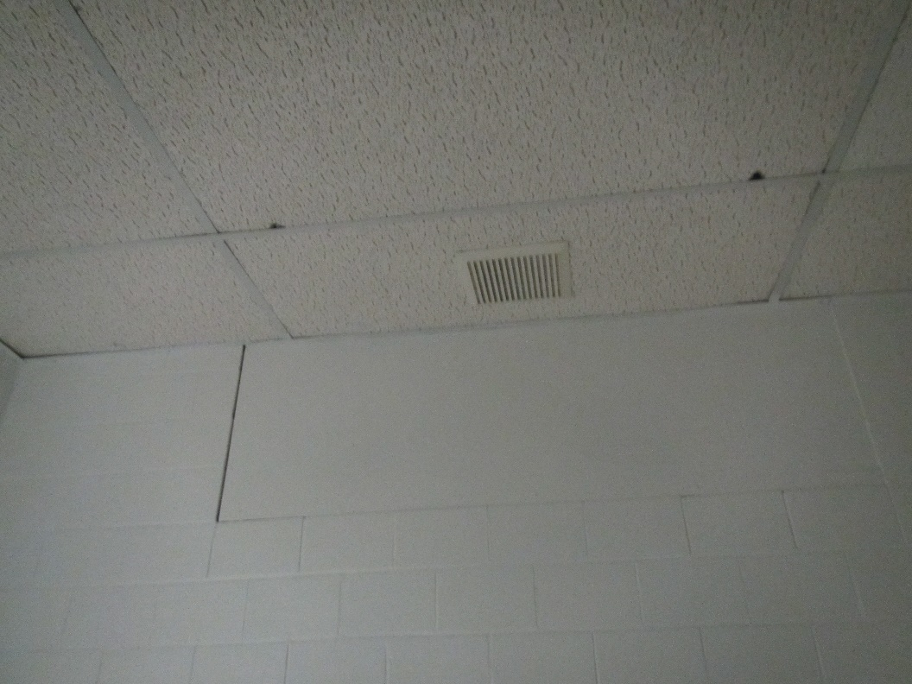

**Ceiling-mounted exhaust vent in a restroom**

**Picture 9**

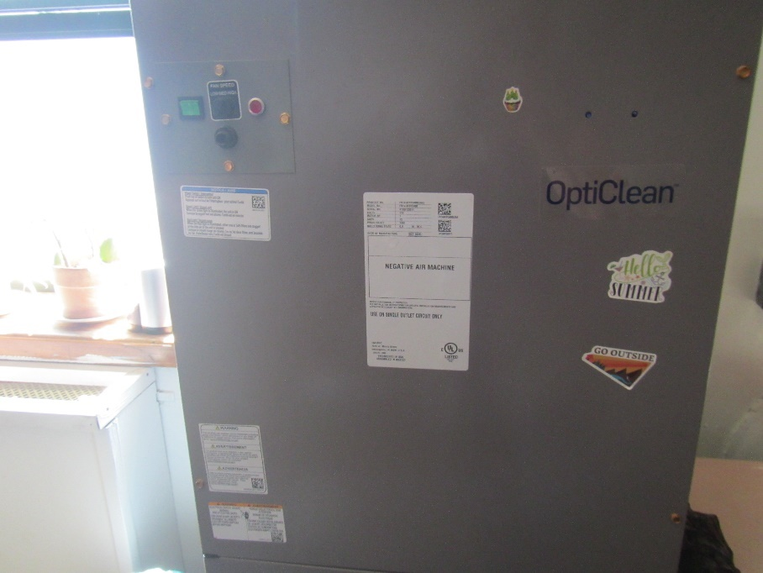

**Large format air purifier (Carrier Opticlean HEPA equipped filter systems )**

Water Damage pictures

**Picture 10**

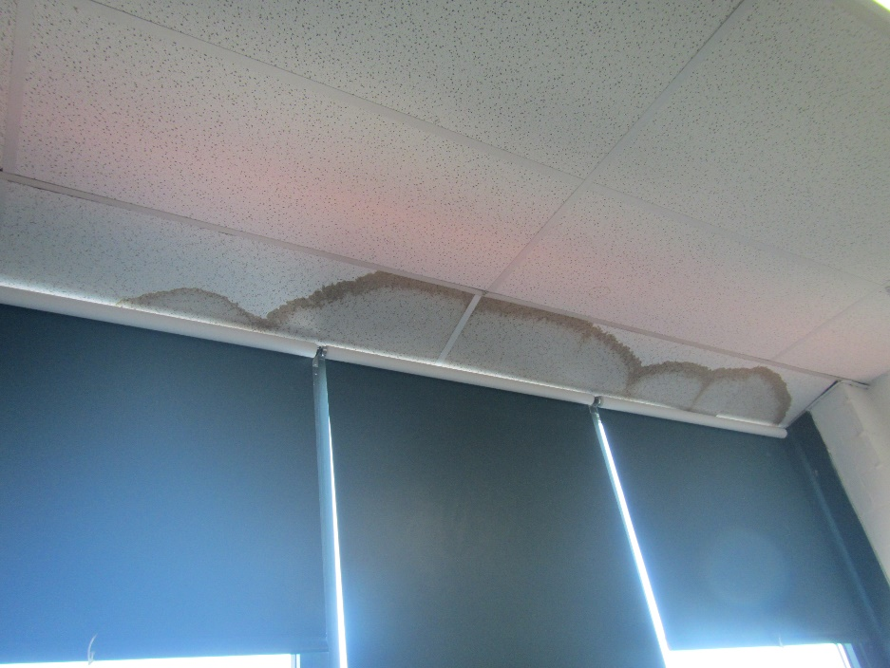

**Water-damaged ceiling tiles**

**Picture 11**

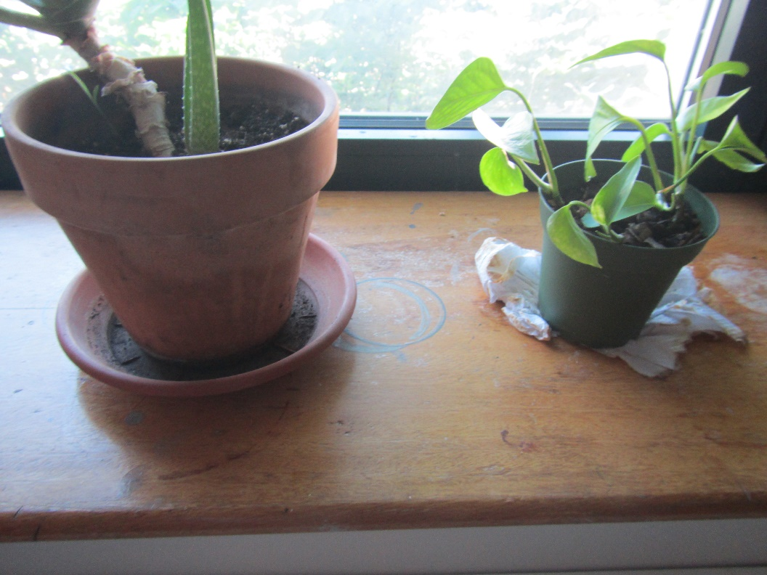

**Water-damaged windowsill due to plants, and plants on paper towels**

**Picture 12**

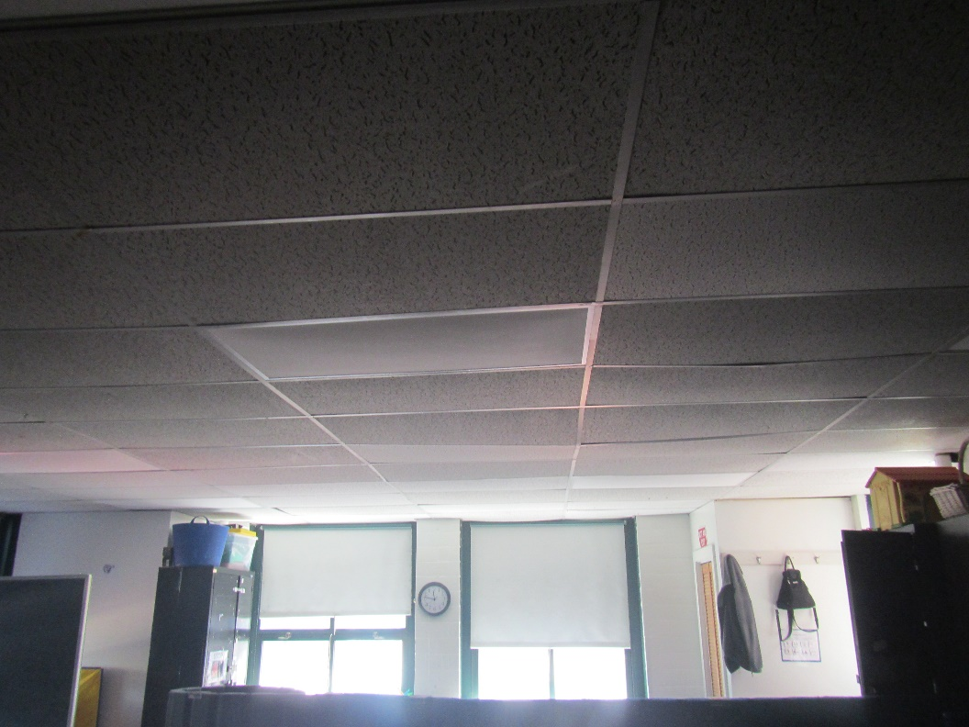

**Bowed/sagging ceiling tiles**

**Picture 13**

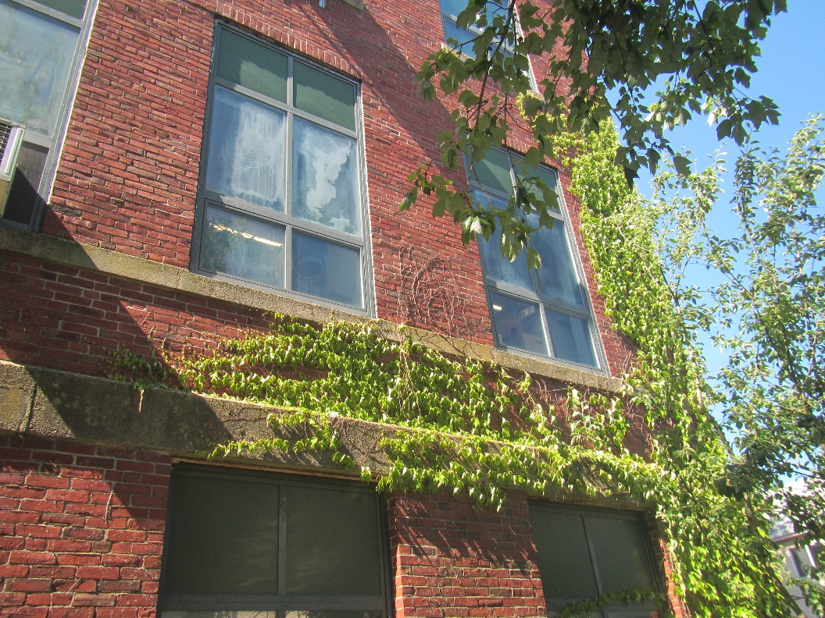

**Plants and vines on and near the building**

Respiratory Irritants pictures

**Picture 14**

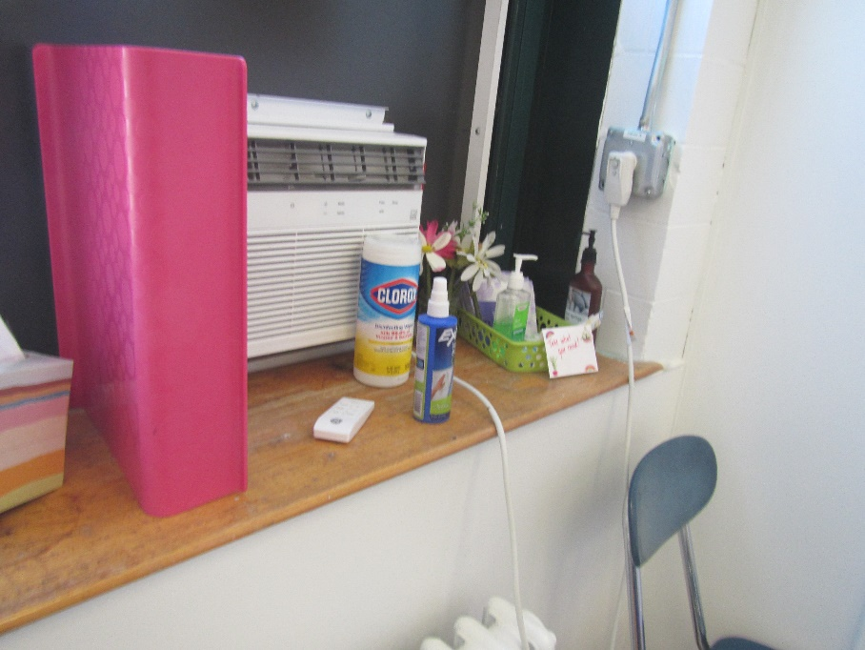

**Sanitizers, cleaning products, and dry erase materials**

**Picture 15**

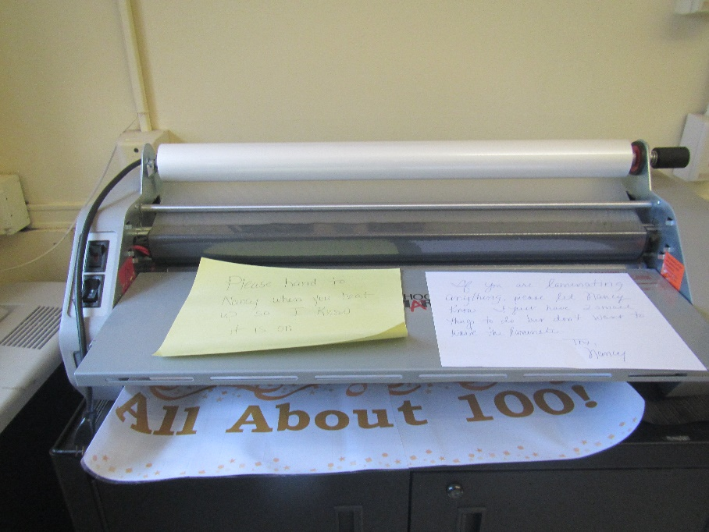

**Laminator in a staff workroom**

**Picture 16**

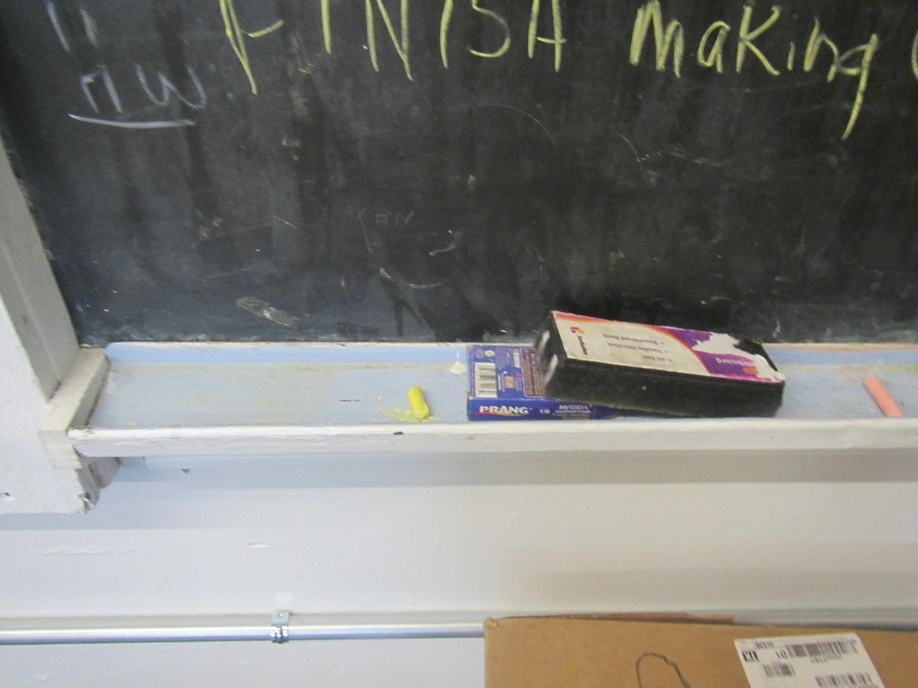

**Chalk and chalk dust**

**Picture 17**

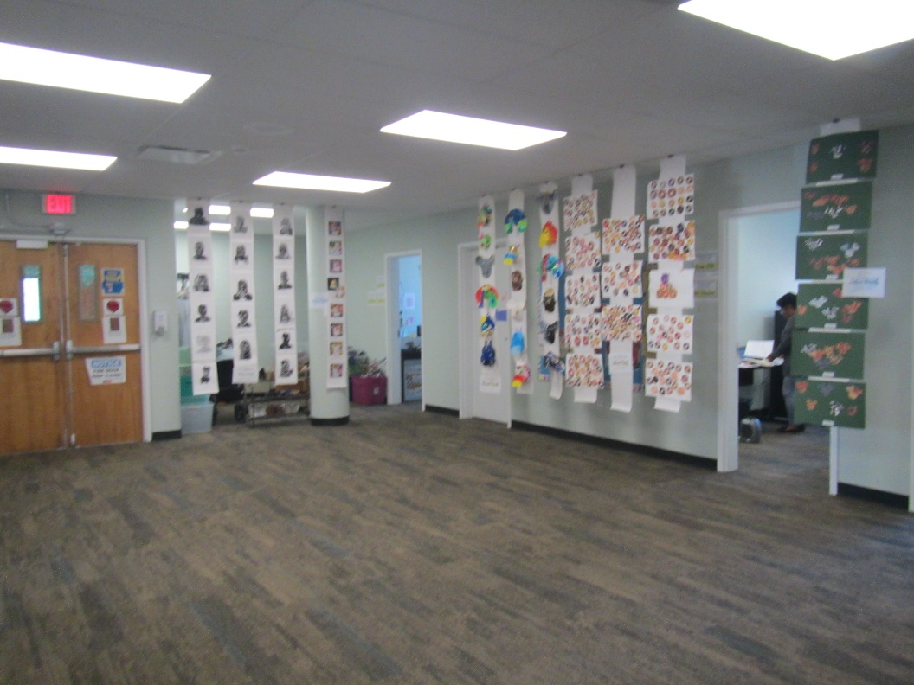

**Items hanging from the ceiling**

Click to link back to report

# Table 1

| Location | **Carbon**  **Dioxide**  **(ppm)** | **Carbon Monoxide**  **(ppm)** | **Temp**  **(°F)** | **Relative**  **Humidity**  **(%)** | **PM2.5**  **(µg/m3)** | **Occupants**  **in Room** | **Windows**  **Openable** | **Ventilation** | | **Remarks** |
| --- | --- | --- | --- | --- | --- | --- | --- | --- | --- | --- |
| **Supply** | **Exhaust** |
| Background (outside) | 373 | 3.5 | 75 | 34 | 3 |  |  |  |  | Sunny, warm, traffic |
| Third floor | | | | | | | | | | |
| 3rd floor women’s restroom |  |  |  |  |  |  |  | N | Y | 1 WD CT |
| 014 | 994 | ND | 74 | 47 | 2 | 3 | Y | N | N | 2 WAC on, PC, carpet, dumbwaiter |
| 013 | 1039 | 1.1 | 74 | 49 | 1 | 0 | N | N | N | Kitchen, old wood floor, sink |
| 012 | 1066 | 1.2 | 75 | 47 | 3 | 3 | Y | N | N | Carpet, WAC, DEM |
| 011 | 1099 | 1.2 | 75 | 46 | 2 | 4 | Y | N | N | WAC on, carpet, boxes on floor |
| 010 | 1097 | 1.3 | 74 | 44 | 2 | 2 | Y | N | N | Area rug, WAC on, DEM, PF, AP |
| 009 | 1084 | 1.3 | 74 | 48 | ND | 1 | Y 1 open | N | N | WAC, wood floor |
| 009A | 948 | 1.3 | 74 | 48 | 1 | 1 | Y 2 open | N | N | WAC, wood floor, plant |
| 007 | 923 | 1.3 | 74 | 49 | 2 | 0 | Y | N | N | WAC, DEM, plant, area rug, chalk |
| 006 | 735 | 1.4 | 74 | 46 | 2 | 0 | Y 1 open | N | Y | Mats, carpet, plant, WAC |
| 005 | 781 | 1.3 | 73 | 49 | 1 | 1 | N | N | Y |  |
| 004 | 792 | 1.2 | 73 | 42 | 1 | 6 | Y 2 open | N | N | 2 AT, DEM, CP, wood floor, HS |
| 003 | 835 | 1.2 | 74 | 48 | 1 | 2 | Y | N | N | WAC, area rug, plants, CP |
| 002 | 959 | 1.2 | 73 | 44 | 1 | 12 | Y 2 open | N | N | WAC, DEM |
| 001 | 932 | 1.2 | 74 | 48 | 3 | 0 | Y | N | N | Wood floor, plants, DEM, chalk |
| Sped | 1519 | 1.3 | 72 | 45 | 1 | 0 | Y | N | N | WAC on, chalk, DEM, carpet |
| 308 | 1063 | 1.2 | 72 | 48 | 1 | 4 | Y | N | N | 1 AT, carpet, WAC on, HS, missing CT |
| 307 | 1043 | 1 | 72 | 45 | 1 | 1 | N | N | Y | WAC, carpet |
| 307 inner | 1056 | 1 | 71 | 46 | 1 | 0 | N | N | N | AP, carpet |
| 313 | 1043 | 1 | 71 | 47 | 1 | 0 | Y | N |  | WAC on, carpet |
| 307B | 799 | 0.9 | 72 | 44 | 2 | 0 | Y 4 open | N | Y | 3 WD CT, carpet |
| 306 | 1051 | 0.9 | 73 | 50 | 1 | 4 | Y 1 open | N | N | WAC on, wood floor, carpet |
| 314 | 1080 | 1 | 73 | 48 | 1 | 14 | Y | N | N | Carpet, WAC, plants |
| 306A | 1099 | 1 | 73 | 50 | 1 | 7 | Y | N | N | Carpet, attached restroom with exhaust, WAC on |
| Inner office | 1181 | 1 | 73 | 51 | 1 | 0 | y | N | N | 1 WD CT, carpet |
| 305 | 1276 | 1.1 | 73 | 45 | 3 | 15 | Y | N |  | WD plaster ceiling, carpet, WAC, plants |
| 304 | 1249 | 1.1 | 74 | 49 | 3 | 16 | Y | N | N | Carpet, WAC |
| 303 | 1149 | 1.1 | 75 | 45 | 3 | 3 | Y | N | N | WAC, carpet, plants |
| 302 | 1100 | 1.1 | 76 | 47 | 3 | 0 | Y 1 open | N | N | Large (industrial) AP, carpet, WAC on |
| 301 | 790 | 1.5 | 76 | 45 | 3 | 15 | Y | N | N | Carpet, large AP, chalk |
| 300 | 1761 | 1.6 | 74 | 49 | 5 | 16 | Y | N | N | WAC, carpet, DEM, chalk |
| 300A | 1409 | 1.6 | 72 | 57 | 1 | 0 | N | N | N | WAC on, HS/CP, odor from AF, and reports of other odors in room |
| Second Floor | | | | | | | | | | |
| 201 | 1295 | 1.5 | 75 | 54 | 3 | 5 | Y | N | N | WAC, carpet, area rug |
| 200 | 1131 | 1.7 | 75 | 48 | 2 | 5 | Y | N | N | AT, carpet, area rug, DEM, restroom with window attached |
| 202 | 686 | 1.7 | 74 | 37 | 4 | 1 | Y 1 open | N | N | WAC on, carpet, DEM, flaking ceiling plaster |
| 216 | 1070 | 1.8 | 74 | 56 | 3 | 11 | Y | N | N | Gym |
| 203 | 981 | 1.6 | 74 | 41 | 4 | 0 | Y 2 open | N |  | WAC on, carpet, art supplies |
| 204 | 2489 | 1.8 | 74 | 51 | 2 | 20 | Y | N |  | WAC on, carpet and area rug |
| 207D | 1498 | 1.6 | 75 | 55 | 4 | 1 | Y | N | N | Plants, WAC, heater, carpet and area rug |
| 207B | 1648 | 2.8 | 75 | 53 | 2 | 0 | Y | N | N | Plush items, carpet and area rug, PFs on, WAC, DEM, CP |
| 214 | 1129 | 2.0 | 73 | 38 | 2 | 0 | Y | N | N | Staff conference room, laminator, plants, WAC on |
| 207A | 1242 | 2.1 | 70 | 59 | 2 | 5 | Y | N | Y | Art room, sink with items underneath, WAC on, NC, area rug |
| 213 | 1136 | 1.8 | 72 | 50 | 3 | 0 | Y | N | N | CP, WAC, NC |
| 211A nurse | 1254 | 1.9 | 70 | 48 | 2 | 2 | N | Y |  | Sink and fridge |
| 210B | 1421 | 1.9 | 69 | 59 | 2 | 16 | Y | N | Y | WAC, carpet, area rug |
| 211F conference | 1093 | 1.7 | 67 | 50 | 1 | 0 | Y | Y | Y | Supply vent from air handling unit, carpet |
| 210C | 947 | 1.5 | 67 | 49 | 2 | 0 | Y | Y | Y | Carpet |
| 210D | 974 | 1.3 | 70 | 49 | 3 | 0 | Y 3 open | Y | Y | Music, PF on, NC with area rug, DEM |
| 211D | 649 | 1.3 | 69 | 43 | 1 | 0 | N | Y | Y | Carpet, costumes, windows blocked with cardboard and curtains |
| 211E | 636 | 1.3 | 68 | 42 | 2 | 0 | Y | Y | Y | Carpet |
| 211 | 636 | 1.2 | 69 | 42 | 2 | 2 | Y | N | N | Carpet, perfume odor |
| 211M | 667 | 1.1 | 68 | 43 | 2 | 2 | Y | Y | Y | Carpet, plant, clothes |
| 211C | 732 | 1.2 | 67 | 44 | 1 | 2 | Y | Y | Y | Carpet, books/papers |
| 211K | 715 | 1.1 | 66 | 44 | 1 | 1 | Y | Y | Y | Carpet, heater |
| 211J | 574 | 0.9 | 67 | 42 | 2 | 0 | Y 1 open | Y | Y | WAC on, carpet |
| 211I | 656 | 0.8 | 66 | 45 | 2 | 1 | Y | Y | Y | Carpet |
| First Floor | | | | | | | | | | |
| 110 | 1550 | 0.7 | 70 | 53 | 5 | 1 | Y | N | N | WAC, plants, transfer air vent |
| 109 | 1161 | 0.8 | 71 | 60 | 7 | 2+ | Y | N | N | WAC, carpet and area rug, plants, DEM, mats |
| 113 sensory | 1030 | 1.1 | 70 | 46 | 3 | 0 | Y | N | N | WAC on, carpet, area rug, mats |
| 108A | 645 | 1.2 | 70 | 45 | 5 | 0 | Y 2 open | N | N | Door to outside, WAC, carpet and area rug |
| 114 | 783 | 1.3 | 71 | 51 | 5 | 0 | N | N | N | NC, Mats |
| 108B | 554 | 1.4 | 73 | 43 | 1 | 0 | Y 1 open | N | N | Carpet and area rug |
| 115 | 1144 | 1.7 | 72 | 46 | 10 | 8 | N | N | N | Cafeteria extension, WAC |
| 108C | 943 | 1.9 | 71 | 47 | 5 | 1 | Y | N | N | WAC on, attached restroom with exhaust vent, carpet and area rug, HS |
| Cafeteria | 1088 | 1.7 | 74 | 52 | 7 | >50 | Y 3 open | Y |  | Door to outside |
| Custodian | 1014 | 1.6 | 76 | 50 | 7 | 0 | Y | N | N | Aquarium, restroom and sink, fridge |
| 106A | 908 | 2.4 | 73 | 45 | 3 | 0 | Y | N | N | WAC, WD CT, carpet, bowed CT |
| 105 | 1086 | 3.1 | 73 | 46 | 4 | 4 | Y | N | N | Carpet and area rug. WAC on |
| 101 | 947 | 3.3 | 74 | 46 | 3 | 13 | Y 2 open | N | N | Carpet and area rug, WAC, door |
| 100 | 874 | 3.4 | 74 | 45 | 2 | 12 | Y 1 open | N | N | Missing tile, new wood or laminate floor, area rug |

(Click to link back to report)

# Table 2A

|  |  |  |  |  |  |
| --- | --- | --- | --- | --- | --- |
| **Equipment Present in Building**  **(X = Yes)** | **Type of Heating/Cooling Ventilation**  **Equipment** | **Fresh**  **Air**  **Supply**  **(X = Yes)** | **Type of Location(s)** | **Air Filters Installed**  **MERV Rating**  **(1-15, U*)**  **(X = Yes)** | **Comments** |
|  | Univents |  |  |  |  |
| X | Rooftop Air Handling Units | Y | One second floor wing | U |  |
|  | Outdoor, Ground-Installed Air Handling Units |  |  |  |  |
|  | Attic/Crawlspace Air Handling Units |  |  |  |  |
|  | Ceiling-Mounted Air Handling Units (including inside plenum) |  |  |  |  |
|  | Basement/Crawlspace-Installed Air Handling Units |  |  |  |  |
|  | Mechanical Room-installed Air Handling Units |  |  |  |  |
|  | Fan Coil Units |  |  |  |  |
| X | Window-Mounted Air Conditioners | X | Classrooms, offices |  |  |
|  | Wall Louver-Controlled Gravity Air Supply |  |  |  |  |
| X | Windows |  | Most rooms |  |  |
|  | Fan in window (blowing in) |  |  |  |  |
|  | Built in wall fan (switched) |  |  |  |  |
|  | Heat recovery ventilator unit |  |  |  |  |
|  | Energy recovery ventilator unit |  |  |  |  |
|  | Chilled Beam |  |  |  |  |
|  | Passive combustion supply vent in basement/boiler room |  |  |  |  |

*U = Filter Rating underdetermined due to inaccessibility during building visit

(Click to link back to report)

# Table 2B

|  |  |  |  |  |
| --- | --- | --- | --- | --- |
| **Equipment Present in Building**  **(X = Yes)** | **Type of Exhaust Ventilation**  **Equipment** | **Ducted**  **To Outdoors**  **(X = Yes)** | **Type of Location(s)** | **Comments** |
| X | Rooftop Motors/Fans | X | 2nd floor classrooms |  |
|  | Unit Exhaust |  |  |  |
|  | Ceiling Return Vent |  |  |  |
|  | Ceiling Return Vent, Plenum |  |  |  |
|  | Wall Return Vent |  |  |  |
|  | Kitchen Stove Hood |  |  |  |
| X | Restroom Exhaust Vent | X | Restrooms without windows | Some appear to be household style retrofit |
|  | Photocopier Exhaust Vent |  |  |  |
|  | Garage |  |  |  |
|  | Chemical Hood(s) |  |  |  |
|  | Locker Rooms |  |  |  |
|  | Showers |  |  |  |
|  | Clothes Dryers |  |  |  |
|  | Gas Water Heaters |  |  |  |
|  | Furnace-Flue to Chimney |  |  |  |
|  | Furnace/Boiler direct vent or power vent (no combustion air supply) |  |  |  |
|  | Kiln, Pottery |  |  |  |
|  | Dark Room |  |  |  |
|  | Generator Room |  |  |  |
|  | Wood Shop Dust Collector |  |  |  |
|  | Spray Paint Booths |  |  |  |
|  | Fan in window (blowing out) |  |  |  |

# Table 2C

|  |  |  |  |
| --- | --- | --- | --- |
| **Equipment Present in Building**  **(X = Yes)** | **Type of Equipment** | **Type of Location(s)** | **Comments** |
| X | Floor Fans, pedestal | Classrooms, offices |  |
| X | Floor Fans, portable | Classrooms, offices |  |
| X | Air Purifier (HEPA, other) | Classrooms, offices |  |
|  | Floor heaters, portable |  |  |
| X | Refrigerators, Cold Beverage Vending Machines |  |  |
| X | Radiator, wall-mounted | All rooms with exterior walls |  |
|  | Radiator, floor-mounted |  |  |
| X | Passive Vents (Wall/Door) | One room as noted |  |

(Click to link back to report)

# Table 3

| **Found in Building**  **X = Yes** | **Water-Damaged Materials, Building Components or Stored Materials** | **Location** | **Visible Microbial Growth?**  **X = Yes** | **Musty odor detected?**  **X = Yes** | **Comments** |
| --- | --- | --- | --- | --- | --- |
|  | Books-other bound materials |  |  |  |  |
|  | Brick walls – broken, missing mortar |  |  |  |  |
|  | Brick walls – blocked weep holes |  |  |  |  |
|  | Cardboard boxes |  |  |  |  |
|  | Carpet tiles |  |  |  |  |
|  | Carpet - Area rugs |  |  |  |  |
|  | Carpet wall-to-wall |  |  |  |  |
|  | Ceiling tiles - affixed directly to ceiling surface |  |  |  |  |
| X | Ceiling tiles - bowing-in suspended ceiling | Some first floor rooms | No | No |  |
|  | Ceiling tiles - water-stained in splined ceiling |  |  |  |  |
| X | Ceiling tiles - water-stained in suspended ceiling | By windows in a few classrooms | No | No |  |
|  | Chairs - laminated |  |  |  |  |
|  | Cloth |  |  |  |  |
|  | Countertops (around sinks) |  |  |  |  |
|  | Curtains |  |  |  |  |
|  | Dust/debris within AHU, uninvent, HVAC, chilled beam units, etc. (WD through condensation, humidity, or leaks) |  |  |  |  |
|  | Efflorescence (i.e., mineral deposits) |  |  |  |  |
|  | Engineered woods - particleboard, plywood, Masonite |  |  |  |  |
|  | Flooring – loosened tiles |  |  |  |  |
|  | Flooring - wooden |  |  |  |  |
|  | Furniture - laminated |  |  |  |  |
|  | Furniture - upholstered |  |  |  |  |
|  | Gypsum wallboard - ceiling |  |  |  |  |
|  | Gypsum wallboard - restroom wall |  |  |  |  |
|  | Gypsum wallboard - interior wall |  |  |  |  |
|  | Gypsum wallboard – located on exterior wall |  |  |  |  |
|  | HVAC drain pan – lack of draining |  |  |  |  |
|  | HVAC filters |  |  |  |  |
|  | Insulation- attic (paper-backed) |  |  |  |  |
|  | Insulation - inside air handling unit |  |  |  |  |
|  | Insulation - on pipe(s) fiberglass |  |  |  |  |
|  | Insulation - on pipe(s) other/plaster-like material |  |  |  |  |
|  | Insulation - wall cavity |  |  |  |  |
|  | Insulation – ceiling plenum |  |  |  |  |
|  | Modular furniture – walls/cloth partitions |  |  |  |  |
|  | Musical instrument cases |  |  |  |  |
| X | Plaster ceilings | A few classrooms |  |  | (Table 1) |
|  | Records/files |  |  |  |  |
|  | Refrigerator - door gasket |  |  |  |  |
|  | Refrigerator - drip pan |  |  |  |  |
|  | Refrigerator - Interior surfaces |  |  |  |  |
|  | Room divider - ceiling-mounted, sliding |  |  |  |  |
|  | Sink backsplash |  |  |  |  |
|  | Tables – laminated |  |  |  |  |
|  | Wallpaper |  |  |  |  |
|  | Wood - attic/roof materials |  |  |  |  |
|  | Wood - floor joists in basement ceiling |  |  |  |  |
|  | Wood - wall framing |  |  |  |  |
|  | Wood - window sills |  |  |  |  |
|  | Wood - window-mounted air conditioner framing |  |  |  |  |
|  | OTHER |  |  |  |  |

WHAT ARE ENVIRONMENTAL ASTHMA TRIGGERS?

Asthma triggers are any chemical, pollutant, or allergen that can make your asthma worse. Asthma triggers can also be strong chemical smells, dust, or pets. Your asthma triggers may be different from those of other people. Not all asthma triggers affect people the same way. Environmental asthma triggers are found both indoors and outdoors. DPH link: [Asthma and Your Environment (mass.gov)](https://www.mass.gov/doc/asthma-and-your-environment-english/download)

(click to link back to report)

# Table 4

| **Condition Present**  **X = Yes** | **Possible asthma symptom-inducing environmental pollutant** | **Recommendation to reduce or eliminate the pollutant** |
| --- | --- | --- |
| X | Water Damage and/or Mold  (allergen) | Identify water source and repair to eliminate.  Clean non-porous materials.  Remove and replace porous materials susceptible to mold growth.  Perform regular water damage assessments as a tool to ensure timely mitigation as needed.  Use NIOSH water damage assessment protocol as a guide: [NIOSH water damage assessment guideline](https://www.cdc.gov/niosh/docs/2019-115/pdfs/2019-115.pdf?id=10.26616/NIOSHPUB2019115&inf_contact_key=241b5c2ed98c27d94b530dedc36f1623f651f238aa2edbb9c8b7cff03e0b16a0). |
|  | Moistening of building components during hot, humid weather (>2 days in length) (mold, allergen) | Remove materials not dried in <2 days in a manner consistent with [US EPA Mold Removal in Commercial Buildings guideline](https://www.epa.gov/mold/pdf-version-checklist-mold-remediation-mold-remediation-schools-and-commercial-buildings).  Use dehumidification in occupied basement areas and other areas with chronic dampness. |
| X | Vegetation against exterior of building (water damage-mold) | Remove all vegetation preventing building exterior drying.  Remove all vegetation capable of falling onto a building or depositing debris onto the roof. |
|  | Personal humidifiers (lack of proper maintenance)  (pollutant and allergen) | Clean and maintain properly.  Use distilled water to eliminate metal and water treatment odors.  Maintain hydration by increasing water consumption. |
|  | Drains: Floor drains, Sink drains (abandoned use)  Water bubblers (abandoned use) | If in use, pour water into drain at least twice a week.  If not in use, seal the drain with an appropriate material in accordance with Massachusetts Plumbing Code (248 CMR 10.00). |
|  | Live Animals (turtles, gerbils, birds, rabbits, etc.) | Ensure cleanliness or remove animals from the location. |
|  | Improperly maintained aquariums and terrariums (allergen) | Maintain such equipment properly to eliminate odor.  Discontinue use. |
| X | Plants and flowers  (allergen and mold) | Keep indoor plants well maintained and not overwatered. Monitor for signs of mold and pests.  Ensure water for cut flowers does not become stagnant.  Ensure dried plant material is free of odors, mold, and pests and handled carefully  If asthma risks are high, eliminate plants and flowers. |
|  | HVAC system moisture issues  (mold, allergen) | Consult ASHRAE’s minimum standards for HVAC maintenance and inspection of commercial HVAC systems (<https://www.ashrae.org/technical-resources/bookstore/standards-180-and-211>). |
|  | HVAC system contaminant issues (allergen) | Consult ASHRAE’s minimum standards for HVAC maintenance and inspection of commercial HVAC systems (<https://www.ashrae.org/technical-resources/bookstore/standards-180-and-211>). |
|  | Indoor swimming pool odors outside of swimming pool (mold, chemical) | Maintain and operate pool HVAC systems to vent odors from building.  Ensure locker room exhaust vents are operating during building hours.  All doors leading to pool should be rendered airtight and be closed. |
| X | Pollen (allergen) | Recommend installation of MERV 8 or better filters if HVAC engineer confirms HVAC system can be so equipped without adversely affecting function.  Cut grass after hours.  Cut grass in a pattern to direct clippings away from exterior wall.  Remove trees and shrubs from in front of windows and air intakes. |
|  | Dry air | Maintain hydration.  Avoid overheating of air. |
|  | Dust mites  (allergen) | Recommendation to remove non-official upholstered furniture, area rugs, pillows, cushions, etc.  Cleaning with use of HEPA-filtered vacuum cleaner.  Eliminating clutter, storing items in dust and moisture-proof containers, and regularly removing dust through wet wiping. |
| X | Pests, including rodents and cockroaches  (allergen) | Use of integrated pest management guidelines, including:   * Proper disposal of food containers * Proper storage of food products in airtight containers * Elimination of use of food as art projects * Remove pest harborages/clutter * Regular monitoring for pests   [EPA IPM guideline link](https://www.epa.gov/ipm/introduction-integrated-pest-management) |
|  | Latex-containing materials | Remove tennis balls from furniture legs. |
| X | Fragrances  (chemical) | Eliminate point sources, such as:   * Plug-in air fresheners * Aroma/oil reed diffusers * Scented sprays * Discontinue use of other scented materials * Consult DPH fragrance guideline: [*Clean air is odor-free*](https://www.mass.gov/doc/clean-air-is-odor-free-removing-fragrances-to-improve-indoor-air-quality-in-schools-and-0/download) |
|  | Strong smells from /use of Chemicals (such as cleaning products)  (chemical) | Use building-issued cleaning products.  Use products in accordance with manufacturer’s instructions including dilution, application, and ventilation.  Avoid using products that are stronger than needed for the situation. |
|  | Strong odors from new building materials (carpeting/furniture)  (chemical) | Use low VOC-emitting materials.  Air out materials (outside or in unoccupied area) prior to installation. |
|  | Tobacco smoke  Secondhand Smoke  (pollutant) | Eliminate tobacco smoking.  Seal all shared wall penetrations. |
| X | Products with a strong odor such as paint, perfume, hairspray, air fresheners, bug-spray, laminators, candles, wax melters, dry erase markers and other VOC-containing products  (chemical) | If essential:   * Provide proper exhaust ventilation to eject aerosolized product directly outdoors. * Avoid/reduce use during occupied hours.   If not necessary, remove and eliminate. |
| X | Vehicle exhaust  (pollutant) | Enforce anti-idling regulations and post signs to give notice.  Relocate vehicles away from fresh air intakes.  Require cars to park face-in at building walls.  [MA anti-idling law FAQs](https://www.mass.gov/files/documents/2018/02/20/idling-faq.pdf#:~:text=The%20Massachusetts%20Anti-Idling%20Law%20The%20goal%20of%20the,sometime%20wonder%20when%20idling%20might%20be%20considered%20necessary.) |
|  | Vapors and or fumes from gas, oil, or kerosene stoves  (pollutant) | Operate stove hood when stove in use.  Install stove hood if not present.  Ensure equipment is in good working order. |
|  | Ozone (pollutant) | Eliminate use of ozone generating equipment. |
| X | Window Air Conditioners (if not properly maintained) (allergen) | Equip with proper filter and clean periodically.  Clean drip pans.  Install in window with weathertight, non-mold-growth sustaining material. |
|  | Pottery (pollutant) | Do not operate kiln during occupied hours.  Operate kiln with exhaust system activated.  Seal all seams and holes in kiln vent.  Ensure kiln exhaust discharge terminates outdoors. |
| X | Carpeting (allergen) | Clean carpeting in a manner consistent with IICRC standards, including regular vacuuming with a high efficiency particulate air (HEPA) filtered vacuum in combination with annual cleaning or semi-annual cleaning in soiled high traffic areas. |
|  | Sweeping/dusting vs HEPA vacuuming/wet wiping  (allergen or pollutant) | Refrain from using feather dusters or brooms.  Utilize HEPA vacuums and wet wiping to minimize aerosolizing particulate matter. |
| X | Lack of adequate air exchange/mechanical ventilation | Make repairs as necessary and ensure all HVAC system components are operating continuously when building is occupied. |
|  | Lack of local exhaust at source of pollution (vocational shop activities, kitchen exhaust hood) (all) | Recommend installation of exhaust ventilation to direct pollutants directly outdoors. |
|  | Renovating buildings while occupied  (chemical) | Use all SMACNA guidelines for Renovation While Buildings Are Occupied. For information, visit <https://www.mass.gov/service-details/construction-and-renovation-generated-pollutants-in-occupied-buildings>. |
|  | Chemistry program chemical storage  (chemical) | Repair (if needed) and operate chemical storeroom vents appropriately.  Reduce or eliminate unneeded or overstocked chemicals.  Store all chemicals in a manner to separate incompatible chemicals.  Keep chemical storerooms clean. |
| X | Photocopiers/duplicating machines | All machines should have dedicated exhaust vents. |