INDOOR AIR QUALITY ASSESSMENT

Winthrop Elementary School
162 First Street
Melrose, Massachusetts 02176



Prepared by:
Massachusetts Department of Public Health
Bureau of Environmental Health
Indoor Air Quality Program
June 2009

Background/Introduction
At the request of Ruth Clay, Director of the Melrose Health Department (MHD), the Massachusetts Department of Public Health (MDPH), Bureau of Environmental Health (BEH) conducted an assessment of indoor air quality (IAQ) at the Winthrop Elementary School (WES), 162 First Street, Melrose, Massachusetts. This assessment was a follow-up to previous IAQ assessments (MDPH, 2001; MDPH, 2002; MDPH, 2007). On February 5, 2009, a visit to conduct an assessment was made to the WES by Sharon Lee, an Indoor Air Inspector/ Environmental Analyst within BEH’s Indoor Air Quality (IAQ) Program. Ms. Lee returned to the WES on May 21, 2009 to conduct a re-assessment after the heating, ventilation and air-conditioning (HVAC) was adjusted.
The school is a two-story brick structure. The original school building was completed in 1926. An addition was constructed in 1956. Openable energy efficient windows were installed throughout the building. Based on recommendations made in previous MDPH assessments (MDPH, 2001, MDPH, 2002, and MDPH, 2007), the HVAC system was reactivated.
Prior to the February 2009 assessment, the MPS installed a filter bank system within the ductwork of the HVAC system in an effort to provide filtration of fresh air distributed to classrooms. This installation included construction of new ductwork and the placement of pleated filters post air-handling unit (AHU). The BEH was asked to evaluate the indoor air quality of the WES subsequent to the filtration system installation. At the time of the February 2009 assessment, the installation of the filter bank and its filters were completed. At that time, BEH staff recommended further adjustments to the ventilation system to increase fresh air supply based on observations made during the February 2009 assessment. The MHD in conjunction with the Melrose Public School’s (MPS) Facilities Department conducted indoor air assessments in the interim (MHD, 2009).
BEH staff returned to the MES to conduct a follow-up assessment on May 21, 2009. Subsequent to the most recent assessment, the MPS reported that new exhaust motors for the 1956 wing of the building were installed following the May 21, 2009 assessment.
The following HVAC improvement activities are reportedly planned for summer of 2009:
- Calibration of all thermostats in the building;
- Modifications to thermostats to run independent of the boiler system to allow for increased control over the fresh air supply and exhaust systems; and
- Ensuring all valves and actuator motors are operating properly.
The MPS has also worked with a number of consultants regarding lead paint and mold remediation concerns. Based on reports provided to the BEH, lead paint is not present in the school (AmeriSci, 2008). In addition, a private consultant conducted airborne mold-sampling in the building. These reports indicate that there are “no indications of abnormal mold growth or airborne mold spore levels”; based on those findings, no recommendations were made (Universal Environmental Consultants, 2009a; Universal Environmental Consultants, 2009b).

Methods
Air tests for carbon monoxide, carbon dioxide, temperature and relative humidity were conducted with the TSI, Q-Trak, IAQ Monitor, Model 7565. Air tests for airborne particle matter with a diameter less than 2.5 micrometers were taken with the TSI, DUSTTRAK™ Aerosol Monitor Model 8520. BEH staff also performed a visual inspection of building materials for water damage and/or microbial growth.

Results
The school houses approximately 400 kindergarten through fifth grade students and approximately 40 staff members. The tests were taken during normal operations at the school. Test results appear in Tables 1 and 2.

Discussion

Ventilation
Carbon dioxide levels were above 800 parts per million (ppm) in 21 out of 31 areas surveyed on February 5, 2009 (Table 1) and 4 of 30 areas assessed on May 21, 2009. Carbon dioxide levels measured on May 21, 2009 generally indicate an overall improvement in air quality exchange. Please note, however, windows were open in some classrooms during the May 21, 2009 assessment. Open windows can reduce carbon dioxide levels; levels would increase with windows closed. Opening windows in conjunction with operating ventilation equipment is recommended to facilitate air exchange.
Fresh air to classrooms in the 1926 building is provided by an AHU located in a large air mixing room on the ground floor of the building. Fresh air is passively provided to the air mixing room (Picture 1). Air is drawn through heating elements and into a fan unit (Picture 2), where it is filtered (Picture 3). Heated air is distributed to classrooms via ductwork located in a crawlspace beneath the 1926 building that connects the AHU to classroom air diffusers. Exhaust ventilation is provided by rooftop fans connected to wall vents. Obstructions to exhaust vents were observed during the assessments (Tables 1 and 2; Pictures 4 and 5). During the May 2009 assessment, BEH staff observed a folder taped across the bottom portion of a supply vent (Picture 6) and a vinyl curtain drawn over a closet area where an exhaust vent is located, preventing adequate movement of air from the classroom to the closet exhaust (Picture 7).
Carbon dioxide levels were elevated in a number of rooms during the February assessment; however, that assessment was conducted following maintenance and installation of pleated filters to the AHU servicing the 1926 building. The elevated levels may in part be related to the installation of these pleated filters.
To decrease aerosolized particulates in the airstream, disposable filters were installed. The dust spot efficiency is the ability of a filter to remove particulates of a certain diameter from air passing through the filter. Filters that have been determined by ASHRAE to meet its standard for a dust spot efficiency of a minimum of 40 percent (Minimum Efficiency Reporting Value equal to 9) would be sufficient to reduce many airborne particulates (Thornburg, 2000; MEHRC, 1997; ASHRAE, 1992). Note that increasing filtration can reduce airflow, a condition known as pressure drop. A drop in air pressure can reduce the efficiency of the AHU due to increased resistance.
As described in previous reports, the WES AHU was not originally designed to have a filtration system. As a result of the new filter system, the ability of the AHU to supply air to classrooms was likely reduced because of the pressure drop. To best address this, BEH staff recommended balancing and adjusting the system to improve air exchange with the AHU operating with pleated filters.
A number of modifications were made to the AHU prior to the May 2009 assessment. Based on conversations with Mr. Robert Ciampi, Facilities Director, MPS, fresh air make-up was increased to decrease pressure drop; ductwork from the 3rd floor to the intake area was cleaned, and heating units for the AHU were repaired.
As discussed previously, at the time of the May 21, 2009 assessment, carbon dioxide levels were generally reduced. Concerns regarding testing while windows were open were voiced by some staff. Carbon dioxide levels measured during the May visit in rooms with no open windows/slightly open window (e.g., classrooms 26, 27, 33, 34; Table 2) were significantly lower than carbon dioxide levels measured in the same rooms assessed in February (Table 1). Carbon dioxide levels in these aforementioned rooms were reduced by at least 300 ppm.
Unit ventilator (univent) systems provide fresh air to classrooms in the 1956 portion of the building. A univent draws air from outdoors through a fresh air intake located on the exterior wall of the building and returns air through an air intake located at the base of the unit (Figure 1). Fresh and return air are mixed, filtered, heated and provided to classrooms through a fresh air diffuser located in the top of the unit. As with the 1926 portion of the building, exhaust ventilation in the 1956 building is provided by rooftop exhaust fan ducted to wall vents. The rooftop exhaust for the 1956 portion of the building was replaced with one with greater horsepower following the May 21, 2009 assessment. This new exhaust unit would likely improve exhaust capabilities. Univents and exhaust ventilation were operating at the time of both assessments; however, obstructions to airflow, such as boxes and tables blocking ventilation equipment, were observed in a number of classrooms (Pictures 8 and 9). In order for univents and exhaust vents to function as designed, the equipment was be operating and remain free of obstructions.
To maximize air exchange, the MDPH recommends that both supply and exhaust ventilation operate continuously during periods of school occupancy. In order to have proper ventilation with a mechanical supply and exhaust system, the systems must be balanced to provide an adequate amount of fresh air to the interior of a room while removing stale air from the room. It is recommended that HVAC systems be re-balanced every five years to ensure adequate air systems function (SMACNA, 1994). As reported by the MPS, these systems were balanced during the 2009 school year.
The Massachusetts Building Code requires that each area have a minimum ventilation rate of 15 cubic feet per minute (cfm) per occupant of fresh outside air or openable windows (SBBRS, 1997; BOCA, 1993). The ventilation must be on at all times that the room is occupied. Providing adequate fresh air ventilation with open windows and maintaining the temperature in the comfort range during the cold weather season is impractical. Mechanical ventilation is usually required to provide adequate fresh air ventilation.
Carbon dioxide is not a problem in and of itself. It is used as an indicator of the adequacy of the fresh air ventilation. As carbon dioxide levels rise, it indicates that the ventilating system is malfunctioning or the design occupancy of the room is being exceeded. When this happens, a buildup of common indoor air pollutants can occur, leading to discomfort or health complaints. The Occupational Safety and Health Administration (OSHA) standard for carbon dioxide is 5,000 parts per million parts of air (ppm). Workers may be exposed to this level for 40 hours/week, based on a time-weighted average (OSHA, 1997).
The MDPH uses a guideline of 800 ppm for publicly occupied buildings. A guideline of 600 ppm or less is preferred in schools due to the fact that the majority of occupants are young and considered to be a more sensitive population in the evaluation of environmental health status. Inadequate ventilation and/or elevated temperatures are major causes of complaints such as respiratory, eye, nose and throat irritation, lethargy and headaches. For more information concerning carbon dioxide, consult Appendix A.
Temperature measurements in the school ranged from 65° F to 82° F on February 5, 2009 (Table 1) and 76° F to 81° F on May 21, 2009 (Table 2). Temperatures in the majority of areas surveyed on both dates of assessment were within or close to the MDPH recommended temperature range. The MDPH recommends that indoor air temperatures be maintained in a range of 70º F to 78º F in order to provide for the comfort of building occupants. In many cases concerning indoor air quality, fluctuations of temperature in occupied spaces are typically experienced, even in a building with an adequate fresh air supply.
The relative humidity measured in the building on February 5, 2009 ranged from 9 to 21 percent (Table 1), which was below the MDPH recommended comfort range. On May 21, 2009, indoor relative humidity ranged from 29 to 42 percent (Table 2), also below the MDPH recommended comfort range. The MDPH recommends a comfort range of 40 to 60 percent for indoor air relative humidity. Relative humidity levels in the building would be expected to drop during the winter months due to heating. “Extremely low (below 20%) relative humidity may be associated with eye irritation [and]…may affect the mucous membranes of individuals with bronchial constriction, rhinitis, or cold and influenza related symptoms (Arundel et al., 1986). The sensation of dryness and irritation is common in a low relative humidity environment. Low relative humidity is a very common problem during the heating season in the northeast part of the United States.

Microbial/Moisture Concerns
Several potential sources of water damage and/or mold growth were observed during the assessment. Evidence of water penetration, including peeling paint and water stains to ceiling plaster and ceiling tiles were observed at the WES (Pictures 10 and 11). The source causing such damage is either water leaks from pipes, the roof or moisture penetration through the building’s envelope. Moisture accumulation below the surface of the paint is the most likely cause of peeling paint; however, the materials to which the paint is applied are not likely to support mold growth. Water-damaged ceiling tiles can provide a source for mold growth and should be replaced after a water leak is discovered and repaired. Tiles at the WES were glued directly to the ceiling. This type of ceiling tile is difficult to remove; appropriate precautions should be taken when removing and replacing these tiles.
BEH staff examined the exterior of the building to identify breaches in the building envelope that could provide a source of water penetration. Several potential sources were identified such as damaged brickwork and missing/damaged mortar around masonry (Pictures 12 to 14). These conditions can undermine the integrity of the building envelope and provide a means of water entry by capillary action into the building through exterior walls, foundation concrete and masonry (Lstiburek & Brennan, 2001). In addition, they can serve as pathways for insects, rodents and other pests into the building.
Several classrooms had a number of plants, some of which were located on univents (Picture 9). Moistened plant soil and drip pans can be a source of mold growth. Plants should be equipped with drip pans; the lack of drip pans can lead to water pooling and mold growth. Plants are also a source of pollen. Plants should be located away from the air stream of ventilation sources to prevent the aerosolization of mold, pollen or particulate matter throughout the classroom.
Open seams between sink countertops and walls were observed in several rooms. In many rooms, the vinyl covering for the sink countertop and backslash were peeling or not laying flat, exposing the wood boards (Picture 15 to 17). If not watertight, water can penetrate through seams and other openings, causing water damage. Improper drainage or sink overflow can lead to water penetration into the countertop, cabinet interior and areas behind cabinets. Water penetration and chronic exposure of porous and wood-based materials can cause these materials to swell and show signs of water damage.
The US Environmental Protection Agency (US EPA) and the American Conference of Governmental Industrial Hygienists (ACGIH) recommends that porous materials be dried with fans and heating within 24 to 48 hours of becoming wet (US EPA, 2001; ACGIH, 1989). If porous materials are not dried within this time frame, mold growth may occur. Water-damaged porous materials cannot be adequately cleaned to remove mold growth. The application of a mildewcide to moldy porous materials is not recommended.

Other IAQ Evaluations
Indoor air quality can be negatively influenced by the presence of respiratory irritants, such as products of combustion. The process of combustion produces a number of pollutants. Common combustion emissions include carbon monoxide, carbon dioxide, water vapor and smoke (fine airborne particle material). Of these materials, exposure to carbon monoxide and particulate matter with a diameter of 2.5 micrometers (μm) or less (PM2.5) can produce immediate, acute health effects upon exposure. To determine whether combustion products were present in the school environment, BEH staff obtained measurements for carbon monoxide and PM2.5.

Carbon Monoxide
Carbon monoxide is a by-product of incomplete combustion of organic matter (e.g., gasoline, wood and tobacco). Exposure to carbon monoxide can produce immediate and acute health affects. Several air quality standards have been established to address carbon monoxide and prevent symptoms from exposure to these substances. The MDPH established a corrective action level concerning carbon monoxide in ice skating rinks that use fossil-fueled ice resurfacing equipment. If an operator of an indoor ice rink measures a carbon monoxide level over 30 ppm, taken 20 minutes after resurfacing within a rink, that operator must take actions to reduce carbon monoxide levels (MDPH, 1997).
The American Society of Heating Refrigeration and Air-Conditioning Engineers (ASHRAE) has adopted the National Ambient Air Quality Standards (NAAQS) as one set of criteria for assessing indoor air quality and monitoring of fresh air introduced by HVAC systems (ASHRAE, 1989). The NAAQS are standards established by the US EPA to protect the public health from six criteria pollutants, including carbon monoxide and particulate matter (US EPA, 2006). As recommended by ASHRAE, pollutant levels of fresh air introduced to a building should not exceed the NAAQS levels (ASHRAE, 1989). The NAAQS were adopted by reference in the Building Officials & Code Administrators (BOCA) National Mechanical Code of 1993 (BOCA, 1993), which is now an HVAC standard included in the Massachusetts State Building Code (SBBRS, 1997). According to the NAAQS, carbon monoxide levels in outdoor air should not exceed 9 ppm in an eight-hour average (US EPA, 2006).
Carbon monoxide should not be present in a typical, indoor environment. If it is present, indoor carbon monoxide levels should be less than or equal to outdoor levels. On February 5, 2009 and May 21, 2009, all outdoor and indoor carbon monoxide concentrations were non-detect (ND) (Tables 1 and 2).

Particulate Matter (PM2.5)
The US EPA has established NAAQS limits for exposure to particulate matter. Particulate matter is airborne solids that can be irritating to the eyes, nose, and throat. The NAAQS originally established exposure limits to particulate matter with a diameter of 10 μm or less (PM10). According to the NAAQS, PM10 levels should not exceed 150 microgram per cubic meter (μg/m³) in a 24-hour average (US EPA, 2006). These standards were adopted by both ASHRAE and BOCA. Since the issuance of the ASHRAE standard and BOCA Code, US EPA established a more protective standard for fine airborne particles. This more stringent PM2.5 standard requires outdoor air particle levels be maintained below 35 μg/m³ over a 24-hour average (US EPA, 2006). Although both the ASHRAE standard and BOCA Code adopted the PM10 standard for evaluating air quality, MDPH uses the more protective PM2.5 standard for evaluating airborne particulate matter concentrations in the indoor environment.
Outdoor PM2.5 concentrations taken on February 5, 2009 were measured at 10 μg/m³. PM2.5 levels measured inside the school ranged from 6 to 17 μg/m³ (Table 1), which were below the NAAQS PM2.5 level of 35 μg/m³. Outdoor PM2.5 concentrations taken on May 21, 2009 were measured at 13 μg/m³. PM2.5 levels measured inside the school ranged from 9 to 21 μg/m³ (Table 2), which were also below the NAAQS PM2.5 level of 35 μg/m³. Frequently, indoor air levels of particulates (including PM2.5) can be at higher levels than those measured outdoors. A number of mechanical devices and/or activities that occur in schools can generate particulate during normal operations. Sources of indoor airborne particulates may include but are not limited to particles generated during the operation of fan belts in the HVAC system, cooking in the cafeteria stoves and microwave ovens; use of photocopiers, fax machines and computer printing devices; operation of an ordinary vacuum cleaner and heavy foot traffic indoors.

TVOCs
Indoor air concentrations can be greatly impacted by the use of products containing volatile organic compounds (VOCs). VOCs are carbon-containing substances that have the ability to evaporate at room temperature. Frequently, exposure to low levels of total VOCs (TVOCs) may produce eye, nose, throat and/or respiratory irritation in some sensitive individuals. For example, chemicals evaporating from a paint can stored at room temperature would most likely contain VOCs. In an effort to identify materials that can potentially increase indoor VOC concentrations, BEH staff examined classrooms for products containing these respiratory irritants.
Some classrooms contained dry erase boards and dry erase markers. Materials such as dry erase markers and dry erase board cleaners may contain volatile organic compounds (VOCs) (e.g., methyl isobutyl ketone, n-butyl acetate and butyl-cellusolve), which can be irritating to the eyes, nose and throat (Sanford, 1999). Accumulated dry erase particulate was observed in dry erase board trays. When windows are opened and/or mechanical ventilation components are operating, these materials can become airborne. Once aerosolized, they can act as irritants to the eyes and respiratory system.
Cleaning products were found on countertops and in unlocked cabinets beneath sinks in some classrooms (Picture 18). Like dry erase materials, cleaning products contain chemicals that can be irritating to the eyes, nose and throat of sensitive individuals. These products should be properly labeled and stored in an area inaccessible to children. Additionally, Material Safety Data Sheets (MSDS’) should be available at a central location for these products in the event of an emergency. Consideration should be given to providing teaching staff with school issued cleaning supplies to prevent any potential for adverse chemical interactions between residues left from cleaners used by the schools facilities staff and those left by cleaners brought in by others.
Both spray and plug-in air deodorizers (Picture 19) were observed in a number of rooms throughout the school. Air deodorizers contain chemicals that can be irritating to the eyes, nose and throat of sensitive individuals. Many air fresheners contain 1,4-dichlorobenzene, a VOC which may cause reductions in lung function (NIH, 2006). Furthermore, deodorizing agents do not remove materials causing odors, but rather mask odors that may be present in the area.

Other Conditions
Other conditions that can affect indoor air quality were observed during the assessments. A Honeywell IFD ultraviolet air purifier was observed on the floor of classroom 23. This type of air purifier emits low levels (i.e. less than 50 parts per billion) of ozone as a by-product (Consumer Reports, 2007). Ozone is a highly irritating substance to the respiratory system. While this device does not intentionally release ozone and is not considered an ozone generating air purifier, caution should be used when operating this equipment. The efficacy of ozone as an indoor air cleaner is currently being examined by several government agencies. While ozone may be effective in removing some odors of biological origin (e.g. skunk), its use as a universal air cleaner has not been established (US EPA, 2003). Until more definitive information becomes available, the use of ozone generators in occupied areas should be done with caution. If use of an air purifier is desired, consideration should be given to replacing the ultraviolet air purifier with one that is equipped with a high efficiency particulate air (HEPA) filter. Filters for HEPA air purifiers should be cleaned or changed as per manufacturer’s instructions to avoid the build up and re-aerosolization of dirt, dust and particulate matter.
As discussed previously, unit ventilators and exhausts were blocked by furniture, bookcases, posters and accumulated paper (Picture 19). In addition, items were observed on the floor, windowsills, tabletops, counters, bookcases and desks in several areas. The large number of items stored in classrooms provides a source for dusts to accumulate. These items (e.g., papers, folders, boxes) make it difficult for custodial staff to clean. Items should be relocated and/or be cleaned periodically to avoid excessive dust build up. In addition, dust can accumulate on flat surfaces (e.g., desktops, shelving and carpets) in occupied areas and subsequently be re-aerosolized causing further irritation.
A number of exhaust/return vents as well as the interior of univents and personal fans were observed to have accumulated dust/debris (Pictures 20 to 22). If exhaust vents are not functioning, backdrafting can occur, which can re-aerosolize accumulated dust particles. Re-activated supply vents and fans can also aerosolize dust accumulated on vents/fan blades.
A window-mounted air conditioner was observed in one room. Like AHUs and univents, air conditioners are normally equipped with filters that should be cleaned or changed as per manufacturer’s instructions to avoid the build-up and re-aerosolization of dirt, dust and particulate matter.
Large throw pillows were seen in a few classrooms. These upholstered items are covered with fabric that comes in contact with human skin. This type of contact can leave oils, perspiration, hair and skin cells. Dust mites feed upon human skin cells and excrete waste products that contain allergens. Further, increased relative humidity levels above 60 percent can perpetuate dust mite proliferation (US EPA, 1992). In order to remove dust mites and other pollutants, frequent vacuuming of upholstered furniture is recommended (Berry, 1994). If upholstered furniture is present in schools, it should be professionally cleaned on an annual basis or every six months if dusty conditions exist (IICRC, 2000).
Missing and ajar ceiling tiles were observed in some areas of the MES (Picture 23). Missing ceiling tiles can provide a means of egress for odors, fumes, dusts and vapors between rooms and floors. The movement of ceiling tiles can introduce dirt, dust and particulate matter into occupied areas. These materials can be irritating to certain individuals.
A bird nests was observed in a classroom. Nests can contain bacteria and may also be a source of allergenic material. Nests should be placed in resealable bags to prevent aerosolization of allergenic material.
Accumulated chalk dust was noted in a few classrooms. Chalk dust is a fine particulate, which can become easily aerosolized and serve as a source of eye and respiratory irritation.
Lastly, tennis balls were observed on chair legs during the February 5, 2009 assessment. These tennis balls were likely installed as an effort to reduce noise from sliding chairs (Picture 24). Tennis balls are made of a number of materials that are a source of respiratory irritants. Constant wearing of tennis balls can produce fibers and off gas VOCs. Tennis balls are made with a natural rubber latex bladder, which becomes abraded when used as a chair leg pad. Use of tennis balls in this manner may introduce latex dust into the school environment. Some individuals are highly allergic to latex (e.g., spina bifida patients) (SBAA, 2001). It is recommended that the use of materials containing latex be limited in buildings to reduce the likelihood of symptoms in sensitive individuals (NIOSH, 1997). A question and answer sheet concerning latex allergy is attached as Appendix B (NIOSH, 1998). It is important to note that tennis balls were not observed on chair legs during the May 21, 2009 assessment.

Conclusions/Recommendations
In view of the findings at the time of the assessment, the following recommendations are:
- Use openable windows in conjunction with mechanical ventilation to facilitate air exchange. Care should be taken to ensure windows are properly closed at night and weekends to avoid the freezing of pipes and potential flooding.
- Operate both supply and exhaust continuously during periods of school occupancy.
- Change filters for air-handling equipment (e.g., univents, AHUs and ACs) as per the manufacturer’s instructions or more frequently if needed. Vacuum interior of units prior to activation to prevent the aerosolization of dirt, dust and particulates. Ensure filters fit flush in their racks with no spaces in between allowing bypass of unfiltered air into the unit.
- Remove obstructions (furniture, bookcases, posters and accumulated paper) from in front of unit ventilators and exhausts.
- Continue with plans regarding the HVAC systems’ thermostats, as well as those relating the valves and actuators.
- Consider adopting a balancing schedule of every 5 years for all mechanical ventilation systems, as recommended by ventilation industrial standards (SMACNA, 1994).
- For buildings in New England, periods of low relative humidity during the winter are often unavoidable. Therefore, scrupulous cleaning practices should be adopted to minimize common indoor air contaminants whose irritant effects can be enhanced when the relative humidity is low. To control for dusts, a high efficiency particulate arrestance (HEPA) filter equipped vacuum cleaner in conjunction with wet wiping of all surfaces is recommended. Avoid the use of feather dusters. Drinking water during the day can help ease some symptoms associated with a dry environment (throat and sinus irritations).
- Ensure leaks are repaired as they are discovered. Repoint/repair exterior walls/foundation to prevent water penetration and pest entry.
- Replace water damaged, missing and ill-fitting ceiling tiles. Examine the area above and around these areas for mold growth. Disinfect areas of water leaks with an appropriate antimicrobial.
- Ensure plants have drip pans. Examine drip pans periodically for mold growth and disinfect with an appropriate antimicrobial where necessary. Remove plants from the air stream of mechanical ventilation.
- Seal areas around sinks to prevent water damage to the interior of cabinets and adjacent wallboard. Repair/replace vinyl covering to prevent damage to countertop and backsplash. If necessary, replace damaged wood countertops.
- Store cleaning products out of reach of students. Ensure spray bottles are properly labeled. All products used at the facility should be approved by the school department with MSDS’ available at a central location.
- Discontinue the use of air deodorizers.
- Clean exhaust/return vents and personal fans of accumulated dust periodically to prevent the aerosolization of dirt, dust and particulates.
- Relocate or consider reducing the amount of materials stored in classrooms to allow for more thorough cleaning of classrooms. Clean items regularly with a wet cloth or sponge to prevent excessive dust build-up.
- Clean chalk and dry erase boards and trays to prevent accumulation of materials.
- Clean upholstered furniture annually.
- Consider adopting the US EPA (2000) document, “Tools for Schools”, as an instrument for maintaining a good indoor air quality environment in the building. This document is available at: http://www.epa.gov/iaq/schools/index.html.
- Refer to resource manual and other related indoor air quality documents located on the MDPH’s website for further building-wide evaluations and advice on maintaining public buildings. These documents are available at: http://mass.gov/dph/indoor_air.

References
ACGIH. 1989. Guidelines for the Assessment of Bioaerosols in the Indoor Environment. American Conference of Governmental Industrial Hygienists, Cincinnati, OH.
Arundel et al. 1986. Indirect Health Effects of Relative humidity on Indoor Environments. Env. Health Perspectives 65:351-361.
ASHRAE. 1989. Ventilation for Acceptable Indoor Air Quality. American Society of Heating, Refrigeration and Air Conditioning Engineers. ANSI/ASHRAE 62-1989
Berry, M.A. 1994. Protecting the Built Environment: Cleaning for Health, Michael A. Berry, Chapel Hill, NC.
BOCA. 1993. The BOCA National Mechanical Code/1993. 8th ed. Building Officials and Code Administrators International, Inc., Country Club Hill, IL.
IICRC, 2002. A Life-Cycle Cost Analysis for Floor Coverings in School Facilities. Institute of Inspection, Cleaning and Restoration Certification, Vancouver, WA
IICRC. 2000. IICRC S001 Reference Guideline for Professional On-Location Cleaning of Textile Floor Covering Materials Institute of Inspection, Cleaning and Restoration Certification. Institute of Inspection Cleaning and Restoration, Vancouver, WA.
Lstiburek, J. & Brennan, T. 2001. Read This Before You Design, Build or Renovate. Building Science Corporation, Westford, MA. U.S. Department of Housing and Urban Development, Region I, Boston, MA
MDPH. 1997. Requirements to Maintain Air Quality in Indoor Skating Rinks (State Sanitary Code, Chapter XI). 105 CMR 675.000. Massachusetts Department of Public Health, Boston, MA.
MDPH. 2001. Indoor Air Quality Assessment, Winthrop Elementary School, Melrose, Massachusetts. Massachusetts Department of Public Health, Bureau of Environmental Health Assessment, Boston, MA. August, 2001.
MDPH. 2002. Indoor Air Quality Re-assessment, Winthrop Elementary School. Melrose, Massachusetts. Massachusetts Department of Public Health, Bureau of Environmental Health Assessment, Boston, MA. June, 2002.
MDPH, 2007. Indoor Air Quality Re-assessment, Winthrop Elementary School. Melrose, Massachusetts. Massachusetts Department of Public Health, Bureau of Environmental Health Assessment, Boston, MA. April, 2007.
MEHRC. 1997. Indoor Air Quality for HVAC Operators & Contractors Workbook. MidAtlantic Environmental Hygiene Resource Center, Philadelphia, PA.
MHD, 2009. Memo to Michael Feeney from Ruth Clay dated March 17, 2009 regarding IAQ Winthrop School.
NIH. 2006. Chemical in Many Air Fresheners May Reduce Lung Function. NIH News. National Institute of Health. July 27, 2006. http://www.nih.gov/news/pr/jul2006/niehs-27.htm
OSHA. 1997. Limits for Air Contaminants. Occupational Safety and Health Administration. Code of Federal Regulations. 29 C.F.R 1910.1000 Table Z-1-A.
Sanford. 1999. Material Safety Data Sheet (MSDS No: 198-17). Expo® Dry Erase Markers Bullet, Chisel, and Ultra Fine Tip. Sanford Corporation. Bellwood, IL.
SBBRS. 1997. Mechanical Ventilation. State Board of Building Regulations and Standards. Code of Massachusetts Regulations. 780 CMR 1209.0
SMACNA. 1994. HVAC Systems Commissioning Manual. 1st ed. Sheet Metal and Air Conditioning Contractors’ National Association, Inc., Chantilly, VA.
Thornburg, D. 2000. Filter Selection: a Standard Solution. Engineering Systems 17:6 pp. 74-80.
Universal Environmental Consultants, 2009a. Airborne Mold Testing, Winthrop School. Melrose, MA. Universal Environmental Consultants, Framingham, MA. February, 2009.
Universal Environmental Consultants, 2009b. Airborne Mold Testing, Winthrop School. Melrose, MA. Universal Environmental Consultants, Framingham, MA. March, 2009.
US EPA. 1992. Indoor Biological Pollutants. US Environmental Protection Agency, Environmental Criteria and Assessment Office, Office of Health and Environmental Assessment, Research Triangle Park, NC. ECAO-R-0315. January 1992.
US EPA. 2000. Tools for Schools. Office of Air and Radiation, Office of Radiation and Indoor Air, Indoor Environments Division (6609J). EPA 402-K-95-001, Second Edition. http://www.epa.gov/iaq/schools/tools4s2.html.
US EPA. 2003. “Ozone Generators that are Sold as Air Cleaners: An Assessment of Effectiveness and Health Consequences”. US Environmental Protection Agency, Office of Air and Radiation, Indoor Environments Division, Washington, D.C. http://www.epa.gov/iaq/pubs/ozonegen.html last updated April 1, 2009
US EPA. 2006. National Ambient Air Quality Standards (NAAQS). US Environmental Protection Agency, Office of Air Quality Planning and Standards, Washington, DC. http://www.epa.gov/air/criteria.html.
US EPA. 2001. “Mold Remediation in Schools and Commercial Buildings”. Office of Air and Radiation, Indoor Environments Division, Washington DC. EPA 402-K-01-001. March 2001. Available at: http://www.epa.gov/iaq/molds/mold_remediation.html
Picture 1

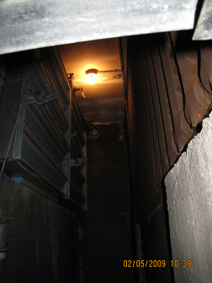

Make up fresh air and heating elements in the air mixing room

Picture 2

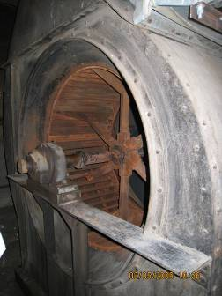

Fan unit in air mixing room

Picture 3

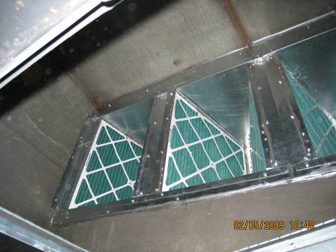

Pleated filters in the AHU

Picture 4

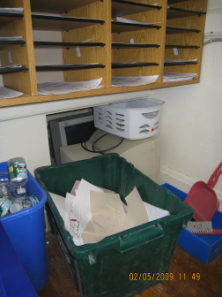

Items stored in exhaust ‘cubby’ hole

Picture 5

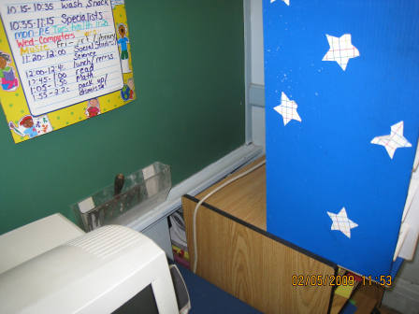

Exhaust ‘cubby’ blocked

Picture 6

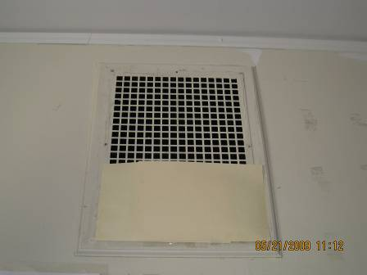

Folder partially blocking supply vent

Picture 7



Vinyl curtain in front of closet preventing exhaust

Picture 8

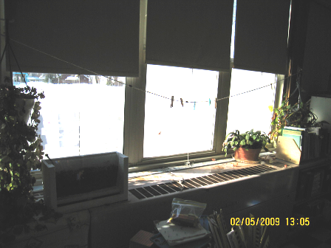

Items stored in front of univent

Picture 9

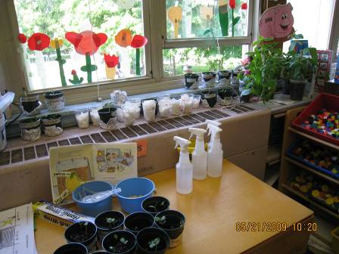

Plants and other items/furniture stored on top/in front of univent

Picture 10

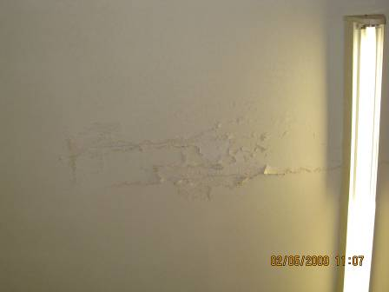

Peeling ceiling paint

Picture 11

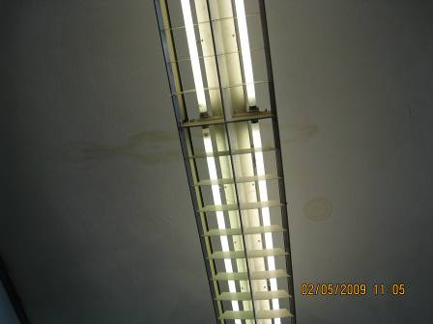

Water stained ceiling plaster

Picture 12

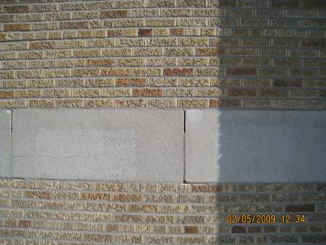

Breaches in foundation wall

Picture 13

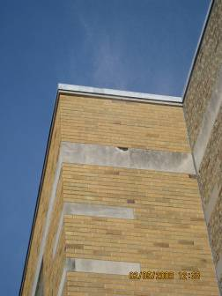

Damage to foundation wall

Picture 14

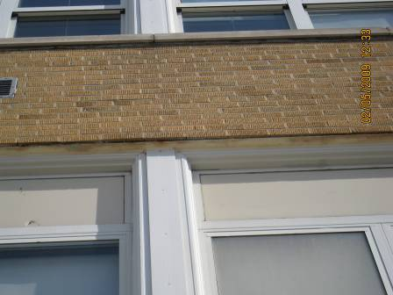

Degraded sealant above window

Picture 15

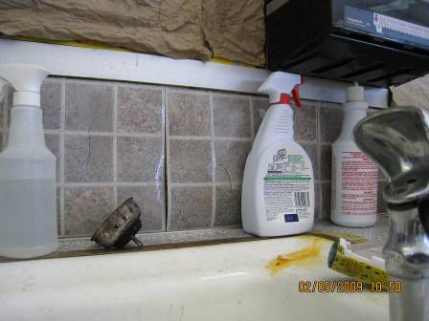

Vinyl backsplash no longer flush with wall

Picture 16

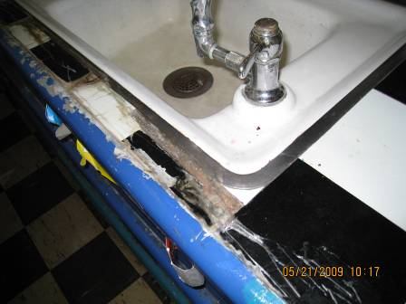

Damaged vinyl countertop covering

Picture 17

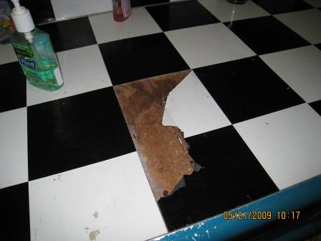

Damaged vinyl countertop covering

Picture 18

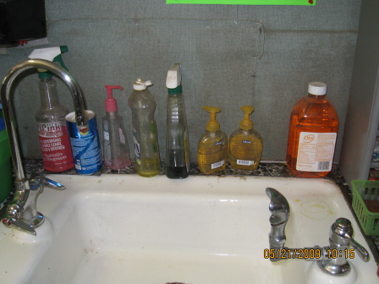

Assortment of cleaners

Picture 19

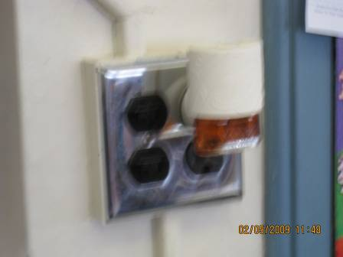

Plug-in air deodorizer

Picture 20

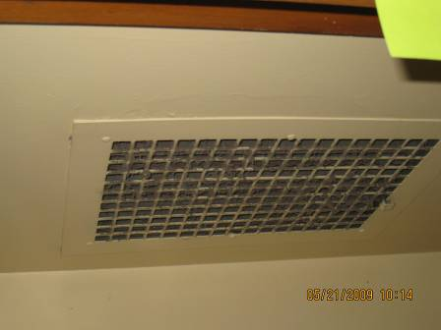

Exhaust vent occluded with dust

Picture 21

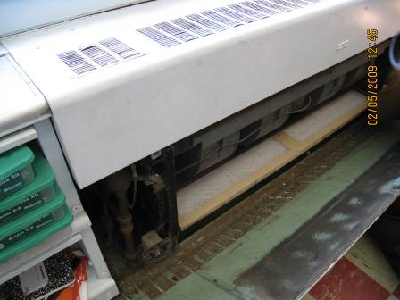

Dust in univent cabinet

Picture 22

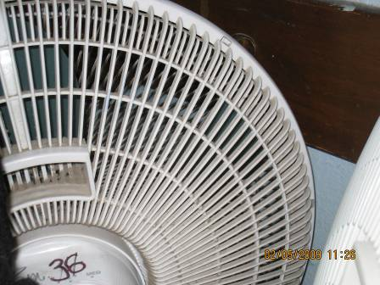

Personal fan occluded with dust

Picture 23

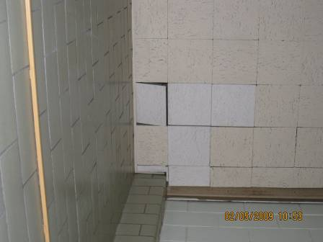

Ajar ceiling tile

Picture 24

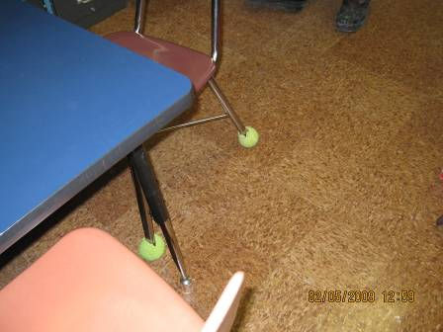

Tennis balls on chair legs
Location | Occupants  in Room | Temp  (°F) | Relative  Humidity  (%) | Carbon  Dioxide  (ppm) | Carbon Monoxide  (ppm) | PM2.5  (µg/m3) | Windows  Openable | Ventilation |  | Remarks
 |  |  |  |  |  |  |  | Supply | Exhaust | Remarks
Outside (Background) |  | 17 | 15 | 346 | ND | 10 |  |  |  | sunny
All-purpose room (gym/cafeteria) | 140 | 75 | 21 | 1438 | ND | 14 | Y | Y | Y  Off
Art room | 22 | 78 | 16 | 1252 | ND | 14 | N | N | N | DO, DEM, plants, cleaners
Front entry/hallway | 0 | 65 | 16 | 770 | ND | 14 | N | N | N | 2 copiers
Front stairs |  |  |  |  |  |  |  |  |  | Window leak, window will be replaced summer 2009
Hallway, first floor |  |  |  |  |  |  |  |  |  | 7 MT
MSN | 0 | 75 | 15 | 1159 | ND | 11 | N | N | Passive | DO, water stained ceiling plaster, paint cracking
Music room/ solarium | 9 | 82 | 19 | 1453 | ND | 11 | Y | N | Y  Fan off
Nurses office | 0 | 77 | 14 | 1038 | ND | 11 | Y | N | N | DO, Cracked paint/walls
OT/speech | 2 | 77 | 13 | 1172 | ND | 8 | N | Y | N | DO, PF
Pych office | 2 | 75 | 16 | 1423 | ND | 11 | N | Y | Passive
Reading | 1 | 79 | 14 | 1177 | ND | 9 | N | Y | N | TB
Rear stairwell |  |  |  |  |  |  |  |  |  | 1 AT
Special Education | 4 | 75 | 17 | 1351 | ND | 16 | Y | N | Passive | PF
Storage room | 2 | 73 | 11 | 783 | ND | 12 | N | Passive | Y
11 | 21 | 72 | 11 | 708 | ND | 8 | Y | Y | Y | Plug-in AD, cleaners
12 | 73 | 74 | 9 | 726 | ND | 6 | Y | Y | Y | DO, plants, cleaners
21 | 25 | 74 | 13 | 783 | ND | 7 | Y | Y | Y  Dust
22 | 25 | 76 | 9 | 647 | ND | 8 | Y | Y  Items | Y | DO, cleaners
23 | 0 | 73 | 11 | 755 | ND | 9 | Y | Y | Y | AD, PF, plants, items
24 | 18 | 77 | 18 | 1168 | ND | 13 | Y | Y | Y  Blocked | PF, DEM, plants
25 | 25 | 76 | 15 | 1063 | ND | 17 | Y | Y | Y  Blocked | DEM, plants
26 | 21 | 77 | 13 | 1059 | ND | 9 | Y | Y | Y  Blocked | DEM, cleaners, plants, items
27 | 14 | 78 | 14 | 1012 | ND |  | Y | Y | Y | DO, plug-in AD, water infiltration from exterior wall, bubbled paper on interior wall (monitor for moisture)
28 | 26 | 74 | 16 | 1136 | ND | 9 | Y | Y | Y  Vent closed | PF, items
30 | 0 | 74 | 15 | 717 | ND | 6 | Y | Y | Y
31 | 21 | 69 | 14 | 1010 | ND | 6 | Y | Y  Debris (univent) | Y | DO, CD
32 | 21 | 79 | 17 | 1272 | ND | 13 | Y | Y | Y | DO, cleaners, PF, items, WD countertop sink area, pneumatics broken, ducts/filters cleaned/changed Dec 30, 2008
33 | 21 | 73 | 174 | 1072 | ND | 7 | Y | Y | Y | DO, WD-ceiling plaster
34 | 22 | 72 | 14 | 1099 | ND | 13 | Y | Y | Y  Weak | DO, items, CD
35 | 24 | 75 | 19 | 1403 | ND | 10 | Y | Y | Y  Weak
36 | 23 | 73 | 16 | 773 | ND | 9 | Y | Y | Y  Blocked, weak | DO, DEM, items
37 | 19 | 75 | 17 | 1215 | ND | 10 | Y | Y | Y  Blocked | DO, PF, DEM
38 | 23 | 73 | 15 | 974 | ND | 9 | Y | Y | Y | PF, DEM, cleaners, cleaner odors
39 | 1 | 72 | 12 | 774 | ND | 6 | Y | Y | Y  Blocked | DEM, ~30 computers

Location | Occupants  in Room | Temp  (°F) | Relative  Humidity  (%) | Carbon  Dioxide  (ppm) | Carbon Monoxide  (ppm) | PM2.5  (µg/m3) | Windows  Openable | Ventilation |  | Remarks
 |  |  |  |  |  |  |  | Supply | Exhaust | Remarks
Outside (Background) |  | 81 | 43 | 329 | ND | 13 |  |  |  | sunny
All-purpose room (gym/cafeteria) | 100 | 76 | 36 | 518 | ND | 16 | Y  0/3 open | Y | Y
Art room | 20 | 75 | 42 | 1220 | ND | 15 | N | N | N | DO, DEM, items
Front entry/hallway | 0 | 81 | 31 | 613 | ND | 15 | N | N | N | 2 copiers
MSN | 2 | 78 | 33 | 582 | ND | 13 | N | N | Passive | DEM
Music room/ solarium | 8 | 78 | 43 | 818 | ND | 21 | Y  0/3 open | N | Y
Nurses office | 1 | 77 | 34 | 652 | ND | 15 | Y  1/2 open | N | N | DO, Cracked paint/walls
OT/speech | 2 | 77 | 36 | 643 | ND | 14 | N | Y | N | DO, PF
Reading | 1 | 76 | 39 | 647 | ND | 13 | N | Y | N | DO
Special Education | 5 | 79 | 31 | 542 | ND | 14 | Y  1/2 open | N | Passive | CD, cleaners
11 | 17 | 76 | 40 | 893 | ND | 17 | Y | Y  Plants, items | Y  Dusty, off | DO, Pine cone project, cleaners, items
12 | 23 | 75 | 37 | 812 | ND | 15 | Y  1/9 open | Y  Plant, items | Y  Dusty | DO, CD, items, cleaners
21 | 21 | 78 | 31 | 649 | ND | 12 | Y  1/9 open | Y  Plants | Y | DO, WD-sink counter, food storage
22 | 23 | 77 | 39 | 772 | ND | 13 | Y  1/9 open | Y  Plants, Items | Y | DO, WD-sink counter, cleaners, items
23 | 17 | 78 | 33 | 492 | ND | 12 | Y  2/7 open | Y | Y | Plants, items, ultraviolet AP on floor, items
24 | 23 | 78 | 34 | 678 | ND | 12 | Y  2/7 open | Y | Y  Items
25 | 24 | 78 | 33 | 621 | ND | 12 | Y  3/7 open | Y | Y | Plants, PF, UF
26 | 26 | 76 | 35 | 687 | ND | 13 | Y  0/7 open | Y  Cardboard covering | Y  Blocked | DO, CD, DEM, plants
27 | 19 | 77 | 36 | 718 | ND | 13 | Y  1/7 open | Y | Y | DO, DEM
28 | 22 | 78 | 37 | 608 | ND | 18 | Y  2/7 open | Y | Y | DO, PF, AC, weed-wacking outdoors
30 | 30 | 79 | 35 | 776 | ND | 12 | Y  0/3 open | Y | Y
31 | 18 | 78 | 34 | 701 | ND | 14 | Y  1/9 open | Y | Y | PF, CD, cleaners
32 | 19 | 79 | 29 | 520 | ND | 13 | Y  6/9 open | Y | Y | DO, cleaners, WD countertop sink area
33 | 22 | 79 | 35 | 772 | ND | 12 | Y  0/7 open | Y | Y  Blocked by vinyl curtain | PF, strong DEM odors (DEM in use)
34 | 20 | 79 | 34 | 725 | ND | 15 | Y  0/6 open | Y | Y  Blocked | PF, nest
35 | 22 | 79 | 31 | 678 | ND | 11 | Y  3/7 | Y | Y | PF
36 | 24 | 79 | 32 | 666 | ND | 12 | Y  2/7 open | Y | Y  Blocked | DEM, PF, WD-ceiling plaster
37 | 21 | 79 | 32 | 639 | ND | 12 | Y  4/7 open | Y | Y  Blocked | DO, PF, DEM
38 | 20 | 79 | 32 | 668 | ND | 11 | Y  3/7 open | Y | Y  Blocked | PF, DEM, AD
39 | 23 | 79 | 32 | 541 | ND | 11 | Y  2/6 | Y | Y | DO, DEM, ~30 computers
Principal’s office | 4 | 79 | 30 | 447 | ND | 9 | Y | Y | Y | copier

