**WATER DAMAGE ASSESSMENT**

**Winthrop Elementary School**

**Room 15**

**65 Central Street**

**Ipswich, MA**

**

Prepared by:

Massachusetts Department of Public Health

Bureau of Climate and Environmental Health

Indoor Air Quality Program

October 2024

# BACKGROUND

|  |  |
| --- | --- |
| Building: | Winthrop Elementary School (WES) |
| Address: | 65 Central Street, Ipswich, MA |
| Requestor: | Brian Blake, Superintendent of Schools,  Ipswich Public Schools (IPS) |
| Reason for Request: | Water damage and mold odors in a northwest corner classroom of the 1987 wing. |
| Date of Assessment: | October 3, 2024 |
| Massachusetts Department of Public Health/Bureau of Climate and Environmental Health (MDPH/BCEH) Staff Conducting Assessment: | Michael Feeney, Director, Indoor Air Quality (IAQ) Program |
| Building Description: | The WES is a two-story, brick building built in 1957 with a wing added in 1987 to the west of the original building. The 1987 wing has a slab floor. |
| Windows: | Openable |

# EXECUTIVE SUMMARY

The BCEH/IAQ Program was asked to examine WES for the presence of water damage/mold odor resulting from high relative humidity weather conditions that occurred in August of 2024. The WES experienced water damage in the northwest corner of the 1987 wing. Water damage remediation contractors used the US EPA guidelines Mold Remediation in Schools and Commercial Buildings (<https://www.epa.gov/mold/mold-remediation-schools-and-commercial-buildings-guide-chapter-1>) to conduct remediation, which include:

* Identifying the source of moisture that caused water damage,
* Removing water-damaged porous materials capable of supporting mold growth (ceiling tiles, carpeting, and various stored materials), and
* Cleaning of non-porous surfaces (e.g., painted cement walls, laminated counters, floor tile).

The IAQ staff examined the ground floor of the WES where the mold odor had been reported. The source of mold odors appears to be carpeting under and inside the unit ventilator and its attached metal shelving. The source of the water damage was likely a combination of high relative humidity weather that occurred in August 2024 and water vapor migration from school water drains with dry drain traps.

The following recommendations were made:

* Remove all carpet tiles from beneath the univent and attached shelves/cabinets.
* Remove carpet tile adhesive to remove odors.
* Install a properly-sized air filter in the univent with a Minimum Efficiency Rating Value (MERV) of at least 9.
* Ensure that all sink drain traps are wetted regularly (weekly) to ensure a good trap seal.

In addition, the IAQ Program has offered to conduct a general IAQ assessment of the WES. Please note that this building was previously assessed in 2009. This report can be assessed as this link: <https://www.mass.gov/doc/winthrop-elementary-school-october-2009-0/download> and is attached as Appendix A.

# METHODS

The IAQ Program conducted visual inspections of the affected ground floor areas. Air temperature and relative humidity were measured. Please refer to the IAQ Manual for methods, equipment, sampling procedures, and interpretation of results (MDPH, 2015).

**RESULTS AND DISCUSSION**

The following is a summary of indoor air testing results:

* ***Air Temperature*** in Room 15 was 69°F which was below the MDPH recommended range of 70°F to 78°F. Note that windows were open and the outdoor temperature was 69°F.
* ***Relative Humidity*** in Room 15 was 64% which is above the MDPH recommended comfort range of 40% to 60%. Relative humidity outdoors was 62%. All relative humidity measurements inside were nearly equal to outdoor measurements.

Based on these observations, conditions that could results in condensation were not present at the time of this assessment. The most likely source of water vapor causing the damage was extended periods of hot, humid weather with relative humidity over 70% for two or more days. When this weather occurs, buildings that have floor slabs on soil may have temperatures below the dew point, which would cause condensation to accumulate on the floor, moistening carpeting, and other materials.

## Water Damage

### Mold odor

Upon entering classroom 15, a musty odor was identified, traced to the classroom univent. It was noted that the univent filter was the wrong size and did not completely fill the space that draws air into the univent coils and fans (Picture 1). Without a well-fitted filter, air is drawn through the univent fan without filtration, which aerosolizes odors that are associated with mold.

While the IPS staff reported that the classroom floor covering was cleaned, they did not note that carpeting was installed **under** the univent and adjacent shelving (Picture 2). This section of carpeting appeared curled, which may indicate water exposure. The odor may be associated with the carpet, carpet adhesive, or dust and debris adhered to the adhesive.

### High relative humidity

One sign of high relative humidity in the WES is the presence of bowed ceiling tiles. If a building experiences high relative humidity indoors over an extended period, moisture exposure may cause ceiling tiles to bow. Bowed ceiling tiles without discoloration/stains are not mold colonized but are a sign of chronic water vapor exposure.

It is important to note that the WES heating, ventilating, and air conditioning (HVAC) system is not equipped with chillers to provide cooling during hot weather. In addition to providing cooling, HVAC systems can reduce humidity during operation. Use of dehumidifiers during hot, humid weather on the ground floor may reduce humidity.

In general, the floors that are on slab that are in direct contact with soil have surface temperatures that are below the measured air temperature. This condition may indicate that soil contact is cooling floors and walls. This is called a thermal bridge. These conditions may lead to condensation on the floor which can moisten materials on the floor or in contact with walls.

Hot humid summers are becoming more frequent due to climate change. Massachusetts has experienced hot, humid, and rainy summers in 2018, 2021, and 2023. July of 2021 was the wettest ever recorded in Massachusetts, and the three-month period from June through August, known as the meteorological summer, was the fourth wettest on record, according to the National Oceanic and Atmospheric Administration’s (NOAA) Centers for Environmental Information (NOAA, 2021). The summer of 2023 was also hot, and wet, being measured as the second rainiest on record (WBUR, 2023). The summer of 2024 has also had significant stretches of hot, humid weather. These conditions are challenging for buildings, particularly those without central air conditioning.

Under these weather conditions, public buildings experienced extended periods of water vapor exposure from high relative humidity. When exposed to these conditions, porous materials such as gypsum wallboard, cardboard, carpeting and other materials may become moistened and colonized with mold, particularly if located in areas that are prone to developing condensation, such as floors and walls in contact with the ground (e.g., below grade space).

The guideline “Preventing Mold Growth In Schools During Hot, Humid Weather” <https://www.mass.gov/info-details/preventing-mold-growth-in-massachusetts-schools-during-hot-humid-weather> should be used to minimize the impact of such weather on classroom materials. This includes the use of air conditioning and dehumidifiers, ensuring exhaust vents are on and operable, keeping windows closed, and ensuring air can circulate around porous materials.

A stairwell with an access door to the crawlspace exists beneath the 1957 wing. Space around this access door can allow crawlspace odors and associated musty odors to enter the hallway.

### Dry drain traps

Bowing ceiling tiles are typically found in schools with sink drains, floor drains and/or water bubbler drains where the trap has dried. A trap is a section of pipe below the drain opening that fills with water to form an airtight seal. The airtight seal prevents combustible sewer gas, odors, and water vapor from the drain systems from backup up the drain to enter occupied space. Water evaporates from the trap if a plumbing fixture is not used for an extended period.

An airtight water seal is particularly important when heavy rains occur, which pressurizes the storm drain and sewer systems, so air and the associated water vapor/odors/pollutants can be forced up drainpipe, which is prevented from entering the occupied space by the wet drain trap.

Schools are particularly vulnerable to dry drain traps due to the extended summer vacation when the building is unoccupied by students. School locations with bowed ceiling tiles are often ones with multiple sinks that are not used during summer vacations, such as science classrooms.

# CONCLUSIONS/RECOMMENDATIONS

Based on the observations made during the visit, it appears that most water-damaged materials were thoroughly dried and/or removed. The following recommendations are made:

1. Remove carpeting beneath univent and adjacent cabinets.
2. Remove carpet adhesive beneath carpeting.
3. Do not reinstall carpeting. Consider alternative floor material that is not susceptible to mold growth.
4. Install a filter that completely fits the univent. Use a filter with a MERV rating of at least 9.
5. Seal any spaces in the univent interior wall above the air filter with foil/insulated tape.
6. Install weather stripping and door sweep on crawlspace access door.
7. Implement recommendations made in the previous IAQ assessment (Appendix A and <https://www.mass.gov/doc/winthrop-elementary-school-october-2009-0/download>).
8. As previously recommended, reduce water accumulation on building exterior. This includes relocating the garden and vegetation shown in Picture 3 to another location that is not in contact with the WES exterior walls.
9. Consider removing carpet flooring in first floor classrooms at least 4 feet from exterior walls. Replace with a flooring that would not be susceptible to mold.
10. Determine if other classrooms have carpet beneath the univent and adjacent cabinet. If so, replace.
11. Continue to examine equipment and supplies for visible mold growth or odors. If found, discard and replace the affected materials.
12. Wet drain traps weekly during the summer and any other time they are unused.
13. For more information on mold refer to the US EPA’s “Mold Remediation in Schools and Commercial Buildings,” available at: <http://www.epa.gov/mold/mold-remediation-schools-and-commercial-buildings-guide>.
14. Management of buildings in extreme relative humidity and rain can be challenging. The following documents can provide guidance that can be used to reduce the impact of hot, humid weather in buildings:
    1. Mold Growth Prevention During Hot, Humid Weather <https://www.mass.gov/service-details/preventing-mold-growth-in-massachusetts-schools-during-hot-humid-weather> and
    2. Remediation and Prevention of Mold Growth and Water Damage in Public Schools <https://www.mass.gov/service-details/remediation-and-prevention-of-mold-growth-and-water-damage-in-public-schools-and>.
15. Refer to resource manuals and other related IAQ documents for further building-wide evaluations and advice on maintaining public buildings. Copies of these materials are located on the MDPH’s website: <http://mass.gov/dph/iaq>.
16. If desired, contact the IAQ Program for a full building assessment following the completion of remediation and reconstruction work when school is in session.

# REFERENCES

MDPH. 2015. Massachusetts Department of Public Health. Indoor Air Quality Manual: Chapters I-III. Available at: <https://www.mass.gov/lists/indoor-air-quality-manual-and-appendices#indoor-air-quality-manual->.

NOAA. 2021. Summer 2021 neck and neck with Dust Bowl summer for hottest on record. National Oceanic and Atmospheric Administration, 1401 Constitution Avenue NW, Room 5128, Washington, DC 20230 <https://www.noaa.gov/news/summer-2021-neck-and-neck-with-dust-bowl-summer-for-hottest-on-record>.

WBUR. 2023. “It's been a summer of rain and flooding misery in Mass.” WBUR local news. September 12, 2023. <https://www.wbur.org/news/2023/09/12/summer-flooding-rain-massachusetts>

**Picture 1**

**Undersized univent air filter, note carpeting adjacent to univent.
The bracket shows a gap created by undersized filter**

**Undersized univent air filter creating a gap (bracket), note carpeting adjacent to univent.**

**Picture 2**

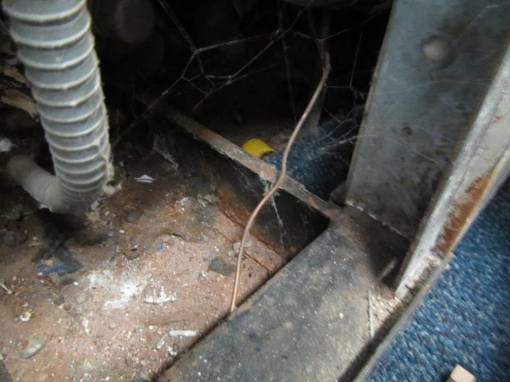

**Carpeting under shelving attached to univent (arrow)**

**Picture 3**

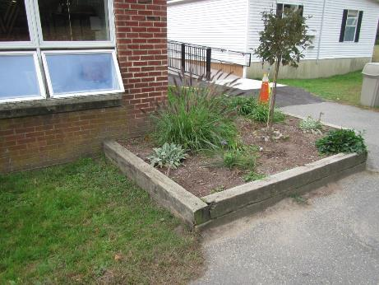

**Garden on exterior wall outside room 15**

**INDOOR AIR QUALITY ASSESSMENT**

**Winthrop Elementary School**

**65 Central Street**

**Ipswich, Massachusetts 01938**



Prepared by:

Massachusetts Department of Public Health

Bureau of Environmental Health

Indoor Air Quality Program

October 2009

**Background/Introduction**

At the request of Paul Bedard, Facilities Maintenance/Custodial Supervisor for Ipswich Public Schools, the Massachusetts Department of Public Health (MDPH), Bureau of Environmental Health (BEH) provided assistance and consultation regarding indoor air quality at the Winthrop Elementary School (WES) located at 65 Central Street, Ipswich***,*** Massachusetts. BEH staff made an initial visit to the school in November 2008 to examine conditions at the school. On June 12, 2009, James Tobin, Environmental Analyst/Inspector in BEH’s Indoor Air Quality Program, returned to the school to conduct air testing.

The WES is a two-story, brick building built in 1957 on a slab foundation. In 1987, an addition was built expanding the western side of the building. A modular classroom building was installed for use 12 years ago. The school houses general classrooms, a library, gymnasium, cafeteria/auditorium, art room, music room and office space. Windows are openable throughout the building.

**Methods**

Air tests for carbon dioxide, temperature, relative humidity, and carbon monoxide were conducted with the TSI, Q-Trak, IAQ Monitor, Model 7565. Air tests for airborne particle matter with a diameter less than 2.5 micrometers were taken with the TSI, DUSTTRAK™ Aerosol Monitor Model 8520. BEH staff also performed visual inspection of building materials for water damage and/or microbial growth.

**Results**

The school houses approximately 450 students in grades pre-K through 5 with approximately 40 staff members. Tests were taken during normal operations at the school and results appear in Table 1.

**Discussion**

**Ventilation**

It can be seen from Table 1 that carbon dioxide levels were above 800 parts per million (ppm) in 14 of 35 areas, indicating inadequate air exchange in 40% of the areas evaluated at the time of the assessment. It is also important to note that a number of areas had open windows or were empty/sparsely populated, both of which can greatly reduce carbon dioxide levels. Carbon dioxide levels would be expected to increase with higher occupancy and windows closed.

Fresh air for classrooms is supplied by unit ventilator (univent) systems (Picture 1). A univent draws outdoor air through a fresh air intake located on the exterior wall of the building (Picture 2), and return air from the room through an air intake located at the base of the unit ([Figure 1](http://www.mass.gov/Eeohhs2/docs/dph/environmental/iaq/appendices/univent.doc)). Fresh and return air are mixed, filtered, heated, and distributed to the room through an air diffuser located in the top of the unit. Univents were operating in the majority of rooms at the time of the assessment; however, BEH staff found several univents switched ‘off’, preventing fresh air from being introduced into these rooms. Univent air diffusers and returns were blocked by furniture and other stored items in front and on top of the unit, thereby limiting airflow in these rooms. In one area, the univent had a missing panel exposing the interior of the unit (Picture 3). In order for univents to provide fresh air as designed, air diffusers, intakes and returns must remain free of obstructions. Importantly, these units must remain “on” and be allowed to operate while rooms are occupied. A univent operating to provides continual supply of fresh, outdoor air can improve both indoor air quality and comfort, since this continual source of fresh air dilutes pollutants that typically accumulate in indoor environments.

Exhaust ventilation is provided by vents ducted to rooftop motors. Exhaust vents at the WES are located on the ceiling, wall, or at the top of storage closets/shelving (Pictures 4 through 7). Exhaust ventilation systems continuously remove air that has become stale from moisture, odors, and pollutants. In order to function properly, exhaust vents must be activated and allowed to operate without obstruction while rooms are occupied. Without adequate exhaust ventilation, excess heat and stale air can build up leading to indoor air quality and comfort complaints. The work room is not equipped with exhaust ventilation. This area contains photocopiers and a lamination machine each of which can be a source of pollutants such asheat and odors, particularly if the equipment is older and in frequent use.

Wall-mounted air handling units (AHUs) provide ventilation for the modular classroom wing (Picture 8). The modular wing houses three rooms; however, only two AHUs exist. One room lacks mechanical ventilation; therefore, windows and an exterior door are the only means of introducing fresh air to this area. AHUs draw fresh air through an air intake on the exterior of the modular classroom and then distribute it to the room through an air diffuser at the top of the AHU. Stale air from the room is returned to the AHU through a vent at the base of the unit to an exhaust vent on the building exterior. Thermostats that control the AHU system in the modular classrooms have fan settings of “on” and “automatic”. The “automatic” setting on the thermostat activates the AHU system at a preset temperature, and then deactivates the system once the preset temperature is reached. In the fan “on” setting, the AHU system provides continuous airflow to the rooms.

On the exterior wall of the modular classroom, the fresh air intake is directly above the exhaust vent (Picture 9). The configuration of the intake and vent is problematic since pollutants that are exhausted from the classroom can be brought back inside via the air intake**.** The exhaust vent should be ducted away from the fresh air intake. BEH staff also found the fresh air intakes coated with accumulated dust and debris (Picture 10).

Air conditioners (AC) were used in several rooms (Pictures 11 and 12). ACs are normally equipped with filters, which should be cleaned or changed as per manufacturers’ instructions to avoid the build-up and re-aerosolization of dirt, dust, and particulate matter.

To maximize air exchange, the MDPH recommends that both supply and exhaust ventilation operate continuously during periods of school occupancy. In order to have proper ventilation with a mechanical supply and exhaust system, the systems must be balanced to provide an adequate amount of fresh air to the interior of a room while removing stale air from the room. It is recommended that heating, ventilating and air conditioning (HVAC) systems be re-balanced every five years to ensure adequate air systems function (SMACNA, 1994).

The Massachusetts Building Code requires that each room have a minimum ventilation rate of 15 cubic feet per minute (cfm) per occupant of fresh outside air or openable windows (SBBRS, 1997; BOCA, 1993). The ventilation must be on at all times that the room is occupied. Providing adequate fresh air ventilation with open windows and maintaining the temperature in the comfort range during the cold weather season is impractical. Mechanical ventilation is usually required to provide adequate fresh air ventilation.

Carbon dioxide is not a problem in and of itself. It is used as an indicator of the adequacy of the fresh air ventilation. As carbon dioxide levels rise, it indicates that the ventilating system is malfunctioning or the design occupancy of the room is being exceeded. When this happens, a buildup of common indoor air pollutants can occur, leading to discomfort or health complaints. The Occupational Safety and Health Administration (OSHA) standard for carbon dioxide is 5,000 parts per million parts of air (ppm). Workers may be exposed to this level for 40 hours/week, based on a time-weighted average (OSHA, 1997).

The MDPH uses a guideline of 800 ppm for publicly occupied buildings. A guideline of 600 ppm or less is preferred in schools due to the fact that the majority of occupants are young and considered to be a more sensitive population in the evaluation of environmental health status. Inadequate ventilation and/or elevated temperatures are major causes of complaints such as respiratory, eye, nose and throat irritation, lethargy, and headaches. For more information concerning carbon dioxide, consult [Appendix A](http://www.mass.gov/Eeohhs2/docs/dph/environmental/iaq/appendices/carbon_dioxide.doc).

Indoor temperature measurements ranged from 66o F to 70o F, which were below or at the lower end of the MDPH recommended comfort range (Table 1). The MDPH recommends that indoor air temperatures be maintained in a range of 70o F to 78o F in order to provide for the comfort of building occupants. In many cases concerning indoor air quality, fluctuations of temperature in occupied spaces are typically experienced, even in a building with an adequate fresh air supply. In addition, it is difficult to control temperature and maintain comfort without operating the ventilation equipment as designed (e.g., univents deactivated/obstructed).

The relative humidity in the building ranged from 58 to 75 percent, which was above the MDPH recommended comfort range in some areas (Table 1). The MDPH recommends a comfort range of 40 to 60 percent for indoor air relative humidity. Elevated indoor relative humidity would be expected in a building that, with the exception of select areas, lacks AC to remove excess moisture from the air on a day when outdoor relative humidity is 80 to 90 percent (Table 1). Without a dehumidification system or central AC, indoor relative humidity is difficult to maintain in a comfort range when outdoor relative humidity is high. Relative humidity levels in the building would be expected to drop during the winter months due to heating. The sensation of dryness and irritation is common in a low relative humidity environment. Low relative humidity is a very common problem during the heating season in the northeast part of the United States.

**Microbial/Moisture Concerns**

In order for building materials to support mold growth, a source of water exposure is necessary. Identification and elimination of the source of water moistening building materials is necessary to control mold growth. BEH staff examined the building to identify breaches in the building envelope that could provide a source of water penetration.

BEH staff examined the building to identify breaches in the building envelope that could provide a source of water penetration. BEH identified the following conditions that could lead to water penetration:

* Shrubs and trees growing against the building, holding moisture against exterior brick (Pictures 13 through 15);
* Plants and shrubs growing in front of fresh air intakes allowing moisture-laden air to be drawn in by the fresh air intake (Pictures 15 through 17); and,
* Exterior brick was damaged and water stained indicating a heavy and/or continuous water exposure (Pictures 18 and 19).

These conditions indicate that water has penetrated through the building envelope. Moisture laden air can infiltrate through breaches and condense on building materials. A heavy and/or continuous water exposure to the building exterior can undermine the integrity of the building envelope and provide a means of water entry into the building via capillary action through foundation concrete (i.e., cement slab) and masonry (Lstiburek & Brennan, 2001).

A number of rooms had water-damaged ceiling tiles, which can indicate leaks from the roof, plumbing system or through the building envelope. Water-damaged ceiling tiles can indicate sources of water penetration and provide a source of mold growth. Ceiling tiles should be replaced after a water leak is discovered and repaired.

The US Environmental Protection Agency (US EPA) and the American Conference of Governmental Industrial Hygienists (ACGIH) recommend that porous materials be dried with fans and heating within 24 to 48 hours of becoming wet (US EPA, 2001; ACGIH, 1989). If not dried within this time frame, mold growth may occur. Once mold has colonized porous materials, they are difficult to clean and should be removed and discarded.

A number of classrooms had plants (Picture 20). Plants can be a source of pollen and mold, which can be respiratory irritants for individuals. Plants should be properly maintained and equipped with drip pans to prevent water damage to porous building materials, which can lead to mold growth. Plants should also be located away from ventilation sources (e.g., air intakes, univent diffusers) to prevent the entrainment and/or aerosolization of dirt, pollen, or mold.

Aquariums were also located in a number of classrooms (Picture 21). Aquariums should be properly maintained to prevent microbial/algae growth, which can emit unpleasant odors.

**Other IAQ Evaluations**

Indoor air quality can be negatively influenced by the presence of respiratory irritants, such as products of combustion. The process of combustion produces a number of pollutants. Common combustion emissions include carbon monoxide, carbon dioxide, water vapor and smoke (fine airborne particle material). Of these materials, exposure to carbon monoxide and particulate matter with a diameter of 2.5 micrometers (μm) or less (PM2.5) can produce immediate, acute health effects upon exposure. To determine whether combustion products were present in the school environment, BEH staff obtained measurements for carbon monoxide and PM2.5.

*Carbon Monoxide*

Carbon monoxide is a by-product of incomplete combustion of organic matter (e.g., gasoline, wood, and tobacco). Exposure to carbon monoxide can produce immediate and acute health effects. Several air quality standards have been established to address carbon monoxide and prevent symptoms from exposure to these substances. The MDPH established a corrective action level concerning carbon monoxide in ice skating rinks that use fossil-fueled ice resurfacing equipment. If an operator of an indoor ice rink measures a carbon monoxide level over 30 ppm, taken 20 minutes after resurfacing within a rink, that operator must take actions to reduce carbon monoxide levels (MDPH, 1997).

The American Society of Heating Refrigeration and Air-Conditioning Engineers (ASHRAE) has adopted the National Ambient Air Quality Standards (NAAQS) as one set of criteria for assessing indoor air quality and monitoring of fresh air introduced by HVAC systems (ASHRAE, 1989). The NAAQS are standards established by the US EPA to protect the public health from six criteria pollutants, including carbon monoxide and particulate matter (US EPA, 2006). As recommended by ASHRAE, pollutant levels of fresh air introduced to a building should not exceed the NAAQS levels (ASHRAE, 1989). The NAAQS were adopted by reference in the Building Officials & Code Administrators (BOCA) National Mechanical Code of 1993 (BOCA, 1993), which is now an HVAC standard included in the Massachusetts State Building Code (SBBRS, 1997). According to the NAAQS, carbon monoxide levels in outdoor air should not exceed 9 ppm in an eight-hour average (US EPA, 2006).

*Carbon monoxide should not be present in a typical, indoor environment*. If it *is* present, indoor carbon monoxide levels should be less than or equal to outdoor levels. Outdoor carbon monoxide concentrations ranged from 1 to 2 ppm due to idling buses in front of the school (Table 1). Carbon monoxide levels measured inside the building were ND (Table 1).

*Particulate Matter (PM2.5)*

The US EPA has established NAAQS limits for exposure to particulate matter. Particulate matter is airborne solids that can be irritating to the eyes, nose, and throat. The NAAQS originally established exposure limits to particulate matter with a diameter of 10 μm or less (PM10). According to the NAAQS, PM10 levels should not exceed 150 microgram per cubic meter (μg/m3) in a 24-hour average (US EPA, 2006). These standards were adopted by both ASHRAE and BOCA. Since the issuance of the ASHRAE standard and BOCA Code, US EPA established a more protective standard for fine airborne particles. This more stringent PM2.5 standard requires outdoor air particle levels be maintained below 35 μg/m3 over a 24-hour average (US EPA, 2006). Although both the ASHRAE standard and BOCA Code adopted the PM10 standard for evaluating air quality, MDPH uses the more protective PM2.5 standard for evaluating airborne particulate matter concentrations in the indoor environment.

Outdoor PM2.5 concentrations were measured at 6 μg/m3 at the time of the assessment (Table 1). PM2.5 levels measured in the school ranged from 2 to 19μg/m3 (Table 1). Both indoor and outdoor PM2.5 levels were below the NAAQS PM2.5 level of 35 μg/m3. Frequently, indoor air levels of particulates (including PM2.5) can be at higher levels than those measured outdoors. A number of mechanical devices and/or activities that occur in schools can generate particulate during normal operations. Sources of indoor airborne particulates may include but are not limited to particles generated during the operation of fan belts in the HVAC system, cooking in the cafeteria stoves and microwave ovens; use of photocopiers, fax machines and computer printing devices; operation of an ordinary vacuum cleaner and heavy foot traffic indoors.

*Volatile Organic Compounds*

Indoor air concentrations can be greatly impacted by the use of products containing volatile organic compounds (VOCs). VOCs are carbon-containing substances that have the ability to evaporate at room temperature. Frequently, exposure to low levels of total VOCs (TVOCs) may produce eye, nose, throat and/or respiratory irritation in some sensitive individuals. For example, chemicals evaporating from a paint can stored at room temperature would most likely contain VOCs. In an effort to identify materials that can potentially increase indoor VOC concentrations, BEH staff examined rooms for products containing these respiratory irritants.

Cleaning products were found in rooms throughout the building. The type and brand of these products varied from room to room. Cleaning products contain chemicals that can be irritating to the eyes, nose, and throat of sensitive individuals. These products should be properly labeled and stored in an area that is not accessible to children. Additionally, a Material Safety Data Sheet (MSDS) should be available at a central location for each product in the event of an emergency. Consideration should be given to providing teaching staff with school issued cleaning products and supplies to prevent any potential for adverse chemical interactions between residues left from cleaners used by the school’s facilities staff and those left by cleaners brought in by others.

Several classrooms contained dry erase boards and related materials. Materials such as dry erase markers and dry erase board cleaners may contain VOCs, such as methyl isobutyl ketone, n-butyl acetate and butyl-cellusolve (Sanford, 1999), which can be irritating to the eyes, nose, and throat.

*Other Conditions*

Other conditions that can affect indoor air quality were observed during the assessment. In several classrooms, stored items were observed on windowsills, tabletops, counters, bookcases, and desks. The large number of items stored in classrooms provides a source for dusts to accumulate. These items (e.g., papers, folders, boxes) make it difficult for custodial staff to clean. Items should be relocated and/or be cleaned periodically to avoid excessive dust build up. In addition, these materials can accumulate on flat surfaces (e.g., desktops, shelving, and carpets) in occupied areas and subsequently be re-aerosolized causing further irritation.

A number of univent/supply air diffusers, exhaust vents and personal fans in classrooms were observed to have accumulated dust/debris (Picture 22). Re-activated supply vents/fans can aerosolize dust accumulated on fan blades/housing. If exhaust vents are not functioning, backdrafting can occur, which can re-aerosolize dust particles.

Lastly, a classroom had a pet bird who was housed in a cage (Picture 23). Animal dander, fur and wastes can all be sources of respiratory irritants. Animal cages should be cleaned regularly to avoid the aerosolization of allergenic materials and/or odors.

**Conclusions/Recommendations**

In view of the findings at the time of the assessment, the following recommendations are made to improve indoor air quality:

1. Operate all ventilation systems throughout the building *continuously* during periods of school occupancy. To increase airflow in classrooms, set univent controls to “high”. School staff should be encouraged not to deactivate classroom univents; rather, report any complaints to the facilities department.
2. Inspect all exhaust motors and belts periodically for proper function. Repair and replace as necessary.
3. Remove all blockages from univents and exhaust vents to ensure adequate airflow.
4. Consider installing exhaust ventilation in work room.
5. Use openable windows in conjunction with mechanical ventilation to increase air exchange. Care should be taken to ensure windows are properly closed at night and weekends to avoid the freezing of pipes and potential flooding.
6. Duct exhaust vents away from fresh air intakes on exterior wall of modular classrooms.
7. Clean accumulated dust and debris from fresh air intakes on exterior wall of modular classrooms.
8. Consider adopting a balancing schedule of every 5 years for all mechanical ventilation systems, as recommended by ventilation industrial standards (SMACNA, 1994).
9. Change filters for air-handling equipment (e.g., univents, AHUs and ACs) as per the manufacturer’s instructions or more frequently if needed. Vacuum interior of units prior to activation to prevent the aerosolization of dirt, dust, and particulates. Ensure filters fit flush in their racks with no spaces in between allowing bypass of unfiltered air into the unit.
10. For buildings in New England, periods of low relative humidity during the winter are often unavoidable. Therefore, scrupulous cleaning practices should be adopted to minimize common indoor air contaminants whose irritant effects can be enhanced when the relative humidity is low. To control for dusts, a high efficiency particulate arrestance (HEPA) filter equipped vacuum cleaner in conjunction with wet wiping of all surfaces is recommended. Avoid the use of feather dusters. Drinking water during the day can help ease some symptoms associated with a dry environment (throat and sinus irritations).
11. Cut shrubs and trees in a manner to maintain a space of 3 feet from the building exterior and univent fresh air intakes, to prevent moisture from being held against exterior brick and moisture-laden air to be drawn in by the fresh air intake.
12. Consider having exterior walls re-pointed and waterproofed to prevent water intrusion. This measure should include a full building envelope evaluation.
13. Repair any existing water leaks and replace any remaining water-damaged ceiling tiles. Examine the area above these tiles for mold growth. Disinfect areas of water leaks with an appropriate antimicrobial, as needed.
14. Move plants away from univents in classrooms. Avoid over-watering and examine drip pans periodically for mold growth. Disinfect with an appropriate antimicrobial where necessary.
15. Clean and maintain aquariums and animal cages to prevent mold growth and associated odors.
16. Store cleaning products properly and out of reach of students. All cleaning products used at the facility should be approved by the school department with MSDS’ available at a central location.
17. Relocate or consider reducing the amount of materials stored in classrooms to allow for more thorough cleaning of classrooms. Clean items regularly with a wet cloth or sponge to prevent excessive dust build-up.
18. Clean accumulated dust and debris periodically from univent air diffusers, exhaust vents and blades of personal fans.
19. Consider adopting the US EPA (2000) document, “Tools for Schools”, as an instrument for maintaining a good indoor air quality environment in the building. This document is available at: <http://www.epa.gov/iaq/schools/index.html>.
20. Refer to resource manual and other related indoor air quality documents located on the MDPH’s website for further building-wide evaluations and advice on maintaining public buildings. These documents are available at: <http://mass.gov/dph/iaq>.

**References**

ACGIH. 1989. Guidelines for the Assessment of Bioaerosols in the Indoor Environment. American Conference of Governmental Industrial Hygienists, Cincinnati, OH.

ASHRAE. 1989. Ventilation for Acceptable Indoor Air Quality. American Society of Heating, Refrigeration and Air Conditioning Engineers. ANSI/ASHRAE 62-1989.

BOCA. 1993. The BOCA National Mechanical Code/1993. 8th ed. Building Officials & Code Administrators International, Inc., Country Club Hills, IL.

Lstiburek, J. & Brennan, T. 2001. Read This Before You Design, Build or Renovate. Building Science Corporation, Westford, MA. U.S. Department of Housing and Urban Development, Region I, Boston, MA

MDPH. 1997. Requirements to Maintain Air Quality in Indoor Skating Rinks (State Sanitary Code, Chapter XI). 105 CMR 675.000. Massachusetts Department of Public Health, Boston, MA.

OSHA. 1997. Limits for Air Contaminants. Occupational Safety and Health Administration. Code of Federal Regulations. 29 C.F.R 1910.1000 Table Z-1-A.

Sanford. 1999. Material Safety Data Sheet (MSDS No: 198-17). Expo® Dry Erase Markers Bullet, Chisel, and Ultra Fine Tip. Sanford Corporation. Bellwood, IL.

SBBRS. 1997. Mechanical Ventilation. State Board of Building Regulations and Standards. Code of Massachusetts Regulations. 780 CMR 1209.0

SMACNA. 1994. HVAC Systems Commissioning Manual. 1st ed. Sheet Metal and Air Conditioning Contractors’ National Association, Inc., Chantilly, VA.

US EPA. 2000. Tools for Schools. Office of Air and Radiation, Office of Radiation and Indoor Air, Indoor Environments Division (6609J). EPA 402-K-95-001, Second Edition. <http://www.epa.gov/iaq/schools/tools4s2.html>.

US EPA. 2001. “Mold Remediation in Schools and Commercial Buildings”. Office of Air and Radiation, Indoor Environments Division, Washington, DC. EPA 402-K-01-001. March 2001. Available at: <http://www.epa.gov/iaq/molds/mold_remediation.html>.

US EPA. 2006. National Ambient Air Quality Standards (NAAQS). US Environmental Protection Agency, Office of Air Quality Planning and Standards, Washington, DC. <http://www.epa.gov/air/criteria.html>.

**Picture 1**

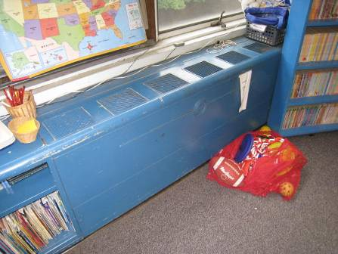

**Classroom Univent**

**Picture 2**

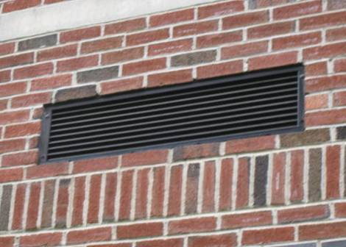

**Univent Fresh Air Intake on Exterior Wall**

**Picture 3**

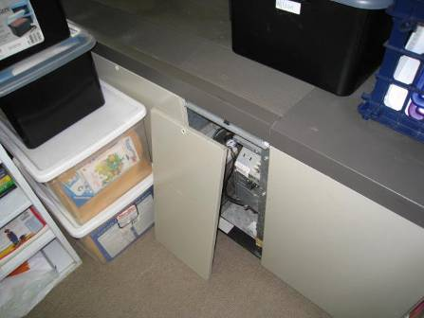

**Stored Items on Top and in Front of Univent, Note Panel Removed**

**Picture 4**

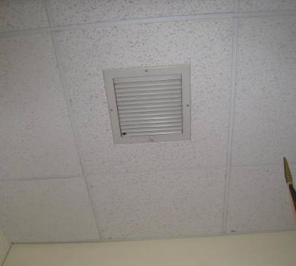

**Exhaust Vent on Ceiling**

**Picture 5**

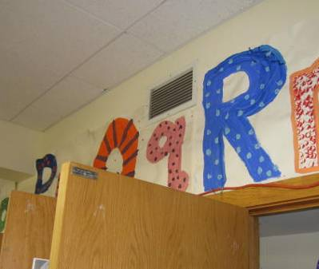

**Exhaust Vent on Wall**

**Picture 6**

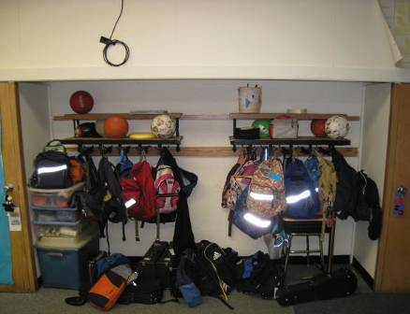

**Exhaust Vent in Storage Closet**

**Picture 7**

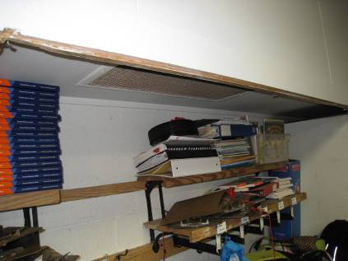

**Exhaust Vent in Classroom Shelving**

**Picture 8**

Air Handling Unit on Wall in Modular Classroom
Air Diffuser at Top, Exhaust Vent at Base


**Air Handling Unit on Wall in Modular Classroom**

**Air Diffuser at Top, Exhaust Vent at Base**

**Picture 9**

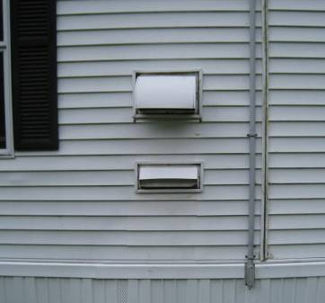

**Air Intake Directly Above Exhaust Vent on Exterior Wall**

**Picture 10**

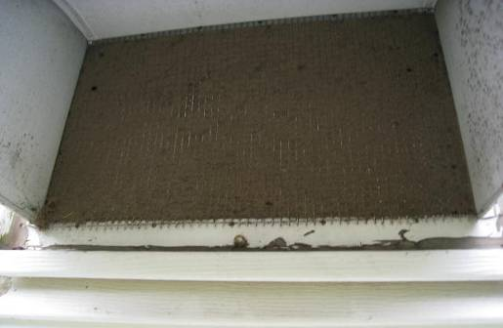

**Accumulated Dust and Debris on Air Intake**

**Picture 11**

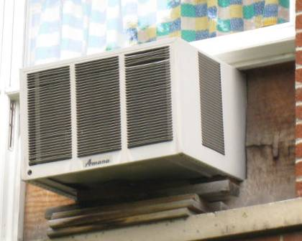

**Air Conditioner in Window**

**Picture 12**

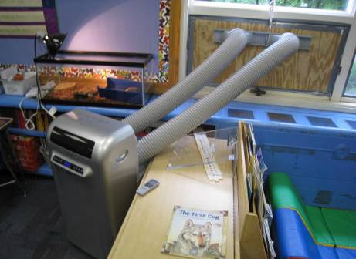

**Air Conditioner Ducted to Window by Hoses**

**Picture 13**

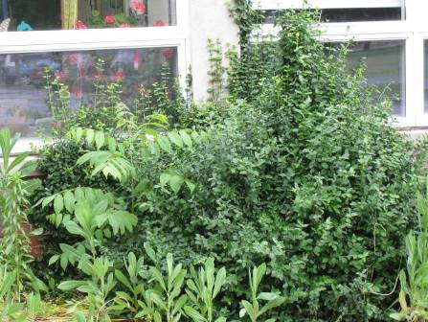

**Shrubs Growing Against Building**

**Picture 14**

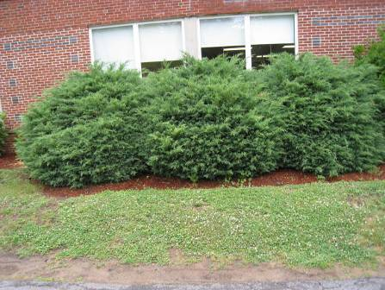

**Shrubs Growing Against Building**

**Picture 15**

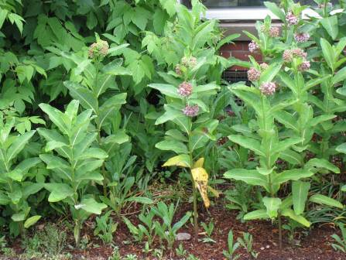

**Plants and Shrubs Growing in Front of Fresh Air Intake**

**Picture 16**

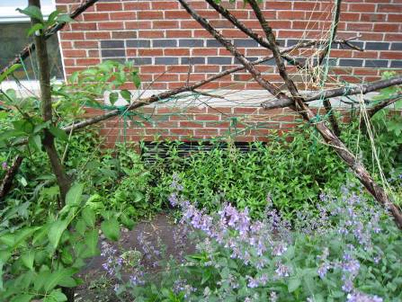

**Plants Growing in Front of Fresh Air Intake**

**Picture 17**

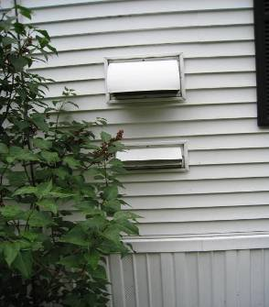

**Shrubs Growing near Fresh Air Intake**

**Picture 18**

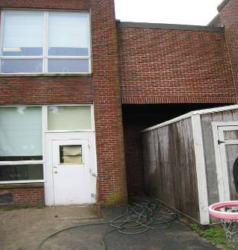

**Water Stains on Exterior Brick and Storage Shed**

**Picture 19**

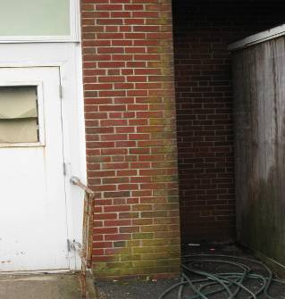

**Water Stains on Exterior Brick**

**Picture 20**

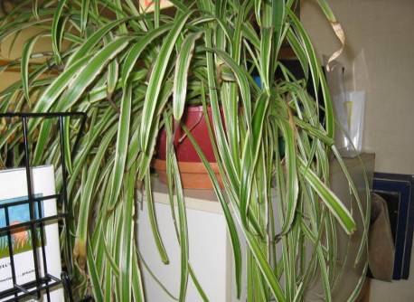

**Plants in Classrooms**

**Picture 21**

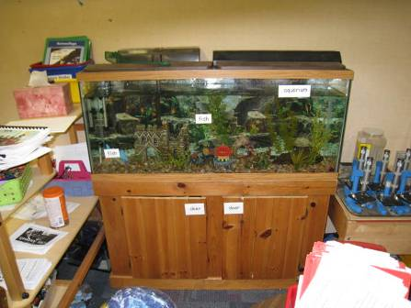

**Aquarium in Classrooms**

**Picture 22**

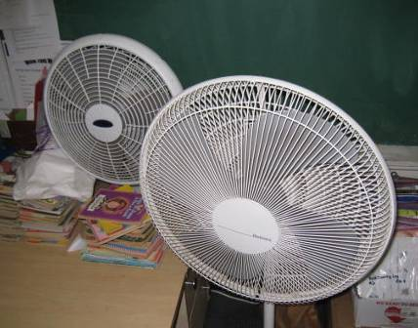

**Accumulated Dust and Debris on Fan Blades**

**Picture 23**

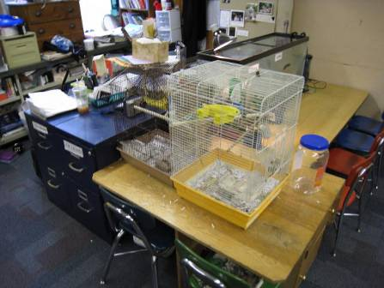

**Bird in Classroom**

| **Location/ Room** | **Occupants**  **in Room** | **Temp**  **(°F)** | **Relative**  **Humidity**  **(%)** | **Carbon**  **Dioxide**  **(ppm)** | **Carbon Monoxide**  **(ppm)** | **PM2.5**  **(µg/m3)** | **Windows**  **Openable** | **Ventilation** | | **Remarks** |
| --- | --- | --- | --- | --- | --- | --- | --- | --- | --- | --- |
| **Supply** | **Exhaust** |
| outside school A.M. |  | 62 | 80 | 442 | 1 – 2 | 6 |  |  |  | Overcast; Buses idling about to leave |
| outside school P.M. |  | 64 | 90 | 398 | ND | 13 |  |  |  | Light rain |
| Library | 3 | 66 | 67 | 545 | ND | 3 | Y | UV off | Y | Stored items on UV; Exhaust vent dusty; PF; plants; CPs |
| Title I | 2 | 66 | 67 | 531 | ND | 4 | Y | Y | Y | Stored items on and in front of UV, UV panel open; window AC; PF |
| 2 | 23 | 69 | 73 | 879 | ND | 9 | Y | Y | Y | Stored items on UV |
| 3 | 25 | 70 | 73 | 1084 | ND | 19 | 1 of 3 open | UV off | Y | DEM; PF; exterior door; indoor recess |
| 4 | 0 | 69 | 70 | 759 | ND | 8 | Y | Y | Y | Plants near UV; PFs |
| 5 | 0 | 68 | 72 | 678 | ND | 8 | Y | Y | Y | Stored items and furniture blocking UV; exterior door; DEM |
| 6 | 1 | 69 | 70 | 778 | ND | 10 | Y | Y | Y | Stored items and furniture blocking UV; DO |
| 7 | 25 | 69 | 73 | 1018 | ND | 10 | Y | Y | Y | UV blocked by table; CPs; DEM; DO; exterior door |
| 8 | 25 | 69 | 71 | 819 | ND | 6 | Y | UV off | Y | Water cooler; UF; DO |
| 9 | 1 | 69 | 70 | 924 | ND | 11 | Y | UV off | Y | Aqua; window AC; TB |
| 11 | 9 | 68 | 67 | 822 | ND | 5 | Y | Y | Y | Stored items and PF on UV |
| 13 | 17 | 68 | 67 | 781 | ND | 7 | Y | Y | Y | Stored items on and in front of UV; window AC; water cooler |
| 14 | 22 | 69 | 68 | 945 | ND | 12 | Y | Y | Y | Stored items on UV; CPs; Aqua; DO |
| 15 | 3 | 68 | 68 | 945 | ND | 6 | Y | Y | Y | Aqua; plants; DO; Bird Cage |
| 16 | 0 | 68 | 67 | 852 | ND | 9 | Y | Y | Y | CPs |
| 17 | 2 | 69 | 65 | 589 | ND | 8 | Y | UV off | Y | DEM; DO |
| 18 | 10 | 70 | 65 | 732 | ND | 10 | Y | Y | Y | WD CTs; DO; PF |
| 19 | 26 | 70 | 66 | 913 | ND | 12 | Y | Y | Y | UV blocked by books and furniture; DO |
| 20 | 25 | 70 | 65 | 968 | ND | 12 | Y | Y | Y | UV blocked by furniture; PF; DEM; DO |
| 21 | 3 | 70 | 64 | 794 | ND | 11 | Y | Y | Y | UV blocked by furniture; DEM; PF |
| 22 | 20 | 70 | 67 | 989 | ND | 19 | Y | Y | Y | PF |
| 23 | 24 | 70 | 66 | 1059 | ND | 14 | Y | Y | Y | UV blocked by furniture |
| 24 | 23 | 69 | 68 | 798 | ND | 9 | Y | Y | Y | UV blocked in front; CPs; UF; AD; DEM |
| 25 | 15 | 68 | 67 | 775 | ND | 19 | Y | Y | Y | Stored items on and in front of UV; PF |
| 26 Art | 1 | 68 | 65 | 508 | ND | 5 | Y | Y | Y | WD CTs; Kiln with local exhaust |
| 27 | 22 | 68 | 68 | 856 | ND | 18 | Y | UV off | Y | DEM; carpet |
| Gym | 0 | 67 | 73 | 633 | ND | 13 | 4 of 4 open | 1 of 2 UV off | Y |  |
| Physical Therapy | 1 | 68 | 73 | 628 | ND | 7 | Y | Y | Y | Exhaust blocked; AC |
| Nurse | 1 | 68 | 73 | 738 | ND | 9 | Y | N | N |  |
| Cafeteria | 64 | 68 | 75 | 654 | ND | 11 |  | Y | Y | CPs; CFs; exterior door |
| Main office | 2 | 68 | 72 | 631 | ND | 8 | Y | N | N | Wall AC; plants |
| Work room | 3 | 67 | 72 | 613 | ND | 8 | N | N | N | 3 PCs; DO; passive vent in door |
| Music | 0 | 68 | 58 | 463 | ND | 2 | Y | Y | Y | PF; DEM |
| Band Practice | 0 | 68 | 58 | 459 | ND | 2 | Y | N | N | 2 DO |
| Speech | 0 | 68 | 60 | 468 | ND | 3 | Y | Y | Y | DEM |