INDOOR AIR QUALITY REASSESSMENT

Winthrop Middle School
151 Pauline Street
Winthrop, Massachusetts

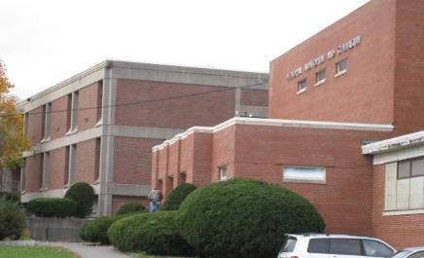

Prepared by:
Massachusetts Department of Public Health
Bureau of Environmental Health
Indoor Air Quality Program
August 2014

Background/Introduction
At the request of John J. Macero, Superintendent, Winthrop Public Schools, the Massachusetts Department of Public Health’s (MDPH), Bureau of Environmental Health (BEH) conducted a follow-up assessment of indoor air quality (IAQ) at the Winthrop Middle School (WMS), 151 Pauline Street, Winthrop, Massachusetts. The BEH/IAQ program has made previous visits to the WMS. The most recent report was issued in January of 2013 based on a November 2012 IAQ assessment. Various recommendations to improve IAQ conditions at the school were made at that time. Appendix A of this report shows the recommendations from the 2013 report and actions that have been taken.
On June 17, 2014, a visit was made to the WMS by Michael Feeney, Director of BEH’s IAQ Program. He was accompanied by Ruth Alfasso, Environmental Engineer/Inspector and Jason Dustin, Environmental Analyst/Inspector in BEH’s IAQ Program. The request was to evaluate the WMS to identify possible issues regarding IAQ and efforts to address recommendations made in previous BEH/IAQ assessments prior to the use of the WMS as swing space to house high school students during the demolition and construction of the new Winthrop High School.
The WMS is a two-story building with an occupied basement. The original portion of the building was constructed around 1945. The gym was added in 1954, and the rest of the school was constructed in 1972. The building has multi-level flat roofs that are approximately fifteen years old. The school consists of classrooms, a gymnasium, auditorium, library and offices. Windows throughout the school are openable. The building is adjacent to an ice rink used by the community and students.

Methods
Air tests for carbon dioxide, carbon monoxide, temperature and relative humidity were conducted with the TSI, Q-Trak, IAQ Monitor, Model 7565. Air tests for airborne particle matter with a diameter less than 2.5 micrometers were taken with the TSI, DUSTTRAK™ Aerosol Monitor Model 8520 and the TSI DUSTTRAK™ II Aerosol monitor 8532. BEH/IAQ staff also performed a visual inspection of building materials for water damage and/or microbial growth.

Results
The school houses approximately 475 students in sixth through eighth grade with approximately 50 staff members. Tests were taken during normal operations, and results appear in Table 1.

Discussion

Ventilation
It can be seen from Table 1 that carbon dioxide levels were below 800 parts per million (ppm) in 46 of 64 areas tested, indicating adequate air exchange in about three quarters of the areas surveyed (Table 1). It is also important to note that most areas with openable windows had them open and many areas were empty/sparsely populated, which can greatly reduce carbon dioxide levels (Table 1). In many areas, ventilation equipment was found deactivated, therefore no means of mechanical ventilation was being provided to these areas at the time of testing. Carbon dioxide levels would be expected to increase with higher occupancy, windows closed and mechanical ventilation components deactivated.
Fresh air to exterior classrooms is supplied by unit ventilator (univent) systems (Picture 1). A univent draws air from the outdoors through a fresh air intake located on the exterior wall of the building (Picture 2). Return air from the classroom is drawn through an air intake located at the base of the unit (Figure 1). Fresh and return air are mixed, filtered, heated and provided to classrooms through an air diffuser located in the top of the unit. As mentioned, the majority of univents were found deactivated at the time of the assessment (Picture 3; Table 1). In addition, some univents were found obstructed by furniture and other items on top of air diffusers and/or in front of return vents along the bottom of the units. Some univent covers were ajar (Picture 1). Other univents had what appeared to be replacement diffusers consisting of a metal panel with holes drilled in it (Picture 4). This non-standard part may not be able to supply adequate fresh air and may also cause backpressure, which can damage the univent. In order for univents to provide fresh air as designed, they must remain “on” and operating while rooms are occupied and remain free of obstructions.
The type of filter medium used in most univents comes in a bulk roll and must be cut to size before inserted into a metal lattice “cage” (Picture 5). This method is resource intensive, and results are variable. If the filter medium is not properly fitted, gaps can allow unfiltered air into the room and/or reduce the useful life of the unit. In some of the univents examined, the filter medium had been folded to fit into the cage, which indicates that filter medium cutting may not be standardized.
Disposable filters with an appropriate dust spot efficiency and similar cost can be installed in univents. The dust spot efficiency is the ability of a filter to remove particulates of a certain diameter from air passing through the filter. Filters that have been determined by the American Society of Heating, Refrigeration and Air-Conditioning Engineers (ASHRAE) to meet its standard for a dust spot efficiency of a minimum of 40% would be sufficient to reduce airborne particulates (MEHRC, 1997; ASHRAE, 1992). Note that increased filtration can reduce airflow produced by an air handling unit (AHU) or univent due to increased resistance. Prior to any increase of filtration, each unit should be evaluated by a ventilation engineer as to whether it can maintain function with more efficient filters. In one of the univents examined, disposable filters were found to be installed, however these were observed to be of a very low efficiency type (Picture 6), which do not remove significant amount of particulates.
Some of the univents examined had dust and debris accumulated inside cabinets and on radiator fins. This material should be removed through vacuuming during regular filter changes. Spaces were also observed around pipes leading to univent cabinets (Picture 7). In addition, some of the gaps in the rear of univent cabinets had been blocked/filled with what appeared to be insulation batting, which is not only ineffective in blocking air through the gaps, but can also be a source of particulates. These gaps should be sealed with an appropriate fire-rated material to prevent the draw of odors and materials from other areas of the building into the univent.
Note that the univents are original equipment, more than 35 years old. Function of equipment of this age is difficult to maintain, since compatible replacement parts are often unavailable. According to the American Society of Heating, Refrigeration and Air-Conditioning Engineers (ASHRAE), the service life for a unit heater, hot water or steam is 20 years, assuming routine maintenance of the equipment (ASHRAE, 1991). Despite attempts to maintain the univents, the operational lifespan of the equipment has been exceeded. Maintaining the balance of fresh air to exhaust air will become more difficult as the equipment ages and as replacement parts become increasingly difficult to obtain.
Exhaust ventilation for classrooms with univents is provided by wall-mounted exhaust vents ducted to rooftop motors. Some of the wall-mounted exhaust vents were blocked at the time of the assessment and many were found to be off or drawing air weakly (Table 1). As with supply ventilation, exhaust ventilation must be free of blockages and allowed to operate continuously while the building is occupied.
Mechanical ventilation for interior classrooms and common areas (e.g., auditorium, gymnasium) is provided by rooftop AHUs. Fresh air is distributed via ceiling- or wall- mounted air diffusers or supply grills and ducted back to the AHUs via ceiling- or wall-mounted return vents. The ventilation system appeared to be on and operating in these interior classrooms. Note: the location of some of the exhaust vents are next to the supply vents. This configuration is not optimal for airflow, as fresh air can be captured by the exhaust vent before mixing with the room air (called short-circuiting).
Exhaust ventilation is in place for restrooms and other areas, connected directly to exhaust fans on the roof. Many exhausts, however, were found not working or drawing weakly (Table 1). Of particular concern was the kitchen stove exhaust hood, which was not drawing air despite its on/off light indicating that the motor was activated. Restroom and kitchen exhaust ventilation is important because these areas generate heat, moisture, odors and pollutants that should be directly removed from the building. The kitchen in particular, has not only cooking odors and particulates but combustion products from the use of gas-fired appliances. Additional concerns regarding the kitchen area are discussed later in this report.
To maximize air exchange, the MDPH recommends that both supply and exhaust ventilation operate continuously during periods of occupancy. In order to have proper ventilation with a mechanical supply and exhaust system, the systems must be balanced to provide an adequate amount of fresh air to the interior of a room while removing stale air from the room. It is recommended HVAC systems be re-balanced every five years to ensure adequate air systems function (SMACNA, 1994). The date of the last balancing of these systems was not available at the time of assessment.
Minimum design ventilation rates are mandated by the Massachusetts State Building Code (MSBC). Until 2011, the minimum ventilation rate in Massachusetts was higher for both occupied office spaces and general classrooms, with similar requirements for other occupied spaces (BOCA, 1993). The current version of the MSBC, promulgated in 2011 by the State Board of Building Regulations and Standards (SBBRS), adopted the 2009 International Mechanical Code (IMC) to set minimum ventilation rates. Please note that the MSBC is a minimum standard that is not health-based. At lower rates of cubic feet per minute (cfm) per occupant of fresh air, carbon dioxide levels would be expected to rise significantly. A ventilation rate of 20 cfm per occupant of fresh air provides optimal air exchange resulting in carbon dioxide levels at or below 800 ppm in the indoor environment in each area measured. MDPH recommends that carbon dioxide levels be maintained at 800 ppm or below. This is because most environmental and occupational health scientists involved with research on IAQ and health effects have documented significant increases in indoor air quality complaints and/or health effects when carbon dioxide levels rise above the MDPH guidelines of 800 ppm for schools, office buildings and other occupied spaces (Sundell et al., 2011). The ventilation must be on at all times that the room is occupied. Providing adequate fresh air ventilation with open windows and maintaining the temperature in the comfort range during the cold weather season is impractical. Mechanical ventilation is usually required to provide adequate fresh air ventilation.
Carbon dioxide is not a problem in and of itself. It is used as an indicator of the adequacy of the fresh air ventilation. As carbon dioxide levels rise, it indicates that the ventilating system is malfunctioning or the design occupancy of the room is being exceeded. When this happens, a buildup of common indoor air pollutants can occur, leading to discomfort or health complaints. The Occupational Safety and Health Administration (OSHA) standard for carbon dioxide is 5,000 parts per million parts of air (ppm). Workers may be exposed to this level for 40 hours/week, based on a time-weighted average (OSHA, 1997).
The MDPH uses a guideline of 800 ppm for publicly occupied buildings. A guideline of 600 ppm or less is preferred in schools due to the fact that the majority of occupants are young and considered to be a more sensitive population in the evaluation of environmental health status. Inadequate ventilation and/or elevated temperatures are major causes of complaints such as respiratory, eye, nose and throat irritation, lethargy and headaches. For more information concerning carbon dioxide, consult Appendix B.
Indoor temperatures ranged from 74°F to 90°F, with most readings within the MDPH recommended range; a few areas were above recommended guidelines, particularly the kitchen which was at 90°F, further indicating the lack of exhaust ventilation and air exchange (Table 1). The MDPH recommends that indoor air temperatures be maintained in a range of 70°F to 78°F in order to provide for the comfort of building occupants. In many cases concerning indoor air quality, fluctuations of temperature in occupied spaces are typically experienced, even in a building with an adequate fresh air supply. In addition, it is difficult to control temperature and maintain comfort without operating the ventilation equipment as designed (e.g., univents/exhaust vents deactivated/obstructed).
Window-mounted air conditioners were observed in several areas. These units are normally equipped with filters, which should be cleaned or changed as per manufacturer’s instructions to avoid the build-up and re-aerosolization of dirt, dust and particulate matter.
Indoor relative humidity measurements the day of the assessment ranged from 53 to 80 percent, most of which were within or close to the MDPH recommended comfort range (Table 1), and reflective of outdoor conditions. The MDPH recommends a comfort range of 40 to 60 percent for indoor air relative humidity. Again, of note is the relative humidity of 80 percent in the kitchen area indicating the lack of exhaust ventilation to remove heat and moisture generated by kitchen activities.
Relative humidity levels in the building would be expected to drop during winter months due to heating. The sensation of dryness and irritation is common in a low relative humidity environment. Low relative humidity is a very common problem during the heating season in the northeast part of the United States.

Microbial/Moisture Concerns
Water-damaged ceiling tiles were observed in many areas (Picture 8), reportedly from leaks from the hot water and/or steam heating system. In other areas, ceiling tiles had been removed due to water damage (Picture 9). A bucket was observed inside the ceiling plenum in a hallway to catch leaks (Picture 10). In room 6C (lower level next to the cafeteria), a ceiling tile was observed to have dark staining indicating mold growth; this stain was reported to be new as the ceiling tile had been recently changed out. This room is located in a partially below-grade area that was also of concern during the 2012 visit.
In some areas, water-damaged tiles were the interlocking mineral variety, which can be difficult to replace. As mentioned in the 2012 report, these interlocking mineral tiles may contain asbestos mastic. A determination should be made concerning whether these tiles contain asbestos. If they do, the tiles should be left in place until they can be removed by a licensed asbestos remediation contractor.
Water damage was observed in the form of efflorescence along the bottom of walls on the second floor behind vinyl coving. Efflorescence is a characteristic sign of water damage to brick and mortar, but it is not mold growth. As moisture penetrates and works its way through mortar, brick or plaster, water-soluble compounds dissolve, creating a solution. As the solution moves to the surface of the material, the water evaporates, leaving behind white, powdery mineral deposits. This indicates that chronic moistening of these areas is occurring. In these cases, the coving is preventing the wall materials, which are non-organic and do not grow mold, from drying and should be removed until a long-term solution to prevent water infiltration in these areas can be implemented.
In the kitchen, along with typical sources of moisture, a washer and dryer were observed in the food preparation area. The clothes dryer was observed to be venting into a lint collector on the floor. Although it was reported that this dryer is not used, if it was, it would vent significant amounts of moisture, odors and products of combustion directly into the kitchen area.
As also observed during the 2012 IAQ assessment, drinking fountains in the main hallways were found to be out of order and covered with plastic (Picture 11). In addition, lab sinks in a science classroom were covered and the cabinets beneath them were locked. It is not known if the water service to these disused fixtures had been shut off. To prevent both water leaks and the infiltration of sewer gases through unused drains, it is recommended that these fixtures be repaired or properly abandoned.
Plants were observed in some areas (Table 1). Plants should be properly maintained and equipped with drip pans. Plants should also be located away from ventilation sources to prevent aerosolization of dirt, pollen or mold. Plants should not be placed on porous materials, since water damage to porous materials may lead to microbial growth.
Some refrigerators examined had dark staining indicating mold growth on gaskets (Picture 12). The gaskets should be cleaned with a mild detergent or antimicrobial solution. Frequent/excessive mold staining on gaskets is an indication that the refrigerator does not seal properly and needs to be repaired/replaced.
Several doors to the exterior were observed to be broken or lacking weather-stripping. These breaches can allow drafts, moisture and pests into the building (Picture 13).

Other IAQ Evaluations
Indoor air quality can be negatively influenced by the presence of respiratory irritants, such as products of combustion. The process of combustion produces a number of pollutants. Common combustion emissions include carbon monoxide, carbon dioxide, water vapor and smoke (fine airborne particle material). Of these materials, exposure to carbon monoxide and particulate matter with a diameter of 2.5 micrometers (μm) or less (PM2.5) can produce immediate, acute health effects upon exposure. To determine whether combustion products were present in the indoor environment, BEH/IAQ staff obtained measurements for carbon monoxide and PM2.5.

Carbon Monoxide
Carbon monoxide is a by-product of incomplete combustion of organic matter (e.g., gasoline, wood and tobacco). Exposure to carbon monoxide can produce immediate and acute health affects. Several air quality standards have been established to address carbon monoxide and prevent symptoms from exposure to these substances. The MDPH established a corrective action level concerning carbon monoxide in ice skating rinks that use fossil-fueled ice resurfacing equipment. If an operator of an indoor ice rink measures a carbon monoxide level over 30 ppm, taken 20 minutes after resurfacing within a rink, that operator must take actions to reduce carbon monoxide levels (MDPH, 1997).
The American Society of Heating Refrigeration and Air-Conditioning Engineers (ASHRAE) has adopted the National Ambient Air Quality Standards (NAAQS) as one set of criteria for assessing indoor air quality and monitoring of fresh air introduced by HVAC systems (ASHRAE, 1989). The NAAQS are standards established by the US EPA to protect the public health from six criteria pollutants, including carbon monoxide and particulate matter (US EPA, 2006). As recommended by ASHRAE, pollutant levels of fresh air introduced to a building should not exceed the NAAQS levels (ASHRAE, 1989). The NAAQS were adopted by reference in the Building Officials & Code Administrators (BOCA) National Mechanical Code of 1993 (BOCA, 1993), which is now an HVAC standard included in the MSBC (SBBRS, 2011). According to the NAAQS, carbon monoxide levels in outdoor air should not exceed 9 ppm in an eight-hour average (US EPA, 2006).
Carbon monoxide should not be present in a typical, indoor environment. If it is present, indoor carbon monoxide levels should be less than or equal to outdoor levels. Outdoor carbon monoxide concentrations were non-detect (ND) at the time of assessment (Table 1). No measureable levels of carbon monoxide were detected inside the building during the assessment (Table 1).

Particulate Matter
The US EPA has established NAAQS limits for exposure to particulate matter. Particulate matter is airborne solids that can be irritating to the eyes, nose and throat. The NAAQS originally established exposure limits to particulate matter with a diameter of 10 μm or less (PM10). According to the NAAQS, PM10 levels should not exceed 150 micrograms per cubic meter (μg/m³) in a 24-hour average (US EPA, 2006). These standards were adopted by both ASHRAE and BOCA. Since the issuance of the ASHRAE standard and BOCA Code, US EPA established a more protective standard for fine airborne particles. This more stringent PM2.5 standard requires outdoor air particle levels be maintained below 35 μg/m³ over a 24-hour average (US EPA, 2006). Although both the ASHRAE standard and BOCA Code adopted the PM10 standard for evaluating air quality, MDPH uses the more protective PM2.5 standard for evaluating airborne particulate matter concentrations in the indoor environment.
Outdoor PM2.5 concentrations the day of assessment were measured at 24 μg/m³. PM2.5 levels measured inside the building ranged from 16 to 70 μg/m³ (Table 1). Some of the indoor measurements were above the NAAQS PM2.5 level of 35 μg/m³. Frequently, indoor air levels of particulates (including PM2.5) can be at higher levels than those measured outdoors. A number of activities that occur indoors and/or mechanical devices can generate particulate matter during normal operations. Sources of indoor airborne particulates may include but are not limited to particles generated during the operation of fan belts in the HVAC system, use of stoves and/or microwave ovens in kitchen areas; use of photocopiers, fax machines and computer printing devices; operation of an ordinary vacuum cleaner and heavy foot traffic indoors.

Volatile Organic Compounds
Indoor air concentrations can be greatly impacted by the use of products containing volatile organic compounds (VOCs). VOCs are carbon-containing substances that have the ability to evaporate at room temperature. Frequently, exposure to low levels of total VOCs (TVOCs) may produce eye, nose, throat and/or respiratory irritation in some sensitive individuals. For example, chemicals evaporating from a paint can stored at room temperature would most likely contain VOCs. In an effort to identify materials that can potentially increase indoor VOC concentrations, BEH/IAQ staff examined rooms for products containing these respiratory irritants.
Cleaning products were found in a number of rooms throughout the building (Table 1). Cleaning products contain chemicals that can be irritating to the eyes, nose and throat of sensitive individuals. These products should be properly labeled and stored in an area inaccessible to children. In addition, Material Safety Data Sheets (MSDS) should be available at a central location for each product in the event of an emergency. Consideration should be given to providing teaching staff with school issued cleaning products and supplies to prevent any potential for adverse chemical interactions between residues left from cleaners used by the facilities staff and those left by cleaners brought in by others.
There are several rooms in the building containing photocopiers and lamination machines. Photocopiers and lamination machines can be sources of pollutants such as VOCs, ozone, heat and odors, particularly if the equipment is older and in frequent use. Both VOCs and ozone are respiratory irritants (Schmidt Etkin, 1992). Photocopiers should be kept in well ventilated rooms, and should be located near windows or exhaust vents.
Many classrooms contained dry erase boards and related materials. In some areas, dry erase material debris was collected on the marker tray. Materials such as dry erase markers and dry erase board cleaners may contain VOCs, such as methyl isobutyl ketone, n-butyl acetate and butyl-cellusolve (Sanford, 1999), which can be irritating to the eyes, nose and throat.
Air fresheners and deodorizing materials were observed in some areas (Table 1). Air deodorizers contain chemicals that can be irritating to the eyes, nose and throat of sensitive individuals. Many air fresheners contain 1,4-dichlorobenzene, a VOC which may cause reductions in lung function (NIH, 2006). Importantly, deodorizing agents do not remove materials causing odors, but rather mask odors that may be present in the area.

Other Conditions
Other conditions that can affect indoor air quality were observed during the assessment. As mentioned in the 2013 report, a storeroom adjacent to the art area has two pottery kilns. These can be a significant source of moisture and other pollutants when operating. Pottery kilns are also a source of waste heat that can present a safety/fire hazard. The kilns appeared to be electrically operated, and there was a switch-operated exhaust fan in the wall near but not directly adjacent to the kilns. The kilns were not outfitted with dedicated exhaust hoods to remove heat and pollutants directly outside the building. In addition, the switch for the exhaust may be difficult to reach when the kilns are in operation, since the switches are located next to the fan on the wall. Kilns should be vented directly outdoors and kept away from students.
In many areas, ceiling tiles were missing, reportedly due to water leaks and ongoing repairs. This makes the ceiling tile system discontinuous, which can allow particulates from above the ceiling tile system to enter the classroom below, particularly when classrooms are depressurized where exhaust is functioning without supply ventilation.
In some classrooms and offices, items were observed on windowsills, tabletops, counters, bookcases and desks (Table 1). The large number of items stored in classrooms provides a source for dusts to accumulate. These items (e.g., papers, folders, boxes) make it difficult for custodial staff to clean. Items should be relocated and/or be cleaned periodically to avoid excessive dust build up. In addition, these materials can accumulate on flat surfaces (e.g., desktops, shelving and carpets) in occupied areas and subsequently be re-aerosolized causing further irritation.
Dust was also observed accumulated on the blades of personal fans, univent diffusers and exhaust vents. Univents, exhaust vents and fans should be cleaned periodically in order to prevent them from serving as a source of aerosolized particulates. Floors in some areas were also found to be dirty; dirt and dust on the floors can also become a source of aerosolized particulates.
As mentioned in the 2013 report, exposed fiberglass insulation was observed around pipes leading into univent cabinets. Fiberglass particles are a source of irritation to the eyes, skin and respiratory system. Pipe wrapping should be examined, and exposed insulation should be re-wrapped to prevent aerosolization of fiberglass materials.
Birds were observed to be nesting inside sections of a window (Picture 14). Birds and bird wastes can be sources of allergens and microbial contamination. The birds should be removed and the windows repaired or replaced.

Conclusions/Recommendations
It was reported to BEH/IAQ staff that there may be plans to replace the WMS after the construction of the new Winthrop High School. If this plan goes forward, a new school would not be available until approximately 2016. As a result, the BEH/IAQ Program recommends a two-phase approach. The first consists of short-term measures to improve air quality and the second consists of long-term measures that will require planning and resources to adequately address overall IAQ concerns, particularly if no new middle school is planned in the near future.

Short-Term Recommendations
- Complete the recommendations from the 2013 report (Appendix A).
- Operate all ventilation systems throughout the building including univents and interior classroom HVAC systems continuously during periods of occupancy to maximize air exchange, particulary given the high levels of carbon dioxide documented in numerous areas of the school.
- Consult with an HVAC engineering firm regarding the feasibility of repair vs. replacement of ventilation system components given their age. In the interim, work with an HVAC engineering firm to adjust/repair univents and exhaust vents to improve air exchange in classrooms. This should include replacement of the makeshift air diffusers such as those shown in Picture 4 with standard ones.
- Remove all blockages/items from the surface of univent air diffusers and return vents (along front/bottom) to ensure adequate airflow.
- Remove all blockages from exhaust vents.
- Consult with a ventilation contractor to evaluate and repair the kitchen exhaust hood.
- Consider replacing metal filter racks with proper fitting disposable filters with an equal or greater dust-spot efficiency to eliminate the time needed to replace filters from bulk material rolls. Prior to any increase of filtration, each piece of air handling equipment should be evaluated by a ventilation engineer as to whether it can maintain function with more efficient filters. The time saved through this measure may allow an increased frequency of filter changes; changing filters 2-4 times a year is recommended.
- Consider adopting a balancing schedule of every 5 years for all mechanical ventilation systems, as recommended by ventilation industrial standards (SMACNA, 1994).
- Use openable windows to supplement fresh air in the classrooms during occupancy. If thermal comfort is a concern, consider opening windows between classes and during unoccupied periods. Care should be taken to ensure windows are closed at the day’s end.
- For buildings in New England, periods of low relative humidity during the winter are often unavoidable. Therefore, scrupulous cleaning practices should be adopted to minimize common indoor air contaminants whose irritant effects can be enhanced when the relative humidity is low. To control dusts, a high efficiency particulate arrestance (HEPA) filter equipped vacuum cleaner in conjunction with wet wiping of all surfaces is recommended. Avoid the use of feather dusters. Drinking water during the day can help ease some symptoms associated with a dry environment (throat and sinus irritations).
- Determine whether interlocking ceiling tiles contain asbestos. If so, remediate damaged tiles in conformance with Massachusetts asbestos remediation and hazardous waste disposal laws.
- Make repairs to the heating system piping to prevent leaks. Replace stained and missing ceiling tiles and ensure that the ceiling plenum is complete/intact to prevent migration of particulates from above the ceiling tile system into occupied areas.
- Remove coving from the base of walls on the second floor to allow for drying of water infiltrating through bricks until the exterior of the building can be repaired.
- Remove the washer and dryer from the kitchen area.
- Seal holes/breaches where pipes from univents and sinks penetrate into the crawlspace or wall cavity with appropriate fire-rated sealant to prevent movement of odors/particles from wall cavities and subfloor areas.
- Repair broken/unused plumbing fixtures or decommission them completely.
- Ensure indoor plants are equipped with drip pans. Examine drip pans periodically for mold growth and disinfect with an appropriate antimicrobial, as needed. Move plants away from the air stream of mechanical ventilation equipment.
- Store cleaning products properly and out of reach of students. All cleaning products used at the facility should be approved by the school department with MSDS’ available at a central location.
- Refrain from using air fresheners and deodorizers to prevent exposure to VOCs.
- Ensure that dedicated exhaust ventilation is operating every time the kilns are in use and for a period of time afterward to remove heat, particulates and other pollutants. Consider replacing the wall-mounted exhaust with a hood fitted directly over the kilns.
- Remove birds from the window shown in Picture 14 and repair/replace the window to prevent reoccurrence.
- Relocate or consider reducing the amount of materials stored in classrooms to allow for more thorough cleaning of classrooms. Clean items regularly with a wet cloth or sponge to prevent excessive dust build-up.
- Clean air diffusers, exhaust/return vents and personal fans periodically of accumulated dust.
- Clean portable air conditioner filters as per manufacturer’s instructions to avoid the build-up and re-aerosolization of dirt, dust and particulate matter.
- Clean chalk and dry-erase marker trays of accumulated dust and debris regularly using a damp cloth or HEPA filtered vacuum attachment.
- Ensure local exhaust is operating in areas with photocopiers and lamination machines; if not feasible consider relocating to areas with local exhaust ventilation or install local exhaust ventilation in areas where this equipment is used to reduce excess heat and odors.
- Encapsulate exposed fiberglass insulation around univent pipes in classrooms.
- Consider adopting the US EPA (2000) document, “Tools for Schools”, as an instrument for maintaining a good indoor air quality environment in the building. This document is available at: http://www.epa.gov/iaq/schools/index.html
- Refer to resource manual and other related indoor air quality documents located on the MDPH’s website for further building-wide evaluations and advice on maintaining public buildings. These documents are available at: http://mass.gov/dph/iaq

Long-Term Recommendations
- Consult with an HVAC engineering firm for a plan to replace ventilation system components. Take into consideration the current and likely future use of spaces to determine the placement of supply and exhaust ventilation to maximize airflow and removal of pollutants and odors, including dedicated exhaust ventilation in areas where copy machines, laminators, kilns, chemicals, and food preparation equipment are used.
- Repair exterior, including repointing of brickwork as needed to prevent water infiltration.
- Consult with an engineering firm to determine if all or portions of the roof should be replaced.

References
ASHRAE. 1989. Ventilation for Acceptable Indoor Air Quality. American Society of Heating, Refrigeration and Air Conditioning Engineers. ANSI/ASHRAE 62-1989.
ASHRAE. 1991. ASHRAE Applications Handbook, Chapter 33 “Owning and Operating Costs”. American Society of Heating, Refrigeration and Air Conditioning Engineers, Atlanta, GA.
ASHRAE. 1992. Gravimetric and Dust-Spot Procedures for Testing Air-Cleaning Devices Used in General Ventilation for Removing Particulate Matter. American Society of Heating, Refrigeration and Air Conditioning Engineers. ANSI/ASHRAE 52.1-1992.
BOCA. 1993. The BOCA National Mechanical Code/1993. 8th ed. Building Officials & Code Administrators International, Inc., Country Club Hills, IL.
IMC, 2009. 2009 International Mechanical Code. International Code Council Inc., Country Club Hills, IL.
MDPH. 1997. Requirements to Maintain Air Quality in Indoor Skating Rinks (State Sanitary Code, Chapter XI). 105 CMR 675.000. Massachusetts Department of Public Health, Boston, MA.
MEHRC. 1997. Indoor Air Quality for HVAC Operators & Contractors Workbook.
OSHA. 1997. Limits for Air Contaminants. Occupational Safety and Health Administration. Code of Federal Regulations. 29 C.F.R 1910.1000 Table Z-1-A.
NIH. 2006. Chemical in Many Air Fresheners May Reduce Lung Function. NIH News. National Institute of Health. July 27, 2006. http://www.nih.gov/news/pr/jul2006/niehs-27.htm
Sanford. 1999. Material Safety Data Sheet (MSDS No: 198-17). Expo® Dry Erase Markers Bullet, Chisel, and Ultra Fine Tip. Sanford Corporation. Bellwood, IL.
SBBRS. 2011. Mechanical Ventilation. State Board of Building Regulations and Standards. Code of Massachusetts Regulations, 8th edition. 780 CMR 1209.0.
Schmidt Etkin, D. 1992. Office Furnishings/Equipment & IAQ Health Impacts, Prevention & Mitigation. Cutter Information Corporation, Indoor Air Quality Update, Arlington, MA.
SMACNA. 1994. HVAC Systems Commissioning Manual. 1st ed. Sheet Metal and Air Conditioning Contractors’ National Association, Inc., Chantilly, VA.
Sundell. 2011. Sundell, J., H. Levin, W. W. Nazaroff, W. S. Cain, W. J. Fisk, D. T. Grimsrud, F. Gyntelberg, Y. Li, A. K. Persily, A. C. Pickering, J. M. Samet, J. D. Spengler, S. T. Taylor, and C. J. Weschler. Ventilation rates and health: multidisciplinary review of the scientific literature. Indoor Air, Volume 21: pp 191–204.
US EPA. 2000. Tools for Schools. Office of Air and Radiation, Office of Radiation and Indoor Air, Indoor Environments Division (6609J). EPA 402-K-95-001, Second Edition. http://www.epa.gov/iaq/schools/tools4s2.html
US EPA. 2006. National Ambient Air Quality Standards (NAAQS). US Environmental Protection Agency, Office of Air Quality Planning and Standards, Washington, DC. http://www.epa.gov/air/criteria.html
Picture 1

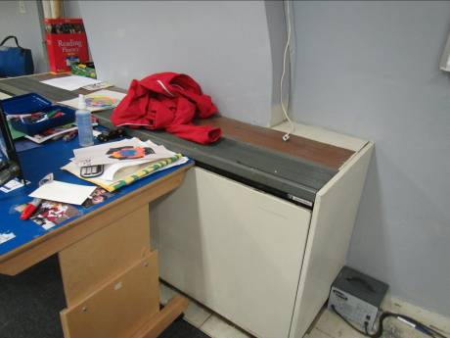

Typical univent, note obstructions, ajar cover, items on top

Picture 2

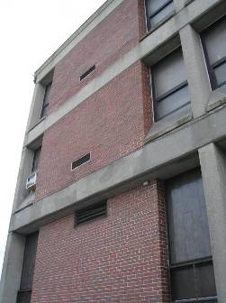

Univent fresh air intakes (arrows)
Picture 3

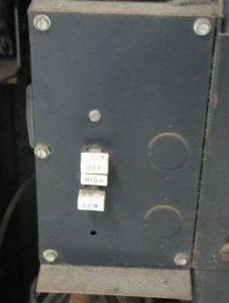

Univent controls, univent is off

Picture 4

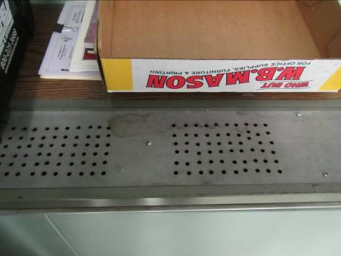

Top of univent showing non-standard replacement diffuser
Picture 5

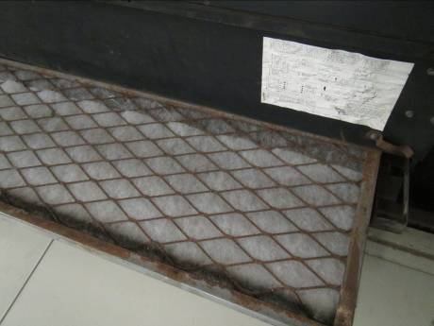

Univent filter medium in lattice cage, note rust/deterioration of cage

Picture 6

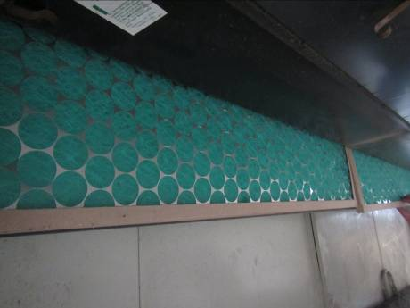

Disposable filter in univent cabinet; this type of filter has a very low dust spot efficiency
Picture 7

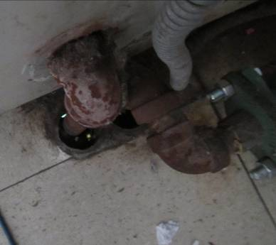

Pipe to univent cabinet with spaces (see light) around it to floor below

Picture 8

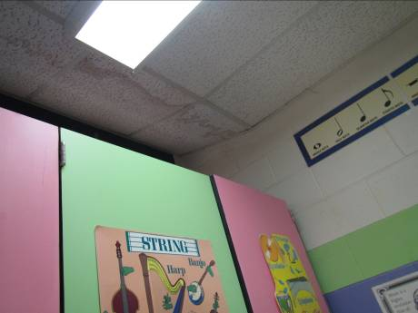

Water-damaged ceiling tiles
Picture 9

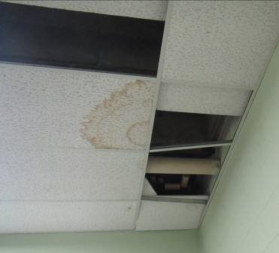

Water-damaged ceiling tiles and missing tiles

Picture 10

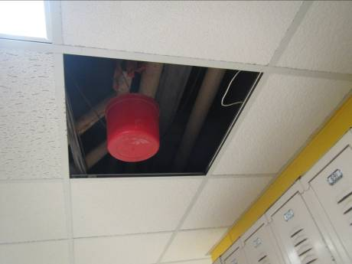

Missing ceiling tile and bucket in hallway
Picture 11

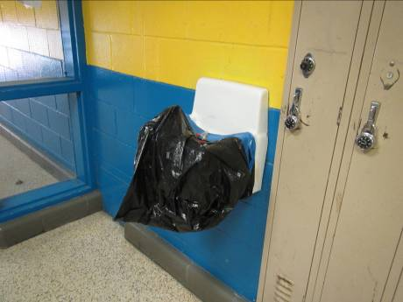

Covered water fountain in hallway

Picture 12

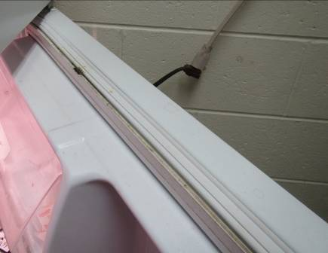

Refrigerator with dark staining/mold on gaskets
Picture 13

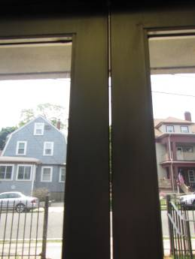

Gaps where doors to outside lack weather stripping

Picture 14

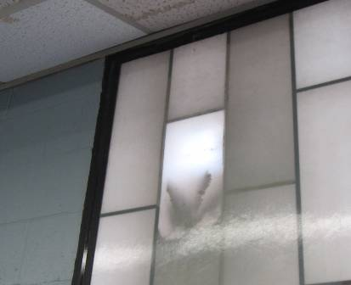

Bird nesting inside window
Location | Carbon  Dioxide  (ppm) | Carbon Monoxide  (ppm) | Temp  (°F) | Relative  Humidity  (%) | PM2.5  (µg/m³) | Occupants  in Room | Windows  Openable | Ventilation |  | Remarks
 |  |  |  |  |  |  |  | Supply | Exhaust | Remarks
Background | 415 | ND | 80 | 52 | 24 |  |  |  |  | Cloudy, humid, hazy
1st floor ladies |  |  |  |  |  |  | N | N | Y  Dusty/Weak | CP/AD
A (A.D.) | 514 | ND | 78 | 62 | 21 | 0 | Y  Open | Y  Off | N | AI, in-boxes for mail
Advisor/counselor | 530 | ND | 77 | 63 | 23 | 1 | N | Y | Y | 1 MT, DO
Art room supply area | 814 | ND | 78 | 54 | 19 | 0 | N | N | Y | Door vent
Assistant principal | 479 | ND | 77 | 63 | 43 | 0 | Y Open | Y UV Off | N | WAC
Boys Bathroom off cafeteria |  |  |  |  |  |  |  |  | Y  Weak | MT, WD-CT
Cafeteria | 1107 | ND | 77 | 70 | 26 | 100+ | N | Y | Y
Cafeteria | 1060 | ND | 78 | 65 | 21 | 112 | N | Y | Y | Strong cooking/grease odors
D (sped) | 839 | ND | 77 | 63 | 21 | 1 | Y  Open | N | N | PC, Printer, MT, DO
Gym | 495 | ND | 76 | 61 | 26 | 0 | N | Y | Y o
Kiln Room |  |  |  |  |  | 0 | N | N | Y  Switch | MT
Kitchen | 689 | ND | 90 | 80 | 23 | 10 | N | Y | Y  Off | 2 WD CT, broken CT
Library | 546 | ND | 76 | 65 | 22 | 0 | N | Y | Y | 1 MT, DO
Main Office | 465 | ND | 79 | 60 | 38 | 1 | Y  Open | Y UV Off |  | WAC on (window closed when turned on), DO, PC
Music Storage Area |  |  |  |  |  |  | N | N | Y | Microwave, MF, PF, AP, items, small room
Office Kitchenette | 543 | ND | 77 | 64 | 38 | 1 | N | N | Y | Sink, fridge, microwave, toaster
Principal’s Office | 544 | ND | 80 | 53 | 31 | 4 | Y  2 Open | Y | Y | PF, WAC
Special Education | 795 | ND | 77 | 55 | 20 | 0 | N | N | Y
Staff Restroom |  |  |  |  |  |  | N | N | Y | Exhaust off
Storeroom |  |  |  |  |  |  |  |  |  | WD CT
Storeroom | 653 | ND | 78 | 62 | 24 | 0 | N | N | Y | Door unit for supply air, WD CTs (5), DO
Technology/storage | 658 | ND | 76 | 60 | 30 | 0 | N | Y |  | Partially carpeted, overhead door broken at bottom
Theater | 498 | ND | 74 | 69 | 26 | 0 | N | Y o | Y | DO
Theater R | 465 | ND | 74 | 74 | 31 | 0 | Y | Y o | Y o | 4 MT
Therapy | 617 | ND | 74 | 66 | 24 | 0 | N | Y | Y | DO
2nd Floor C Special ed Office | 644 | ND | 78 | 62 | 31 | 2 | Y 1  Open | Y UV Off |  | WAC
04 | 816 | ND | 77 | 60 | 21 | 3 | Y  Closed | Y  Off | Y | Kitchen, plant, UF, 6 MT, several WD CTs
05 Special Ed | 630 | ND | 75 | 60 | 34 | 0 | Y | Y |  | Open CT area, bowed CTs, sink, mastic up on floor
06A Special Ed | 832 | ND | 76 | 64 | 46 | 5 | Y | Y |  | WD CT reported new, possible mold on CT, CP under sink, holes to subfloor, fridge, microwave
07 | 702 | ND | 76 | 60 | 19 | 3 | Y | Y | Y | DEM, PF, 2 bowed CTs
08 (Music) | 1038 | ND | 77 | 61 | 31 | 1 | Unknown | Y UV Off | Y | WD CT, AP, items
015 | 625 | ND | 76 | 61 | 23 | 2 | Y | Y | Y | DO
102 | 727 | ND | 77 | 63 | 43 | 24 | Y  Open | Y UV Off | Y | DO, PS, DEM
103 | 580 | ND | 77 | 61 | 21 | 4 | Y  2 Open w/fan | Y  Off | Y | DEM, AI, boxes
105 | 660 | ND | 78 | 64 | 21 | 5 | Y  3 Open | Y  On | Y | DEM, plush doll, CP
106 | - | ND | 78 | 65 | 28 | 2 | Y Open | Y | Y | DEM, DO
107 | 531 | ND | 77 | 61 | 37 | 0 | Y Open | Y UV Off | Y
107 | 466 | ND | 78 | 60 | 22 | 0 | Y  2 Open | Y  Off | Y | DEM, AI
108 | 563 | ND | 78 | 64 | 28 | 1 | Y Open | N | Y | Fan in window, DO
109 | 559 | DN | 77 | 63 | 21 | 0 | Y  2 Open | Y  Off | Y | AI, DEM
111 | 507 | ND | 78 | 60 | 29 | 3 | N | Y UV On | Y | CD
112 | 520 | ND | 78 | 62 | 34 | 1 | Y  Open | Y UV On | Y | PF in window, DEM, AP
113 | 472 | ND | 77 | 60 | 35 | 1 | Y  2 Open | Y | Y | PF on, UV ajar, DEM, opening in ceiling/MT
114 | 518 | ND | 78 | 60 | 35 | 2 | Y  Open | Y | Y | Sinks, most of them blocked off, CP, chalk, area rug (dirty)
115 | 809 | ND | 79 | 62 | 70 | 25 | Y | Y | Y | Area rug
116 Computer (Front) | 605 | ND | 77 | 62 | 20 | 0 | Y  Closed | Y  Off | Y | MT, computers, chalk board
116 Computer (Rear) | 1214 | ND | 80 | 63 | 19 | 29 | Y  2 Open | Y | Y | Computers, DEM, AC unit (off)
121 | 544 | ND | 76 | 65 | 23 | 0 | N | Y | Y | 1 MT, laminator, plants, DO
201 | 696 | ND | 78 | 59 | 31 | 0 | Y  2 Open | Y UV Off | Y  Off | PF on, PS, movable wall material
202 | 705 | ND | 77 | 60 | 18 | 1 | Y  Open | N | Y  On | DEM
203 | 914 | ND | 78 | 62 | 31 | 18 | Y  2 Open | Y UV Off | Y | DEM
204 | 791 | ND | 77 | 64 | 23 | 12 | N | Y | Y
205 | 904 | ND | 79 | 61 | 31 | 21 | Y  2 Open | Y UV Off | Y | DEM, plants
206 | 627 | ND | 75 | 64 | 22 | 4 | N | Y | Y | DO
207 | 714 | ND | 79 | 61 | 31 | 24 | Y  2 Open | Y UV Off | Y | AP, DEM, DO
208 | 911 | ND | 76 | 67 | 24 | 22 | N | Y | Y | MTs, clutter
209 | 738 | ND | 79 | 60 | 31 | 24 | Y  2 Open | Y UV Off | Y | DO, PF on, DEM
210 | 815 | ND | 78 | 64 | 30 | 18 | Y  Open | Y | Y | Floor fan, MT, DO
211 (mostly storage) | 714 | ND | 78 | 57 | 32 | 1 | Y | Y UV Off-  blocked | Y  On | Plush toys, items
212 | 650 | ND | 79 | 61 | 32 | 0 | Y  Open | Y? | Y
213 | 760 | ND | 78 | 61 | 41 | 25 | Y  Open | Y UV Off |  | AP, CD, DEM
214 | 789 | ND | 78 | 61 | 24 | 19 | N | Y | Y | CD, DO
215 | 1192 | ND | 79 | 58 | 17 | 10 | N | Y | Y | DEM, AI
216 | 1287 | ND | 76 | 64 | 16 | 26 | N |  |  | DEM
217 | 1018 | ND | 78 | 65 | 23 | 26 | Y  2 Open | Y  Off | Y | DEM
218 | 1534 | ND | 78 | 65 | 18 | 15 | Y  2 Open | Y  Off | Y | DEM
219 | 583 | ND | 76 | 60 | 20 | 0 | Y  2 Open | Y  Off | Y  Off | DEM, class not used (empty)
220 | 961 | ND | 78 | 61 | 21 | 23 | Y | Y | Y  Off | Sink needs caulking at backsplash, DEM,  art supplies
221A | 613 | ND | 77 | 60 | 31 | 4 | Y  2 Open | Y UV Off | Y | DEM, PF – dusty, partially carpeted
221B | 482 | ND | 78-79 | 62 | 36 | 3 | Y  1 Open | Y UV Off | N | Fridge, PF on
227 Physical Therapy | 582 | ND | 76 | 62 | 17 | 0 | N | Y | Y | DEM, DO

Actions on MDPH Recommendations at
Winthrop Middle School, Winthrop, MA

The following is a status report of action(s) taken on MDPH recommendations made in the January 2013 MDPH report (in bold) based on reports from school officials, maintenance staff, documents, photographs and MDPH staff observations taken during the June 2014 reassessment.
Short-Term Recommendations:
- Operate all ventilation systems throughout the building including univents and interior classroom HVAC systems continuously during periods of occupancy to maximize air exchange. This is of critical importance given the high levels of carbon dioxide documented in numerous areas of the school.
- Action: Not done. The majority of all unit ventilators were manually turned off at the time of the June 17, 2014 visit. Multiple exhaust ventilation fans were also not functioning or had very weak draw at the vent location.
- Consult with an HVAC engineering firm regarding the feasibility of repair vs. replacement of ventilation system components given their age. In the interim, work with an HVAC engineering firm to adjust/repair univents and exhaust vents to improve air exchange in classrooms.
- Action: Maintenance personnel informed BEH/IAQ staff that a sum of $30,000 had been spent to improve conditions. Unit ventilators opened for examination appeared to function (turned on, created air flow), but were found turned off and remained in the “winter” setting for heating rather than unheated ventilation.
- Remove all blockages/items from the surface of univent air diffusers and return vents (along front/bottom) to ensure adequate airflow. Remove all blockages from exhaust vents.
- Action: Not done. Many rooms still had items stored on top of uninvent diffusers and in front of return vents.
- Consider replacing metal filter racks with proper fitting disposable filters with an equal or greater dust-spot efficiency to eliminate the time needed to replace filters from bulk material rolls. Prior to any increase of filtration, each piece of air handling equipment should be evaluated by a ventilation engineer as to whether it can maintain function with more efficient filters. The time saved through this measure may allow an increased frequency of filter changes; changing filters at least twice a year is recommended.
- Action: Not done. The majority of uninvent filters examined had metal filter racks with cut-to-fit filter material, some of which was found folded and otherwise improperly fitted to the racks. Racks were found in deteriorated/rusted states during the examination.
- Consider adopting a balancing schedule of every 5 years for all mechanical ventilation systems, as recommended by ventilation industrial standards (SMACNA, 1994).
- Action: It could not be determined when the last system balancing was performed.
- Use openable windows to supplement fresh air in the classrooms during occupancy. If thermal comfort is a concern, consider opening windows between classes and during unoccupied periods. Care should be taken to ensure windows are closed at the day’s end.
- Action: Most classrooms with windows had them open as the sole source of ventilation since the unit ventilators were turned off.
- For buildings in New England, periods of low relative humidity during the winter are often unavoidable. Therefore, scrupulous cleaning practices should be adopted to minimize common indoor air contaminants whose irritant effects can be enhanced when the relative humidity is low. To control dusts, a high efficiency particulate arrestance (HEPA) filter equipped vacuum cleaner in conjunction with wet wiping of all surfaces is recommended. Avoid the use of feather dusters. Drinking water during the day can help ease some symptoms associated with a dry environment (throat and sinus irritations).
- Action: Not done. Accumulated items on surfaces, chalk & dry erase marker debris in trays, and general dusty conditions indicate that scrupulous cleaning practices have not been adopted.
- Ensure roof flashing/junctions and plumbing leaks are repaired and replace any remaining water-damaged ceiling tiles and wall materials. Examine the area above these tiles for mold growth. Disinfect areas of water leaks with an appropriate antimicrobial, as needed.
- Action: The roof was not examined at the time of the June 17, 2014 visit. Maintenance personnel stated that water-damaged ceiling tiles and other evidence of water penetration stem from leaks from the hot water heating system.
- Determine whether interlocking ceiling tiles contain asbestos. If so, remediate damaged tiles in conformance with Massachusetts asbestos remediation and hazardous waste disposal laws.
- Action: Not done. Damaged interlocking ceiling tiles remain in place. No information regarding asbestos determination was available at the time of the June 17, 2014 visit.
- Clean partition wall between rooms 107 and 109 with an antimicrobial agent and allow it to dry completely; layers of paint may also need to be scraped off to get at the wall substrate layer. Consider moving the black fabric wall hanging from this location to prevent this area from accumulating moisture.
- Action: Partition wall in this room appeared to be free from mold/staining.
- Seal holes/breaches where pipes from univents and sinks penetrate into the crawlspace or wall cavity with appropriate fire-rated sealant to prevent movement of odors/particles from wall cavities and subfloor areas. Particular attention should be paid to room 6A.
- Action: Not done. Many holes/breaches were observed at the time of the June 17, 2014 visit including Room 6A.
- Repair broken/unused plumbing fixtures or decommission them completely.
- Action: Not done. Plumbing fixtures such as broken water fountains remain in place.
- Ensure plants, trees and shrubs are located at least five feet away from exterior walls/foundation of the building.
- Action: It was not determined to what extent this had been performed; some trees and shrubs were still located close to the outside of the building.
- Repoint cracks and missing mortar on the outside of the building to prevent water infiltration.
- Action: It was not determined to what extent this had been performed as the outside of the building was not thoroughly examined during the June 17, 2014 visit.
- Ensure indoor plants are equipped with drip pans. Examine drip pans periodically for mold growth and disinfect with an appropriate antimicrobial, as needed. Move plants away from the air stream of mechanical ventilation equipment.
- Action: Only a few plants were observed during the June 17, 2014 visit.
- Store cleaning products properly and out of reach of students. All cleaning products used at the facility should be approved by the school department with MSDS’ available at a central location.
- Action: Cleaning products were accessible in unlocked storage cabinets in a number of rooms.
- Refrain from using air fresheners and deodorizers to prevent exposure to VOCs.
- Action: Not done. Air fresheners and deodorizers were observed in several classrooms during the July 17, 2014 visit.
- Ensure that the dedicated exhaust ventilation is operating every time the kiln is in use and for a period of time afterward to remove heat, particulates and other pollutants. Consider replacing the wall-mounted exhaust with a hood fitted directly over the kilns.
- Action: Kiln room remains with switched window exhaust.
- Relocate or consider reducing the amount of materials stored in classrooms to allow for more thorough cleaning of classrooms. Clean items regularly with a wet cloth or sponge to prevent excessive dust build-up.
- Action: Not done. Many rooms still had large amounts of stored items in boxes and on surfaces.
- Clean air diffusers, exhaust/return vents and personal fans periodically of accumulated dust.
- Action: Not done. Univent cabinets were particularly full of dust/debris. Some fans and vents were dusty as well.
- Clean chalk and dry-erase marker trays of accumulated dust and debris regularly using a damp cloth.
- Action: Not done. Some trays contained accumulated dust and debris.
- Consider replacing tennis balls with latex-free tennis balls or glides.
- Action: Completed. Tennis balls were not observed on chair legs at the time of the June 17, 2014 visit.
- Ensure local exhaust is operating in areas with photocopiers and lamination machines; if not feasible consider relocating to areas with local exhaust ventilation or install local exhaust ventilation in areas where this equipment is used to reduce excess heat and odors.
- Action: Not done. Copiers were located in some areas without local exhaust ventilation.
- Investigate function of marked-out device on ceiling of teachers’ lounge and repair or replace as needed.
- Action: The device had been removed by the time of the June 17, 2014 visit.
- Encapsulate exposed fiberglass insulation around univent pipes in classrooms.
- Action: Not done. Some univents examined still had exposed fiberglass insulation within the cabinets.
- Ensure regular air testing for carbon monoxide and nitrogen dioxide is conducted and recorded in facility logbook as required by State Sanitary Code, Chapter XI, 105 CMR 675.000.
- Action: BEH/IAQ staff did not inspect logbook or visit the ice rink area at the time of the June 17, 2014 assessment.
Long-Term Recommendations:
- Consult with an HVAC engineering firm for a plan to replace ventilation system components. Take into consideration the current and likely future uses of spaces to determine the placement of supply and exhaust ventilation to maximize airflow and removal of pollutants and odors, including dedicated exhaust ventilation in areas where copy machines, laminators, kilns, chemicals, and food preparation equipment are used.
- Action: Unknown whether an HVAC engineering firm has been consulted.
- Consult with an engineering firm to determine if all or portions of the roof should be replaced.
- Action: Unknown whether this had been conducted.

The service life is the median time during which a particular system or component of …[an HVAC]… system remains in its original service application and then is replaced. Replacement may occur for any reason, including, but not limited to, failure, general obsolescence, reduced reliability, excessive maintenance cost, and changed system requirements due to such influences as building characteristics or energy prices (ASHRAE, 1991).

