INDOOR AIR QUALITY ASSESSMENT

Winthrop Middle School
151 Pauline Street
Winthrop, Massachusetts

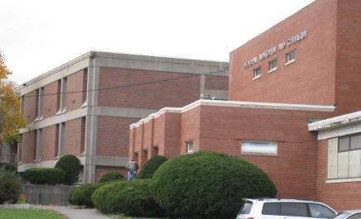

Prepared by:
Massachusetts Department of Public Health
Bureau of Environmental Health
Indoor Air Quality Program
January 2013

Background/Introduction
At the request of Eric Moore, Public Health Administrator, Winthrop Health Department, the Massachusetts Department of Public Health’s (MDPH), Bureau of Environmental Health (BEH) conducted an indoor air quality (IAQ) assessment at the Winthrop Middle School (WMS), 151 Pauline Street, Winthrop, Massachusetts. On November 2, 2012, a visit was made to the WMS by Sharon Lee, Environmental Analyst/Inspector for BEH’s IAQ Program, and Ruth Alfasso, Environmental Engineer/Inspector for BEH’s IAQ Program. The request was in response to general concerns regarding IAQ.
The WMS is a two-story building with an occupied basement. The original portion of the building was constructed around 1945. The gym was added in 1954, and the rest of the school was constructed in 1972. The building has multi-level flat roofs that are about fifteen years old. The school consists of classrooms, a gymnasium, auditorium, library and offices. Windows throughout the school are openable. The building is adjacent to a building containing an ice rink used by the community and students. An inspection of the ice rink was also conducted during this visit.
The BEH/IAQ Program previously visited this building in 1994, 1998 and 1999. A general IAQ report was issued in 1999 and is available on request.

Methods
Air tests for carbon dioxide, carbon monoxide, temperature and relative humidity were conducted with the TSI, Q-Trak, IAQ Monitor, Model 7565. Air tests for airborne particle matter with a diameter less than 2.5 micrometers were taken with the TSI, DUSTTRAK™ Aerosol Monitor Model 8520. Air sampling in the ice rink for carbon monoxide and nitrogen dioxide was conducted using a handheld Dräger Chip Measurement System (CMS) device with carbon monoxide and nitrogen dioxide chips provided by the rink operator. BEH/IAQ staff also performed a visual inspection of building materials for water damage and/or microbial growth.

Results
The school houses approximately 475 students in sixth through eighth grade with approximately 50 staff members. Tests were taken during normal operations, and results appear in Table 1.

Discussion

Ventilation
It can be seen from Table 1 that carbon dioxide levels were above 800 parts per million (ppm) in 51 of 62 areas tested and significantly higher in more than 20 areas. These levels indicate poor air exchange in most areas at the time of assessment. In some rooms, carbon dioxide levels were above 3,000 ppm (Table 1). In many areas, ventilation equipment was found deactivated, therefore no means of mechanical ventilation was being provided to these areas at the time of testing. It is also important to note that several areas had open windows or were empty/sparsely populated, which can greatly reduce carbon dioxide levels. Carbon dioxide levels would be expected to increase with higher occupancy and windows closed.
Fresh air to exterior classrooms is supplied by unit ventilator (univent) systems (Picture 1). A univent draws air from the outdoors through a fresh air intake located on the exterior wall of the building (Picture 2). Return air from the classroom is drawn through an air intake located at the base of the unit (Figure 1). Fresh and return air are mixed, filtered, heated and provided to classrooms through an air diffuser located in the top of the unit. As mentioned, the majority of univents were found deactivated at the time of assessment (Picture 3; Table 1). In addition, some univents were found obstructed by furniture and other items on top of air diffusers and/or in front of return vents along the bottom of the units (Picture 1). Some univent covers were ajar (Picture 4), compromising filtration. In order for univents to provide fresh air as designed, they must remain “on” and operating while rooms are occupied and remain free of obstructions.
The type of filter medium used by the school comes in a bulk roll and must be cut to size before it is inserted into a metal lattice “cage” (Picture 5). This method is extremely time intensive, and the results are variable. If the filter medium is not properly fitted, gaps can allow unfiltered air into the room and/or reduce the useful life of the unit. Disposable filters with an appropriate dust spot efficiency and similar cost can be installed in univents. The dust spot efficiency is the ability of a filter to remove particulates of a certain diameter from air passing through the filter. Filters that have been determined by the American Society of Heating, Refrigeration and Air-Conditioning Engineers (ASHRAE) to meet its standard for a dust spot efficiency of a minimum of 40% would be sufficient to reduce airborne particulates (MEHRC, 1997; ASHRAE, 1992). Note that increased filtration can reduce airflow produced by an air handling unit (AHU) or univent due to increased resistance. Prior to any increase of filtration, each unit should be evaluated by a ventilation engineer as to whether it can maintain function with more efficient filters.
It was reported to BEH/IAQ staff that filters are only changed every two years. Univent filters are typically replaced two to four times a year. Many of the univents examined had dust and debris accumulated inside cabinets and on radiator fins. This material should be removed through vacuuming during each filter change. Spaces were also observed around pipes in some univent cabinets. These gaps should be sealed with an appropriate fire-rated material to prevent the draw of odors and materials from other areas of the building into the univent.
Note that the univents are original equipment, more than 35 years old. Function of equipment of this age is difficult to maintain, since compatible replacement parts are often unavailable. According to the American Society of Heating, Refrigeration and Air-Conditioning Engineers (ASHRAE), the service life for a unit heater, hot water or steam is 20 years, assuming routine maintenance of the equipment (ASHRAE, 1991). Despite attempts to maintain the univents, the operational lifespan of the equipment has been exceeded. Maintaining the balance of fresh air to exhaust air will become more difficult as the equipment ages and as replacement parts become increasingly difficult to obtain.
Exhaust ventilation for classrooms with univents is provided by wall-mounted exhaust vents ducted to rooftop motors. Some of the wall-mounted exhaust vents were blocked at the time of assessment. As with supply ventilation, exhaust ventilation must be free of blockages and allowed to operate while the building is occupied.
Mechanical ventilation for interior classrooms and common areas (e.g., auditorium, gymnasium) is provided by rooftop AHUs. Fresh air is distributed via ceiling- or wall- mounted air diffusers or supply grills and ducted back to the AHUs via ceiling- or wall-mounted return vents. In many interior classrooms, the ventilation system was not operating. In one case, a supply diffuser appeared to be sealed with plastic/tape (Picture 6). In addition, the location of some of the exhaust vents relative to the supply vents, for example directly next to each other on the same wall, are not optimal for airflow in the room, as fresh air can be captured by the exhaust vent before mixing with the room air.
To maximize air exchange, the MDPH recommends that both supply and exhaust ventilation operate continuously during periods of occupancy. In order to have proper ventilation with a mechanical supply and exhaust system, the systems must be balanced to provide an adequate amount of fresh air to the interior of a room while removing stale air from the room. It is recommended HVAC systems be re-balanced every five years to ensure adequate air systems function (SMACNA, 1994). The date of the last balancing of these systems was not available at the time of the assessment.
Minimum design ventilation rates are mandated by the Massachusetts State Building Code (MSBC). Until 2011, the minimum ventilation rate in Massachusetts was higher for both occupied office spaces and general classrooms, with similar requirements for other occupied spaces (BOCA, 1993). The current version of the MSBC, promulgated in 2011 by the State Board of Building Regulations and Standards (SBBRS), adopted the 2009 International Mechanical Code (IMC) to set minimum ventilation rates. Please note that the MSBC is a minimum standard that is not health-based. At lower rates of cubic feet per minute (cfm) per occupant of fresh air, carbon dioxide levels would be expected to rise significantly. A ventilation rate of 20 cfm per occupant of fresh air provides optimal air exchange resulting in carbon dioxide levels at or below 800 ppm in the indoor environment in each area measured. MDPH recommends that carbon dioxide levels be maintained at 800 ppm or below. This is because most environmental and occupational health scientists involved with research on IAQ and health effects have documented significant increases in indoor air quality complaints and/or health effects when carbon dioxide levels rise above the MDPH guidelines of 800 ppm for schools, office buildings and other occupied spaces (Sundell et al., 2011). The ventilation must be on at all times that the room is occupied. Providing adequate fresh air ventilation with open windows and maintaining the temperature in the comfort range during the cold weather season is impractical. Mechanical ventilation is usually required to provide adequate fresh air ventilation.
Carbon dioxide is not a problem in and of itself. It is used as an indicator of the adequacy of the fresh air ventilation. As carbon dioxide levels rise, it indicates that the ventilating system is malfunctioning or the design occupancy of the room is being exceeded. When this happens, a buildup of common indoor air pollutants can occur, leading to discomfort or health complaints. The Occupational Safety and Health Administration (OSHA) standard for carbon dioxide is 5,000 parts per million parts of air (ppm). Workers may be exposed to this level for 40 hours/week, based on a time-weighted average (OSHA, 1997).
The MDPH uses a guideline of 800 ppm for publicly occupied buildings. A guideline of 600 ppm or less is preferred in schools due to the fact that the majority of occupants are young and considered to be a more sensitive population in the evaluation of environmental health status. Inadequate ventilation and/or elevated temperatures are major causes of complaints such as respiratory, eye, nose and throat irritation, lethargy and headaches. For more information concerning carbon dioxide, consult Appendix A.
Temperatures ranged from 64°F to 75°F, with most of the readings within the MDPH recommended range; a few areas (e.g., the gym and the little theater) were below recommended guidelines (Table 1). The MDPH recommends that indoor air temperatures be maintained in a range of 70°F to 78°F in order to provide for the comfort of building occupants. In many cases concerning indoor air quality, fluctuations of temperature in occupied spaces are typically experienced, even in a building with an adequate fresh air supply. In addition, it is difficult to control temperature and maintain comfort without operating the ventilation equipment as designed (e.g., univents/exhaust vents deactivated/obstructed).
Window-mounted air conditioners were observed in several areas. These units are normally equipped with filters, which should be cleaned or changed as per manufacturer’s instructions to avoid the build-up and re-aerosolization of dirt, dust and particulate matter. Several of the units were missing filters and the cooling fins were occluded with dust and debris, which can provide a mold growth media when moistened.
Relative humidity measurements in the building ranged from 35 to 69 percent at the time of assessment, which were within or close to the MDPH recommended comfort range in the majority of areas surveyed (Table 1). The MDPH recommends a comfort range of 40 to 60 percent for indoor air relative humidity. Of note is that the highest relative humidity levels were measured in rooms 208 and 220; these rooms also had carbon dioxide levels in excess of 3,000 ppm (Table 1), indicating that the ventilation in these rooms was inadequate for the number of people in them to remove both carbon dioxide and water vapor generated by occupants. In addition, room 208 was occupied by 50 people at the time of testing, exceeding normal occupancy.
Relative humidity levels in the building would be expected to drop during the winter months due to heating. The sensation of dryness and irritation is common in a low relative humidity environment. Low relative humidity is a very common problem during the heating season in the northeast part of the United States.

Microbial/Moisture Concerns
Water leaks from the roof were reported in hallways and some classrooms. Additional leaks from plumbing were also reported in lower level classrooms, including room 6A. BEH/IAQ staff noted damage to the flashing/sealing material around the rooftop access hatch and other junction areas on the roof (Picture 7). Repairs to these areas should prevent further water infiltration. Consideration should also be given to replacing the current roof, which was installed over 15 years ago and is nearing its end of useful service life.
Water-stained and missing ceiling tiles were observed in some classrooms (Picture 8). In some areas, water-damaged tiles were the interlocking mineral variety, which can be difficult to replace. These interlocking mineral tiles may also contain asbestos mastic (Picture 9). A determination should be made concerning whether these tiles contain asbestos. If they do, the tiles should be left in place until they can be removed by a licensed asbestos remediation contractor.
Plants were observed in some areas (Table 1). Plants should be properly maintained and equipped with drip pans. Plants should also be located away from ventilation sources to prevent aerosolization of dirt, pollen or mold. Plants should not be placed on porous materials, since water damage to porous materials may lead to microbial growth. One area also had an aquarium (Picture 10). Aquariums need to be properly maintained and cleaned so as not to emit odors; they should not be placed on or near univents.
Drinking fountains in the main hallways and a toilet in the staff lounge were found to be out of order and covered with plastic (Picture 11). In addition, lab sinks in a science classroom were covered (Picture 12) and the cabinets beneath them were locked. It is not known if the water service to these disused fixtures had been shut off. To prevent both water leaks and the infiltration of sewer gases through unused drains, it is recommended that these fixtures be repaired, if desired, or properly abandoned.
Specific concerns regarding water damage, mold and musty odors were expressed for room 6A. This room is located in a partially below-grade area and was also subject to a flooding incident from a pipe leak in the past. No mold growth was noted at the time of the assessment, but there were several water-damaged ceiling tiles in this room. In addition, there were breaches noted between the areas under sinks and cabinets that open into an unfinished subfloor and wall cavity (Picture 13). These breaches can allow moisture and odors into the occupied space and should be sealed with an appropriate sealant.
Below-grade areas often present moisture-control challenges, including the potential for condensation on the floor during humid weather. In addition, room 6A did not appear to have exhaust ventilation, which would make removal of moisture from occupants, sinks and a dishwasher present in the room much more difficult.
There were concerns regarding mold on an interior partition wall between rooms 107 and 109. BEH/IAQ staff examined the area of concern and noted dots of black staining on the wall underneath a large fabric wall hanging (Picture 14). It was reported that the spots kept reappearing following cleaning and painting. The presence of the wall hanging is likely preventing this area from drying following hot, humid weather, and may be contributing to mold growth. It is recommended that the affected area be thoroughly cleaned with an antimicrobial agent and allowed to dry completely; layers of paint may also need to be scraped off to get at the wall substrate layer. Unlike most of the school, which is composed of cement block and similar materials, these partition walls are composed of organic materials that may support mold colonization if they become and stay moist.
Additional concerns were reported regarding the presence of mold in the teachers’ room closet. BEH/IAQ staff observed conditions in this closet. A number of items were stored directly on the floor; however, no items appeared to be moist or water-damaged. Dark staining/debris was observed on the cement walls, particularly at the corners where the walls and floor meet (Picture 15). Cement is a semi-porous material that is not a source of mold growth, and no signs of water damage (e.g. efflorescence) were noted on these walls. The paint applied to the walls also does not support mold growth. Given the location and concentration of the dark material, it is likely that the debris collected in the uneven surface of the cement walls stems from dirt suspended on a mop. Measures should be taken to clean the walls thoroughly to remove the material. Floors should be cleaned with well-rinsed mops to prevent future build up.
During an examination of the exterior of the building, BEH/IAQ staff observed trees and shrubs in close proximity to the building (Picture 16). Shrubs/trees in close proximity to the building hold moisture against the building exterior and prevent drying. The growth of roots against exterior walls can bring moisture in contact with the foundation. Plant roots can eventually penetrate the wall, leading to cracks and/or fissures in the sublevel foundation. Over time, these conditions can undermine the integrity of the building envelope and provide a means of water entry into the building via capillary action through exterior walls, foundation concrete and masonry (Lstiburek & Brennan, 2001). The freezing and thawing action of water during the winter months can create cracks and fissures in the foundation that can result in additional penetration points for both water and pests. Trees and shrubs can also be a source of pollen, debris and mold into univents and windows. Consideration should be given to removing landscaping in close proximity to the building so as to maintain a space of 5 feet between shrubbery and the building.
There were also cracks/missing mortar observed above windowsills and air intake vents (Picture 17). These cracks may lead to water infiltration during times of wind-driven rain and need to be repaired.

Other IAQ Evaluations
Indoor air quality can be negatively influenced by the presence of respiratory irritants, such as products of combustion. The process of combustion produces a number of pollutants. Common combustion emissions include carbon monoxide, carbon dioxide, water vapor and smoke (fine airborne particle material). Of these materials, exposure to carbon monoxide and particulate matter with a diameter of 2.5 micrometers (μm) or less (PM2.5) can produce immediate, acute health effects upon exposure. To determine whether combustion products were present in the indoor environment, BEH/IAQ staff obtained measurements for carbon monoxide and PM2.5.

Carbon Monoxide
Carbon monoxide is a by-product of incomplete combustion of organic matter (e.g., gasoline, wood and tobacco). Exposure to carbon monoxide can produce immediate and acute health affects. Several air quality standards have been established to address carbon monoxide and prevent symptoms from exposure to these substances. The MDPH established a corrective action level concerning carbon monoxide in ice skating rinks that use fossil-fueled ice resurfacing equipment. If an operator of an indoor ice rink measures a carbon monoxide level over 30 ppm, taken 20 minutes after resurfacing within a rink, that operator must take actions to reduce carbon monoxide levels (MDPH, 1997).
The American Society of Heating Refrigeration and Air-Conditioning Engineers (ASHRAE) has adopted the National Ambient Air Quality Standards (NAAQS) as one set of criteria for assessing indoor air quality and monitoring of fresh air introduced by HVAC systems (ASHRAE, 1989). The NAAQS are standards established by the US EPA to protect the public health from six criteria pollutants, including carbon monoxide and particulate matter (US EPA, 2006). As recommended by ASHRAE, pollutant levels of fresh air introduced to a building should not exceed the NAAQS levels (ASHRAE, 1989). The NAAQS were adopted by reference in the Building Officials & Code Administrators (BOCA) National Mechanical Code of 1993 (BOCA, 1993), which is now an HVAC standard included in the MSBC (SBBRS, 2011). According to the NAAQS, carbon monoxide levels in outdoor air should not exceed 9 ppm in an eight-hour average (US EPA, 2006).
Carbon monoxide should not be present in a typical, indoor environment. If it is present, indoor carbon monoxide levels should be less than or equal to outdoor levels. Outdoor carbon monoxide concentrations were non-detect (ND) at the time of the assessment (Table 1). No measureable levels of carbon monoxide were detected inside the building during the assessment (Table 1).

Particulate Matter
The US EPA has established NAAQS limits for exposure to particulate matter. Particulate matter is airborne solids that can be irritating to the eyes, nose and throat. The NAAQS originally established exposure limits to particulate matter with a diameter of 10 μm or less (PM10). According to the NAAQS, PM10 levels should not exceed 150 micrograms per cubic meter (μg/m³) in a 24-hour average (US EPA, 2006). These standards were adopted by both ASHRAE and BOCA. Since the issuance of the ASHRAE standard and BOCA Code, US EPA established a more protective standard for fine airborne particles. This more stringent PM2.5 standard requires outdoor air particle levels be maintained below 35 μg/m³ over a 24-hour average (US EPA, 2006). Although both the ASHRAE standard and BOCA Code adopted the PM10 standard for evaluating air quality, MDPH uses the more protective PM2.5 standard for evaluating airborne particulate matter concentrations in the indoor environment.
Outdoor PM2.5 concentrations the day of the assessment were measured at 4 μg/m³. PM2.5 levels measured inside the building ranged from 1 to 21 μg/m³ (Table 1). Both indoor and outdoor PM 2.5 levels were below the NAAQS PM2.5 level of 35 μg/m³. Frequently, indoor air levels of particulates (including PM2.5) can be at higher levels than those measured outdoors. A number of activities that occur indoors and/or mechanical devices can generate particulate during normal operations. Sources of indoor airborne particulates may include but are not limited to particles generated during the operation of fan belts in the HVAC system, use of stoves and/or microwave ovens in kitchen areas; use of photocopiers, fax machines and computer printing devices; operation of an ordinary vacuum cleaner and heavy foot traffic indoors.

Volatile Organic Compounds
Indoor air concentrations can be greatly impacted by the use of products containing volatile organic compounds (VOCs). VOCs are carbon-containing substances that have the ability to evaporate at room temperature. Frequently, exposure to low levels of total VOCs (TVOCs) may produce eye, nose, throat and/or respiratory irritation in some sensitive individuals. For example, chemicals evaporating from a paint can stored at room temperature would most likely contain VOCs. In an effort to identify materials that can potentially increase indoor VOC concentrations, BEH/IAQ staff examined rooms for products containing these respiratory irritants.
Cleaning products were found in a number of rooms throughout the building (Table 1). Cleaning products contain chemicals that can be irritating to the eyes, nose and throat of sensitive individuals. These products should be properly labeled and stored in an area inaccessible to children. In addition, Material Safety Data Sheets (MSDS) should be available at a central location for each product in the event of an emergency. Consideration should be given to providing teaching staff with school issued cleaning products and supplies to prevent any potential for adverse chemical interactions between residues left from cleaners used by the facilities staff and those left by cleaners brought in by others.
In an effort to reduce noise, tennis balls had been sliced open and placed on the base of desk/chair legs in some classrooms (Picture 18). Tennis balls are made of a number of materials that are a source of respiratory irritants. Constant wearing of tennis balls can produce fibers and cause VOCs to off-gas. Tennis balls are made with a natural rubber latex bladder, which becomes abraded when used as a chair leg pad. Use of tennis balls in this manner may introduce latex dust into the school environment. Some individuals are highly allergic to latex (e.g., spina bifida patients) (SBAA, 2001). It is recommended that the use of materials containing latex be limited in buildings to reduce the likelihood of symptoms in sensitive individuals (NIOSH, 1997).
There are several copy rooms in the building containing photocopiers and lamination machines. Photocopiers and lamination machines can be sources of pollutants such as VOCs, ozone, heat and odors, particularly if the equipment is older and in frequent use. Both VOCs and ozone are respiratory irritants (Schmidt Etkin, 1992). Photocopiers should be kept in well ventilated rooms, and should be located near windows or exhaust vents.
Air fresheners and deodorizing materials were observed in a couple of areas (Table 1). Air deodorizers contain chemicals that can be irritating to the eyes, nose and throat of sensitive individuals. Many air fresheners contain 1,4-dichlorobenzene, a VOC which may cause reductions in lung function (NIH, 2006). Furthermore, deodorizing agents do not remove materials causing odors, but rather mask odors that may be present in the area.
Many classrooms contained dry erase boards and related materials. In some areas, dry erase material debris was collected on the marker tray (Picture 19). Materials such as dry erase markers and dry erase board cleaners may contain VOCs, such as methyl isobutyl ketone, n-butyl acetate and butyl-cellusolve (Sanford, 1999), which can be irritating to the eyes, nose and throat.

Ice Rink
An ice rink is adjacent to the WMS. The facility has a single ice rink, a small entry area with locker rooms, several offices, and a small stand of bleachers. The facility is regularly used by students, school teams and the community. BEH/IAQ staff examined the rink to determine if the potential for the rink to impact IAQ in the school environment exists. The facility uses propane-powered resurfacing equipment, which was reportedly used about one hour previous to the BEH visit. BEH/IAQ staff were not able to access the facility logbook, which was reported by the rink operator to be temporarily unavailable due to office renovations. The facility logbook contains records of sampling, maintenance and other activities for the facility. BEH/IAQ staff performed sampling for carbon monoxide and nitrogen dioxide, products of fuel combustion. Nitrogen dioxide testing was conducted due to the presence of propane-powered equipment. In response to a request by building management, sampling for carbon monoxide was also conducted to determine whether additional combustion sources were present. Note that sampling was performed next to the perimeter of the ice rink at a point close to one of the end zones, rather than center ice or on the perimeter at the center line as required by regulation due to access issues. The purpose of this sampling was not to determine regulatory compliance, but rather to determine if products of combustion might be impacting general indoor air quality.
Facility staff reported no self-sampling results in excess of the limits for carbon monoxide, as described previously in the carbon monoxide section of this report. BEH/IAQ sampling with both the Q-trak and the Dräger CMS instruments showed no detection of carbon monoxide at the time of the visit.
Ice rink operators with fuel-powered surfacing equipment are also required to sample for nitrogen dioxide, the product of fuel combustion related to propane-powered equipment. Exposure to levels of nitrogen dioxide above MDPH guidance can be hazardous to human health. The MDPH established a corrective action level concerning nitrogen dioxide in ice skating rinks that use fossil-fueled ice resurfacing equipment. If an operator of an indoor ice rink measures a nitrogen dioxide level over 0.5 ppm, taken 20 minutes after resurfacing within a rink, that operator must take actions to reduce the nitrogen dioxide levels (MDPH, 1997). Facility staff reported no self-sampling results in excess of the limits for nitrogen dioxide. BEH/IAQ sampling with the Dräger tube instrument showed no detection of nitrogen dioxide at the time of the visit, with a detection limit of 0.5 ppm.

Other Conditions
Other conditions that can affect indoor air quality were observed during the assessment. In a storeroom adjacent to the art area were two pottery kilns (Picture 20). Pottery kilns can be a significant source of water vapor, particulate and other related pollutants when operating. In addition, a pottery kiln is a source of waste heat that can present a safety/fire hazard. The kilns appeared to be electrically operated, and there was a switch-operated exhaust fan in the wall near but not directly adjacent to the kilns (Picture 21). The kilns were not outfitted with a dedicated exhaust hood, which removes heat and pollutants outside building. In addition, the switch for the exhaust may be difficult to reach when the kilns are in operation, since the switches are located next to the fan on the wall. Kilns should be vented directly outdoors and kept away from students. Bottles of pottery glazing materials were examined and they were labeled as “lead free”, which is appropriate and recommended to protect the safety and health of staff and students.
In some classrooms and offices, items were observed on windowsills, tabletops, counters, bookcases and desks (Table 1). The large number of items stored in classrooms provides a source for dusts to accumulate. These items (e.g., papers, folders, boxes) make it difficult for custodial staff to clean. Items should be relocated and/or be cleaned periodically to avoid excessive dust build up. In addition, these materials can accumulate on flat surfaces (e.g., desktops, shelving and carpets) in occupied areas and subsequently be re-aerosolized causing further irritation.
Dust was also observed accumulated on the blades of personal fans, univent diffusers and exhaust vents. Univents, exhaust vents and fans should be cleaned periodically in order to prevent them from serving as a source of aerosolized particulates. Floors in some areas were also found to be dirty; dirt and dust on the floors can become source of aerosolized particulates.
Exposed fiberglass insulation was observed around pipes leading into univent cabinets (Picture 22). Fiberglass particles are a source of irritation to the eyes and respiratory system. Pipe wrapping should be examined, and exposed insulation should be re-wrapped to prevent aerosolization of fiberglass materials.
Breaches were observed around pipes within univent cabinets. These breaches can allow odors and materials to be drawn from the pipe chaseway, into the univent and subsequently distributed to the classroom. Univent cabinets should also be examined for holes that may exist in the metal wall separating the cabinet and fan/heating elements. Air drawn through these spaces can allow for the distribution of un-filtered air.
Black tape was observed on a device that is likely a fire detector in the teachers’ lounge (Picture 23). Measures should be taken to determine whether this unit is operable. If not, this fire detector should be replaced.

Conclusions/Recommendations
It was reported to BEH/IAQ staff that there may be plans to replace the WMS in the near future; however even if this plan goes forward, a new school would not be available until approximately 2016. If the plan for a new school moves forward, the resources available to make repairs to the existing school may understandably be limited. As a result, the BEH IAQ program recommends a two-phase approach. The first consists of short-term measures to improve air quality and the second consists of long-term measures that will require planning and resources to adequately address the overall indoor air quality concerns, particularly if no new middle school is planned in the near future.

Short-Term Recommendations
- Operate all ventilation systems throughout the building including univents and interior classroom HVAC systems continuously during periods of occupancy to maximize air exchange. This is of critical importance given the high levels of carbon dioxide documented in numerous areas of the school.
- Consult with an HVAC engineering firm regarding the feasibility of repair vs. replacement of ventilation system components given their age. In the interim, work with an HVAC engineering firm to adjust/repair univents and exhaust vents to improve air exchange in classrooms.
- Remove all blockages/items from the surface of univent air diffusers and return vents (along front/bottom) to ensure adequate airflow. Remove all blockages from exhaust vents.
- Consider replacing metal filter racks with proper fitting disposable filters with an equal or greater dust-spot efficiency to eliminate the time needed to replace filters from bulk material rolls. Prior to any increase of filtration, each piece of air handling equipment should be evaluated by a ventilation engineer as to whether it can maintain function with more efficient filters. The time saved through this measure may allow an increased frequency of filter changes; changing filters at least twice a year is recommended.
- Consider adopting a balancing schedule of every 5 years for all mechanical ventilation systems, as recommended by ventilation industrial standards (SMACNA, 1994).
- Use openable windows to supplement fresh air in the classrooms during occupancy. If thermal comfort is a concern, consider opening windows between classes and during unoccupied periods. Care should be taken to ensure windows are closed at the day’s end.
- For buildings in New England, periods of low relative humidity during the winter are often unavoidable. Therefore, scrupulous cleaning practices should be adopted to minimize common indoor air contaminants whose irritant effects can be enhanced when the relative humidity is low. To control dusts, a high efficiency particulate arrestance (HEPA) filter equipped vacuum cleaner in conjunction with wet wiping of all surfaces is recommended. Avoid the use of feather dusters. Drinking water during the day can help ease some symptoms associated with a dry environment (throat and sinus irritations).
- Ensure roof flashing/junctions and plumbing leaks are repaired and replace any remaining water-damaged ceiling tiles and wall materials. Examine the area above these tiles for mold growth. Disinfect areas of water leaks with an appropriate antimicrobial, as needed.
- Determine whether interlocking ceiling tiles contain asbestos. If so, remediate damaged tiles in conformance with Massachusetts asbestos remediation and hazardous waste disposal laws.
- Clean partition wall between rooms 107 and 109 with an antimicrobial agent and allow it to dry completely; layers of paint may also need to be scraped off to get at the wall substrate layer. Consider moving the black fabric wall hanging from this location to prevent this area from accumulating moisture.
- Seal holes/breaches where pipes from univents and sinks penetrate into the crawlspace or wall cavity with appropriate fire-rated sealant to prevent movement of odors/particles from wall cavities and subfloor areas. Particular attention should be paid to room 6A.
- Repair broken/unused plumbing fixtures or decommission them completely.
- Ensure plants, trees and shrubs are located at least five feet away from exterior walls/foundation of the building.
- Repoint cracks and missing mortar on the outside of the building to prevent water infiltration.
- Ensure indoor plants are equipped with drip pans. Examine drip pans periodically for mold growth and disinfect with an appropriate antimicrobial, as needed. Move plants away from the air stream of mechanical ventilation equipment.
- Store cleaning products properly and out of reach of students. All cleaning products used at the facility should be approved by the school department with MSDS’ available at a central location.
- Refrain from using air fresheners and deodorizers to prevent exposure to VOCs.
- Ensure that the dedicated exhaust ventilation is operating every time the kiln is in use and for a period of time afterward to remove heat, particulates and other pollutants. Consider replacing the wall-mounted exhaust with a hood fitted directly over the kilns.
- Relocate or consider reducing the amount of materials stored in classrooms to allow for more thorough cleaning of classrooms. Clean items regularly with a wet cloth or sponge to prevent excessive dust build-up.
- Clean air diffusers, exhaust/return vents and personal fans periodically of accumulated dust.
- Clean chalk and dry-erase marker trays of accumulated dust and debris regularly using a damp cloth.
- Consider replacing tennis balls with latex-free tennis balls or glides.
- Ensure local exhaust is operating in areas with photocopiers and lamination machines; if not feasible consider relocating to areas with local exhaust ventilation or install local exhaust ventilation in areas where this equipment is used to reduce excess heat and odors.
- Investigate function of marked-out device on ceiling of teachers’ lounge and repair or replace as needed.
- Encapsulate exposed fiberglass insulation around univent pipes in classrooms.
- Ensure regular air testing for carbon monoxide and nitrogen dioxide is conducted and recorded in facility logbook as required by State Sanitary Code, Chapter XI, 105 CMR 675.000.
- Consider adopting the US EPA (2000) document, “Tools for Schools”, as an instrument for maintaining a good indoor air quality environment in the building. This document is available at: http://www.epa.gov/iaq/schools/index.html
- Refer to resource manual and other related indoor air quality documents located on the MDPH’s website for further building-wide evaluations and advice on maintaining public buildings. These documents are available at: http://mass.gov/dph/iaq

Long-Term Recommendations
- Consult with an HVAC engineering firm for a plan to replace ventilation system components. Take into consideration the current and likely future uses of spaces to determine the placement of supply and exhaust ventilation to maximize airflow and removal of pollutants and odors, including dedicated exhaust ventilation in areas where copy machines, laminators, kilns, chemicals, and food preparation equipment are used.
- Consult with an engineering firm to determine if all or portions of the roof should be replaced.

References
ASHRAE. 1989. Ventilation for Acceptable Indoor Air Quality. American Society of Heating, Refrigeration and Air Conditioning Engineers. ANSI/ASHRAE 62-1989.
ASHRAE. 1991. ASHRAE Applications Handbook, Chapter 33 “Owning and Operating Costs”. American Society of Heating, Refrigeration and Air Conditioning Engineers, Atlanta, GA.
ASHRAE. 1992. Gravimetric and Dust-Spot Procedures for Testing Air-Cleaning Devices Used in General Ventilation for Removing Particulate Matter. American Society of Heating, Refrigeration and Air Conditioning Engineers. ANSI/ASHRAE 52.1-1992.
BOCA. 1993. The BOCA National Mechanical Code/1993. 8th ed. Building Officials & Code Administrators International, Inc., Country Club Hills, IL.
IMC, 2009. 2009 International Mechanical Code. International Code Council Inc., Country Club Hills, IL.
Lstiburek, J. & Brennan, T. 2001. Read This Before You Design, Build or Renovate. Building Science Corporation, Westford, MA. U.S. Department of Housing and Urban Development, Region I, Boston, MA.
MDPH. 1997. Requirements to Maintain Air Quality in Indoor Skating Rinks (State Sanitary Code, Chapter XI). 105 CMR 675.000. Massachusetts Department of Public Health, Boston, MA.
MEHRC. 1997. Indoor Air Quality for HVAC Operators & Contractors Workbook. MidAtlantic Environmental Hygiene Resource Center, Philadelphia, PA.
NIH. 2006. Chemical in Many Air Fresheners May Reduce Lung Function. NIH News. National Institute of Health. July 27, 2006. http://www.nih.gov/news/pr/jul2006/niehs-27.htm
NIOSH. 1997. NIOSH Alert Preventing Allergic Reactions to Natural Rubber latex in the Workplace. National Institute for Occupational Safety and Health, Atlanta, GA.
OSHA. 1997. Limits for Air Contaminants. Occupational Safety and Health Administration. Code of Federal Regulations. 29 C.F.R 1910.1000 Table Z-1-A.
Sanford. 1999. Material Safety Data Sheet (MSDS No: 198-17). Expo® Dry Erase Markers Bullet, Chisel, and Ultra Fine Tip. Sanford Corporation. Bellwood, IL.
SBAA. 2001. Latex In the Home And Community Updated Spring 2001. Spina Bifida Association of America, Washington, DC.
SBBRS. 2011. Mechanical Ventilation. State Board of Building Regulations and Standards. Code of Massachusetts Regulations, 8th edition. 780 CMR 1209.0.
Schmidt Etkin, D. 1992. Office Furnishings/Equipment & IAQ Health Impacts, Prevention & Mitigation. Cutter Information Corporation, Indoor Air Quality Update, Arlington, MA.
SMACNA. 1994. HVAC Systems Commissioning Manual. 1st ed. Sheet Metal and Air Conditioning Contractors’ National Association, Inc., Chantilly, VA.
Sundell. 2011. Sundell, J., H. Levin, W. W. Nazaroff, W. S. Cain, W. J. Fisk, D. T. Grimsrud, F. Gyntelberg, Y. Li, A. K. Persily, A. C. Pickering, J. M. Samet, J. D. Spengler, S. T. Taylor, and C. J. Weschler. Ventilation rates and health: multidisciplinary review of the scientific literature. Indoor Air, Volume 21: pp 191–204.
US EPA. 2000. Tools for Schools. Office of Air and Radiation, Office of Radiation and Indoor Air, Indoor Environments Division (6609J). EPA 402-K-95-001, Second Edition. http://www.epa.gov/iaq/schools/tools4s2.html
US EPA. 2006. National Ambient Air Quality Standards (NAAQS). US Environmental Protection Agency, Office of Air Quality Planning and Standards, Washington, DC. http://www.epa.gov/air/criteria.html
Picture 1

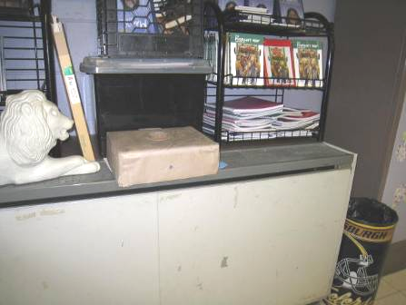

Typical univent, note items on top

Picture 2

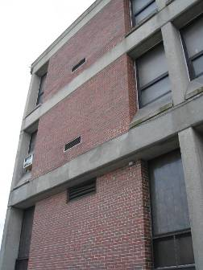

Univent fresh air intakes (arrows)

Picture 3

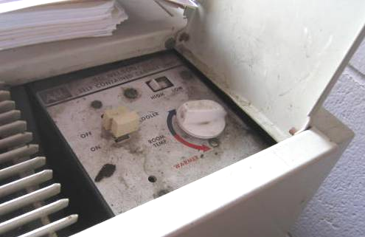

Univent controls, showing unit is shut off

Picture 4

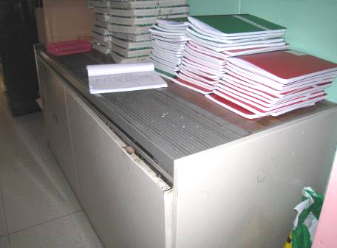

Univent with cover ajar

Picture 5

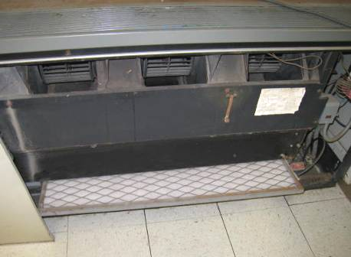

Open univent showing filter material in lattice “cage”

Picture 6

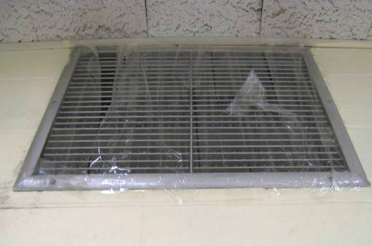

Vent sealed with plastic tape

Picture 7

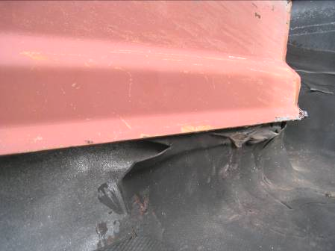

Damaged sealing material around rooftop access hatch

Picture 8

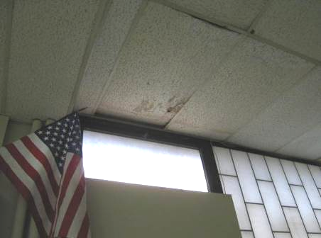

Water-damaged ceiling tiles in room 6A

Picture 9

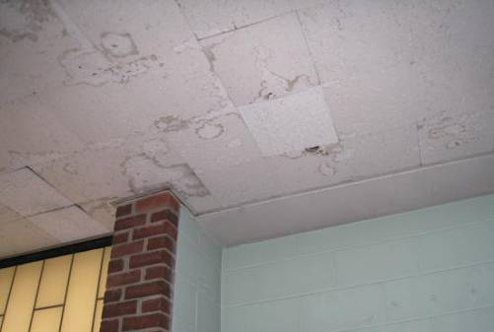

Water-damaged interlocking ceiling tiles

Picture 10

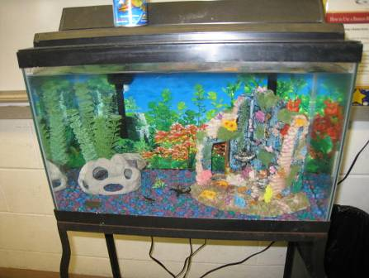

Classroom aquarium

Picture 11

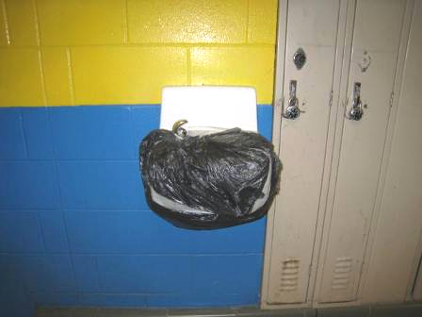

Out of service water fountain

Picture 12

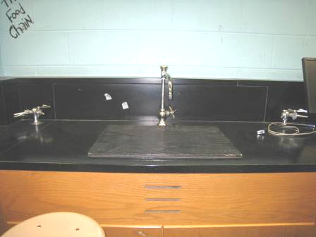

Covered/sealed science lab sink

Picture 13

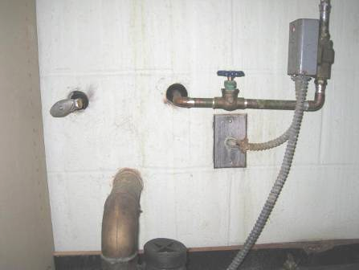

Breaches under sink in room 6A

Picture 14

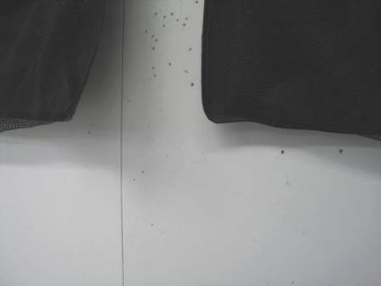

Black staining/possible mold growth on partition wall

Picture 15

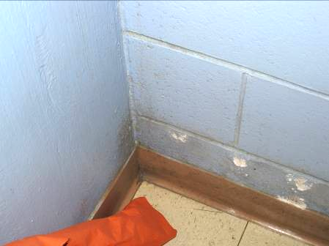

Staining/dirt on wall in teachers’ room closet

Picture 16

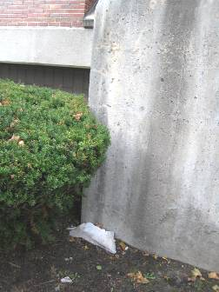

Shrub next to foundation

Picture 17

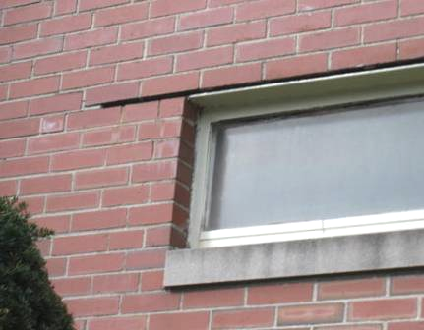

Missing mortar above window

Picture 18

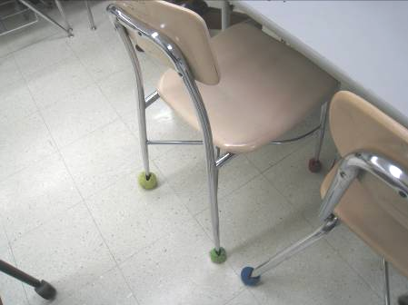

Tennis balls used as chair glides

Picture 19

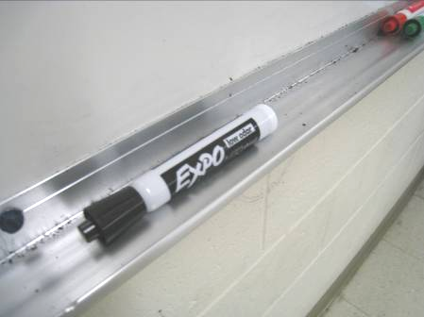

Whiteboard marker debris

Picture 20

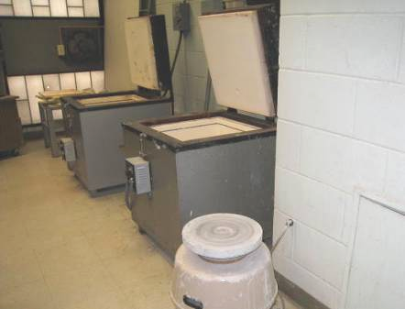

Pottery kilns, note wall-mounted switch-activated exhaust fan several feel away (arrow)

Picture 21

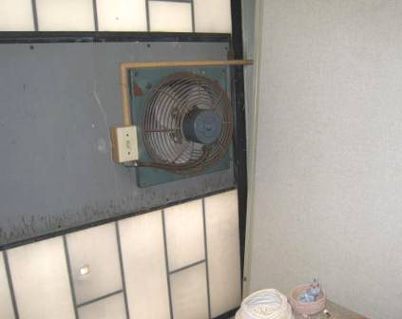

Kiln room exhaust fan with switch

Picture 22

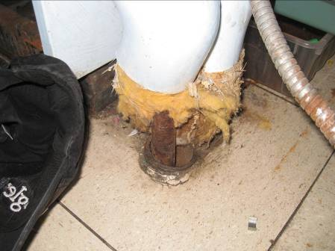

Exposed fiberglass pipe insulation

Picture 23

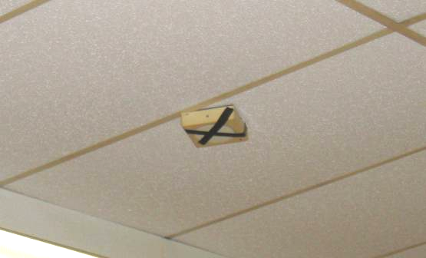

Black tape markings on device on teachers’ lounge ceiling

Location/ Room | Carbon Dioxide  (ppm) | Carbon Monoxide  (ppm) | Temp  (°F) | Relative Humidity (%) | PM2.5  (µg/m³) | Occupants in Room | Windows  Openable | Ventilation |  | Remarks
 |  |  |  |  |  |  |  | Supply | Exhaust | Remarks
Background | 461 | ND | 55 | 46 | 4 |  |  |  |  | Mostly cloudy, light wind
03 practice room |  |  |  |  |  |  |  |  | Y dusty | Microwave, fridge and food
101 | 935 | ND | 69 | 44 | 2 | 0 | N | N | N | AD, DO
102 | 539 | ND | 70 | 35 | 2 | 0 | Y, 2 open | Y off | Y off | DO, TB, debris in UV
103 | 915 | ND | 70 | 43 | 6 | 0 | Y | Y 2 UV off | Y off | UV ajar, DEM
104 | 767 | ND | 73 | 38 | 4 | 0 | N | Y off | Y off | DEM, DO, TBs
105 | 965 | ND | 70 | 48 | 6 | 0 | Y | Y UV off | Y off | Items, food
106 | 768 | ND | 72 | 37 | 5 | 9 | T | Y off | Y off | DO, DEM
107 | 1077 | ND | 69 | 37 | 11 | 18 | Y, 3 open | Y UV off | Y | Report of black staining on other side of interior partition wall
108 | 637 | ND | 67 | 35 | 5 | 15 | Y open | Y off | Y | Items, DEM, paint, plants
109 | 1117 | ND | 72 | 39 | 6 | 14 | Y | Y UV off | Y | PF
110 | 2217 | ND | 74 | 54 | 6 | 25 | N | Y | Y | DEM
111 | 1131 | ND | 75 | 43 | 4 | 23 | N | Y | Y | DEM, AT, MT
112 | 919 | ND | 71 | 46 | 3 | 5 | Y | Y off | Y | TB, items on UV
113 | 1942 | ND | 74 | 48 | 7 | 23 | Y | Y off | Y off | DEM, PF
114 Book storage |  |  |  |  |  |  |  |  |  | PF blowing into room 111
114 Science | 821 | ND | 70 | 46 | 7 | 0 | Y | Y off | Y | Sinks covered and locked
115 | 1113 | ND | 72 | 46 | 6 | 0 | Y | Y | Y | MT
115 computer storage | 745 | ND | 73 | 47 | 4 | 0 | Y | Y off | Y off
116 computer | 657 | ND | 74 | 40 | 1 | 0 | Y | Y | N | Wall AC, DO, water infiltration, WD-CT
201 | 1317 | ND | 71 | 46 | 8 | 0 | Y | Y UV | Y on | DEM
202 | 1428 | ND | 72 | 47 | 9 | 12 | Y | Y UV | Y on | DEM
203 | 1408 | ND | 72 | 47 | 6 | 14 | Y | Y UV off | Y off | PF, DEM
204 | 1499 | ND | 72 | 49 | 11 | 17 | N (interior room) | Y off | Y | Lysol, DEM, MT, partition wall
205 | 1320 | ND | 72 | 43 | 8 | 0 | Y, 2 open | Y UV off | Y | DEM, DO
206 | 1236 | ND | 71 | 48 | 5 | 0 | N (interior room) | Y off | Y off | Items/clutter, exhaust/supply vents look the same
207 | 1314 | ND | 71 | 46 | 11 | 0 | Y, 2 open | Y UV off | Y off | DEM, PF dusty
208 | 3282 | ND | 74 | 60 | 15 | 50 | N | Y off | Y off
209 | 1686 | ND | 71 | 49 | 12 | 21 | Y open | Y UV off | Y off | Paper debris in UV, 2 PF (dusty), DEM
210 | 2530 | ND | 72 | 55 | 11 | 24 | Y | Y off | Y off | DEM, items on UV
211 teacher’s room | 1291 | ND | 70 | 46 | 4 | 8 | Y | Y off | Y off
212 | 1972 | ND | 71 | 50 | 6 | 3 | Y | Y off | Y off | PF, DEM
213 | 1774 | ND | 71 | 50 | 7 | 23 | Y | Y UV off |  | CP, DEM
214 | 2050 | ND | 73 | 50 | 12 | 24 | N (interior room) | Y | Y | DEM, chalk, AP, items, dirty floor, PS, CP
215 | 1406 | ND | 73 | 51 | 5 | 19 | N | Y |  | DEM
216 | 1288 | ND | 71 | 50 | 6 | 12 | N | Y |  | DEM, MT, DO
217 | 1253 | ND | 72 | 45 | 2 | 13 | Y, 2 open | Y off | Y off | PF, exposed fiberglass wrap in UV pipes
218 | 1541 | ND | 72 | 52 | 10 | 28 | Y | Y off | Y off | Items on UV, DEM, PF
219 | 1756 | ND | 69 | 53 | 7 | 0 | Y | Y UV off | Y | Dirty on floor, DO
220 | 3353 | ND | 71 | 69 | 16 | 24 | Y | Y off | Y off | Items on UV, backsplash unsealed
221 SPED | 1439 | ND | 70 | 49 | 7 | 1 (class left 1 hour ago) | Y | Y UV off | Y | PF, cardboard under sink, DEM
221B | 1457 | ND | 70 | 50 | 5 | 5 | Y | Y UV off |  | Items on UV, AQ, PF
2nd floor girls room |  | ND | 70 | 49 | 8 | 0 | Y | N | Y off
2nd floor staff copy room D | 1544 | ND | 70 | 49 | 6 | 0 | Y | Y off | N | MT, PC – odors, DO
3 teachers room | 1174 | ND | 72 | 46 | 3 | 12 | Y | Y off | Y | PC, smoke alarm crossed out, WD-CT, Window AC, DEM, dusty supply
4 | 616 | ND | 71 | 40 | 5 | 1 | Y | Y off | Y | 3MT, irregular leak reported, 12 WD-CT
5 | 1190 | ND | 71 | 43 | 14 | 3 | Y | Y off | Y | UV open, has debris. Sink
6 | 1088 | ND | 70 | 45 | 10 | 4 | Unknown | Y UV off | N | MTs
6A, special ed. inclusion room | 1116 | ND | 71 | 44 | 21 | 2 | Y open | Y off | N | Concerns about odors, holes between sink and wall cavity, subflooring. Microwave, dishwasher, other kitchen items
7 | 807 | ND | 71 | 43 | 8 | 1 | Y | Y | Y
A | 936 | ND | 71 | 43 | 8 | 0 | Y | Y UV off |  | DO
Assistant Principal | 728 | ND | 71 | 40 | 6 | 0 | Y | Y UV off | N | Window AC, small MT
Band/Music | 487 | ND | 64 | 40 | 5 | 0 | N | Y | Y
C SPED office | 1240 | ND | 72 | 44 | 9 | 0 | Y | Y UV off | N | Window AC, MT with electric wires, DO, area rug
Cafeteria | 1273 | ND | 72 | 45 | 18 | ~200 | Y | Y | Y
D (copy) | 1591 | ND | 70 | 50 | 9 | 0 | Y blocked | Y UV on | N | DO, MT, PC, soiled walls, copy machine odor
Faculty women’s room |  |  |  |  |  |  |  |  |  | Deodorant scent
Gym | 414 | ND | 64 | 37 | 7 | 14 | N | Y | Y
Library | 1094 | ND | 73 | 44 | 2 | 0 | N | Y off | Y off
Library copy room | 1227 | ND | 72 | 42 | 10 | 1 | N, interior room | Y | Y | Laminator, PC, sink, toaster, microwave, WD-CT, MT
Little theater | 707 | ND | 66 | 51 | 16 | 25 | Y | Y |  | MT
Main office | 1074 | ND | 72 | 41 | 8 | 3 | Y | Y UV off |  | Window AC, shredder, PC, electronics, items
Music | 996 | ND | 71 | 42 | 4 | 0 | Y | Y | Y off | 8 WD-CT
Nurse | 965 | ND | 71 | 44 | 7 | 0 | N | Y UV off | Y off
Occupational Therapy room | 1455 | ND | 73 | 44 | 7 | 1 | N | Y off | Y off | DEM, sanitizers, sink
Principal’s Office | 901 | ND | 71 | 41 | 5 | 1 | Y | Y UV off | N | Window AC, clutter
Reward room/health | 805 | ND | 70 | 41 | 11 | 1 | Y | Y off | Y | Sink
S8 (kiln closet) |  |  |  |  |  |  | N | N | Y | Exhaust is wall-mounted to outside on switch near kiln. MT, lead-free glazes
Staff lounge right side restroom |  |  |  |  |  |  |  |  |  | Buzzing light, toilet out of order
Storeroom |  |  |  |  |  |  |  |  |  | Cluttered
Women’s first floor restroom |  |  |  |  |  |  |  |  | Y off

The service life is the median time during which a particular system or component of …[an HVAC]… system remains in its original service application and then is replaced. Replacement may occur for any reason, including, but not limited to, failure, general obsolescence, reduced reliability, excessive maintenance cost, and changed system requirements due to such influences as building characteristics or energy prices (ASHRAE, 1991).

