INDOOR AIR QUALITY REASSESSMENT

Winthrop High School
(Formerly Winthrop Middle School)
151 Pauline Street
Winthrop, Massachusetts

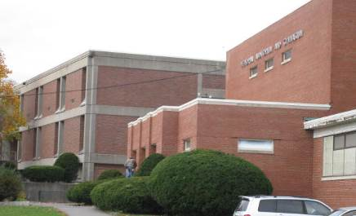

Prepared by:
Massachusetts Department of Public Health
Bureau of Environmental Health
Indoor Air Quality Program
October 2015

Background/Introduction
At the request of John J. Macero, Superintendent, Winthrop Public Schools (WPS) and Albert Legee, Commissioner of Winthrop Inspection Services, the Massachusetts Department of Public Health’s (MDPH), Bureau of Environmental Health (BEH), Indoor Air Quality (IAQ) Program conducted a limited IAQ assessment on August 27, 2014 at 151 Pauline Street, Winthrop, Massachusetts (“The building”) currently serves as the temporary home of the Winthrop High School (WHS).
Commissioner Legee and Superintendent Macero requested that the IAQ Program assess the status of implementation of MDPH recommendations made regarding the building’s heating, ventilating and air-conditioning (HVAC) system. This assessment included: examination of the HVAC system in each room (where accessible); visual observation for water damage; and observations of conditions needing further remediation. It is important to note that this assessment was conducted prior to the opening of the school. A summary of the actions taken by WPS in response to the recommendations in the June 17, 2014 IAQ assessment is included as Appendix A.

Methods
BEH/IAQ staff performed an inspection of mechanical ventilation equipment and a visual inspection of building materials for water damage and/or microbial growth. As mentioned, since the school was unoccupied by students and faculty at the time of the visit, no measurements for carbon dioxide or other IAQ measurements were conducted.

Results
The school was planned to temporarily house approximately 500+ students in 8th through 12th grade with approximately 50 staff members. The conditions of each classroom’s ventilation equipment and related issues are reported in Table 1.

Discussion

Ventilation Equipment
Fresh air to exterior classrooms is supplied by unit ventilator (univent) systems (Picture 1). A univent draws air from the outdoors through a fresh air intake located on the exterior wall of the building. Return air from the classroom is drawn through an air intake located at the base of the unit (Figure 1). Fresh and return air are mixed, filtered, heated and provided to classrooms through an air diffuser located in the top of the unit. In common areas and some interior classrooms, air handling units (AHUs) provide fresh air and heating via ceiling or wall-mounted diffusers.
During the previous BEH/IAQ visit, the majority of univents were found deactivated and some were found obstructed by furniture and other items on top of air diffusers and/or in front of return vents along the bottom of the units. In addition, other conditions were observed that could impact effective operation of the univents (e.g. open univent cabinets, unsealed spaces, and inefficient filters).
During this current assessment, most of the univents in accessible areas were opened and examined as well. Several other supply and exhaust vents in classrooms and common areas were evaluated (Table 1). Significant progress on recommendations issued in the report from the June 17, 2014 visit was observed, including:
- The majority of univent front covers were properly closed;
- Disposable, properly-fitting air filters were observed in all standard sized classroom univents instead of metal cages with cut-to-fit filters as denoted in previous assessments (Picture 2).
- Most univents (Table 1) were operating at the time of the visit;
- Most univent cabinets appeared to have been cleaned. Some had debris in either the bottom of the cabinet or the top (Pictures 3 and 4);
- Space in univents were sealed as recommended. Some univents still contained gaps (Picture 5).
Remaining univent issues were observed including:
- A number of univents still had jerry-rigged hole punched sheet metal in place of the original vanes fresh air diffusers (Picture 6);
- Univents larger than the standard classroom size (e.g., Music room 08) or smaller than the standard classroom size (e.g., Room 05) continued to have metal cages with cut-to-fit filters;
- Some of the univent pipes still had insulation in poor condition (Picture 7).

It was also reported that faculty and staff were to receive from WPS a letter regarding univent purpose and function, with a reinforcement of instruction not to block univent airflow (e.g., books on top of fresh air diffusers).

Microbial/Moisture Concerns
Some areas still had missing and/or water-damaged ceiling tiles (Picture 8). However, it was reported that ceiling tiles were missing in some areas due to a rewiring project being pursued for life safety systems. Replacement of all remaining water-damaged/missing ceiling tiles would be completed before the beginning of the school year.
Water bubblers had been removed and the water service capped (Picture 9). The drains were still in place. Some drain pipes were sealed, others had water in their traps. The pipes with water in their traps will eventually dry out and potentially allow sewer gases into the building. The sealing of the drains should be confirmed for all removed fixtures, including any lab sinks if they were also decommissioned. In addition, there were holes in the walls where the fixtures had been hung (Picture 9 and 10), which can allow odors and particulate matter from the wall cavity to enter into occupied spaces. These holes should be sealed. The walls where the fixtures had been were also in need of cleaning (Picture 10).

Conclusions/Recommendations
The August 27, 2014 reassessment confirmed that a number of the recommendations included in the report from the June 2014 visit had been addressed and several more were in progress (Appendix A). The following additional recommendations are made:
- Complete the recommendations from the report written on the June 2014 visit (Appendix A).
- Operate all ventilation systems throughout the building including univents and interior classroom HVAC systems continuously during periods of occupancy to maximize air exchange, particulary given the high levels of carbon dioxide documented in numerous areas of the school during previous visits.
- In the interim, continue to work with an HVAC engineering firm to adjust/repair univents and exhaust vents to improve air exchange in classrooms. This should include replacement of the makeshift air diffusers such as those shown in Picture 2 with standard ones.
- Ensure removal of all items from the surface of univent air diffusers and return vents (along front/bottom) to ensure adequate airflow.
- Remove any blockages from exhaust vents.
- Acquire properly-fitting disposable filters for non-standard sized univents.
- Use openable windows to supplement fresh air in the classrooms during occupancy. If thermal comfort is a concern, consider opening windows between classes and during unoccupied periods. Care should be taken to ensure windows are closed at the day’s end.
- Seal holes/breaches where pipes from univents and sinks penetrate into the crawlspace or wall cavity with appropriate fire-rated sealant to prevent movement of odors/particles from wall cavities and subfloor areas.
- Refrain from using air fresheners and deodorizers to prevent exposure to VOCs.
Picture 1
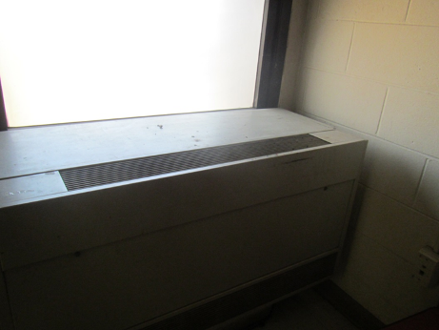
Univent
Picture 2
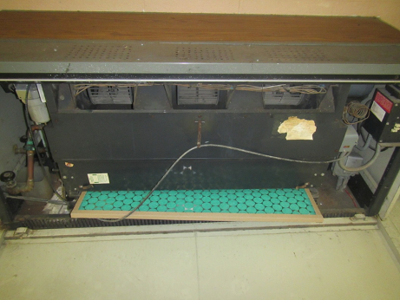
Disposable filter installed in univent; note filter was clean/new
Picture 3
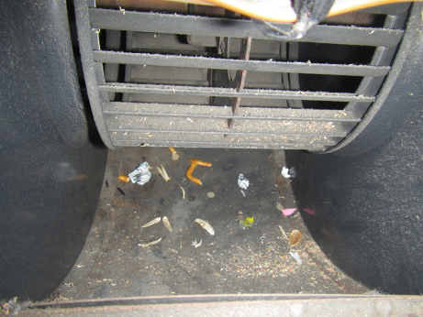
Debris inside univent
Picture 4
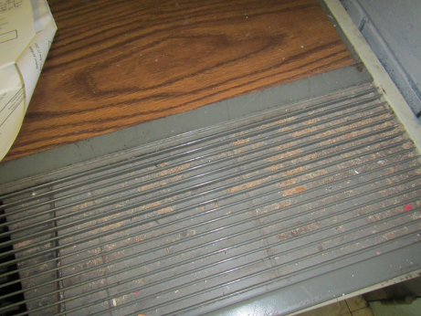
Pencil shavings and other debris in univent diffuser area
Picture 5
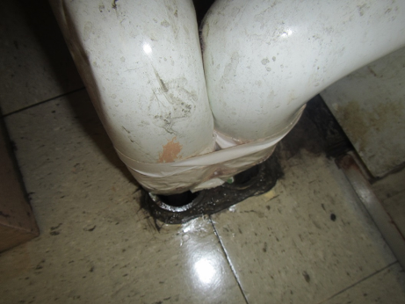
Holes where univent pipes enter the floor
Picture 6
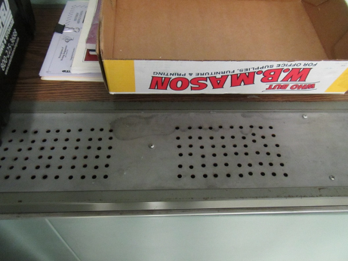
Non-standard univent cover
Picture 7
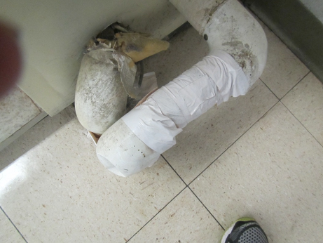
Messy pipe wrap and exposed fibrous materials
Picture 8
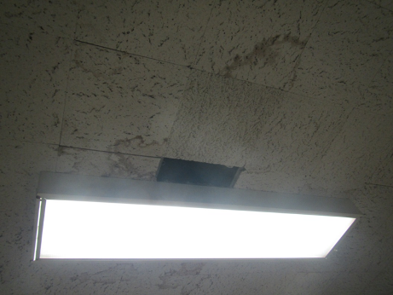
Water-damaged and missing ceiling tiles
Picture 9
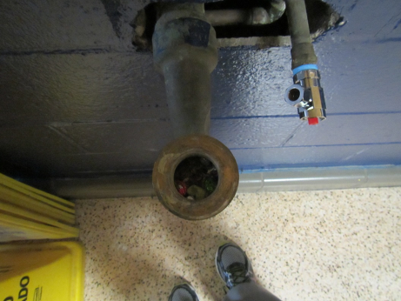
Capped water service line (arrow) and drain, note debris in drain and hole in wall
Picture 10
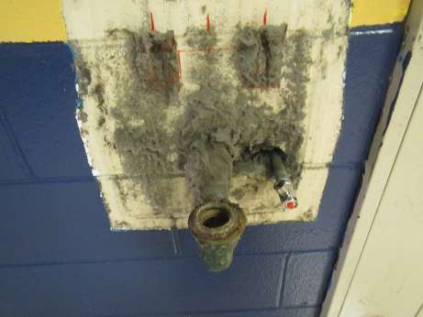
Holes remaining in wall where water fixture was removed, note dust
Location | Ventilation |  | Remarks
 | Supply | Exhaust
04 | Y UV  Off | Y | Old style cut to fit filter  Kitchen, plant, UF, 6 MT, several WD CTs
05 Special Ed | Y |  | Old style cut to fit filter  Open CT area, bowed CTs, sink, mastic up on floor
06A Special Ed | Y | Y | Old style cut to fit filter  WD CT reported new, possible mold on CT, CP under sink, holes to subfloor, fridge, microwave
07 | Y | Y | DEM, PF, 2 bowed CTs
08 (Music) | Y UV Off | Y | WD CT, AP, items
015 | Y | Y | DO
102 | Y UV Off | Y | Cut to fit filter - very dusty; debris/crayons in UV
103 | 1 UV on | Y | Old style cut to fit filter
104 | Y | Y | MT/ATs
105 | Y  On | Y | Pipes next to UV with pipe wrap, holes into floor
106 | Y | Y | Cut to fit filter dusty
107 | Y | Y | UV off
107 | Y | Y | UV off, DEM, AI
108 | N | Y | Fan in window, DO
109 | Y | Y | Old style cut to fit filters in both, debris in cabinets (especially upper part)
111 | Y | Y
111 | Y | Y
112 | Y | Y | UV off, Cut to fit filter – very dusty; dust in UV cabinet
113 | Y | Y | PF on, UV ajar, DEM, opening in ceiling/MT
114 | Y | Y | Old style cut to fit filter  Dusty; dust in UV cabinet
115 | Y | Y | Old style cut to fit filter  Area rug
116 Computer (Front) | Y | Y | UV off, MT, computers, chalk board  Could not access UV interior
116 Computer (Rear) | Y | Y | Old style cut to fit filter  Computers, DEM, AC unit (off)
121 | Y | Y | 1 MT, laminator, plants, DO
201 | Y | Y | Dusty PF, debris in UV
202 | N | Y | DEM
203 | Y | Y | UV off, Cut to fit filter; debris in UV supply
204 | Y | Y | Wall-mounted supply on exhaust off
205 | Y | Y | DEM, plants
206 (speech) | Y | Y | Wall-mounted supply and exhaust on, dusty PF, storage items
207 | Y | Y | Both UVs on; DEM, debris in UV cabinets
208 | Y | Y | MTs, clutter
209 | Y | Y | Debris in UV cabinet; UV front panel not secure
210 | Y | Y | UV top with holes not standard, clean disposable filter, rag/bucket in UV cabinet. MT near projector
211 | Y | Y | UV off, top with holes not standard, new disposable filter, interior is clean
212 | Y | Y | UV top with holes (not standard), clean disposable filter, interior clean
213 | Y | Y | UV on, top with holes (not standard), clean disposable filter, interior clean
214 | Y | Y | Wall-mounted supply and exhaust on
215 | Y | Y
216 | Y | Y | AT
217 | Y | Y | DEM  UV off
218 | Y | Y | UV off, cabinet ajar, old-style cut to fit filter, top with holes (not standard). UV pipes hissing
219 | Y | Y
220 | Y | Y | Exhaust off, Sink caulking improved, but gap remains
221A (small) | Y | Y | UV off
221B (large) | Y | Y | UV off, Fiberglass insulation in UV cabinet
227 Physical Therapy | Y | Y | New CT, some ajar
2nd floor “B” | Y | N | UV off, taped shut, disposable filter needs changing
S-5 | N | N | 2 missing tiles
1st floor ladies | N | Y | CP/AD, dust on exhaust vent, weakly drawing exhaust vent
Advisor/counselor | Y | Y | 1 MT
Art room supply area | N | Y
Assistant principal | Y | N | WAC  UV off
Boys Bathroom off cafeteria | N | Y | MT, WD-CT, weak drawing exhaust vent
C | N | N | Breaches in CT system
Cafeteria | Y | Y
D (sped) | N | N | PC, Printer, MT
Gym | Y | Y
Kiln Room | N | Y | Switch exhaust operates, no hood
Kitchen | Y | Y | Kitchen hood repaired  Clothes washer and dryer  2 WD CT, broken CT
Library | Y | Y | 1 MT
Main Office | N` | N | WAC on (window closed when turned on)
Music Storage Area | N | Y
Office Kitchenette | N | Y
Principal’s Office | Y | Y | WAC
Special Education | N | Y
Staff Restroom | N | N | Exhaust off
Theater | Y | Y | Supply and exhaust off
Theater back room | Y | Y o | UV off 4 MT
Therapy | Y | Y
2nd Floor C Special ed Office | N | N | WAC

Actions on MDPH Recommendations at
Winthrop Middle School, Winthrop, MA

The following is a status report of action(s) taken on MDPH recommendations (specific short-term recommendations only) made in the August 6, 2014 MDPH report (in bold) based on reports from school officials, maintenance staff, documents, photographs and MDPH staff observations taken during the August 27, 2014 reassessment.
Short-Term Recommendations
- Operate all ventilation systems throughout the building including univents and interior classroom HVAC systems continuously during periods of occupancy to maximize air exchange, particularly given the high levels of carbon dioxide documented in numerous areas of the school.
- Action: Most of the univents were found operating/on at the time. Those that were not, appeared to be operational. It was also reported that function of the univents will be explained to staff in a welcome to school letter and frequently reiterated, in order to prevent blockage of airflow with items on top or in front.
- Consult with an HVAC engineering firm regarding the feasibility of repair vs. replacement of ventilation system components given their age. In the interim, work with an HVAC engineering firm to adjust/repair univents and exhaust vents to improve air exchange in classrooms. This should include replacement of the makeshift air diffusers with standard ones.
- Action: Makeshift air diffusers were still found on many univents.
- Remove all blockages/items from the surface of univent air diffusers and return vents (along front/bottom) to ensure adequate airflow.
- Action: Univents were found free of blockages by items and furniture.
- Remove all blockages from exhaust vents.
- Action: Most exhaust vents that were examined were free of blockages.
- Consult with a ventilation contractor to evaluate and repair the kitchen exhaust hood.
- Action: The kitchen exhaust hood was fully operational.
- Consider replacing metal filter racks with proper fitting disposable filters with an equal or greater dust-spot efficiency to eliminate the time needed to replace filters from bulk material rolls. Prior to any increase of filtration, each piece of air handling equipment should be evaluated by a ventilation engineer as to whether it can maintain function with more efficient filters. The time saved through this measure may allow an increased frequency of filter changes; changing filters 2-4 times a year is recommended.
- Action: Most standard-sized univents were found to have disposable filters installed.
- Consider adopting a balancing schedule of every 5 years for all mechanical ventilation systems, as recommended by ventilation industrial standards (SMACNA, 1994).
- Action: It is unknown if the systems have been balanced.
- Use openable windows to supplement fresh air in the classrooms during occupancy. If thermal comfort is a concern, consider opening windows between classes and during unoccupied periods. Care should be taken to ensure windows are closed at the day’s end.
- Action: As school was not in session on the day of the visit, windows in most classrooms were closed.
- Determine whether interlocking ceiling tiles contain asbestos. If so, remediate damaged tiles in conformance with Massachusetts asbestos remediation and hazardous waste disposal laws.
- Action: It was not determined if this had been conducted.
- Make repairs to the heating system piping to prevent leaks. Replace stained and missing ceiling tiles and ensure that the ceiling plenum is complete/intact to prevent migration of particulates from above the ceiling tile system into occupied areas.
- Action: Many water-damaged ceiling tiles had been replaced. Some tiles were found missing, but were reportedly to be replaced following upgrades to the electrical systems in the building.
- Remove coving from the base of walls on the second floor to allow for drying of water infiltrating through bricks until the exterior of the building can be repaired.
- Action: It could not be determined if this had been conducted.
- Remove the washer and dryer from the kitchen area.
- Action: The washer and dryer had not been removed at the time of the visit, but it was reported that removal of these appliances would occur before school opened.
- Seal holes/breaches where pipes from univents and sinks penetrate into the crawlspace or wall cavity with appropriate fire-rated sealant to prevent movement of odors/particles from wall cavities and subfloor areas.
- Action: Many of these areas had been sealed at the time of the visit.
- Repair broken/unused plumbing fixtures or decommission them completely.
- Action: Many of the broken plumbing fixtures, including hallway water fountains, had been removed and most appeared to have been properly capped. Some additional work to seal wall cavities and some drains was needed at the time of the visit.
- Remove birds nesting in broken windows and repair/replace to prevent reoccurrence.
- Action: Birds had been removed and the area cleaned/sealed.
- Encapsulate exposed fiberglass insulation around univent pipes in classrooms.
- Action: Exposed fiberglass insulation was still observed in some areas.

