**INDOOR AIR QUALITY ASSESSMENT**

**Woburn District Court**

**30 Pleasant Street**

**Woburn, MA**

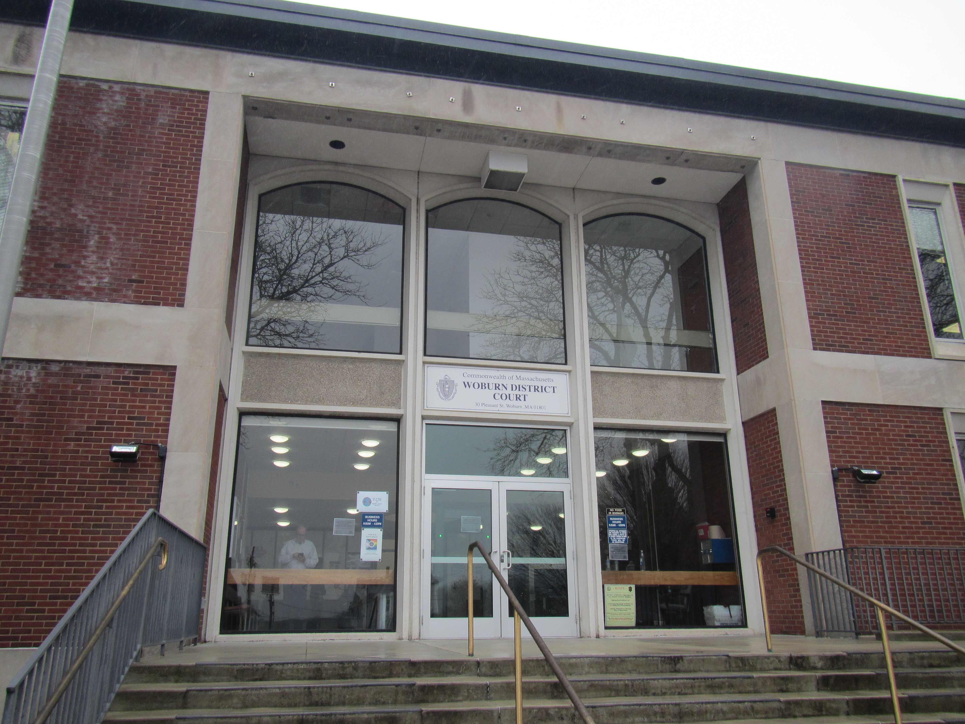

Prepared by:

Massachusetts Department of Public Health

Bureau of Environmental Health

Indoor Air Quality Program

February 2023

# BACKGROUND

|  |  |
| --- | --- |
| Building: | Woburn District Court (WDC) |
| Address: | 30 Pleasant Street, Woburn |
| Assessment Requested By: | Mike Lane, Office of the Trial Court |
| Reason for Request: | General indoor air quality (IAQ) concerns |
| Date of Assessment: | January 5, 2023 |
| Massachusetts Department of Public Health/Bureau of Environmental Health (MDPH/BEH) Staff Conducting Assessment: | Michael Feeney, Director, and Ruth  Alfasso, Environmental  Engineer/Inspector, IAQ Program |
| Building Description: | The WDC occupies a three-story brick building built in 1965. The building has a flat roof. |
| Windows: | Some windows are openable |

# METHODS

Please refer to the IAQ Manual for methods, sampling procedures, and interpretation of results (MDPH, 2015).

# RESULTS AND DISCUSSION

The following is a summary of indoor air testing results (Table 1).

* ***Carbon dioxide levels*** were below or close to 800 parts per million (ppm) in most areas assessed. Note that some areas were lightly occupied or unoccupied at the time of the assessment, carbon dioxide levels would be expected to be higher with higher occupancy.
* ***Temperature*** was within the recommended range of 70°F to 78°F in most areas assessed.
* ***Relative humidity*** was slightly below the recommended range of 40% to 60% in most areas assessed.
* ***Carbon monoxide*** levels were non-detectable (ND) in all areas assessed.
* ***Fine particulate matter (PM2.5)*** concentrations measured were below the National Ambient Air Quality Standard (NAAQS) level of 35 μg/m3 in all areas assessed

## Ventilation

A heating, ventilating, and air conditioning (HVAC) system has several functions. First it provides heating and, if equipped, cooling. Second, it is a source of fresh air. Finally, an HVAC system will dilute and remove normally occurring indoor environmental pollutants by not only introducing fresh air, but by filtering the airstream, and ejecting stale air to the outdoors via exhaust ventilation. Even if an HVAC system is operating as designed, point sources of respiratory irritation may exist and cause symptoms in sensitive individuals. The following analysis examines and identifies components of the HVAC system and likely sources of respiratory irritant/allergen exposure due to water damage, aerosolized dust, and/or chemicals found in the indoor environment.

The WDC has air handling units located in a mechanical penthouse. These units draw air in from outside, filter it, heat/cool it, and distribute it to rooms in the building. Supply air is introduced into rooms through ceiling-mounted or wall-mounted fresh air vents (Picture 1). Return vents remove stale air back to the AHU (Picture 2). Exhaust vents that remove air directly outside are located in restrooms throughout the building. Exhaust airflow was detected from vents that were accessible.

Each AHU should be equipped with appropriate filters that match the function, design, and capacity of the ventilation system equipment. Filters used in the AHUs were upgraded in 2020 to have a minimum efficiency reporting value rating (MERV rating) of 13, which is considered excellent for removing pollen, mold, dust, and microbes. Filters should be changed on a regular schedule, at least twice a year and more often if needed; maintenance staff report that filters are changed about every two months. During filter changes, AHU cabinets should be cleaned as well.

Additional fresh air is available through openable windows in many areas although occupants are discouraged from using them. Windows should only be used for fresh air during temperate weather and kept closed during hot and humid or wet weather to avoid introducing water and water vapor into the building. Windows should not be opened when air conditioning is operating in the room, as this may lead to condensation on chilled surfaces. Windows should be tightly closed when not in use to prevent the infiltration of outside air and pests. Additional heating is provided by hot-water radiant ceiling panels (Picture 2) and radiators around the building perimeter.

To maximize air exchange, the MDPH recommends that both supply and exhaust ventilation operate continuously during periods of occupancy. To have proper ventilation with a mechanical supply and exhaust system, the systems must be balanced to provide an adequate amount of fresh air to the interior of a room while removing stale air from the room. It is recommended that HVAC systems be re-balanced every five years to ensure adequate air systems function (SMACNA, 2013). These systems were last balanced in 2021.

## Microbial/Moisture Concerns

Water-damaged ceiling tiles and other signs of water intrusion were observed in various areas around the building (Pictures 3 and 4; Table 1). Water-damaged ceiling tiles indicate leaks from plumbing/HVAC or the building envelope. Leaks should be repaired when they are found, and water-damaged materials such as ceiling tiles repaired or replaced. Water-damaged ceiling tiles can become a source of mold or odors if moistened chronically or repeatedly. No dark staining indicating mold, or moldy odors, were noted during the assessment.

In general, it is recommended that porous material be dried with fans and heating within 24 to 48 hours of becoming wet (US EPA, 2008, ACGIH, 1989). If porous materials are not dried within this time frame, mold growth may occur. Water-damaged porous materials cannot be adequately cleaned to remove mold growth.

Water coolers and small refrigerators were located on carpet (Table 1; Picture 5) which can be moistened by spills. Plants were noted in a few offices (Table 1). Plants can be a source of pollen, mold, and odors, particularly if not well maintained. Plants should be kept in good condition, not overwatered, and placed on waterproof drip pans that are periodically cleaned.

Several water fountains were found covered in plastic (Picture 6). Facility staff report that all water fountains had been covered/closed in 2020 due to concerns about disease transmission, and that some remain closed due to needing service. When water fountains or other plumbing fixtures are not used for a long period of time, the drains can dry out which removes the drain trap seal. This can allow sewer gases into occupied areas. Unused drains should be either wetted periodically or sealed.

The exterior doors in the rear of the building had light visible beneath and between the doors (Picture 7). These gaps can allow moisture and pests into the building. Weatherstripping should be installed or replaced to render exterior doors tighter.

### Building Materials That May Be Prone to Condensation

It is important to note that Massachusetts experienced extended periods of relative humidity during the summer of 2021. July of 2021 was the wettest ever recorded in Massachusetts, and the three-month period from June through August 2021 (meteorological summer), was the fourth wettest on record, according to the National Oceanic and Atmospheric Administration’s Centers for Environmental Information. The three-month period also was the third warmest ever in the state and was tied for the warmest on record across the United States. (HG, 2021, NOAA, 2021). These conditions are challenging for buildings, particularly those without air conditioning.

The key to managing condensation in hot, humid weather indoors is understanding dew point. When warm, moist air passes over a cooler surface, condensation can form. Condensation is the collection of moisture on a surface at or below the dew point. The dew point is the temperature that air must reach for saturation to occur. If a building material/component has a temperature below the dew point, condensation will accumulate on that material and may lead to water damage.

A method to locate areas in a building prone to condensation is to measure air and building material temperatures using a laser thermometer (Table 2). If a wide temperature range exists between measurements (>5°F), the building materials at the colder end of the range may be prone to becoming moistened with condensation if exposed to hot, humid weather for extended periods of time. According to the test results in Table 2, floors on the lowest level of the building were warmer than the surrounding air, which indicates heating components likely exist in the exterior walls/floors and/or ceiling. Based on these observations, it could not be determined if the basement floor may be prone to condensation under high-humidity conditions (during extended periods of hot, humid weather during summer months). Measuring of floor temperatures during a time when the heating system is not on would be advised, particularly during a time when the HVAC system is in chilling mode.

To prevent microbial growth and odors, floors that may be subject to condensation should not be carpeted. If relative humidity indoors is >70 %, that is a sufficient concentration that can cause building materials to become moistened (ASHRAE, 1989).

Note that some rooms on the basement level had bowed ceiling tiles (Picture 8; Table 1). As ceiling tiles become moistened by high relative humidity, ceiling tiles can start to sag (bow) while sitting in the suspended ceiling rails. One source of water vapor that can increase indoor relative is extended periods of hot, humid weather with heavy rains, as occurred during the summer of 2021.

## Other Concerns

Exposure to low levels of total volatile organic compounds (TVOCs) may produce eye, nose, throat, and/or respiratory irritation in some sensitive individuals. BEH/IAQ staff noted hand sanitizers, cleaners, and air fresheners in the office space (Table 1). All of these products have the potential to be irritants to the eyes, nose, throat, and respiratory system of sensitive individuals.

Several kinds of stand-alone air purifiers were found in the WDC. Air purifiers using high-efficiency particulate arrestance (HEPA) filter technology are a good choice for removing fine particulates, including viruses. Filters need to be changed in accordance with manufacturer’s instructions. Some of the units examined use additional technologies that may produce ozone, which is a respiratory irritant, or other reactive chemicals such as hydrogen peroxide. The BEH IAQ Program does not recommend these for use in occupied areas.

Some areas of carpeting in the WDC is older and in poor condition. Carpeting should be vacuumed regularly with a high efficiency particulate arrestance (HEPA) filter equipped vacuum cleaner to avoid particulates from causing further irritation or serving as a reservoir for microbial colonization. Also, carpeting and rugs should be deep cleaned at least once per year according to IICRC recommendations (IICRC 2012). Carpeting has an expected service life of 10 years. Once the service life of carpet is exceeded, fiber from carpet can become more readily loosed and possible aerosolized.

Food and food preparation equipment was found in several places in the building (Table 1). Cooking equipment, such as toasters, refrigerators, and microwaves should be kept clean to prevent odors, microbial growth, smoke, and pests. Food should be stored in pest-proof containers and any food debris should be cleaned promptly.

Facility staff reported concerns about radon. Radon is a radioactive gas that comes from the natural decay of uranium and radium found in nearly all rocks and soils. Radon moves up from the ground and into buildings through the openings that exist in floors or walls. Because radon comes from rocks and soils, it typically collects in rooms that are in contact with the ground, like basements. The EPA and the Surgeon General recommend testing all homes and schools for radon. Any building in contact with the ground can also have radon, and testing of offices and other buildings is encouraged.

Testing for radon in a large building should be conducted by a certified measurement specialist through either the National Radon Safety Board ([www.nrsb.org](http://www.nrsb.org)) or the National Radon Proficiency Program (<https://nrpp.info>). Measurement of radon in buildings should be conducted in accordance with standards developed by the American Association of Radon Scientists and Technologists (<https://standards.aarst.org/>). Additional information on radon can be found on the DPH radon website at <https://www.mass.gov/radon>.

# CONCLUSIONS AND RECOMMEDATIONS

The WDC building is occupied on all floors including the lowest level of the building which was designed for various court offices. Based on the observations made during this assessment, the IAQ program makes the following recommendations:

## Ventilation Recommendations

1. Ensure ventilation is on and operating during occupied periods.
2. Change filters in AHU equipment regularly in accordance with manufacturer’s instructions. Continue to use high-quality filters with a Minimum Efficiency Rating Value (MERV) rating of 13 in equipment that can operate with them.

## Water Damage Recommendations

1. Replace water-damaged ceiling tiles once the source of the leak is identified and repaired.
2. Consider using waterproof mats in areas where refrigerators and water dispensers are used or move this equipment to areas without carpeting.
3. Ensure plants in offices are well maintained, and not overwatered. Place plants on waterproof drip pans that are cleaned regularly.
4. Consider removing carpeting from below-grade spaces and replace with water resistant flooring.
5. Avoid storage of porous materials on floors in below-grade areas.
6. Repair or replace weatherstripping on exterior doors to render them as airtight as possible.
7. Repair broken water fountains. Ensure drains in unused or seldom-used fixtures are wetted periodically to maintain the drain trap.
8. Floor and wall surface temperature measurements on the lower level should be conducted during the cooling season. If requested, the IAQ Program would conduct such testing during that timeframe.

## Other Recommendations

1. Keep food storage and preparation equipment clean. Only store food in sealed pest-proof containers.
2. Clean all carpeting in accordance with IICRC recommendations (IICRC, 2012). This includes daily vacuuming with a HEPA-equipped vacuum cleaner, and annual or semi-annual deep cleaning.
3. Consider replacing older, worn carpeting.
4. If the building is to be tested to radon, testing should be conducted by a certified measurement specialist. See [www.nrsb.org](http://www.nrsb.org) or <https://nrpp.info> to find certified measurement professionals. Measurement of radon in buildings should be conducted in accordance with standards developed by the American Association of Radon Scientists and Technologists (https://standards.aarst.org/). Consult <https://www.mass.gov/radon> for more information.
5. Refer to resource manual and other related IAQ documents located on the MDPH’s website for further building-wide evaluations and advice on maintaining public buildings. These documents are available at: <http://mass.gov/dph/iaq>.

# REFERENCES

ACGIH. 1989. Guidelines for the Assessment of Bioaerosols in the Indoor Environment. American Conference of Governmental Industrial Hygienists, Cincinnati, OH.

HG. 2021. Mold keeps South Hadley High School shuttered. Hampshire Gazette. <https://www.gazettenet.com/South-Hadley-High-School-still-closed-amid-mold-remediation-42413519>.

IICRC. 2012. Institute of Inspection, Cleaning and Restoration Certification. Carpet Cleaning: FAQ.

MDPH. 2015. Massachusetts Department of Public Health. Indoor Air Quality Manual: Chapters I-III. Available at: <https://www.mass.gov/lists/indoor-air-quality-manual-and-appendices>.

NOAA. 2021. Summer 2021 neck and neck with Dust Bowl summer for hottest on record. National Oceanic and Atmospheric Administration, 1401 Constitution Avenue NW, Room 5128, Washington, DC 20230 <https://www.noaa.gov/news/summer-2021-neck-and-neck-with-dust-bowl-summer-for-hottest-on-record>

SMACNA. 2013. HVAC Systems Commissioning Manual. 2nd ed. Sheet Metal and Air Conditioning Contractors’ National Association, Inc., Chantilly, VA.

US EPA. 2008. “Mold Remediation in Schools and Commercial Buildings”. Office of Air and Radiation, Indoor Environments Division, Washington, DC. EPA 402-K-01-001. September 2008. Available at: <http://www.epa.gov/mold/mold-remediation-schools-and-commercial-buildings-guide>.

**Picture 1**

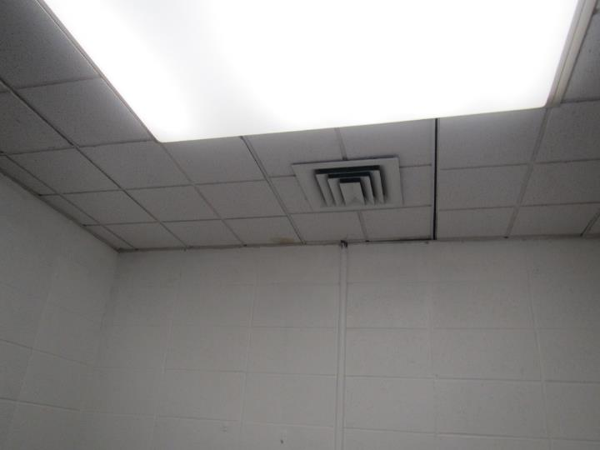

**One style of ceiling-mounted supply vent**

**Picture 2**

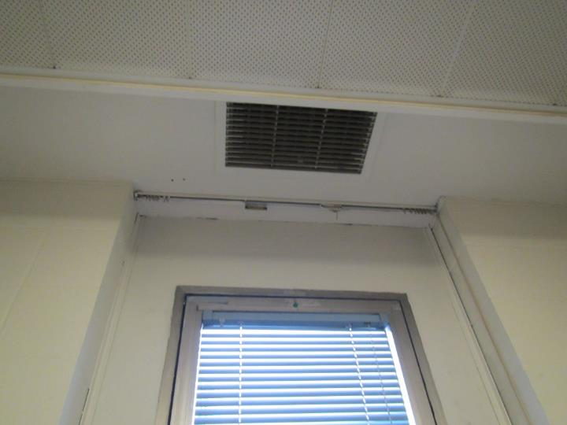

**Ceiling-mounted return vent, also note textured ceiling with radiant heat**

**Picture 3**

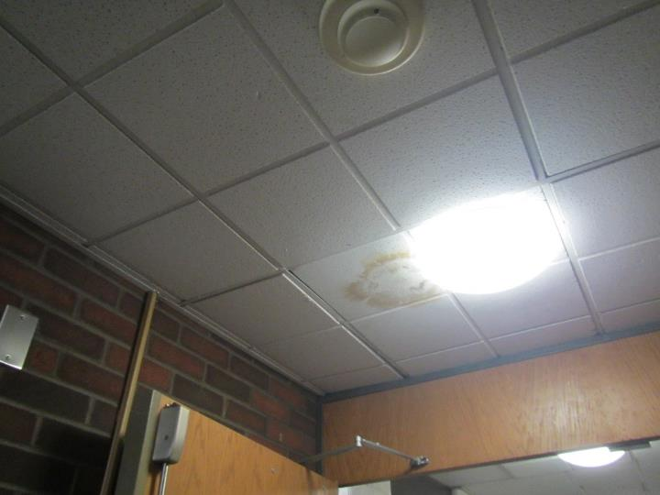

**Water-damaged ceiling tile**

**Picture 4**

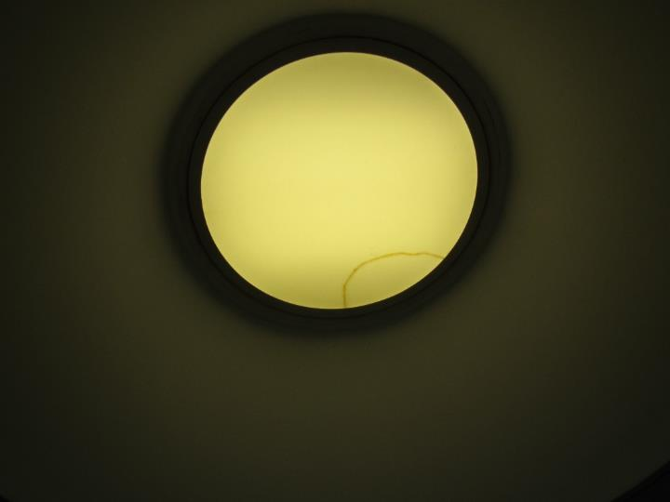

**Water stain in light fixture**

**Picture 5**

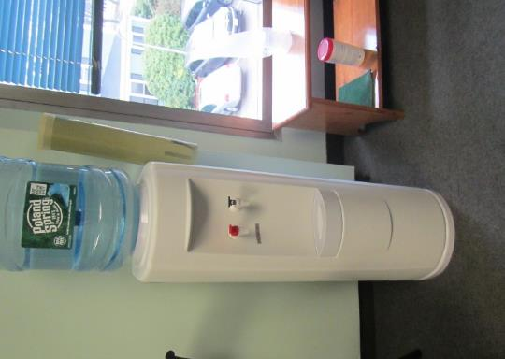

**Water cooler on carpet**

**Picture 6**

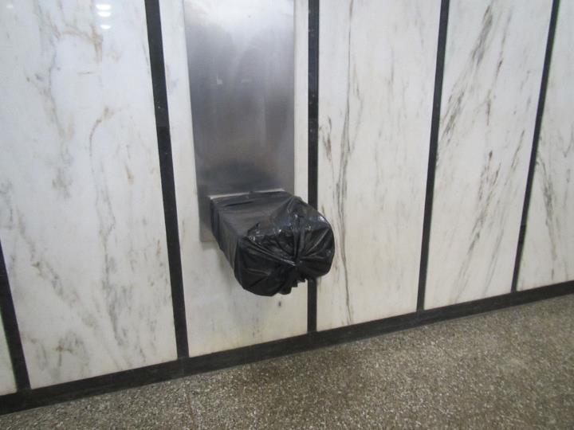

**Water fountain covered in plastic**

**Picture 7**

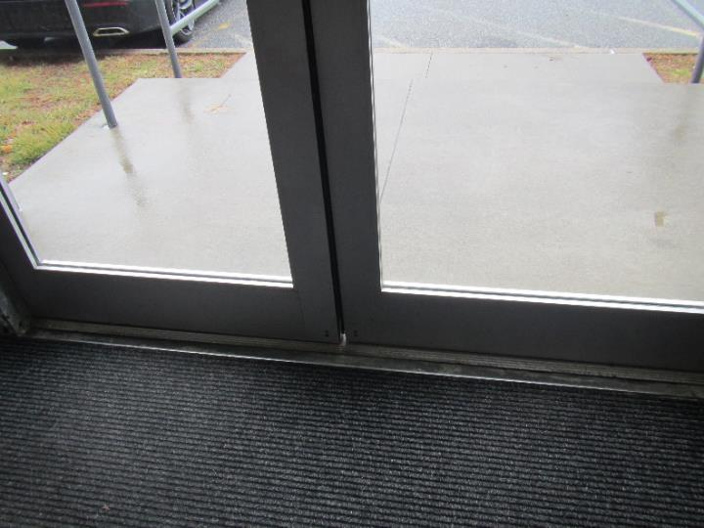

**Exterior door with gap underneath and between doors**

**Picture 8**

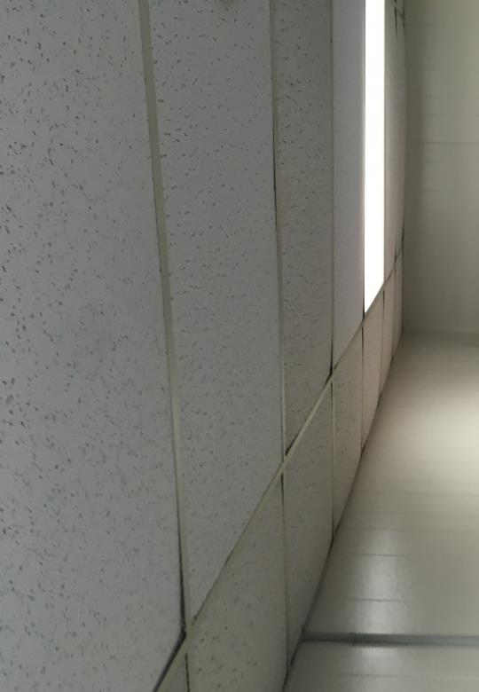

**Bowing Ceiling Tiles**

| **Location** | **Carbon**  **Dioxide**  **(ppm)** | **Carbon Monoxide**  **(ppm)** | **Temp**  **(°F)** | **Relative**  **Humidity**  **(%)** | **PM2.5**  **(µg/m3)** | **Occupants**  **in Room** | **Windows**  **Openable** | **Ventilation** | | **Remarks** |
| --- | --- | --- | --- | --- | --- | --- | --- | --- | --- | --- |
| **Supply** | **Exhaust** |
| Background |  |  | 52 | 36 |  |  |  |  |  | Light rain and mist |
| Second Floor | | | | | | | | | | |
| 205 | 690 | ND | 74 | 35 | ND | 0 | Y | Y | Y |  |
| 201 | 674 | ND | 73 | 36 | ND | 1 | Y | Y | Y |  |
| 208 | 653 | ND | 73 | 35 | ND | 0 | Y | Y | Y |  |
| 218 | 796 | ND | 72 | 38 | ND | 0 | Y | Y | Y | Jury deliberation room, DEM, AP, 2 restrooms attached |
| 222 | 646 | ND | 73 | 36 | ND | 0 | Y |  | Y | Carpeted, plush couch, coffee maker |
| 220 | 715 | ND | 73 | 37 | ND | 0 | Y | Y | Y | Carpet, fridge and microwave |
| 219 | 708 | ND | 74 | 37 | ND | 0 | N | Y | Y | Carpet, 1 WD CT |
| Hearing room | 755 | ND | 76 | 35 | ND | 0 | N | Y | Y | AP, carpet |
| Judge’s Lobby | 756 | ND | 75 | 35 | ND | 0 | Y | Y | Y | Carpet, water cooler, leather furniture |
| First Floor | | | | | | | | | | |
| 120 | 835 | ND | 74 | 37 | ND | 0 | Y | Y | Y | Carpet, microwave |
| 122 | 762 | ND | 74 | 37 | ND | 0 | Y | Y | Y | Carpet |
| Clerk lobby | 805 | ND | 74 | 37 | ND | 1 | Y | Y | Y | Carpet, PC, fridge and microwave |
| Research vault | 877 | ND | 74 | 37 | ND | 1 | N | N | N |  |
| Men’s restroom |  |  |  |  |  |  | N | Y | Y | WD CT, CP, AF |
| Women’s restroom |  |  |  |  |  |  | N | Y | Y | AT, CP, AF, candles |
| Clerks | 880 | ND | 73 | 38 | ND | 4 | N | Y | Y | WD CT, water cooler on carpet, PF |
| 150 | 805 | ND | 73 | 38 | ND | 0 | Y | Y | Y |  |
| Clerk waiting area | 790 | ND | 74 | 38 | ND | 0 | N | Y | Y | Mismatched CT |
| Front lobby | 808 | ND | 73 | 37 | ND | 3+ | N (door) | Y | Y | WD in light fixture cover |
| 105 Judge’s lobby | 811 | ND | 73 | 39 | ND | 1 | Y | Y | Y | Water cooler on carpet |
| 101 Judge’s office | 801 | ND | 73 | 38 | ND | 0 | Y | Y | Y | Food, leather furniture, carpet, and area rug |
| 105 | 765 | ND | 73 | 38 | ND | 1 | Y | Y | Y |  |
| 101 | 754 | ND | 73 | 37 | ND | 0 | Y | Y | Y |  |
| 108 | 790 | ND | 73 | 38 | ND | 0 | Y | Y | Y | Toaster with crumbs |
| 107 | 812 | ND | 75 | 37 | ND | 0 | Y | Y | Y | Plants |
| 109 | 796 | ND | 73 | 37 | ND | 0 | Y | Y | Y |  |
| Probation cube | 892 | ND | 74 | 38 | ND | 6 | Y | Y | Y |  |
| 111 | 823 | ND | 74 | 37 | ND | 2 | Y | Y | Y |  |
| Session 1 | 1730 | ND | 66 | 59 | ND | 15 | N | Y | Y |  |
| Basement level | | | | | | | | | | |
| 005 | 753 | ND | 72 | 38 | ND | 0 | Y | Y | Y | Bowed CT, 1 WD CT |
| 018A | 763 | ND | 73 | 39 | ND | 0 | N | Y | Y | AP, coffee, microwave, fridge, food |
| 018B | 768 | ND | 73 | 37 | ND | 0 | N | Y | Y | Food, worn carpet, AT, PC, fridge, microwave |
| 018D | 747 | ND | 72 | 38 | ND | 2 | N | Y | Y | Bowed CT |
| 025 | 757 | ND | 73 | 37 | ND | 2 | Y | Y | Y | PC, water cooler on carpet, WD CT |
| Civil and small claims | 755 | ND | 72 | 38 | ND | 2 | Y | Y | Y | Worn carpet, food, WD CT, PC |
| Furnace | 551 | ND | 71 | 37 | ND | 0 | N | Y | Y |  |
| Lockup |  | ND | 72 | 39 | ND | 2 | N | Y | Y | Ceiling grills (2) |
| Maintenance office | 1074 | ND | 70 | 45 | ND | 7 | N | Y | Y | Not carpeted, utility sink, fridge, microwave |

| **Location** | **Air Temp**  **(°F)** | **Relative Humidity**  **(%)** | **Dew Point**  **(°F)** | **Floor Temp**  **(°F)** | **Temp at Floor/ Exterior Wall Junction**  **(°F)** | **Window/Window frame**  **(°F)** | **Water-Damaged**  **Bowed Ceiling Tile** | **Ventilation** | | | **Floor to Air Temp**  **Difference**  **(°F)** |
| --- | --- | --- | --- | --- | --- | --- | --- | --- | --- | --- | --- |
| **Windows openable** | **Supply** | **Exhaust** |
| Background (outdoors) | 52 | 53 | 35 |  |  |  |  |  |  |  |  |
| 005 | 72 | 38 | 45 | 77 | 77 |  |  | Y |  |  | -5 |
| 018 |  |  |  | 80 |  |  |  | N |  |  |  |
| 018A | 73 | 39 | 46 | 84 |  |  |  | N |  |  | -11 |
| 018B | 73 | 37 | 45 | 83 |  |  |  | N |  |  | -10 |
| 018C |  |  |  | 80 |  |  |  |  |  |  |  |
| 020 |  |  |  | 78 | 81 | 70 |  |  |  |  |  |
| 023 |  |  |  | 84 | 82 | 74 |  |  |  |  |  |
| 025 | 73 | 37 | 45 | 79 | 80 | 67 |  | Y |  |  | -6 |
| Hallway |  |  |  | 80 |  |  |  |  |  |  |  |
| Stairwell |  |  |  | 74 |  |  |  |  |  |  |  |
| Vault |  |  |  | 76 | 70 |  |  |  |  |  |  |