INDOOR AIR QUALITY ASSESSMENT

**Woburn Street School**

**227 Woburn Street, Wilmington**

**March 2025**

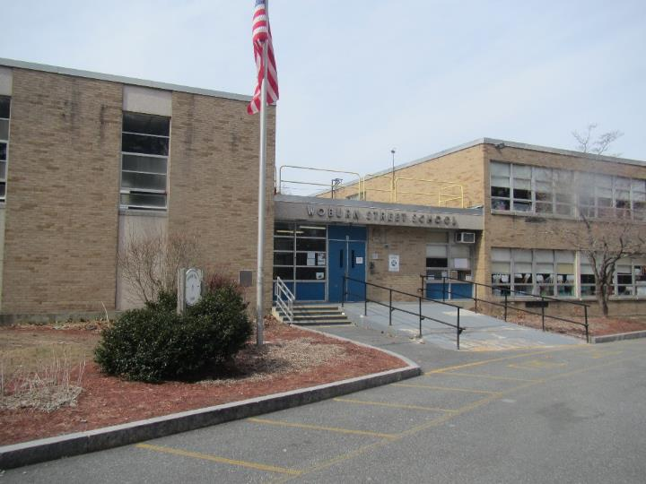

Prepared by:

Massachusetts Department of Public Health

Bureau of Climate and Environmental Health

Division of Environmental Health Regulations and Standards

# CONTENTS

EXECUTIVE SUMMARY 3

BACKGROUND 4

RESULTS AND DISCUSSION 5

Ventilation 6

HVAC System Maintenance 7

HVAC Types and Specific Conditions 8

Water Damage and Moisture Concerns 8

Sources of Respiratory Irritants/Possible Asthma Triggers 11

Other IAQ Issues 13

CONCLUSIONS AND RECOMMENDATIONS 13

Short-term Recommendations 13

Long-term Recommendations 18

REFERENCES 19

FIGURES 21

PICTURES 22

Ventilation Pictures 22

Water Damage Pictures 29

External Damage Pictures 34

Respiratory Irritants Pictures 36

Table 1 39

Table 2A 45

Table 2B 46

Table 2C 47

Table 3 48

Table 4 50

# EXECUTIVE SUMMARY

The Massachusetts Department of Public Health’s (MDPH) Division of Environmental Health Regulations and Standards (EHRS) conducted an Indoor Air Quality (IAQ) assessment of Woburn Street Elementary School located at 227 Woburn St, Wilmington on March 13, 2025. This assessment was requested by the Wilmington Health Department.

Any building can have IAQ issues. These issues can worsen through conditions common to marginalized communities (Environmental Justice communities or EJ) such as inequitable exposure to outdoor air pollution and a greater likelihood of poor building conditions leading to deterioration of IAQ, resulting in higher asthma rates. Woburn Street School is not within an EJ community (<https://matracking.ehs.state.ma.us/Environmental-Data/ej-vulnerable-health/environmental-justice.html>). Note that the pediatric asthma rate for Wilmington as of 2024 is 7.7%. This rate is statistically significantly lower than the statewide pediatric asthma prevalence rate and is lower than the statewide rate of 9.6% (MAEPHT, 2024).

The assessment was conducted by evaluating several key elements within the school: a visual inspection of the heating, cooling, and ventilation (HVAC) systems, water/microbial damage, cleanliness, point sources of respiratory irritants such as chemicals, and electronic measurement of carbon dioxide (CO2), carbon monoxide (CO), temperature, relative humidity (RH), and fine particulate matter (PM2.5), all taken with a Trak XP monitor. Data collected in this manner identifies potential asthma triggers, allergens, and other environmental factors that can cause IAQ symptoms. Please refer to the [Indoor Air Quality Manual](https://www.mass.gov/lists/indoor-air-quality-manual-and-appendices#indoor-air-quality-manual-) on the MDPH website for methods, sampling procedures, and interpretation of results.

Additionally, the school has annual Indoor Air Quality assessments throughout their school district. They made a considerable change to improve IAQ by addressing multiple roof leaks, asbestos abatement whenever possible and address pest management concerns. Signs of mold on building materials inside the building were present, and few areas had water-damaged ceiling tiles from current or historic roof or plumbing leaks. Many of the materials used in construction of schools of this age, such as concrete, hard wood, floor tile, and brick, are resistant to mold growth. (Results and Discussion)

As a result of this assessment, a number of primary recommendations are made to optimize existing systems and improve air exchange. (Conclusions and Recommendations)

* Have a building envelope specialist determine if the wall/façade shown in Picture 28 is in danger of collapse and recommend repairs.
* Have the supply and exhaust system on and operational during occupied hours in all rooms.
* Continue with plans to repair the roof. Until roof repairs are completed, take steps to minimize water-damaged materials in the building.

As climate change and global warming intensifies, the urgent need for modern, energy-efficient solutions becomes clear, without significant repair of the building envelope and repair/upgrade of interior HVAC components, building conditions and indoor air quality will continue to degrade.

Please note: this report contains a series of recommendations that should serve as Best Practices that apply to most public-school buildings across the Commonwealth and should be shared amongst other buildings in the school district. (Conclusions and Recommendations)

# BACKGROUND

|  |  |
| --- | --- |
| Building: | Woburn Street Elementary School |
| Address: | 227 Woburn Street, Wilmington |
| Coordinated Via: | Shelly Newhouse, Director, Wilmington Health Department |
| Reason for Request: | General indoor air quality (IAQ) issues |
| Date of Assessment: | March 13, 2025 |
| Massachusetts Department of Public Health/Bureau of Climate and Environmental Health/**Division of Environmental Health Regulations and Standards** (MDPH/BCEH/EHRS) Staff Conducting Assessment: | Bharathi Patimalla-Dipali, Environmental Analyst, Division of Bureau of Environmental Health Regulations and Standards (EHRS) and Ruth Alfasso, Environmental Engineer, EHRS. |
| Building Description: | The Woburn Street Elementary school is a two-story building with a partial basement, The siding is brick, and the roof is flat and mostly asphalt. It was built in 1965 with an addition built later. Other renovations have occurred, including a new roof in the 1980s, but much of the equipment in the building is original. |
| Windows: | Windows in the building are openable. |
| **Building Population:** | Approximately 430 students and 100 staff |

# RESULTS AND DISCUSSION

The following is a summary of indoor air testing results (Table 1)

|  |  |  |
| --- | --- | --- |
| * ***Carbon dioxide (CO2)*** | *a measure of the adequacy of ventilation* | Levels were above the MDPH guideline of 800 parts per million (ppm) in less than half of areas surveyed, indicating a lack of air exchange in those areas. |
| * ***Temperature*** | *a measure of comfort* | It was mostly within the MDPH recommended range of 70°F to 78°F in occupied areas, however some levels were above that range, and occupants reported temperature control issues. |
| * ***Relative humidity*** | *a measure of comfort and, when in excess for an extended period, a way to reflect the potential for mold and fungal growth* | It was below the lower level of the MDPH recommended range of 40 to 60% in all areas tested. Low relative humidity is typical during the heating season. Relative humidity would be expected to be higher during hot, humid weather. |
| * ***Carbon monoxide***   ***(CO)*** | *a product of combustion that can result in acute and long term cardiovascular, respiratory, and neurological symptoms* | Levels were non-detect (ND) in all occupied areas tested. A level of 3 ppm was measured in the boiler room. |
| * ***Particulate matter (PM2.5)*** | *a way to measure inhalable particle distribution in the air* | Concentrations were below the National Ambient Air Quality Standard (NAAQS) of 35 micrograms per cubic meter (μg/m3) in all areas tested. |

## Ventilation

Ventilation refers to both the supply of fresh air and the removal of stale air from a room. The introduction of fresh air into an occupied space will dilute normally occurring pollutants that are generated by occupancy and other activities. In addition, an HVAC system will remove pollutants from a building if operating appropriately. All ventilation systems throughout the building should operate continuously during periods of occupancy.

Most classrooms are equipped with unit ventilators **(univent, Picture 1)**. Univents bring in fresh air from a vent on the outside of the building **(Picture 2)**, filter, heat it, and supply the air through a vent on the top. Some room air is recirculated along with the fresh air through a vent at the bottom **(Figure 1)**.

Mechanical ventilation to some central areas like the gymnasium is provided by ceiling-mounted air handling units **(AHUs, Picture 3)**. An AHU draws in air from the outside, heats it and distributes it via ducted vents near the ceiling.

Exhaust vents for most classrooms are located inside closets **(Picture 4)**. At the time of assessment, exhaust ventilation in most rooms was found to be functioning. Without proper supply and exhaust ventilation, normally occurring environmental pollutants can build up and lead to IAQ/comfort complaints. In addition, without proper exhaust ventilation, excess moisture cannot be removed from the building, which can lead to mold growth conditions over the summer.

Most classrooms had, in addition to the univent along the exterior wall, a similarly positioned radiator. Radiators only provide heat, as they have no fresh air vent and no mechanical fan. However, these should also remain unblocked by furniture or items.

Many rooms are equipped with ceiling fans **(Picture 5)** which can help control temperatures and create airflow. In addition, most classrooms had openable windows. Windows can be used to introduce fresh air when the weather outside is temperate.

Window-mounted air conditioners were found in some offices and classrooms **(Picture 6; Table 1)**. These can provide cooling but only a minimal amount of fresh air. The media center has two ductless (mini-split) air conditioners on the wall **(Picture 7)** which provide cooling and no fresh air.

Also note that some offices did not have any source of ventilation, or only a window and no mechanical ventilation **(Table 1)**. It is recommended that every room intended for occupancy have both supply and return or exhaust ventilation, or an openable window.

The various types of ventilation components as well as devices that can move/redirect airflow that were identified in the building are listed in Table 2A, Table 2B and Table 2C.

### HVAC System Maintenance

* **A univent was opened and the filter examined. A filter with a minimum efficiency rating value of 8 was installed in the unit (Picture 8).** MDPH recommends that filters of at least a Minimum Efficiency Rating Value (MERV) 8 be used as these are adequate to filter out pollen, mold, and similar particulates (ASHRAE, 2012). Older equipment may not be able to operate effectively with higher rated filters. MDPH recommends that filters be changed two to four times a year or as per the manufacturers’ recommendations. It was reported that filters are replaced four times a year.
* **Some of the univents were obstructed by items in front of return vents (Picture 9) or along the top.** To provide mechanical ventilation as designed and to prevent damage to machinery, both the supply and return vents (along the front/bottom of the unit) should be free and clear of obstructions.
* **In addition, some univents had items such as plants and pencil sharpeners on or near them.** Plant soil, pencil shavings, and plastic items can produce odors and irritating dusts when heated and distributed around a room.
* Radiators were also found obstructed, **and several were found with significant amounts of dust, debris, and items inside** **(Picture 10 and 11)**. Because radiators have no filters they may not be cleaned as often as the univents.
* **Univents and radiators of the age found in this building are considered beyond their service life.** According to the American Society of Heating, Refrigeration, and Air-Conditioning Engineering (ASHRAE), the service life of this type of unit is 15-20 years, assuming routine maintenance of the equipment (ASHRAE, 1991). Many of them showed signs of wear or damage, and some had non-standard grills or other parts on them (Picture 12).
* **Window-mounted air conditioners appeared to be of a very old style** **(Picture 6)**. The performance of air conditioners degrades over time, and older models may be less energy efficient (USEPA, undated). Air conditioners have filters that need to be cleaned periodically. In addition, the wood used to fit these into windows is, in some cases, water-damaged or otherwise showing wear.

**Balancing**

To have proper ventilation with a mechanical supply and exhaust system, a system must be balanced to provide an adequate amount of fresh air to the interior of a room while also removing stale air from the room. It is recommended that HVAC systems be re-balanced every five years to ensure adequate air systems function (SMACNA, 1994).

### HVAC Types and Specific Conditions

(see Ventilation pictures)

**Additional HVAC Conditions:**

* **Air purifiers were also found in classrooms (Picture 13; Table 2).** High-efficiency particulate arrestance (HEPA) air purifiers remove up to 99% of airborne contaminants as small as 0.1 microns including airborne mold spores. These are good choices for use in occupied areas. Air purifiers that may produce ozone should not be used (EPA, 2003). All air purifiers should be cleaned and maintained in accordance with manufacturers’ instructions. Air purifiers should be also placed away from walls and open doors to ensure proper air intake.
* **The staff lounge is equipped with what looks like a vintage household exhaust vent (Picture 14).** It could not be determined whether this item is connected to a rooftop vent or another vent. It is important that kitchens be vented outside to remove smoke and odors from cooking.

## Water Damage and Moisture Concerns

Please note that the MDPH does not recommend conducting mold testing in a typical water damage remediation. For details, please consult [Guidance Regarding Testing for Mold in Water-Damaged Public Buildings](https://www.mass.gov/info-details/guidance-regarding-testing-for-mold-in-water-damaged-public-buildings) | Mass.gov

The application of a mildewcide to moldy porous materials is not recommended.

Molds are found naturally in our environment both indoors and outdoors. Inside, mold growth may occur when items, particularly porous products such as paper or gypsum wallboard, are exposed to moisture. Typical water sources include leaks, floods, and condensation. To avoid mold growth, dry all water-damaged items and affected areas within 24-48 hours and reduce indoor humidity. Some people with chronic respiratory conditions, such as asthma, are more likely to experience health symptoms associated with molds, including allergic reactions and respiratory irritation. Controlling moisture is the key to preventing mold growth and potential health symptoms.

Hot humid summers are becoming more frequent due to climate change. Massachusetts has experienced hot, humid, and rainy summers in 2018, 2021, and 2023. July of 2021 was the wettest ever recorded in Massachusetts, and the three-month period from June through August, known as the meteorological summer, was the fourth wettest on record, according to the National Oceanic and Atmospheric Administration’s (NOAA) Centers for Environmental Information (NOAA, 2021). The summer of 2023 was also hot, and wet, being measured as the second rainiest on record (WBUR, 2023). The summer of 2024 also had significant stretches of hot, humid weather. These conditions are challenging for buildings, particularly those without central air conditioning.

During these hot and wet summers, extended periods of outdoor relative humidity above 70% occurred. Under this weather, public buildings experienced extended periods of water vapor exposure from high relative humidity. When exposed to these conditions, porous materials such as gypsum wallboard, cardboard, and other materials may become prone to developing mold colonization, particularly if located in areas that are prone to developing condensation on floors and walls (e.g., below grade space).

All rooms were assessed for the presence of either mold or visible water damage and an exterior evaluation was conducted to identify potential pathways for water penetration. The following issues were noted.

* **A roof leak diverter drainage system was installed in a classroom** (**Picture 15**). These funnel receptacles should have proper hose connections and drain to a sink or to a container that is emptied and cleaned frequently. These are a good option to reduce the impact of roof leaks on occupants before repairs can be made.
* **Water-damaged ceiling tiles were found in several locations (Picture 15 and 16; Table 1),** Water-damaged ceiling tiles can provide a source of mold and should be replaced after a water leak is discovered and repaired.
* **Light was seen penetrating around exterior doors (Picture 17).** Good door-sweeps/weatherstripping can not only exclude pests but can keep unconditioned outside air and moisture from entering the building.
* **Rooms that were originally the boys’ and girls’ locker rooms are currently used for storage. Both rooms have experienced water damage over time**. The source of water in this room probably includes unsealed windows (Picture 18) and condensation from high humidity exposure. Note that these rooms contain plumbing, including drains that have not been used for a considerable amount of time. Drains require water in the trap seal to prevent sewer gases from entering occupied spaces. When drains are allowed to dry out due to lack of use, it can not only allow sewer odors into the room, but may also allow humidity, particularly when wet weather causes sewer overcharges. What appeared to be mold growth was noted in the girls’ locker room on pipe insulation (Picture 19) and ceilings (Picture 20). Note that large amounts of items are stored in these rooms, which may also be subject to water exposure and mold growth. Moldy materials should be cleaned following the guidance in EPA’s Mold Remediation in Schools and Commercial Building (US EPA, 2008).
* **Dry drain traps may be present in other areas of the school.** Drains that are not used regularly should have water poured down them periodically. If plumbing is not needed it should be cut and capped in accordance with good plumbing practice**.**
* **Several issues were noted with classrooms sinks:**
  + **Many faucets showed signs of corrosion (Picture 21),** and others could not be fully turned off. This can lead to water damage.
  + **Many sinks showed damage to countertops and backsplashes (Picture 21).** When backsplashes are not intact, water can continue to penetrate them, and they can be very difficult to keep clean.
  + **The cabinets under sinks showed signs of water damage and were often in poor condition (Picture 22).** This makes them difficult to clean.
  + **Porous items and large amounts of items were found under many sinks (Picture 22).** This makes leaks more difficult to detect and porous items can become mold-colonized.
* **Plants were found in some classrooms and offices (Picture 9; Table 1).** Plants should not be placed on ventilation equipment, should be well-maintained, and placed on non-porous drip pans that are cleaned frequently.
* **Paint was peeling in many areas, particularly near windows and doors (Picture 23).** This is a sign of water damage, can make surfaces difficult to clean, and can introduce dust and debris into rooms. Given the age of the school, paint may contain lead and should be addressed appropriately (CLPPP, 2025).
* **Water-damaged ceiling plaster was noted in a few areas (Picture 24).** Note that while this is a sign of water exposure, it is not mold growth.
* **The gasket for the freezer in the staff lounge was discolored and may be mold colonized**. This should be cleaned. If cleaning with an antimicrobial solution or soap and water do not remove the discoloration, the gasket should be replaced.
* **Bowing ceiling tiles were noted in many classrooms (Picture 25).** This is often a sign of chronic exposure to high humidity, however, in many rooms it appeared that tiles are slightly the wrong size for the ceiling tile grid. Tiles should fit tightly into the grid to keep dust and debris out of occupied spaces.
* **Mini-split air conditioners create condensation that needs to drain properly.** Units should be inspected periodically to ensure drainage hoses and pumps do not leak or contain stagnant water. Mini-split systems should also be kept clean in accordance with manufacturers’ instruction to prevent mold growth and odors due to dust on components,

An exterior evaluation was also conducted to identify potential pathways for water penetration and pest entry. The following issues were noted.

* **Damaged wood and delaminating paint were found along the roof eaves, trim, and exterior walls (Picture 26)**, which can accelerate water damage and rot allowing a pathway for drafts, moisture, and pest entry into the building.
* **Damaged concrete masonry (Picture 27) was noted.** Significant pieces of concrete were missing. If concrete falls from a height, it can be a safety hazard.
* **The wall in classroom B8 was found to be bowing noticeably, leaving a gap at least two inches wide behind the univent in that classroom (Picture 28).** While the classroom’s teacher reported that this condition had existed for over a decade, a structural engineer should assess the wall to ensure it is not in danger of collapse, and to recommend the best methods of repair.
* **Some plants were noted near the building**. It is advised to maintain them at least 5 ft away from the exterior of the building.

A list of water damage issues identified inside and outside the building is included as Table 3.

(see Water Damage Pictures)

**Mold Growth**

Porous materials (e.g., gypsum wallboard, ceiling tiles and carpeting) can be dried with fans and heating within 24 to 48 hours of becoming wet (US EPA, 2008).

If porous materials are not dried within this time frame, mold growth may occur.

## Sources of Respiratory Irritants/Possible Asthma Triggers

Asthma is a lung disease that can make breathing difficult. Without careful management of asthma, some people can have symptoms, like a tight feeling in the chest, shortness of breath, coughing, or wheezing. Although there is no cure for asthma, people with asthma can live healthy, active lives. A safe and healthy environment helps to reduce asthma symptoms.

**Comparison of Local and State-wide Asthma Rates (2023-2024)**

([**https://matracking.ehs.state.ma.us/Health-Data/Asthma/index.html**](https://matracking.ehs.state.ma.us/Health-Data/Asthma/index.html)**)**

7.7 % of children

have asthma.

**Wilmington**

9.6% of children

have asthma.

**Massachusetts**

5.0% of children

have asthma.

**Woburn Street School**

* **Sometimes, learning tools and personal items in a classroom can be a source of irritants.** For example, a bird or insect nest is a great learning tool for students but may harbor microbes and allergens. Similarly, food-based projects can attract pests that carry disease or trigger allergies.
* **Dust, a common respiratory and eye irritant, can collect on surfaces and items.** Although janitorial and maintenance staff perform routine cleaning in classrooms, they may not be able to clean as effectively if classroom items are not picked up or surfaces are cluttered.
* Even with a properly functioning ventilation system, it is necessary to **reduce the use of materials that can be a source of respiratory irritants** to prevent symptoms in individuals who have sensitivity to such pollutants.

For guidance on maintaining an asthma-friendly healthy school environment, please consult the MDPH Asthma Prevention and Control Program’s [Clearing the Air: An Asthma Toolkit for Healthy Schools](https://www.maasthma.org/schooltoolkit).

Possible asthma triggers and/or airborne pollutants exist in the building. These are listed below as well as in (Table 4).

(see Sources of Respiratory Irritant Pictures)

* **Many classrooms had area rugs, pillow cushions, and upholstered chairs (Table 1).** Area rugs need to be cleaned regularly to remove dust, debris, and odors. Area rugs should also be stored off the floor in a climate-controlled area during the summer to prevent moistening by condensation. Used area rugs should not be brought into the school as they may harbor allergens such as pet dander.
* **Exposure to low levels of total volatile organic compounds (TVOCs)** may produce eye, nose, throat, and/or respiratory irritation in some sensitive individuals. Testing for TVOCs was not conducted, however MDPH staff examined rooms for products containing VOCs. **MDPH staff noted diffusing oils, hand sanitizers, sanitizing products, and dry erase materials (Pictures 29 and 30; Table 1) in use within the building.** These products have the potential to be an irritant to the eyes, nose, throat, and respiratory system of sensitive individuals. Consult “[Clean Air Is Odor Free](https://www.mass.gov/doc/clean-air-is-odor-free-removing-fragrances-to-improve-indoor-air-quality-in-schools-and-offices-0/download)” for more information on fragrances in schools and other building.
* **Laminators and photocopiers were found in the school (Picture 31; Table 1).** Laminators melt plastic and create odors, and photocopiers, especially if older or heavily-used can create odors and particulates. This equipment should be used in a well-ventilated area away from students.
* **A kiln was in the storage area (Table 1).** The electric kiln is vented outside as recommended. No items should be stored near or above the kiln to reduce odors and the potential for fire hazards, Kilns should be monitored periodically when in use.
* **Chalk dust was noted in some chalk trays (Picture 32);** this can be an irritating dust if aerosolized. Chalk dust should be cleaned using a method that does not make it airborne.
* **The cafetorium is equipped with curtains that may be original to the building and were dusty**. School staff reported that when attempts were made to clean similar curtains in another school, they disintegrated. If these curtains are no longer needed, it may be advisable to remove them completely using containment such as large plastic bags. This work is best conducted while the building is not in use, such as during a vacation.
* **In some areas supply/exhaust vents and personal fans were dusty (Table 1; Pictures 33 and 34).** This dust can be aerosolized under certain conditions and can also be a medium for mold growth.
* **There were many air purifiers found in classrooms with some in use.** Air purifiers should be cleaned and maintained in accordance with the manufacturer’s instructions.
* **Low levels of carbon monoxide (3 ppm) were detected in the boiler room.** Combustion equipment should be maintained regularly to reduce the emission of products of combustion. Enough make-up air should be present to allow all combustion equipment to operate fully.

## Other IAQ Issues

*Radon*

Radon is a naturally occurring radioactive gas that seeps into buildings from the surrounding soil and can increase the risk of lung cancer at elevated levels.

The Environmental Protection Agency (EPA) conducted a National School Radon Survey “in which it discovered nearly one in five schools has at least one schoolroom with a short-term radon level above the action level of 4pCi/L (picocuries per liter) – the level at which the EPA recommends that schools take action to reduce the level” (US EPA, 1993).

Testing for radon has been conducted in the past and the Woburn Street School has two sub-slab depressurization units to remove radon currently installed. The school tests for radon annually to ensure the systems are working as designed and has them inspected regularly to ensure proper functioning. Additional information on radon can be found at: <https://www.mass.gov/radon>.

# 

# CONCLUSIONS AND RECOMMENDATIONS

Please note: this report contains a series of recommendations that should serve as *Best Practices* that apply to most public-school buildings across the Commonwealth and should be shared amongst other buildings in the Wilmington School District.

Also note that this school may be scheduled for replacement within the next 5 years. Therefore, it is unlikely that significant capital improvement projects will be undertaken at the school. Recommendations are made with this in mind. Recommendations are divided into **short-term** **recommendations** which can be implemented as soon as practicable. **Long-term recommendations** are also included but may not be practical given the building may not be in use for many more years.

|  |  |  |  |
| --- | --- | --- | --- |
| Short-term Recommendations | | | |
|  | **HVAC System** | | **Helpful Links** |
|  | Reactivate exhaust vents throughout the building. |  | |
|  | Remove blockages from univents and exhaust vents. |  | |
| 1. If | Ensure all univents are on and operating continuously during occupied periods. |  | |
|  | Use openable windows during temperate weather. Keep them closed during heavy precipitation, extreme cold, poor outdoor air quality, high pollen counts, idling vehicles, or excessive noise. | <https://www.airnow.gov/> | |
|  | Ensure windows are closed tightly at the end of the day as well as during periods of elevated relative humidity (70%) and during freezing weather to prevent pipe bursts. |  | |
|  | Change HVAC filters 2-4 times a year using MERV 8 or the best MERV-rating that can work with current equipment. | [ANSI/ASHRAE Standard 52.2-2017](https://www.ashrae.org/File%20Library/Technical%20Resources/COVID-19/52_2_2017_COVID-19_20200401.pdf) | |
|  | During filter changes, clean dust and debris from the inside of HVAC cabinets. |  | |
|  | Clean dust and debris from inside radiator cabinets regularly |  | |
|  | Clean dust and debris from vents, ceiling fans, and personal fans periodically. |  | |
|  | Have the HVAC system balanced if it has been more than 5 years since the last balancing. |  | |
|  | Check the condition of window-mounted air conditioners and replace those which are too old to function effectively. Keep air conditioner filters clean. If wood around the air conditioner is water-damaged or poorly sealed, replace. |  | |
|  | Ensure air purifiers are maintained in accordance with the manufacturer’s instructions. When in use, place the outlet air in the breathing zone whenever possible. |  | |
|  | Determine how the vent in the staff lounge operates and if it is ducted outside. Ensure this vent is on whenever the school is occupied. If it does not vent outside, particular care needs to be taken to avoid creating cooking odors and smoke. |  | |
|  | **Water damage** | | |
|  | Consult with a building envelope specialist regarding the condition of the bowed wall in classroom B8. If the wall is found to be safe and stable, ensure the gap behind the univent in this room is cleaned frequently. If not, have the wall repaired. |  | |
|  | Also consult with regards to damaged masonry and repair any that might be a falling hazard. |  | |
|  | Replace water-damaged suspended ceiling tiles. Repeated water damage to ceiling tiles indicates leaks from the roof or plumbing/HVAC system which should be repaired. | <http://www.epa.gov/mold/mold-remediation-schools-and-commercial-buildings-guide> | |
|  | Until roof repairs are complete, continue to use leak diverter ceiling tiles. Keep them and any drainage receptacles clean. |  | |
|  | Clean or replace mold-colonized freezer gaskets. |  | |
|  | Remediate water damage and mold growth in the former locker rooms. Replace water-damaged wooden window covers with water-resistant material. Consider moving porous items to another storage location. |  | |
|  | Ensure all drains are wetted periodically (about every other week) to maintain the trap seal including in the former locker rooms and in custodian staff areas. |  | |
|  | Conduct an assessment of all classroom sinks for plumbing issues and have them repaired. |  | |
|  | Clean and repair the cabinets underneath sinks to create surfaces that are easier to clean. |  | |
|  | Repair or replace sink backsplashes to create a more water-tight and cleanable surface. |  | |
|  | Avoid storing large amounts of items, particularly porous items, under sinks, |  | |
|  | Maintain plants, aquariums, and terrariums to prevent odors and mold growth. |  | |
|  | Ensure the ceiling tiles fit snugly in the ceiling tile grid. |  | |
|  | Periodically monitor mini-splits for proper drainage of condensate, and clean in accordance with manufacturer’s instruction. |  | |
|  | Use these guidelines to control moisture and increase comfort in a non-air-conditioned school, especially during heatwaves. | * Mold Growth Prevention During Hot, Humid Weather <https://www.mass.gov/service-details/preventing-mold-growth-in-massachusetts-schools-during-hot-humid-weather> * Remediation and Prevention of Mold Growth and Water Damage in Public Schools <https://www.mass.gov/service-details/remediation-and-prevention-of-mold-growth-and-water-damage-in-public-schools-and> * Methods for Increasing Comfort in Non-air-conditioned Schools <https://www.mass.gov/doc/methods-for-increasing-comfort-in-non-air-conditioned-schools/download> | |
|  | Seal spaces in and around exterior doors with weatherstripping to prevent drafts, moisture, and pest entry. |  | |  |
|  | Trim trees, branches, and shrubbery at least 5 feet away from the building. |  | |
|  | Consider repairs to damaged wood siding and trim. |  | |
|  | Ensure there is a system for reporting and monitoring leaks. Building occupants should ensure they report active leaks to building management for investigation and repairs. |  | |
|  | Ensure the principles of integrated pest management (IPM) are followed in accordance with state regulations. Continue with district-wide plans to work with a professional pest contractor to address rodent infestation issues, including:   * reducing harborages inside and outside the building, * sealing breaches and pathways of entry, * centralizing food prep appliances to central location, * reducing/eliminating eating in classrooms, and * improving cleaning protocols. | <https://massnrc.org/ipm/docs/ipmkitforbuildingmanagers.pdf> | |
|  | **Respiratory Irritants/Possible Asthma Triggers** | | |
|  | Clean dust from surfaces, including dry erase and chalk dust, frequently using methods that do not aerosolize the dust, including HEPA-equipped vacuuming or wet wiping. Avoid using feather dusters or sweeping dust into the air. |  | |
|  | Reduce clutter. Periodically remove unwanted items. Store the remaining items neatly and off the floor. Where rooms have a history of moisture issues, consider storing items in waterproof totes. |  | |
|  | Reduce use of products and equipment that create irritating volatile organic compounds (VOCs) and only use in well-ventilated areas. Minimize the use of air fresheners (e.g., plug-ins), deodorizers, and scented products. | <https://www.mass.gov/cleaner-greener-healthier-schools>  [Clean Air Is Odor Free](https://www.mass.gov/doc/clean-air-is-odor-free-removing-fragrances-to-improve-indoor-air-quality-in-schools-and-offices-0/download) | |
|  | Use only District-approved cleaning products. Keep spray bottles properly labeled and out of the reach of children. |  | |
|  | Clean area rugs frequently using a HEPA-equipped vacuum cleaner. Avoid bringing used area rugs or pillows/cushions into the school. |  | |
|  | Clean classroom learning tools like aquariums or terrariums regularly to prevent odors. |  | |
|  | Consider removing curtains in the Cafetorium using containment; perform this work when the school is unoccupied. |  | |
|  | Air purifiers that use HEPA filters, with or without carbon filters, are good choices for occupied areas. Units that may produce ozone should not be used. Maintain all in accordance with manufacturer’s instructions.  Place them so the filtered airstream is in the breathing zone of occupants and away from open doors. | <https://www.epa.gov/indoor-air-quality-iaq/ozone-generators-are-sold-air-cleaners> | |
|  | Maintain combustion equipment in the boiler room to ensure clean combustion. Ensure enough combustion make-up air is present for equipment to work properly. Ensure there is a carbon monoxide detector present in the boiler room that can be heard or monitored from outside the room. |  | |
|  | **Other Recommendations to Improve Air Quality Conditions** | | |
|  | Continue with testing the school for radon by a certified radon measurement specialist during the heating season when school is in session, and continue to monitor and maintain the radon remediation system. | Radon measurement specialists and other information can be found at: [www.nrsb.org](http://www.nrsb.org), and <http://aarst-nrpp.com/wp> | |
|  | To learn more about radon, review the MDPH’s Radon in Schools and Childcare Programs factsheet. | <https://www.mass.gov/radon>. | |
|  | Utilize the US EPA’s (2000), “Tools for Schools” as an instrument for maintaining a good IAQ environment in the building. | <https://www.epa.gov/iaq-schools>. | |
|  | For guidance on maintaining an asthma-friendly healthy school environment, please consult the MDPH Asthma Prevention and Control Program’s Clearing the Air: An Asthma Toolkit for Healthy Schools. | <https://www.maasthma.org/schooltoolkit> | |
|  | Include an IAQ component in the school’s Wellness Advisory Committee program. An IAQ plan should have an IAQ liaison/teacher representative, a member of maintenance/facilities and administration that conduct regular walk-throughs to identify on-going and/or potential environmental issues. |  | |
|  | Long-term Recommendations | | |
|  | Have the full exterior of the building evaluated for leaks, masonry disrepair, and damage, and have repairs made. |  | |
|  | Consider a full evaluation of the building’s HVAC system to determine if replacement of HVAC units is feasible. |  | |

# REFERENCES

ASHRAE. 1991. ASHRAE Applications Handbook, Chapter 33 “Owning and Operating Costs”. American Society of Heating, Refrigeration and Air Conditioning Engineers, Atlanta, GA.

ASHRAE. 2012. American Society of Heating, Refrigeration and Air Conditioning Engineers (ASHRAE) Standard 52.2-2012 – Method of Testing General Ventilation Air-Cleaning Devices for Removal Efficiency by Particle Size (ANSI Approved).

CLPPP. 2025. Childhood Lead Poising Prevention Program. Massachusetts Department of Public Health – Bureau of Climate and Environmental Health, <https://www.mass.gov/info-details/learn-about-interim-control-of-lead-paint-hazards>

MAEPHT. 2024. Massachusetts Environmental Public Health Tracking. Massachusetts Department of Public Health – Bureau of Climate and Environmental Health. <https://matracking.ehs.state.ma.us/>

NOAA. 2021. Summer 2021 neck and neck with Dust Bowl summer for hottest on record. National Oceanic and Atmospheric Administration, 1401 Constitution Avenue NW, Room 5128, Washington, DC 20230 <https://www.noaa.gov/news/summer-2021-neck-and-neck-with-dust-bowl-summer-for-hottest-on-record>

SBAA. 2001. Latex In the Home And Community Updated Spring 2001. Spina Bifida Association of America, Washington, DC.

SMACNA. 1994. HVAC Systems Commissioning Manual. 1st ed. Sheet Metal and Air Conditioning Contractors’ National Association, Inc., Chantilly, VA.

US EPA. 1993. Radon Measurement in Schools, Revised Edition. Office of Air and Radiation, Office of Radiation and Indoor Air, Indoor Environments Division (6609J). EPA 402-R-92-014.

US EPA. 2000. Tools for Schools. Office of Air and Radiation, Office of Radiation and Indoor Air, Indoor Environments Division (6609J). EPA 402-K-95-001, Second Edition. <https://www.epa.gov/iaq-schools>.

US EPA. 2003. “Ozone Generators that are Sold as Air Cleaners: An Assessment of Effectiveness and Health Consequences”. United States Environmental Protection Agency, Office of Air and Radiation, Indoor Environments Division, Washington, DC. Last updated September, 2018. <https://www.epa.gov/indoor-air-quality-iaq/ozone-generators-are-sold-air-cleaners>

US EPA. 2008. Mold Remediation in Schools and Commercial Buildings. US Environmental Protection Agency, Office of Air and Radiation, Indoor Environments Division, Washington, D.C. EPA 402-K-01-001. <http://www.epa.gov/mold/mold-remediation-schools-and-commercial-buildings-guide>.

US EPA, undated, Heat & Cool Efficiently: When is it time to replace? <https://www.energystar.gov/saveathome/heating-cooling/replace>

WBUR. 2023. “It’s been a summer of rain and flooding misery in Mass.” WBUR local news. September 12, 2023. <https://www.wbur.org/news/2023/09/12/summer-flooding-rain-massachusetts>

(Click to link back to report)

# FIGURES

**Figure 1**

**Unit Ventilator (Univent)**

Mixed Air

Air Diffuser

**Outdoors Indoors**

Fan

Heating/Cooling Coil

Air Mixing Plenum

Filter

Outdoor Return

Air Air

Air

Flow

Control

Louvers

**Air Flow**

= Fresh Air/Return Air

= Mixed Air

# PICTURES

## Ventilation Pictures

**Picture 1**

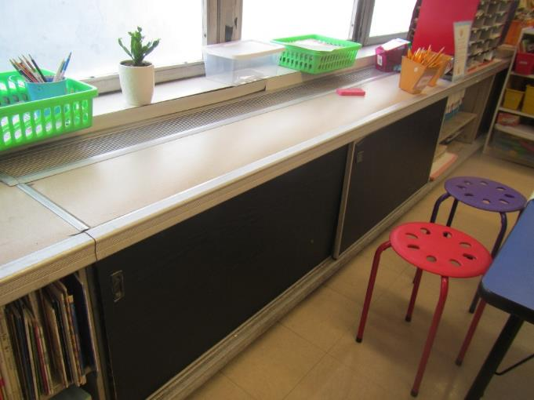

**One style of classroom unit ventilator (univent)**

**Picture 2**

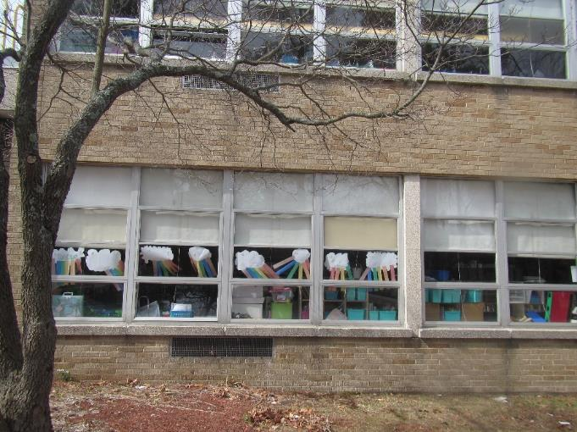

**Univent fresh air vent on the exterior of the building**

**Picture 3**

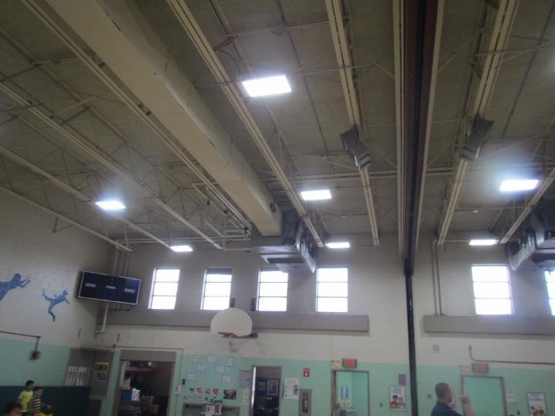

**Air handling units in the ceiling of the gym (arrows)**

**Picture 4**

**.** 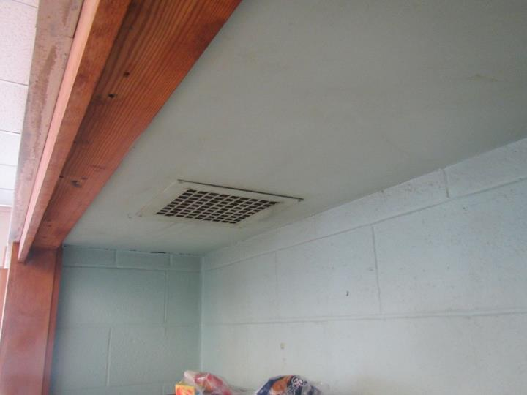

**Classroom exhaust vent**

**Picture 5**

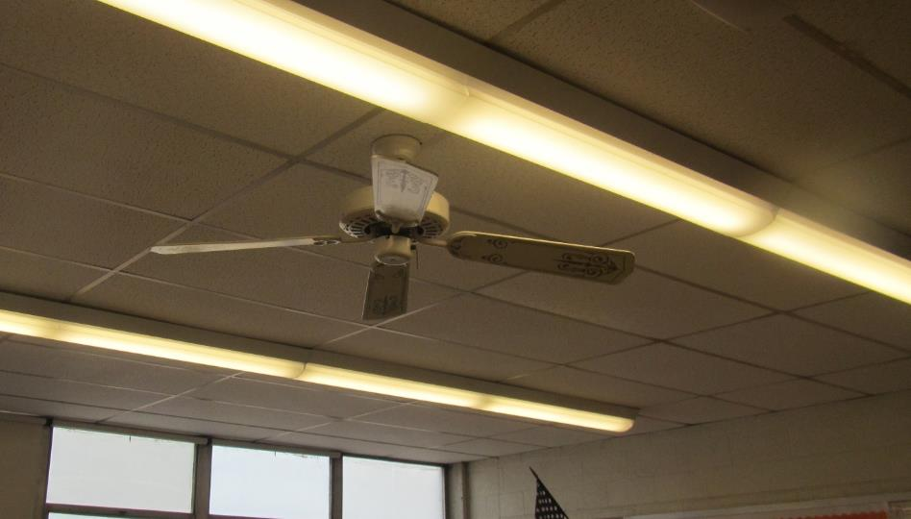

**Ceiling fan in classroom**

**Picture 6**

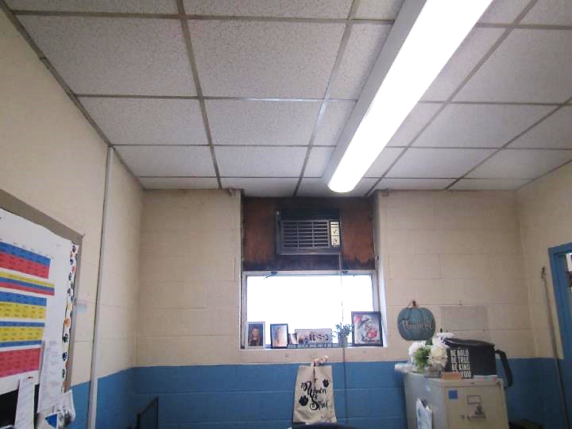

**Window-mounted air conditioner; note age of unit and condition of wood around it**

**Picture 7**

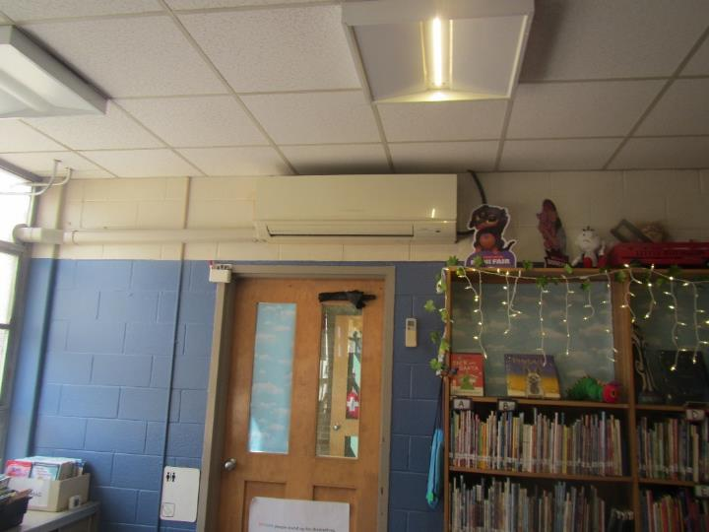

**Wall-mounted mini-split on the wall of the media center**

**Picture 8**

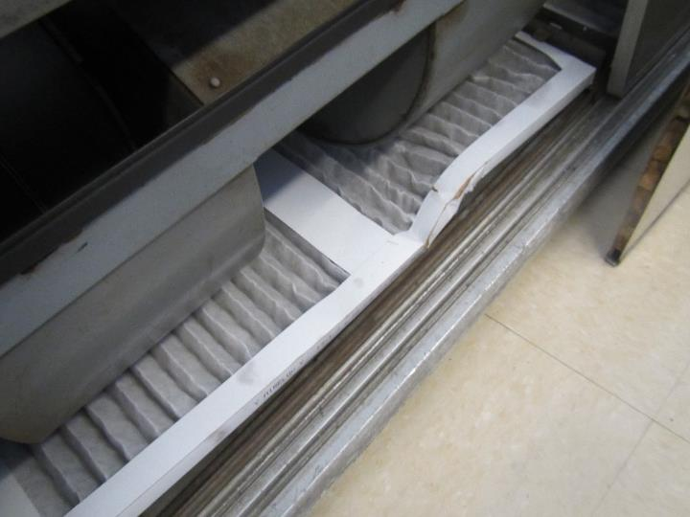

**MERV 8 filter in classroom univent**

**Picture 9**

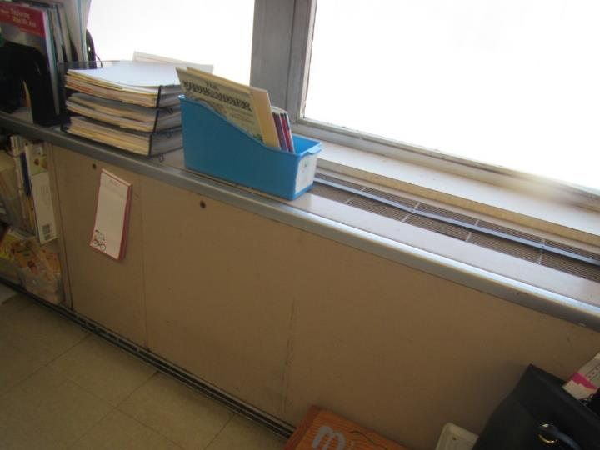

**Univent partially blocked by furniture and items**

**Picture 10**

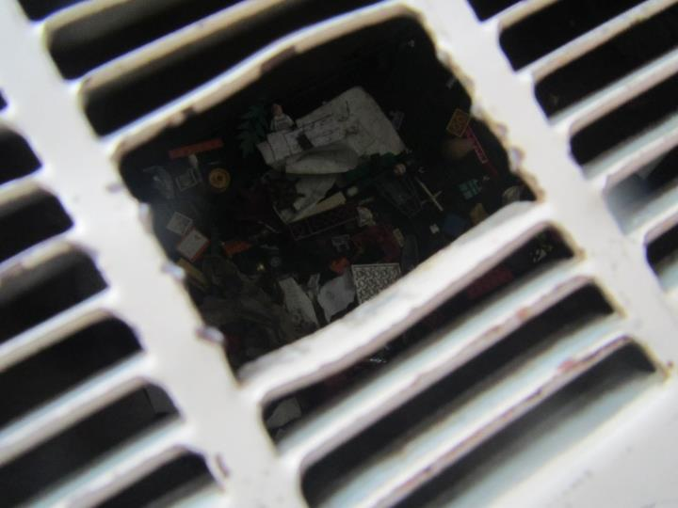

**Hole in radiator showing debris and items inside**

**Picture 11**

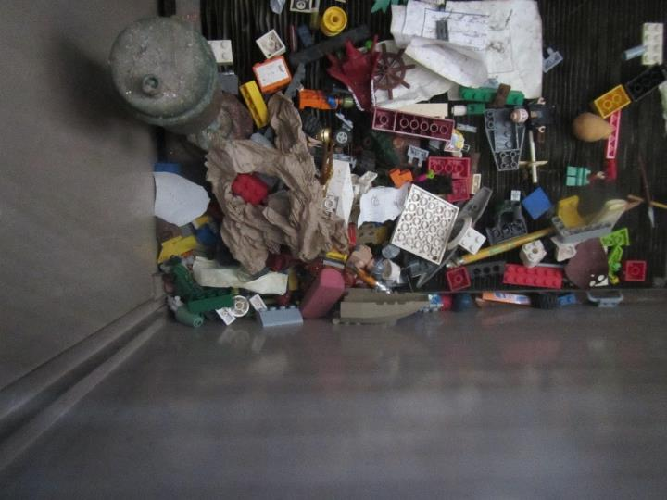

**View inside radiator showing a pile of plastic toys and other items inside**

**Picture 12**

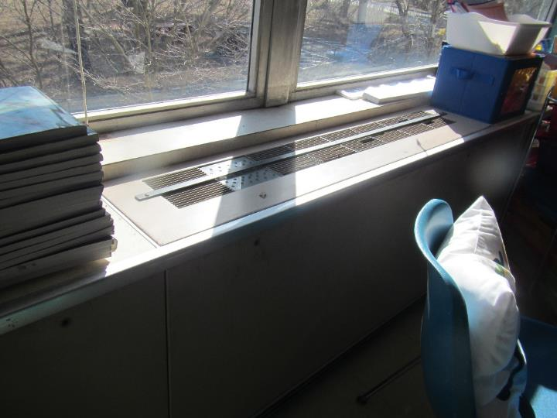

**Replacement grill part on univent looks handmade and non-standard**

**Picture 13**

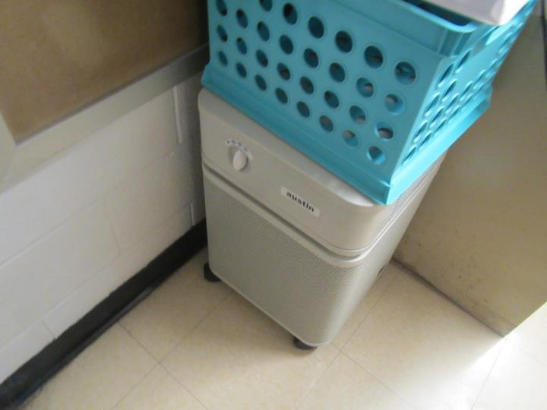

**Example of an air purifier in a classroom**

**Picture 14**

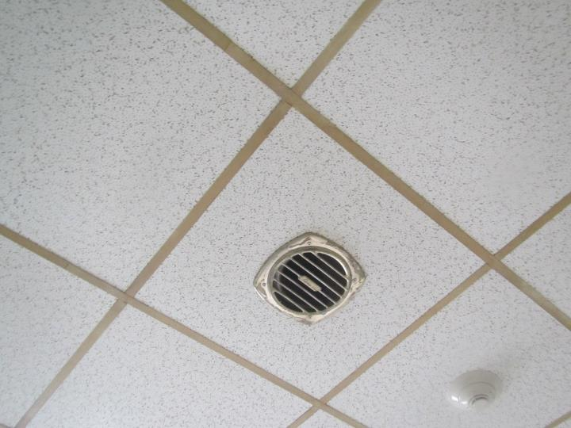

**Exhaust vent in the teacher’s lounge**

## Water Damage Pictures

Picture 15

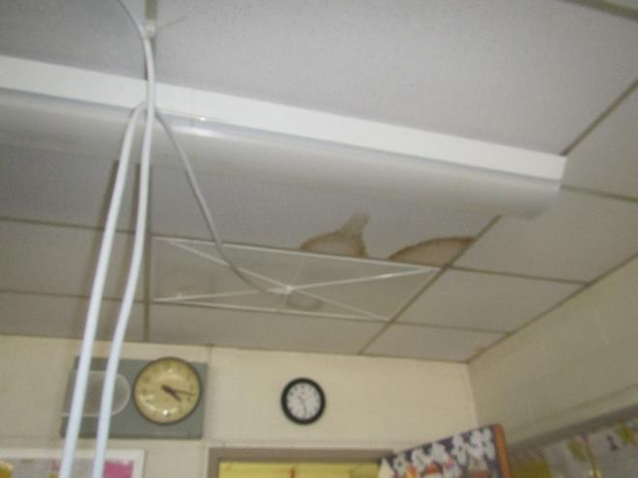

Funnel-shaped roof leak diverter in classroom

Picture 16

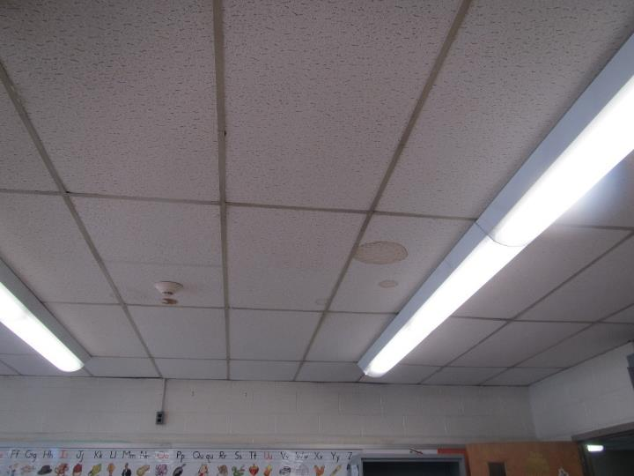

Water-damaged ceiling tile

Picture 17

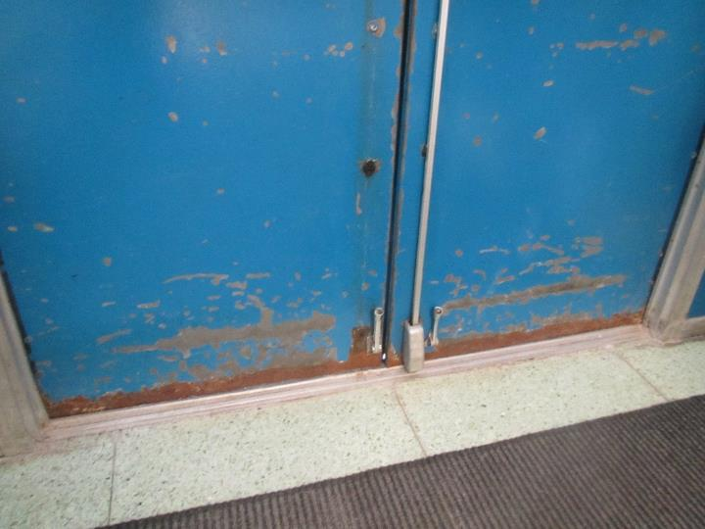

Rusted door edge and light visible between bottom of doors

Picture 18

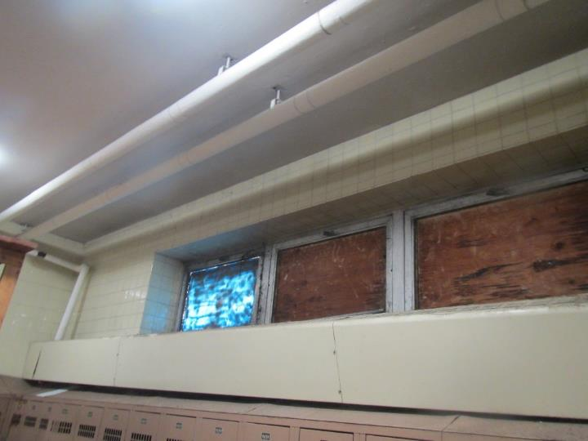

Water damage to wood covering windows in unused locker room

Picture 19

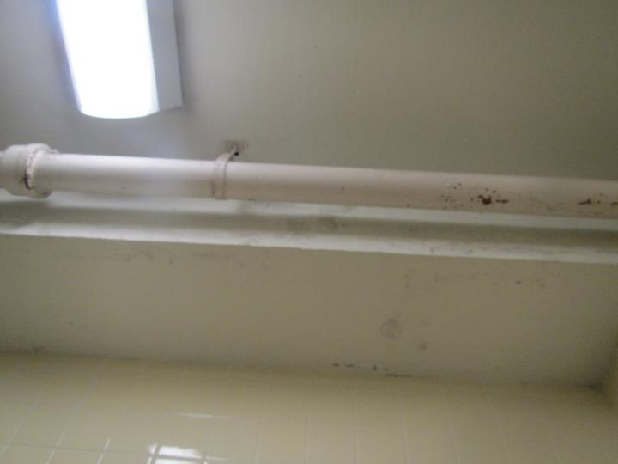

Possible mold growth on pipe insulation and ceiling material in disused locker room

Picture 20

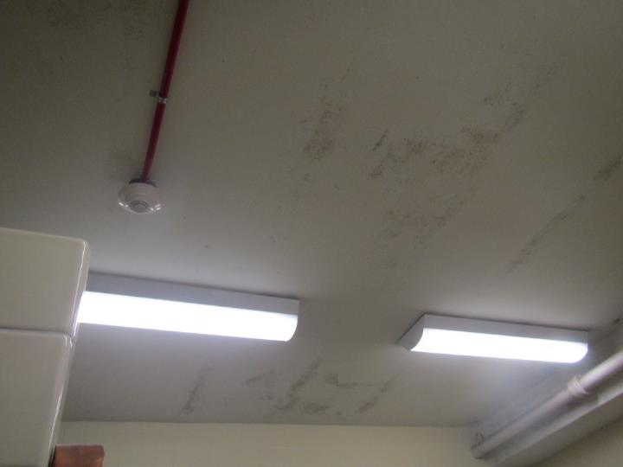

Potential mold growth on ceiling in disused locker room

Picture 21

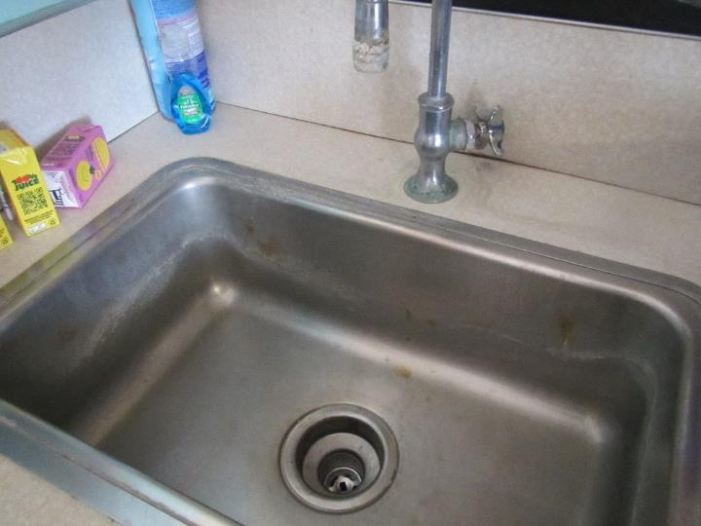

Corrosion on faucet and damaged backsplash

Picture 22

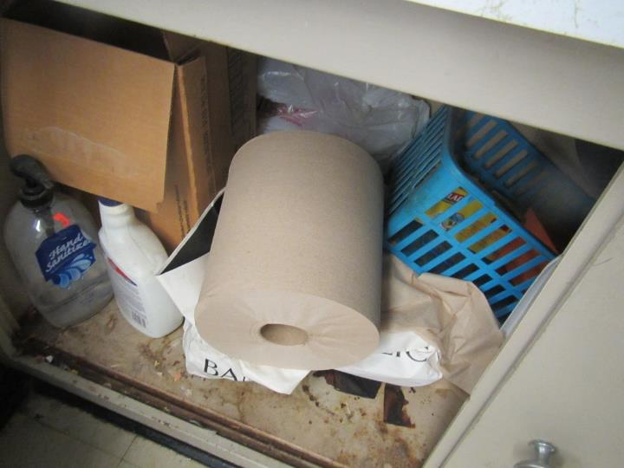

Damaged sink cabinet with porous items underneath

Picture 23

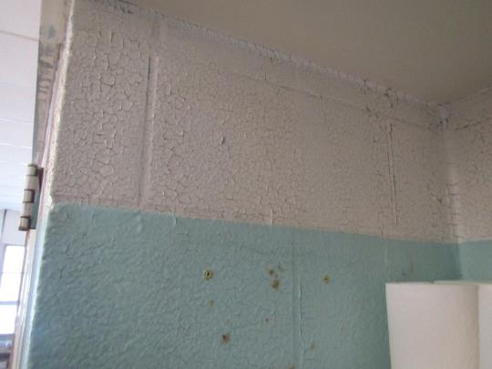

Chipped, peeling paint

Picture 24

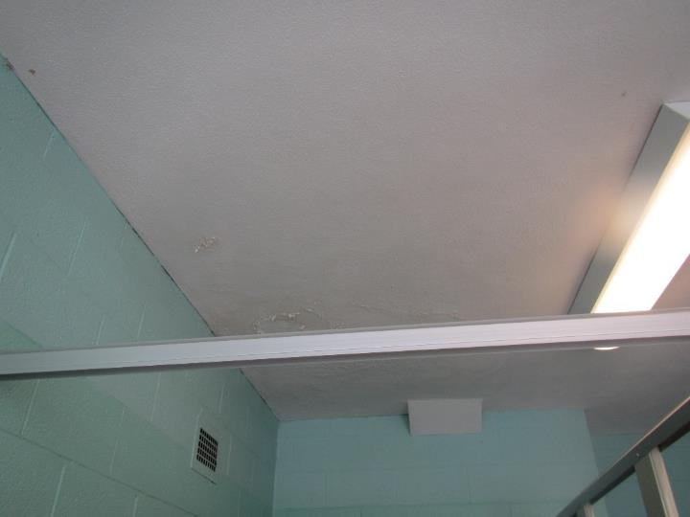

Water-damaged ceiling plaster

Picture 25

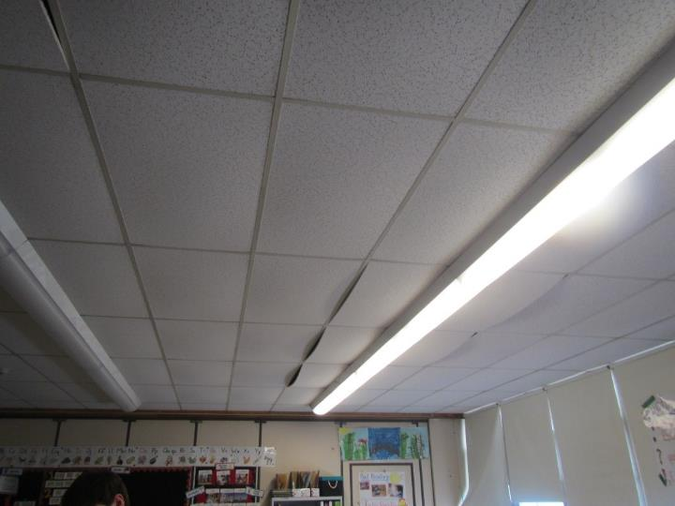

Bowed, poorly fitted ceiling tiles

## External Damage Pictures

Picture 26

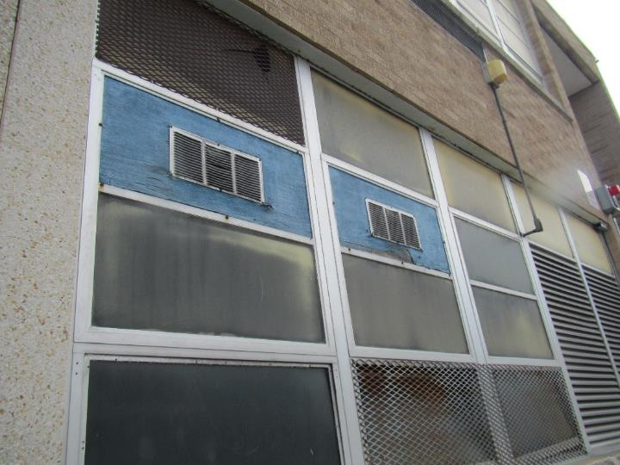

Water-damaged wood and rusted vent grill on the building exterior

Picture 27

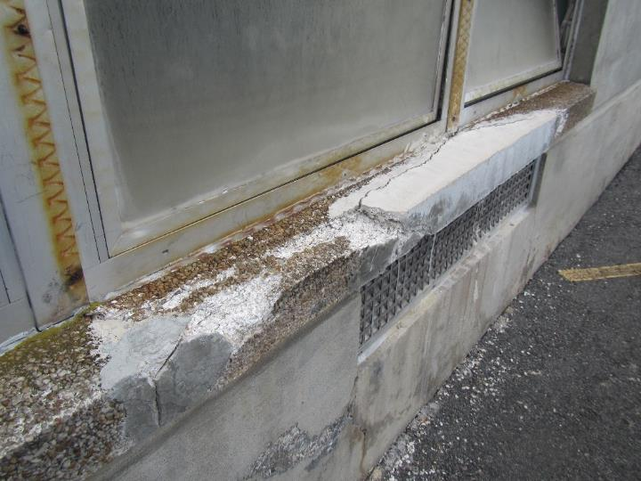

Damaged masonry with pieces missing

Picture 28

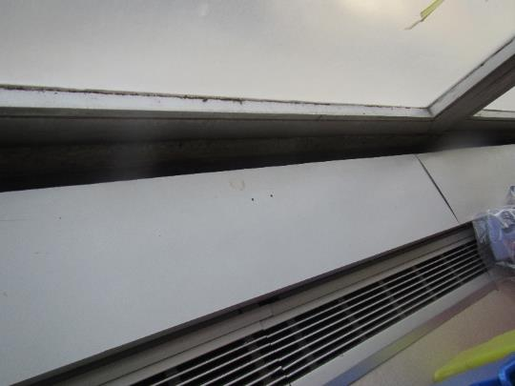

Gap between univent and wall in classroom B8 due to wall bowing outward

## Respiratory Irritants Pictures

Picture 29

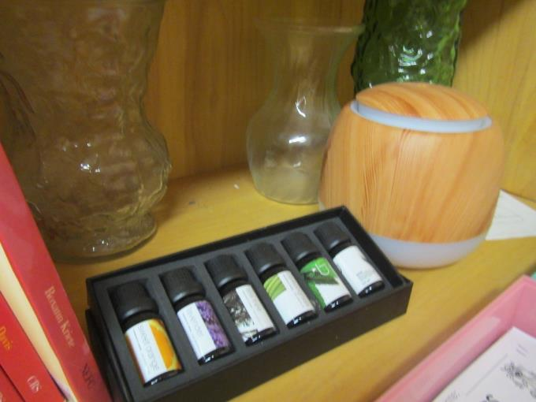

Oil diffuser and essential oils

Picture 30

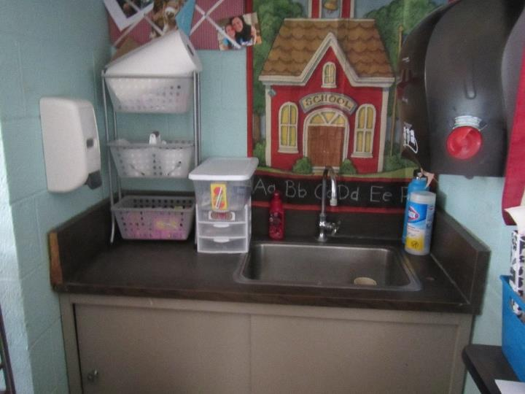

Sanitizing products in a classroom

Picture 31

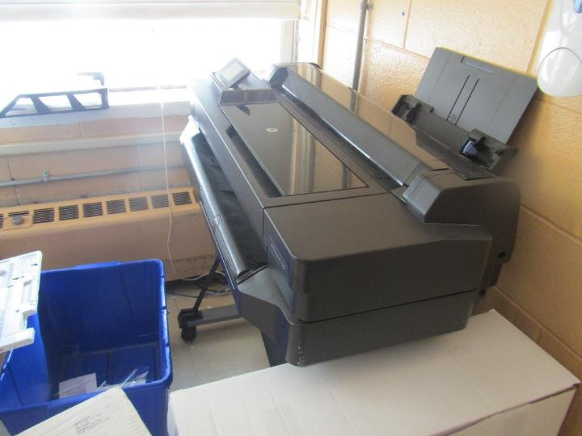

Laminator in the staff lounge

Picture 32

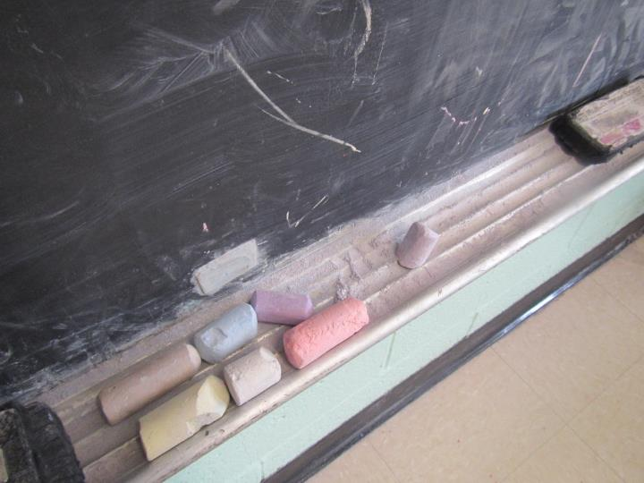

Chalk dust

Picture 33

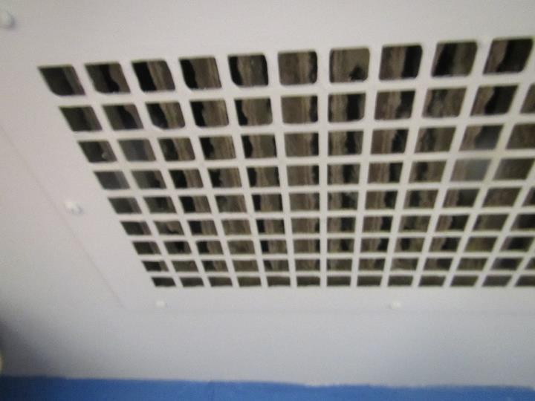

Dusty exhaust vent

Picture 34

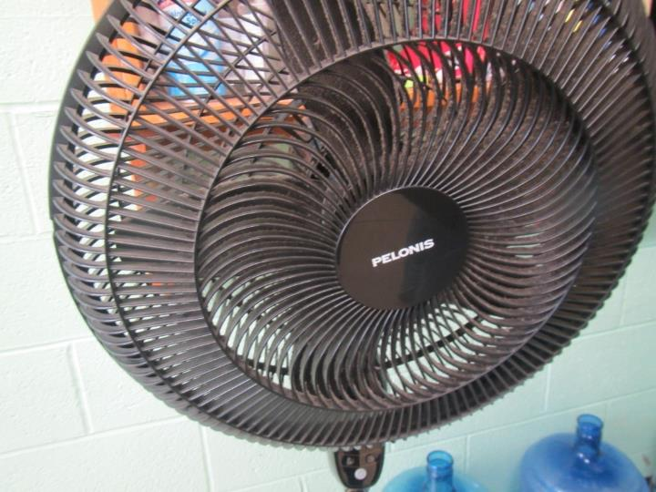

Dusty classroom fan

Click to link back to report

# Table 1

| **Location** | **Carbon**  **Dioxide**  **(ppm)** | **Carbon Monoxide**  **(ppm)** | **Temp**  **(°F)** | **Relative**  **Humidity**  **(%)** | **PM2.5**  **(g/m3)** | **Occupants**  **in Room** | **Windows**  **Openable** | **Ventilation** | | **Remarks** |
| --- | --- | --- | --- | --- | --- | --- | --- | --- | --- | --- |
| **Supply** | **Exhaust** |
| Background (outside) | 437 | ND | 49 | 33 | ND |  |  |  |  | Cool and clear day |
| C1 | 830 | ND | 77 | 19 | ND | 20 | Y  Open | Y | Y | Area rug, ceiling fan, DEM, Below the sink is packed with supplies. |
| C2 | 800 | ND | 80 | 38 | ND | 10 | Y | Y | Y | AP, DEM, Faucet leaking and corroded, Clorox CP and paint peeling by the back of the room. |
| C3 | 1000 | ND | 81 | 17 | ND | 19 | Y | Y | Y | AP, Area rug, DEM, WD CT, Condensation and paint peeling along the back wall. |
| Girls’ restrooms |  |  |  |  |  |  |  |  | Y | Recently painted/odor. Paint peeling along back wall. |
| C4 | 859 | ND | 81 | 16 | ND | 0 | Y | Y | Y | Area rug, AP. CF, two different CT – being replaced due to WD. |
| C5 | 898 | ND | 79 | 21 | ND | 0 | Y | Y | Y | Area rug, CF, DEM |
| C6 | 863 | ND | 77 | 21 | ND | 0 | Y | Y | Y | Area rug, CF, DEM, PF, Plants, Rust and peeling paint |
| Boys’ bathroom | 1120 | ND | 77 | 19 |  |  |  |  | Y | Peeling paint |
| Janitorial closet |  |  |  |  |  |  |  |  | Y |  |
| C7 | 872 | ND | 79 | 17 | ND | 18 | Y | Y | Y | Area rug, CF, DEM, CP |
| C8 | 811 | ND | 77 | 18 | ND | 18 | Y | Y | Y | Area rug, AP, DEM, Faucet dripping, PF-dirty. |
| C9 | 665 | ND | 73 | 17 | ND | 19 | Y | Y | Y | Area rug, DEM, CF, PF, Faucet dripping |
| C10 | 788 | ND | 74 | 18 | ND | 0 | Y | Y | Y | Area rug, DEM, PF, Verified use of MERV 8 filters in the univents |
| C11 | 819 | ND | 77 | 19 | ND | 22 | Y  Open | Y | Y | AR, DEM, CF, PF, Toys/debris in the radiator, sink backsplash not flush to the wall |
| C12 | 694 | ND | 74 | 18 | ND | 6 | Y | Y | Y  Off | AR, DEM, Stuffed toys arranged all over the room, Personal fan, fridge and a dirty toaster over |
| C13 | 651 | ND | 73 | 15 | ND | 5 | Y | Y | Y | AR, DEM, Exhaust in the bathroom, Sink out of order |
| Gymnasium | 841 | ND | 79 | 17 | ND | 21 | Y  Open | N | N | AHU in the ceiling brings in fresh air, mats and gym equipment |
| Gym Office | 625 | ND | 74 | 14 | ND | 0 | Y  Open | N | Y | Gym equipment - stored in bins off the ground |
| Steam Closet | 815 | ND | 75 | 16 |  |  |  |  | Y | Used as storage, and WD insulation |
| A6 | 850 | ND | 77 | 19 | ND | 17 | Y | Y | Y | AR, DEM, Pencil sharpener next to the uninvent- pencil debris found in the vent |
| Boys’ room closet | 1470 | ND | 77 | 19 | ND | 61 | Y | Y | Y | Kiln stored in this area, this space is not used, therefore the floor drains not used – sewer gas concerns? |
| Girls’ bathroom |  |  |  |  |  |  |  |  |  | Black specks by matte piping on the ceiling– mold? WD by windows that are boarded up with wood planks possible mold growth |
| A3 | 705 | ND | 73 | 19 | ND | 0 | Y | Y | Y |  |
| A4 | 845 | ND | 70 | 22 | ND | 16 | N | Y | Y  On | AR, DEM, Windows rusted, Exhaust dirty |
| A1 | 690 | ND | 73 | 19 | ND | 15 | Y | Y | Y | AR, DEM, CP, sink backsplash not flush to the wall |
| A2 | 640 | ND | 72 | 18 | ND | 0 | Y | Y | Y  On | Area rug, DEM, WD ceiling tile, Exhaust dirty |
| B10 | 860 | ND | 74 | 22 | ND | 21 | Y  Open | Y | Y  On | AR, DEM, Oil Diffuser, ceiling tiles bowing/out of their channel (cut too big?) |
| Media Center | 678 | ND | 77 | 16 | ND | 16 |  |  | Y | AR, CF, 2 Mini splits, new LED lights |
| Mothers’ room | 675 | ND | 75 | 17 | ND | 0 |  |  |  | WD-CT |
| Staff Lounge | 541 | ND | 72 | 15 | ND | 0 | Y  Open | N | N | Radiator heating, Photocopiers, Laminator, printer/copiers |
| Staff Lounge main area | 746 | ND | 73 | 17 | ND | 0 | Y | Y | Y | AP, Kitchenette area - Fridge, microwave |
| B8 | 977 | ND | 76 | 22 | ND | 8 | Y | Y | Y | AR, DEM, WD-CT, back wall bowing/not flush against the windowsill, ceiling tiles bowing/out of their channel (cut too big?) |
| B7 – Art room | 675 | ND | 76 | 16 | ND | 12 | Y  Open | Y | Y | AR, DEM, PF, noisy uninvent – dust/debris inside |
| B6 | 706 | ND | 75 | 18 | ND | 5 | Y | Y | Y | AR, DEM, uninvent blocked, ceiling tiles bowing/out of their channel (cut too big?) |
| B5 | 681 | ND | 74 | 18 | ND | 0 | Y | Y | Y | AR, DEM, Oil diffuser, Univent blocked |
| Boys’ bathroom |  |  |  |  |  |  |  |  |  | Efflorescence on the ceiling over the toilets |
| B4 | 714 | ND | 74 | 19 | ND | 1 |  |  |  | AR, DEM, Plants, ceiling tiles bowing/out of their channel (cut too big?), microwave, sink backsplash not flush against the wall |
| B2 | 750 | ND | 74 | 18 | ND | 8 |  |  |  | AR, DEM, Oil diffuser, sink backsplash not flush against the wall |
| B3 | 630 | ND | 74 | 17 | ND | 1 |  |  |  | AR, DEM, Univent blocked |
| Girls’ bathroom |  |  |  |  |  |  | Y  Open |  |  | Efflorescence on the ceiling over the toilets |
| B-12 | 554 | ND | 81 | 15 | ND | 0 | Y | N | N | Window, AC, PF |
| Conference room |  |  |  |  |  |  |  |  |  |  |
| B1 | 640 | ND | 76 | 16 | ND | 1 | Y  Open | Y | Y | AR, DEM, ceiling tiles bowing/out of their channel (cut too big?), sink backsplash not flush against the wall |
| Staff/Reading Room | 600 | ND | 77 | 15 |  |  | Y | Y | Y |  |
| Copy Room |  |  |  |  |  |  | Y | Y | Y |  |
| Boiler Room | 1280 | 3 | 78 | 15 | ND |  | Y | Y | Y  Off |  |
| Boiler Room bathroom |  |  |  |  |  |  |  |  |  | Toilet rusted – not in use |
| Councilors’ Office | 730 | ND | 78 | 16 | ND |  | Y |  |  | Oil diffuser, WD-CT |
| Nurses’ Office | 736 | ND | 79 | 15 | ND |  | Y | N | N  Off | Radiator heat, AC |
| Staff Lounge | 833 | ND | 80 | 16 | ND | 7 | Y | N | Y | Retrofitted exhaust vent |
| Custodian Office | 670 | ND | 78 | 15 | ND |  | Y  Open | Y | Y  On | Fridge - mold around the freezer door rubber stripping |
| Cafeteria |  |  |  |  |  | ~100 | Y  Open | N | Y  On | Radiators, CF, WD-CT, old curtains in the back – very dusty |
| Woman’s room |  |  |  |  |  |  |  |  |  |  |
| Main Office | 815 | ND | 75 | 19 | ND | 1 | Y | N | N | Window and front door for air exchange |

(Click to link back to report)

# Table 2A

|  |  |  |  |  |  |
| --- | --- | --- | --- | --- | --- |
| **Equipment Present in Building**  **(X = Yes)** | **Type of Heating/Cooling Ventilation**  **Equipment** | **Fresh**  **Air**  **Supply**  **(X = Yes)** | **Type of Location(s)** | **Air Filters Installed**  **MERV Rating**  **(1-15, U*)**  **(X = Yes)** | **Comments** |
| X | Univents | X | Classrooms | X |  |
|  | Rooftop Air Handling Units |  |  |  |  |
|  | Outdoor, Ground-Installed Air Handling Units |  |  |  |  |
|  | Attic/Crawlspace Air Handling Units |  |  |  |  |
| X | Ceiling-Mounted Air Handling Units (including inside plenum) | X | Common areas | U |  |
|  | Basement/Crawlspace-Installed Air Handling Units |  |  |  |  |
|  | Mechanical Room-installed Air Handling Units |  |  |  |  |
|  | Fan Coil Units |  |  |  |  |
| X | Window-Mounted Air Conditioners | X | Some offices |  |  |
|  | Portable air conditioners |  |  |  |  |
|  | Wall Louver-Controlled Gravity Air Supply |  |  |  |  |
| X | Windows | X | Most rooms |  | Openable |
|  | Fan in window (blowing in) |  |  |  |  |
|  | Built in wall fan (switched) |  |  |  |  |
|  | Heat recovery ventilator unit |  |  |  |  |
|  | Energy recovery ventilator unit |  |  |  |  |
|  | Chilled Beam |  |  |  |  |
|  | Passive combustion supply vent in basement/boiler room |  |  |  |  |

*U = Filter Rating underdetermined due to inaccessibility during building visit

# Table 2B

|  |  |  |  |  |
| --- | --- | --- | --- | --- |
| **Equipment Present in Building**  **(X = Yes)** | **Type of Exhaust Ventilation**  **Equipment** | **Ducted**  **To Outdoors**  **(X = Yes)** | **Type of Location(s)** | **Comments** |
| X | Rooftop Motors/Fans | X | Classrooms and common areas | Not functioning |
|  | Unit Exhaust |  |  |  |
|  | Ceiling Return Vent |  |  |  |
|  | Ceiling Return Vent, Plenum |  |  |  |
|  | Wall Return Vent |  |  |  |
| X | Ceiling fan |  | Classrooms |  |
|  | Kitchen Stove Hood |  |  |  |
| X | Restroom Exhaust Vent | X |  | Not functioning |
|  | Photocopier Exhaust Vent |  |  |  |
|  | Garage |  |  |  |
|  | Chemical Hood(s) |  |  |  |
|  | Locker Rooms |  |  |  |
|  | Showers |  |  |  |
|  | Clothes Dryers |  |  |  |
|  | Gas Water Heaters |  |  |  |
|  | Furnace-Flue to Chimney |  |  |  |
|  | Furnace/Boiler direct vent or power vent (no combustion air supply) |  |  |  |
| X | Kiln, Pottery | X |  |  |
|  | Dark Room |  |  |  |
|  | Generator Room |  |  |  |
|  | Wood Shop Dust Collector |  |  |  |
|  | Spray Paint Booths |  |  |  |
|  | Fan in window (blowing out) |  |  |  |

# Table 2C

|  |  |  |  |
| --- | --- | --- | --- |
| **Equipment Present in Building**  **(X = Yes)** | **Type of Equipment** | **Type of Location(s)** | **Comments** |
|  | Floor Fans, pedestal |  |  |
| X | Floor Fans, portable | Classrooms, offices |  |
| X | Air Purifier (HEPA, other) | Classrooms, offices |  |
|  | Floor heaters, portable |  |  |
| X | Refrigerators, Cold Beverage Vending Machines | Staff Room |  |
|  | Radiator, wall-mounted |  |  |
|  | Radiator, floor-mounted |  |  |
|  | Passive Vents (Wall/Door) |  |  |

(Click to link back to report)

# Table 3

| **Found in Building**  **X = Yes** | **Water-Damaged Materials, Building Components or Stored Materials** | **Location** | **Visible Microbial Growth?**  **X = Yes** | **Musty odor detected?**  **X = Yes** | **Comments** |
| --- | --- | --- | --- | --- | --- |
|  | Books-other bound materials |  |  |  |  |
| X | Brick walls – broken, missing mortar | Exterior |  |  | Damage in several areas |
|  | Brick walls – blocked weep holes |  |  |  |  |
|  | Cardboard boxes |  |  |  |  |
|  | Carpet tiles |  |  |  |  |
| X | Carpet - Area rugs |  |  |  |  |
|  | Carpet wall-to-wall |  |  |  |  |
|  | Ceiling tiles - affixed directly to ceiling surface |  |  |  |  |
|  | Ceiling tiles - bowing-in suspended ceiling |  |  |  |  |
|  | Ceiling tiles - water-stained in splined ceiling |  |  |  |  |
| X | Ceiling tiles - water-stained in suspended ceiling | Classrooms/common areas | No | No |  |
|  | Chairs - laminated |  |  |  |  |
| X | Cloth | Classrooms | No | No |  |
| X | Countertops (around sinks) |  |  |  |  |
|  | Curtains |  |  |  |  |
|  | Dust/debris within AHU, uninvent, HVAC, chilled beam units, etc. (WD through condensation, humidity, or leaks) |  |  |  |  |
| X | Efflorescence (i.e., mineral deposits) | Restroom ceiling | No | No |  |
|  | Engineered woods - particleboard, plywood, Masonite |  |  |  |  |
|  | Flooring – loosened tiles |  |  |  |  |
|  | Flooring - wooden |  |  |  |  |
|  | Furniture - laminated |  |  |  |  |
| X | Furniture - upholstered | Classrooms | No | No |  |
|  | Gypsum wallboard - ceiling |  |  |  |  |
|  | Gypsum wallboard - restroom wall |  |  |  |  |
|  | Gypsum wallboard - interior wall |  |  |  |  |
|  | Gypsum wallboard – located on exterior wall |  |  |  |  |
|  | HVAC drain pan – lack of draining |  |  |  |  |
|  | HVAC filters |  |  |  |  |
|  | Insulation- attic (paper-backed) |  |  |  |  |
|  | Insulation - inside air handling unit |  |  |  |  |
|  | Insulation - on pipe(s) fiberglass |  |  |  |  |
| X | Insulation - on pipe(s) other/plaster-like material | Former locker room | maybe | No |  |
|  | Insulation - wall cavity |  |  |  |  |
|  | Insulation – ceiling plenum |  |  |  |  |
|  | Modular furniture – walls/cloth partitions |  |  |  |  |
|  | Musical instrument cases |  |  |  |  |
|  | Plaster ceilings |  |  |  |  |
|  | Records/files |  |  |  |  |
| X | Refrigerator - door gasket | Teacher’s Breakroom | Yes | Yes | Visible mold on gaskets of refrigerator and freezer |
|  | Refrigerator - drip pan |  |  |  |  |
|  | Refrigerator - Interior surfaces |  |  |  |  |
|  | Room divider - ceiling-mounted, sliding |  |  |  |  |
|  | Sink backsplash |  |  |  |  |
|  | Tables – laminated |  |  |  |  |
|  | Wallpaper |  |  |  |  |
|  | Wood - attic/roof materials |  |  |  |  |
|  | Wood - floor joists in basement ceiling |  |  |  |  |
|  | Wood - wall framing |  |  |  |  |
|  | Wood - window sills |  |  |  |  |
|  | Wood - window-mounted air conditioner framing |  |  |  |  |
| X | OTHER | Exterior trim |  |  | Damage in many areas |

WHAT ARE ENVIRONMENTAL ASTHMA TRIGGERS?

Asthma triggers are any chemical, pollutant, or allergen that can make your asthma worse. Asthma triggers can also be strong chemical smells, dust, or pets. Your asthma triggers may be different from those of other people. Not all asthma triggers affect people the same way. Environmental asthma triggers are found both indoors and outdoors. DPH link: [Asthma and Your Environment (mass.gov)](https://www.mass.gov/doc/asthma-and-your-environment-english/download)

(click to link back to report)

# Table 4

| **Condition Present**  **X = Yes** | **Possible asthma symptom-inducing environmental pollutant** | **Recommendation to reduce or eliminate the pollutant** |
| --- | --- | --- |
| X | Water Damage and/or Mold  (allergen) | Identify water source and repair to eliminate.  Clean non-porous materials.  Remove and replace porous materials susceptible to mold growth.  Perform regular water damage assessments as a tool to ensure timely mitigation as needed.  Use NIOSH water damage assessment protocol as a guide: [NIOSH water damage assessment guideline](https://www.cdc.gov/niosh/docs/2019-115/pdfs/2019-115.pdf?id=10.26616/NIOSHPUB2019115&inf_contact_key=241b5c2ed98c27d94b530dedc36f1623f651f238aa2edbb9c8b7cff03e0b16a0). |
|  | Moistening of building components during hot, humid weather (>2 days in length) (mold, allergen) | Remove materials not dried in <2 days in a manner consistent with [US EPA Mold Removal in Commercial Buildings guideline](https://www.epa.gov/mold/pdf-version-checklist-mold-remediation-mold-remediation-schools-and-commercial-buildings).  Use dehumidification in occupied basement areas and other areas with chronic dampness. |
| X | Vegetation against exterior of building (water damage-mold) | Remove all vegetation preventing building exterior drying.  Remove all vegetation capable of falling onto a building or depositing debris onto the roof. |
| X | Personal humidifiers (lack of proper maintenance)  (pollutant and allergen) | Clean and maintain properly.  Use distilled water to eliminate metal and water treatment odors.  Maintain hydration by increasing water consumption. |
| X | Drains: Floor drains, Sink drains (abandoned use)  Water bubblers (abandoned use) | If in use, pour water into drain at least twice a week.  If not in use, seal the drain with appropriate material in accordance with the Massachusetts Plumbing Code (248 CMR 10.00). |
|  | Live Animals (turtles, gerbils, birds, rabbits, etc.) | Ensure cleanliness or remove animals from the location. |
| X | Improperly maintained aquariums and terrariums (allergen) | Maintain such equipment properly to eliminate odor.  Discontinue use. |
| X | Plants and flowers  (allergen and mold) | Keep indoor plants well maintained and not overwatered. Monitor for signs of mold and pests.  Ensure water for cut flowers does not become stagnant.  Ensure dried plant material is free of odors, mold, and pests and handled carefully  If asthma risks are high, eliminate plants and flowers. |
|  | HVAC system moisture issues  (mold, allergen) | Consult ASHRAE’s minimum standards for HVAC maintenance and inspection of commercial HVAC systems (<https://www.ashrae.org/technical-resources/bookstore/standards-180-and-211>). |
|  | HVAC system contaminant issues (allergen) | Consult ASHRAE’s minimum standards for HVAC maintenance and inspection of commercial HVAC systems (<https://www.ashrae.org/technical-resources/bookstore/standards-180-and-211>). |
|  | Indoor swimming pool odors outside of swimming pool (mold, chemical) | Maintain and operate pool HVAC systems to vent odors from building.  Ensure locker room exhaust vents operate during building hours.  All doors leading to the pool should be rendered airtight and be closed. |
|  | Pollen (allergen) | Recommend installation of MERV 8 or better filters if HVAC engineer confirms HVAC system can be so equipped without adversely affecting function.  Cut grass after hours.  Cut grass in a pattern to direct clippings away from exterior wall.  Remove trees and shrubs from in front of windows and air intakes. |
| X | Dry air | Maintain hydration.  Avoid overheating of air. |
| X | Dust mites  (allergen) | Recommendation to remove non-official upholstered furniture, area rugs, pillows, cushions, etc.  Cleaning with use of HEPA-filtered vacuum cleaner.  Eliminating clutter, storing items in dust and moisture-proof containers, and regularly removing dust through wet wiping. |
| X | Pests, including rodents and cockroaches  (allergen) | Use of integrated pest management guidelines, including:   * Proper disposal of food containers * Proper storage of food products in airtight containers * Elimination of use of food as art projects * Remove pest harborages/clutter * Regular monitoring for pests   [EPA IPM guideline link](https://www.epa.gov/ipm/introduction-integrated-pest-management) |
|  | Latex-containing materials | Remove tennis balls from furniture legs. |
| X | Fragrances  (chemical) | Eliminate point sources, such as:   * Plug-in air fresheners * Aroma/oil reed diffusers * Scented sprays * Discontinue use of other scented materials * Consult DPH fragrance guideline: [*Clean air is odor-free*](https://www.mass.gov/doc/clean-air-is-odor-free-removing-fragrances-to-improve-indoor-air-quality-in-schools-and-0/download) |
|  | Strong smells from /use of Chemicals (such as cleaning products)  (chemical) | Use building-issued cleaning products.  Use products in accordance with manufacturer’s instructions including dilution, application, and ventilation.  Avoid using products that are stronger than needed for the situation. |
|  | Strong odors from new building materials (carpeting/furniture)  (chemical) | Use low VOC-emitting materials.  Air out materials (outside or in an unoccupied area) prior to installation. |
|  | Tobacco smoke  Secondhand Smoke  (pollutant) | Eliminate tobacco smoking.  Seal all shared wall penetrations. |
| X | Products with strong odor such as paint, perfume, hairspray, air fresheners, bug-spray, laminators, candles, wax melters, dry erase markers and other VOC-containing products  (chemical) | If essential:   * Provide proper exhaust ventilation to eject aerosolized products directly outdoors. * Avoid/reduce use during occupied hours.   If not necessary, remove and eliminate. |
|  | Vehicle exhaust  (pollutant) | Enforce anti-idling regulations and post signs to give notice.  Relocate vehicles away from fresh air intakes.  Require cars to park face-in at building walls.  [MA anti-idling law FAQs](https://www.mass.gov/files/documents/2018/02/20/idling-faq.pdf#:~:text=The%20Massachusetts%20Anti-Idling%20Law%20The%20goal%20of%20the,sometime%20wonder%20when%20idling%20might%20be%20considered%20necessary.) |
|  | Vapors and or fumes from gas, oil, or kerosene stoves  (pollutant) | Operate stove hood when stove is in use.  Install stove hood if not present.  Ensure the equipment is in good working order. |
|  | Ozone (pollutant) | Eliminate use of ozone generating equipment. |
|  | Window Air Conditioners (if not properly maintained) (allergen) | Equip with proper filter and clean periodically.  Clean drip pans.  Install in window with weathertight, non-mold-growth sustaining material. |
| X | Pottery (pollutant) | Do not operate kiln during occupied hours.  Operate kiln with exhaust system activated.  Seal all seams and holes in kiln vent.  Ensure kiln exhaust discharge terminates outdoors. |
| X | Carpeting (allergen) | Clean carpeting in a manner consistent with IICRC standards, including regular vacuuming with a high efficiency particulate air (HEPA) filtered vacuum in combination with annual cleaning or semi-annual cleaning in soiled high traffic areas. |
| X | Sweeping/dusting vs HEPA vacuuming/wet wiping  (allergen or pollutant) | Refrain from using feather dusters or brooms.  Utilize HEPA vacuums and wet wiping to minimize aerosolizing particulate matter. |
| X | Lack of adequate air exchange/mechanical ventilation | Make repairs as necessary and ensure all HVAC system components are operating continuously when building is occupied. |
| X | Lack of local exhaust at source of pollution (vocational shop activities, kitchen exhaust hood) (all) | Recommend installation of exhaust ventilation to direct pollutants directly outdoors. |
|  | Renovating buildings while occupied  (chemical) | Use all SMACNA guidelines for Renovation While Buildings Are Occupied. For information, visit <https://www.mass.gov/service-details/construction-and-renovation-generated-pollutants-in-occupied-buildings>. |
|  | Chemistry program chemical storage  (chemical) | Repair (if needed) and operate chemical storeroom vents appropriately.  Reduce or eliminate unneeded or overstocked chemicals.  Store all chemicals in a manner to separate incompatible chemicals.  Keep chemical storerooms clean. |
| X | Photocopiers/duplicating machines | All machines should have dedicated exhaust vents. |