**WATER DAMAGE ASSESSMENT**

**Wolf Swamp Rd Elementary School**

**62 Wolf Swamp Road**

**Longmeadow, MA**

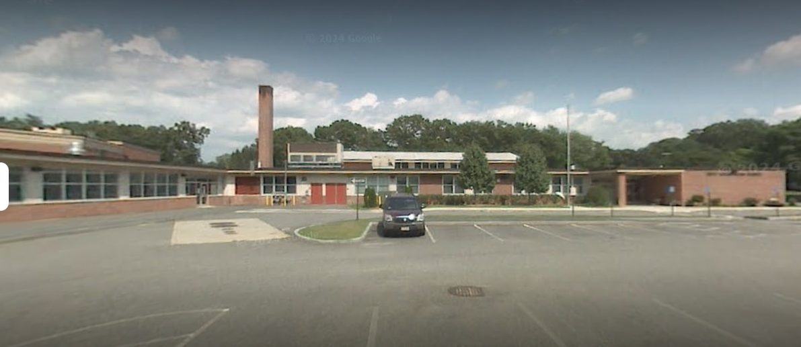

Prepared by:

Massachusetts Department of Public Health

Bureau of Climate and Environmental Health

Indoor Air Quality Program

August 2024

# BACKGROUND

|  |  |
| --- | --- |
| Building: | Wolf Swamp Elementary School (WSES) |
| Address: | 62 Wolf Swamp Road, Longmeadow, MA |
| Requestor: | Nicholas Georgantas, Facilities Director, Town of Longmeadow |
| Reason for Request: | Water damage |
| Date of Assessment: | August 16, 2024 |
| Massachusetts Department of Public Health/Bureau of Environmental Health (MDPH/BCEH) Staff Conducting Assessment: | Stefanie Santora, Environmental Analyst, Indoor Air Quality (IAQ) Program |
| Building Description: | The WSES is a variable story, red-brick building constructed in 1956 with a major renovation in 2002. The school consists of classrooms, offices, cafeteria, kitchen, library, art and music rooms, a computer room, and a gymnasium. |
| Windows: | Openable |

The BCEH/IAQ Program was asked to examine Wolf Swamp Rd Elementary School for the presence of water damage/mold growth, with a focus on areas that were damaged by condensation i.e., ceilings, insulation, carpeting, and classroom materials.

# METHODS

Please refer to the IAQ Manual for methods, sampling procedures, and interpretation of results (MDPH, 2015).

**RESULTS AND DISCUSSION**

The following is a summary of indoor air testing results:

* ***Temperature*** was within the MDPH recommended range of 70°F to 78°F in areas tested during the assessment.
* ***Relative Humidity*** was above the MDPH recommended comfort range of 40 to 60% in all areas tested. Note that the chiller was not operating during this time. If relative humidity exceeds 70%, for extended periods of time, mold growth may occur due to wetting of building materials even in the absence of liquid water (ASHRAE, 2019).

A flood restoration firm was present during this visit. Flood restoration activities included:

* Use of fans and dehumidifiers to accelerate drying of carpeting and classroom materials.
* Use of exhaust vents to vent water vapor outdoors.
* Removing and replacing water damaged ceiling tiles and insulation.
* Cleaning of coving from impacted walls.
* Cleaning of non-porous classroom materials.
* Moving cabinets, floor mats, and area rugs on the floor.

At the time of the MDPH/IAQ visit, remediation activities (removal and drying of water-damaged building materials) were fully active and were being conducted in accordance with US EPA guidance (US EPA, 2008). Water-damaged materials had been removed and/or dried and rooms were being cleaned. IAQ staff examined all accessible classroom and other occupied spaces in the building and did not observe visible mold/associated odors during this visit.

In general, the US Environmental Protection Agency (US EPA) and the American Conference of Governmental Industrial Hygienists (ACGIH) recommend that porous materials (e.g., wallboard, carpeting) be dried with fans and heating within 24 to 48 hours of becoming wet (US EPA, 2008; ACGIH, 1989). If porous materials are not dried within this time frame, mold growth may occur.

Hot humid summers are becoming more frequent due to climate change. Massachusetts has experienced hot, humid, and rainy summers in 2018, 2021, and 2023. July of 2021 was the wettest ever recorded in Massachusetts, and the three-month period from June through August, known as the meteorological summer, was the fourth wettest on record, according to the National Oceanic and Atmospheric Administration’s (NOAA) Centers for Environmental Information (NOAA, 2021). The summer of 2023 was also hot, and wet, being measured as the second rainiest on record (WBUR, 2023). The summer of 2024 has also had significant stretches of hot, humid weather. These conditions are challenging for buildings, particularly those without central air conditioning.

Under these weather conditions, public buildings experienced extended periods of water vapor exposure from high relative humidity. When exposed to these conditions, porous materials such as gypsum wallboard, cardboard, carpeting and other materials may become moistened and colonized with mold, particularly if located in areas that are prone to developing condensation, such as floors and walls in contact with the ground (e.g., below grade space).

As previously mentioned, the assessment was requested due to the presence of mold on ceiling tiles. At the time of the assessment, most ceiling tiles in affected classrooms were removed and new tiles were in place or were awaiting replacement. No water-damaged, moldy, or musty materials were found on walls or items in any of the rooms examined, with the exception of lightly water-stained ceiling tiles in two rooms which had not yet been remediated.

The guideline “Preventing Mold Growth In Schools During Hot, Humid Weather” <https://www.mass.gov/info-details/preventing-mold-growth-in-massachusetts-schools-during-hot-humid-weather> should be used to minimize the impact of such weather on classroom materials. This includes use of air conditioning and dehumidifiers, ensuring exhaust vents are on and operable, keeping windows closed, and ensuring air can circulate around porous materials.

# CONCLUSIONS/RECOMMENDATIONS

Based on the observations made during the visit, it appears that most water-damaged materials were thoroughly dried and/or removed. The following recommendations are made:

1. Continue with restoration/reconstruction plans to replace all water-damaged building materials (ceilings, walls, floors, pipes, electrical, etc.).
2. Prior to re-occupancy:

* Operate/flush out the HVAC system for 24 hours and change filters. The MDPH recommends pleated filters with a Minimum Efficiency Reporting Value (MERV) of 8, which are adequate in filtering out pollen and mold spores (ASHRAE, 2012).
* Once remediation activities are completed, clean all items and surfaces with a high efficiency particulate arrestance (HEPA) filter equipped vacuum cleaner combined with wet wiping and have carpets professionally cleaned.

1. For more information on mold refer to the US EPA’s “Mold Remediation in Schools and Commercial Buildings,” available at: <http://www.epa.gov/mold/mold-remediation-schools-and-commercial-buildings-guide>.
2. Management of buildings in extreme relative humidity and rain can be challenging. The following documents can provide guidance that can be used to reduce the impact of hot, humid weather in buildings:
   1. Mold Growth Prevention During Hot, Humid Weather <https://www.mass.gov/service-details/preventing-mold-growth-in-massachusetts-schools-during-hot-humid-weather> and
   2. Remediation and Prevention of Mold Growth and Water Damage in Public Schools <https://www.mass.gov/service-details/remediation-and-prevention-of-mold-growth-and-water-damage-in-public-schools-and>.
3. Refer to resource manuals and other related IAQ documents for further building-wide evaluations and advice on maintaining public buildings. Copies of these materials are located on the MDPH’s website: <http://mass.gov/dph/iaq>.
4. If desired, contact the IAQ Program for a post-occupancy assessment following the completion of remediation and reconstruction work when school is in session.

# REFERENCES

ACGIH. 1989. Guidelines for the Assessment of Bioaerosols in the Indoor Environment. American Conference of Governmental Industrial Hygienists, Cincinnati, OH.

ASHRAE. 2012. American Society of Heating, Refrigeration and Air Conditioning Engineers (ASHRAE) Standard 52.2-2012 – Method of Testing General Ventilation Air-Cleaning Devices for Removal Efficiency by Particle Size (ANSI Approved).

ASHRAE. 2019. American Society of Heating, Refrigeration and Air Conditioning Engineers (ASHRAE) Ventilation for Acceptable Indoor Air Quality. ANSI/ASHRAE Standard 62.1-2019. Atlanta, GA.

MDPH. 2015. Massachusetts Department of Public Health. Indoor Air Quality Manual: Chapters I-III. Available at: <https://www.mass.gov/lists/indoor-air-quality-manual-and-appendices#indoor-air-quality-manual->.

NOAA. 2021. Summer 2021 neck and neck with Dust Bowl summer for hottest on record. National Oceanic and Atmospheric Administration, 1401 Constitution Avenue NW, Room 5128, Washington, DC 20230 <https://www.noaa.gov/news/summer-2021-neck-and-neck-with-dust-bowl-summer-for-hottest-on-record>.

US EPA. 2008. “Mold Remediation in Schools and Commercial Buildings”. Office of Air and Radiation, Indoor Environments Division, Washington, DC. EPA 402-K-01-001. September 2008. Available at: <http://www.epa.gov/mold/mold-remediation-schools-and-commercial-buildings-guide>.

WBUR. 2023. “It's been a summer of rain and flooding misery in Mass.” WBUR local news. September 12, 2023. <https://www.wbur.org/news/2023/09/12/summer-flooding-rain-massachusetts>