________________________
September 14, 2012

In the Matter of Docket No. WET-2012-016
William H. Wolf File No. SE 211-0878
Mansfield
________________________

FINAL DECISION

I have reviewed the attached Settlement Agreement fully executed by the applicant/petitioner’s representative Matthew Watsky, Esq., by the Mansfield Conservation Commission’s representative Kenneth F. Whittaker, Esq., and by C. David Bragg, Esq., for the Department on August 7, 2012. The Department issues this Final Decision incorporating the Settlement Agreement and Final Order of Resource Area Delineation, which I have also reviewed.
Under the terms of 310 CMR 1.01(8)(c), these proceedings are dismissed with the parties waiving whatever rights they may have to further administrative review before the Department as well as appeal to court. 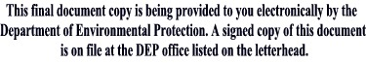
__________________________
Kenneth Kimmell, Commissioner

