INDOOR AIR QUALITY ASSESSMENT

Wollaston Elementary School
205 Beale St
Quincy, MA

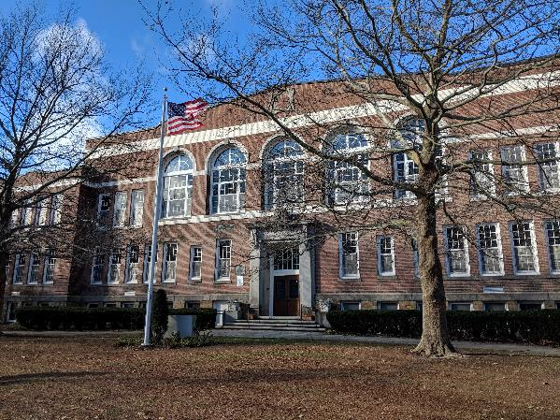

Prepared by:
Massachusetts Department of Public Health
Bureau of Environmental Health
Indoor Air Quality Program
March 2019

Background

Building: | Wollaston Elementary School
Address: | 205 Beale Street, Quincy, MA
Assessment Coordinated Through: | Kevin Segalla, Coordinator of Custodial Services
Reason for Request: | Water damage and general indoor air quality (IAQ) concerns
Date of Assessment: | November 27, 2018
Massachusetts Department of Public Health/Bureau of Environmental Health (MDPH/BEH) Staff Conducting Assessment: | Sharon Lee, Environmental Analyst,  IAQ Program
Date of Building Construction: | 1913
Building Description: | Two story brick structure with classrooms on the first and second floors. The basement level includes classrooms, offices, library, computer lab, and access to the cafetorium
Building Population: | Approximately 330 K-5 students and 35 staff
Windows: | Openable

IAQ Testing Results
Please refer to the IAQ Manual for methods, sampling procedures, and interpretation of results (MDPH, 2015). The following is a summary of indoor air testing results (Table 1).
- Carbon dioxide levels were above 800 parts per million (ppm) in more than half of the locations assessed, indicating that increased air exchange is warranted.
- Temperature was within or slightly below the recommended range of 70°F to 78°F on the day of assessment. Staff reported excessive heat/lack of temperature control.
- Relative humidity was within or slightly below the recommended range of 40 to 60 percent in the areas assessed.
- Carbon monoxide levels were non-detectable in all indoor areas tested.
- Fine particulate matter (PM2.5) concentrations measured were below the NAAQS limit of 35 μg/m³ in all areas.

Ventilation
A heating, ventilating, and air conditioning (HVAC) system has several functions. First, it provides heating and, if equipped, cooling. Second, it is a source of fresh air. Finally, an HVAC system will dilute and remove normally occurring indoor environmental pollutants by not only introducing fresh air but also filtering the airstream and ejecting stale air to the outdoors via exhaust ventilation. Even if an HVAC system is operating as designed, point sources of respiratory irritation may exist and cause symptoms in sensitive individuals.
Fresh air in the majority of classrooms is provided by unit ventilators (univents; Picture 1). Univents draw fresh air through a vent on the exterior wall (Picture 2). Air is mixed with return air from the room, filtered, heated (if needed), and delivered back to the room (Figure 1). Some univents were not operating at the time of the assessment, preventing the circulation of fresh air into the building. In addition, many univents were obstructed by items placed on top or blocking the front of the units (Pictures 3 and 4). Scented items placed on univents can be heated and the odors distributed (Picture 4). Both the top and the return vent at the bottom need to be kept clear of obstructions for the units to operate as designed.
Univent filters are reported to be changed three times a year. In examining the filters, MDPH/IAQ staff determined the filters to be a type that provides minimal filtration. Pleated filters with a minimum efficiency reporting value (MERV) of 8 are recommended because they can adequately filter out pollen and mold spores (ASHRAE, 2012). Note, however, that an increase in filtration can cause stress on equipment. The univents should be evaluated to determine if the higher-rated filters will allow adequate function.
It is important to note that univents in some area of the building are well over 50 years old. Efficient function of equipment of this age is difficult to maintain, since compatible replacement parts are often unavailable. According to the American Society of Heating, Refrigeration and Air-Conditioning Engineering (ASHRAE), the service life for the various components of the HVAC system is between 20 to 30 years, assuming routine maintenance of the equipment (ASHRAE, 1991).
Classrooms do not have mechanical exhaust ventilation. Areas serviced by univents originally relied on a gravity ventilation system and openable windows for fresh air movement/exhaust. Although the original gravity system was abandoned, many of the original components are still present.
As originally designed, fresh heated air was provided by a grated air vent located on the interior wall, near the ceiling in each classroom (Picture 5). An airshaft connected the vent to an air mixing chamber in the basement of the building. Inside the mixing chamber was a heating element that was connected to the school boiler. Airflow to the classroom was controlled by a pull-chain connected to a louver within the airshaft. A corresponding grated vent was observed at floor level, near the classroom door (Picture 6). This vent was likely connected to an exhaust ventilation shaft that ran from the roof to the basement’s air-mixing chamber. Classrooms were constructed around these shafts to provide exhaust ventilation. The exhaust ventilation shafts likely extended through the roof; however, the upper ends of these shafts were sealed during roof repair and replacement projects.
In its original design, air movement was provided by the “stack effect,” a term that describes how warm air rises and draws cold air into the air mixing chamber at the basement. Because of air temperature differences between the basement mixing room, classrooms, and outside, warm air (supplied to the classroom and created by radiators) eventually moves up the exhaust ventilation shaft located near the doorway. Warm air rising in the shaft to the outdoors creates a draw air from the classroom, thereby removing normally occurring pollutants.
Mr. Segalla reported that the supply and exhaust shafts were sealed at both ends (roof and basement). However, vents in the classroom were not sealed. Over time, dust and debris can collect in these shafts. Although air exchange within the shaft is limited, measures should be taken to seal these vents if there are no future plans to add mechanical ventilation components (e,g. exhaust fans) to these shafts to create exhaust ventilation.
Energy recovery ventilators were retrofitted in some areas that previously lacked mechanical ventilation (Picture 7). An energy recovery ventilator provides heated fresh air to the classroom, and removes stale air through the exhaust system. During warmer months, this unit can also help reduce indoor humidity. The unit has washable filters, which should be cleaned periodically.
A window-mounted air conditioner was observed in the teachers’ lounge. This equipment has a filter that can be washed. The filter should be washed periodically per manufacturer’s recommendations to ensure filtration when the system is operating.
Rooftop air-handling units (AHUs) provide fresh air to the multi-purpose gymnasium/ cafeteria/auditorium. Air from the AHUs is filtered, heated, and delivered to rooms via ducted supply vents. Air is returned to AHUs via wall-mounted return vents. The AHU was operating at the time of assessment.
Some areas lacked mechanical supply ventilation, relying on openable windows as the sole source of fresh air. Use of cross-ventilation can aid in air movement in these areas and throughout the school (Figures 2 and 3). Consideration should be given to retrofitting these areas with energy-recovery ventilators or other sources of mechanical ventilation.
In order to have proper ventilation with a mechanical supply and exhaust system, these systems must be balanced to provide an adequate amount of fresh air while removing stale air from a room. It is recommended that existing ventilation systems be re-balanced every five years to ensure adequate air systems function (SMACNA, 1994). It is unknown the last time these systems were balanced. Please note, balancing classroom univents may be difficult without mechanical exhaust ventilation.

Microbial/Moisture Concerns
Mold growth was reported in room 18, which is located at the rear of the basement level. Basement level classrooms in New England are prone to increased indoor humidity, particularly during the summer months. Mold was reported to grow on plastic/composite chairs and upholstered furniture. Mr. Segalla and Mr. Hennessey reported that items were either cleaned or removed following discovery of mold growth. Mold growth can occur on plastic/composite materials, however, these non-porous items can be cleaned and disinfected. In contrast, upholstered furniture can be difficult to clean; if mold-cotaminated materials cannot be readily washed and dried they should be discarded. When mold growth occurs, cleanup activities should be consistent with those recommended in the US Environmental Protection Agency’s Mold Remediation for Schools and Commercial Buildings guidance document (US EPA, 2008). Consideration should be given to placing classroom items (e.g. books, teaching aids) in plastic storage containers and storing them in less humid rooms to prevent any potential mold spores from settling on items. Porous items, such as cardboard boxes (Picture 8), should not be stored on basement floors as they may be subject to moistening due to leaks or condensation.
Dehumidifiers were provided to classroom 18 to reduce excess humidity (Picture 9). Dehumidifiers should be operated as much as practicable during times of high humidity. Dehumidifiers should be emptied regularly, and the water collection containers should be cleaned to prevent odors.
Both historic and active leaks were reported throughout the building. Water-damaged, ajar, missing, and bowing ceiling tiles were observed in many classrooms and hallways (Table 1). These conditions indicate leaks from the building envelope or plumbing system. Tiles should be replaced after a leak is found and repaired.
At the time of assessment, school staff reported an active leak in classroom 14. Missing ceiling tiles and water-damaged wall paint were also observed (Pictures 5 and 10). The damage observed was attributed to damage to an elbow in roof drain piping. This area should be cleaned and disinfected once the repair is complete. Porous materials, such as a corkboard, should be removed to allow the area to dry thoroughly before cleaning.
Breaches were observed between the counter and sink backsplashes in some classrooms (Picture 11; Table 1). If not watertight, water can penetrate through these seams. Water damage was also observed in sink cabinets. Water penetration and chronic exposure of porous and wood-based materials can cause these materials to swell and show other signs of water damage, which can subsequently lead to mold growth.
Plants were observed in a few areas, including on top of univents (Table 1). Plants can be a source of pollen and mold, which can be respiratory irritants to some individuals. Plants should be properly maintained and equipped with drip pans and should be located away from air diffusers to prevent the aerosolization of dirt, pollen, and mold.

Other IAQ Evaluations
Damaged floor tiles were observed in the basement area (Picture 12). Given the age of the building, these floor tiles may contain asbestos. Intact asbestos-containing materials do not pose a health hazard. If damaged, asbestos-containing materials can be rendered friable and become aerosolized. Any damage to tile should be remediated by a licensed asbestos remediation firm in accordance with state and federal regulations. In 1986, the Asbestos Hazard Emergency Response Act [AHERA; Asbestos Containing Materials (ACM) in Schools, 40 CFR Part 763, Subpart E] was enacted. AHERA requires the inspection of schools for asbestos containing building materials (location, type, and condition) and preparation of management plans which recommend the best way to reduce asbestos hazards (US EPA, 1986). Under AHERA, facilities are required to be inspected for asbestos containing material (visually every six months and comprehensively every three years by an accredited inspector). The Massachusetts Department of Labor Standards (MDLS) Asbestos Program provides technical assistance to schools in Massachusetts by reviewing management plans and conducting on-site assessments for compliance with AHERA. In addition, MDLS regulates asbestos abatement in schools and other buildings through its regulations, licensing, site visits, and enforcement.
Exposure to low levels of total VOCs (TVOCs) may produce eye, nose, throat, and/or respiratory irritation in some sensitive individuals. To determine if VOCs were present, BEH/IAQ staff examined rooms for products containing VOCs. BEH/IAQ staff noted hand sanitizers, cleaning products, air fresheners and deodorizers, and dry erase materials in use within the building (Pictures 4 and 13; Table 1). These products have the potential to be irritants to the eyes, nose, throat, and respiratory system of sensitive individuals. Note that an essential oil diffuser was observed in one area (Picture 14). These units are designed to release a mist infused with fragrant oil. Synthetic and natural fragrances can trigger irritation in more sensitive individuals. Furthermore, the water wells can be a source for bacterial growth if not cleaned regularly. Attached as Appendix A is the BEH/IAQ guidance document “Clean Air is Odor-free” for more information about fragrances.
Photocopiers were observed in a few areas. Photocopiers can emit ozone and TVOCs, especially when they are older or heavily used. Exhaust ventilation can help reduce the accumulation of heat, odor, and pollutants.
Carpeting was observed inside the univent cabinets (Picture 15). The carpet appears to be original to the installation of univent, and was not removed when the classroom carpet was replaced with vinyl floor tiles. The carpet should be vacuumed periodically to prevent dust accumulation. If water from a pipe leak damages carpeting within the univent cabinet, measures should be taken to ensure that the carpet is dried immediately.
A few classrooms have area rugs, which should also be cleaned regularly and discarded when too worn out or soiled to be cleaned. Plush and upholstered items such as couches, pillows, and toys were also observed. These items should be cleaned regularly to remove the build-up of oils and debris.
Personal fans were observed in many classrooms. Some of these had dusty blades (Picture 16; Table 1). This dust can be reaerosolized when the equipment is activated.
In many areas, items, including books, papers, toys and decorative items were observed on floors, windowsills, tabletops, counters, bookcases, and desks (Picture 17; Table 1), which can make it more difficult for custodial staff to clean. In basement areas in particular, water damage can be difficult to identify. In a few classrooms, items were hanging from the ceiling, which can collect dust. Disruption of the ceiling tile system, including hanging items and missing or ajar tiles, can allow unconditioned air and debris from above the ceiling to enter occupied spaces.
In some classrooms, tennis balls had been sliced open and placed on table/chair footings to reduce noise (Picture 18; Table 1). Tennis balls are made of a number of materials that are a source of respiratory irritants. Constant wearing of tennis balls can produce fibers and lead to off-gassing of VOCs. Tennis balls are made with a natural rubber latex bladder, which becomes abraded when used as a chair leg pad. Use of tennis balls in this manner may introduce latex dust into the school environment. Some individuals are highly allergic to latex (e.g., spina bifida patients) (SBAA, 2001). It is recommended that the use of materials containing latex be limited in buildings to reduce the likelihood of symptoms in sensitive individuals (NIOSH, 1997; NIOSH, 1998).
Note that EPA conducted a National School Radon Survey in which it discovered nearly one in five schools had “…at least one frequently occupied ground contact room with short-term radon levels above 4 [picocuries per liter] pCi/L” (US EPA, 1992). The BEH/IAQ Program therefore recommends that every school be tested for radon, and that this testing be conducted during the heating season while school is in session in a manner consistent with USEPA radon testing guidelines. Radon measurement specialists and other information can be found at www.nrsb.org and http://aarst-nrpp.com/wp, with additional information at: http://www.mass.gov/eohhs/gov/departments/dph/programs/environmental-health/exposure-topics/iaq/radon.

Conclusions/Recommendations
The following recommendations are made to assist in improving IAQ:
- Operate all supply and exhaust ventilation equipment continuously during occupied periods. Consider adjusting univent dampers to increase fresh air to the building.
- Use openable windows to supplement fresh air during temperate weather. During winter, consider opening windows slightly to increase air movement. Cross ventilation (e.g., opening windows and classroom doors on opposing sides of the building) can rapidly increase air circulation in a building. Ensure all windows are tightly closed at the end of the day.
- Contact an HVAC professional to determine if restoring classroom exhaust ventilation is feasible.
- Remove items and furniture blocking univents.
- Ensure univent tops and interiors are vacuumed during filter changes. Ensure carpet stays dry. Consider removing carpet from univent cabinets during future equipment replacement work.
- Consider upgrading to a pleated filter of MERV 8 in univents and AHUs, if these can be used with the current equipment. Continue to change filters 2-4 times a year.
- Consider adopting a balancing schedule of every 5 years for all mechanical ventilation systems, as recommended by ventilation industrial standards (SMACNA, 1994).
- Continue with plans to install energy recovery ventilators or other mechanical ventilation in rooms that lack mechanical ventilation equipment.
- Ensure filters energy recovery ventilators and window-mounted air conditioning units are cleaned regularly.
- Maintain rooftop AHUs and change filters regularly to ensure proper function.
- Use dehumidifiers during periods of increased humidity, particularly in below grade areas. Install additional units as necessary. Ensure dehumidifiers are emptied regularly and water collection wells are disinfected periodically to prevent odors.
- Ensure porous materials (paper, cardboard, cloth) are not placed directly on the floor when items are stored. Consider placing all items routinely stored in the basement into resealable, air tight containers to prevent mold growth during the summer.
- Discard porous materials that are colonized by mold.
- Examine the roof and ensure the rubber membrane roof and roof drains are intact. Make repairs as needed to prevent leakage and poor drainage.
- Ensure roof and plumbing leaks, including the active leak in classroom 14, are repaired and replace water-damaged ceiling tiles.
- Repair water-damaged building materials in classrooms, hallways, and activity areas after repairs to the building exterior and roof are made.
- Properly maintain indoor plants, including drip pans, to prevent water damage to porous materials. Plants should also be located away from air diffusers to prevent the aerosolization of dirt, pollen, and mold.
- Use caulking to seal gap between sink backsplash and countertop.
- Contact a licensed asbestos professional to examine damaged floor tiles in the basement. If these tiles contain asbestos, encapsulate or remove as recommended by the professional.
- Review the school’s AHERA. If an asbestos assessment has not been completed in the last three years, contact the MDLS for assistance.
- Reduce use of products and equipment that create VOCs and ozone and only use in well-ventilated areas. Avoid the use of air freshening products including plug-ins and sprays.
- Ensure exhaust ventilation is operating in areas with photocopiers and laminators.
- Remove essential oil diffusers to prevent the dissemination of potential respiratory irritants in the air.
- Consider reducing the amount of items stored in classrooms to make cleaning easier. Periodically move items to clean flat surfaces.
- Avoid hanging items from the ceiling tile system. Ensure all tiles are flush with the ceiling tile grid.
- Clean upholstered and plush items regularly to remove oils, dust, and debris.
- Clean area rugs regularly and discard those that are worn out or too soiled to be cleaned.
- Clean fan blades of fans to prevent aerosolization of dust when the unit is operating.
- Ensure all refrigerators are kept clean to prevent microbial growth and odors. Clean gaskets and other surfaces with a mild antimicrobial solution to remove debris and mold. Clean in and around food appliances regularly.
- Replace tennis balls on chair/table footings with latex-free glides.
- Continue to adopt the US EPA (2009) document, “Tools for Schools”, as an instrument for maintaining a good IAQ environment in the building available at: http://www.epa.gov/iaq/schools/index.html.
- The school should be tested for radon by a certified radon measurement specialist during the heating season when school is in session. Radon measurement specialists and other information can be found at: www.nrsb.org, and http://aarst-nrpp.com/wp/.
- Refer to resource manual and other related IAQ documents located on the MDPH’s website for further building-wide evaluations and advice on maintaining public buildings. These documents are available at: http://mass.gov/dph/iaq.

References
ASHRAE. 1991. ASHRAE Applications Handbook, Chapter 33 “Owning and Operating Costs”. American Society of Heating, Refrigeration and Air Conditioning Engineers, Atlanta, GA.
ASHRAE. 2012. American Society of Heating, Refrigeration and Air Conditioning Engineers (ASHRAE) Standard 52.2-2012 -- Method of Testing General Ventilation Air-Cleaning Devices for Removal Efficiency by Particle Size (ANSI Approved). 2012.
MDPH. 2015. Massachusetts Department of Public Health. “Indoor Air Quality Manual: Chapters I-III”. Available at: http://www.mass.gov/eohhs/gov/departments/dph/programs/environmental-health/exposure-topics/iaq/iaq-manual/.
NIOSH. 1997. National Institute for Occupational Safety and Health. Alert Preventing Allergic Reactions to Natural Rubber latex in the Workplace. National Institute for Occupational Safety and Health, Atlanta, GA.
NIOSH. 1998. National Institute for Occupational Safety and Health. Latex Allergy A Prevention. National Institute for Occupational Safety and Health, Atlanta, GA.
SBAA. 2001. Latex In the Home And Community Updated Spring 2001. Spina Bifida Association of America, Washington, DC.
SMACNA. 1994. HVAC Systems Commissioning Manual. 1st ed. Sheet Metal and Air Conditioning Contractors’ National Association, Inc., Chantilly, VA.
US EPA. 1986. Asbestos Hazard Emergency Response Act. Hazard Emergency Response Act of 1986 (AHERA) Public Law 99-519, Oct 22, 1986. 15 USC Section 2651.
US EPA. 1992. Radon Measurement in Schools, Revised Edition. Office of Air and Radiation, Office of Radiation and Indoor Air, Indoor Environments Division (6609J). EPA 402-R-92-014. https://www.epa.gov/sites/production/files/2014-08/documents/radon_measurement_in_schools.pdf
US EPA. 2008. Mold Remediation in Schools and Commercial Buildings. US Environmental Protection Agency, Office of Air and Radiation, Indoor Environments Division, Washington, D.C. EPA 402-K-01-001. http://www.epa.gov/mold/mold-remediation-schools-and-commercial-buildings-guide.
US EPA. 2009. Tools for Schools. Office of Air and Radiation, Office of Radiation and Indoor Air, Indoor Environments Division (6609J). EPA 402-K-95-00. https://www.epa.gov/iaq-schools.
Picture
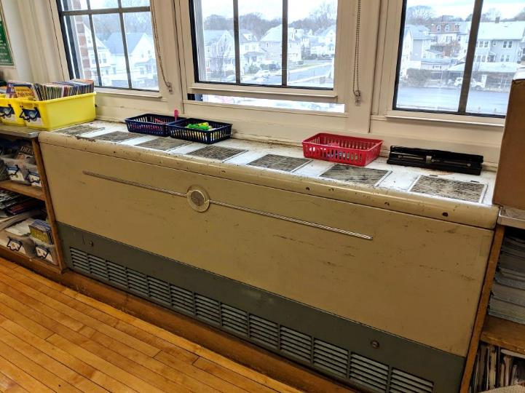
Classroom univent
Picture
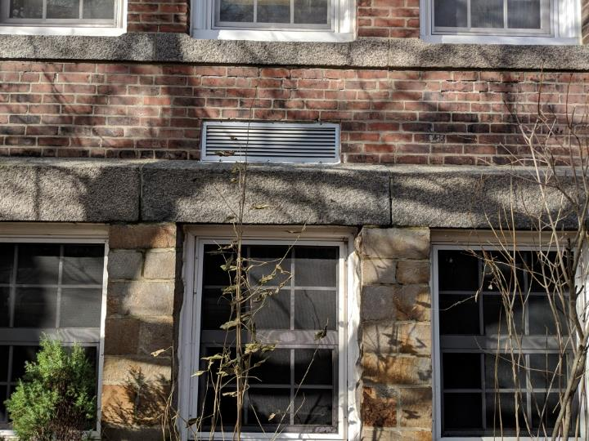
Univent fresh air intake
Picture
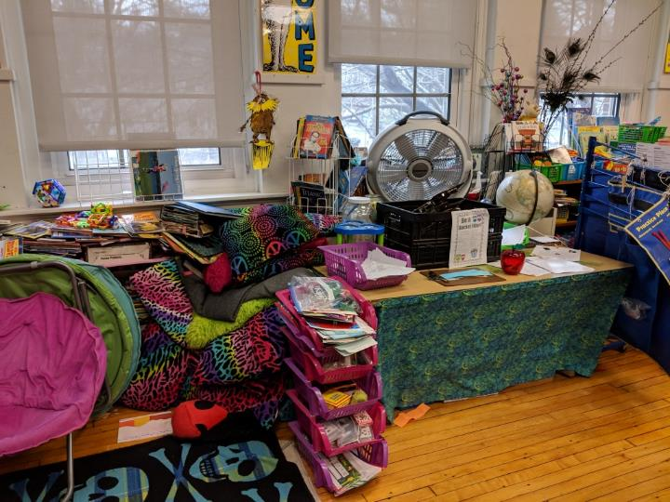
Items in front and on top of univent
Picture
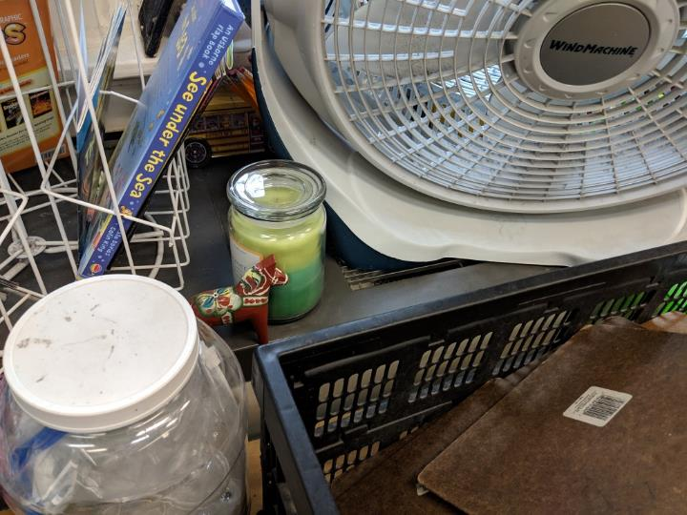
Scented candle on univent
Picture
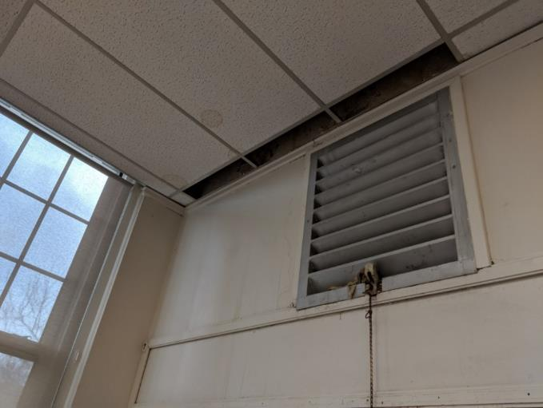
Original equipment that brought heat into a classroom, note water-damaged ceiling tiles and missing tiles
Picture
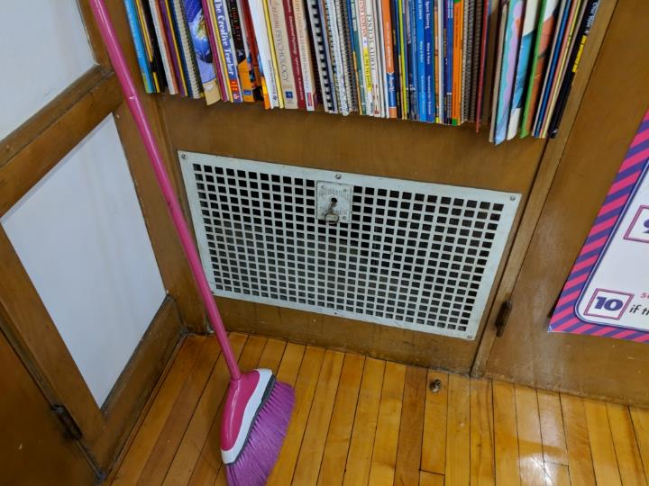
Original equipment that brought provided exhaust to a classroom
Picture
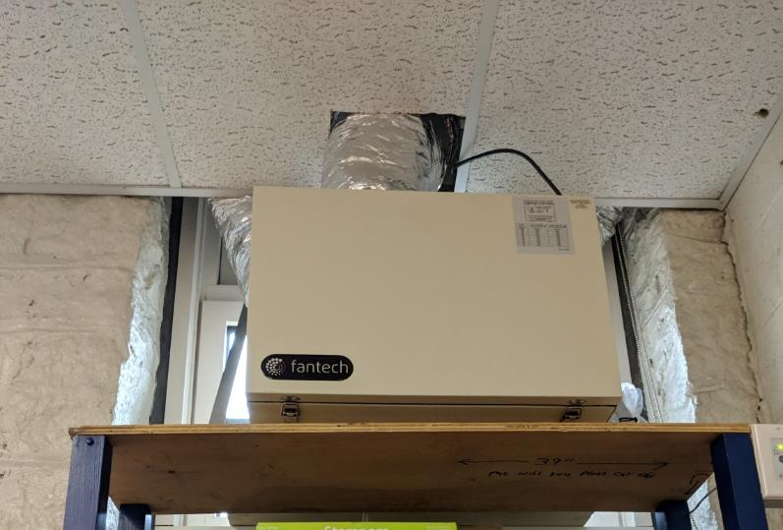
Energy recovery ventilator
Picture
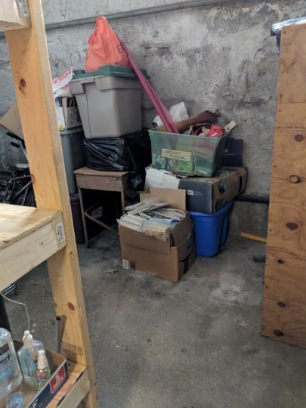
Cardboard box stored on basement floor
Picture
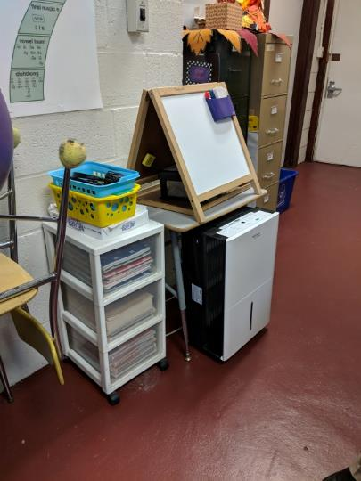
Dehumidifier
Picture
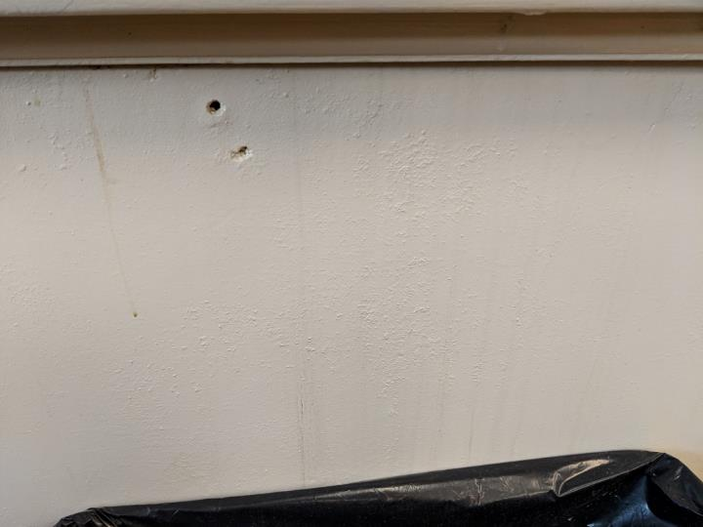
Water stains on classroom wall
Picture
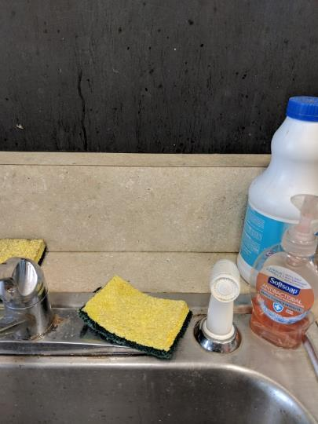
Breach between sink countertop and backsplash
Picture
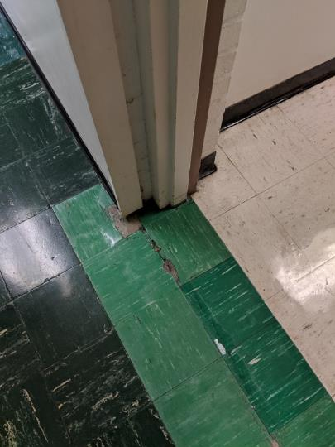
Damaged floor tiles in basement
Picture
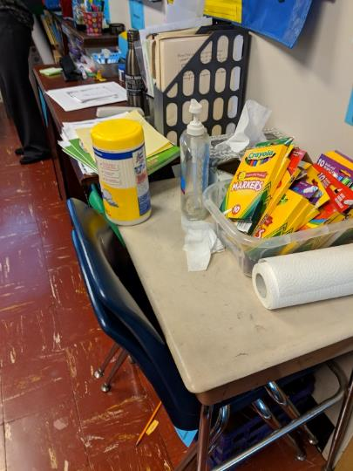
Cleaning products and hand sanitizer
Picture
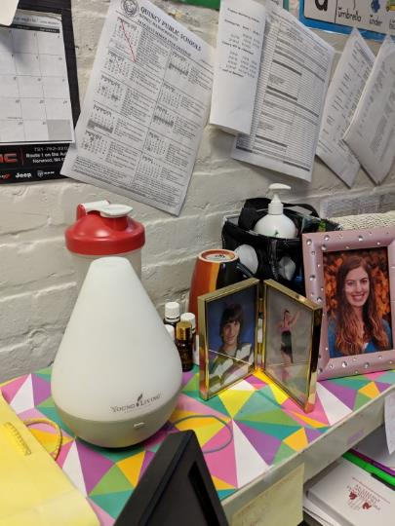
Essential oil air diffuser
Picture
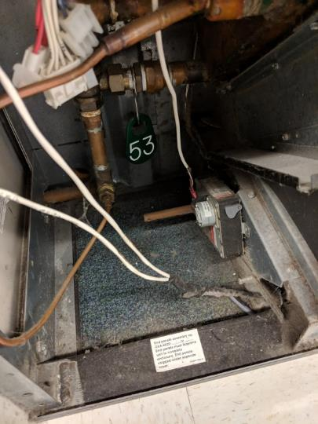
Carpeting inside univent cabinet
Picture
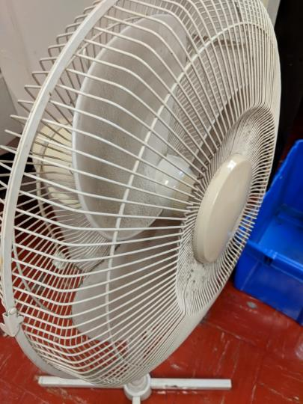
Dusty blades of a personal fan
Picture
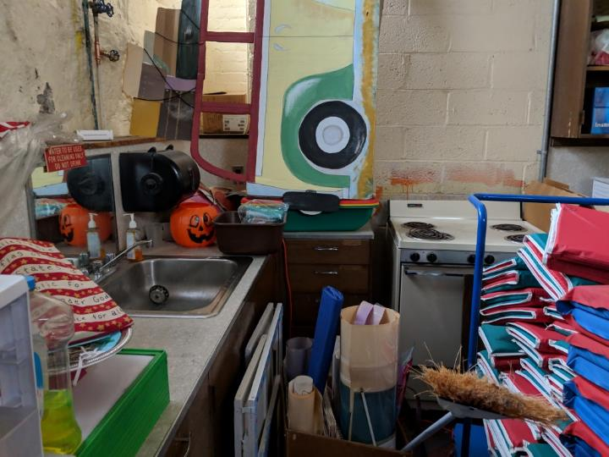
Unorganized items in storage area
Picture
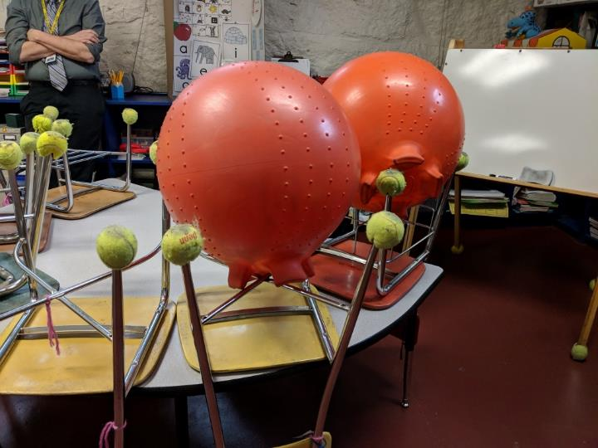
Tennis balls on chairs
Location | Carbon  Dioxide  (ppm) | Carbon Monoxide  (ppm) | Temp  (°F) | Relative  Humidity  (%) | PM2.5  (µg/m3) | Occupants  in Room | Windows  Openable | Ventilation |  | Remarks
 |  |  |  |  |  |  |  | Supply | Exhaust
Background | 390 | ND | 51 | 46 | 13
Boiler room |  | ND | 72 | 31 |  |  |  |  | N
Hunt | 849 | ND | 73 | 38 | 5 | 0 | N | N | N | CPs, WD-CTs
Vandersheet | 784 | ND | 74 | 37 | 3 | 0 | Y | N | N
Speech/language | 874 | ND | 73 | 38 | 3 | 5 | Y | N | N | HS,CPs, DO, DEM
ELL | 945 | ND | 74 | 36 | 1 | 3 | N | passive | N | CPs, DEM
Gym | 473 | ND | 69 | 35 | 3 | 3 | Y | Y | N
Teachers' lounge | 789 | ND | 75 | 33 | 2 | 5 | Y | Y | N | CPs, copier, WAC, DO
Principal's Office | 739 | ND | 75 | 32 | 7 | 0 | Y | N | N | plants
Main office | 668 | ND | 76 | 31 | 4 | 1 | Y | N | N | MT, DO
Nurse's office | 686 | ND | 76 | 32 | 2 | 0 | Y | N | N | DO, HS
1 | 1043 | ND | 75 | 33 | 3 | 0 | Y | Y  items |  | AD, CPs, DEM, DO
2 | 1431 | ND | 76 | 37 | 3 | 0 | Y | Y items, blocked | N | PF, DEM, TB, DO, HS
3 | 932 | ND | 76 | 34 | 3 | 0 | Y | Y | N | CPs, TB, DEM
4a | 720 | ND | 75 | 33 | 2 | 5 | Y | Y | N | DO
5 | 594 | ND | 75 | 30 | ND | 0 | Y | Y  items | N | DO, DEM, CPs, HS
6 | 718 | ND | 75 | 33 | 4 | 0 | Y | Y  items | N | DEM, CPs, HS, PF
7 | 767 | ND | 75 | 33 | 4 | 0 | Y | Y | N | DEM, CPs, HS, essential oil diffuser
8 | 707 | ND | 75 | 32 | 4 | 2 | Y | Y | N | DO, DEM, CPs, HS
9 | 1316 | ND | 75 | 39 | 3 | 0 | Y | Y | N | PF, DEM
10 | 1568 | ND | 75 | 37 | 4 | 0 | Y | Y | N | PF, CPs, DEM, DO
11 | 1131 | ND | 75 | 37 | 3 | 16 | Y | Y  off, items | N | DEM in use (odors), CPs, TB
12 | 975 | ND | 75 | 46 | 3 | 19 | Y | Y off | N | CPs, DEM, DO
13 | 1556 | ND | 73 | 45 | 3 | 19 | Y | Y  items | N | PF, HS, DEM, CPs, WD-CTs, items
14 | 1313 | ND | 72 | 44 | 3 | 15 | Y | Y  items | N | MT, roof drain leak - plans for repair, WD-CTs, CPs, HS, DEM, DO
15 | 1148 | ND | 75 | 40 | 3 | 21 | Y | Y  off | N | PF, CPs, DO, DEM
16 | 1120 | ND | 76 | 36 | 3 | 18 | Y  open | Y | N | PF, WD-CTs, DEM
17 | 1144 | ND | 76 | 35 | 3 | 0 | Y | Y | N | PF, DEM, CPs
18A | 940 | ND | 68 | 46 | 7 | 4 | Y | Y | N | reported mold growth on chairs, TB, HS, CPs, DEM, PF, essential oil diffuser
18 | 1132 | ND | 71 | 43 | 8 | 21 | Y | Y  off | N | DEM, CPs, HS, MTs
19 | 942 | ND | 72 | 34 | 3 | 20 | Y  open | N | N | items, CPs
19a | 530 | ND | 71 | 33 | 2 | 0 | Y  open | N | N | DEM, TB, HS, humidifier
20 | 1009 | ND | 74 | 41 | 3 | 1 | Y | Y | N | DEM, PF, HS, DO
21 | 1424 | ND | 73 | 43 | 4 | 12 | Y | N | N | PF, HS, CPs, AT
22 | 946 | ND | 71 | 37 | 4 | 11 | Y  open | N | N | CPs, HS, MTs, WD-CTs, stored items on floor

The service life is the median time during which a particular system or component of …[an HVAC]… system remains in its original service application and then is replaced. Replacement may occur for any reason, including, but not limited to, failure, general obsolescence, reduced reliability, excessive maintenance cost, and changed system requirements due to such influences as building characteristics or energy prices (ASHRAE, 1991).

