MOLD Assessment

Wollaston Elementary School
205 Beale Street
Quincy, MA 02170

Prepared by:
Massachusetts Department of Public Health
Bureau of Environmental Health
Indoor Air Quality Program
January 2014

Background/Introduction
At the request of Kevin Segalla, Coordinator of Custodial Services, Quincy Public Schools (QPS), the Massachusetts Department of Public Health (MDPH), Bureau of Environmental Health (BEH) conducted an assessment at the Wollaston Elementary School (WES), located at 205 Beale Street, Quincy, Massachusetts. The request was prompted by concerns related to water damage and mold. On September 30, 2013, a visit was made to the WES by Sharon Lee, an Environmental Analyst within BEH’s Indoor Air Quality (IAQ) Program. Ms. Lee was accompanied by Mr. Segalla and James Hennessy, Principal.
BEH/IAQ staff conducted a limited assessment of the building focused on sources of water vapor/moisture in the lowest level of the WES. The overall function of the heating, ventilating, and air-conditioning (HVAC) system was not assessed during this visit.
The WES is a three-story building, constructed in 1913. A portion of the lowest level is built into a hill and below grade. The lowest level of the building contains classrooms, offices, and general use spaces. Windows throughout the building are openable.

Methods
Air tests for temperature and relative humidity were conducted with the TSI, Q-Trak, IAQ Monitor, Model 7565. Moisture content of wall materials was measured using a Delmhorst BD-2100 Moisture Meter. BEH/IAQ staff also performed a visual inspection of building materials for water damage and/or microbial growth.

Results
The WES serves approximately 340 pre-K to fifth grade students with approximately 40 staff. Measurements were taken while the school was occupied and appear in Table 1.

Discussion

Microbial/Moisture Concerns
Mr. Segalla and Mr. Hennessy reported mold growth was observed on walls and school furniture (e.g. upholstered chairs) and educational materials (e.g. fabric-bound items, paper) in the lowest level of the building in August of 2013 prior to school opening for the year. Damaged furniture and educational materials were reportedly discarded and replaced, and building surfaces were cleaned and disinfected.
On the day of assessment, the outdoor relative humidity was measured at 65 percent (Table 1). Indoor relative humidity ranged from 56 to 61 percent, which was lower than outdoor relative humidity. The MDPH recommends a comfort range of 40 to 60 percent for indoor air relative humidity. Please note, average outdoor relative humidity levels were above 70 percent for several consecutive days each at various times during July, August, and September of 2013 (Weather Underground, 2013). According to the American Society of Heating Refrigeration and Air-Conditioning Engineers (ASHRAE), relative humidity in excess of 70 percent for an extended period of time can provide an environment for mold and fungal growth in building materials (ASHRAE, 1989).
Temperatures in the building were measured in a range of 70°F to 72°F (Table 1) which were within the MDPH comfort range. The MDPH recommends that indoor air temperatures be maintained in a range of 70ºF to 78ºF in order to provide for the comfort of building occupants.
The dew point was also measured in the building. Dew point is another way of representing humidity; the dew point is the temperature at which the water vapor in the air will start to condense. If a surface in contact with the air has a temperature at or below the dew point, it will collect condensation and become wet. Dew points in the building ranged from 54°F to 66°F on the day of assessment (Table 1). The dew point measured at the time of the visit indicates that condensation formation was not likely for the conditions observed at that time; however, condensation is more likely in this area during hot humid weather.
BEH/IAQ staff examined gypsum wallboard (GW) in basement-level offices and classrooms. Water damage was observed on GW in some areas, particularly in a suite of offices including the Guidance office (Picture 1). Mold growth was observed on GW underneath plastic wall coving, which was removed for inspection (Picture 2). Using a moisture meter, BEH/IAQ staff also determined GW in these areas had elevated moisture levels.
The US Environmental Protection Agency (US EPA) and the American Conference of Governmental Industrial Hygienists (ACGIH) recommends that porous materials be dried with fans and heating within 24 to 48 hours of becoming wet (US EPA, 2001; ACGIH, 1989). If porous materials are not dried within this time frame, mold growth may occur. Water-damaged porous materials cannot be adequately cleaned to remove mold growth. The application of a mildewcide to moldy porous materials is not recommended.
Finally, BEH staff observed water-damaged ceiling tiles. Common sources contributing to water damage of ceiling tiles include leaks from pipes, and water penetration through the building exterior (e.g., roof or window leaks). Water-damaged ceiling tiles should be replaced after the source of moisture has been identified and remediated.

Conclusions/Recommendations
As noted previously, this assessment was focused on identifying sources of moisture in the lowest level of the building. Upon request, the BEH IAQ Program can return to the building conduct a full IAQ evaluation during the heating season. In view of the findings at the time of the visit, the following is recommended:
- Remove water-damaged GW in accordance with the recommendations outlined by the EPA (2001) guidance: “Mold Remediation in Schools and Commercial Buildings”.
- Consider replacing partition walls with cement board, which is less likely to wick water than GW.
- Consider painting the stone basement wall with an appropriately-formulated paint rather than erecting a full wall against the exterior. This can prevent future moisture concerns with GW.
- Refrain from storing cloth, paper, and other porous materials in the basement during hot, humid weather. Materials that are stored in the basement should be placed in airtight containers to avoid exposure to moist air.
- Replace water-damaged ceiling tiles.
- Consider replacing cloth-bound chairs with chairs consisting of easy to clean surfaces (e.g. plastic, vinyl, or leather).
- Employ methods outlined in the document “Preventing Mold Growth in Massachusetts Schools During Hot, Humid Weather” (Appendix A) to prevent water damage from hot, humid weather.
- Consider adopting the US EPA (2000) document “Tools for Schools” to maintain a good indoor air quality environment in the building. This document can be downloaded from the Internet at http://www.epa.gov/iaq/schools/index.html.
- Refer to resource manuals and other related indoor air quality documents for further building-wide evaluations and advice on maintaining public buildings. Copies of these materials are located on the MDPH’s website: http://mass.gov/dph/iaq.

References
ASHRAE. 1989. ASHRAE Standard: Ventilation for Acceptable Indoor Air Quality. Sections 5.11, 5.12. American Society of Heating, Refrigerating and Air-Conditioning Engineers, Inc. Atlanta, GA.
ACGIH. 1989. Guidelines for the Assessment of Bioaerosols in the Indoor Environment. American Conference of Governmental Industrial Hygienists, Cincinnati, OH.
IICRC. 2000. IICRC S001. Reference Guideline for Professional On-Location Cleaning of Textile Floor Covering Materials. Institute of Inspection, Cleaning and Restoration Certification. Institute of Inspection Cleaning and Restoration, Vancouver, WA.
US EPA. 2000. Tools for Schools. Office of Air and Radiation, Office of Radiation and Indoor Air, Indoor Environments Division (6609J). EPA 402-K-95-001, Second Edition. http://www.epa.gov/iaq/schools/index.html.
US EPA. 2001. “Mold Remediation in Schools and Commercial Buildings”. Office of Air and Radiation, Indoor Environments Division, Washington, DC. EPA 402-K-01-001. March 2001. Available at: http://www.epa.gov/iaq/molds/mold_remediation.html.
Weather Underground. 2013. Weather History for Boston, July 1, 2013 to September 29, 2013. Retrieved from http://www.wunderground.com/history/airport/KBOS/2013/7/1/CustomHistory.html?dayend=29&monthend=9&yearend=2013&req_city=NA&req_state=NA&req_statename=NA

Picture 1
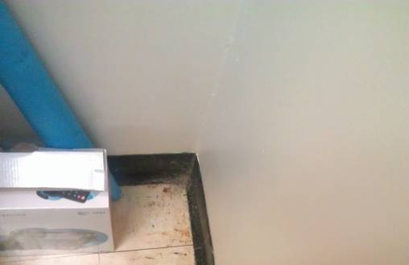
Water-damaged GW, note bubbled paint and stained floor tiles
Picture 2
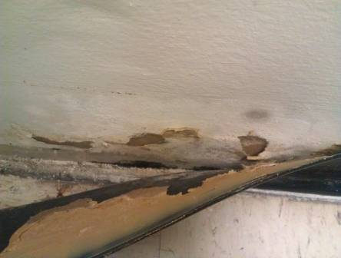
Mold growth behind plastic coving
Location/ Room |  | Temp (°F) |  | Relative Humidity (%) |  | Dew Point |  | Occupants  in Room | Windows Openable | Ventilation |  | Remarks
 |  |  |  |  |  |  |  |  |  | Supply | Exhaust
 | Background |  | 58 |  | 65 |  | 51
 | 18 |  | 71 |  | 56 |  | 54 | 10 | Y | N | N | TB, items
 | 19 |  | 70 |  | 61 |  | 56 | 20 | Y | N | N
 | 20 |  | 72 |  | 57 |  | 56 | 20 | N | N | N
 | 21 |  | 72 |  | 57 |  | 56 | 5 | N | N | N
 | 22 |  | 72 |  | 58 |  | 55 | 10 | N | N | N
 | ELL |  | 70 |  | 56 |  | 55 | 7 | Y | N | N
 | Guidance |  | 71 |  | 58 |  | 55 | 1 | N | N | N | WD-CTs, GW – elevated moisture level
 | Psychologist |  | 72 |  | 57 |  | 55 | 0 | N | N | N | GW - elevated moisture level; DO, WD-CT from steam pipe
 | Speech |  | 71 |  | 57 |  | 55 | 1 | N | N | N | GW - elevated moisture level; DO, TB

Condensation is the collection of moisture on a surface with a temperature below the dew point. The dew point is a temperature determined by air temperature and relative humidity. For example, at a temperature of 73º F and relative humidity of 57 percent indoors, the dew point for water to collect on a surface is approximately 57 º F (IICRC, 2000).

