Massachusetts Department of Public Health
Bureau of Infectious Disease and Laboratory Sciences
Massachusetts HIV Epidemiologic Profile: Data as of 7/1/2024
Population Report: Women, Accessible Version, optimized for screen reader use
Please note that while the content of this report is the same as the PDF version, the format and pagination have been modified significantly to optimize use with screen readers to ensure access for audiences who are blind or visually impaired.
Suggested citation:
Massachusetts Department of Public Health, Bureau of Infectious Disease and Laboratory Sciences. Massachusetts HIV Epidemiologic Profile: Data as of 7/1/2024, Population Report: Women, https://www.mass.gov/lists/hivaids-epidemiologic-profiles Published December 2024. Accessed [date].
Bureau of Infectious Disease and Laboratory Sciences
Massachusetts Department of Public Health
Jamaica Plain Campus/State Public Health Laboratory
305 South Street
Jamaica Plain, MA 02130
Questions about this report
Tel: (617) 983-6560
To reach the Reporting and Partner Services Line
Tel: (617) 983-6999
To speak to the on-call epidemiologist
Tel: (617) 983-6800
Questions about infectious disease reporting
Tel: (617) 983-6801
HIV Data Dashboard
https://www.mass.gov/info-details/hiv-data-dashboard
Requests for additional data
https://www.mass.gov/lists/infectious-disease-data-reports-and-requests
Slide sets for HIV Epidemiologic Profile Reports
https://www.mass.gov/lists/hivaids-epidemiologic-profiles

Please note the following data among women represent that of individuals assigned female at birth (AFAB) only and therefore do not represent the gender identity or expression of transgender women (N=18 transgender women diagnosed with HIV infection from 2021–2023 and N=128 transgender women living with HIV infection in Massachusetts as of 12/31/2023, according to data current as of 7/1/2024). These data may include transgender men diagnosed with HIV infection, who were assigned female sex at birth.
HIV INCIDENCE AND PREVALENCE AMONG WOMEN
N=396, 28% of 1,435 new HIV diagnoses from 2021–2023 were among individuals AFAB
N=7,016, 29% of 24,119 persons living with HIV infection in MA as of 12/31/2023 were individuals AFAB

RACE/ETHNICITY
FIGURE 1. Percentage of individuals AFAB diagnosed with HIV infection by race/ethnicity, Massachusetts 2021–2023 (N=396)
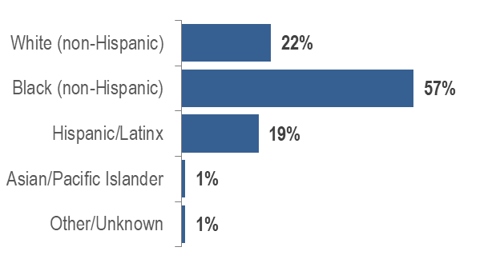
- Fifty-seven percent of individuals AFAB recently diagnosed with HIV infection were Black (non-Hispanic), 22% were White (non-Hispanic), 19% were Hispanic/Latinx, 1% were Asian/Pacific Islander, and 1% were other/unknown race/ethnicity.
- Forty-eight percent of individuals AFAB living with HIV infection were Black (non-Hispanic), 28% were Hispanic/Latinx, 21% were White (non-Hispanic), and 2% were other/unknown race/ethnicity.

FIGURE 2. Average age-adjusted rate of HIV infection diagnosis per 100,000 population among individuals AFAB by race/ethnicity, Massachusetts 2021–2023
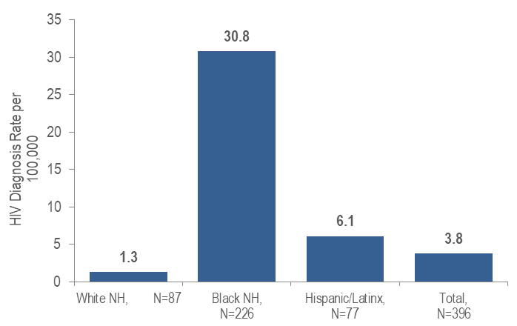

Note: Total includes other/unknown race/ethnicities (N=6)
KEY FINDING
- The average annual age-adjusted HIV diagnosis rate for 2021 to 2023 among Black (non-Hispanic) individuals AFAB was 24 times, and among Hispanic/Latinx individuals AFAB was five times, that of White (non-Hispanic) individuals AFAB.

FIGURE 3. Age-adjusted HIV prevalence rate per 100,000 population among individuals AFAB by race/ethnicity, Massachusetts 2023
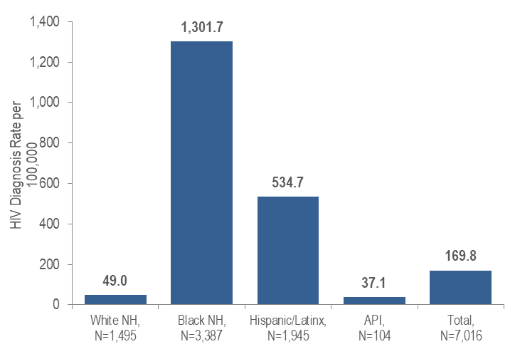
Note: Total includes other/unknown race/ethnicities (N=85)
KEY FINDING
- The age-adjusted prevalence rate of HIV infection among Black (non-Hispanic) individuals AFAB was 27 times, and among Hispanic/Latinx individuals AFAB was 11 times, greater than the rate among White (non-Hispanic) individuals AFAB.

EXPOSURE MODE
- Forty-seven percent of 396 individuals AFAB diagnosed with HIV infection during 2021 to 2023 were reported with presumed heterosexual exposure mode, 27% with no identified risk, 13% with injection drug use, 12% with heterosexual sex, and 1% with other exposure modes.
- Thirty-three percent of 7,016 individuals AFAB living with HIV infection on 12/31/2023 were reported with heterosexual exposure mode, 32% with presumed heterosexual, 17% with injection drug use, 14% with no identified risk, and 3% with other exposure modes.
FIGURE 4. Individuals AFAB diagnosed with HIV infection by race/ethnicity and exposure mode, Massachusetts 2021–2023
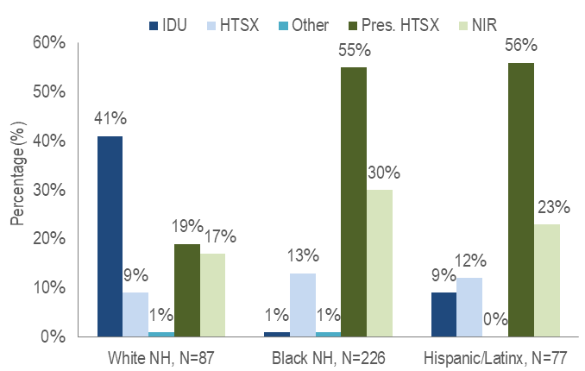
IDU=injection drug use; HTSX=heterosexual sex; Pres. HTSX=presumed heterosexual exposure, includes individuals assigned female at birth with a negative history of injection drug use who report having sex with an individual that identifies as male of unknown HIV status and risk; NIR=no identified risk; NH=non-Hispanic
- Injection drug use was the predominant exposure mode among White (non-Hispanic) individuals AFAB recently diagnosed with HIV infection (41%), while presumed heterosexual sex accounted for the largest proportions among Black (non-Hispanic) (55%) and Hispanic/Latinx (56%) individuals AFAB.

PLACE OF BIRTH
- Sixty-one percent of 396 individuals AFAB diagnosed with HIV infection during 2021 to 2023 were born outside the US [compared to 39% of 1,039 individuals assigned male at birth (AMAB)], 37% were born in the US (compared to 59% of individuals AMAB), and 2% were born in Puerto Rico/US Dependency (compared to 3% of individuals AMAB).
- Forty-five percent of 7,016 individuals AFAB living with HIV infection on 12/31/2023 were born outside US (compared to 64% of 17,103 individuals AMAB), 44% were born in the US (compared to 28% of individuals AMAB), and 11% were born in Puerto Rico/US Dependency (compared to 8% of individuals AMAB).
FIGURE 5. Percentage of individuals AFAB diagnosed with HIV infection by race/ethnicity and place of birth, Massachusetts 2021–2023
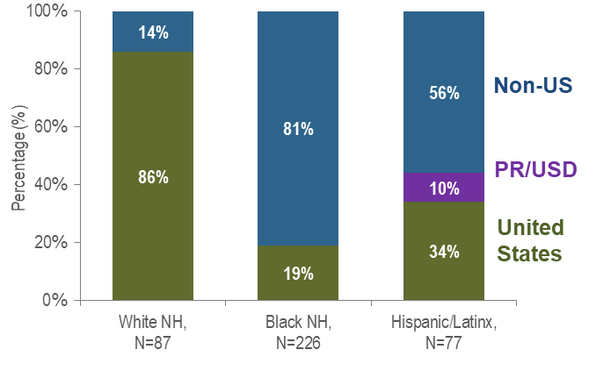
PR/USD = Puerto Rico/US Dependency
KEY FINDING
- Eighty-one percent of Black (non-Hispanic) individuals AFAB recently diagnosed with HIV infection were born outside the US, compared to 56% of Hispanic/Latinx and 14% of White (non-Hispanic) individuals AFAB. An additional 10% of Hispanic/Latinx individuals AFAB were born in Puerto Rico compared to no White (non-Hispanic) or Black (non-Hispanic) individuals AFAB.

AGE

FIGURE 6. Percentage of individuals AFAB diagnosed with HIV infection by age at diagnosis (years), Massachusetts 2021–2023 (N=396)
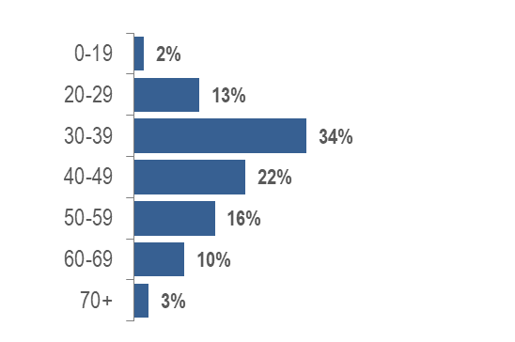
- Individuals AFAB newly diagnosed with HIV infection in Massachusetts during 2021 to 2023 were predominantly in their thirties and forties (34% 30–39 year-olds and 22% 40–49 year-olds).
- Individuals AFAB living with HIV infection on 12/31/2023 were predominantly 50 years of age or above (<1% 0–19 years, 3% 20–29 years, 11% 30–39 years, 20% 40–49 years, 30% 50–59 years, 26% 60–69 years, and 9% 70+ years).

PLACE OF RESIDENCE
TABLE 1. Massachusetts cities/towns with the highest percentage of HIV diagnoses among individuals AFAB, 2021–2023
 | HIV Diagnoses Among individuals AFAB (N) | HIV Diagnoses Among Individuals AFAB as Percent of Total HIV Diagnoses in City/Town (%)
Massachusetts Total | 396 | 28%
Top Cities/Towns
Brockton | 42 | 56%
Lynn | 18 | 41%
New Bedford | 12 | 40%
Worcester | 22 | 31%
Boston | 96 | 27%
Lawrence | 9 | 26%
Lowell | 11 | 26%
Everett | 5 | 24%
Framingham | 5 | 23%
Springfield | 12 | 21%
All Other Cities/Towns | 164 | 24%

- Among cities and towns with more than 20 reported HIV diagnoses during 2021 to 2023, Brockton had the highest percentage of HIV diagnoses among individuals AFAB at 56%, followed by Lynn and New Bedford at 41% and 40%, respectively.

INFORMATION FROM ADDITIONAL DATA SOURCES
Behavioral Risk Factors: Recent statewide surveys describe sexual and drug use behaviors among individuals AFAB in Massachusetts.
Massachusetts Behavioral Risk Factor Surveillance Survey (BRFSS): A continuous anonymous telephone survey of adults ages 18 and older that collects data on a variety of health risk factors, preventive behaviors, chronic conditions, and emerging public health issues.
- Among sexually active individuals AFAB ages 18–64 years from 2021 to 2023:
  - 19.7% (95% confidence interval [CI]: 17.1%–22.2%) reported condom use at their last sexual encounter, compared to 25.1% (95% CI: 22.6%–27.5%) of individuals AMAB; and
  - 8.4% (95% CI: 6.8%–10.0%) reported two or more sexual partners in the past year, 60.8% (95% CI: 58.2%–63.3%) reported one partner, and 30.8% (95% CI: 28.5%–33.2%) reported none; compared to 12.6% (95% CI: 10.8%–14.4%), 61.2% (95% CI: 58.7%–63.8%), and 26.1% (95% CI: 23.8%–28.5%), respectively, of individuals AMAB.
Data Source: Health Survey Program, Office of Data Management and Outcomes Assessment, Massachusetts Behavioral Risk Factor Surveillance System (BRFSS). For more information, see: Health Survey Program, Office of Data Management and Outcomes Assessment, Massachusetts Department of Public Health. A Profile of Health Among Massachusetts Adults, 2022, Results from the Behavioral Risk Factor Surveillance System, December 2023, https://www.mass.gov/lists/brfss-statewide-reports-and-publications
Massachusetts Youth Risk Behavior Survey (YRBS): An anonymous survey of public high school students conducted every odd year that collects data on health-related behaviors.
- Students AFAB reported the following rates of sexual behaviors in the 2023 YRBS:
  - Sexual intercourse before age 13: 2.2% (95% CI: 1.4%–3.0%; n=1,336);
  - Having four or more lifetime sexual partners: 4.0% (95% CI: 2.7%–5.4%, n=1,332);
  - Using a condom at last intercourse: 44.1% (95% CI: 37.2%–51.1%, n=288); and
  - Drinking alcohol or using drugs before last sexual intercourse: 17.5% (95% CI: 11.1%–23.9%, n=289).
- Reported rates of condom use were significantly lower among students AFAB compared to students AMAB (60.3%, 95% CI: 51.7%-68.9%; n=279). None of the other reported rates above differed significantly from rates reported among students AMAB.
Data Source: Massachusetts Department of Elementary and Secondary Education and Massachusetts Department of Public Health, Office of Data Management and Outcomes Assessment
HIV Surveillance Data Source: MDPH Bureau of Infectious Disease and Laboratory Sciences, data are current as of 7/1/2024 and may be subject to change

Providers may use this number to report individuals newly diagnosed with a notifiable sexually transmitted infection, including HIV, or request partner services. Partner services is a free and confidential service for individuals recently diagnosed with a priority infection. The client-centered program offers counseling, linkage to other health and social services, anonymous notification of partners who were exposed and assistance with getting testing and treatment. For more information, see: https://www.mass.gov/service-details/partner-services-program-information-for-healthcare-providers)
Please consider the impact of the COVID-19 pandemic on infectious disease screening, treatment, and surveillance in the interpretation of data from 2020 to 2023
As of 1/1/2020, BIDLS calculates rates per 100,000 population using denominators estimated by the University of Massachusetts Donahue Institute using a modified Hamilton-Perry model (Strate S, et al. Small Area Population Estimates for 2011 through 2020, report published Oct 2016). Note that rates and trends calculated using previous methods cannot be compared to these. All rates are age-adjusted using the 2000 US standard population.
Please consider the impact of the COVID-19 pandemic on infectious disease screening, treatment, and surveillance in the interpretation of data from 2020 to 2023
As of 1/1/2020, BIDLS calculates rates per 100,000 population using denominators estimated by the University of Massachusetts Donahue Institute using a modified Hamilton-Perry model (Strate S, et al. Small Area Population Estimates for 2011 through 2020, report published Oct 2016). Note that rates and trends calculated using previous methods cannot be compared to these. All rates are age-adjusted using the 2000 US standard population.
Please consider the impact of the COVID-19 pandemic on infectious disease screening, treatment, and surveillance in the interpretation of data from 2020 to 2023
Please consider the impact of the COVID-19 pandemic on infectious disease screening, treatment, and surveillance in the interpretation of data from 2020 to 2023
94% of individuals diagnosed with HIV infection from 2021–2023 and 98% of persons living with HIV infection on 12/31/2023 who were born in a US dependency were born in Puerto Rico.
Please consider the impact of the COVID-19 pandemic on infectious disease screening, treatment, and surveillance in the interpretation of data from 2020 to 2023
Please consider the impact of the COVID-19 pandemic on infectious disease screening, treatment, and surveillance in the interpretation of data from 2020 to 2023
City/town is based on residence at HIV infection diagnosis
Among cities and towns with more than 20 total HIV diagnoses from 2021–2023.
All Other Cities/Towns includes individuals diagnosed in a correctional facility

